Quiero invitarte

Activity 1
Listen to the statements and tick the box(es) with the correct information:
- This is an invitation to
☐ a party
☐ a festival
on the
☐ 2 September ☐ 12 September.
- The person is declining the invitation because
☐ they don’t want to go
☐ they have other plans.
- The person is planning to attend a party for
☐ el Cinco de Mayo
☐ el Día de los Muertos.
- The person is
☐ accepting
☐ declining
the invitation.
- The person is asking
☐ what they will be doing,
☐ where the party is taking place,
☐ what the party is for,
☐ what time the party starts.
- The person is inviting someone to a
☐ New Year’s Eve
☐ Christmas Eve party
which is
☐ at their home
☐ in a restaurant.
- The person
☐ is
☐ is not
looking forward to the event.
- The person is talking about a party to celebrate
☐ his brother’s
☐ his sister’s
☐ birthday
☐ 15th birthday.
- The person is inviting someone to their
☐ farewell party
☐ 15th birthday party.
- The person
☐ does
☐ does not
want to attend the event.

Activity 2
Use the cues in the table below to write an invitation to an event, including the place, date and time, beginning with the phrase Quiero invitarte a la fiesta de [event].
The first one has been done for you as an example.
 | Event | Date | Time | Place | Yes or no
1 |  |  | 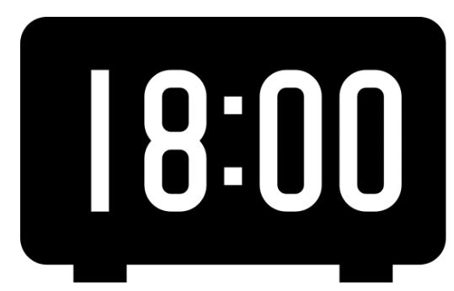
2 |  | 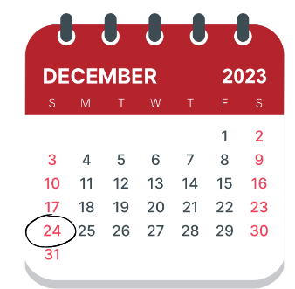 | 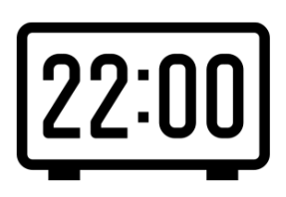
3 | 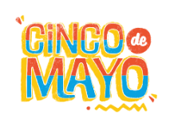
4
5 |  |  | 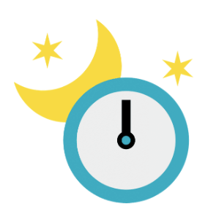
6 |  |  | 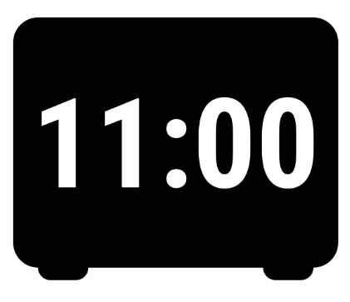
1 | Quiero invitarte a la fiesta de mi cumpleaños, el doce de abril, a las seis de la noche en mi casa.
2
3
4
5
6

Activity 3
Using the cues in the final column of the table in Activity 2, accept or decline the invitation to the event. The first one has been done for you.
1 | ¡Claro que sí! ¡Me encantaría!
2
3
4
5
6

For the teacher

Activity 1

Transcript and audio files
1. Te quería invitar a una fiesta el doce de septiembre. Text 1.mp3 (0:04)
2. Lo siento no puedo, ese día ya tengo otros planes. Text 2.mp3 (0:07)
3. ¡Nos vemos en la fiesta del Cinco de Mayo! Text 3.mp3 (0:05)
4. ¡Claro que sí! Text 4.mp3 (0:03)
5. ¿Dónde y a qué hora será la fiesta? Text 5.mp3 (0:04)
6. Quiero invitarte a la cena de Nochebuena en un restaurante. Text 6.mp3 (0:06)
7. Espero con ansias nuestro encuentro. Text 7.mp3 (0:05)
8. Hay una fiesta para celebrar el cumpleaños de mi hermano. Text 8.mp3 (0:06)
9. ¿Te gustaría venir a mi quinceañera? Text 9.mp3 (0:03)
10. ¡Por supuesto! Text 10.mp3 (0:03)

Answers
- This is an invitation to
☒ a party
☐ a festival
on the
☐ 2 September ☒ 12 September.
- The person is declining the invitation because
☐ they don’t want to go
☒ they have other plans.
- The person is planning to attend a party for
☒ el Cinco de Mayo
☐ el Día de los Muertos.
- The person is
☒ accepting
☐ declining
the invitation.
- The person is asking
☐ what they will be doing,
☒ where the party is taking place,
☐ what the party is for,
☒ what time the party starts.
- The person is inviting someone to a
☐ New Year’s Eve
☒ Christmas Eve party
which is
☐ at their home
☒ in a restaurant.
- The person
☒ is
☐ is not
looking forward to the event.
- The person is talking about a party to celebrate
☒ his brother’s
☐ his sister’s
☒ birthday
☐ 15th birthday.
- The person is inviting someone to their
☐ farewell party
☒ 15th birthday party.
- The person
☒ does
☐ does not
want to attend the event.

Activity 2
- Quiero invitarte a la fiesta de mi cumpleaños, el doce de abril, a las seis de la noche en mi casa.
- Quiero invitarte a la fiesta de Noche Buena, el veinticuatro de diciembre, a las diez de la noche al restaurante.
- Quiero invitarte a la fiesta del Cinco de Mayo, el cinco de mayo al mediodía en el parque.
- Quiero invitarte a la fiesta de mi quinceañera el veintiocho de septiembre a las ocho de la noche en mi casa.
- Quiero invitarte a la fiesta de Navidad, el veinticinco de diciembre a las once de la mañana al restaurante.
- Quiero invitarte a la fiesta del Día de Muertos, el dos de noviembre a las once de la mañana en la ciudad.

Activity 3
There is more than one possible answer. Some examples are:
- ¡Claro que sí!
- ¡Me encantaría!
- Lo siento, no puedo
- Ese día tengo otros planes
- ¿Podemos organizar una salida la próxima semana?
- ¡Por supuesto!

© State of New South Wales (Department of Education), 2023
The copyright material published in this resource is subject to the Copyright Act 1968 (Cth) and is owned by the NSW Department of Education or, where indicated, by a party other than the NSW Department of Education (third-party material).
Copyright material available in this resource and owned by the NSW Department of Education is licensed under a Creative Commons Attribution 4.0 International (CC BY 4.0) license.
This license allows you to share and adapt the material for any purpose, even commercially.
Attribution should be given to © State of New South Wales (Department of Education), 2023.
Material in this resource not available under a Creative Commons license:
- the NSW Department of Education logo, other logos and trademark-protected material
- material owned by a third party that has been reproduced with permission. You will need to obtain permission from the third party to reuse its material.
Links to third-party material and websites
Please note that the provided (reading/viewing material/list/links/texts) are a suggestion only and implies no endorsement, by the New South Wales Department of Education, of any author, publisher, or book title. School principals and teachers are best placed to assess the suitability of resources that would complement the curriculum and reflect the needs and interests of their students.
If you use the links provided in this document to access a third-party's website, you acknowledge that the terms of use, including licence terms set out on the third-party's website apply to the use which may be made of the materials on that third-party website or where permitted by the Copyright Act 1968 (Cth). The department accepts no responsibility for content on third-party websites.

