¿Qué desea?

Activity 1
Using the cues provided in the first column, complete the table below with a detailed answer to the question ¿Qué desea? including colour/design and size. The first one has been done for you as an example. Make sure you use the correct word for sizes of clothing or shoes.
Article and size | ¿Qué desea? | ¿De qué talla/número?
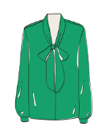 40 | Quiero una blusa verde. | De la talla cuarenta.
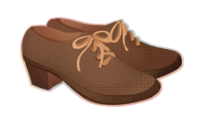 37
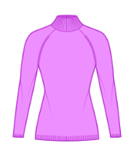 36
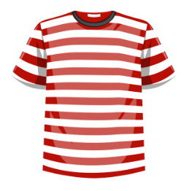 28
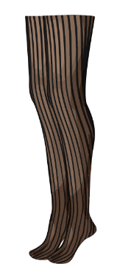 32
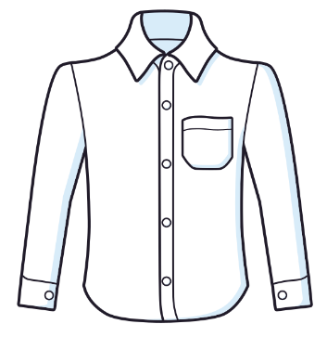 48
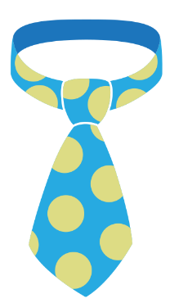 50
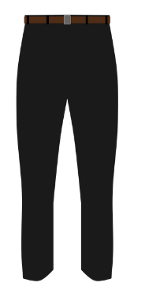 52
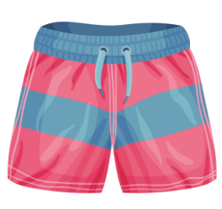 32
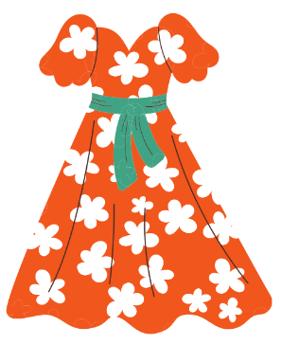 42
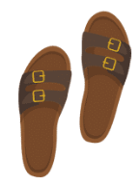 42
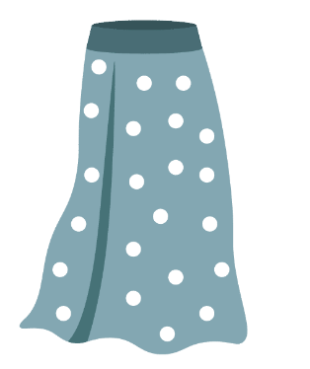 36
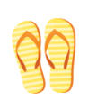 38

Activity 2
Write a description of an item of clothing or shoes in Spanish in the space below. Include at least two adjectives of pattern and/or colour and a size. For example, Quiero unos shorts floreados azules de la talla cuarenta.
Quiero __________________________________________________________________
Then, interview 5 people in your class asking them to describe their item of clothing/shoes using the questions modelled in Activity 1, and complete the table below.
nombre | ropa/zapatos | talla/número

For the teacher
Differentiation examples
The following strategies provide a starting point for how you can differentiate the teaching and learning activities in this resource for a range of learners. Adapt or design alternative activities to meet the needs of students in your class.
High potential and gifted students – students access the Spanish clothing brand websites Desigual, Flamingos’ Life and indi & cold and create a shopping phrase book with essential vocabulary (clothing items and accessories) and phrases, for example ‘on sale’, ‘in season’ ‘reduced’, or ‘new season’ to make a clothing purchase. This may be in addition to, or in place of, Activity 1.
Advanced proficiency – with a like-ability partner, students create and perform a conversation in a clothing shop which includes making comparisons, negotiating choices (including sizes) and cost. This may be in addition to, or in place of, Activity 1.
Students requiring additional support – for Activity 1, provide students with the answers for columns 2 and 3, on sticky notes. Students then place the sticky notes into the corrects cells in the table. Students then use these responses as a model to write one sentence of their own to express what they want. For Activity 2, provide students with the ‘¿Qué desea? sentence scaffold’ resource [DOCX 230 KB], if required.

Activity 1
Item and size | ¿Qué desea? | ¿De qué talla/número?
40 | Quiero una blusa verde. | De la talla cuarenta.
37 | Quiero unos zapatos marrones. | Del número treinta y siete.
36 | Quiero un suéter violeta. | De la talla treinta y seis.
28 | Quiero una camiseta a rayas roja y blanca. | De la talla veintiocho.
32 | Quiero unas mallas negras. | De la talla treinta y dos.
48 | Quiero una camiseta blanca. | De la talla cuarenta y ocho.
50 | Quiero una corbata a lunares. | De la talla cincuenta.
52 | Quiero unos pantalones negros. | De la talla cincuenta y dos.
32 | Quiero unos shorts a rayas rojos y azules. | De la talla treinta y dos.
42 | Quiero un vestido floreado rojo. | De la talla cuarenta y dos.
42 | Quiero unas sandalias marrones. | Del número cuarenta y dos.
36 | Quiero una falda a lunares azul. | De la talla treinta y seis.
38 | Quiero unas chancletas a rayas amarillas. | Del número treinta y ocho.

© State of New South Wales (Department of Education), 2023
The copyright material published in this resource is subject to the Copyright Act 1968 (Cth) and is owned by the NSW Department of Education or, where indicated, by a party other than the NSW Department of Education (third-party material).
Copyright material available in this resource and owned by the NSW Department of Education is licensed under a Creative Commons Attribution 4.0 International (CC BY 4.0) license.
This license allows you to share and adapt the material for any purpose, even commercially.
Attribution should be given to © State of New South Wales (Department of Education), 2023.
Material in this resource not available under a Creative Commons license:
- the NSW Department of Education logo, other logos and trademark-protected material
- material owned by a third party that has been reproduced with permission. You will need to obtain permission from the third party to reuse its material.
Links to third-party material and websites
Please note that the provided (reading/viewing material/list/links/texts) are a suggestion only and implies no endorsement, by the New South Wales Department of Education, of any author, publisher, or book title. School principals and teachers are best placed to assess the suitability of resources that would complement the curriculum and reflect the needs and interests of their students.
If you use the links provided in this document to access a third-party's website, you acknowledge that the terms of use, including licence terms set out on the third-party's website apply to the use which may be made of the materials on that third-party website or where permitted by the Copyright Act 1968 (Cth). The department accepts no responsibility for content on third-party websites.

