Me lo llevo

Activity 1
Choose the appropriate direct object pronoun for each item of clothing in the table below. The first one has been done for you as an example.
Item | Direct object pronoun
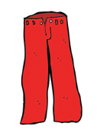 | lo/la/los/las
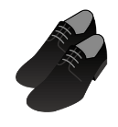 | lo/la/los/las
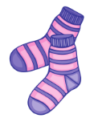 | lo/la/los/las
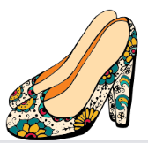 | lo/la/los/las
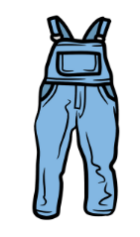 | lo/la/los/las
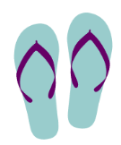 | lo/la/los/las
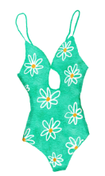 | lo/la/los/las
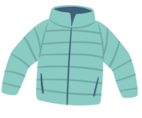 | lo/la/los/las
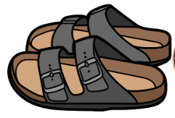 | lo/la/los/las
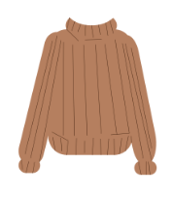 | lo/la/los/las

Activity 2
Identify the item in the table below and then say that you will take it, using the appropriate direct object pronoun (lo, la, los, las) with the phrase Me llevo. The first one has been done for you as an example.
Item | Description | Me [direct object pronoun] llevo
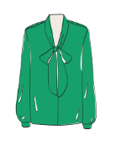 | la blusa verde | Me la llevo.
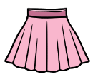
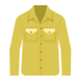
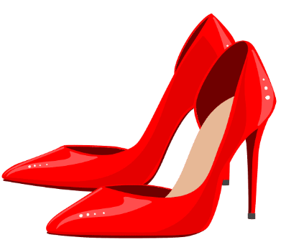
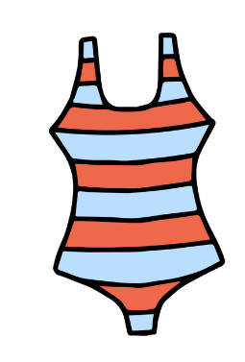
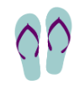
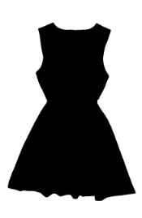

Activity 3
Make a statement to compare the 2 items in the table using the correct demonstrative pronoun (este, esta, estos, estas). Complete the table below by saying you will take it, using the correct direct object pronoun as for Activity 1 (lo, la, los, las). The first one has been done for you as an example. Fill in the blanks to help you complete the next 2 sentences, and then construct the rest of the sentences on your own.
Items | Comparative statement | Me [direct object pronoun] llevo
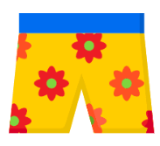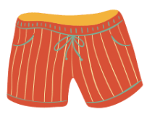 | Estos shorts floreados son más bonitos que los a rayas. | Me los llevo.
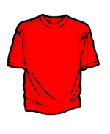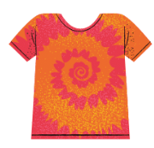 | ______ camiseta lisa es menos _____ que la estampada. | Me ___ llevo.
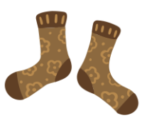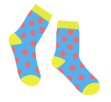 | ____ calcetines _______ son tan _____ como ___________. | Me ___ _____.
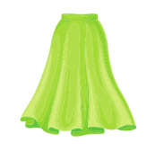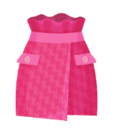
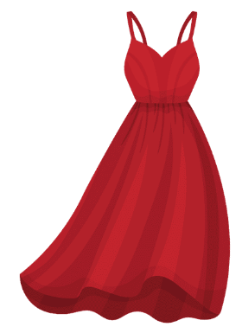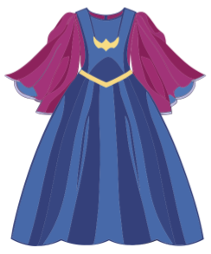
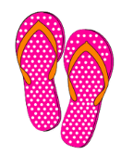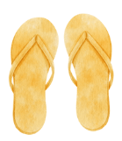
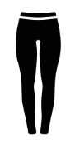

For the teacher

Activity 1
Item | Direct object pronoun
 | lo/la/los/las
 | lo/la/los/las
 | lo/la/los/las
 | lo/la/los/las
 | lo/la/los/las
 | lo/la/los/las
 | lo/la/los/las
 | lo/la/los/las
 | lo/la/los/las
 | lo/la/los/las

Activity 2
Item | Description | Me [direct object pronoun] llevo
 | la blusa verde | Me la llevo.
 | la falda rosa | Me la llevo.
 | la camisa amarilla | Me la llevo.
 | los tacones rojos | Me los llevo.
 | el traje de baño de rayas | Me lo llevo.
 | las chancletas azules y violetas | Me las llevo.
 | el vestido negro | Me lo llevo.

Activity 3
Items | Comparative statement | Me [direct object pronoun] llevo
 | Estos shorts floreados son más bonitos que los a rayas. | Me los llevo.
 | Esta camiseta lisa es menos fea que la estampada. | Me la llevo.
 | Los calcetines floreados son tan feos como los a lunares. | Me los llevo.
 | La falda verde es más larga que la rosa. | Me la llevo.
 | La corbata azul de rayas es más elegante que la roja. | Me la llevo.
 | El vestido rojo es menos anticuado que el azul. | Me lo llevo.
 | Las chancletas amarillas son tan feas que los rosas. | Me las llevo.
 | Las mallas rosas son menos cómodas que las negras. | Me las llevo.

© State of New South Wales (Department of Education), 2023
The copyright material published in this resource is subject to the Copyright Act 1968 (Cth) and is owned by the NSW Department of Education or, where indicated, by a party other than the NSW Department of Education (third-party material).
Copyright material available in this resource and owned by the NSW Department of Education is licensed under a Creative Commons Attribution 4.0 International (CC BY 4.0) license.
This license allows you to share and adapt the material for any purpose, even commercially.
Attribution should be given to © State of New South Wales (Department of Education), 2023.
Material in this resource not available under a Creative Commons license:
- the NSW Department of Education logo, other logos and trademark-protected material
- material owned by a third party that has been reproduced with permission. You will need to obtain permission from the third party to reuse its material.
Links to third-party material and websites
Please note that the provided (reading/viewing material/list/links/texts) are a suggestion only and implies no endorsement, by the New South Wales Department of Education, of any author, publisher, or book title. School principals and teachers are best placed to assess the suitability of resources that would complement the curriculum and reflect the needs and interests of their students.
If you use the links provided in this document to access a third-party's website, you acknowledge that the terms of use, including licence terms set out on the third-party's website apply to the use which may be made of the materials on that third-party website or where permitted by the Copyright Act 1968 (Cth). The department accepts no responsibility for content on third-party websites.

