Describing clothing

Activity 1
Choose the correct description of the item in the table below. Ensure you have carefully checked the adjective for the correct agreement where necessary. The first one has been done for you as an example.
Item | Description
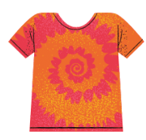 | Es una camiseta  estampada/estampado.
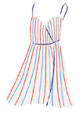 | Es un vestido  a rayas/a lunares.
Es una corbata
roja/rosa.
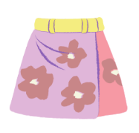 | Es una falda  lisa/floreada.
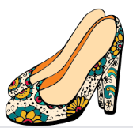 | Son tacones  feo/feos.
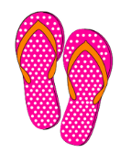 | Son unas chancletas  a lunares/a rayas.
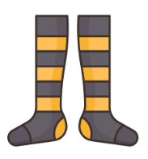 | Son calcetines  largos/largas.
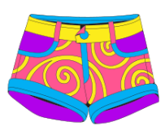 | Son shorts  corto/cortos.
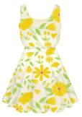 | Es un vestido  floreada/floreado.
Es una corbata
a rayas/a lunares.

Activity 2
Create a sentence in the table below to describe the item of clothing. Make sure you use the correct form of the adjective. The first one has been done for you as an example.
Item | Spanish sentence
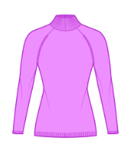 | Es un suéter violeta.
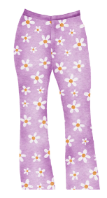
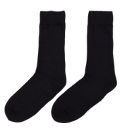
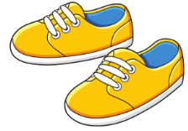
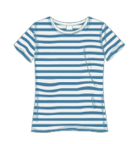
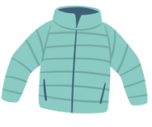
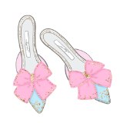
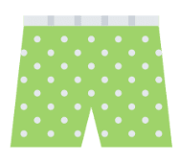
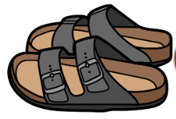

Activity 3
Draw an outfit on the outline below, including a range of colours and patterns. Make sure to include shoes too. Then, give your drawing to a partner for them to describe the clothing by writing sentences in their books, beginning with Lleva…
When your partner has completed the description, review it and give them feedback. For each item look for:
Element | Yes or no
The correct article (un/una/unos/unas)
A description (colour and/or design)
Correct adjectival agreement (masculine/feminine/singular/plural)
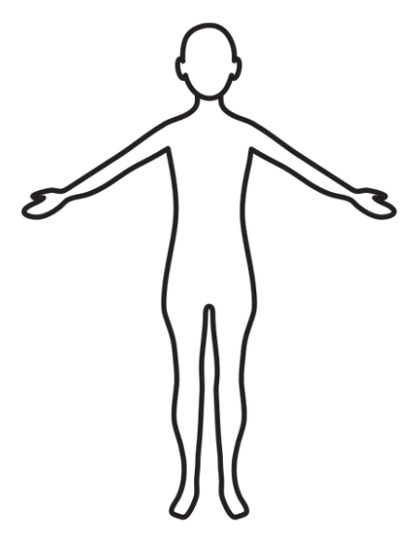

For the teacher

Activity 1
Item | Description
 | Es una camiseta estampada.
 | Es un vestido a rayas.
 | Es una corbata roja.
 | Es una falda floreada.
 | Son tacones feos.
 | Son unas chancletas a lunares.
 | Son calcetines largos.
 | Son shorts cortos.
 | Es un vestido floreado.
 | Es una corbata a rayas.

Activity 2
There may be more than one response for each item. One possible response has been provided below.
Item | Spanish sentence
 | Es un suéter violeta.
 | Son unos pantalones estampados y violetas.
 | Son unos calcetines negros y lisos.
 | Son unas zapatillas amarillas.
 | Es una camiseta de rayas.
 | Es una chaqueta verde.
 | Son unos tacones anticuados.
 | Son unos shorts verdes de lunares.
 | Son unas sandalias negros y feos.

© State of New South Wales (Department of Education), 2023
The copyright material published in this resource is subject to the Copyright Act 1968 (Cth) and is owned by the NSW Department of Education or, where indicated, by a party other than the NSW Department of Education (third-party material).
Copyright material available in this resource and owned by the NSW Department of Education is licensed under a Creative Commons Attribution 4.0 International (CC BY 4.0) license.
This license allows you to share and adapt the material for any purpose, even commercially.
Attribution should be given to © State of New South Wales (Department of Education), 2023.
Material in this resource not available under a Creative Commons license:
- the NSW Department of Education logo, other logos and trademark-protected material
- material owned by a third party that has been reproduced with permission. You will need to obtain permission from the third party to reuse its material.
Links to third-party material and websites
Please note that the provided (reading/viewing material/list/links/texts) are a suggestion only and implies no endorsement, by the New South Wales Department of Education, of any author, publisher, or book title. School principals and teachers are best placed to assess the suitability of resources that would complement the curriculum and reflect the needs and interests of their students.
If you use the links provided in this document to access a third-party's website, you acknowledge that the terms of use, including licence terms set out on the third-party's website apply to the use which may be made of the materials on that third-party website or where permitted by the Copyright Act 1968 (Cth). The department accepts no responsibility for content on third-party websites.

