Clothing and colours

Activity 1
Tick the correct description of each item in the table below.
Item | Description
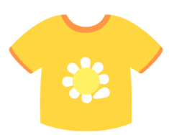 | ☐ Es una camiseta amarilla.  ☐ Es una camiseta amarillo.
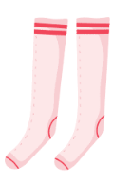 | ☐ Son unos calcetines rojas.  ☐ Son unos calcetines rosas.
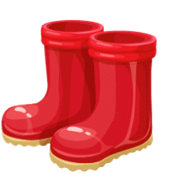 | ☐ Son unas botas rojas.  ☐ Son unas botas rojos.
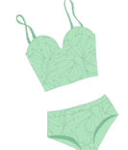 | ☐ Es un traje de baño verdes.  ☐ Es un traje de baño verde.
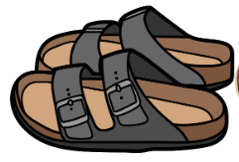 | ☐ Son unas sandalias negros.  ☐ Son unas sandalias negras.
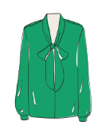 | ☐ Es una camiseta verde.  ☐ Es una camisa verde.
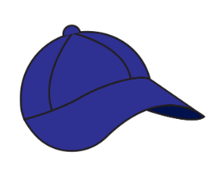 | ☐ Es una gorra azul.  ☐ Es una gorra azula.
☐ Es una corbata roja.
☐ Es una corbata rojo.

Activity 2
In the table below, the statements describing each item are incorrect. The number in brackets indicates how many errors there are in each statement. Find the error(s) and rewrite the description correctly. The first one has been done for you as an example.
Clothing | Incorrect description – find the error(s) | Write the correct description
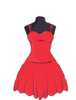 | Es un vestido roja. (1) | Es un vestido rojo.
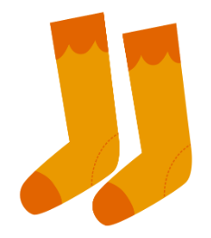 | Son unas calcetines naranja. (2)
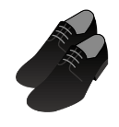 | Es unos zapatos negras. (2)
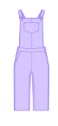 | Es un mono violeto. (1)
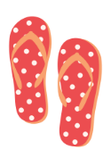 | Son unas chancletas rosos. (2)
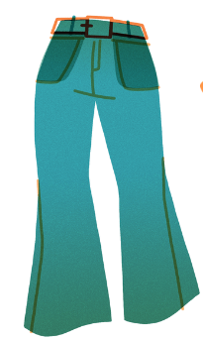 | Es unos pantalones verde. (2)
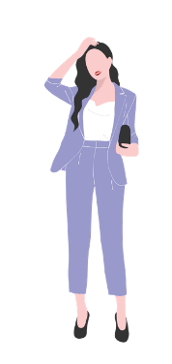 | Son una traje violeta. (3)
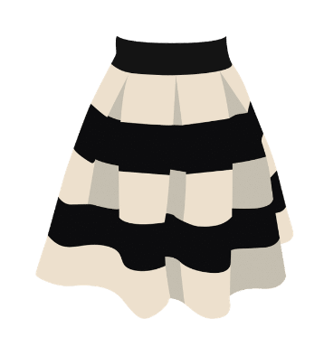 | Es una falda negro y blanco. (2)
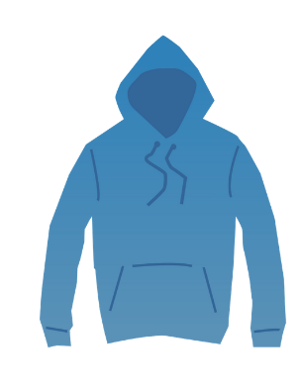 | Es una suéter azul. (1)

Activity 3
Describe each item in the table below using the correct colour. Make sure you use the correct form of the adjective (masculine, feminine, singular, plural). The first one has been done for you as an example.
Item | Description
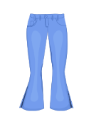 | Son unos vaqueros azules.
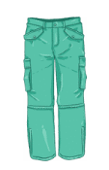
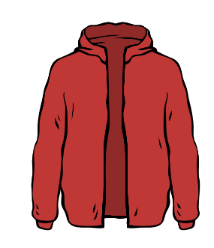
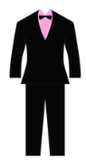
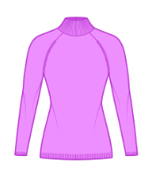
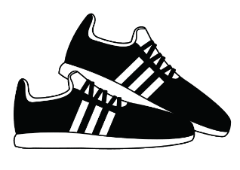
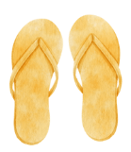

Activity 4
Choose one of the people from the images below and describe their clothing using the correct form of the colours.
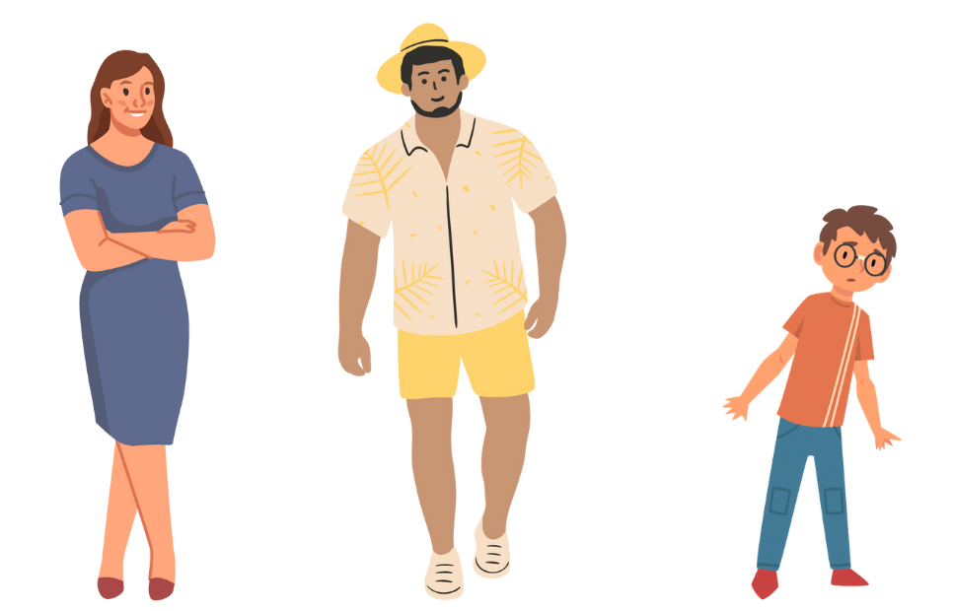

For the teacher

Activity 1
Item | Description
☒ Es una camiseta amarilla.
☐ Es una camiseta amarillo.
☐ Son unos calcetines rojas.
☒ Son unos calcetines rosas.
☒ Son unas botas rojas.
☐ Son unas botas rojos.
☐ Es un traje de baño verdes.
☒ Es un traje de baño verde.
☐ Son unas sandalias negros.
☒ Son unas sandalias negras.
☐ Es una camiseta verde.
☒ Es una camisa verde.
☒ Es una gorra azul.
☐ Es una gorra azula.
☒ Es una corbata roja.
☐ Es una corbata rojo.

Activity 2
Clothing | Incorrect description – find the error(s) | Write the correct description
 | Es un vestido roja. (1) | Es un vestido rojo.
 | Son unas calcetines naranja. (2) | Son unos calcetines naranjas.
 | Es unos zapatos negras. (2) | Son unos zapatos negros.
 | Es un mono violeto. (1) | Es un mono violeta.
 | Son unas chancletas rosos. (2) | Son unas chancletas rojas.
 | Es unos pantalones verde. (2) | Es unos pantalones verdes.
 | Son una traje violeta. (3) | Es un traje violeto.
 | Es una falda negro y blanco. (2) | Es una falda negra y blanca.
 | Es una suéter azul. (1) | Es un suéter azul.

Activity 3
Item | Description
 | Son unos vaqueros azules.
 | Son unos pantalones verdes
 | Es una chaqueta roja.
 | Es un traje negro.
 | Es un suéter violeta.
 | Son unas zapatillas negras y blancas.
 | Son unas mallas rosas.
 | Son unas claquetas amarillas.

Activity 4
Woman: un vestido azul, unos tacones/zapatos rojos
Man: unos shorts amarillos, una camisa blanca y amarilla, unos zapatos blancos
Boy: una camiseta marrón, unos vaqueros azules, unos zapatos rojos

© State of New South Wales (Department of Education), 2023
The copyright material published in this resource is subject to the Copyright Act 1968 (Cth) and is owned by the NSW Department of Education or, where indicated, by a party other than the NSW Department of Education (third-party material).
Copyright material available in this resource and owned by the NSW Department of Education is licensed under a Creative Commons Attribution 4.0 International (CC BY 4.0) license.
This license allows you to share and adapt the material for any purpose, even commercially.
Attribution should be given to © State of New South Wales (Department of Education), 2023.
Material in this resource not available under a Creative Commons license:
- the NSW Department of Education logo, other logos and trademark-protected material
- material owned by a third party that has been reproduced with permission. You will need to obtain permission from the third party to reuse its material.
Links to third-party material and websites
Please note that the provided (reading/viewing material/list/links/texts) are a suggestion only and implies no endorsement, by the New South Wales Department of Education, of any author, publisher, or book title. School principals and teachers are best placed to assess the suitability of resources that would complement the curriculum and reflect the needs and interests of their students.
If you use the links provided in this document to access a third-party's website, you acknowledge that the terms of use, including licence terms set out on the third-party's website apply to the use which may be made of the materials on that third-party website or where permitted by the Copyright Act 1968 (Cth). The department accepts no responsibility for content on third-party websites.

