Les vacances actives

Activity 1 – reading
Read the text below, then complete the table which follows.
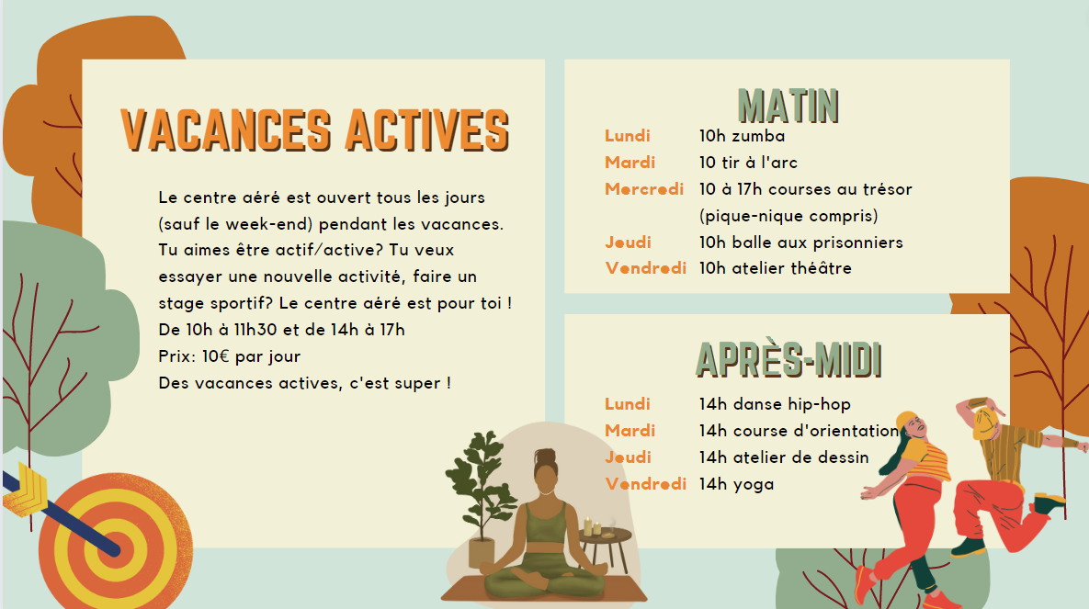
Images sourced from Canva and used in accordance with the Canva Content Licence Agreement.
Place a tick in the correct column, depending on whether the statement is true, false or not mentioned.
Statement | true | false | not mentioned
The holiday centre is open every day during the holidays.
It’s free to participate.
Wednesdays there is a picnic included.
Drama people would prefer Friday mornings.
There is lunch provided.
The holiday centre caters to sporty and creative kids.
Hip-hop class is on Monday afternoons.
Yoga is Friday mornings.
Zumba is on Tuesdays.
Orienteering is on Tuesday afternoons.
Dodge ball is on every morning.
The centre closes for lunch every day.
The providers are all trained in first aid.

Activity 2 – listening
Listen to the conversation about the various activities that people do and complete the table.
Person | Monday | Tuesday | Wednesday | Thursday | Friday | Other details
Lucie
Jacques
Julie
Bastien

Activity 3 – interacting
Using structures similar to those explored on slide 7 of the ‘Sentence builders and conversation scaffolds’ resource [PPTX 744KB], interact with a partner to organise to do an activity together at the centre aéré.
First, each of you chooses an activity you like (or are prepared to do, as there may not be something of interest to you!). Then, arrange with your partner to go together.
This scaffold may help you. One of you will be Student A and one of you will be Student B.
- Exchange greetings.
- Student A says what they would prefer to do, for example Je préfère yoga, and asks Student B to come, for example Tu viens au yoga avec moi ?
- Student B accepts the invitation.
- Student A says the day and time of the activity.
- Student B asks when to meet.
- Student A says when and where to meet.
- Student B asks how to get there.
- Student A says how to get there.
- Conclude with a farewell.
Then swap roles, so Student A becomes Student B, and have another interaction.

Activity 4 – creating text
Send a message to a friend or family member, telling them what you did at the centre aéré, based on your interaction in Activity 3, using the past tense.
Include:
- when you went, for example la semaine dernière
- who you went with
- how you got there
- how it was (using c’était + an adjective).

For the teacher
Allow students time to access the holiday brochure and tick the true/false/not mentioned statements in the table. Discuss the responses with the class.

Activity 1 – responses
Statement | true | false | not mentioned
The holiday centre is open every day during the holidays.
It’s free to participate.
Wednesdays there is a picnic included.
Drama people would prefer Friday mornings.
There is lunch provided.
The holiday centre caters to sporty and creative kids.
Hip-hop class is on Monday afternoons.
Yoga is Friday mornings.
Zumba is on Tuesdays.
Orienteering is on Tuesday afternoons.
Dodge ball is on every morning.
The centre closes for lunch every day.
The providers are all trained in first aid.

Activity 2
Play the audio file. Students complete the table for each person, including days on which they participate in the activity and any other details they hear – for example, Lucie does archery on Tuesdays, she says it’s difficult, but that it’s great.

Audio file
Les vacances actives Activity 2 audio.mp3 (1:03)

Transcript of audio
Bonjour, Lucie, quelles activités fais-tu pendant les vacances ?
Je vais au centre aéré et je fais du tir à l’arc le mardi. C’est difficile mais c’est génial !
Jacques ?
Je fais une course d’orientation le mardi après-midi et je joue à la balle aux prisonniers le jeudi.
Et toi, Julie ?
Moi, je fais du yoga pendant deux heures le vendredi après-midi.
Super ! Et toi Bastien, tu aimes la zumba ?
Ah non, c’est pas pour moi la Zumba ! Je fais du dessin le jeudi de 14 heures à 16 heures. C’est vraiment passionnant. Je fais aussi du théâtre le vendredi matin.
Merci tout le monde … continuez à rester actifs !

Responses
Person | Monday | Tuesday | Wednesday | Thursday | Friday | Other details
Lucie |  | Archery |  |  |  | It’s difficult but great
Jacques |  | Orienteering |  | Dodge ball
Julie |  |  |  |  | Yoga | Two hours
Bastien |  |  |  | Drawing | Drama | He is passionate about drawing but Zumba is not his thing

© State of New South Wales (Department of Education), 2023
The copyright material published in this resource is subject to the Copyright Act 1968 (Cth) and is owned by the NSW Department of Education or, where indicated, by a party other than the NSW Department of Education (third-party material).
Copyright material available in this resource and owned by the NSW Department of Education is licensed under a Creative Commons Attribution 4.0 International (CC BY 4.0) license.
This license allows you to share and adapt the material for any purpose, even commercially.
Attribution should be given to © State of New South Wales (Department of Education), 2023.
Material in this resource not available under a Creative Commons license:
- the NSW Department of Education logo, other logos and trademark-protected material
- material owned by a third party that has been reproduced with permission. You will need to obtain permission from the third party to reuse its material.
Links to third-party material and websites
Please note that the provided (reading/viewing material/list/links/texts) are a suggestion only and implies no endorsement, by the New South Wales Department of Education, of any author, publisher, or book title. School principals and teachers are best placed to assess the suitability of resources that would complement the curriculum and reflect the needs and interests of their students.
If you use the links provided in this document to access a third-party's website, you acknowledge that the terms of use, including licence terms set out on the third-party's website apply to the use which may be made of the materials on that third-party website or where permitted by the Copyright Act 1968 (Cth). The department accepts no responsibility for content on third-party websites.

