Expressions of frequency
Listen to the statements about the activities below. Identify which picture is being described. Write the corresponding activity number in the first column of the table.
Then listen again, and see if you can identify the expression of frequency that is included in each statement. Complete columns 2 and 3 of the table.
You may use a dictionary, if needed.

Les activités
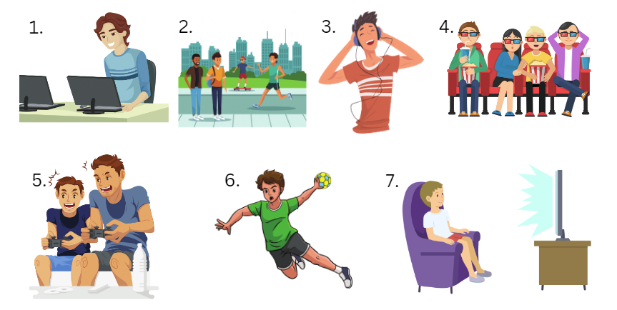
Images sourced from Canva and used in accordance with the Canva Content License Agreement.
Activity number | French expression of frequency | English translation

For the teacher
Read or play the recording of the statements below to the students as they number them in the table. Read or play the statements a second time (or as many times as required) for students to identify the expression of frequency in each statement. Discuss the meaning and provide the English translation on the board for the students to copy.

Transcripts and audio files
- Tous les jours, je passe deux heures sur mon ordi. | Expressions of frequency text 1.mp3 (0:03)
- J’écoute souvent de la musique. | Expressions of frequency text 2.mp3 (0:01)
- Le samedi soir, je vais au cinéma. | Expressions of frequency text 3.mp3 (0:02)
- Je joue au handball une fois par semaine. | Expressions of frequency text 4.mp3 (0:02)
- Le dimanche matin, je joue sur ma console de jeux vidéo. | Expressions of frequency text 5.mp3 (0:04)
- Le dimanche soir, je regarde quelquefois la télé. | Expressions of frequency text 6.mp3 (0:03)
- Je vais en ville le weekend. | Expressions of frequency text 7.mp3 (0:02)

Answers
Activity number | French expression of frequency | English translation
1 | tous les jours | every day
3 | souvent | often
4 | samedi soir | on Saturday nights
6 | une fois par semaine | once a week
5 | le dimanche matin | on Sunday mornings
7 | le dimanche soir | on Sunday evenings
2 | le weekend | on the weekends

© State of New South Wales (Department of Education), 2023
The copyright material published in this resource is subject to the Copyright Act 1968 (Cth) and is owned by the NSW Department of Education or, where indicated, by a party other than the NSW Department of Education (third-party material).
Copyright material available in this resource and owned by the NSW Department of Education is licensed under a Creative Commons Attribution 4.0 International (CC BY 4.0) license.
This license allows you to share and adapt the material for any purpose, even commercially.
Attribution should be given to © State of New South Wales (Department of Education), 2023.
Material in this resource not available under a Creative Commons license:
- the NSW Department of Education logo, other logos and trademark-protected material
- material owned by a third party that has been reproduced with permission. You will need to obtain permission from the third party to reuse its material.
Links to third-party material and websites
Please note that the provided (reading/viewing material/list/links/texts) are a suggestion only and implies no endorsement, by the New South Wales Department of Education, of any author, publisher, or book title. School principals and teachers are best placed to assess the suitability of resources that would complement the curriculum and reflect the needs and interests of their students.
If you use the links provided in this document to access a third-party's website, you acknowledge that the terms of use, including licence terms set out on the third-party's website apply to the use which may be made of the materials on that third-party website or where permitted by the Copyright Act 1968 (Cth). The department accepts no responsibility for content on third-party websites.

