Daily routine
Read the routine of 2 different teenagers. Complete the table with the activity and time (if mentioned) for each activity.

La routine de Emily
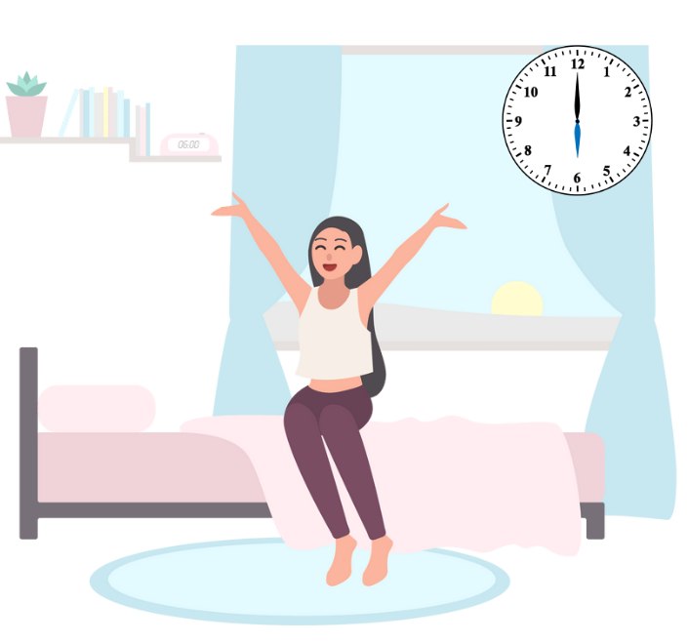
Je me lève à six heures. Je mange mon petit déjeuner et je m’habille pour l’école. Je quitte la maison à sept heures et demie et je vais à l’arrêt de bus à pied. Je prends le bus pour aller à l’école à sept heures quarante-cinq. Je fais mes cours et je déjeune à la cantine avec mes copines. Je rentre à la maison à quinze heures vingt. Je promène le chien, je mange un casse-croûte et je fais mes devoirs. Quelquefois je regarde des clips. J’écoute toujours de la musique. Je dîne en famille vers sept heures. Après le dîner j’aide mes parents avec la vaisselle et je donne à manger au chien. J’envoie des textos et je tchate avec mes copines jusqu’à vingt heures. Je me couche à vingt heures trente.

La routine de Max
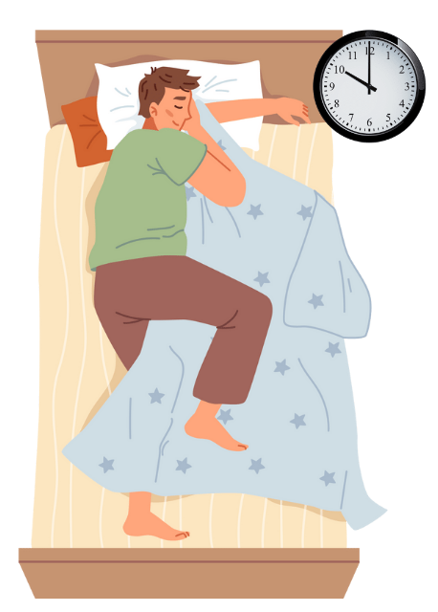
Je fais la grasse matinée et je me réveille à onze heures. Je tchate avec mes copains et je me lève à onze heures et demie mais je ne m’habille pas. Quelquefois je vais en ville en bus avec mes copains vers midi. Je déjeune au café, je fais du shopping ou je fais du sport et je rentre à la maison à cinq heures. Je ne fais jamais mes devoirs. Je dîne souvent au restaurant en famille et de temps en temps je vais chez un ami pour manger et regarder un film. Je rentre avant minuit. Je me couche à une heure du matin.
Emily – activity | Emily – time | Max – activity | Max – time
Which day or days of the week do you think Emily is describing? Justify your response with 3 references to the text.
Which day or days of the week do you think Max is describing? Justify your response with 3 references to the text.

For the teacher
Emily – activity | Emily – time | Max – activity | Max – time
I get up | 6 am | I sleep in
I eat breakfast |  | I wake up | 11 am
I get dressed for school |  | I chat online with friends
I leave the house | 7:30 am | I get up | 11:30 am
I walk to the bus stop |  | I don’t get dressed
I take the bus to school | 7:40 am | Sometimes I go to town with friends | 12 pm
I do my classes |  | I have lunch at a café
I eat at the canteen with friends |  | I do some shopping or play sport
I go home | 3 pm | I get home | 5 pm
I walk the dog |  | I don’t do any homework
I eat a snack |  | I eat out at a restaurant with my family
I do my homework |  | Sometimes I go to friends’ houses to eat and watch movies
I watch clips |  | I get home | 12 am
I listen to music |  | I go to bed | 1 am
I have dinner with the family | 7 pm
I help with the dishes
I feed the dog
I send texts and chat online | 8 pm
I go to bed | 8:30 pm
Emily is describing a weekday, for example Monday to Friday, as she gets up early, goes to school and has lunch in the canteen with her friend. (Note: Other reasons are possible.)
Max is describing the weekend, Saturday or Sunday, as he sleeps in, then goes into town with his friends. He also goes to bed past midnight. (Note: Other reasons are possible.)

© State of New South Wales (Department of Education), 2023
The copyright material published in this resource is subject to the Copyright Act 1968 (Cth) and is owned by the NSW Department of Education or, where indicated, by a party other than the NSW Department of Education (third-party material).
Copyright material available in this resource and owned by the NSW Department of Education is licensed under a Creative Commons Attribution 4.0 International (CC BY 4.0) license.
This license allows you to share and adapt the material for any purpose, even commercially.
Attribution should be given to © State of New South Wales (Department of Education), 2023.
Material in this resource not available under a Creative Commons license:
- the NSW Department of Education logo, other logos and trademark-protected material
- material owned by a third party that has been reproduced with permission. You will need to obtain permission from the third party to reuse its material.
Links to third-party material and websites
Please note that the provided (reading/viewing material/list/links/texts) are a suggestion only and implies no endorsement, by the New South Wales Department of Education, of any author, publisher, or book title. School principals and teachers are best placed to assess the suitability of resources that would complement the curriculum and reflect the needs and interests of their students.
If you use the links provided in this document to access a third-party's website, you acknowledge that the terms of use, including licence terms set out on the third-party's website apply to the use which may be made of the materials on that third-party website or where permitted by the Copyright Act 1968 (Cth). The department accepts no responsibility for content on third-party websites.

