Blog posts
In this text, francophone teenagers from around the world describe what sports and activities they prefer and why. Read each text, then complete the activity that follows.

Tu es sportif/sportive ? – Are you sporty?
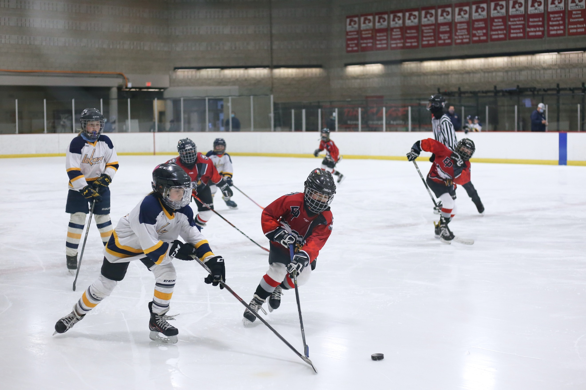 | Salut! Je m’appelle Cristina et je suis canadienne. Le hockey sur glace, c’est ma passion. Je joue au hockey depuis l’âge de six ans. Je joue pour l’équipe de mon école. Mon équipe préférée, c’est les Toronto Maple Leaves. Je joue aussi au basket le lundi soir avec mes copains et copines. J’aime beaucoup le basket, c’est génial!
 | Je m’appelle Sophie et je ne suis pas sportive. Je n’aime ni le foot ni le basket. Je déteste tous les sports. Au collège j’ai deux heures de sport par semaine mais c’est fatigant et rasant et je déteste ça. Le sport, c’est nul !
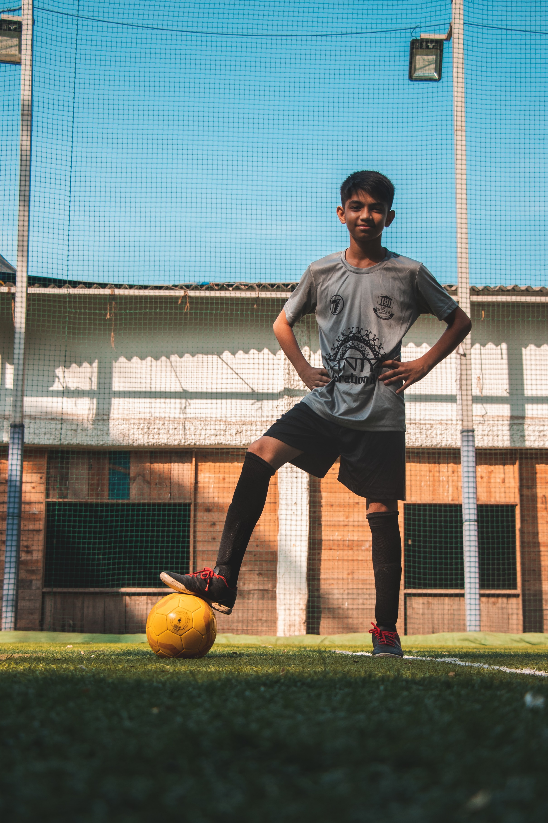 | Salut je suis Rachid et je suis fan de foot. Mon joueur préféré, c’est Lionel Messi. Je joue pour l’équipe de notre village. J’ai un entraînement une fois par semaine, le mercredi après-midi. Je fais aussi de l’athlétisme et du tennis. J’adore le tennis, c’est super et passionnant !
Images licensed under Unsplash License.

Complete the table below using the equivalent French phrase/vocabulary from the text.
French | English
 | I am not sporty
 | My favourite player is
 | I play for my town’s team
 | it’s my passion
 | tiring
 | boring
 | terrible
 | I am a soccer fan
 | I have training
 | exciting

For the teacher
French | English
je ne suis pas sportive | I am not sporty
Mon joueur préféré, c’est | M favourite player is
Je joue pour l’équipe de notre village | I play for my town’s team
c’est ma passion | it’s my passion
fatigant | tiring
rasant | boring
nul | terrible
je suis fan de foot | I am a soccer fan
J’ai un entraînement | I have training
passionnant | exciting

© State of New South Wales (Department of Education), 2023
The copyright material published in this resource is subject to the Copyright Act 1968 (Cth) and is owned by the NSW Department of Education or, where indicated, by a party other than the NSW Department of Education (third-party material).
Copyright material available in this resource and owned by the NSW Department of Education is licensed under a Creative Commons Attribution 4.0 International (CC BY 4.0) license.
This license allows you to share and adapt the material for any purpose, even commercially.
Attribution should be given to © State of New South Wales (Department of Education), 2023.
Material in this resource not available under a Creative Commons license:
- the NSW Department of Education logo, other logos and trademark-protected material
- material owned by a third party that has been reproduced with permission. You will need to obtain permission from the third party to reuse its material.
Links to third-party material and websites
Please note that the provided (reading/viewing material/list/links/texts) are a suggestion only and implies no endorsement, by the New South Wales Department of Education, of any author, publisher, or book title. School principals and teachers are best placed to assess the suitability of resources that would complement the curriculum and reflect the needs and interests of their students.
If you use the links provided in this document to access a third-party's website, you acknowledge that the terms of use, including licence terms set out on the third-party's website apply to the use which may be made of the materials on that third-party website or where permitted by the Copyright Act 1968 (Cth). The department accepts no responsibility for content on third-party websites.

