Spanish – Stage 4 – How much is it?

Introduction
This resource provides an example of how numeracy can be embedded into teaching and learning programs in a meaningful, stage-appropriate way. It can be modified to suit your context, including the needs of your students.

Syllabus outcomes
ML4-UND-01 interprets and responds to information, opinions and ideas in texts to demonstrate understanding
ML4-CRT-01 creates a range of texts for familiar communicative purposes by using culturally appropriate language
Modern Languages K–10 Syllabus © NSW Education Standards Authority (NESA) for and on behalf of the Crown in right of the State of New South Wales, 2022.

Language structures
- Greeting and thanking the shop assistant
- Ordering food (Me gustaría…)
- Understanding pronouns
- Shopping for shoes:
- Me gustan los zapatos.
- Asking to try shoes on (¿Puedo probármelos?)
- Discussing size (¿Qué talla de zapatos lleva? Llevo talla 38.)
- Saying you will take them (Me los llevo.)

Numeracy skills

Proportional thinking
Students convert currency between the Australian dollar and the Euro using the exchange rate (PrT5).

Understanding money
Students determine the best payment option to buy shoes (UnM9).

Further numeracy resources
- Comparing rates
- Working with rates [PDF 202 KB]
- Understanding rates [PDF 193 KB]

Answers

Scenario 1
Are the churros cheaper in Spain or Australia?
- €4 ÷ $0.62 = $6.45 (the cost of the Spanish churros, in dollars)
- $10 x $0.62 = €6,20 (the cost of the Australian churros, in Euro)
Answer: The churros are cheaper in Spain, by $3.55.

Scenario 2
- What is the cheapest option – using your credit card or withdrawing the money from the ATM and paying in cash?
- If I use my credit card:
    - Conversion fee: €2 ÷ €0,62= $3.22
    - Price of shoes: €70 ÷ €0,62= $112.90
The total cost of the shoes if I use my card is $112.90 (shoes) + $3.22 (conversion fee) = $116.12.
- If I withdraw money from an ATM:
    - Price of shoes: €70 ÷ 0,63 = A$111.11
Answer: If I withdraw money from the ATM, the shoes are cheaper by $5.01.
- Now rewrite the dialogue, purchasing las botas (boots).
Person speaking | Spanish dialogue
You | Me gustan las botas. ¿Puedo probármelas?
Shop assistant | ¿Qué talla de botas lleva usted?
You | Llevo talla 38.
Shop assistant | Ellas encajan?
You | Sí, ellas encajan bien. Me las llevo.

Student worksheet – How much is it?

¿Cuánto cuesta?
Oh no! There is no internet so you cannot calculate currency conversions online! Read each scenario and answer the questions.

Scenario 1
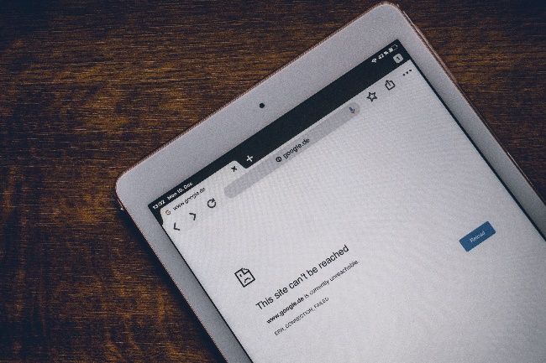  Images licensed under Unsplash License. | 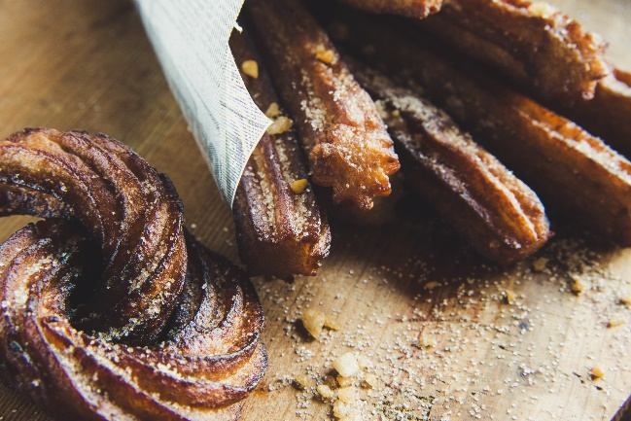  Images licensed under Unsplash License.
You are in a cafetería in Barcelona and you want to order churros con chocolate.
In Australia, you can get churros con chocolate at San Churros for $10. In Barcelona, the price for churros con chocolate is €4.
The last time you checked, the exchange rate was $1 to €0,62.
- Are the churros cheaper in Spain or Australia? Show your working and then write your answer.
- In Spanish, write how you would greet the shop assistant and order the churros:

Scenario 2
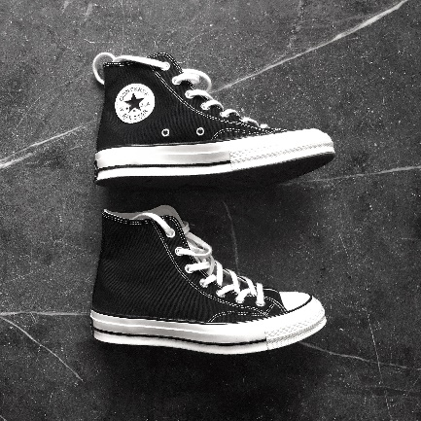
Image licensed under Unsplash License.
You’ve seen a pair of shoes that you love in a tienda de zapatos.
The shoes cost €70.
You can buy them on your credit card – your credit card is offering an exchange rate of $1 to €0,62. However, you will also be charged a €2 currency conversion fee if you use your card.
Alternatively, you can withdraw money from the nearest ATM at a rate of $1 to €0,63. You will not be charged a conversion fee at the ATM.
- What is the cheapest option – using your credit card or withdrawing the money from the ATM and paying in cash? Show your working and then write your answer.

- Look at the sample conversation between you and the shop assistant.
Person speaking | Spanish dialogue
You | Me gustan los zapatos. ¿Puedo probármelos?
Shop assistant | ¿Qué talla de zapatos lleva usted?
You | Llevo talla 38.
Shop assistant | Ellos encajan?
You | Sí, ellos encajan bien. Me los llevo.
The word for shoes is los zapatos.
In the dialogue above, there are 2 forms of pronouns referring to the shoes. (A pronoun is a word used to replace a noun.)
- Ellos encajan bien. (They fit well – ‘they’ replaces ‘the shoes’ as the subject of the sentence.)
- Me los llevo. (I’ll take them – ‘them’ replaces ‘the shoes’ as the direct object of the sentence.)
Highlight these words in the dialogue – take care, as one ‘los’ is hiding in another word!
Now rewrite the dialogue, purchasing las botas (boots).
Person speaking | Spanish dialogue
You
Shop assistant
You
Shop assistant
You

References
This resource contains NSW Curriculum and syllabus content. The NSW Curriculum is developed by the NSW Education Standards Authority. This content is prepared by NESA for and on behalf of the Crown in right of the State of New South Wales. The material is protected by Crown copyright.
Please refer to the NESA Copyright Disclaimer for more information https://educationstandards.nsw.edu.au/wps/portal/nesa/mini-footer/copyright.
NESA holds the only official and up-to-date versions of the NSW Curriculum and syllabus documents. Please visit the NSW Education Standards Authority (NESA) website https://educationstandards.nsw.edu.au/ and the NSW Curriculum website https://curriculum.nsw.edu.au/home.
Modern Languages K–10 Syllabus © NSW Education Standards Authority (NESA) for and on behalf of the Crown in right of the State of New South Wales, 2022.

© State of New South Wales (Department of Education), 2023
The copyright material published in this resource is subject to the Copyright Act 1968 (Cth) and is owned by the NSW Department of Education or, where indicated, by a party other than the NSW Department of Education (third-party material).
Copyright material available in this resource and owned by the NSW Department of Education is licensed under a Creative Commons Attribution 4.0 International (CC BY 4.0) license.
This license allows you to share and adapt the material for any purpose, even commercially.
Attribution should be given to © State of New South Wales (Department of Education), 2023.
Material in this resource not available under a Creative Commons license:
- the NSW Department of Education logo, other logos and trademark-protected material
- material owned by a third party that has been reproduced with permission. You will need to obtain permission from the third party to reuse its material.
Links to third-party material and websites
Please note that the provided (reading/viewing material/list/links/texts) are a suggestion only and implies no endorsement, by the New South Wales Department of Education, of any author, publisher, or book title. School principals and teachers are best placed to assess the suitability of resources that would complement the curriculum and reflect the needs and interests of their students.
If you use the links provided in this document to access a third-party's website, you acknowledge that the terms of use, including licence terms set out on the third-party's website apply to the use which may be made of the materials on that third-party website or where permitted by the Copyright Act 1968 (Cth). The department accepts no responsibility for content on third-party websites.

