Mini task 3 menu
Work in groups of 3 to create the script for a conversation about eating out.
Use slides 5–7 from the ‘Sentence builders and conversation scaffolds’ resource [PPTX 350 KB].
Include the following in your conversation:
- greeting your friend(s) and the server appropriately
- asking and responding to questions about personal preferences including one food or drink that you like, one food or drink that you do not like and one food or drink that you have not tried
- adjectives to describe the food or drink to justify your preferences, including what you think it would be like if you have not tried it
- the conjunctions porque (because), pero (but) and y (and)
- a comparison between items on the menu
- appropriate language to order items from a menu
- an adverb to express how frequently you drink or eat an item.
When you have finished, swap the text of your conversation with another pair or group, and use the 4-square criteria to provide peer feedback to them.

Use the image of the menu below in your conversation with your partner.
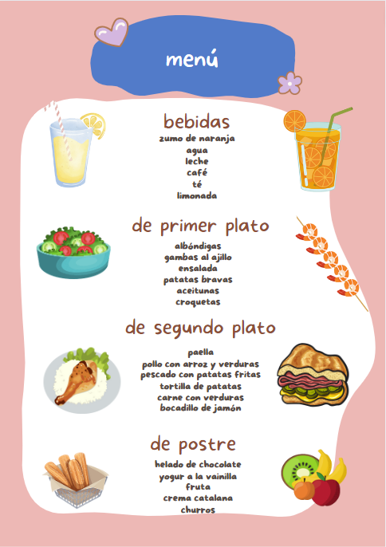

4-square criteria
Gender and verb  - Has the correct article been used for each noun? (el/la/los/las)  - Has the correct form of the verb been used? (como/comes/comer/bebo/bebes/beber) | Content  Are the following included:  - an appropriate greeting for your friend(s) and the server  - an exchange of information about a food or drink you like or do not like, with reasons  - a food or drink you do not know with a likely description  - a comparison between at least 2 items from the menu  - an order of at least 2 foods and one drink per person  - conversation fillers  - an adverb to express how frequently you eat or drink an item.
Conjunctions  - Does the text include all 3 conjunctions (y, pero, porque) | Adjectives  - Has a range of adjectives been used?  - Do the adjectives agree with the nouns they describe?

For the teacher
Edit the menu in the table below, if preferred:
bebidas | de primer plato | de segundo plato | de postre
zumo de naranja  agua  leche  café  té  limonada | albóndigas  gambas al ajillo  ensalada  patatas bravas  aceitunas  croquetas | paella  pollo con arroz y verduras  pescado con patatas fritas  tortilla de patatas  carne con verduras  bocadillo de jamón | helado de chocolate  yogur a la vainilla  fruta  crema catalana  churros

© State of New South Wales (Department of Education), 2023
The copyright material published in this resource is subject to the Copyright Act 1968 (Cth) and is owned by the NSW Department of Education or, where indicated, by a party other than the NSW Department of Education (third-party material).
Copyright material available in this resource and owned by the NSW Department of Education is licensed under a Creative Commons Attribution 4.0 International (CC BY 4.0) license.
This license allows you to share and adapt the material for any purpose, even commercially.
Attribution should be given to © State of New South Wales (Department of Education), 2023.
Material in this resource not available under a Creative Commons license:
- the NSW Department of Education logo, other logos and trademark-protected material
- material owned by a third party that has been reproduced with permission. You will need to obtain permission from the third party to reuse its material.
Links to third-party material and websites
Please note that the provided (reading/viewing material/list/links/texts) are a suggestion only and implies no endorsement, by the New South Wales Department of Education, of any author, publisher, or book title. School principals and teachers are best placed to assess the suitability of resources that would complement the curriculum and reflect the needs and interests of their students.
If you use the links provided in this document to access a third-party's website, you acknowledge that the terms of use, including licence terms set out on the third-party's website apply to the use which may be made of the materials on that third-party website or where permitted by the Copyright Act 1968 (Cth). The department accepts no responsibility for content on third-party websites.

