Menú semanal

Activity 1
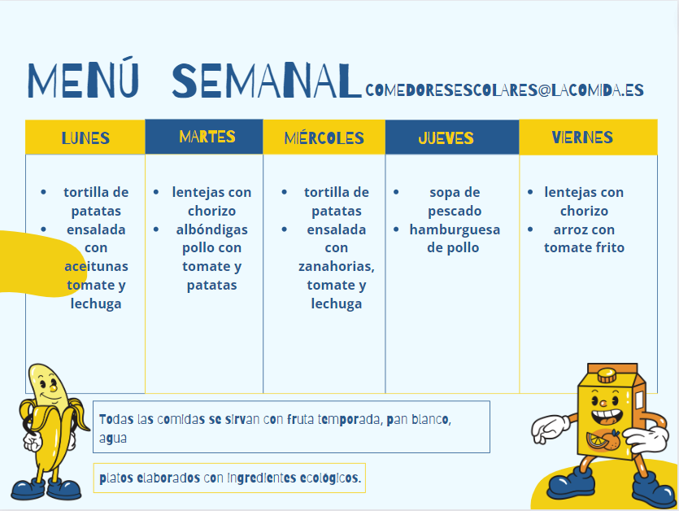
Read the weekly menu for a school cafeteria in Spain and answer the questions in English. You may need a dictionary for some words.
- What kind of meatballs are served on Tuesdays? With what are they served?
- How many different salads are served during the week?
- On which day is rice on the menu?
- What are ‘lentejas’ and what are they served with?
- On which day is chicken burger served?
- What kind of soup is served on Thursdays?
- How many times in the week is a Spanish omelette served? Which days?
- What do you think ‘platos elaborados con ingredients ecológicos’ means?
- All meals are served with what?
- What do you think ‘semanal’ means?

Activity 2
In the table below, write the day(s) in Spanish that the following foods are available.
To write ‘every day’, use ‘todos los días’.
Food or drink | Day(s) available
tortilla de patatas
lentejas con chorizo
arroz con tomate frito
agua
hamburguesa de pollo
ensalada
pan blanco

Activity 3
Based on the menu, write true or false after each sentence.
- Se come arroz una vez por semana.
- Se come sopa a veces.
- Se bebe té siempre.
- Se come yogur nunca.
- Se bebe agua dos veces por semana.
- Se come tortilla de patatas a menuda.
- Se bebe el zumo todos los días.
- Se comen albóndigas una vez por semana.

Activity 4
Using the cues provided, create sentences for each food or drink. Ensure you include the verb como (I eat) or bebo (I drink) in your sentence. The first one has been done for you as an example.
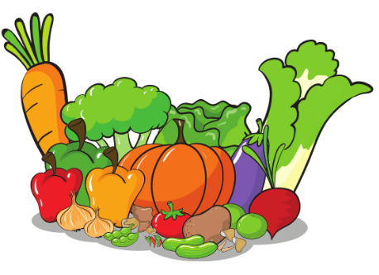 | never | Como verduras nunca.
 | every day
 | always
 | once a week
 | twice a week
 | often
 | never
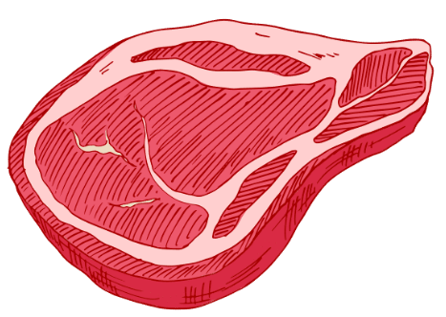 | sometimes

Activity 5
Listen to the statements being read out and tick or highlight the correct option from each pair:
1 | Todos los días  Todos los viernes | como  bebo | ensalada  sopa | con tomates.  con patatas.
2 | A menudo  Siempre | bebo  como | zumo  helado | de naranja.  de manzana.
3 | Siempre  Todos los días | como  bebo | sopa  zumo | de pollo.  de fruta.
4 | Todos los jueves  Todos los lunes | como  comes | pescado  pollo | con verduras.  con ensalada.
5 | Nunca  A menudo | bebo  bebes | café  té | con leche.  con limón.

Activity 6
Translate the sentences from the table into English in the spaces provided
1.
2.
3.
4.
5.

Activity 7
Complete the menu planner below for each meal with the foods in Spanish you generally eat and/or drink during the school day and after school.
 | lunes | martes | miércoles | jueves | viernes
la pausa
la comida
la merienda
When you have finished, write 5–10 sentences describing how often you eat and/or drink certain items, and when, for example: Bebo siempre agua para la pausa.

For the teacher

Activity 1
You can access an editable version of the resource, to amend for your own context. Alternately, an accessible version of the resource is provided below:
lunes | martes | miércoles | jueves | viernes
- tortilla de patatas  - ensalada con aceitunas, tomate y lechuga | - lentejas con chorizo  - albóndigas pollo con tomate y patatas | - tortilla de patatas  - ensalada con zanahorias, tomate y lechuga | - sopa de pescado  - hamburguesa de pollo | - lentejas con chorizo  - arroz con tomate frito
- Todas las comidas se sirvan con fruta temporada, pan blanco, agua.
- Platos elaborados con ingredientes ecológicos.
- What kind of meatballs are served on Tuesdays? With what are they served? Chicken meatballs with tomato and potato
- How many different salads are served during the week? Two
- On which day is rice on the menu? Friday
- What are ‘lentajas’ and what are they served with? Lentils, served with chorizo
- On which day is chicken burger served? Thursday
- What kind of soup is served on Thursdays? Fish
- How many times in the week is a Spanish omelette served? Which days? Twice, on Monday and Wednesday
- What do you think ‘platos elaborados con ingredients ecológicos’ means? Dishes prepared with eco-friendly ingredients
- All meals are served with what? Seasonal fruit, bread and water
- What do you think ‘semanal’ means? Weekly

Activity 2
Write the day(s) in Spanish that the following foods are available?
To write ‘every day’, use ‘todos los días’.
Food or drink | Day(s) available
tortilla de patatas | los lunes, los miércoles
lentejas con chorizo | los martes, los viernes
arroz con tomate frito | los viernes
agua | todos los días
hamburguesa de pollo | los jueves
ensalada | los lunes, los miércoles
pan blanco | todos los días

Activity 3
Based on the menu, write true or false after each sentence.
- Se come arroz una vez por semana. True
- Se come sopa a veces. True
- Se bebe té siempre. False
- Se come yogur nunca. True
- Se bebe agua dos veces por semana. False
- Se come tortilla de patatas a menudo. True
- Se bebe los zumos todos los días. False
- Se comen albóndigas una vez por semana. True

Activity 4
 | never | Como verduras nunca.
 | every day | Como pan todos los días.
 | always | Bebo refrescos siempre.
 | once a week | Como pescado una vez por semana.
 | twice a week | Como helado dos veces por semana.
 | often | Como fruta a menudo.
 | never | Bebo café nunca.
 | sometimes | Como carne a veces.

Activity 5

Audio
Activity 5 audio.mp3 (0:37)

1 | Todos los días  Todos los viernes | como  bebo | ensalada  sopa | con tomates.  con patatas.
2 | Una vez por semana  Siempre | bebo  como | zumo  helado | de naranja.  de manzana.
3 | Siempre  Todos los días | como  bebo | sopa  zumo | de pollo.  de fruta.
4 | Todos los jueves  Todos los lunes | como  comes | pescado  pollo | con verduras.  con ensalada.
5 | Nunca  A menudo | bebo  bebes | café  té | con leche.  con limón.

Activity 6
- Every day I eat salad with tomatoes.
- I always drink orange juice.
- Every day I eat chicken soup.
- Every Monday you eat fish with vegetables.
- You often drink tea with lemon.

© State of New South Wales (Department of Education), 2023
The copyright material published in this resource is subject to the Copyright Act 1968 (Cth) and is owned by the NSW Department of Education or, where indicated, by a party other than the NSW Department of Education (third-party material).
Copyright material available in this resource and owned by the NSW Department of Education is licensed under a Creative Commons Attribution 4.0 International (CC BY 4.0) license.
This license allows you to share and adapt the material for any purpose, even commercially.
Attribution should be given to © State of New South Wales (Department of Education), 2023.
Material in this resource not available under a Creative Commons license:
- the NSW Department of Education logo, other logos and trademark-protected material
- material owned by a third party that has been reproduced with permission. You will need to obtain permission from the third party to reuse its material.
Links to third-party material and websites
Please note that the provided (reading/viewing material/list/links/texts) are a suggestion only and implies no endorsement, by the New South Wales Department of Education, of any author, publisher, or book title. School principals and teachers are best placed to assess the suitability of resources that would complement the curriculum and reflect the needs and interests of their students.
If you use the links provided in this document to access a third-party's website, you acknowledge that the terms of use, including licence terms set out on the third-party's website apply to the use which may be made of the materials on that third-party website or where permitted by the Copyright Act 1968 (Cth). The department accepts no responsibility for content on third-party websites.

