Me gusta

Activity 1
Choose the correct form of the verb – me gusta or me gustan – to complete the sentence.
The first answer has been marked in bold as an example.
- Me gusta/gustan el pollo.
- No me gusta/gustan la leche.
- Me gusta/gustan los cereales.
- No me gusta/gustan el jamón.
- Me gusta/gustan la fruta.
- No me gusta/gustan el pescado.
- Me gusta/gustan la ensalada.
- No me gusta/gustan las verduras.

Activity 2
Write a sentence for each food and preference using the visual cue as a prompt:
- me gusta(n) mucho
- me gusta(n)
- no me gusta(n)
- no me gusta(n) nada.
The first one has been done for you.
Food or drink | Like or dislike | Sentence
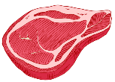 |  | Me gusta la carne.
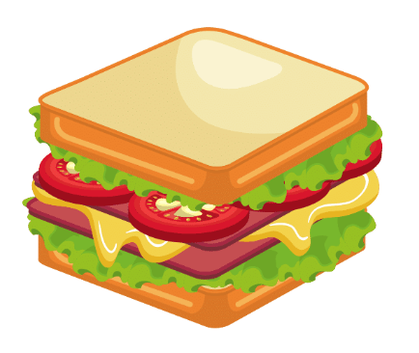
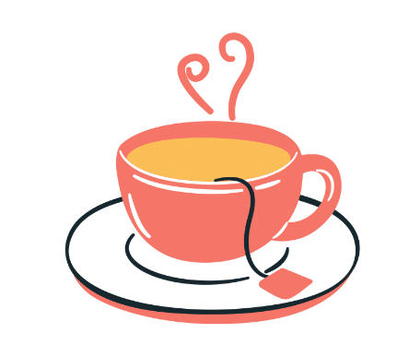
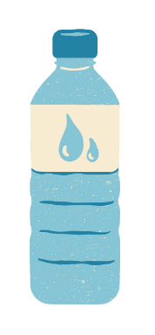
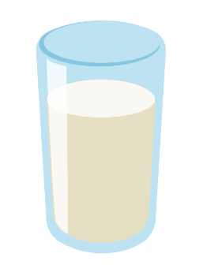
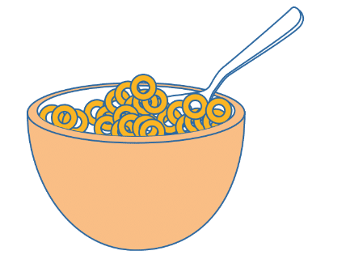
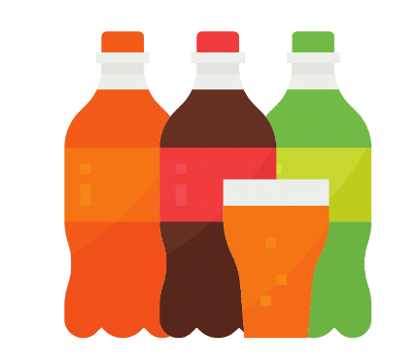
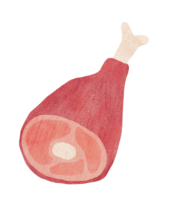
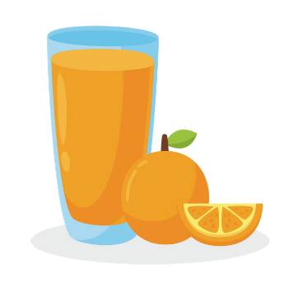
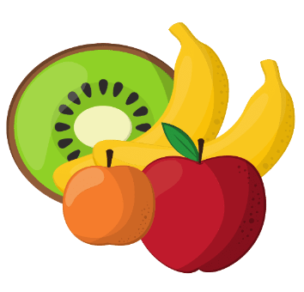

Activity 3
Complete these sentences with your own preferences using:
- Me gusta(n) mucho, Me gusta(n), No me gusta(n) or Me gusta(n) nada
los cereales.
las verduras.
el jamón.
la leche.
el yogur.
los refrescos.
- an appropriate food or drink (use a dictionary to identify relevant food or drink items)
Me gusta ________________________.
Me gusta mucho ________________________.
No me gusta ________________________.
Me gustan ________________________.
No me gustan ________________________.
No me gustan nada ________________________.

Activity 4
Complete the question with 3 foods and one drink of your choice in Spanish. Careful with the plurals!
¿Te gusta ________________________?
¿Te gusta ________________________?
¿Te gusta ________________________?
¿Te gustan ________________________?
Now write the foods and/or drinks you have written above in the first column of the table below.
Add a sentence in the second column, in Spanish, to say if you like or dislike each food or drink item.
Then find someone who has the same opinion as you by asking ¿Te gusta(n) [food or drink]? and write their name in the third column.
Food or drink | Like or dislike? | Student name

For the teacher

Activity 1
- Me gusta/gustan el pollo.
- No me gusta/gustan la leche.
- Me gusta/gustan los cereales.
- No me gusta/gustan el jamón.
- Me gusta/gustan la fruta.
- No me gusta/gustan el pescado.
- Me gusta/gustan la ensalada.
- No me gusta/gustan las verduras.

Activity 2
Food or drink | Like or dislike | Sentence
 |  | Me gusta la carne.
 |  | Me gusta mucho el bocadillo.
 |  | No me gusta el té.
 |  | Me gusta el agua.
 |  | No me gusta nada la leche.
 |  | Me gustan mucho los cereales.
 |  | Me gustan los refrescos.
 |  | Me gusta el jamón.
 |  | Me gusta el zumo de naranja.
 |  | No me gusta nada la fruta.

© State of New South Wales (Department of Education), 2023
The copyright material published in this resource is subject to the Copyright Act 1968 (Cth) and is owned by the NSW Department of Education or, where indicated, by a party other than the NSW Department of Education (third-party material).
Copyright material available in this resource and owned by the NSW Department of Education is licensed under a Creative Commons Attribution 4.0 International (CC BY 4.0) license.
This license allows you to share and adapt the material for any purpose, even commercially.
Attribution should be given to © State of New South Wales (Department of Education), 2023.
Material in this resource not available under a Creative Commons license:
- the NSW Department of Education logo, other logos and trademark-protected material
- material owned by a third party that has been reproduced with permission. You will need to obtain permission from the third party to reuse its material.
Links to third-party material and websites
Please note that the provided (reading/viewing material/list/links/texts) are a suggestion only and implies no endorsement, by the New South Wales Department of Education, of any author, publisher, or book title. School principals and teachers are best placed to assess the suitability of resources that would complement the curriculum and reflect the needs and interests of their students.
If you use the links provided in this document to access a third-party's website, you acknowledge that the terms of use, including licence terms set out on the third-party's website apply to the use which may be made of the materials on that third-party website or where permitted by the Copyright Act 1968 (Cth). The department accepts no responsibility for content on third-party websites.

