¿Cómo es?

Activity 1
Using the table below, for each image:
- write the appropriate question, for example ¿Te gusta(n) [food/drink]?
- write your opinion of the item using the appropriate form of me gusta(n), me gusta(n) mucho, no me gusta(n), no me gusta(n) nada. If you have not tried the item, use the phrase ‘Nunca he probado’ [food or drink].
- write a sentence justifying your opinion, using the correct form of the adjective. If you haven’t tried the item, use the phrase ‘me parece(n)’ to write what you think it might taste like.
The first 2 have been done for you.
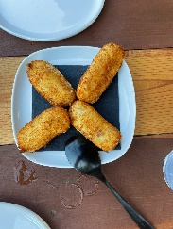 | ¿Te gustan las croquetas?  Nunca he probado las croquetas.  Me parecen ricas.
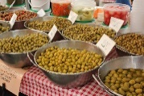 | ¿Te gustan las aceitunas?  Me gustan mucho las aceitunas  Son saladas.
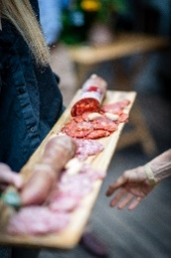
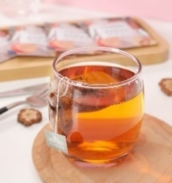
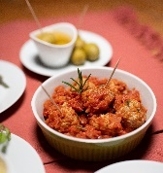
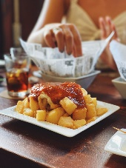
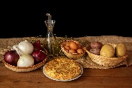
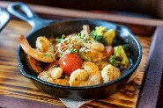
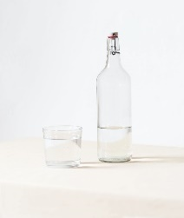
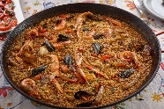
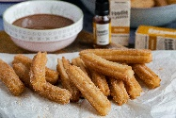
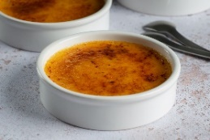
Images licensed under Unsplash License.

Activity 2 – walk and talk
Choose 8 items from Activity 1 and add them to the food/drink column in the table below. When directed to ‘walk’, move around the room until the teacher says ‘talk’. Stop walking and ask the person closest to you their opinion of one of the foods or drinks you have chosen. Write their name and their answer in the space provided. The first row has been completed as an example only.
Food or drink | Opinion | Student name
olives | really likes them, they’re salty | Julia

© State of New South Wales (Department of Education), 2023
The copyright material published in this resource is subject to the Copyright Act 1968 (Cth) and is owned by the NSW Department of Education or, where indicated, by a party other than the NSW Department of Education (third-party material).
Copyright material available in this resource and owned by the NSW Department of Education is licensed under a Creative Commons Attribution 4.0 International (CC BY 4.0) license.
This license allows you to share and adapt the material for any purpose, even commercially.
Attribution should be given to © State of New South Wales (Department of Education), 2023.
Material in this resource not available under a Creative Commons license:
- the NSW Department of Education logo, other logos and trademark-protected material
- material owned by a third party that has been reproduced with permission. You will need to obtain permission from the third party to reuse its material.
Links to third-party material and websites
Please note that the provided (reading/viewing material/list/links/texts) are a suggestion only and implies no endorsement, by the New South Wales Department of Education, of any author, publisher, or book title. School principals and teachers are best placed to assess the suitability of resources that would complement the curriculum and reflect the needs and interests of their students.
If you use the links provided in this document to access a third-party's website, you acknowledge that the terms of use, including licence terms set out on the third-party's website apply to the use which may be made of the materials on that third-party website or where permitted by the Copyright Act 1968 (Cth). The department accepts no responsibility for content on third-party websites.

