Japanese seasons and calendar

Japanese seasons
Above each kanji, write a sentence in Japanese which includes the months of the season. The first season has been done for you.
春は三月と四月と五月です。  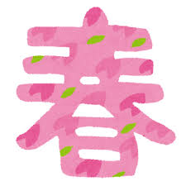 | 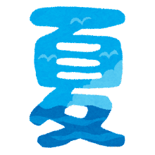
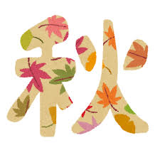
Images by Takashi Mifune are licensed under Irasutoya’s terms of use.

Japanese calendar
In the table below, you can see one Japanese festival or seasonal event for each month of the year. The first example has been done for you.
- Underneath each month, write the season in kanji: 春, 冬, 秋 or 夏.
- Read the festival or seasonal event vocabulary and write the meaning in English next to the Japanese.
- Look at the festival picture for each month and write a sentence in Japanese, following the example 四月はおはなみです.
- In small groups, research each festival or seasonal event and add a brief description in English to the calendar. The description should include 3–4 sentences about the event.
- Identify 3–4 events in Australian life, look up their Japanese term and add these to the relevant months, using the same structure.
Month and season | Japanese festival or seasonal event | Australian festival or seasonal event
一月  冬  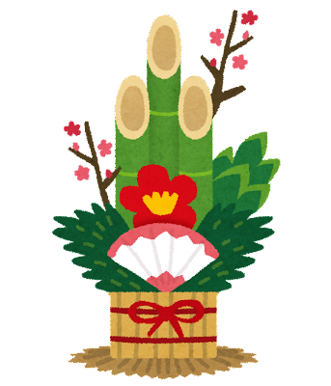 | お正月 （おしょうがつ）New year  一月はおしょうがつです。  Japanese new year celebrates the new calendar year. People send new year cards to family and friends, called nengajō. People eat food such as mochi and buckwheat noodles. Relatives give money to children and Buddhist temples ring bells at midnight 108 times.
二月  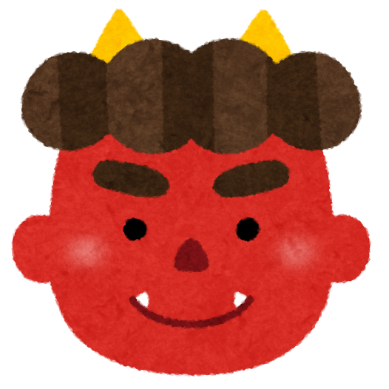 | せつぶん
三月  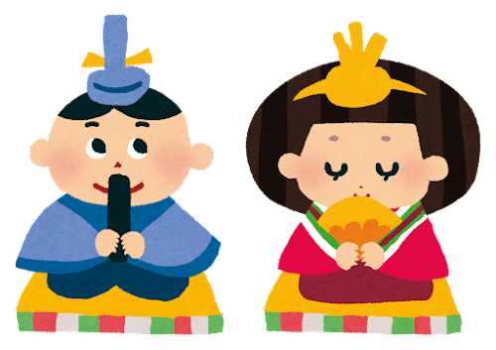 | ひなまつり
四月  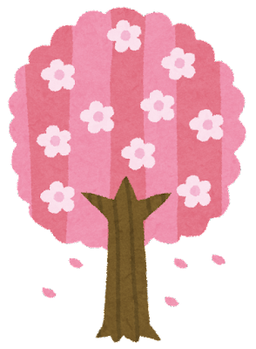 | お花見 （おはなみ）
五月  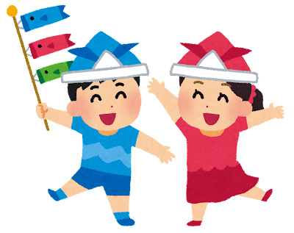 | こどもの日
六月  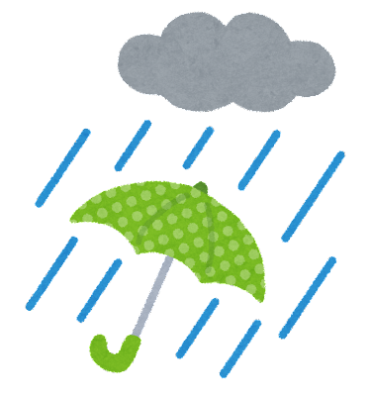 | つゆ
七月  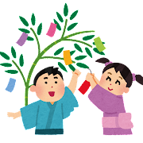 | 七夕 （たなばた）
八月  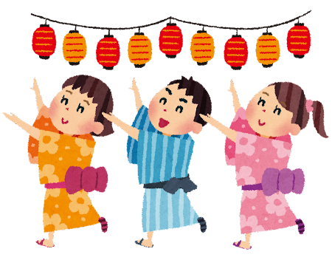 | おぼん
九月  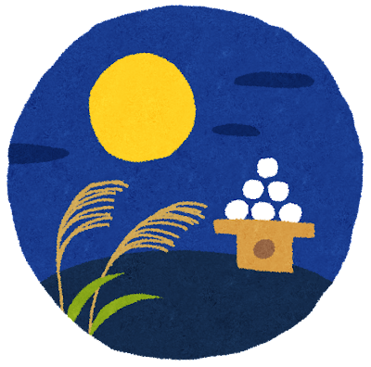 | お月見 (おつきみ)
十月  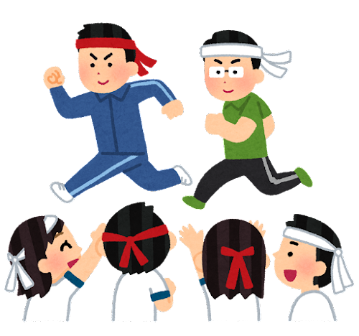 | スポーツの日
十一月  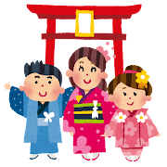 | 七五三 （しちごさん）
十二月  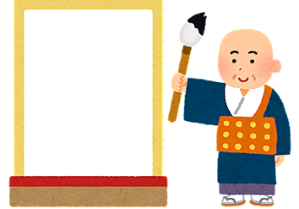 | おおみそか
Images by Takashi Mifune are licensed under Irasutoya’s terms of use.

© State of New South Wales (Department of Education), 2023
The copyright material published in this resource is subject to the Copyright Act 1968 (Cth) and is owned by the NSW Department of Education or, where indicated, by a party other than the NSW Department of Education (third-party material).
Copyright material available in this resource and owned by the NSW Department of Education is licensed under a Creative Commons Attribution 4.0 International (CC BY 4.0) licence.
This licence allows you to share and adapt the material for any purpose, even commercially.
Attribution should be given to © State of New South Wales (Department of Education), 2023.
Material in this resource not available under a Creative Commons licence:
- the NSW Department of Education logo, other logos and trademark-protected material
- material owned by a third party that has been reproduced with permission. You will need to obtain permission from the third party to reuse its material.
Links to third-party material and websites
Please note that the provided (reading/viewing material/list/links/texts) are a suggestion only and implies no endorsement, by the New South Wales Department of Education, of any author, publisher, or book title. School principals and teachers are best placed to assess the suitability of resources that would complement the curriculum and reflect the needs and interests of their students.
If you use the links provided in this document to access a third-party's website, you acknowledge that the terms of use, including licence terms set out on the third-party's website apply to the use which may be made of the materials on that third-party website or where permitted by the Copyright Act 1968 (Cth). The department accepts no responsibility for content on third-party websites.

