Practising the particles に and で
As a group, you will compete in a race-style understanding activity.
In small groups, look at the grid below. For words and phrases in hiragana, make sure everyone in your group understands what they mean in English. For the images, make sure everyone knows these in Japanese.
Cut up the grid to make cards.
In your group, take turns to be the messenger. The messenger:
- goes to the teacher and listens to a sentence read out quietly in Japanese
- returns to the group and repeats the sentence quietly to the group.
Each group will then race other groups to arrange the relevant cards into the correct order based on the sentence they heard. Be careful, you might hear the verb in a different tense!
Call out よかった when you have your cards arranged correctly for your teacher to check. The first group to score 5 points wins.

Images for the race game
で | に | を
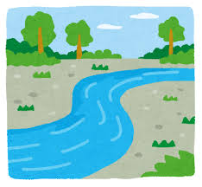 |  | 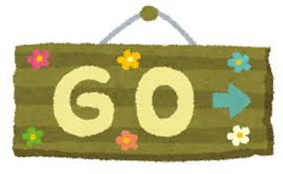
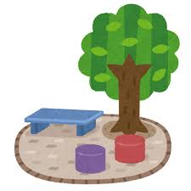 | 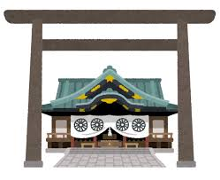
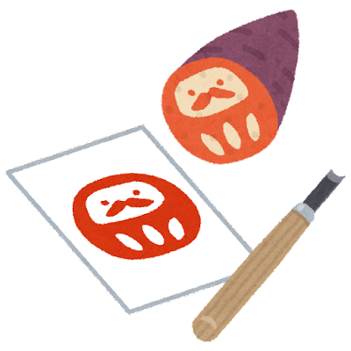 | 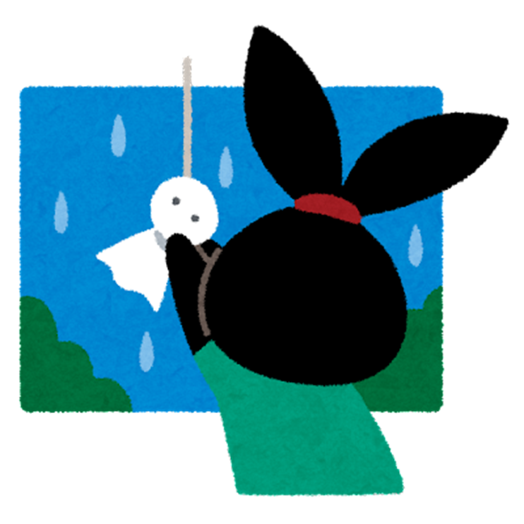 | 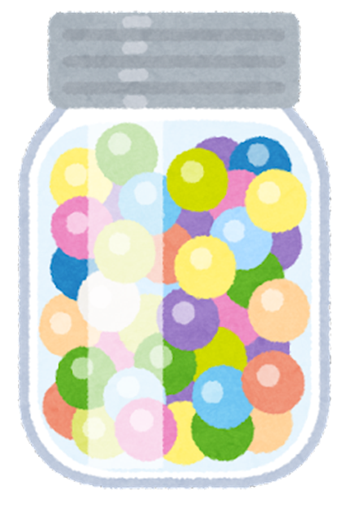
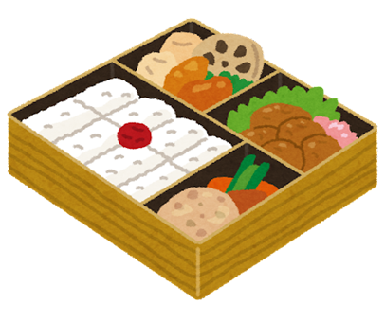 |  | 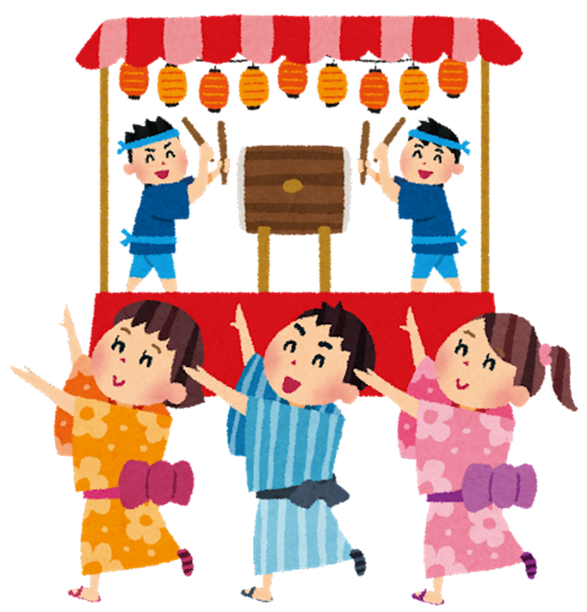
 | 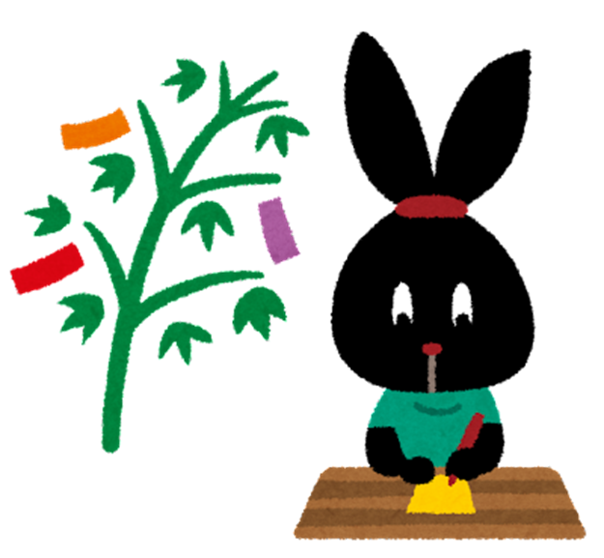 | 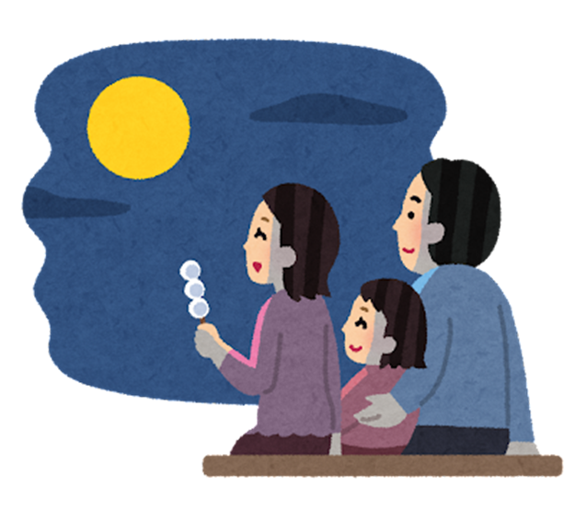
かきます | つくります | たべます
とります | します | みます
Images by Takashi Mifune are licensed under Irasutoya’s terms of use.

© State of New South Wales (Department of Education), 2023
The copyright material published in this resource is subject to the Copyright Act 1968 (Cth) and is owned by the NSW Department of Education or, where indicated, by a party other than the NSW Department of Education (third-party material).
Copyright material available in this resource and owned by the NSW Department of Education is licensed under a Creative Commons Attribution 4.0 International (CC BY 4.0) licence.
This licence allows you to share and adapt the material for any purpose, even commercially.
Attribution should be given to © State of New South Wales (Department of Education), 2023.
Material in this resource not available under a Creative Commons licence:
- the NSW Department of Education logo, other logos and trademark-protected material
- material owned by a third party that has been reproduced with permission. You will need to obtain permission from the third party to reuse its material.
Links to third-party material and websites
Please note that the provided (reading/viewing material/list/links/texts) are a suggestion only and implies no endorsement, by the New South Wales Department of Education, of any author, publisher, or book title. School principals and teachers are best placed to assess the suitability of resources that would complement the curriculum and reflect the needs and interests of their students.
If you use the links provided in this document to access a third-party's website, you acknowledge that the terms of use, including licence terms set out on the third-party's website apply to the use which may be made of the materials on that third-party website or where permitted by the Copyright Act 1968 (Cth). The department accepts no responsibility for content on third-party websites.

