German – Stage 4 – Let’s eat out!

Introduction
This resource provides an example of how numeracy can be embedded into teaching and learning programs in a meaningful, stage-appropriate way. It can be modified to suit your context, including the needs of your students.

Syllabus outcomes
ML4-UND-01 interprets and responds to information, opinions and ideas in texts to demonstrate understanding
ML4-CRT-01 creates a range of texts for familiar communicative purposes by using culturally appropriate language
Modern Languages K–10 Syllabus © NSW Education Standards Authority (NESA) for and on behalf of the Crown in right of the State of New South Wales, 2022.

Language structures
- Bitte schon? – What would you like?
- Ich möchte… – I would like…
- Wir möchten… – We would like…
- einmal/zweimal – one/two (when ordering)
- die Rechnung – the bill
- die Bedienung – the restaurant server
- Stimmt so! – That’s fine! (keep the change)
- die Speisekarte – the menu
- zum Mitnehmen – to take away
- die Spezialitäten – specialty dishes
- die Beilagen – side dishes
- die Nachtische – dessert
- Food vocabulary

Numeracy skills

Understanding money
Students calculate the total costs of items ordered at a restaurant (UnM7).

Proportional thinking
Students calculate:
- the tip as a percentage of the meal cost (PrT2)
- the percentage that the tip is of the cost of the meal (PrT2)
- percentage savings if food is ordered as takeaway instead of table service (PrT2).

Multiplicative strategies
Students:
- calculate the total cost for a take-away order with multiple purchases (MuS8)
- use estimation skills to determine the approximate cost of the take-away order (MuS7).

Further numeracy resources
- Flexible strategies with integers
- Calculating percentages
- Express one quantity as a percentage of another
- Stage 3 multiplicative thinking teaching strategies

Answers

Question 1
Wir möchten einmal/zweimal… (answers will vary, depending on student choices)

Question 2
- Total cost – €17,80
- Tip – €2,20
- Tipped approximately 12.4% of meal cost
- Sample dialogue:
Server | Guten Tag. Bitte schon?
You | Guten Tag. Ich möchte einmal Jägerschnitzel, einmal Apfelstrudel and einmal Mineralwasser, klein bitte.
You (after eating) | Die Rechnung, bitte. Stimmt so. Danke und auf Wiedersehen.
Server | Auf Wiedersehen.

Question 3
- To eat in – €39,20
- To take away – €35,80
- Saved approximately 8.7%
- €26,70
- Yes, it’s cheaper to eat more healthily.
- Ich möchte dreimal gebratenes Fischfilet, bitte.

Student worksheet

Lass uns essen gehen! – Let’s eat out!
Look at the menus for the Potsdamer Schlossküche. There is a 3-page dine-in menu and a 1-page takeaway menu (zum Mitnehmen).
Use these menus to answer the 3 questions below.

Question 1
You have offered to take a friend for dinner at the Potsdamer Schlossküche. You have decided to dine in at the restaurant and have €40 to spend. You would each like to order a main, a dessert and a drink.
What do you order? Write your answer in German, using the structure Wir möchten einmal/zweimal…

Question 2
- You are eating at the restaurant alone tonight. You’ve eaten a Jägerschnitzel and Apfelstrudel, and had a small mineral water to drink. What will the total of your bill (die Rechnung) be?
- It’s time to pay your bill – Die Rechnung, bitte!
You’re happy with the service and would like to leave a small tip for die Bedienung.
You give €20,00 and say Stimmt so! (keep the change)
How much was your tip?

- What percentage of your meal cost did you tip?
- Write the conversation between you and the restaurant server in the table below. The English has been provided as a guide.
Server | Hello. What would you like?
You | Hello. I would like one schnitzel with mushroom gravy, one apple strudel and one small mineral water, please.
You (after eating) | The bill, please. Keep the change. Thank you and goodbye.
Server | Goodbye.

Question 3
You and your friends are in the mood for some burgers. You want to order one Hänchenburger, 2 Hamburger, one Vegi-Burger and 2 portions of Pommes.
- How much will that cost if you eat in?

- How much will that cost if you get takeaway?
- What percentage saving will you receive if you order takeaway?
- How much for 3 fish dishes? Make sure you get the cheapest takeaway options.
- Is it cheaper to eat more healthily in this instance?
- You order on behalf of your friends – what do you say, in German?
Note: All prices shown are in Euro (€).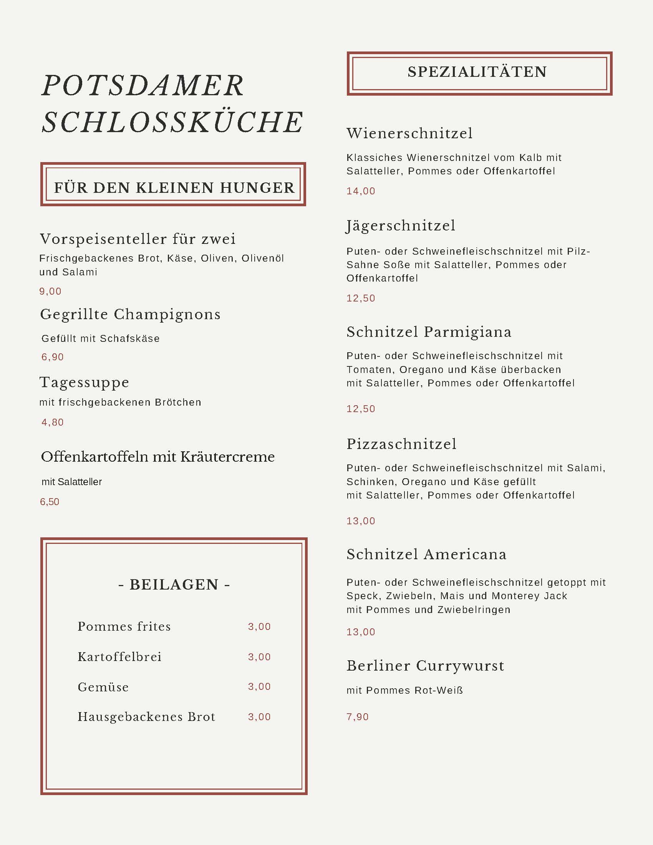
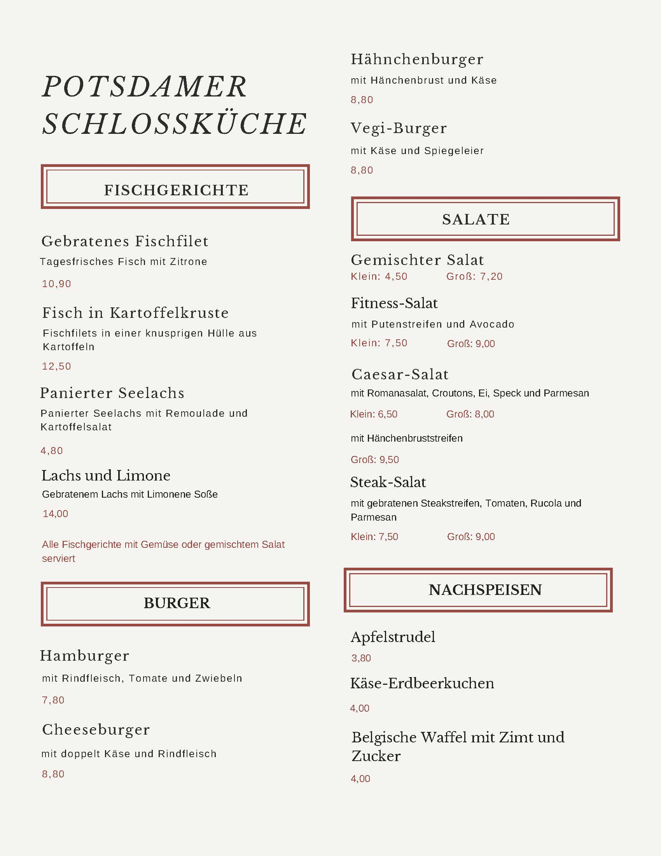
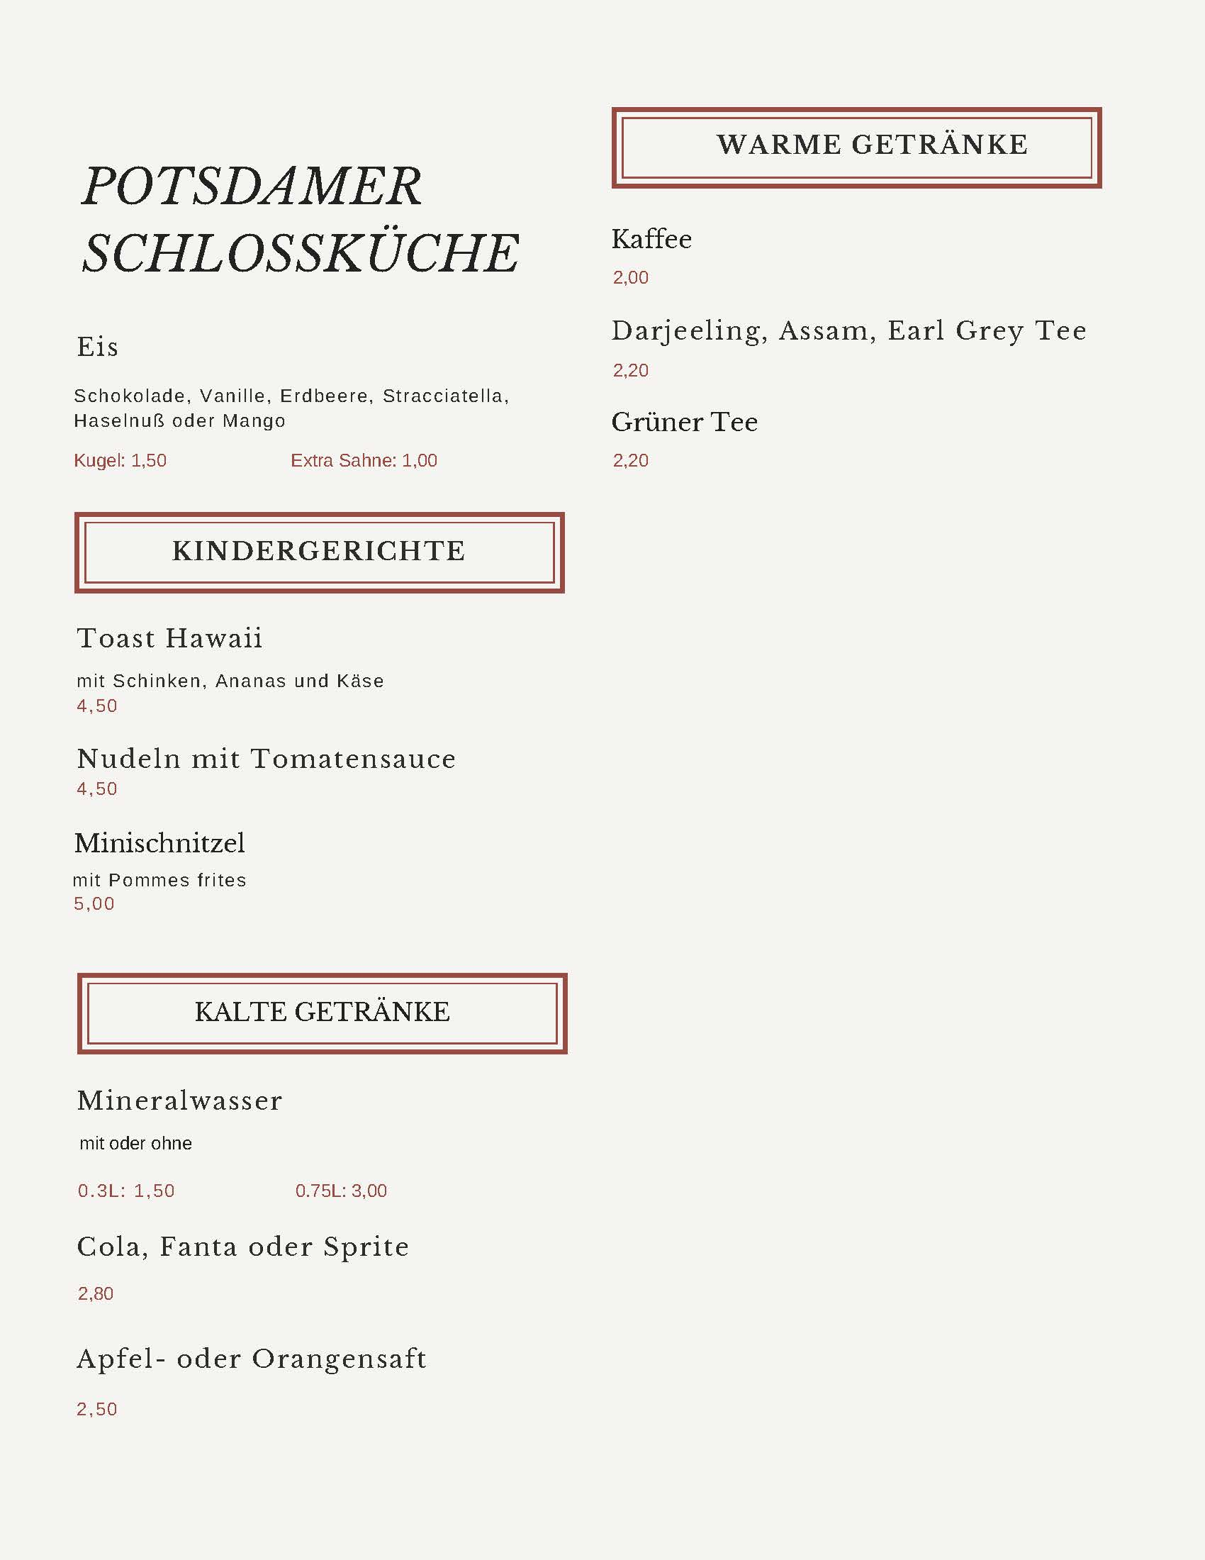
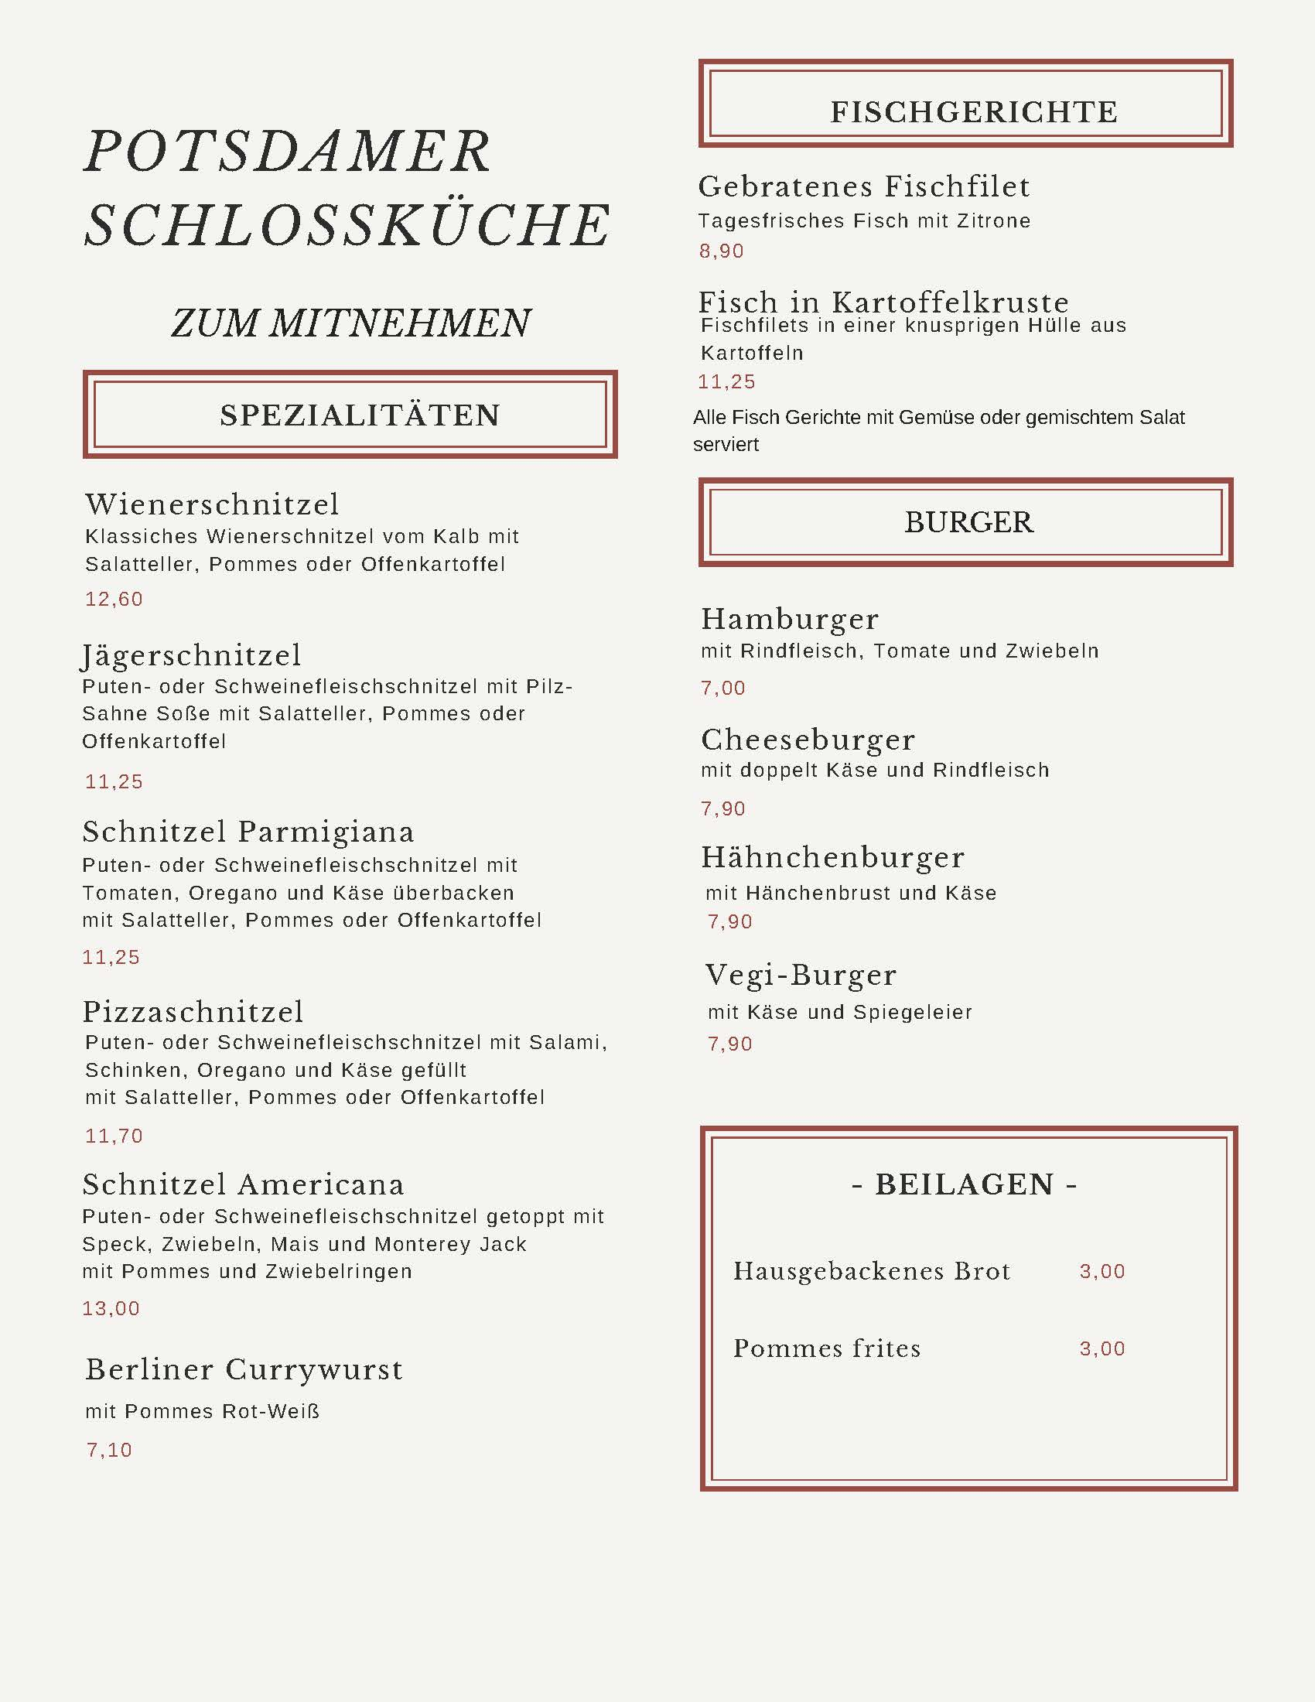

References
This resource contains NSW Curriculum and syllabus content. The NSW Curriculum is developed by the NSW Education Standards Authority. This content is prepared by NESA for and on behalf of the Crown in right of the State of New South Wales. The material is protected by Crown copyright.
Please refer to the NESA Copyright Disclaimer for more information https://educationstandards.nsw.edu.au/wps/portal/nesa/mini-footer/copyright.
NESA holds the only official and up-to-date versions of the NSW Curriculum and syllabus documents. Please visit the NSW Education Standards Authority (NESA) website https://educationstandards.nsw.edu.au/ and the NSW Curriculum website https://curriculum.nsw.edu.au/home.
Modern Languages K–10 Syllabus © NSW Education Standards Authority (NESA) for and on behalf of the Crown in right of the State of New South Wales, 2022.

© State of New South Wales (Department of Education), 2023
The copyright material published in this resource is subject to the Copyright Act 1968 (Cth) and is owned by the NSW Department of Education or, where indicated, by a party other than the NSW Department of Education (third-party material).
Copyright material available in this resource and owned by the NSW Department of Education is licensed under a Creative Commons Attribution 4.0 International (CC BY 4.0) license.
This license allows you to share and adapt the material for any purpose, even commercially.
Attribution should be given to © State of New South Wales (Department of Education), 2023.
Material in this resource not available under a Creative Commons license:
- the NSW Department of Education logo, other logos and trademark-protected material
- material owned by a third party that has been reproduced with permission. You will need to obtain permission from the third party to reuse its material.
Links to third-party material and websites
Please note that the provided (reading/viewing material/list/links/texts) are a suggestion only and implies no endorsement, by the New South Wales Department of Education, of any author, publisher, or book title. School principals and teachers are best placed to assess the suitability of resources that would complement the curriculum and reflect the needs and interests of their students.
If you use the links provided in this document to access a third-party's website, you acknowledge that the terms of use, including licence terms set out on the third-party's website apply to the use which may be made of the materials on that third-party website or where permitted by the Copyright Act 1968 (Cth). The department accepts no responsibility for content on third-party websites.

