Where I live – listening activity
Listen to each person describe where they live and use the map of France to complete the table with the missing information.
Name | Town/city | Type of home | Location of home
Camille |  | apartment | city centre
Cristine
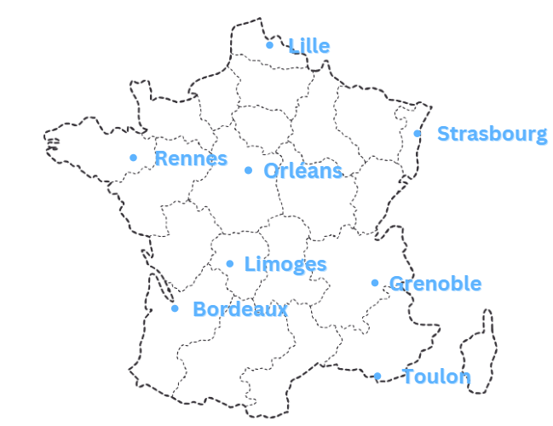
Image sourced from Canva and used in accordance with the Canva Content License Agreement.

For the teacher

Answers
The grey cells indicate there is no information for that person.
Name | Town/city | Type of home | Location of home
Camille | Limoges | apartment | city centre
Sophie | Toulon | (big) house | near the sea
Olivia | Orléans | (2-storey) house | in the suburbs
Alex | (near) Lille | (small) house | in a village
Françoise | Grenoble | cottage/chalet | in the mountains
Monique | (near) Bordeaux | house | on a farm in the country
Cristine | Rennes
Laura | Strasbourg | apartment | in town

Audio file
Where I live listening activity.mp3 (1:48)

Transcript of audio
Bonjour, je suis Camille. J’habite à Limoges, au centre de la France. Notre appartement se trouve au centre-ville.
Salut, moi c’est Sophie. J’habite à Toulon, dans une grande maison près de la mer.
Bonjour, je m’appelle Olivia. J’habite une maison à deux étages à Orléans. Ma maison se trouve en banlieue.
Salut, Alex ici. J’habite près de Lille dans un village dans le nord de la France dans une petite maison.
Je m’appelle Françoise. J’habite dans un chalet à la montagne à Grenoble.
Salut, je suis Monique. Ma maison se trouve dans une ferme à la campagne près de Bordeaux.
Je m’appelle Cristine, j’habite à Rennes. Rennes c’est une grande ville dans le nord-ouest de la France.
Bonjour, je suis Laura. J’habite à Strasbourg dans le nord-est de la France dans un appartement en ville.

© State of New South Wales (Department of Education), 2023
The copyright material published in this resource is subject to the Copyright Act 1968 (Cth) and is owned by the NSW Department of Education or, where indicated, by a party other than the NSW Department of Education (third-party material).
Copyright material available in this resource and owned by the NSW Department of Education is licensed under a Creative Commons Attribution 4.0 International (CC BY 4.0) license.
This license allows you to share and adapt the material for any purpose, even commercially.
Attribution should be given to © State of New South Wales (Department of Education), 2023.
Material in this resource not available under a Creative Commons license:
- the NSW Department of Education logo, other logos and trademark-protected material
- material owned by a third party that has been reproduced with permission. You will need to obtain permission from the third party to reuse its material.
Links to third-party material and websites
Please note that the provided (reading/viewing material/list/links/texts) are a suggestion only and implies no endorsement, by the New South Wales Department of Education, of any author, publisher, or book title. School principals and teachers are best placed to assess the suitability of resources that would complement the curriculum and reflect the needs and interests of their students.
If you use the links provided in this document to access a third-party's website, you acknowledge that the terms of use, including licence terms set out on the third-party's website apply to the use which may be made of the materials on that third-party website or where permitted by the Copyright Act 1968 (Cth). The department accepts no responsibility for content on third-party websites.

