French – Stage 4 – Term 2 – summative assessment task

Outcomes and content
ML4-INT-01 exchanges information and opinions in a range of familiar contexts by using culturally appropriate language
- Express and explain emotions, opinions and personal preferences
- Use features of the sound system in spoken interactions
- Use relevant and familiar vocabulary from a range of themes to interact
Modern Languages K–10 Syllabus © NSW Education Standards Authority (NESA) for and on behalf of the Crown in right of the State of New South Wales, 2022.

Task
In celebration of Bastille Day, your class would like to hold a small party. To help decide what to eat, you will share your opinions about possible food and drink choices for the party.
You will each be given a ‘placemat’ with common French foods and drinks to choose from.
In pairs (or groups of 3), take turns to ask each other about the foods and drinks on the placemat, using the question format Tu aimes… ?
When answering, include your opinion of the food or drink, and the reason. Use conjunctions, for example et, mais and parce que.
For example:
- Tu aimes le jus ? Oui, j’aime le jus, mais c’est mauvais pour la santé.
- Tu aimes le café ? Non, je déteste le café parce que c’est dégoûtant.
- Tu aimes le chocolat chaud ? Oui, j’aime beaucoup le chocolat chaud et c’est délicieux.
Once you have each identified a range of likes and/or dislikes, with reasons, call your teacher over and interact in front of them. Each of you will ask and answer 3 questions, showcasing your knowledge of French foods, drinks, opinions, preferences and reasons.
When you have finished, your teacher will ask you what you would like to eat and drink at the party. Each of you chooses one food and one drink, and ‘orders’ it from your teacher, for example:
Pour la fête je voudrais [name of food] et [name of drink], s’il vous plaît.

For the teacher
This is a sample task only. Adapt it to suit your context and the needs of your students. Amend the structures and/or images, where required, to reflect the vocabulary students have learnt throughout the unit.
Introduce this final summative assessment task at the start of the unit, and explain that all activities completed in this unit of work will build the students’ skills to help them complete the task.
Prior to students completing the assessment task, re-read pages 1–2 of this document, to support students to prepare and revise the relevant vocabulary and structures. On the day of the task, provide students with the placemat only.
Table 1 – placemat of French foods and drinks, with opinions
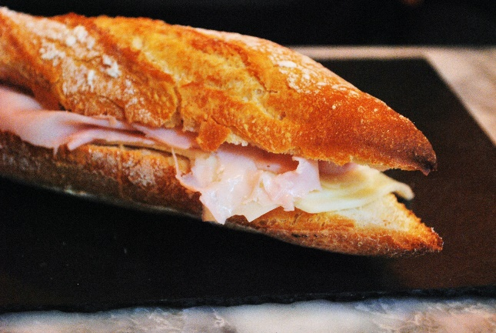 |  | 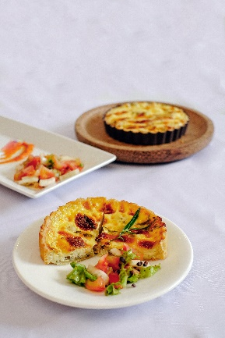
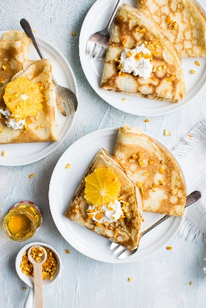
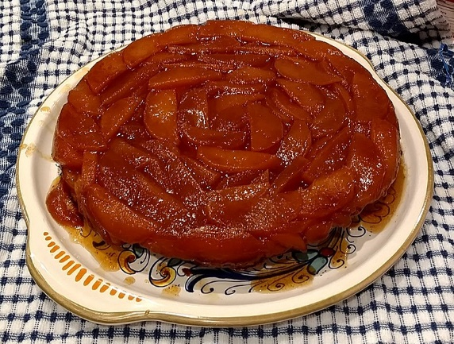 |  | 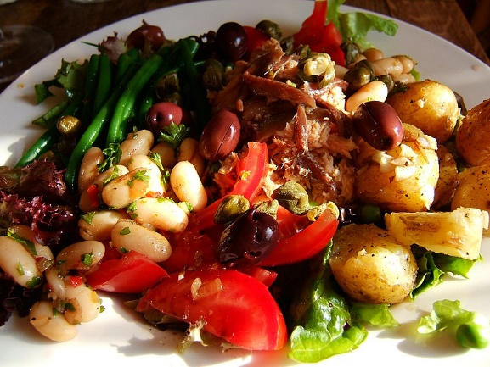
(like or like a lot) | (love or like a lot) | (hate or don’t like)
Images licensed under Unsplash License, image of tarte tatin shared under Creative Commons Attribution-Share Alike 4.0 International license and image of Niçoise salad shared under Creative Commons Attribution 2.0 Generic license.

Marking guidelines
Outcome and content | A – extensive | B – thorough | C – sound | D – basic | E – elementary
ML4-INT-01  - Express and explain emotions, opinions and personal preferences  - Use relevant and familiar vocabulary from a range of themes to interact | Interacts with accuracy, using a range of vocabulary and structures, to:  - provide detailed and varied opinions and reasons, about 3 food and/or drink items from the placemat  - connect ideas using conjunctions  - order 2 items. | Interacts, with minor errors, using a range of vocabulary and structures, to:  - provide detailed and varied opinions and reasons, about 3 food and/or drink items from the placemat  - connect ideas using conjunctions  - order 2 items. | Interacts, with some errors, using a range of vocabulary and structures, to:  - provide opinions and reasons, about 3 food and/or drink items from the placemat  - connect some ideas using conjunctions  - order 2 items. | Interacts, with frequent errors, using some relevant vocabulary and structures, to:  - provide opinions and/or reasons, about some food and/or drink items from the placemat  - connect ideas  - order 1–2 items. | Attempts to interact.
ML4-INT-01  - Use features of the sound system in spoken interactions | Communicates effectively and authentically, using excellent intonation and pronunciation. | Communicates effectively and authentically, with minor errors, using clear intonation and pronunciation. | Communicates with mostly clear intonation and pronunciation, with some errors. | Communicates with errors in intonation and pronunciation that may hinder comprehension. | Attempts to communicate.

References
This resource contains NSW Curriculum and syllabus content. The NSW Curriculum is developed by the NSW Education Standards Authority. This content is prepared by NESA for and on behalf of the Crown in right of the State of New South Wales. The material is protected by Crown copyright.
Please refer to the NESA Copyright Disclaimer for more information https://educationstandards.nsw.edu.au/wps/portal/nesa/mini-footer/copyright.
NESA holds the only official and up-to-date versions of the NSW Curriculum and syllabus documents. Please visit the NSW Education Standards Authority (NESA) website https://educationstandards.nsw.edu.au/ and the NSW Curriculum website https://curriculum.nsw.edu.au/home.
Modern Languages K–10 Syllabus © NSW Education Standards Authority (NESA) for and on behalf of the Crown in right of the State of New South Wales, 2022.

© State of New South Wales (Department of Education), 2023
The copyright material published in this resource is subject to the Copyright Act 1968 (Cth) and is owned by the NSW Department of Education or, where indicated, by a party other than the NSW Department of Education (third-party material).
Copyright material available in this resource and owned by the NSW Department of Education is licensed under a Creative Commons Attribution 4.0 International (CC BY 4.0) license.
This license allows you to share and adapt the material for any purpose, even commercially.
Attribution should be given to © State of New South Wales (Department of Education), 2023.
Material in this resource not available under a Creative Commons license:
- the NSW Department of Education logo, other logos and trademark-protected material
- material owned by a third party that has been reproduced with permission. You will need to obtain permission from the third party to reuse its material.
Links to third-party material and websites
Please note that the provided (reading/viewing material/list/links/texts) are a suggestion only and implies no endorsement, by the New South Wales Department of Education, of any author, publisher, or book title. School principals and teachers are best placed to assess the suitability of resources that would complement the curriculum and reflect the needs and interests of their students.
If you use the links provided in this document to access a third-party's website, you acknowledge that the terms of use, including licence terms set out on the third-party's website apply to the use which may be made of the materials on that third-party website or where permitted by the Copyright Act 1968 (Cth). The department accepts no responsibility for content on third-party websites.

