Team card game
Print off the cards below and then place them in 2 piles at the front of the class – a directions pile and a destinations pile.
Form students into 2 teams (‘direction seekers’ and ‘direction givers’) and ask each team to line up, facing the front. The first student from each team comes to the front and draws a card from their respective pile. The student from the ‘seekers’ team goes first, asking how to get to the destination shown on their card, Pour aller… ? The student from the ‘givers’ team provides the correct directions, based on the card they select.
Students earn a point for their team for responding correctly, using correct French and the correct destination or direction. If both students respond correctly, both teams win a point. Keep playing until every student has had a turn.
Shuffle each pile of cards regularly, to avoid predictability. You may then wish to swap the teams over.

Directions

Destinations
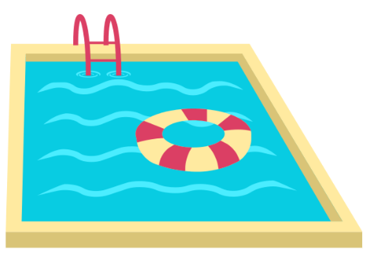
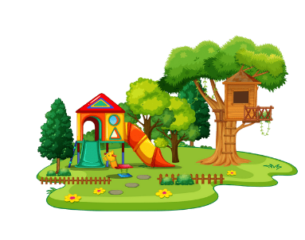
Images sourced from Canva and used in accordance with the Canva Content License Agreement.

© State of New South Wales (Department of Education), 2023
The copyright material published in this resource is subject to the Copyright Act 1968 (Cth) and is owned by the NSW Department of Education or, where indicated, by a party other than the NSW Department of Education (third-party material).
Copyright material available in this resource and owned by the NSW Department of Education is licensed under a Creative Commons Attribution 4.0 International (CC BY 4.0) license.
This license allows you to share and adapt the material for any purpose, even commercially.
Attribution should be given to © State of New South Wales (Department of Education), 2023.
Material in this resource not available under a Creative Commons license:
- the NSW Department of Education logo, other logos and trademark-protected material
- material owned by a third party that has been reproduced with permission. You will need to obtain permission from the third party to reuse its material.
Links to third-party material and websites
Please note that the provided (reading/viewing material/list/links/texts) are a suggestion only and implies no endorsement, by the New South Wales Department of Education, of any author, publisher, or book title. School principals and teachers are best placed to assess the suitability of resources that would complement the curriculum and reflect the needs and interests of their students.
If you use the links provided in this document to access a third-party's website, you acknowledge that the terms of use, including licence terms set out on the third-party's website apply to the use which may be made of the materials on that third-party website or where permitted by the Copyright Act 1968 (Cth). The department accepts no responsibility for content on third-party websites.

