# *Où se trouve… ?* – interacting gap activity

You and your partner each have the names of different people who live in France or Australia. Find out where each person’s home is located. Don’t forget to mention if they live in a house or an apartment.

For example:

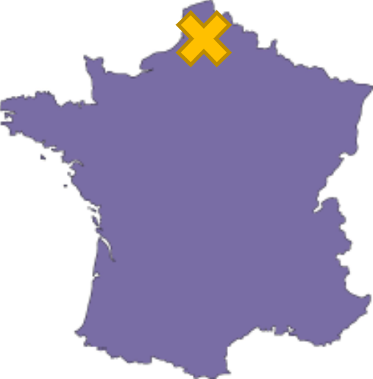 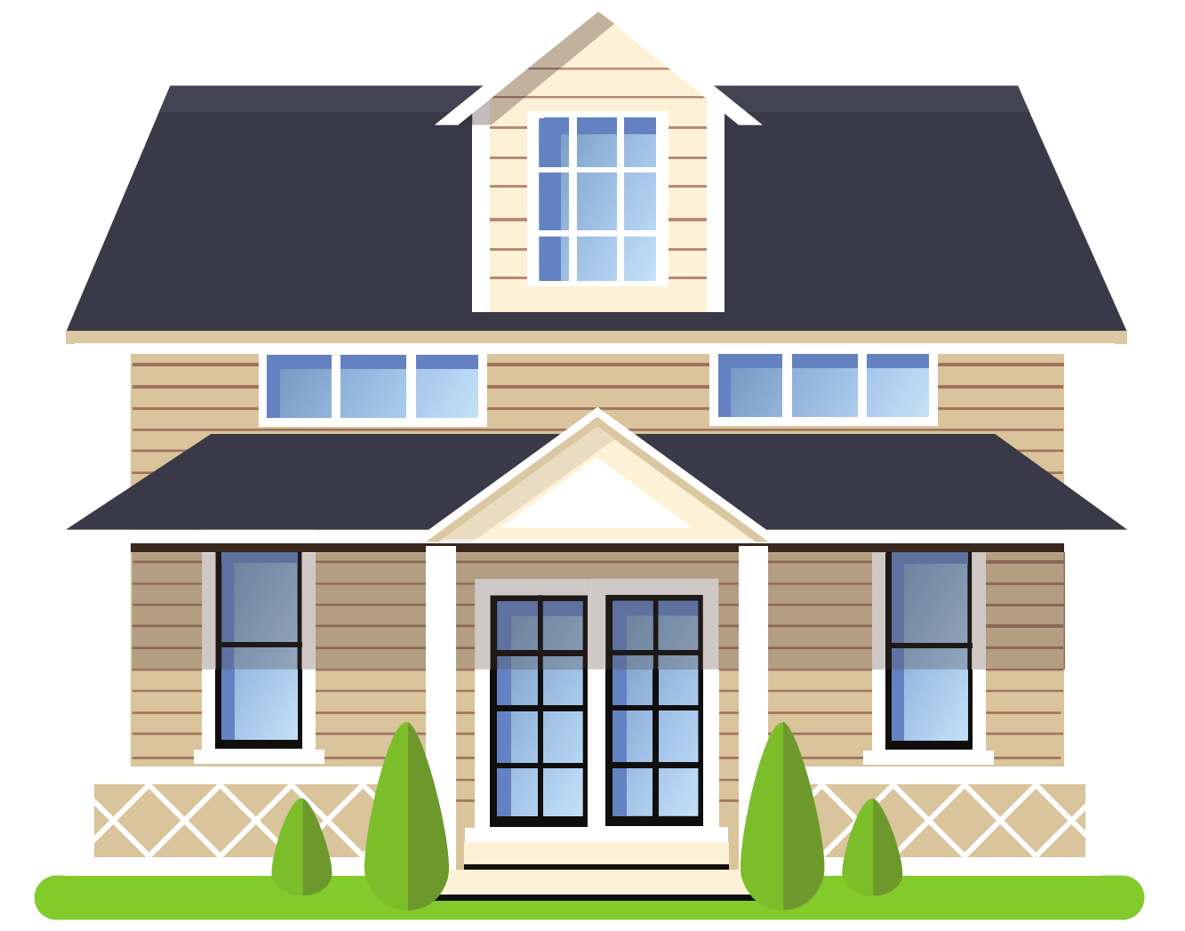Corinne

Question: *Où se trouve la maison de Corinne ?*

Answer: *La maison de Corinne se trouve dans le nord de la France.*

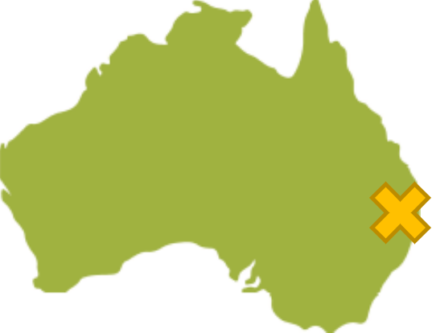 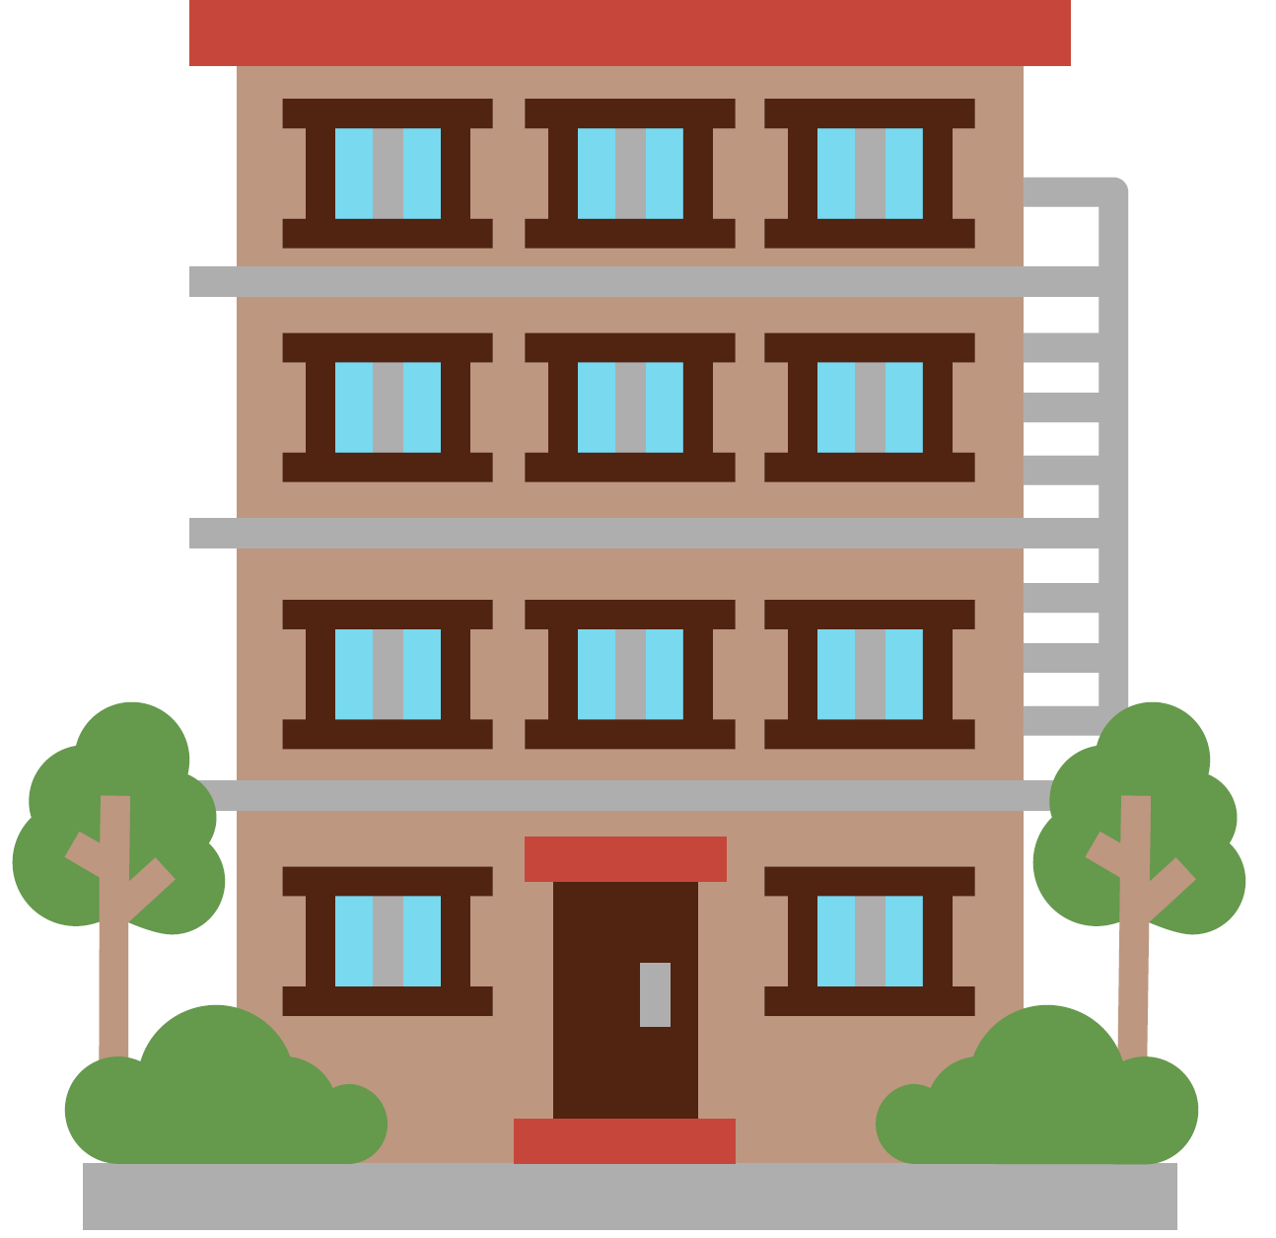 Luke

Question: *Où se trouve l’appartement de Luke ?*

Answer: *L’appartement de Luke se trouve dans l’est de l’Australie.*

When you hear where each home is located, mark it on your map with a cross.

## Student A

|  |  |  |
| --- | --- | --- |
| Où se trouve… ? |  |  |
| The north of France.  An apartment. Léo | Australia.  **An apartment.** Jarrah | The north-east of Australia.  A house. Sarah |
| Australia.  A house. Josh | The south of France.  **An apartment.** Béatrice | **France.**  A house. Camille |
| The south of Australia.  An apartment. Prisha | **France.**  A house. Nala | The south-east of France.  **An apartment.** Louis |
| Australia.  An apartment. Max | The south-west of France.  A house. Juliette | Australia.  A house. Finn |

Images sourced from [Canva](https://www.canva.com/) and used in accordance with the [Canva Content License Agreement](https://www.canva.com/policies/content-license-agreement/).

## Student B

|  |  |  |
| --- | --- | --- |
| Où se trouve… ? |  |  |
| France.  An apartment. Léo | The north of Australia.  **An apartment.** Jarrah | Australia.  A house. Sarah |
| The south-west of Australia.  A house. Josh | **France.**  **An apartment.** Béatrice | The east of France.  A house. Camille |
| Australia.  An apartment. Prisha | The south of France.  A house. Nala | **France.**  **An apartment.** Louis |
| The east of Australia.  An apartment. Max | **France.**  A house. Juliette | The south-east of Australia.  A house. Finn |

Images sourced from [Canva](https://www.canva.com/) and used in accordance with the [Canva Content License Agreement](https://www.canva.com/policies/content-license-agreement/).

**© State of New South Wales (Department of Education), 2023**

The copyright material published in this resource is subject to the *Copyright Act 1968* (Cth) and is owned by the NSW Department of Education or, where indicated, by a party other than the NSW Department of Education (third-party material).

Copyright material available in this resource and owned by the NSW Department of Education is licensed under a [Creative Commons Attribution 4.0 International (CC BY 4.0) license](https://creativecommons.org/licenses/by/4.0/).

[](https://creativecommons.org/licenses/by/4.0/)

This license allows you to share and adapt the material for any purpose, even commercially.

Attribution should be given to © State of New South Wales (Department of Education), 2023.

Material in this resource not available under a Creative Commons license:

* the NSW Department of Education logo, other logos and trademark-protected material
* material owned by a third party that has been reproduced with permission. You will need to obtain permission from the third party to reuse its material.

**Links to third-party material and websites**

Please note that the provided (reading/viewing material/list/links/texts) are a suggestion only and implies no endorsement, by the New South Wales Department of Education, of any author, publisher, or book title. School principals and teachers are best placed to assess the suitability of resources that would complement the curriculum and reflect the needs and interests of their students.

If you use the links provided in this document to access a third-party's website, you acknowledge that the terms of use, including licence terms set out on the third-party's website apply to the use which may be made of the materials on that third-party website or where permitted by the *Copyright Act 1968* (Cth). The department accepts no responsibility for content on third-party websites.