Map task

For the teacher
Print the map on A3 paper, enough copies for one between 2 students.
In pairs or group of 3, students interact to give and ask directions to destinations on the map.
Each pair has one local person and one visitor to the area (or 2 visitors, for groups of 3). The visitor must ask where 4 places are on the map – the park, the supermarket, and 2 more places of their choosing. For groups with 2 visitors, each visitor asks 2 destinations each.
The local person provides clear directions to the destination, including its location in relation to another local place, for example ‘It is next to …’. The instructions are then repeated by the visitor.
The interaction includes the following:
- politely stopping the local person
- appropriate greetings
- asking for 4 local facilities (the park, the supermarket, and 2 more places of their choosing)
- directions to each destination and its location in relation to another local facility
- thanking the local person and saying goodbye.
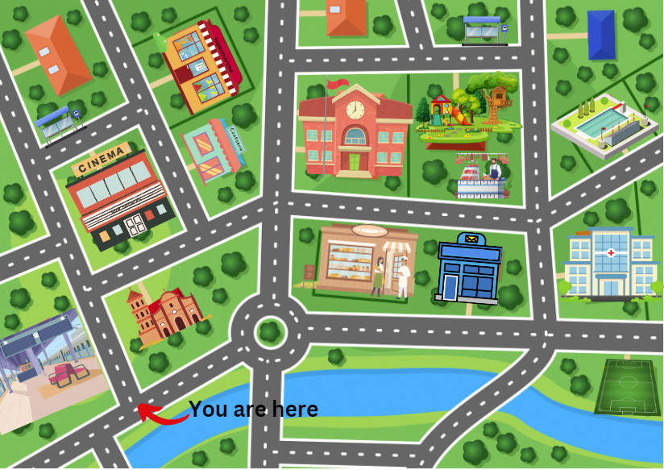
Images sourced from Canva and used in accordance with the Canva Content Licence Agreement.
© State of New South Wales (Department of Education), 2023
The copyright material published in this resource is subject to the Copyright Act 1968 (Cth) and is owned by the NSW Department of Education or, where indicated, by a party other than the NSW Department of Education (third-party material).
Copyright material available in this resource and owned by the NSW Department of Education is licensed under a Creative Commons Attribution 4.0 International (CC BY 4.0) license.
This license allows you to share and adapt the material for any purpose, even commercially.
Attribution should be given to © State of New South Wales (Department of Education), 2023.
Material in this resource not available under a Creative Commons license:
- the NSW Department of Education logo, other logos and trademark-protected material
- material owned by a third party that has been reproduced with permission. You will need to obtain permission from the third party to reuse its material.
Links to third-party material and websites
Please note that the provided (reading/viewing material/list/links/texts) are a suggestion only and implies no endorsement, by the New South Wales Department of Education, of any author, publisher, or book title. School principals and teachers are best placed to assess the suitability of resources that would complement the curriculum and reflect the needs and interests of their students.
If you use the links provided in this document to access a third-party's website, you acknowledge that the terms of use, including licence terms set out on the third-party's website apply to the use which may be made of the materials on that third-party website or where permitted by the Copyright Act 1968 (Cth). The department accepts no responsibility for content on third-party websites.

