Ma ville – listening activity
Write the directions, in French, on the compass below:
le nord, le nord-est, l’est, le sud-est, le sud, le sud-ouest, l’ouest, le nord-ouest.
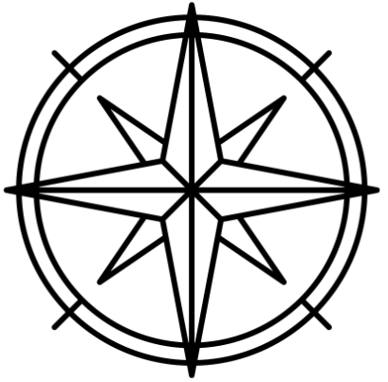
Listen to the 8 sentences. After each sentence, write the name of the city next to the corresponding number, according to the order in which the sentences are read aloud.
- __________________  - __________________  - __________________  - __________________  - __________________  - __________________  - __________________  - __________________ | 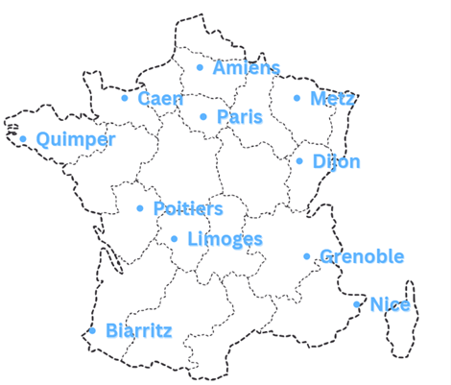
Images sourced from Canva and used in accordance with the Canva Content License Agreement.

For the teacher
Note: The sentences are not numbered in the audio. If playing to the whole class, pause the audio and say the number before each sentence, for example numéro un (and then play the audio of the first sentence).

Audio file
Ma ville listening activity.mp3 (1:14)

Transcript of audio (with answers)
Ma ville se trouve dans le sud-est de la France. (Nice)
Ma ville se trouve dans le nord de la France. (Amiens)
Ma ville se trouve dans le nord-ouest de la France. (Quimper)
Ma ville se trouve dans le nord de la France, au sud d’Amiens, c’est la capitale. (Paris)
Ma ville se trouve au centre de la France, au sud-est de Poitiers. (Limoges)
Ma ville se trouve dans le nord-ouest de la France, entre Amiens et Quimper. (Caen)
Ma ville se trouve dans le sud-est de la France, au nord de Nice. (Grenoble)
Ma ville se trouve dans le nord-est de la France, au nord de Dijon. (Metz)

© State of New South Wales (Department of Education), 2023
The copyright material published in this resource is subject to the Copyright Act 1968 (Cth) and is owned by the NSW Department of Education or, where indicated, by a party other than the NSW Department of Education (third-party material).
Copyright material available in this resource and owned by the NSW Department of Education is licensed under a Creative Commons Attribution 4.0 International (CC BY 4.0) license.
This license allows you to share and adapt the material for any purpose, even commercially.
Attribution should be given to © State of New South Wales (Department of Education), 2023.
Material in this resource not available under a Creative Commons license:
- the NSW Department of Education logo, other logos and trademark-protected material
- material owned by a third party that has been reproduced with permission. You will need to obtain permission from the third party to reuse its material.
Links to third-party material and websites
Please note that the provided (reading/viewing material/list/links/texts) are a suggestion only and implies no endorsement, by the New South Wales Department of Education, of any author, publisher, or book title. School principals and teachers are best placed to assess the suitability of resources that would complement the curriculum and reflect the needs and interests of their students.
If you use the links provided in this document to access a third-party's website, you acknowledge that the terms of use, including licence terms set out on the third-party's website apply to the use which may be made of the materials on that third-party website or where permitted by the Copyright Act 1968 (Cth). The department accepts no responsibility for content on third-party websites.

