Là où j’habite
On the ‘Là où j’habite’ (‘Where I live’) blog, people from francophone countries around the world share general details about where they live.
Read the following blog post from Sophie, who lives in Canada. She has included where her house is located, a description of the house and its rooms.

Reading comprehension
Salut mes copains francophones!
Me voilà chez moi à Dieppe, en Nouveau Brunswick, au Canada. Ici on parle le français et l’angais. Et oui, le Nouveau Brunswick, c’est une province bilingue, il se trouve dans le sud-est du Canada, au bord de l’océan Atlantique.
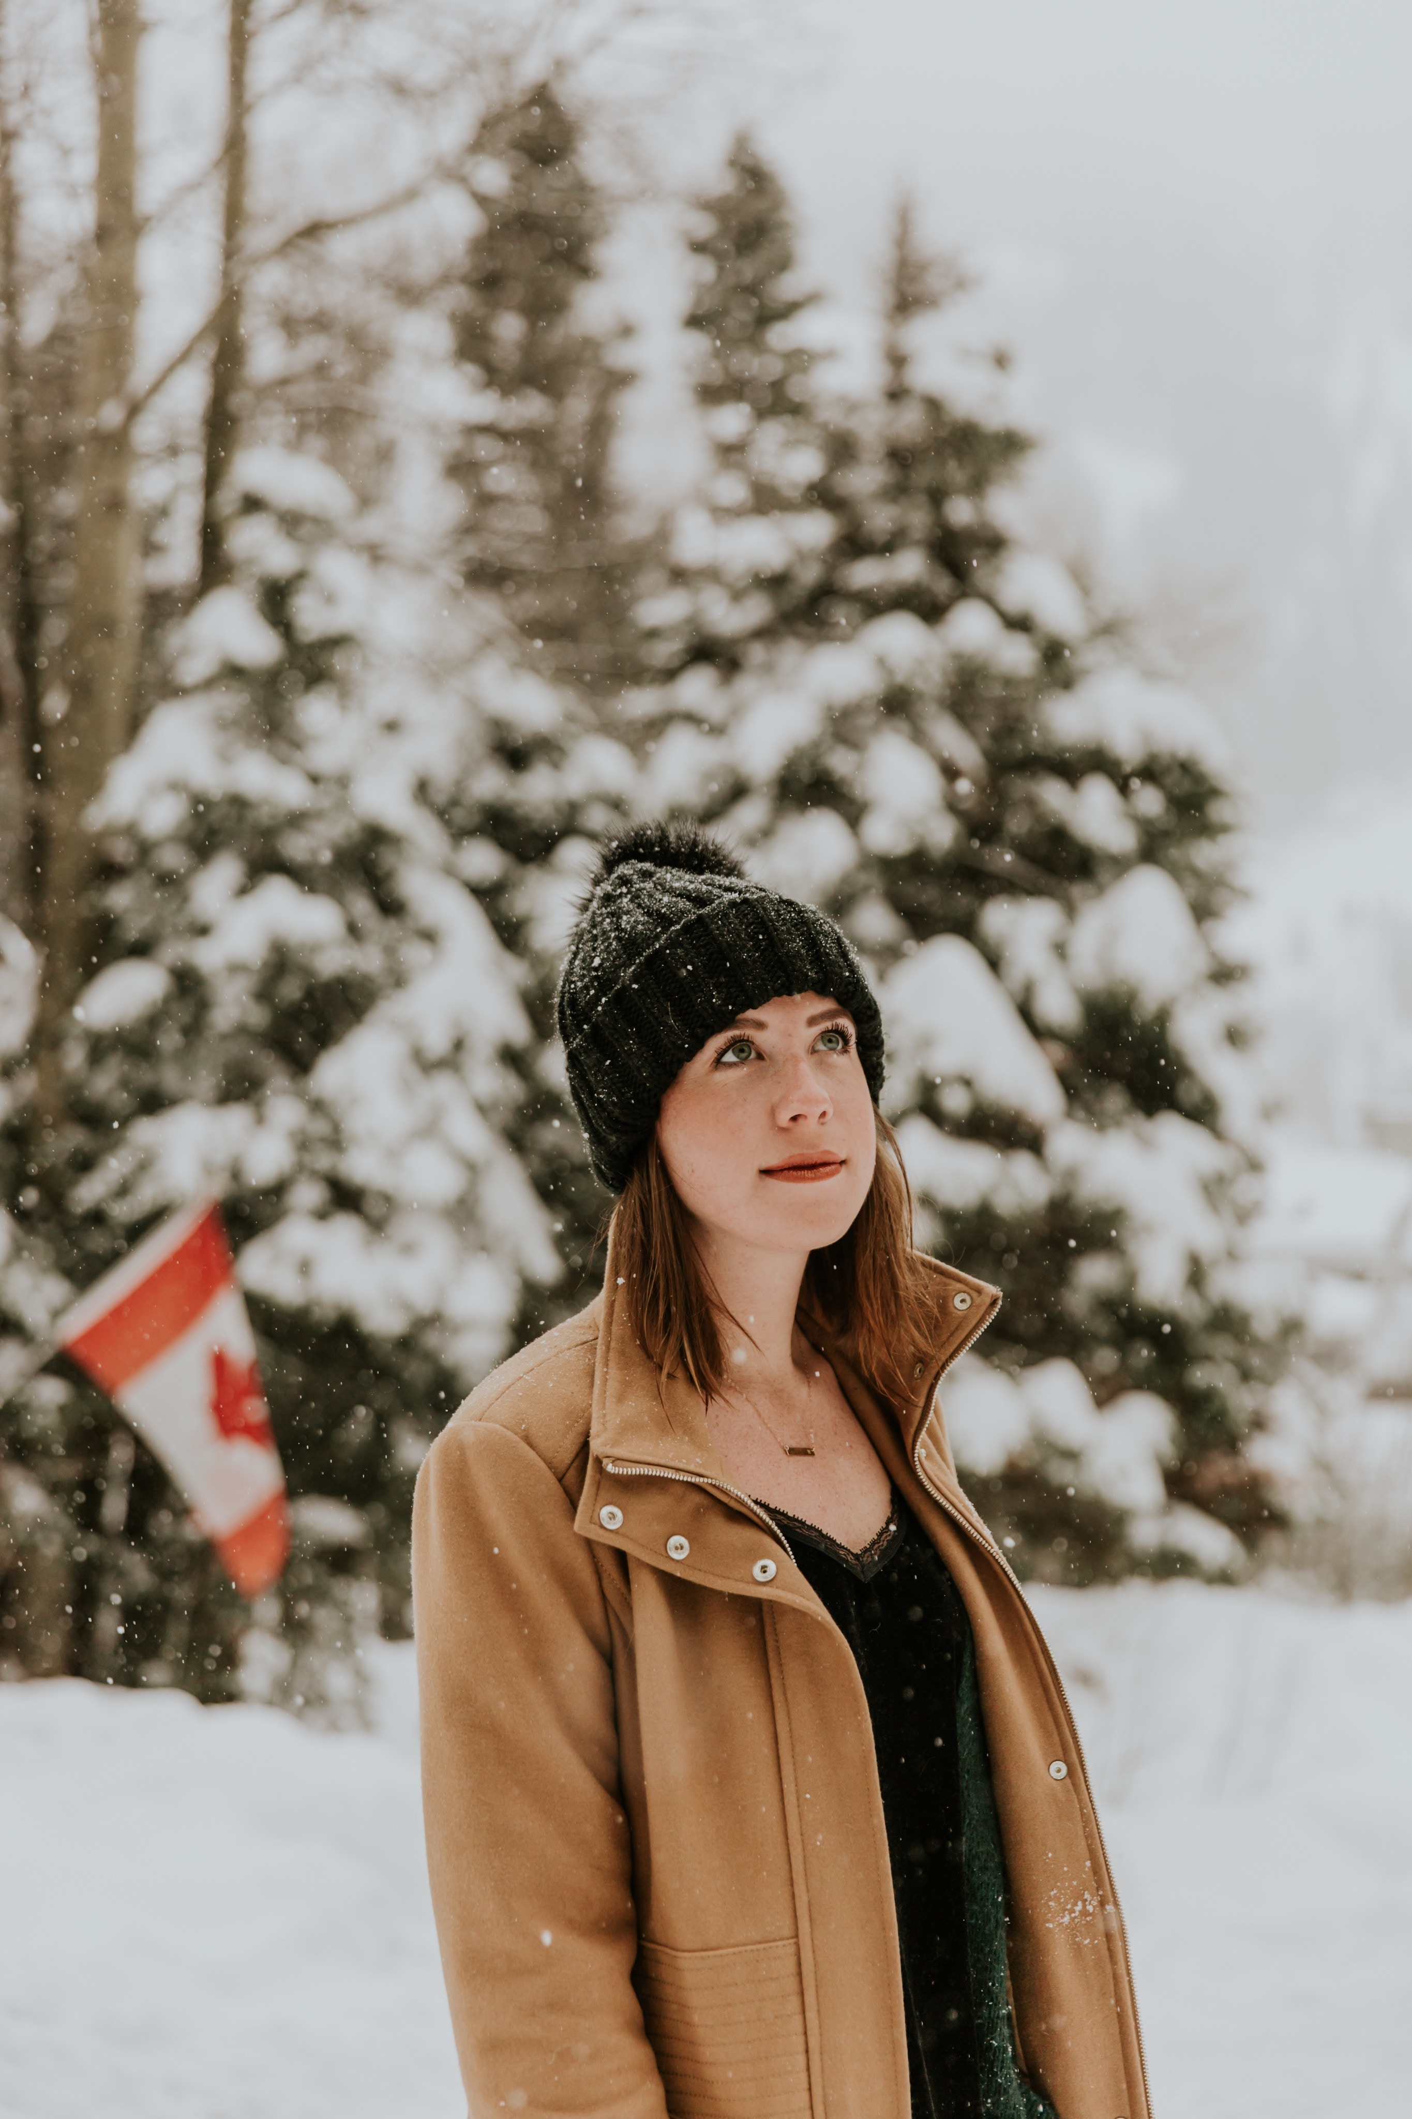
Me voilà devant ma maison
Ma maison se trouve près de la rivière Petitcodiac – ça s’appelle aussi la rivière au chocolat, grâce à sa couleur. C’est une vieille petite maison à deux étages, avec un sous-sol. Toutes les maisons au Canada ont un sous-sol à cause des températures en dessous de zéro degré . Et oui, il fait très froid ici!
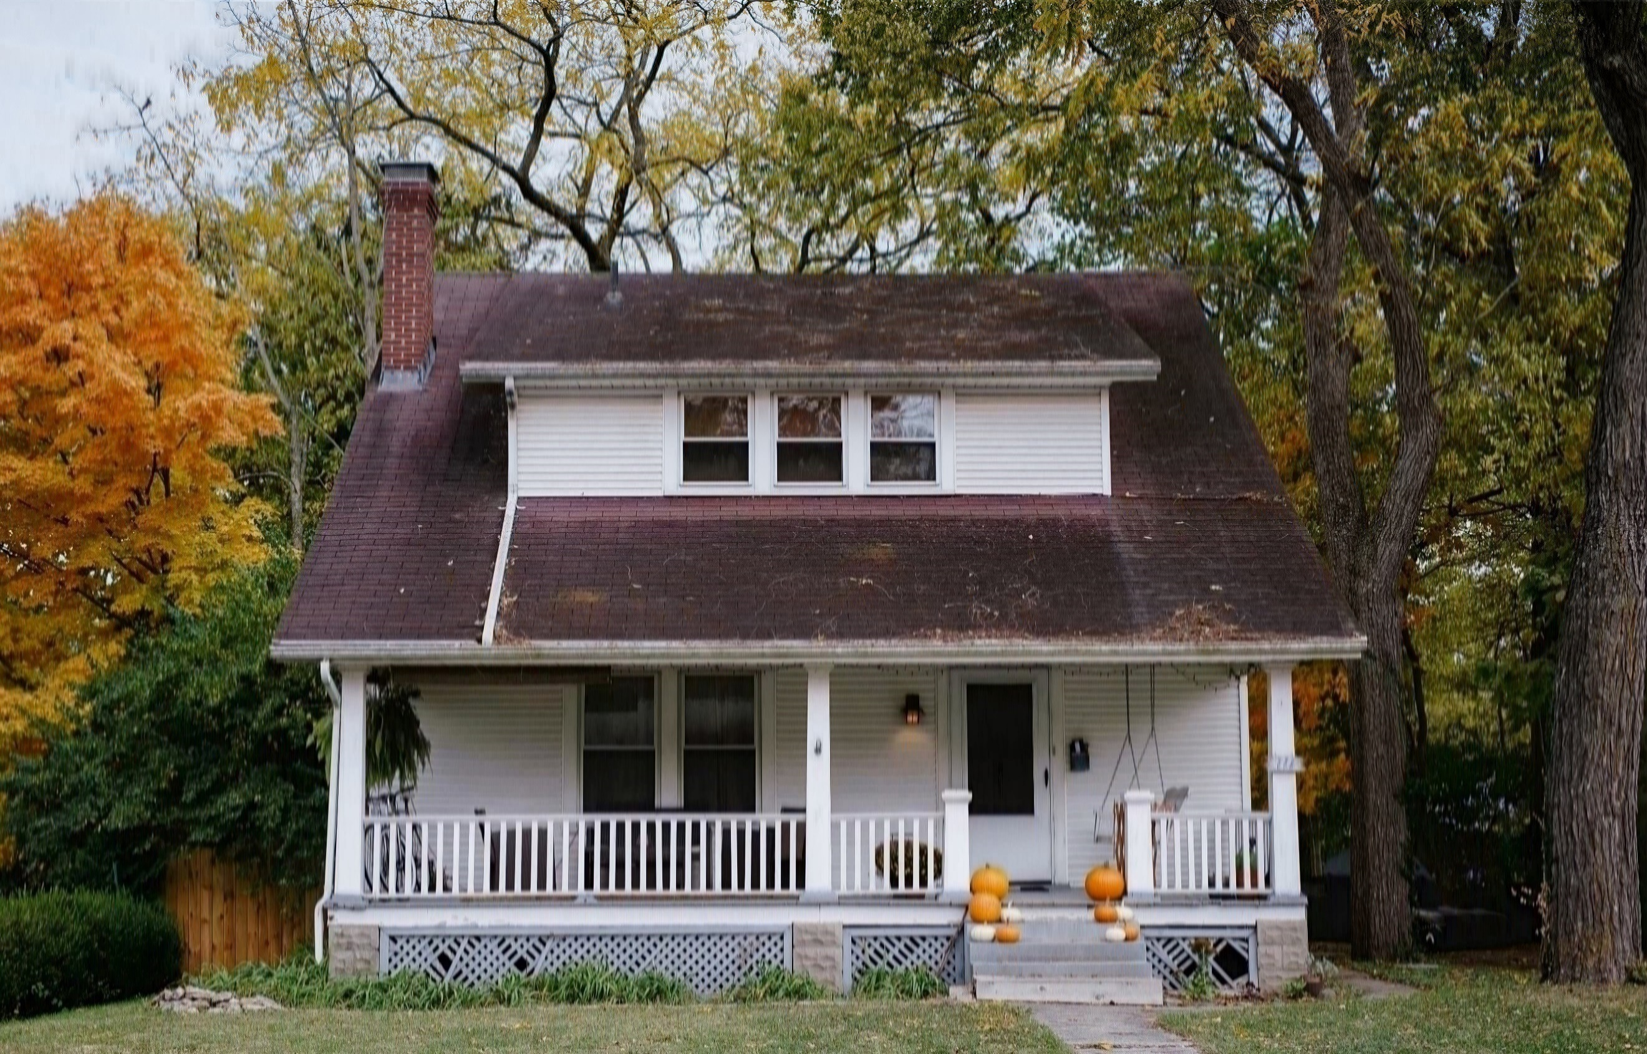
Ma maison en automne
Nous avons un joli jardin devant et derrière la maison, mais il n’y a pas de portail, ni de clôtures comme les maisons en France. Notre chien Toutou adore la neige mais notre chat préfère rester dans la maison.
Dans ma maison il y a trois chambres. Les chambres sont en haut: une pour mes parents, une pour moi et une pour mon petit frère. Ma chambre est assez grande et claire, avec beaucoup de place pour mon lit et mon bureau. J’ai aussi des posters de mes chanteurs préférés, Justin Bieber et Le Weeknd. Ils sont canadiens, c’est super non? Il y a aussi une salle de bains en haut, et une deuxième petite salle de bains en bas. En bas il y a aussi une cuisine moderne – mon père adore faire la cuisine, une salle à manger, un petit salon confortable avec une télévision. La buanderie est au sous-sol à côté d’une petite salle de jeux avec une console de jeux pour mon frère et une table de babyfoot. On adore ça! On aime beaucoup les sports d’hiver comme le snowboard.
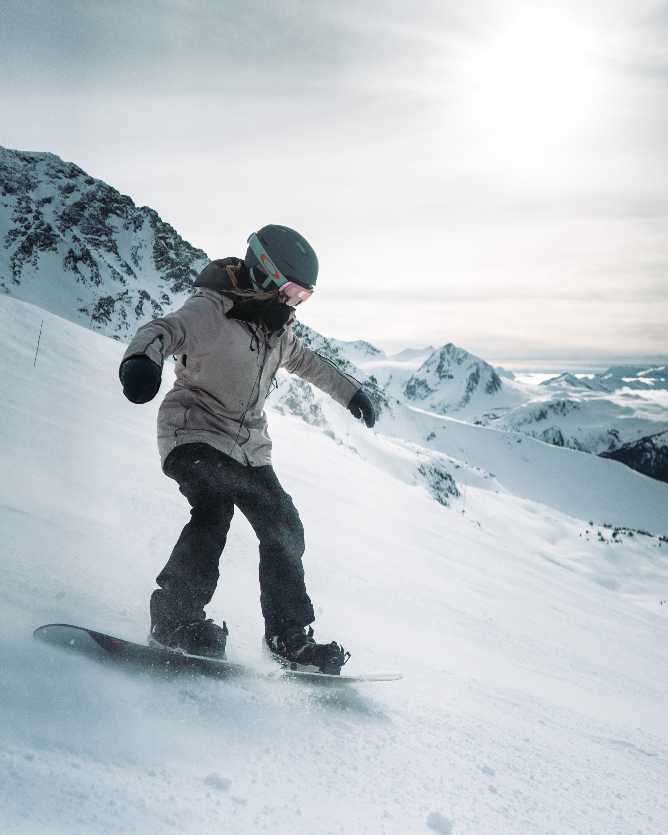
Me voilà avec mon snowboard à la montagne
Et vous? Décrivez-moi les maisons du monde francophone!
À+
Sophie

Comprehension questions
- Where exactly is the town Sophie lives in located?
- According to Sophie, what feature do all Canadian houses have that is different from Australian houses? Why?
- Does she have a front yard? And a backyard?
- What pets does she have?
- How many bedrooms are in the house?
- How does she describe her bedroom?
- How many bathrooms are there and where are they located?
- How does she describe the kitchen?
- What other rooms are located on the ground floor?
- What rooms are located in the basement?
- What activities does the family like doing?
Images licensed under Unsplash License.

For the teacher
This text includes vocabulary which is likely unfamiliar to your students.
Introduce the reading activity by reviewing the strategies for understanding texts – find a couple of sample sentences with unfamiliar words and model the strategies for students. The strategy you choose should best meet the needs of students.
For example, you may ask students to:
- underline words they know, and circle unfamiliar words
- code texts, using ‘*’ for familiar words or structures, ‘+’ for new information, ‘!’ for ‘wow’ (something they find interesting) and ‘?’ for ‘I don’t understand’
- colour code the text to identify prepositions, nouns, adjectives and verbs.
Alternatively, lead students through the following steps:
- Do I know these words?
- Do they look like English words (cognates)?
- Can I extrapolate or guess the meaning from the context?
- Help me, I need a dictionary!
Another approach is to read for context clues.
Step | Action
1. Read and question | Read the text carefully.  Frequently ask yourself ‘Does this make sense?’.
2. Slow advance | Notice when you don’t know the meaning of a word, and slow down.  Read that sentence at least once more, looking for clues.
3. Stop and rewind | If necessary, go back and re-read the preceding sentence, looking for clues that will help you figure out what the word or phrase might mean.
4. Read and question | When you think you’ve figured out what the word or phrase means, substitute your guess for the word or phrase.  If it makes sense, keep reading.  If it doesn’t, stop and rewind, and try again or check meaning in a dictionary.
Students could also use their own strategies.
Allow students time to access the text and questions independently or, if preferred, in pairs. Provide vocabulary hints for students who need additional support.
Point out to students that in France, there is a (non-breaking) space before the following punctuation signs – colon (:), semicolon (;), exclamation mark (!) and question mark (?). However in Canada, the space is only before a colon (:).

Comprehension questions – answers
- Where exactly is the town Sophie lives in located? South-eastern Canada on the Atlantic Ocean.
- According to Sophie, what feature do all Canadian houses have that is different from Australian houses? Why? All houses in Canada have a basement because of the below zero temperatures.
- Does she have a front yard? And a backyard? Her house has a front and back yard but no fences or gates.
- What pets does she have? She has a dog and a cat.
- How many bedrooms are in the house? There are 3 bedrooms.
- How does she describe her bedroom? Her room is big and light with lots of room for her things.
- How many bathrooms are there and where are they located? One bathroom is upstairs and there is a second, smaller bathroom downstairs.
- How does she describe the kitchen? It is a modern kitchen.
- What other rooms are located on the ground floor? The loungeroom is also downstairs.
- What rooms are located in the basement? There is a laundry and games room in the basement.
- What activities does the family like doing? The family enjoys winter sports like snowboarding.

© State of New South Wales (Department of Education), 2023
The copyright material published in this resource is subject to the Copyright Act 1968 (Cth) and is owned by the NSW Department of Education or, where indicated, by a party other than the NSW Department of Education (third-party material).
Copyright material available in this resource and owned by the NSW Department of Education is licensed under a Creative Commons Attribution 4.0 International (CC BY 4.0) license.
This license allows you to share and adapt the material for any purpose, even commercially.
Attribution should be given to © State of New South Wales (Department of Education), 2023.
Material in this resource not available under a Creative Commons license:
- the NSW Department of Education logo, other logos and trademark-protected material
- material owned by a third party that has been reproduced with permission. You will need to obtain permission from the third party to reuse its material.
Links to third-party material and websites
Please note that the provided (reading/viewing material/list/links/texts) are a suggestion only and implies no endorsement, by the New South Wales Department of Education, of any author, publisher, or book title. School principals and teachers are best placed to assess the suitability of resources that would complement the curriculum and reflect the needs and interests of their students.
If you use the links provided in this document to access a third-party's website, you acknowledge that the terms of use, including licence terms set out on the third-party's website apply to the use which may be made of the materials on that third-party website or where permitted by the Copyright Act 1968 (Cth). The department accepts no responsibility for content on third-party websites.

