我不要 number game

Game overview
This number game supports students to interact and socialise in Chinese, understanding Hanzi for numbers. Students can play in groups of 3 to 6 players.
There are 36 cards with numbers from 1 to 36 and there are 60 tokens.
One card is placed in the middle of the table, face-up. On each student’s turn, they must decide between 2 options:
- take the card from the middle and place it in front of them, giving themselves points equal to the value on the card
or
- decline by placing a token next to the card in the middle.
The player to the left is next and faces the same decision – accept the card (including any tokens beside it) or decline and place one of their tokens beside it.
The game continues until all cards have been taken. At the end of the game, the card count minus the amount of tokens gives the score for each student. The player with the fewest points wins.

Setting up the game
- Each student gets 10 tokens. During play, students should keep these hidden from other students.
- The 'dealer' shuffles the number cards, then removes 6 cards. These cards are not needed for this game and are put to the side, without anyone looking at them. The remaining cards are placed in a pile as a face-down deck in the middle of the table.

Scoring
The student with the lowest score wins.
When scoring, each number card is equivalent in points to the number displayed on the card. For example, a 七 card counts as 7 points, a 十八 card counts as 18 points and so on. For example:
- if a student has cards 4, 8 and 12, their score is 24.
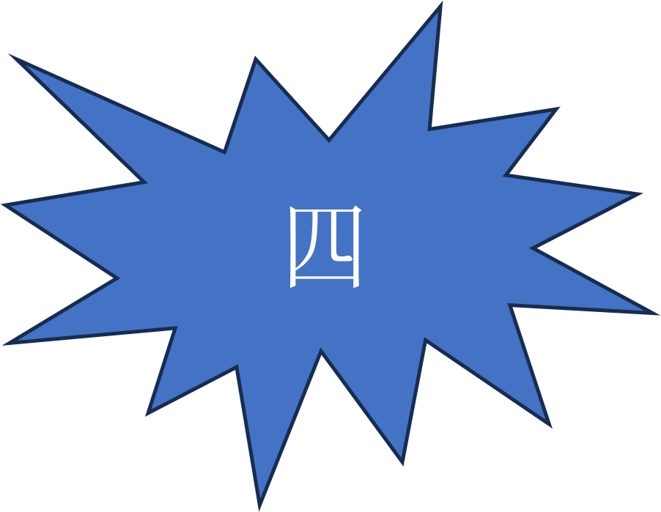 | 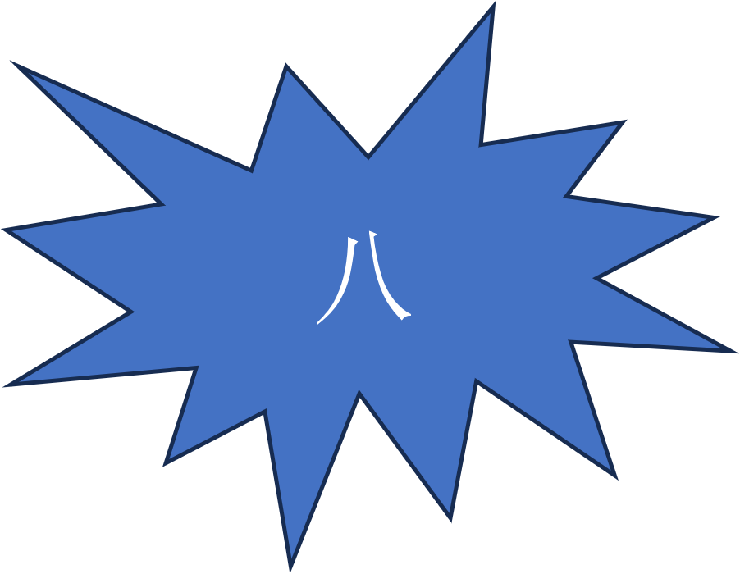 | 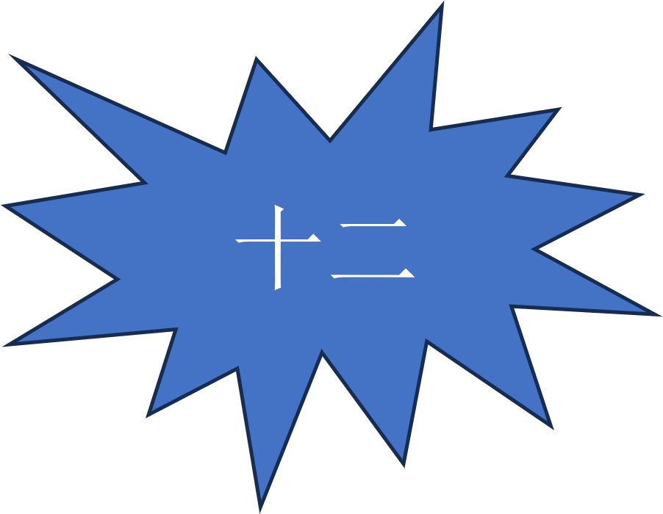 | 4 + 8 + 12 = 24
However, if a student has a sequence of numbers, only the lowest number in the sequence counts. For example:
- if a student has cards 4, 11 and 12, their score is 15 (as only the lowest number in the sequence counts).
4 + 11 + 12 = 15
- if a student has cards 28, 29 and 30, their score is 28 (as only the lowest number in the sequence counts).
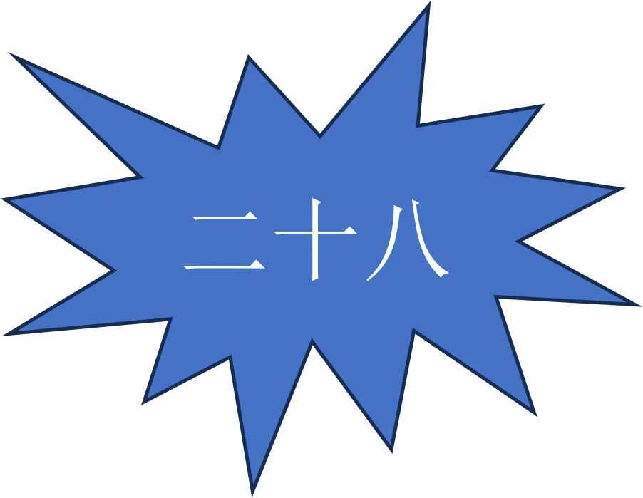 | 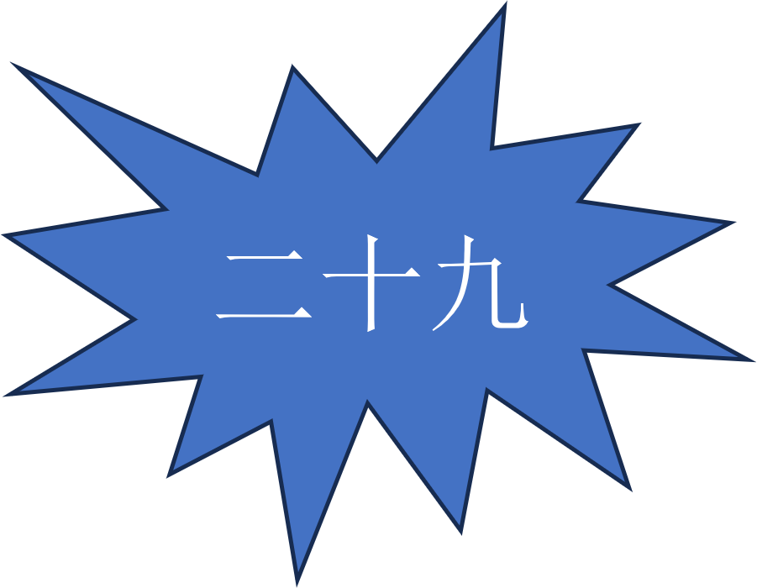 | 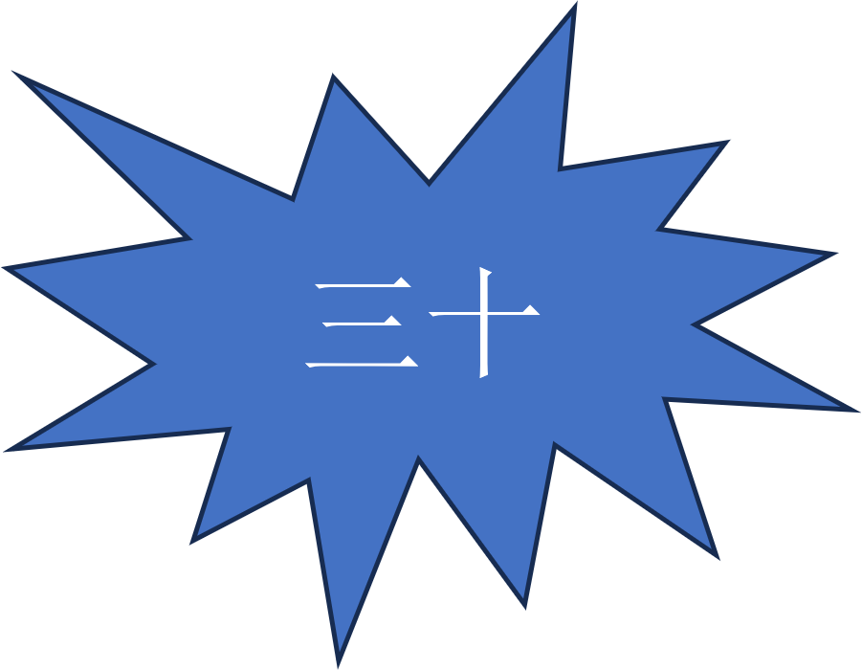 | 28 + 29 + 30 = 28
Tip – collecting running number sequences is better than collecting single cards.
To avoid picking up a card they don’t want, students must ‘pay’ a token. It is a good idea to have lots of playing tokens. At the end of the game, every token a student has is subtracted from the total points. Remember, the student with the lowest score wins.
To score, each student adds up the values of all their individual number cards, plus the lowest card of each running number sequence. From the total, they subtract the number of playing tokens they have.
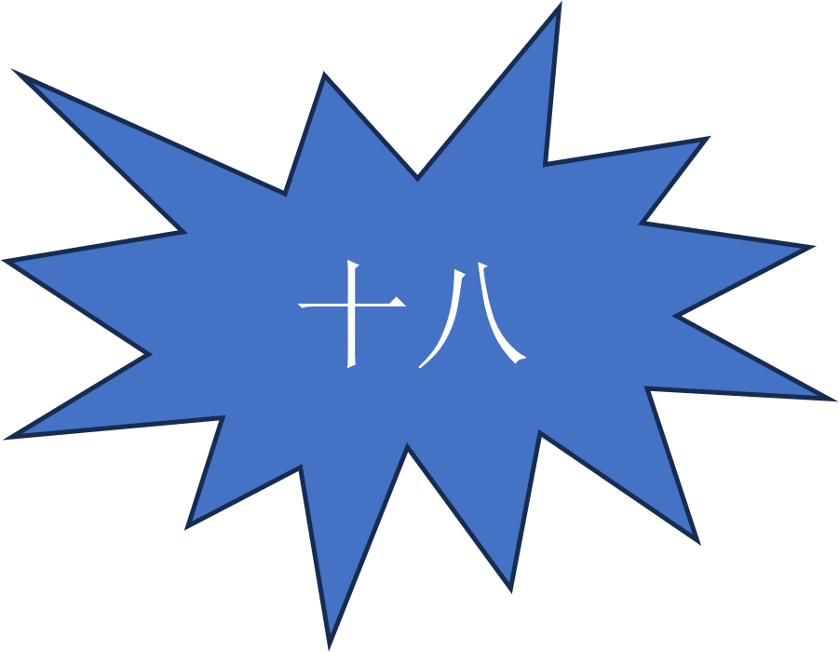 | = 18
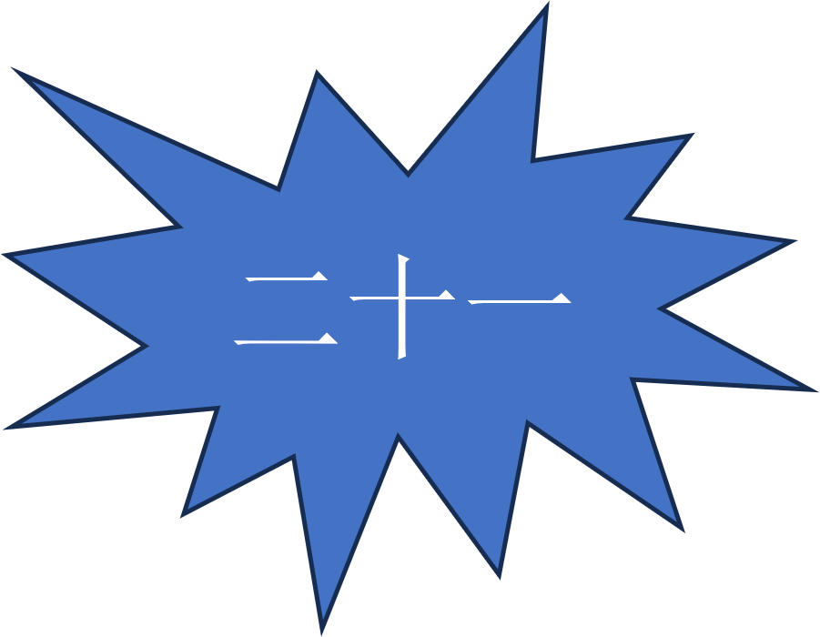 | = 21
 |  | = 7
 |  |  | = 28
 | 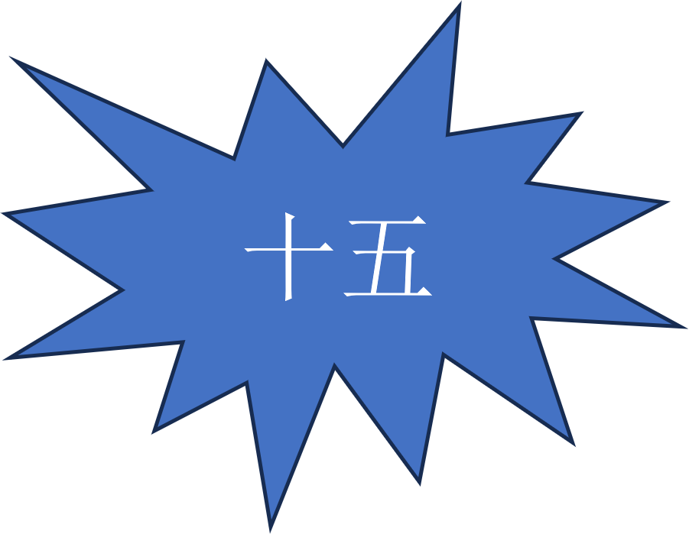 | 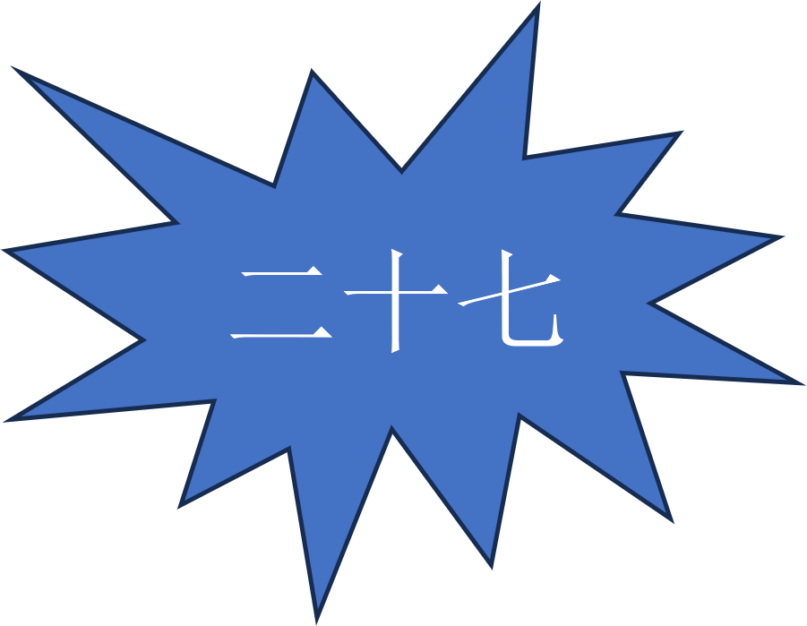 | = 46
Remember, students deduct the amount of tokens from their total number score. For example, if a student finishes the game with 72 in number cards, and 10 tokens, their final score is 62.
Total score at end of game = number card amount – token amount.

Playing the game
The student who arrived earliest to school on the day of play goes first. They turn over the top card of the deck and put it next to the deck, face-up. Then they need to decide to:
- take the card and put it in front of themself, face-up
or
- decline it and ‘pay’ for their decision by placing one of their tokens next to the card.
If the student declines the card, the student to the left takes their turn and faces the same decision.
The game continues this way, with each student deciding whether to take the card (and all the tokens next to it) or decline the card and add one of their own tokens to the pool of tokens beside the card.
When a student finally decides to take the card from the deck (and all the tokens next to it), they put it face-up in front of themselves and put the tokens into their pool of tokens, out of view. After that, this student turns over the next card on the deck. They decide whether to take the card, or decline it and pay a token.
If they decline, game play moves to the student to the left.
If a student has no tokens left, they must take the card.
Note – often, students will decline a card several times so that the number of tokens next to the card becomes large. For example, if a number 27 card is declined 10 times, when it is picked up by a student, they take the number 27 card and 10 tokens, effectively making the total of that game play 17 points.
To easily see how many points each student has, running sequences of cards are placed with the cards overlapping, away from the single cards. All card values need to be visible during the game.
This continues until all the cards in the deck have been used up. Final scores are then counted.

Number cards
 |  | 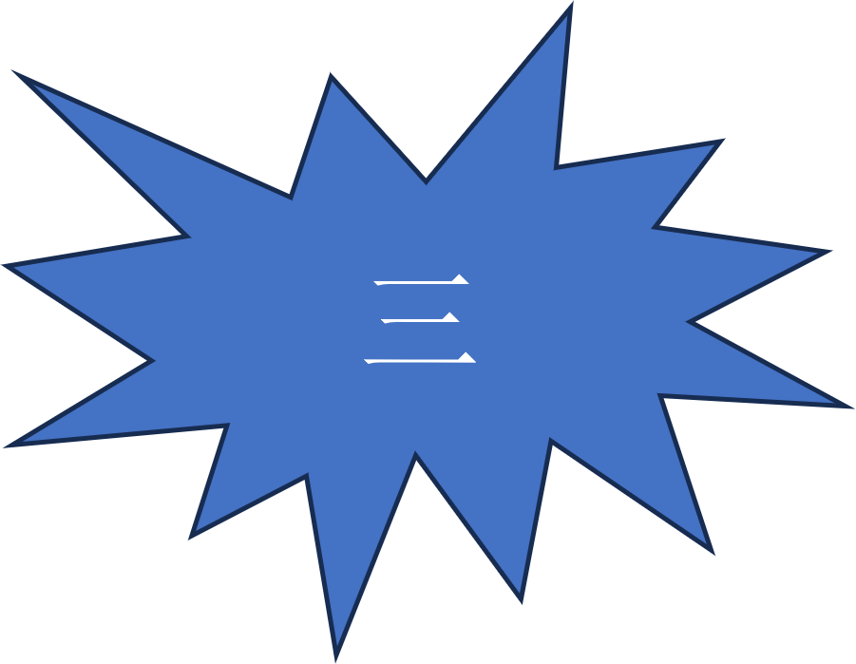
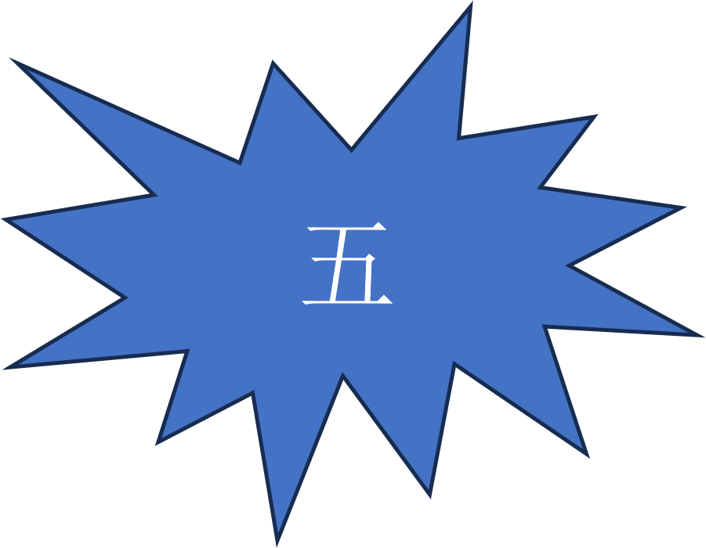
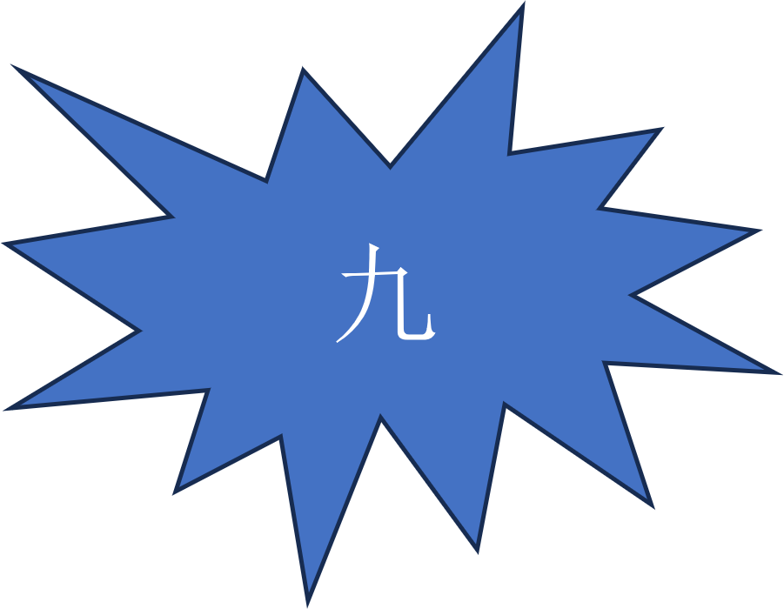
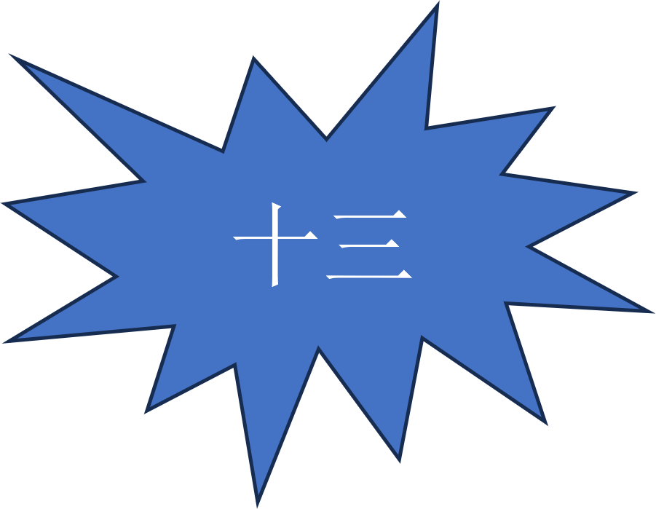 | 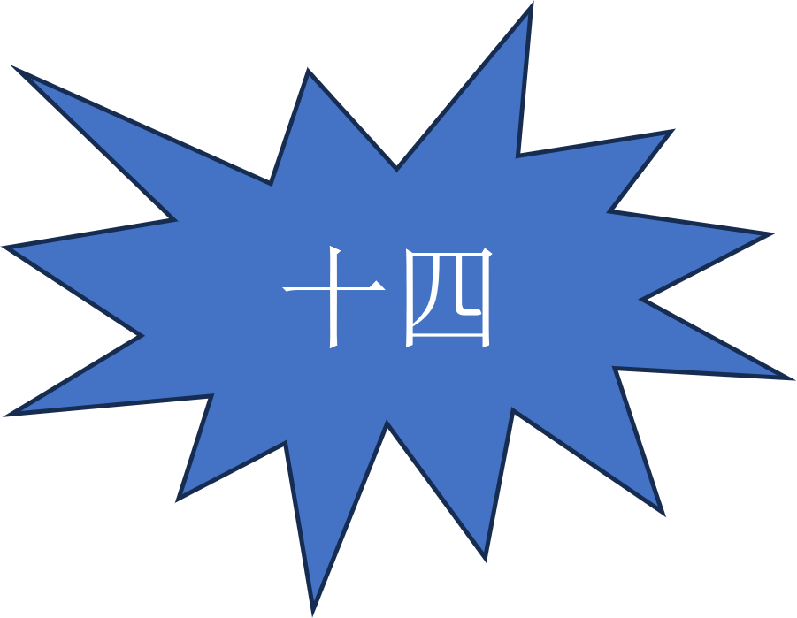 |  | 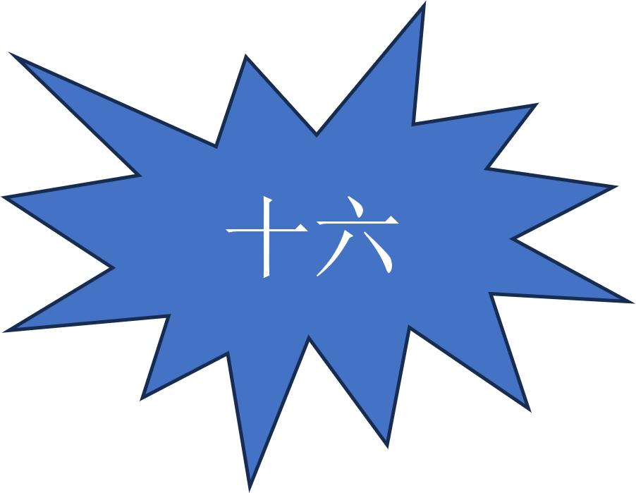
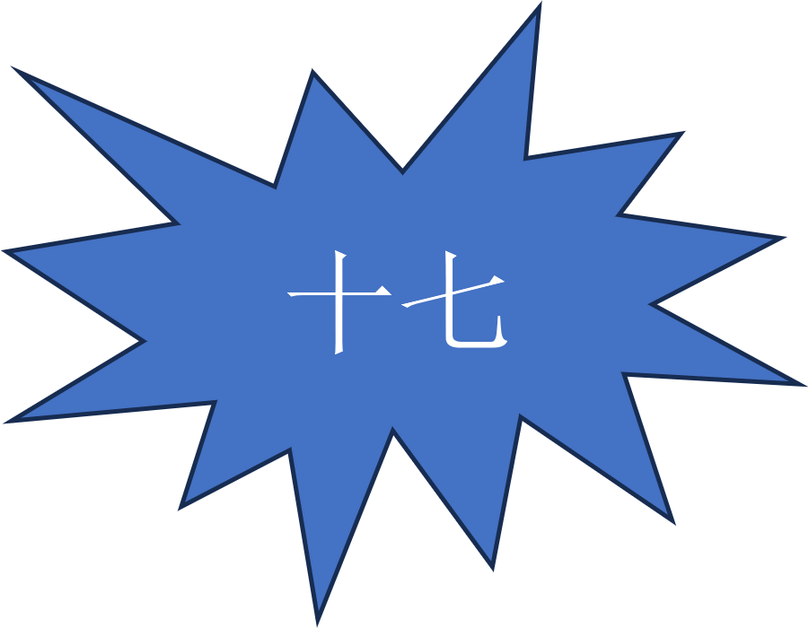 |  | 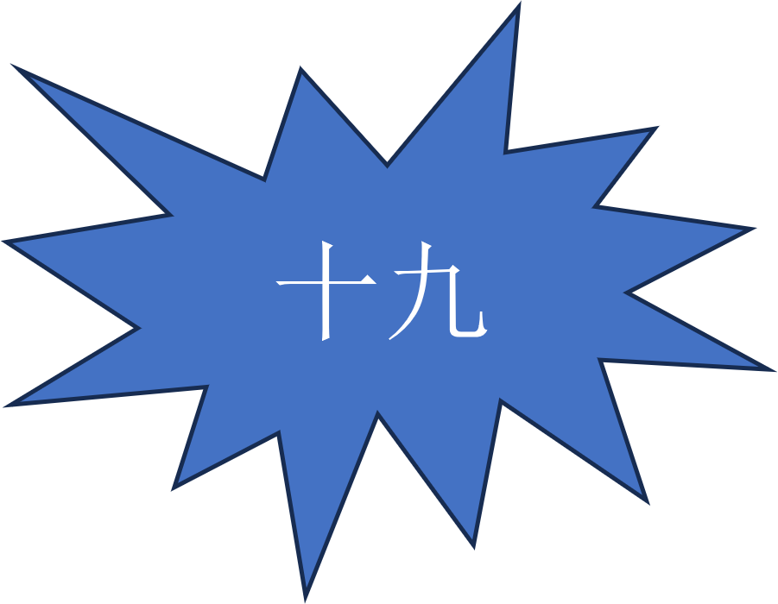 | 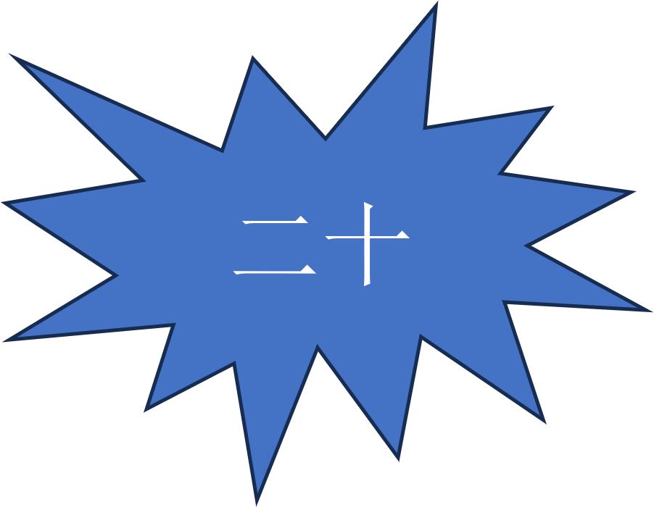
 | 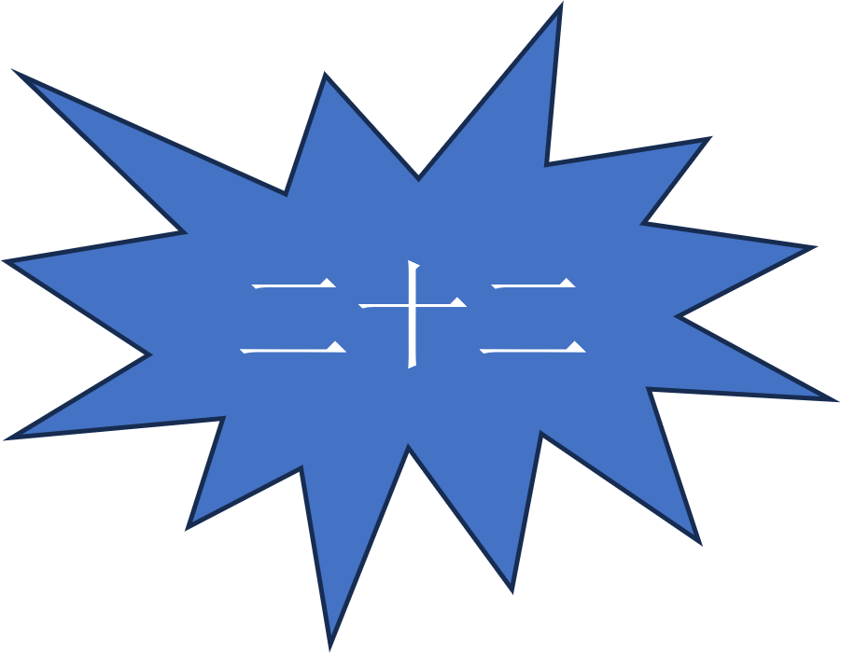 | 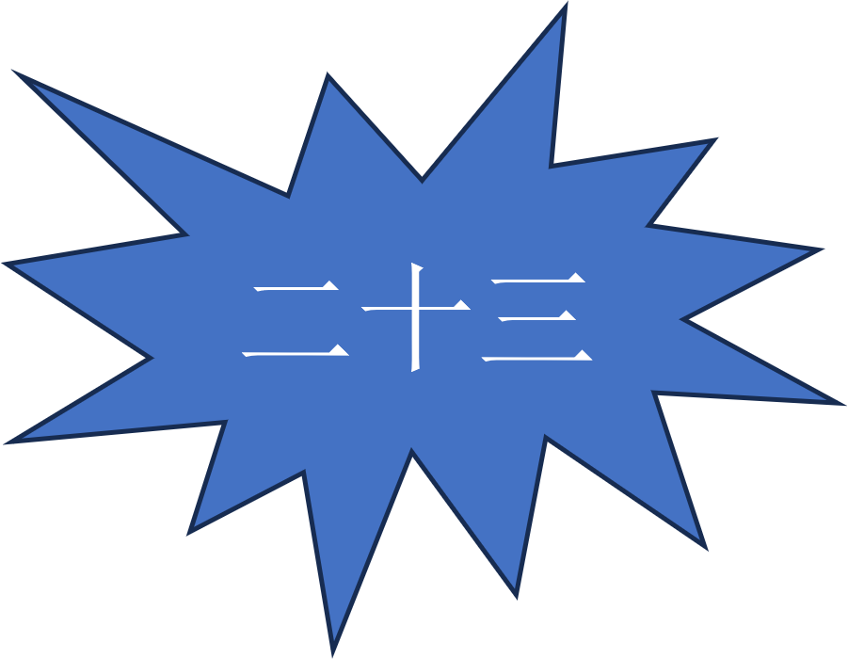 | 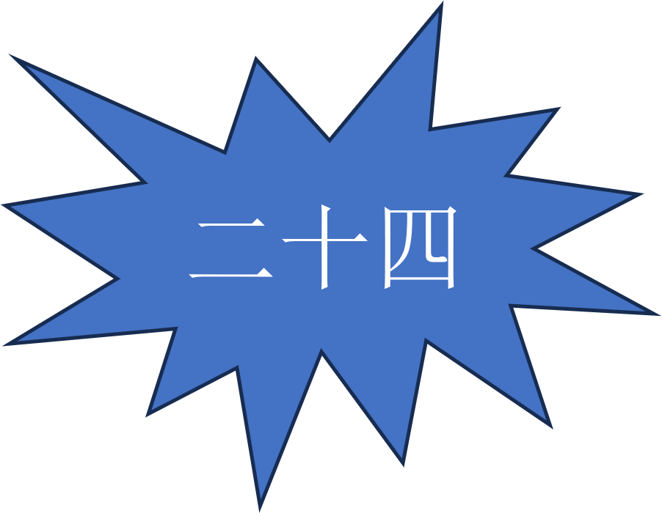
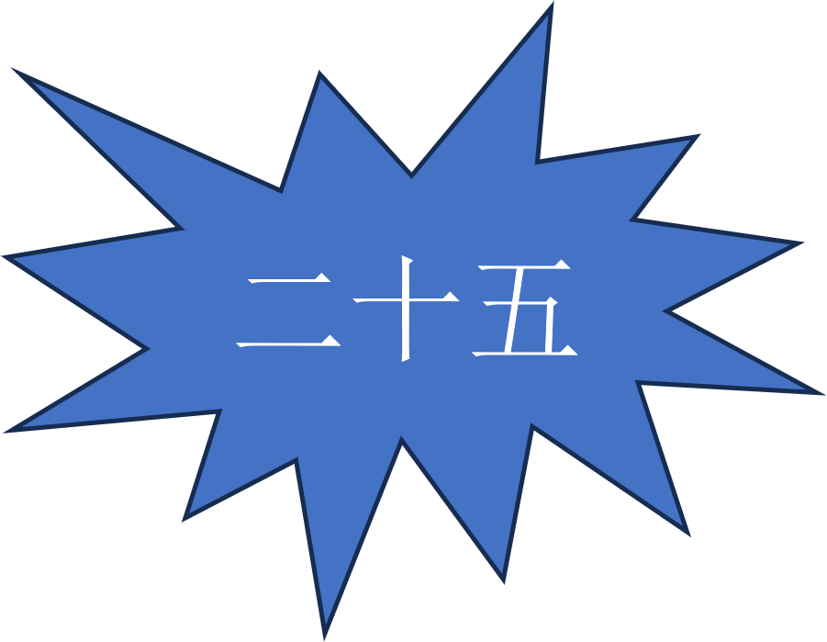 | 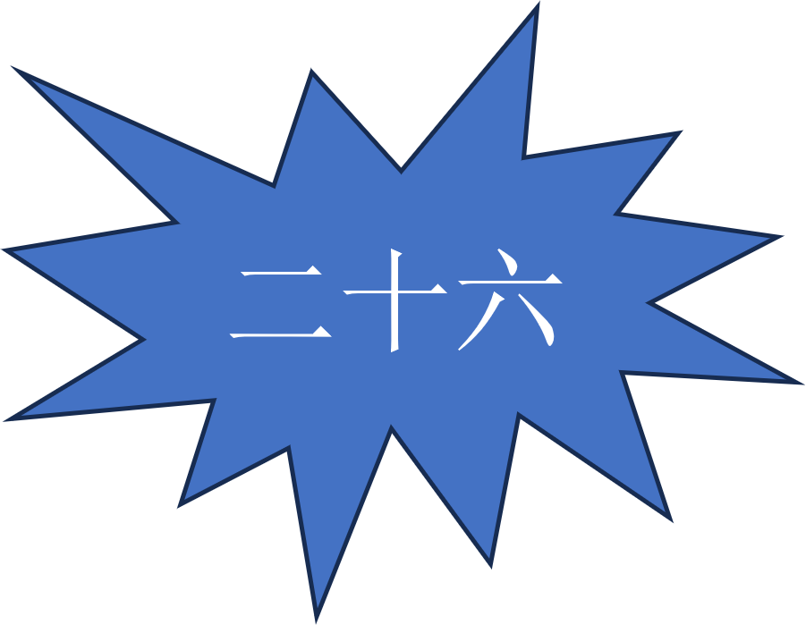
 |  | 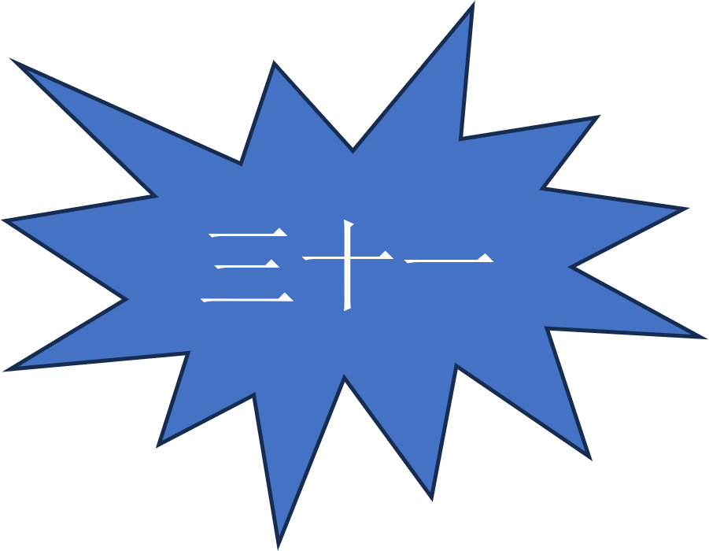 | 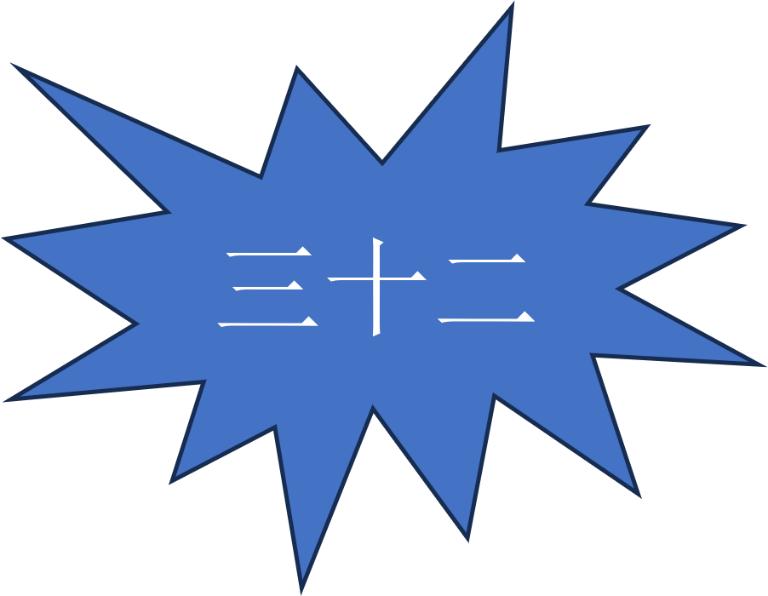
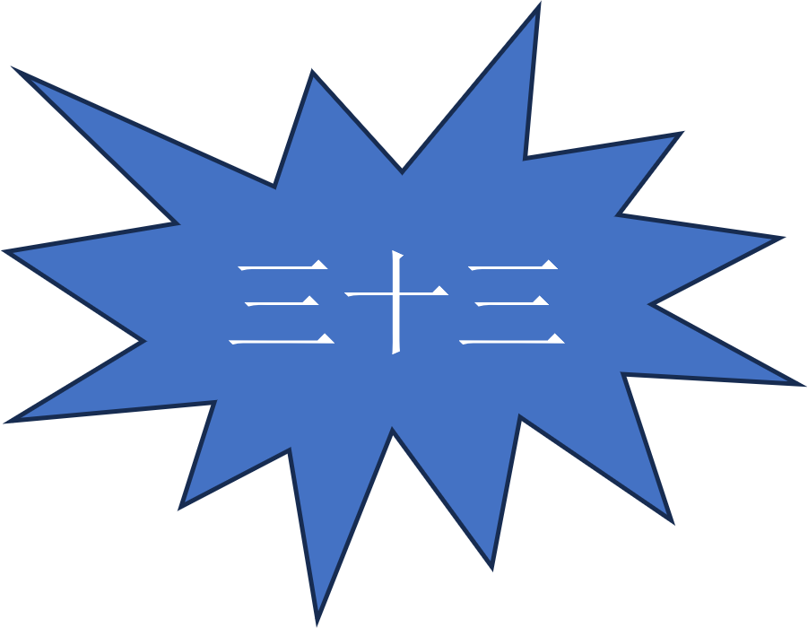 | 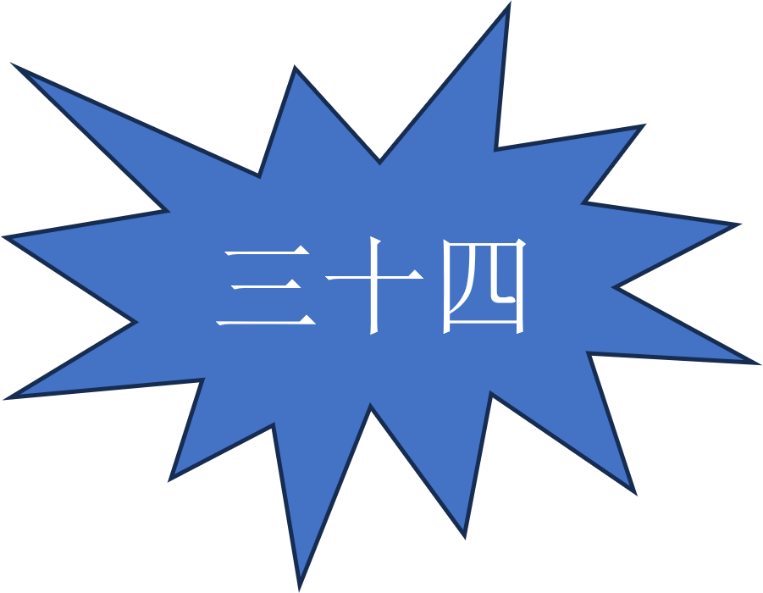 | 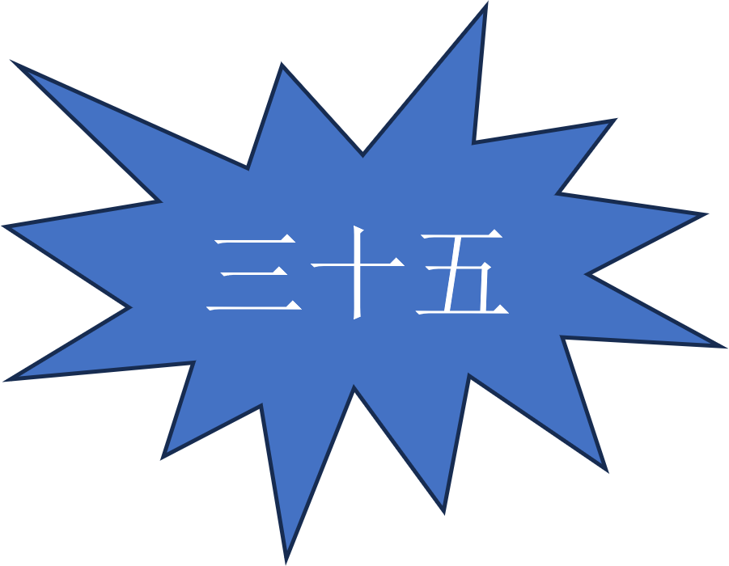 | 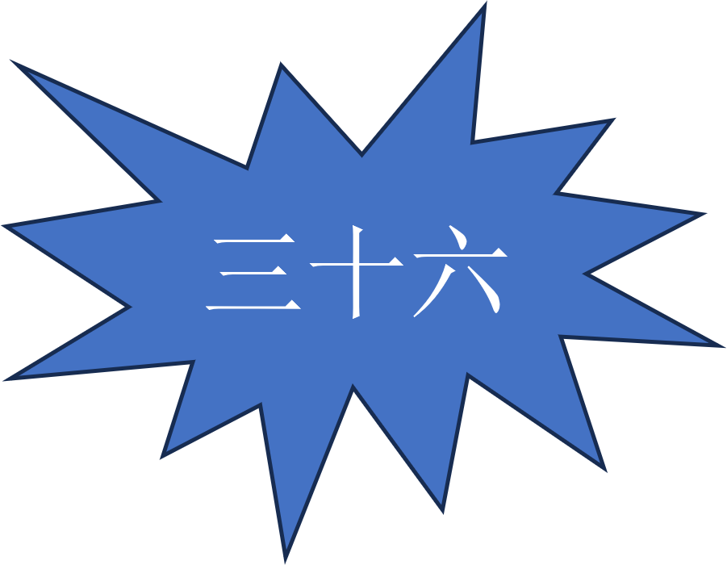

Tokens

© State of New South Wales (Department of Education), 2023
The copyright material published in this resource is subject to the Copyright Act 1968 (Cth) and is owned by the NSW Department of Education or, where indicated, by a party other than the NSW Department of Education (third-party material).
Copyright material available in this resource and owned by the NSW Department of Education is licensed under a Creative Commons Attribution 4.0 International (CC BY 4.0) license.
This license allows you to share and adapt the material for any purpose, even commercially.
Attribution should be given to © State of New South Wales (Department of Education), 2023.
Material in this resource not available under a Creative Commons license:
- the NSW Department of Education logo, other logos and trademark-protected material
- material owned by a third party that has been reproduced with permission. You will need to obtain permission from the third party to reuse its material.
Links to third-party material and websites
Please note that the provided (reading/viewing material/list/links/texts) are a suggestion only and implies no endorsement, by the New South Wales Department of Education, of any author, publisher, or book title. School principals and teachers are best placed to assess the suitability of resources that would complement the curriculum and reflect the needs and interests of their students.
If you use the links provided in this document to access a third-party's website, you acknowledge that the terms of use, including licence terms set out on the third-party's website apply to the use which may be made of the materials on that third-party website or where permitted by the Copyright Act 1968 (Cth). The department accepts no responsibility for content on third-party websites.

