Languages in Chinese

Hanzi practice
Practise writing the characters in the table below, paying attention to the correct stroke order and components. Try to think of ways to remember the characters as you write them. You may add to the list with languages relevant or of interest to you.
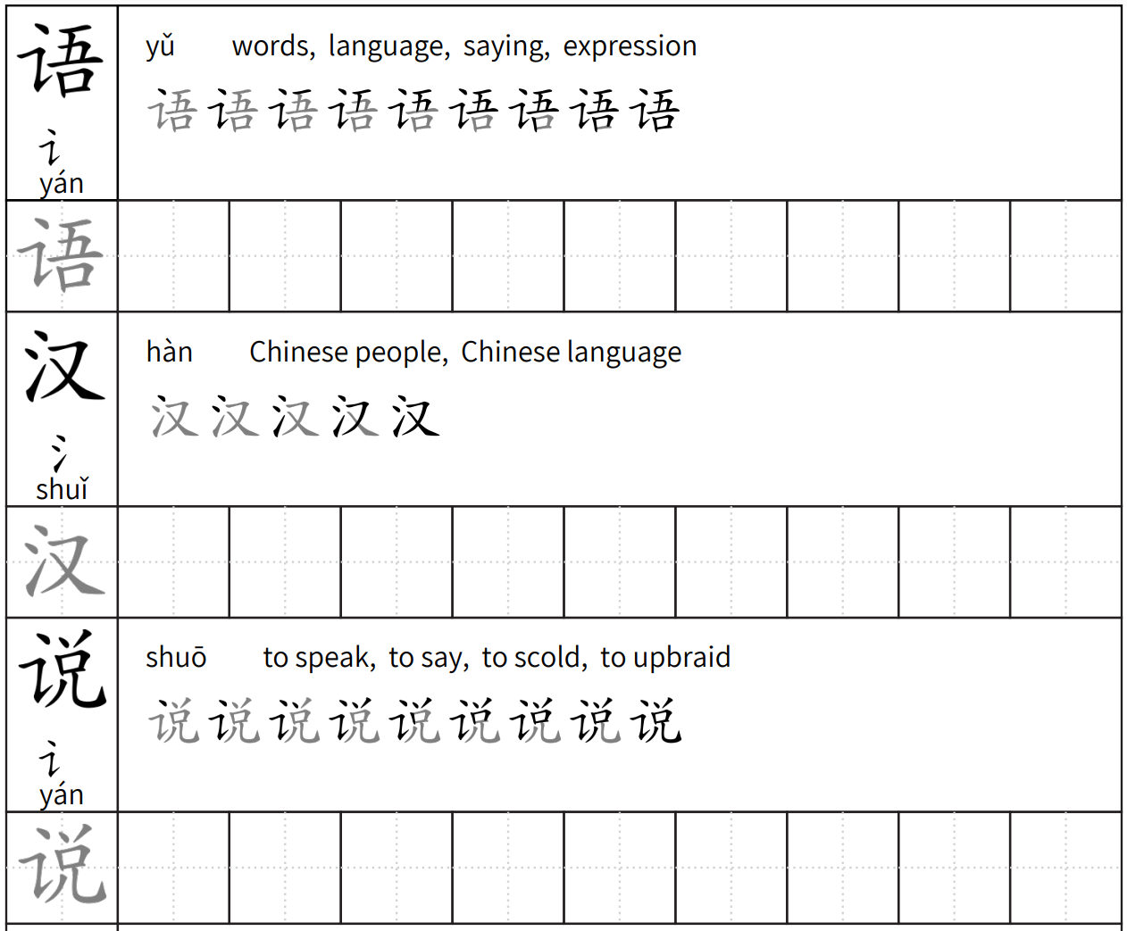
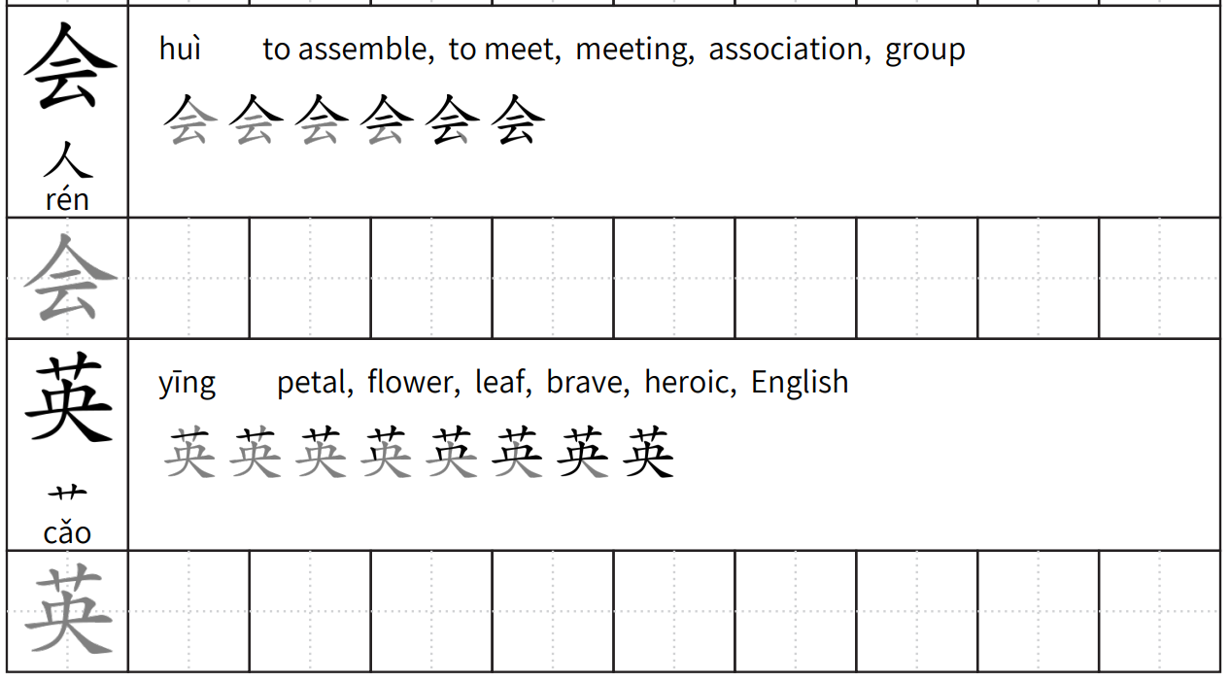

A deeper look
Read the Chinese words for different languages in the table below and see if you can work out what they are in English. Write the English word in the second column. Complete the sentences with the prompts from each row.
Language | English | Write a sentence or question in Chinese using this language as a prompt
汉语 |  | Can you …?
英语 |  | I cannot …
希腊语 |  | I can …
日语 |  | I cannot …
印度尼西亚语 |  | I can …
意大利语 |  | Can you …?

For the teacher

A deeper look
Language | English | Write a sentence or question in Chinese using this language as a prompt
汉语 | Chinese | Can you …?  你会说汉语吗？
英语 | English | I cannot …  我不会说英语。
希腊语 | Greek | I can …  我会说希腊语。
日语 | Japanese | I cannot …  我不会说日语。
印度尼西亚语 | Indonesian | I can …  我会说印度尼西亚语。
意大利语 | Italian | Can you …?  你会说意大利亚玛？

© State of New South Wales (Department of Education), 2023
The copyright material published in this resource is subject to the Copyright Act 1968 (Cth) and is owned by the NSW Department of Education or, where indicated, by a party other than the NSW Department of Education (third-party material).
Copyright material available in this resource and owned by the NSW Department of Education is licensed under a Creative Commons Attribution 4.0 International (CC BY 4.0) license.
This license allows you to share and adapt the material for any purpose, even commercially.
Attribution should be given to © State of New South Wales (Department of Education), 2023.
Material in this resource not available under a Creative Commons license:
- the NSW Department of Education logo, other logos and trademark-protected material
- material owned by a third party that has been reproduced with permission. You will need to obtain permission from the third party to reuse its material.
Links to third-party material and websites
Please note that the provided (reading/viewing material/list/links/texts) are a suggestion only and implies no endorsement, by the New South Wales Department of Education, of any author, publisher, or book title. School principals and teachers are best placed to assess the suitability of resources that would complement the curriculum and reflect the needs and interests of their students.
If you use the links provided in this document to access a third-party's website, you acknowledge that the terms of use, including licence terms set out on the third-party's website apply to the use which may be made of the materials on that third-party website or where permitted by the Copyright Act 1968 (Cth). The department accepts no responsibility for content on third-party websites.

