Chinese flashcards – How are you?

For the teacher
Use the flashcards in this resource to:
- drill questions and responses to ‘How are you?’
- identify and recall Hanzi and correct pronunciation for phrases asking and telling how people are feeling.

Activity 1
Print the cards below (to whatever size suits your purpose) and use them to drill vocabulary with students. Students should pay attention to character recognition, tones and pronunciation meaning.
你好吗
我很好
我也很好
谢谢
我不太好
你呢
不
也
很
太
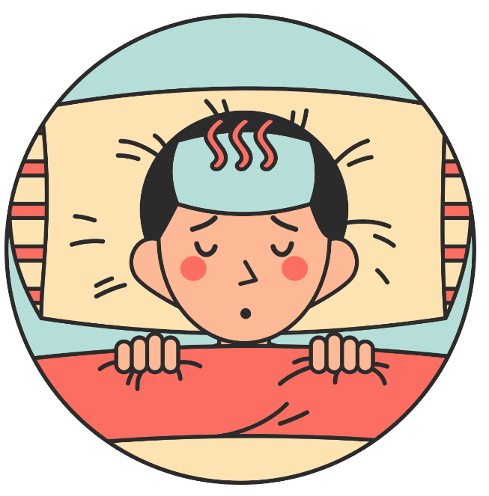

Activity 2
Print and give copies of the table below to students and ask them to cut it up. This activity can be done individually, in pairs or small groups.
Students can use these cards to:
- play a matching memory-style game
- in pairs, randomly select cards to elicit responses from their partner
- play a vocabulary ‘Grab’ game in groups, with the teacher or a student calling out prompts and students racing each other to grab a matching card.
你好吗？ | How are you?
我很好。 | I am very good.
我也很好。 | I am also very good.
谢谢 | Thank you.
我不太好。 | I am not too good.
你呢？ | And you?
不 | not, no
也 | also
很 | very
太 | too
 | 我也很好。
 | 我不太好。
 | 我也很好。
 | 你呢？
 | 谢谢

© State of New South Wales (Department of Education), 2023
The copyright material published in this resource is subject to the Copyright Act 1968 (Cth) and is owned by the NSW Department of Education or, where indicated, by a party other than the NSW Department of Education (third-party material).
Copyright material available in this resource and owned by the NSW Department of Education is licensed under a Creative Commons Attribution 4.0 International (CC BY 4.0) license.
This license allows you to share and adapt the material for any purpose, even commercially.
Attribution should be given to © State of New South Wales (Department of Education), 2023.
Material in this resource not available under a Creative Commons license:
- the NSW Department of Education logo, other logos and trademark-protected material
- material owned by a third party that has been reproduced with permission. You will need to obtain permission from the third party to reuse its material.
Links to third-party material and websites
Please note that the provided (reading/viewing material/list/links/texts) are a suggestion only and implies no endorsement, by the New South Wales Department of Education, of any author, publisher, or book title. School principals and teachers are best placed to assess the suitability of resources that would complement the curriculum and reflect the needs and interests of their students.
If you use the links provided in this document to access a third-party's website, you acknowledge that the terms of use, including licence terms set out on the third-party's website apply to the use which may be made of the materials on that third-party website or where permitted by the Copyright Act 1968 (Cth). The department accepts no responsibility for content on third-party websites.

