Italian Stage 3 – Mangiare in un ristorante (Eating at a restaurant)
Contents
Unit overview 3
Stage 3 outcomes and content to be addressed 4
Learning map 7
Assessment 10
Assessment opportunities 11
Teaching and learning activities 13
Week 1: Il Cibo (Food) 13
Week 2: Questions at a restaurant 17
Week 3: Menus 20
Week 4: Make a chatterbox 23
Week 5: Assessment criteria 26
Week 6: Communicative task – order food at a restaurant 29
Week 7: Feedback and goal setting 32
Week 8: Language review 34
Student resources 38
Resource 1: Il Cibo (Food) flashcards 38
Resource 2: Assessment task – Mangiare in un ristorante 39
Resource 3: Rubric – Mangiare in un ristorante 42
Resource 4: Peer feedback strategy – Two stars and a wish 45
Support and alignment 46
References 49

Unit overview
Stage: 3
Title: Mangiare in un ristorante (Eating at a restaurant)
Description: In this unit, students revise and learn language used in restaurants. Students practise this language and build fluency using a chatterbox. In groups, they act out scenarios in a restaurant; students are assessed when they complete the communicative task of ordering food and drinks from a menu.
Duration: This lesson sequence is designed to be completed over approximately 8 weeks.
Student proficiency levels: It is assumed that most Stage 3 students have been learning Italian since Kindergarten and their proficiency level will be Intermediate. This unit is aimed at intermediate students. Every classroom will be different and teachers will need to adapt to their context. Many classes may include a combination of Beginner, Intermediate and Advanced students. Assessment tasks and opportunities in this unit can be differentiated using the ‘Too hard?’ and ‘Too easy?’ suggestions.

Stage 3 outcomes and content to be addressed
The table below outlines the focus area, outcomes and content points for Stage 3 students.
Focus area and outcome | Content points
Interacting  A student:  - exchanges information and opinions in familiar contexts by using culturally appropriate rehearsed language ML3-INT-01 | Exchanging meaning in oral interactions in the target language  - Understand and share information about themselves and their personal world  - Ask and answer questions with familiar structures  - Ask for clarification or repeat information to facilitate understanding in familiar interactions  Applying knowledge of language systems to interact in the target language  - Use key features of the sound system including pronunciation, intonation patterns, stress and/or rhythms to interact  - Use familiar vocabulary to interact  - Use modelled grammatical structures to interact  Applying knowledge of the target language culture(s) to interact  - Use language and nonverbal communication that are appropriate to cultural practices
Understanding texts  A student:  - identifies and responds to information and opinions in texts to demonstrate understanding ML3-UND-01 | Understanding and responding to target language texts  - Listen to, read and view information and opinions in a range of texts on familiar themes  - Respond in the target language and/or English to main points and specific information in familiar texts to explain understanding and express opinions  Applying knowledge of language systems to understand and respond to target language texts  - Identify and use sound–symbol correspondences to understand and respond to texts  - Use knowledge of vocabulary and phrases from familiar themes to understand and respond to texts  - Use modelled sentence structures and grammar patterns to understand and respond to texts  - Use familiar metalanguage to compare some target language structures and features with English  - Recognise and use familiar structures and features of the target language writing system to understand and respond to texts  Developing intercultural understanding through target language texts  - Respond to texts and consider how language is connected with cultural practices and compare how this is evident in their own language(s), culture(s) and identity
Creating texts  A student:  - creates a range of texts for familiar communicative purposes by using culturally appropriate rehearsed language ML3-CRT-01 | Creating spoken, written and multimodal texts in the target language  - Create imaginative texts appropriate to context, purpose and audience using a series of sequenced sentences and visuals to express ideas on familiar themes  Applying knowledge of language systems to create texts in the target language  - Use sound–symbol correspondences to create written texts  - Use relevant vocabulary, formulaic expressions or modelled phrases from familiar themes to create texts  - Select structures and features of the target language writing system to create written texts  Applying knowledge of the target language culture(s) to create texts  - Use language appropriate to cultural practices to create texts
Modern Languages K–10 Syllabus © NSW Education Standards Authority (NESA) for and on behalf of the Crown in right of the State of New South Wales, 2022.

Learning map
The creation of maps for learning is a planning process that incorporates Aboriginal intellectual tradition. Learning maps are a visual pathway of what students will learn.
Share the learning map with your students, briefly explaining the learning that will happen in each lesson. Provide students with a copy of the learning map or display the learning map in the classroom. This learning map can be adapted to your language from the English version in Learning map – Mangiare in un ristorante (Eating at a restaurant) Stage 3.
Figure 1 – Mangiare in ristorante learning map
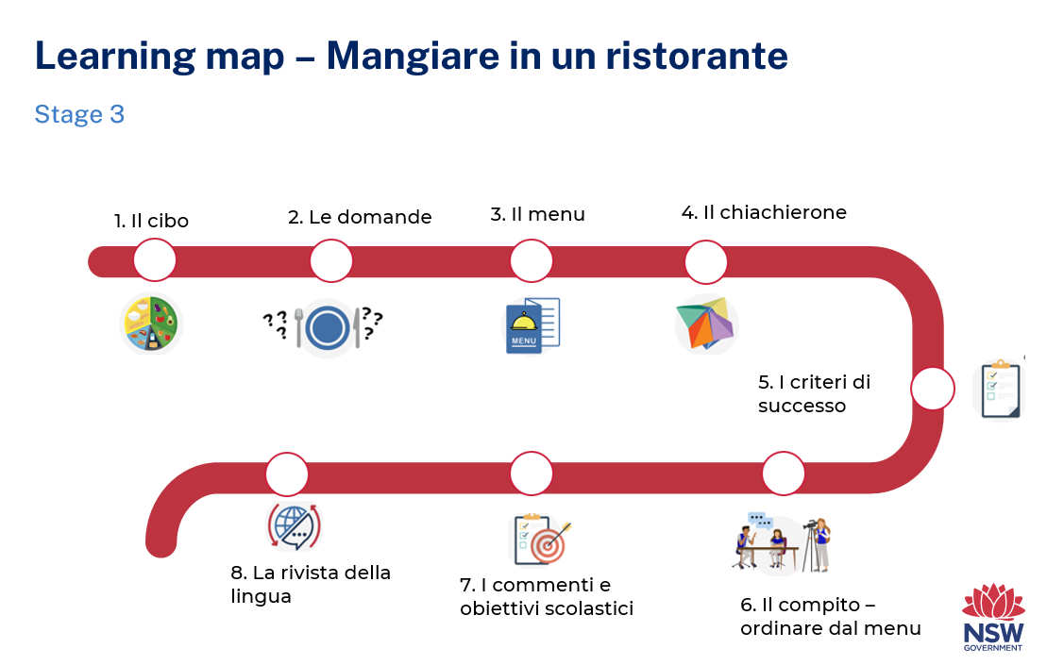
Figure 2 – Eating at a restaurant learning map
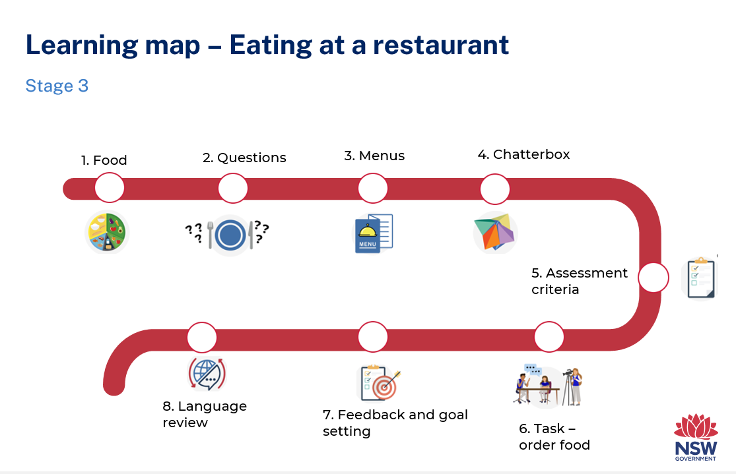

Assessment
Stage 3 communicative task: students will participate in a role-play at a restaurant and order food and drink for themselves and a friend from a menu.
Too hard?
Order food and drinks for yourself from the menu at a restaurant.
Too easy?
After ordering and eating a meal, describe your experience and feelings with the waiter. Use formal language and include what you enjoyed about the food or if you felt dissatisfied.
Context: at a restaurant
Audience: the waiter
Purpose: order food from the menu for yourself and a friend

Assessment opportunities
The table below details assessment opportunities and differentiation ideas.
Assessment opportunities | Too hard? | Too easy?
Week 2: Questions at a restaurant  Questions mingling activity: Split the class in 2. Students in one half of the class hold a card with the questions on it. The other half of the class has nothing. Students are given a time limit to ask the question on their card to as many classmates as possible. When the time is up, the 2 groups switch roles. | Students ask their classmates 1–2 questions within the time limit. | Students ask all the questions listed on their cards within the time limit.
Week 3: Creating a menu  Students will transfer their understanding and knowledge of the cultural cuisine and currency of the target country by developing a menu that includes food, drink and prices. | Students develop a menu to include one main course, a dessert and a drink. All items should have prices. | Students develop a menu including 2 entrees, 2 main courses, 2 desserts and 2 drinks. All items should have prices.
Week 4: Practice Italian on a chatterbox  Students will demonstrate their understanding of grammar, fluency and pronunciation of modelled and rehearsed language through practice conversations with multiple conversations with their class peers using the chatterbox. | Students use 4 panels instead of 8 on each layer of the chatterbox. | Students use the chatterbox as a conversation starter. The conversation continues after the chatterbox question has been answered.

Teaching and learning activities

Week 1: Il Cibo (Food)
The table below outlines the learning intention and success criteria of the lesson, and materials that the teacher and students will need to complete the teaching and learning activities.
Learning intention and success criteria | Materials
Students will communicate words and phrases related to food in Italian.  Students can:  - pronounce Italian food vocabulary correctly  - write Italian food vocabulary accurately. | - Learning Map  - Resource 1: Il Cibo (Food) flashcards  - Italian exercise books  - Whiteboard

Activity 1: Learning map
Explain and display the Learning map to give students a detailed breakdown of lessons during the unit. Point out that the Learning map is a plan that may need to change.

Activity 2: Vocabulary
Vocabulary will include: la pasta (pasta), il riso (rice), il pollo (chicken), le patate (potatoes), il gelato (ice-cream), la torta (cake), i frutti di mare (seafood), le verdure (vegetables), l’acqua (water), il succo d’arancia (orange juice).
Pre-assessment: show students the images in Resource 1: Il Cibo (Food) flashcards, but not the words. Ask students to identify how many words they think they know by showing a thumbs up at their chests in response to the following questions:
- Do you know all the words for these pictures in Italian?
- Do you know most of them?
- Do you know some of them?
- Do you know none of them?
In pairs, students Think-Pair-Share the words they know and report back to class. As a class, ask students to match words to pictures one at a time. After each match, model and drill how to correctly pronounce the vocabulary.
As students say different vocabulary words, co-construct a word cloud using words related to food in Italian.
Note: point out the possessive structure of frutti di mare and succo d’arancia. Explain that di or d’ can have numerous translations in English, including ’s to indicate possession. If time permits, include an activity to practise the use of di and d’ as a possessive.
Evaluation: monitor whether the class already has a sound knowledge of the suggested vocabulary and adjust if necessary.

Activity 2: Communicative game to review food vocabulary
- Play a communicative language learning game, for example, Hot seat.
- Divide the class in 2 teams. One player per team has their back to the board. Write a word related to food in Italian on the board.
- Students give clues in English to their teammate without saying the word, for example, ‘You eat it at a party’. The first student on the chairs to say ‘la torta’ earns a point for their team.
- After each round, model and drill how to correctly pronounce the vocabulary, displaying the words and supporting images on the board or wall.
Note: students with Advanced proficiency give clues in Italian.

Activity 3: Label the healthy eating food plate
Display a segmented blank circle to represent dividing the food plate into at least 3 sections.
In pairs, students suggest labels for the sections in English or Italian. Suggestions include frutte e verdure (fruit and vegetables), carne e pesce (meat and fish), cereali (cereals), cibo per mangiare qualche volte (sometimes food), beve acqua (drink water).
Individually, students draw the plate in their books or on poster paper. They then categorise each type of food and describe their healthy eating plate to a partner.
Note: print and display the new vocabulary to a word cloud. Add new and known words in Italian to the cloud as the unit progresses.

Week 2: Questions at a restaurant
The table below outlines the learning intention and success criteria of the lesson, and materials that the teacher and students will need to complete the teaching and learning activities.
Learning intention and success criteria | Materials
Students will ask appropriate questions and provide appropriate answers in Italian.  Students can:  - ask and answer questions commonly used in Italian restaurants. | - Cards with questions and answers  - Italian exercise books  - Whiteboard

Activity 1: Questions at a restaurant
- Introduce questions that could be asked at a restaurant.
Suggested questions include:
- Vorrei prenotare un tavolo, per favore? – Can I make a reservation please?
- Volete vedere la carta? – Would you like to see the menu?
- Cosa volete mangiare per i secondi? – What would you like for your main course?
- Cosa volete per dolci? – What would you like for dessert?
- Scusi, dov’é il bagno? – Excuse me, where is the toilet?
- Volete qualcosa da bere? – Would you like something to drink?
- Scusi, il conto, per favore? – Excuse me, could I have the bill please?
- Quanto costa (la torta)? – How much is (the cake)?
- Hai le esigenze alimentari? – Do you have any dietary requirements?
- Ripete, per favore? – Could you repeat that, please?
- Model and drill the questions, then display the questions on one side of the board.
- In pairs, students discuss the questions and use their knowledge of Italian to decide on the best translations into English for each. Pairs share their translations with the class. Highlight that there may be several acceptable translations for some of the questions.
- Display the translations on the board.

Activity 2: Suggested answers
Display answers to the questions in Activity 1 at random on the board. In pairs, students match the questions to the answers.
One question at a time, pairs share their answers with the class. Again, highlight that there may be several acceptable answers for some of the questions.
Suggested answers include:
- Vorrei prenotare un tavolo, per favore? Sì, certo. Per quante persone? – Yes, of course. For how many people?
- Volete vedere la carta? Sì, grazie – Yes, thanks.
- Cosa volete per mangiare? Vorrei gli gnocchi con pesto per favore. – I would like gnocchi with pesto please.
- Cosa volete per dolci? Gelato alla fragola per favore. – Strawberry ice cream please.
- Scusi, dov’é il bagno? Laggiù. – Over there.
- Volete qualcosa da bere? L’acqua, per favore. – Water, please.
- Scusi, il conto, per favore? Sì, certo. – Yes, of course.
- Quanto costa (la torta)? Cinque euro. – 5 euros.
- Hai le esigenze alimentari? Non, mangio tutto. – No, I can eat everything.
- Ripete, per favore? – Can you please repeat?

Activity 3: Questions and answers – mingling activity
Split the class in 2. Students in one half of the class hold a card with the questions on it. The other half of the class has nothing.
Give students a time limit to ask as many classmates as possible the question on their card. When the time is up, the 2 groups swap roles.

Activity 4: Recording questions and answers
Students record questions and answers in their language notebooks.

Week 3: Menus
The table below outlines the learning intention and success criteria of the lesson, and materials that the teacher and students will need to complete the teaching and learning activities.
Learning intention and success criteria | Materials
Students will create menus in Italian.  Students can:  - ask and answer questions about menus written in Italian  - write a menu in Italian. | - Italian exercise books  - Menus from Italian restaurants  - Whiteboard

Activity 1: Cultural cuisine
Note: the names of many Italian meals are used in English, for example lasagne, gnocchi and antipasto while ingredients, such as la carne (meat), la cipolla (onion) and le uove (eggs) are often very different to the English word.
In small groups, students brainstorm Italian dishes. After students feed back to the class, ask:
- Which dishes have the same name in English and Italian?
- Which dishes have been given an English name?
- How do you say the names of Italian dishes in your family’s language?
- Are these words for Italian dishes ‘borrowed’ words in English? Discuss the concept of borrowed words.
- How are the English borrowed words used differently to Italian words?

Activity 2: Reading menus
- In groups, give students a different menu in Italian. The menus can be authentic, or teacher made on canva.com.
- Students read the menus and answer questions that demonstrate their understanding of the menu as a text. Students can choose to answer in Italian or English. For example:
- What is the cheapest drink on the menu?
- What are the 2 most expensive main meals?
- If you had $20, what would you buy?
- In English, students record at least 2 observations about the restaurant. They then share their responses and observations with their group.
Note: examples of observations about the restaurant may include, ‘It is quite expensive’ or ‘I would like to eat the lasagne’.

Activity 3: Creating a menu
Students make a menu for an Italian restaurant.
The menus should include i primi (first course), i secondi (main courses), i dolci (desserts), le bevande (drinks) and i prezzi (prices) with 2–4 dishes per section. Students may include images in their menus.

Week 4: Make a chatterbox
The table below outlines the learning intentions and success criteria of the lesson, and materials that the teacher and students will need to complete the teaching and learning activities.
Learning intentions and success criteria | Materials
Students will:  - create a chatterbox with Italian words written correctly  - students will speak Italian fluently when using chatterbox.  Students can:  - correctly write appropriate Italian words and questions on the chatterbox  - speak Italian in a well-paced manner without long pauses. | - 12-sided die  - Coloured pencils  - Completed chatterbox  - Italian exercise books  - Square paper  - Whiteboard

Activity 1: Addition game to review numbers
- Students sit in a circle. Two selected players roll a 12-sided die.
- The first student to add the numbers correctly and call out the correct answer in Italian is the winner.
- The winner competes against the next student. If any student wins 4 in a row, they retire undefeated.
- As a class, count on the decade from 10 to 100 to review these numbers.

Activity 2: Make a chatterbox
View the video Making a chatterbox (5:24). Using a blank square of paper, students follow instructions on folding the paper to make the chatterbox.

Activity 3: Write on and decorate chatterbox
Note: students complete 8 panels for each layer of the chatterbox. Beginner students can complete 4 panels on each layer.
- Show an example of a completed chatterbox.
- On the outer layer of the chatterbox, students draw and write 8 types of food of their choice.
- In the middle layer, students write 8 prices of their choice.
- In the inner layer, students write 8 questions that could be asked at a restaurant from Week 2.
Note: Beginner students will likely write prices from 1–20 euro. Intermediate students will be able to write prices on the decade from 20–100 euro. Advanced students can be encouraged to write prices off the decade from 21–99 euro. Explain that the euro is the currency in Italy and in many European countries.

Activity 4: Practise Italian on a chatterbox
To build fluency, students are encouraged to play with their chatterboxes with as many classmates as possible.
As the students use their chatterboxes, observe and make notes of common areas of success, as well as common areas of mispronunciation, vocabulary and grammar misuse.
Note: give students who haven’t finished completing their chatterbox more time to do so.

Activity 5: Class feedback
After students have had numerous practice conversations with the chatterbox, provide feedback to the whole class.
Praise the class for their improved confidence, fluency and ability to speak Italian.
Point out specific areas of improvement for the class as a whole. Focus on one common area related to mispronunciation, vocabulary misuse and grammatical mistakes. Highlight that these 3 systems, pronunciation, vocabulary and grammar, are the building blocks of language.

Activity 6: Play with chatterbox to build fluency
Children play with their chatterboxes a few more times, making appropriate changes based on your feedback.

Week 5: Assessment criteria
The table below outlines the learning intention and success criteria of the lesson, and materials that the teacher and students will need to complete the teaching and learning activities.
Learning intention and success criteria | Materials
Students will develop a clear understanding of the requirements of the assessment task.  Students can:  - suggest appropriate success criteria  - explain what they need to do to be successful in the task. | - Resource 2: Assessment task – Mangiare in un ristorante  - Resource 3: Rubric – Mangiare in un ristorante  - Resource 4: Peer feedback strategy – Two stars and a wish  - Completed chatterbox  - Italian exercise books  - Whiteboard

Activity 1: Play with chatterbox to build fluency
Ensure that students have several opportunities to play with their chatterbox.

Activity 2: Assessment task
Share Resource 2: Assessment task – Mangiare in un ristorante and lead the class in reading it.

Activity 3: Success criteria
After looking at the assessment task, students Think-Pair-Share and suggest appropriate success criteria, such as:
I will be successful if I can:
- ask my friend what they would like to eat
- use formal Italian to order food for myself and my friend from the waiter
- ask the waiter to repeat something
- ask the waiter for the bill
- use correct sentences with correct grammar:
- use verbs in the correct person and tense
- use nouns with the correct gender
- adjectives agree with the nouns they describe
- use words like, e (and), ma (but), and perché (because), to link ideas
- pronounce the words correctly
- speak in a well-paced manner without long pauses
- end the conversation in an appropriate way, for example, ‘Grazie’ (Thank you).

Activity 4: Discuss the rubric
- Show students an unmarked rubric Resource 3: Rubric – Mangiare in un ristorante. This may need to be adapted if the class has decided on different success criteria.
- Explain the metalanguage, such as fluency, accuracy, pronunciation and vocabulary.
- Point out and provide examples of ‘excellent’ and ‘sort of’ task completion, fluency, accuracy, pronunciation and vocabulary.
- Students read and then discuss the ‘excellent’ column of the rubric in pairs. They then share their understanding of what is needed to be successful.

Activity 5: Peer assessment
Peer feedback will be incorporated into the task. Confirm which peer feedback strategy will be used, for example, Resource 4: Peer feedback strategy – Two stars and a wish, and discuss with students.
Evaluation: students give examples of what stars and wishes would sound like for this task.

Activity 6: Practice task
Students get into groups of 3 and take turns at playing ‘You’, the friend and the waiter.

Week 6: Communicative task – order food at a restaurant
The table below outlines the learning intentions and success criteria of the lesson, and materials that the teacher and students will need to complete the teaching and learning activities.
Learning intention and success criteria | Materials
Students will participate in a role-play at a restaurant and order food from a menu.  Students can:  - ask their friend what they would like to eat  - use formal Italian to order food for themselves and their friend from the waiter  - ask the waiter to repeat something  - ask the waiter for the bill  - use correct sentences with correct grammar  - pronounce the words correctly  - speak in a well-paced manner without long pauses  - end the conversation in an appropriate way, for example, ‘Grazie’ (Thank you). | - Resource 2: Assessment task – Mangiare in un ristorante  - Resource 3: Rubric – Mangiare in un ristorante  - Resource 4: Peer feedback strategy – Two stars and a wish  - Chatterbox  - Tablets or other recording devices  - Tripod and/or microphone (if possible)

Activity 1: Play with chatterbox to build fluency
Ensure students have at least one more opportunity to play with their chatterbox before they are recorded for assessment.

Activity 2: Set up
Students get in groups of 4. Give students a few minutes to ensure everybody knows the order in which they will be performing each role. The diner is the student who is completing the assessed communicative task.
Suggested rotations:
- Role-play 1: Student 1 – Waiter, Student 2 – Friend/Peer assessor, Student 3 – Camera operator, Student 4 – Diner
- Role-play 2: Student 1 – Diner, Student 2 – Waiter, Student 3 – Friend/Peer assessor, Student 4 – Camera operator
- Role-play 3: Student 1 – Camera operator, Student 2 – Diner, Student 3 – Waiter, Student 4 – Friend/Peer assessor
- Role-play 4: Student 1 – Friend/Peer assessor, Student 2 – Camera operator, Student 3 – Diner, Student 4 – Waiter

Activity 3: Communicative task and peer feedback
Note: before recording interactions, check if any students do not have permission to be filmed. Alternatives to video recording include audio recording or watching students’ interactions while taking notes and marking against the rubric.
- Make sure there is space for students to perform their task. If possible, provide microphones to maximise sound quality. Highlight the importance of holding the device still, using a tripod or resting it on a table. Demonstrate how to film using selected device.
- Students get into groups of 4.
- One student records the interaction between the diner and the waiter. The friend will provide peer assessment to the diner after the interaction using the ‘Two stars and a wish’ strategy.
- Students provide peer feedback verbally and follow up by completing the peer feedback slip.
Note: if the friend is a student with Advanced proficiency, that student will complete the task of telling the waiter what they enjoyed about the food or if they felt dissatisfied following the initial interaction. In this case, the camera operator should provide peer feedback.

Week 7: Feedback and goal setting
Note: if there is insufficient time to mark the videos before Week 8, Weeks 7 and 8 can be swapped.
The table below outlines the learning intention and success criteria of the lesson, and materials that the teacher and students will need to complete the teaching and learning activities.
Learning intention and success criteria | Materials
Students will reflect on recordings of themselves to assess how well they completed the task and to set learning goals.  Students can:  - accurately self-assess how they completed the task  - set appropriate learning goals based on previous learning goals as well as teacher, peer- and self-assessment. | - Blank Resource 3: Rubric – Mangiare in un ristorante for self-assessment (one per student)  - Teacher completed copy of Resource 3: Rubric – Mangiare in un ristorante (one per student)  - Italian exercise books  - Tablets or other recording devices

Teacher preparation
Note: prior to this lesson, view each video and mark each student according to the criteria on Resource 3: Rubric – Mangiare in un ristorante.

Activity 1: Self-assessment
Students watch the video of themselves completing the task and mark themselves using the rubric. Students then compare both the teacher completed rubric and the one they completed.

Activity 2: Set learning goals
Students reflect on the teacher, peer- and self-evaluation to set learning goals for the next phase of learning. For example, ‘I will not be worried about making a mistake when speaking Italian’ or ‘I will try to say (a particular sound) correctly’. Students write their learning goals in their language notebooks.
Evaluation: students set appropriate learning goals based on previous learning goals and teacher, peer- and self-assessment.

Week 8: Language review
Note: if there is insufficient time to mark the videos before Week 8, Weeks 7 and 8 can be swapped.
The table below outlines the learning intention and success criteria of the lesson, and materials that the teacher and students will need to complete the teaching and learning activities.
Learning intention and success criteria | Materials
Students will reflect on and ask questions about the language taught in this unit.  Students can:  - ask questions about vocabulary, grammar or pronunciation they have used in this unit  - use the Italian they have learned to communicate with classmates. | - Italian exercise books

Activity 1: Student questions
Remind students of the activities and tasks they have completed over the course of the unit. Give students time to Think-Pair-Share any questions they may have about any aspect of the language taught.

Activity 2: Teacher identified
Gaps in student knowledge, misconceptions and misuse of language will have been identified by the teacher, and possibly by students, over the unit.
These observations are addressed using engaging (and interactive) activities and strategies.
Note: set up different language stations for Activities 3–5 that focus on reinforcing word work, grammar, listening and responding. These activities can be adapted to suit students’ needs. After a set time, students rotate in groups different station to complete activities with a different focus.

Activity 3: Word work
This station will focus on reviewing learnt vocabulary.
Suggested activities:
- Word bingo: students write 10 words from the vocabulary taught throughout the unit. Students take turns at being the caller and call out the word from the list. The first student to tick off all words is the winner.
- Swat it: students write 10 words from the vocabulary list. Take turns to call out words. The first student to swat the word that is called out keeps the word.

Activity 4: Grammar
This station will focus on grammar taught during the unit.
Suggested activities:
- Sentence builders: In pairs, students use images from Resource 1: Il Cibo (Food) flashcards and menus they have created to prompt sentences they can write and say to each other.
- Sentence re-ordering: The words in a sentence are randomly and incorrectly arranged. Students rearrange the words to make a sentence with the correct sentence structure.

Activity 5: Listening and responding
This station will focus on strengthening and reviewing listening and responding to texts skills.
Suggested activities:
- Gap fill activity: Read aloud or play a recorded interaction between a waiter and diner. Alternatively, have another student read a text aloud. Students fill the gaps with the words they hear.
- Comprehension questions: Students listen to the interaction between a waiter and diner. In pairs, students write comprehension questions for a partner to answer. Questions and answers can be written in English or in Italian.
- Lie detector: In pairs, students make up true or false statements in Italian using one of the menus made in Week 3. Student A says a statement and Student B determines whether it is true or false. Change the game halfway so that student A makes up false statements about the menu for student B to correct.

Student resources

Resource 1: Il Cibo (Food) flashcards
 |  |  |  |  |  | 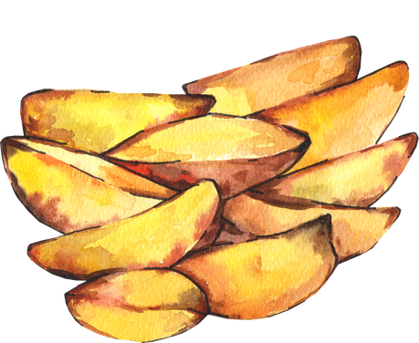
i frutti di mare |  | le verdure |  | il pollo |  | le patate |  | l’acqua
il succo d’arancia |  | la pasta |  | il riso |  | il gelato |  | la torta
Images sourced from Canva and used in accordance with the Canva Content License Agreement.

Resource 2: Assessment task – Mangiare in un ristorante

Outcomes
You will be assessed on how well you:
- exchange information and opinions in familiar contexts by using culturally appropriate rehearsed language.

Task
Order food and drinks for yourself and a friend from the menu at a restaurant.
The table below outlines the communicative task students will need to complete.
Too hard? | Too easy?
Order food and drinks for yourself from the menu at a restaurant. | After ordering and eating a meal, describe your experience and feelings with the waiter. Use formal language and include what you enjoyed about the food or if you felt dissatisfied.

Learning intention
Students will be able to read a menu and order food and drinks for themselves and a friend.

Success criteria
You will order food and drinks for yourself and a friend from a restaurant.
You will be successful if you can:
- ask your friend what they would like to eat
- use formal Italian to order food for yourself and your friend from the waiter
- ask the waiter to repeat something
- ask the waiter for the bill
- use correct sentences with correct grammar:
- use verbs in the correct person and tense
- use nouns with the correct gender
- adjectives agree with the nouns they describe
- use words like, e (and), ma (but), and perché (because), to link ideas
- pronounce the words correctly
- speak in a well-paced manner without long pauses
- end the conversation in an appropriate way, for example, ‘Grazie’ (Thank you).

Task instructions
- This task will be completed in groups of 4. Each student will take turns at all 4 roles:
- the person ordering food and drinks
- the friend
- the waiter
- camera operator
- The person ordering the food is completing the communicative task, so you will only be assessed for task completion while performing this role. You will be assessed on all other criteria in the rubric while performing all roles except for camera operator.
- If you are in mixed ability groups, the student with prior learning should be the friend and describe feelings and experience when the meal has finished.
- When you are the camera operator, you will record the interaction between the other members of your group.
- Either the friend or camera operator will also provide feedback to the person ordering food and drinks. This feedback will take the form of ‘Two stars and a wish’.
- Reflect on your performance and identify areas for improvement. Use this information to set a learning goal for the next stage of learning.

Resource 3: Rubric – Mangiare in un ristorante
Name:
Table 1 – Rubric for ‘Mangiare in un ristorante’
Criteria | Excellent | Got it | Sort of | Getting there | Not yet
Communication | Your audience, the waiter, clearly understands what you want to communicate.  Successfully and thoroughly complete all the following aspects of the task:  - ask a friend what they would like to eat  - use formal language to order food for yourself and your friend from the waiter  - ask the waiter for the bill  - end the conversation in an appropriate way, for example, ‘Grazie’. | Your audience, the waiter, can understand what you want to communicate.  Successfully complete most of the following aspects of the task:  - ask a friend what they would like to eat  - use formal language to order food for yourself and your friend from the waiter  - ask the waiter for the bill  - end the conversation in an appropriate way, for example, ‘Grazie’. | Your audience, the waiter, can mostly understand what you want to communicate.  Complete most of the following aspects of the task:  - ask a friend what they would like to eat  - use formal language to order food for yourself and your friend from the waiter  - ask the waiter for the bill  - end the conversation in an appropriate way, for example, ‘Grazie’. | Your audience, the waiter, struggles to understand what you want to communicate. However, communication is successful.  Rely on non-linguistic resources such as images, gesture and facial expression to communicate. | Your audience, the waiter, is unable to understand what you want to communicate.  Unable to complete any aspect of the task.
Grammar | Always say Italian words in the correct order. | Usually say Italian words in the correct order. | Make some grammar mistakes when speaking. | Rarely make sense when speaking. | Unable to be understood.
Pronunciation | Pronounce the words correctly. | Pronounce most words correctly. | Consistently make pronunciation errors. | Pronounce only a few words correctly. | Unable to be understood.
Fluency | Speak Italian with ease, in a well-paced manner without long pauses. | Speak confidently with appropriate speed and expression. | Usually speak confidently with appropriate speed and expression. | Don’t speak confidently. | Unable to be understood.
Vocabulary | Use full range of vocabulary correctly and use relevant words to expand on the topic. | Use expected vocabulary correctly to complete the task. | Make some mistakes when trying to use expected vocabulary. | Make many mistakes when trying to use expected vocabulary. | Unable to use vocabulary in appropriate context.

Resource 4: Peer feedback strategy – Two stars and a wish
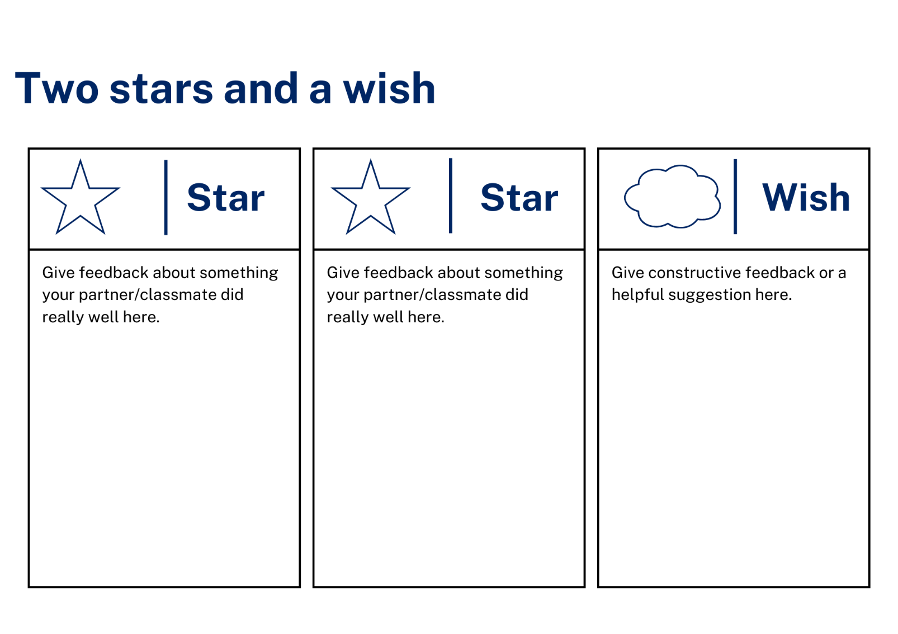

Support and alignment
Resource evaluation and support: all curriculum resources are prepared through a rigorous process. Resources are periodically reviewed as part of our ongoing evaluation plan to ensure currency, relevance, and effectiveness. For additional support or advice, contact the Primary Languages team by emailing primlang@det.nsw.edu.au.
Alignment to system priorities and/or needs: School Excellence Policy, School Success Model
Alignment to the School Excellence Framework: this resource supports the School Excellence Framework elements of curriculum (curriculum provision, teaching and learning programs) and effective classroom practice (lesson planning).
Alignment to Australian Professional Teaching Standards: this resource supports teachers to address Australian Professional Teaching Standards 2.2.2, 3.2.2.
Consulted with: Curriculum, Secondary Learners, school-based staff and NESA subject matter experts. Advice from Aboriginal Outcomes and Partnerships, EAL/D, HPGE and Inclusive Education for Modern Languages Stage 3 Italian Mangiare in Ristorante has been considered in preparing this document.
NSW syllabus: Modern Languages K–10 Syllabus
Syllabus outcomes: ML3-INT-01, ML3-UND-01, ML3-CRT-01
Author: Primary Curriculum
Publisher: State of NSW, Department of Education
Resource: Unit
Related resources: further resources to support Stage 3 Modern Languages can be found on the Languages K-6 curriculum page.
Professional learning: relevant professional learning is available through Primary Languages Networks on Teams (staff only).
Universal Design for Learning: support the diverse learning needs of students using inclusive teaching and learning strategies. Some students may require more specific adjustments to allow them to participate on the same basis as their peers. For further advice see Inclusive practice resources for primary school.
Differentiation: when using these resources in the classroom, it is important for teachers to consider the needs of all students in their class, including:
- Aboriginal and Torres Strait Islander students. Targeted strategies can be used to achieve outcomes for Aboriginal students in K-12 and increase knowledge and understanding of Aboriginal histories and cultures. Teachers should use students’ Personalised Learning Pathways to support individual student needs and goals.
- EAL/D learners. EAL/D learners may require scaffolding to support them to gain content knowledge, while providing extra time and assistance to master the English language required to engage with texts or complete classroom tasks. View some samples of differentiating through scaffolding.
- Students with additional learning needs. Learning adjustments enable students with disability and additional learning and support needs to access syllabus outcomes and content on the same basis as their peers. Teachers can use a range of adjustments to ensure a personalised approach to student learning.
- High potential and gifted learners. Assessing and identifying high potential and gifted learners will help teachers decide which students may benefit from extension and additional challenge. In addition, the Differentiation Adjustment Tool can be used to support the specific learning needs of high potential and gifted students.
Creation date: 28 March 2023
Rights: © State of New South Wales, Department of Education

References
This resource contains NSW Curriculum and syllabus content. The NSW Curriculum is developed by the NSW Education Standards Authority. This content is prepared by NESA for and on behalf of the Crown in right of the State of New South Wales. The material is protected by Crown copyright.
Please refer to the NESA Copyright Disclaimer for more information. https://educationstandards.nsw.edu.au/wps/portal/nesa/mini-footer/copyright
NESA holds the only official and up-to-date versions of the NSW Curriculum and syllabus documents. Please visit the NSW Education Standards Authority (NESA) website https://educationstandards.nsw.edu.au/ and the NSW Curriculum website https://curriculum.nsw.edu.au/home.
Modern Languages K–10 Syllabus © NSW Education Standards Authority (NESA) for and on behalf of the Crown in right of the State of New South Wales, 2022.
8 Ways (n.d.) 8 Aboriginal Ways of Learning [website], accessed 13 December 2022.
AITSL (Australian Institute for Teaching and School Leadership (2017) ‘Feedback Factsheet’, AITSL, accessed 21 March 2023.
Brookhart SM (2011) How to Assess Higher-Order Thinking Skills in Your Classroom, Hawker Brownlow Education, Victoria.
CESE (Centre for Education Statistics and Evaluation) (2020a) What works best: 2020 update, NSW Department of Education, accessed 10 March 2023.
CESE (Centre for Education Statistics and Evaluation) (2020b) What works best in practice, NSW Department of Education, accessed 10 March 2023.
Conti G (28 September 2015) ‘16 tips for effective grammar teaching in the foreign language classroom’, The Language Gym, accessed 21 March 2023.
Conti G (28 May 2017) From Target Language to Model Language – the mind shift that has transformed my teaching, The Language Gym, accessed 20 March 2023.
Harmer J (2014) The Practice of English Language Teaching, 5th edn, Pearson Education, United Kingdom.
Henshaw FG and Hawkins MD (2022) Common Ground: Second Language Acquisition Theory Goes to the Classroom, Focus, Indianapolis, accessed 14 March 2023.
Jones J and Wiliam D (2014) Modern Foreign Languages Inside the Black Box: Assessment for Learning in the Modern Foreign Languages Classroom (Black P, Harrison C, Marshall B and Wiliam D, eds), Learning Sciences International, United States.
NESA (NSW Education Standards Authority) (2022) ‘Proficient Teacher: Standard descriptors’, The Standards, NESA website, accessed 21 December 2022.
Smith S (2022) Becoming an Outstanding Languages Teacher, 2nd edn, Routledge, United Kingdom.
Wiliam D and Leahy S (2015) Embedding Formative Assessment: Practical Techniques for K–12 Classrooms, Learning Sciences International, United States.

© State of New South Wales (Department of Education), 2023
The copyright material published in this resource is subject to the Copyright Act 1968 (Cth) and is owned by the NSW Department of Education or, where indicated, by a party other than the NSW Department of Education (third-party material).
Copyright material available in this resource and owned by the NSW Department of Education is licensed under a Creative Commons Attribution 4.0 International (CC BY 4.0) license.
This license allows you to share and adapt the material for any purpose, even commercially. Attribution should be given to © State of New South Wales (Department of Education), 2023.
Material in this resource not available under a Creative Commons license:
- the NSW Department of Education logo, other logos and trademark-protected material
- material owned by a third party that has been reproduced with permission. You will need to obtain permission from the third party to reuse its material.
Links to third-party material and websites
Please note that the provided (reading/viewing material/list/links/texts) are a suggestion only and implies no endorsement, by the New South Wales Department of Education, of any author, publisher, or book title. School principals and teachers are best placed to assess the suitability of resources that would complement the curriculum and reflect the needs and interests of their students.
If you use the links provided in this document to access a third-party's website, you acknowledge that the terms of use, including licence terms set out on the third-party's website apply to the use which may be made of the materials on that third-party website or where permitted by the Copyright Act 1968 (Cth). The department accepts no responsibility for content on third-party websites.

