[Language] Stage 2 – My neighbourhood
Contents
Unit overview 3
Stage 2 outcomes and content to be addressed 4
Learning map 8
Assessment 10
Assessment opportunities 11
Teaching and learning activities 14
Week 1: Exploring maps 14
Week 2: In my neighbourhood 17
Week 3: How do I get there? 20
Week 4: Treasure hunt 24
Week 5: Assessment criteria and practice task 27
Week 6: Communicative task – Ask a friend for directions 31
Week 7: Self-assessment and goal setting 33
Week 8: Language review 35
Student resources 38
Resource 1: Map of a suburb 38
Resource 2: Location flash cards 39
Resource 3: Describing position 40
Resource 4: Assessment task – My neighbourhood 41
Resource 5: Rubric – My neighbourhood 44
Resource 6: Peer feedback strategy – Two stars and a wish 47
Support and alignment 48
References 51

Unit overview
Stage: 2
Title: My neighbourhood
Description: In this unit, students will create a map of their local neighbourhood along with written directions in [Language] on how to get to an allocated meeting place. They will give instructions on how to get from school to a chosen meeting place using verbs, nouns and adverbs. They will present the map and script to the class as a final assessment.
Duration: This lesson sequence is designed to be completed over approximately 8 weeks.
Student proficiency levels: It is assumed that most Stage 2 students have been learning the language since Kindergarten and their proficiency level will be Intermediate. This unit is aimed at intermediate students. Every classroom will be different and teachers will need to adapt to their context. Many classes may include a combination of Beginner, Intermediate and Advanced students. Assessment tasks and opportunities in this unit can be differentiated by using the ‘Too hard?’ and ‘Too easy?’ suggestions.

Stage 2 outcomes and content to be addressed
The table below outlines the focus area, outcomes and content points for Stage 2 students.
Focus area and outcome | Content points
Interacting  A student:  - exchanges information in familiar contexts by selecting culturally appropriate modelled language ML2-INT-01 | Exchanging meaning in oral interactions in the target language  - Share information about themselves to describe their personal world  - Ask and answer modelled questions in a guided conversation  - Express emotions and preferences  - Interact in conversation with teacher and peers in familiar social contexts  Applying knowledge of language systems to interact in the target language  - Recognise and use modelled sounds, including pronunciation and intonation patterns and/or rhythms to interact  - Select familiar vocabulary and formulaic phrases to interact  - Use modelled sentence structures to interact  Applying knowledge of the target language culture(s) to interact  - Use modelled language structures and nonverbal communication that are appropriate to cultural practices
Understanding texts  A student:  - identifies and responds to information in texts to demonstrate understanding ML2-UND-01 | Understanding and responding to target language texts  - Listen to, read and view information in texts on familiar themes  - Use strategies to locate, organise, classify and sort information in texts for a range of purposes  - Respond to questions about specific information in texts on familiar themes, using modelled target language sentence structures and/or English  - Respond to texts through actions, visuals, written or spoken responses in the target language and/or English to demonstrate understanding and convey meaning  Applying knowledge of language systems to understand and respond to target language texts  - Identify and use the sounds of familiar vocabulary and phrases in the target language to understand and respond to texts  - Recognise and use sound–symbol correspondences to understand and respond to texts  - Identify and use knowledge of vocabulary and formulaic phrases from familiar themes to understand and respond to texts  - Identify and use elements of grammar in familiar language patterns  - Recognise modelled target language features and compare them with English features  - Recognise and use modelled structures and features of the target language writing system to understand and respond to texts  Developing intercultural understanding through target language texts  - Respond to texts and identify connections between language and cultural practices and reflect on their own language(s) and culture(s)
Creating texts  A student:  - creates texts for familiar communicative purposes by selecting culturally appropriate modelled language ML2-CRT-01 | Creating spoken, written and multimodal texts in the target language  - Create informative texts appropriate to context, purpose and audience describing themselves and their personal world  Applying knowledge of language systems to create texts in the target language  - Use pronunciation and intonation patterns to create spoken texts  - Use sound–symbol correspondence to create written texts  - Use vocabulary, formulaic expressions or modelled phrases from familiar themes to create texts  - Use elements of simple grammar patterns in modelled sentence structures to create texts  - Use modelled structures and features of the target language writing system to create written texts  Applying knowledge of the target language culture(s) to create texts  - Select language appropriate to cultural practices to create texts
Modern Languages K–10 Syllabus © NSW Education Standards Authority (NESA) for and on behalf of the Crown in right of the State of New South Wales, 2022.

Learning map
The creation of maps for learning is a planning process that incorporates Aboriginal intellectual tradition. Learning maps are a visual pathway of what students will learn.
Share the learning map with your students, briefly explaining the learning that will happen in each lesson. Provide students with a copy of the learning map and/or display the learning map in the classroom. This learning map can be adapted to [Language] by accessing a copy of Learning map – My neighbourhood (Stage 2).
Figure 1 – Learning map for My neighbourhood unit
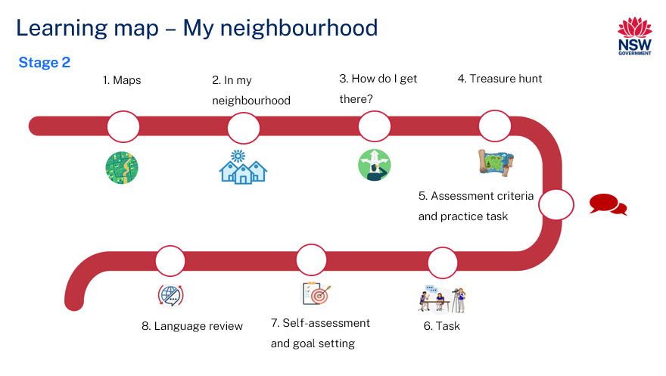

Assessment
Stage 2 communicative task: You have arranged to meet a friend at a place near your school. Your friend does not know how to get to this meeting place, so you need to give them a map with instructions on how to get there.
Too hard?
Tell your friend where to meet after school. Students create a simple map of the local neighbourhood with a few places of interest and streets.
Too easy?
Tell your friend how to get to the meeting place using public transport and on foot. Students can create a more detailed map of the local neighbourhood including additional places of interest.
Context: you have arranged to meet your friend at a certain spot, but they don’t know how to get there
Audience: your friend from school
Purpose: to give your friend instructions on how to get to the meeting place

Assessment opportunities
The table below details assessment opportunities and differentiation ideas.
Assessment opportunities | Too hard? | Too easy?
Week 1: Map of a suburb  Resource 1: Map of a suburb  Provide each student with a map of the local neighbourhood. Students must label places of interest using the word cloud.  Collect all the finished maps to check if they have been labelled correctly. | Students access images for support with understanding the words. | Students include additional places of interest to the map.
Week 3: True or False  Show Resource 2: Location flash cards to students and explain that they will be given sentences describing the positions of different things on this resource.  Sentences will be in [Language] and students will decide if they are true or false. | Provide these sentences in English to begin with until students familiarise themselves with the vocabulary. | Students can use Resource 2: Location flash cards to write their own true or false sentences and test on a peer.
Week 4: Where is the treasure?  Where is the treasure?  Pose the following scenario to students:  You have hidden treasure somewhere in the classroom and you must give instructions to your partner on how to find it.  Give each student a treasure to hide somewhere in the classroom.  Students create instructions for their partner in (Language) to help them find the treasure.  For example:  - turn left at your desk  - walk past the whiteboard  - look beside the bookshelf. | Students create basic instructions in [Language]. For example:  - turn left  - keep going  - look down. | Students must give detailed instructions for the treasure hunt. For example:  - start at the door and turn right  - walk past the computer on the right and turn left  - walk between the teacher’s desk and the wall  - walk under the artwork until you get to the bookshelf  - look under the book in the top right-hand corner.

Teaching and learning activities

Week 1: Exploring maps
The table below outlines the learning intention and success criteria of the lesson, and materials that the teacher and students will need to complete the teaching and learning activities.
Learning intention and success criteria | Materials
Students will recognise and name the important features of a map.  Students can:  - identify features on a map  - label a map of a suburb with important features. | - Resource 1: Map of a suburb  - Resource 2: Location flash cards  - Interactive whiteboard  - Language exercise books  - Writing materials

Activity 1: Learning map
Explain and display the Learning map to give students a more detailed breakdown of lessons during the unit. Point out that the learning map is a plan that may need to change.
Vocabulary to be included: street, houses, park, river, school, library, hospital, medical centre, supermarket, beach.

Activity 2: Vocabulary
Elicit vocabulary words related to places you would find in a neighbourhood by asking students to complete English sentences in [Language]. For example:
- Teacher: In summer, I swim at the…
- Students: Beach.
As a class, co-construct a word cloud using the suggested vocabulary and any additional words from Activity 2. Tell students that the word cloud will be added to throughout the unit.
Evaluation: monitor whether the class already has sound knowledge of the suggested vocabulary.

Activity 3: Features of a map
- Show students an example of a map, such as Resource 1: Map of a suburb.
- Ask students the following questions:
- What is this?
- Where have you seen this before?
- What might it be used for?
- What features can you point out? (Streets, houses, parks, rivers, schools, library, hospital)
- How would a map of your local area look?
- What would you add?
- What would you remove?
- Ask students if they can identify any of the neighbourhood words in [Language].
- Add any additional words to the word cloud.
- Explain that maps can help people find places or get to a place they do not know.
- Explain that students can use a map to give directions on how to get somewhere.

Activity 4: Map of a suburb
Students work in groups. Provide Resource 2: Location flash cards to each group with the names in [Language] of all the places for Resource 1: Map of a suburb. Call out the name of a place of interest in [Language] and English. The first group to hold up the correct flash card gets a point.

Week 2: In my neighbourhood
The table below outlines the learning intention and success criteria of the lesson, and materials that the teacher and students will need to complete the teaching and learning activities.
Learning intention and success criteria | Materials
Students will recognise and know what a map is and be able to add important features to a map.  Students can:  - label a map of their local area in [Language]  - create simple sentences about the features of their local area in [Language]. | - Bilingual dictionaries (class set)  - Interactive whiteboard  - Language exercise books  - Map of the local area (class copy and one per student)  - Writing materials

Activity 1: Our local area
- In pairs students create a mind map or list in [Language] of all the places they can think of in their local neighbourhood.
- Display a map of the local area, making sure the school is included.
Note: local maps can be found on online mapping sites by searching for the school’s suburb.
- Revise all the features that a map contains and the corresponding vocabulary.
- Ask students to name other places of interest that their neighbourhood may have. For example, supermarket, service station, café, post office, doctor’s surgery, beach, park, bank, hospital, church, mosque and so on.
- Ask students if they can identify any of these new words in [Language]. In pairs, students Think-Pair-Share the words they know and report back to the class.
- Add all the new words to the word cloud.

Activity 2: Labelling the map
Display the local map on the smartboard. Display the names of all the features in [Language] so that all students can see them, for example, on pieces of cardboard arranged on the floor, or written on the board. Students must again use visual cues to work out the correct word for each feature. Students take it in turns to place the correct name on each feature of the map. Students can agree or disagree with their peers’ decision with a thumbs up or thumbs down.

Activity 3: Name the feature on the map – Quiz
Provide each student with a map of the local neighbourhood. This is the same local map they have been studying, without any of the local places labelled. Students must label as many places in [Language] as they can, using the word cloud. Collect all the finished maps to check if they have been labelled correctly.

Activity 4: Sentence builders
- Teach students the sentence starter ‘In my neighbourhood there is a…’
- Ask students to write the sentence starter in their books in [Language] and add any features in their own neighbourhood. Suggestions include:
Table 1 – Sentence starter template
In my neighbourhood | there | - is  - are | - a  - some  - two  - many | - school(s)  - supermarket(s)  - park(s)  - beach(es)  - café(s)

Week 3: How do I get there?
The table below outlines the learning intention and success criteria of the lesson, and materials that the teacher and students will need to complete the teaching and learning activities.
Learning intention and success criteria | Materials
Students will familiarise themselves with the language for giving directions and the position of different places on a map.  Students can:  - understand and give directions on how to get from one place to another  - explain the position of a place on a map. | - Resource 1: Map of a suburb  - Resource 3: Describing position  - Interactive whiteboard  - Language exercise books  - Map of the local area  - Writing materials

Activity 1: Vocabulary – Places
Revise all the vocabulary associated with the neighbourhood map. Say all the places in the neighbourhood aloud and have students repeat them using correct pronunciation. Check the meaning of each word with students.
Play an online game to revise the vocabulary learnt so far.

Activity 2: Vocabulary – Adverbs of place
Vocabulary to be included: on the left/right, straight ahead, across, next to, past, near, far, on the corner, between, behind, in front of.
Elicit the vocabulary students already know by using hand gestures and referring to Resource 1: Map of a suburb or your local area map and asking students to complete the English sentences in [Language].
Example sentences include:
- Turn [left] at Forest Rd.
- Walk [across] Wilson St.
- Turn [right] at Cameron St.
- The school is [next to] the preschool.

Activity 3: Giving directions
- Display Resource 1: Map of a suburb or your local area map. Ask students where the park is and how they how they would get there from the school. Student suggestions may include:
- Go down Bryant Rd.
- Turn left at Forest Rd.
- Walk straight ahead until you get to Cameron St.
- Turn right at Cameron St.
- Walk over the river and to the right is the park.
Note: questions and directions can be in [Language] or in English, or a combination of the 2.
- Explain that, when someone does not know how to get to a place, they can ask for directions. Ask students what kind of vocabulary they need to give directions.
- Expected answers include next to, on the left or right, past, straight ahead, near, far, on the corner, between, behind, in front of, over and so on.
- Explain to students that these words are adverbs. Add the adverbs to the word cloud in a different colour to the place names.

Activity 4: True or false
Display Resource 3: Describing position and explain that students will be given sentences describing how things are positioned.
Give students sentences in [Language] and have students determine if the statements are true or false. Example sentences include:
- The bakery is to the right of the candy store.
- The boy is standing behind the swing.
- The water is running under the bridge.
- The sun is in front of the cloud.
- The red barn is close.
- The barber shop is between the flower and candy shop.
- The girl is standing behind the slide.
- The big scissors are beneath the barber shop.

Week 4: Treasure hunt
The table below outlines the learning intention and success criteria of the lesson, and materials that the teacher and students will need to complete the teaching and learning activities.
Learning intention and success criteria | Materials
Students will use language needed to give directions.  Students can:  - create and follow directions on how to find something in the classroom  - create and follow directions on how to find a place on a map. | - Resource 1: Map of a suburb  - Interactive whiteboard  - Language exercise books  - Writing materials

Activity 1: Vocabulary
Suggested activities:
- Word bingo: Students pick 8 words from a word cloud and write them down. Read out the words from the cloud at random as if playing bingo. The winner is the first student to have all their words read out.
- Matching task: Give students a list of vocabulary words you would like them to revise. Write the words on the left in English and the words on the right in [Language]. Make sure they are mixed. Students link the words with lines.

Activity 2: Additional language required to complete task
- Model the phrases ‘Where is the..?’ and ‘How do I get to…?’ by repeating them a number of times.
- Drill the phrases as a whole and in chunks, by asking students to repeat as a class and in smaller groups.
- Display the phrases in the classroom and have students record them in their exercise books.

Activity 3: How to give directions
- Display Resource 1: Map of a suburb, and ask students how you would get to the park from school. You can adapt this activity using your local area map.
- Student suggestions may include:
- Go down Bryant Rd.
- Turn left at Forest Rd.
- Walk straight ahead until you get to Cameron St.
- Turn right at Cameron St.
- Walk over the river and the park is on the right.
- Explain to students that, when someone does not know how to get to a place, they can ask for directions.
- Refer again to Resource 1: Map of a suburb and model giving directions from the school to the hospital in [Language]. You can adapt this activity using your local area map. For example:
- From the school, walk down Bay St.
- Turn right at Wilson Rd and keep walking.
- Turn right at Crawford Rd.
- Walk past the newsagency on your right.
- Walk past Pacific Rd on your left.
- The hospital is on the left in front of you.

Activity 4: Where is the treasure?
- Explain that students will hide a treasure somewhere in the classroom and must give instructions to a partner on how to find the treasure.
- Give each student a treasure to hide somewhere in the classroom.
Note: the treasure can be as simple as giving each student a piece of paper with the word ‘treasure’ written on it.
- In pairs, students create instructions for each other in [Language] to help their partner find the treasure in the classroom.

Week 5: Assessment criteria and practice task
The table below outlines the learning intention and success criteria of the lesson, and materials that the teacher and students will need to complete the teaching and learning activities.
Learning intention and success criteria | Materials
Students will develop a clear understanding of the requirements of the assessment task.  Students can:  - suggest appropriate success criteria  - explain what they need to do to be successful in the task. | - Resource 4: Assessment task – My neighbourhood  - Resource 5: Rubric – My neighbourhood  - Resource 6: Peer feedback strategy – Two stars and a wish  - Graph paper (enough for the whole class)  - Writing materials

Activity 1: Making maps
- Display the local map and explain to students that, when giving directions, it is useful to have a detailed map.
- Give students graph paper to draw their own map. The map must include and label the main features of students’ neighbourhood, their school and any nearby places of interest.
- Remind students that, when creating maps, it is important to include streets and their names and to try to keep the map to scale. It does not need to be perfect.

Activity 2: Giving directions
- Using the map they have created, students choose a place to meet their friend after school.
- Students then write step-by-step directions on how to get to their chosen place from school.
- In pairs, students read their directions to their partners to see whether they can get from school to their allocated meeting place. Students then swap roles and repeat the exercise.

Activity 3: Assessment task
Show students the assessment task. Lead the class in reading Resource 4: Assessment task – My neighbourhood.

Activity 4: Success criteria
After looking at the assessment task, students Think-Pair-Share and suggest appropriate success criteria, such as:
I will be successful if I can:
- draw a labelled map of my neighbourhood
- identify and describe places of interest in my neighbourhood
- use modelled sentences and phrases to give directions
- interact in a conversation using adverbs of place.

Activity 5: Discuss the rubric
- Show students an unmarked rubric, see Resource 5: Rubric – My neighbourhood. This may need to be adapted if the class has decided on different success criteria.
- Explain meta-language, such as fluency, accuracy, pronunciation and vocabulary.
- Students read and then discuss the ‘excellent’ column of the rubric in pairs. Students then share their understanding of what is needed to be successful.
- Point out and provide examples of ‘excellent’ and ‘sound’ task completion, fluency, accuracy, pronunciation and vocabulary.

Activity 6: Peer assessment
Peer feedback will be incorporated into the task, see Resource 6: Peer feedback strategy – Two stars and a wish. Confirm which peer feedback strategy will be used, for example, ‘Two stars and a wish’, and discuss with students.

Activity 7: Task groups
Explain that students will use the same groups for the practice task and the assessed task. Students get into groups of 3 and are given a few minutes to ensure everybody knows the order in which they will be performing each role. ‘You’ is the student who is completing the assessed communicative task.

Suggested rotations:
- Role-play 1: Student 1 – ‘You’, Student 2 – Peer assessor/Camera operator, Student 3 – Friend
- Role-play 2: Student 1 – Friend, Student 2 – ‘You’, Student 3 – Peer assessor/Camera operator
- Role-play 3: Student 1 – Peer assessor/Camera operator, Student 2 – Friend, Student 3 – ‘You’

Activity 8: Practice task
Students get into pairs and take turns to give and receive directions.
Example interaction:
- You: Let’s meet at the park after school.
- Friend: Ok, how do I get there?
- You: You walk down Beach St, then turn left at the supermarket. The park is on the right.
- You: Great, see you there!

Week 6: Communicative task – Ask a friend for directions
The table below outlines the learning intention and success criteria of the lesson, and materials that the teacher and students will need to complete the teaching and learning activities.
Learning intention and success criteria | Materials
Students will ask their friend for directions to a place to meet after school.  Students can:  - draw a labelled map of their neighbourhood  - identify and describe places of interest in their neighbourhood  - use modelled sentences and phrases to give directions  - interact in a conversation using adverbs of place. | - Resource 4: Assessment task – My neighbourhood  - Resource 5: Rubric – My neighbourhood  - Completed map and written directions  - Tablet or other recording device  - Peer feedback slips  - Tripod (if possible)

Activity 1: Task set-up
Students get into the groups decided in the previous lesson. Give groups a few minutes to ensure everybody knows the order in which they will be performing each role. ‘You’ is the student who will be completing the assessed communicative task.
Suggested rotations:
- Role-play 1: Student 1 – ‘You’, Student 2 – Peer assessor/Camera operator, Student 3 – Friend
- Role-play 2: Student 1 – Friend, Student 2 – ‘You’, Student 3 – Peer assessor/Camera operator
- Role-play 3: Student 1 – Peer assessor/Camera operator, Student 2 – Friend, Student 3 – ‘You’

Activity 2: Task completion
- Ensure students have completed their neighbourhood maps along with instructions for their friend on how to get to the designated meeting place.
- Give students time to rehearse their conversation with a peer.
- Students each present their maps and instructions to the class.

Activity 3: Completing the communicative task
Note: before recording interactions, check if any students do not have permission to be filmed. Alternatives to video recording include audio recording or the teacher watching the interactions while taking notes and marking the rubric.
As students will record each other’s presentation, highlight the importance of holding the device still, using a tripod or resting it on a table. Demonstrate how to film using the selected device.
Peer feedback is provided verbally and followed up with the completed peer feedback slip.

Week 7: Self-assessment and goal setting
Note: if there is insufficient time to mark the videos before Week 8, Weeks 7 and 8 can be swapped.
The table below outlines the learning intention and success criteria of the lesson, and materials that the teacher and students will need to complete the teaching and learning activities.
Learning intention and success criteria | Materials
Students will reflect on feedback to set suitable learning goals.  Students can:  - understand the feedback received  - reflect on the feedback provided to establish new learning goals. | - Blank rubric (Resource 5) (one per student)  - Teacher completed copy of rubric (Resource 5) (one per student)  - Language exercise books  - Tablets or other recording devices
Note: prior to this lesson, view each video and mark each student according to the criteria on rubric for communicative language tasks.

Activity 1: Self-assessment
Students watch the video of themselves completing the task and mark themselves using the rubric. Students then compare both the teacher completed rubric and the one they completed.

Activity 2: Set learning goals
Students reflect on the teacher, peer- and self-evaluation to set learning goals for the next phase of learning. For example, ‘I will not be worried about making a mistake when speaking language and I will try to say (a particular sound) correctly’. Students write their learning goals in their language notebooks.

Week 8: Language review
Note: if there is insufficient time to mark the videos before Week 8, Weeks 7 and 8 can be swapped.
The table below outlines the learning intention and success criteria of the lesson, and materials that the teacher and students will need to complete the teaching and learning activities.
Learning intention and success criteria | Materials
Students will review the language learnt during this unit.  Students can:  - ask questions about vocabulary, grammar, or pronunciation they have used in this unit  - use the [Language] they have learned to communicate with classmates. | - Completed map and written directions  - Language exercise books  - Map  - Sentence builders  - Vocabulary words  - Writing materials
Note: over the course of the unit, gaps in student knowledge, misconceptions and misuse of language will have been identified. These observations are addressed using engaging and interactive activities and strategies.

Activity 1: Student questions
Remind students of the activities and tasks they have completed over the course of the unit. Give students time to Think-Pair-Share any questions they may have about any aspect of the language taught.

Activity 2: Language review
Set up different language stations that reinforce word work, grammar, listening and responding. These activities can be adapted to suit the needs of students. After a set amount of time, students rotate to a different station and complete the activities with a different focus.

Word work
This station will focus on strengthening and reviewing vocabulary learnt during the unit.
Suggested activities:
- Word bingo: Students write 10 words from the vocabulary taught throughout the unit. Students take turns calling out the words from the list. The first student to tick off all words is the winner.
- Swat it: Write 10 words from the vocabulary list and have students take turns calling out words. The first student to swat the called word gets to keep the word.

Grammar
This station will focus on strengthening and reviewing grammar taught during the unit.
Suggested activities:
- Sentence builders: In pairs, students give each other sentences in English to translate into [Language].
- Picture task: Students look at a map and give directions from A to B in [Language] using sentence builders.
- Sentence re-ordering: The words in a sentence are randomly and incorrectly arranged. Students rearrange the words to make a sentence with the correct structure.

Listening and responding
This station will focus on strengthening listening skills.
Suggested activities:
- How do I get to...?: Students listen to the directions on a map recorded by the teacher. In pairs, students write their own directions from A to B for a partner to follow.
- Lie detector: In pairs, students make true or false statements about places on a map. For example, Student A says, ‘The supermarket is next to the beach.’ Student B says ‘true’ or ‘false’. Students then swap roles.
- Spot the mistake: Student A makes up false statements based on the map for student B to correct. Students then swap roles.

Student resources

Resource 1: Map of a suburb
This resource can be adapted to [Language] by accessing a copy of Map of a suburb.
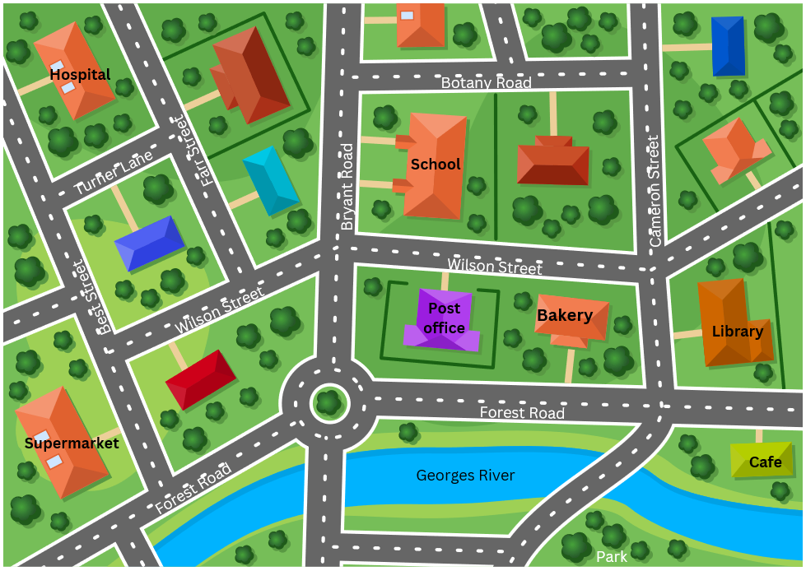
Images sourced from Canva and used in accordance with the Canva Content License Agreement.

Resource 2: Location flash cards
This resource can be adapted by replacing the text to suit your [Language].
hospital |  | school |  | bakery |  | library
post office |  | supermarket |  | cafe |  | park
Images sourced from Canva and used in accordance with the Canva Content License Agreement.

Resource 3: Describing position
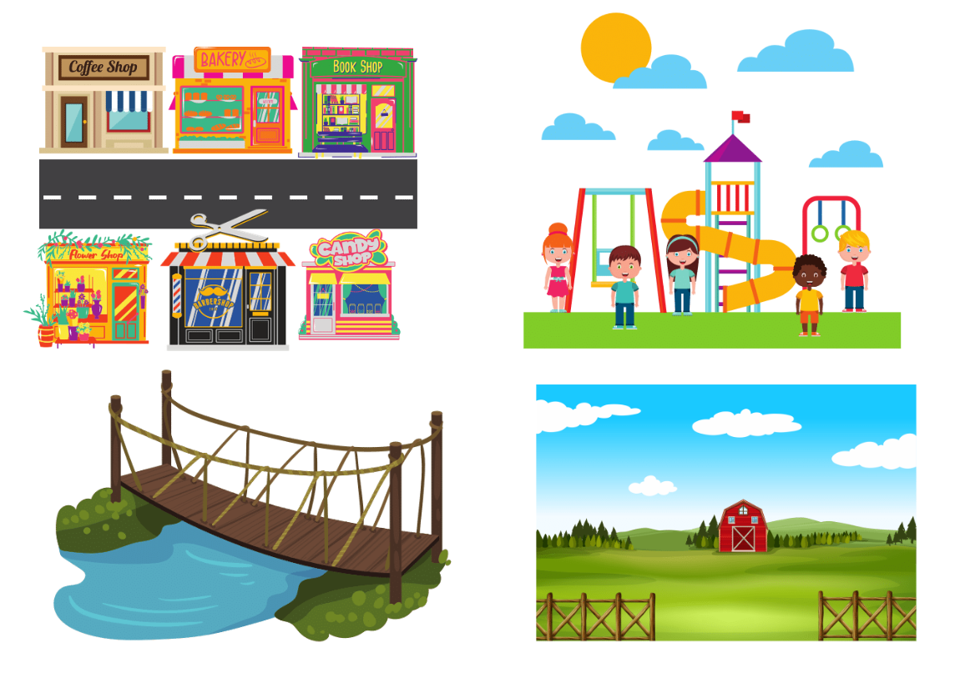
Images sourced from Canva and used in accordance with the Canva Content License Agreement.

Resource 4: Assessment task – My neighbourhood

Outcomes
You will be assessed on how well you:
- exchange information in familiar contexts by selecting culturally appropriate modelled language
- create texts for familiar communicative purposes by selecting culturally appropriate modelled language

Task
You have arranged to meet a friend at a place near your school. Your friend does not know how to get there, so you need to give them a map with some directions.
The table below outlines the communicative task students will need to complete.
Too hard? | Too easy?
- Tell your friend where to meet after school.  - Students create a simple map of the local neighbourhood with a few places of interest and streets. | - Tell your friend how to get to the meeting place using public transport and on foot.  - Students can create a more detailed map of the local neighbourhood including additional places of interest.

Learning intention
Students will create a map of their local neighbourhood and a script with directions for their friend on how to get to an allocated place after school.
Advanced learners
Students will be able to include a more detailed script which includes greetings and everyday language.

Success criteria
You will create a map of the local neighbourhood and a written script with directions on how to get to an allocated place.
You will be successful if you can:
- draw a labelled map of your neighbourhood
- identify and describe different amenities in your neighbourhood
- create a script using modelled sentences and phrases to give directions
- interact in a conversation using adverbs such as left/right, past, straight ahead, near, far, on the corner, between, behind, in front of, over, and so on.

Task instructions
- This task will be presented to the class. You are to present both the map and the instructions on how to get to the allocated meeting place after school.
- Choose a peer in the classroom to assess your presentation using Resource 6: Peer feedback strategy – Two stars and a wish.
- Whilst presenting your work you will be assessed based on all the criteria in the rubric. Your presentation will also be recorded.
- Following the task, you will watch the recording of yourself presenting the task. You can self-assess your presentation by using Resource 5: Rubric – My neighbourhood. Compare your self-assessed rubric with the teacher marked rubric.
- Reflect on your performance and identify areas for improvement. Use this information to set a learning goal for the next stage of learning.

Resource 5: Rubric – My neighbourhood
Name:
Table 2 – Rubric for ‘My neighbourhood’
Criteria | Excellent | Got it | Sort of | Getting there | Not yet
Communication | Your audience, the classmate you have arranged to meet, clearly understands what you want to communicate.  Successfully and thoroughly complete all the following aspects of the task:  - Create directions on how to get from school to an allocated meeting place in both written and oral forms.  - Create a map of the local neighbourhood and name all amenities.  - Present the directions and map to the class confidently. | Your audience, the classmate you have arranged to meet, understands what you want to communicate.  Successfully complete most of the following aspects of the task:  - Create directions on how to get from school to an allocated meeting place in both written and oral forms.  - Create a map of the local neighbourhood and name all amenities.  - Present the directions and map to the class confidently. | Your audience, the classmate you have arranged to meet, can mostly understand what you want to communicate.  Complete most of the following aspects of the task:  - Create directions on how to get from school to an allocated meeting place in both written and oral forms.  - Create a map of the local neighbourhood and name all amenities.  - Present the directions and map to the class confidently. | Your audience, the classmate you have arranged to meet, struggles to understand what you want to communicate. However, communication is successful.  Rely on non-linguistic resources such as gesture and facial expression to communicate. | Your audience, the classmate you have arranged to meet, is unable to understand what you want to communicate.  Unable to complete any aspect of the task.
Fluency | Speak [Language] with ease, in a well-paced manner without long pauses. | Speak confidently with appropriate speed and expression. | Usually speak confidently with appropriate speed and expression. | Rarely speak with appropriate speed and expression. | Unable to be understood.
Grammar | Always say [Language] words in the correct order when speaking language.  Use nouns, verbs and adverbs to give directions. | Usually say [Language] words in the correct order when speaking language.  Use nouns, verbs and adverbs sometimes to give directions. | Make some grammar mistakes when speaking [Language].  Use nouns, verbs and adverbs sometimes to give directions. | Rarely make sense when speaking [Language]. | Unable to be understood.
Pronunciation | Pronounce all words correctly. | Make some pronunciation errors. | Often make pronunciation errors. | Consistently make pronunciation errors. | Unable to be understood.
Vocabulary | Use full range of vocabulary correctly and use relevant words to expand on the topic. | Use expected vocabulary correctly and adds interesting vocabulary to dialogue. | Make some mistakes when trying to use expected vocabulary. | Make many mistakes when trying to use expected vocabulary. | Unable to use vocabulary in appropriate context.

Resource 6: Peer feedback strategy – Two stars and a wish
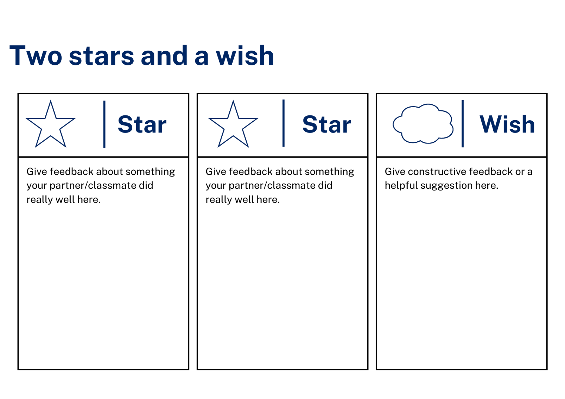

Support and alignment
Resource evaluation and support: all curriculum resources are prepared through a rigorous process. Resources are periodically reviewed as part of our ongoing evaluation plan to ensure currency, relevance, and effectiveness. For additional support or advice, contact the Primary Languages team by emailing primlang@det.nsw.edu.au.
Alignment to system priorities and/or needs: School Excellence Policy, School Success Model
Alignment to the School Excellence Framework: this resource supports the School Excellence Framework elements of curriculum (curriculum provision, teaching and learning programs) and effective classroom practice (lesson planning).
Alignment to Australian Professional Teaching Standards: this resource supports teachers to address Australian Professional Teaching Standards 2.2.2, 3.2.2.
Consulted with: Curriculum, Secondary Learners, school-based staff and NESA subject matter experts. Advice from Aboriginal Outcomes and Partnerships, EAL/D, HPGE and Inclusive Education for Modern Languages Stage 3 Italian Mangiare in Ristorante has been considered in preparing this document.
NSW syllabus: Modern Languages K–10 Syllabus
Syllabus outcomes: ML2-INT-01, ML2-UND-01, ML2-CRT-01
Author: Primary Curriculum
Publisher: State of NSW, Department of Education
Resource: Unit
Related resources: further resources to support Stage 2 Modern Languages can be found on the Languages K-6 curriculum page.
Professional learning: relevant professional learning is available through Primary Languages Networks on Teams (staff only).
Universal Design for Learning: support the diverse learning needs of students using inclusive teaching and learning strategies. Some students may require more specific adjustments to allow them to participate on the same basis as their peers. For further advice see Inclusive practice resources for primary school.
Differentiation: when using these resources in the classroom, it is important for teachers to consider the needs of all students in their class, including:
- Aboriginal and Torres Strait Islander students. Targeted strategies can be used to achieve outcomes for Aboriginal students in K-12 and increase knowledge and understanding of Aboriginal histories and cultures. Teachers should use students’ Personalised Learning Pathways to support individual student needs and goals.
- EAL/D learners. EAL/D learners may require scaffolding to support them to gain content knowledge, while providing extra time and assistance to master the English language required to engage with texts or complete classroom tasks. View some samples of differentiating through scaffolding.
- Students with additional learning needs. Learning adjustments enable students with disability and additional learning and support needs to access syllabus outcomes and content on the same basis as their peers. Teachers can use a range of adjustments to ensure a personalised approach to student learning.
- High potential and gifted learners. Assessing and identifying high potential and gifted learners will help teachers decide which students may benefit from extension and additional challenge. In addition, the Differentiation Adjustment Tool can be used to support the specific learning needs of high potential and gifted students.
Creation date: 28 March 2023
Rights: © State of New South Wales, Department of Education

References
This document contains NSW Curriculum and syllabus content. The NSW Curriculum is developed by the NSW Education Standards Authority. This content is prepared by NESA for and on behalf of the Crown in right of the State of New South Wales. The material is protected by Crown copyright.
Please refer to the NESA Copyright Disclaimer for more information. https://educationstandards.nsw.edu.au/wps/portal/nesa/mini-footer/copyright
NESA holds the only official and up-to-date versions of the NSW Curriculum and syllabus documents. Please visit the NSW Education Standards Authority (NESA) website https://educationstandards.nsw.edu.au/ and the NSW Curriculum website https://curriculum.nsw.edu.au/home.
Modern Languages K–10 Syllabus © NSW Education Standards Authority (NESA) for and on behalf of the Crown in right of the State of New South Wales, 2022.
8 Ways (n.d.) 8 Aboriginal Ways of Learning [website], accessed 13 December 2022.
AITSL (Australian Institute for Teaching and School Leadership) (2017) ‘Feedback Factsheet’, AITSL, accessed 21 March 2023.
Brookhart SM (2011) How to Assess Higher-Order Thinking Skills in Your Classroom, Hawker Brownlow Education, Victoria.
CESE (Centre for Education Statistics and Evaluation) (2020a) What works best: 2020 update, NSW Department of Education, accessed 10 March 2023.
CESE (Centre for Education Statistics and Evaluation) (2020b) What works best in practice, NSW Department of Education, accessed 10 March 2023.
Conti G (28 May 2017) ‘From Target Language to Model Language – the mind shift that has transformed my teaching’, The Language Gym, accessed 20 March 2023.
Conti G (28 September 2015) ‘16 tips for effective grammar teaching in the foreign language classroom’, The Language Gym, accessed 21 March 2023.
Harmer J (2014) The Practice of English Language Teaching, 5th edn, Pearson Education, United Kingdom, accessed 21 March 2023
Henshaw FG and Hawkins MD (2022) Common Ground: Second Language Acquisition Theory Goes to the Classroom, Focus, Indianapolis, accessed 14 March 2023.
Jones J and Wiliam D (2014) Modern Foreign Languages Inside the Black Box: Assessment for Learning in the Modern Foreign Languages Classroom (Black P, Harrison C, Marshall B and Wiliam D, eds), Learning Sciences International, United States, accessed 14 March 2023
NESA (NSW Education Standards Authority) (2022) ‘Proficient Teacher: Standard descriptors’, The Standards, NESA website, accessed 21 December 2022.
Smith S (2022) Becoming an Outstanding Languages Teacher, 2nd edn, Routledge, United Kingdom.
Wiliam D and Leahy S (2015) Embedding Formative Assessment: Practical Techniques for K–12 Classrooms, Learning Sciences International, United States, accessed 14 March 2023.
© State of New South Wales (Department of Education), 2023
The copyright material published in this resource is subject to the Copyright Act 1968 (Cth) and is owned by the NSW Department of Education or, where indicated, by a party other than the NSW Department of Education (third-party material).
Copyright material available in this resource and owned by the NSW Department of Education is licensed under a Creative Commons Attribution 4.0 International (CC BY 4.0) licence.
This licence allows you to share and adapt the material for any purpose, even commercially. Attribution should be given to © State of New South Wales (Department of Education), 2023.
Material in this resource not available under a Creative Commons licence:
- the NSW Department of Education logo, other logos and trademark-protected material
- material owned by a third party that has been reproduced with permission. You will need to obtain permission from the third party to reuse its material.
Links to third-party material and websites
Please note that the provided (reading/viewing material/list/links/texts) are a suggestion only and implies no endorsement, by the New South Wales Department of Education, of any author, publisher, or book title. School principals and teachers are best placed to assess the suitability of resources that would complement the curriculum and reflect the needs and interests of their students.
If you use the links provided in this document to access a third-party's website, you acknowledge that the terms of use, including licence terms set out on the third-party's website apply to the use which may be made of the materials on that third-party website or where permitted by the Copyright Act 1968 (Cth). The department accepts no responsibility for content on third-party websites.

