Arabic Stage 2
(My pet is lost!) ضاع حيواني الاليف!
Contents
Unit overview 6
Stage 2 outcomes and content to be addressed 7
Learning map 11
Assessment 14
Assessment opportunities 15
Teaching and learning activities 17
Week 1 – pets 17
Vocabulary 1 – animals 17
Activity 1 – Learning map 19
Activity 2 – pre-assessment 19
Activity 3 – which animals are pets? 20
Activity 4 – animal vocabulary hotseat 20
Activity 5 – cultural significance of pets in Arabic-speaking countries 21
Week 2 – describing pets 22
Vocabulary 2 – animal body parts 23
Vocabulary 3 – adjectives to describe animals 24
Activity 1 – animals and colours 25
Activity 2 – vocabulary 26
Activity 3 – which animal fits this body part? 26
Activity 4 – adjectives 27
Activity 5 – pairing activity 28
Week 3 – ‘My lost dog’ story 30
Vocabulary 5 – phrases 30
Activity 1 – prediction 31
Activity 2 – ‘My lost dog’ story 31
Activity 3 – True or False? 32
Activity 4 – My lost dog profile 33
Week 4 – make a poster 34
Vocabulary 4 – lost pet flyer details 35
Activity 1 – number revision 36
Activity 2 – pet bingo 36
Activity 3 – my lost pet flyer 37
Activity 4 – asking and answering questions about pets 38
Week 5 – assessment criteria and practice task 39
Activity 1 – word wall recall game 39
Activity 2 – assessment task 40
Activity 3 – success criteria 40
Activity 4 – discuss the rubric 40
Activity 5 – peer assessment 41
Activity 6 – role-play practice task 41
Week 6 – communicative task – describe your lost pet to a neighbour 43
Activity 1 – task preparation 44
Activity 2 – task set-up 44
Activity 3 – communicative task – describe your lost pet to a neighbour 45
Activity 4 – peer feedback 46
Week 7 – feedback and goal setting 47
Activity 1 – odd one out! 48
Activity 2 – self-assessment 48
Activity 3 – set learning goals 48
Week 8 – language review 50
Activity 1 – student questions 51
Activity 2 – roll and read 51
Activity 3 – roll and write 51
Activity 4 – Order matters! Jump up or squat down 52
Student resources 53
Resource 1 – animals flashcards 53
Resource 2 – animal body parts flashcards 57
Resource 3 – adjective flashcards 61
Resource 4 – my lost dog short story 63
Resource 5 – my lost dog profile 65
Resource 6 – my lost dog scaffold card 67
Resource 7 – bingo mat 69
Resource 8 – my lost pet flyer 70
Resource 9 – question cards 72
Resource 10 – assessment task – My pet is lost! 73
Outcomes 73
Task 73
Learning intention 74
Success criteria 74
Task instructions 75
Resource 11 – rubric – My pet is lost! 76
Resource 12 – peer feedback strategy – Two stars and a wish 79
Resource 13 – roll and read card 80
Resource 14 – roll and write card 82
Support and alignment 84
References 87

Unit overview
Stage: 2
Title: (My pet is lost!) ! ضاع حيواني الاليف
Description: In this unit, students create a flyer describing their lost pet. They use modelled language to describe their pet. Students also interact by asking and responding to questions about their lost pet.
Duration: This lesson sequence is designed to be completed over approximately 8 weeks.
Student proficiency levels: It is assumed that many Stage 2 students have been learning Arabic since Kindergarten and for many, their proficiency level will be Intermediate, although some students will still be at the Beginner level. This unit is aimed at intermediate students. Every classroom will be different and teachers will need to adapt to their context. Many Stage 2 classes may include a combination of Beginner, Intermediate and Advanced students. Assessment tasks and opportunities in this unit can be differentiated using the ‘Too hard?’ and ‘Too easy?’ suggestions.
Note: Arabic is a language that is read from right to left, unlike English which is read from left to right. As a result, there are some samples of English and Arabic text in this document where punctuation may appear incorrect in both. Please keep this in mind when using this document.

Stage 2 outcomes and content to be addressed
The table below outlines the focus area, outcomes and content points for Stage 2 students.
Focus area and outcome | Content points
Interacting  A student:  - exchanges information in familiar contexts by selecting culturally appropriate modelled language ML2-INT-01 | Exchanging meaning in oral interactions in the target language  - Share information about themselves to describe their personal world  - Ask and answer modelled questions in a guided conversation  - Express emotions and preferences  - Interact in conversation with teacher and peers in familiar social contexts  Applying knowledge of language systems to interact in the target language  - Recognise and use modelled sounds, including pronunciation and intonation patterns and/or rhythms to interact  - Select familiar vocabulary and formulaic phrases to interact  - Use modelled sentence structures to interact  Applying knowledge of the target language culture(s) to interact  - Use modelled language structures and nonverbal communication that are appropriate to cultural practices
Understanding texts  A student:  - identifies and responds to information in texts to demonstrate understanding ML2-UND-01 | Understanding and responding to target language texts  - Listen to, read and view information in texts on familiar themes  - Use strategies to locate, organise, classify and sort information in texts for a range of purposes  - Respond to questions about specific information in texts on familiar themes, using modelled target language sentence structures and/or English  - Respond to texts through actions, visuals, written or spoken responses in the target language and/or English to demonstrate understanding and convey meaning  Applying knowledge of language systems to understand and respond to target language texts  - Identify and use the sounds of familiar vocabulary and phrases in the target language to understand and respond to texts  - Recognise and use sound–symbol correspondences to understand and respond to texts  - Identify and use knowledge of vocabulary and formulaic phrases from familiar themes to understand and respond to texts  - Identify and use elements of grammar in familiar language patterns  - Recognise modelled target language features and compare them with English features  - Recognise and use modelled structures and features of the target language writing system to understand and respond to texts  Developing intercultural understanding through target language texts  - Respond to texts and identify connections between language and cultural practices and reflect on their own language(s) and culture(s)
Creating texts  A student:  - creates texts for familiar communicative purposes by selecting culturally appropriate modelled language ML2-CRT-01 | Creating spoken, written and multimodal texts in the target language  - Create informative texts appropriate to context, purpose and audience describing themselves and their personal world  - Create imaginative texts appropriate to context, purpose and audience using a series of modelled sentence structures and visuals to add meaning  Applying knowledge of language systems to create texts in the target language  - Use pronunciation and intonation patterns to create spoken texts  - Use sound–symbol correspondence to create written texts  - Use vocabulary, formulaic expressions or modelled phrases from familiar themes to create texts  - Use elements of simple grammar patterns in modelled sentence structures to create texts  - Use modelled structures and features of the target language writing system to create written texts  Applying knowledge of the target language culture(s) to create texts  - Select language appropriate to cultural practices to create texts
Modern Languages K–10 Syllabus © NSW Education Standards Authority (NESA) for and on behalf of the Crown in right of the State of New South Wales, 2022.

Learning map
The creation of maps for learning is a planning process that incorporates Aboriginal intellectual tradition. Learning maps are a visual pathway of what students will learn.
Share the learning map with your students, briefly explaining the learning that will happen in each lesson. Provide students with a copy of the learning map or display the learning map in the classroom. This learning map can be adapted to Arabic by accessing a copy of Learning map – (My pet is lost!) ! ضاع حيواني الاليف (Stage 2).
Figure 1 – My pet is lost! learning map
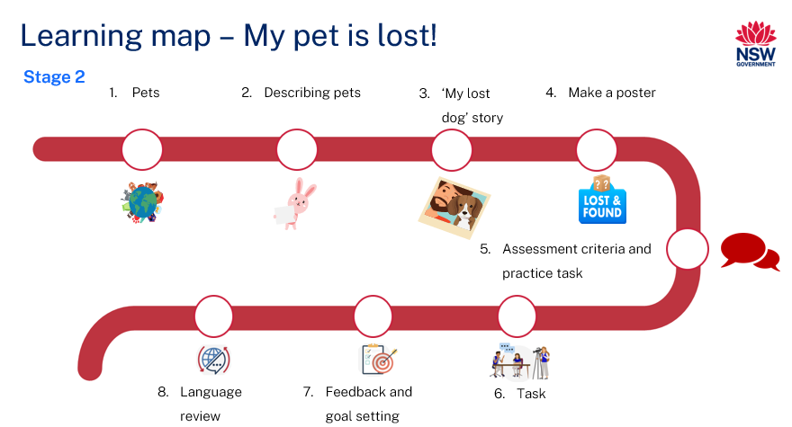
Figure 2 ضاع حيواني الاليف!learning map
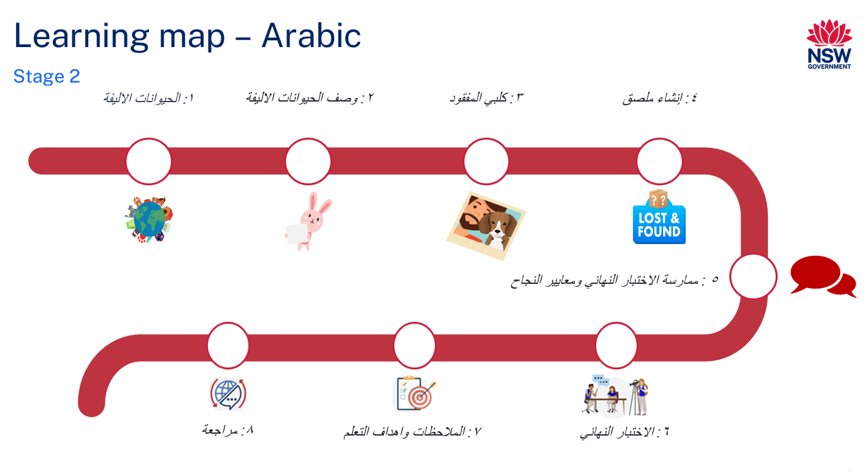

Assessment
Stage 2 communicative task: You have recently moved into a new neighbourhood and have lost your pet. Describe your pet in Arabic to a neighbour so that they can help you find your pet.
Too hard?
Tell your neighbour the type of animal you’ve lost and its name.
Too easy?
Describe your lost pet in detail. Include the type of animal it is, its name, colour, size, physical features, and personality traits.
Context: you have lost your pet
Audience: Arabic speaking neighbours
Purpose: to inform your neighbours about your lost pet

Assessment opportunities
The table below details assessment opportunities and differentiation ideas.
Assessment opportunities | Too hard? | Too easy?
Week 2 – which animal fits this body part?  Divide students into groups of 4. Distribute sticky notes to each group. Students identify body parts on Resource 2 – animal body parts flashcards and write the name of an appropriate pet in Arabic on a sticky note, based on the body part description. | Which animal fits this body part?  Give students a copy of Resource 1 – animal flashcards to assist them in writing pet names. | Which animal fits this body part?  Students include pet animals not already on the class word wall.
Week 3 – my lost dog profile  Provide each student with a copy of Resource 5 – my lost dog profile. Ask them to write 3 sentences that describe the lost dog from the story. | My lost dog profile  Give students a copy of Resource 6 – my lost dog scaffold card to support their sentence writing. | My lost dog profile  Students write a sentence describing a personality trait of the lost dog that is not in the story.
Week 5 – role-play practice task  Students practise describing their lost pet in a role-play activity. | Role-play practice task  Give students their completed Resource 8 – my lost pet flyer to help guide their language during the role-play. | Role-play practice task  During their descriptions, students mention personality traits of their pet.

Teaching and learning activities

Week 1 – pets
The table below outlines the learning intention and success criteria of the lesson, and materials that the teacher and students will need to complete the teaching and learning activities.
Learning intention and success criteria | Materials
Students will learn to identify and pronounce the names of animals in Arabic.  Students can:  - correctly say animals’ names in Arabic. | - Resource 1 – animals flashcards  - Learning map  - Butchers paper  - Writing materials  - Arabic exercise books

Vocabulary 1 – animals
The table below outlines the suggested vocabulary for Activity 2, Activity 3 and Activity 4. It includes the original Arabic script, a Romanised version of the Arabic script, and the corresponding English translations.
English | Romanised Arabic | الترجمة الى اللغة العربية
dog | kalb | كلب
fish | samaka | سمكة
cat | qitta | قطة
bird | usfoor | عصفور
rabbit | arnab | أرنب
lion | asad | أسد
tiger | nimr | نمر
panda | banda | باندا
turtle | sulḥafaa | سلحفاة
kangaroo | kangur | كنغر
falcon | ṣaqr | صقر
camel | jamal | جمل
pets | hayawaanat alyifa | حيوانات أليفة
animals | hayawanat | حيوانات

Activity 1 – Learning map
Explain and display the Learning map to give students a more detailed breakdown of lessons during the unit. Point out that the learning map is a plan that may need to change.

Activity 2 – pre-assessment
Display pictures from Resource 1 – animals flashcards, making sure the words are hidden. Say the first letter of the animal's name in Arabic. For example, for (a cat) قطة, say the first letter, 'ق'. Then, ask students to quietly tell their neighbour the animal's name in Arabic.
Read aloud the words from Resource 1 – animals flashcards and have students repeat each word after you say it.
Note: remind students that pet names in Modern Standard Arabic might vary from colloquial Arabic they hear at home. While discussing these differences, emphasise the use of Modern Standard Arabic in the classroom.

Activity 3 – which animals are pets?
Present Resource 1 – animals flashcards to the class. As you display each card, let students call out the animal's name. Discuss whether the animal displayed is commonly considered a pet, a non-pet, or can be both a pet and a non-pet. Arrange the 'pet' animal cards on the right side of the board and 'non-pet' animals on the left, and those that can be both in the centre. After classifying, list the animal names on butcher paper to start a class word wall.
Students record the animals’ names in their Arabic exercise books.

Activity 4 – animal vocabulary hotseat
- Play a communicative language learning game, ‘hotseat’, with the whole class to practice the vocabulary of family names.
- Divide the class into 2 teams. Select one player from each team to sit with their back to the board.
- Write the word for an animal in Arabic on the board, for example (dog) كلب
- Students from each team will take turns giving clues in English to their teammate in the hotseat, without using the Arabic or English word written on the board; for example, this animal is man’s best friend. The first student in the hotseat to correctly say the word for dog in Arabic earns a point for their team.
Note: Advanced students can give clues in Arabic

Activity 5 – cultural significance of pets in Arabic-speaking countries
Tell students about the cultural importance of animals in Arabic-speaking countries. Emphasise specific animals, such as the camel in Saudi Arabia or the falcon in the United Arab Emirates, and their symbolism in each region.
Ask students what some culturally significant animals in Australia are or in the countries of their backgrounds.
Note: for a deeper understanding, search online for Arabic folktales or fables that showcase these animals, emphasising their cultural representations through stories.
Evaluation: students can correctly pronounce the vocabulary words.

Week 2 – describing pets
The table below outlines the learning intention and success criteria of the lesson, and materials that the teacher and students will need to complete the teaching and learning activities.
Learning intention and success criteria | Materials
Students will describe pets in Arabic.  Students can:  - use nouns and adjectives to describe pets in Arabic. | - Resource 2 – animal body parts flashcards  - Resource 3 – adjective flashcards  - Word wall  - Writing materials  - Individual whiteboards  - Sticky notes  - Timer  - Arabic exercise books

Vocabulary 2 – animal body parts
The table below outlines the suggested vocabulary for, Activity 2, Activity 3 and Activity 5. It includes the original Arabic script, a Romanised version of the Arabic script, and the corresponding English translations.
English | Romanised Arabic | لترجمة الى اللغة العربية
teeth | asnan | أسنان
fur | faro | فرو
ears | aādhān | آذان
nose | anf | أنف
tail | dheil | ذيل
eyes | uyoon | عيون
claws | makhalib | مخالب
feathers | reesh | ريش
beak | munqar | منقار
whiskers | shawarib | شوارب
wings | ajniḥa | أجنحة
paws | kafuf | كفوف

Vocabulary 3 – adjectives to describe animals
The table below outlines the suggested vocabulary for Activity 4 and Activity 5. It includes the original Arabic script, a Romanised version of the Arabic script, and the corresponding English translations.
English | Romanised Arabic | لترجمة الى اللغة العربية
sharp | hadd | حاد
soft | Na’im | ناعم
big | kabir | كبير
small | saghir | صغير
long | tawil | طويل
shiny | laami'ah | لامع
colourful | mulawwan | ملون
short | qaseer | قصير

Activity 1 – animals and colours
- To review colours in Arabic, prepare objects or flashcards of various colours.
- Call out an Arabic colour name, like (yellow) أصفر and show the corresponding object or flashcard.
- When a colour is called out, students must draw an animal typically associated with that colour. For example, if (yellow) أصفر is called, they could draw a lion.
- Set a timer for one minute for each drawing round. When the timer goes off, have students showcase their drawings. In each round, select a student to describe their drawn animal to the class in Arabic. For example, (a yellow lion).أسد أصفر

Activity 2 – vocabulary
- Begin with a pre-assessment by showing students the images from Resource 2 – animals body parts flashcards. To gauge their familiarity with the vocabulary, ask students to give a thumbs-up near their chests as you ask the following questions:
- Do you recognise all the Arabic words for these images?
- Do you recognise most of them?
- Do you recognise some of them?
- Do you recognise none at all?
- Have students pair up and engage in a Think-Pair-Share activity, where they discuss and share the Arabic words they are familiar with.
- Next read out the flashcards and model the correct pronunciation of each Arabic word. Have students repeat each word after you several times. Focus on words with tricky pronunciation, such as (claws) مخالب and break longer words, such as (whiskers) شوارب into syllables.
- Model the words and images displayed on the board and have students record the vocabulary in their Arabic exercise books.

Activity 3 – which animal fits this body part?
Note: for this activity, prepare multiple sets of Resource 2 – animal body parts flashcards.
- Split students into groups of 3 or 4 and give each group a set of Resource 2 – animal body parts flashcards and sticky notes. Ask the groups to match body parts using the flashcards to suitable animals, writing down the words in Arabic on the sticky notes.
- Give students a few minutes to discuss which animals match the body parts on their cards and note down their names in Arabic. For example, if a card shows (tail) 'ذيل' students might write (monkey) 'قرد' or (cat) 'قطة’ on a sticky note, as both animals have (tails) ذيول
- After the groups have completed the activity, ask them to present their cards and the animal names they've listed on their sticky notes.
Note: for students with Beginner proficiency, provide them with a copy of Resource 1 – animals flashcards to assist with writing. Students with Advanced proficiency should list animals not already on the class word wall.

Activity 4 – adjectives
Note: remind students of the general rules for masculine and feminine adjective forms in Arabic. Masculine adjectives, like (big) كبير often have no unique ending or may end with ي. On the other hand, feminine adjectives, such as (big) كبيرة typically end with ة (tāʾ marbūṭah).
- Start with a pre-assessment by displaying Resource 3 – adjective flashcards on the board. When you point to a card, prompt students to discuss its English translation with their partner using the Think-Pair-Share strategy.
- Read the words from Resource 3 – adjective flashcards aloud. Ensure students echo the pronunciation repeatedly until they can articulate the words correctly.
- Write the adjectives on the class word wall. Show students how to change adjectives to their feminine forms by adding a ة. Start by providing an example using one or 2 words, then let students practice this in pairs with the rest of the adjectives, recording their answers in their Arabic exercise books.
Figure 2 – example of adding ة to a masculine word
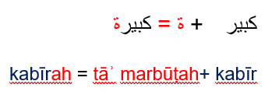

Activity 5 – pairing activity
Note: start by reminding students that in Arabic, adjectives generally come after the nouns they describe, which is different from English.
- Split students into small teams. Hand out sets of Resource 2 – animal body parts flashcards and Resource 3 – adjectives flashcards to each team.
- Explain to students that each team needs to pair nouns from Resource 2 with appropriate adjectives from Resource 3, making sure the gender matches.
- Show them an example using the cards, for example (sharp beak) منقار حاد where the gender of the adjective matches the noun.
- Have students work on the pairing activity and find appropriate pairs and jot down their matches on their individual whiteboards.
Note: after the activity, challenge students to create funny and silly sentences using their paired cards using Resource 2 and Resource 3.

Week 3 – ‘My lost dog’ story
The table below outlines the learning intention and success criteria of the lesson, and materials that the teacher and students will need to complete the teaching and learning activities.
Learning intention and success criteria | Materials
Students will write descriptions of a missing pet.  Students can:  - write descriptions in Arabic using nouns and adjectives in the correct grammatical order and gender  - recall details from the story. | - Resource 4 – my lost dog short story  - Resource 5 – my lost dog profile  - Resource 6 – my lost dog scaffold card  - Writing materials

Vocabulary 5 – phrases
The table below outlines the suggested vocabulary for Activity 4. It includes the original Arabic script, a Romanised version of the Arabic script, and the corresponding English translations.
English | Romanised Arabic | لترجمة الى اللغة العربية
My pet is lost. | Haywani al-aleef mafqood | حيواني الاليف مفقود
He has | Ladayh | لديه
Can you help me find my lost pet? | Hal yumkinuka musa'adati fi al-bahth 'an haywani al-aleef al-mafqood? | هل يمكنك مساعدتي في البحث عن حيواني الاليف المفقود؟

Activity 1 – prediction
Show the class Resource 4 – my lost dog short story, keeping the text hidden. Start a class discussion with the students by asking questions such as:
- Based on the title, what do you think this story is about?
- Could this story be about someone's pet?
- What happens to the pet?
- Do you think the story includes other animals? Why or why not?

Activity 2 – ‘My lost dog’ story
Note: remind students that in Arabic, adjectives generally come after the nouns they describe, unlike in English. Also, the adjectives should agree with the nouns in gender.
Before beginning the shared reading, ask students to pay close attention and listen for any nouns or adjectives as the story progresses.
Read Resource 4 – My lost dog short story to the class. Read Resource 4 – My lost dog short story with the class again. This time, have the students join in by reading the first 2 words of each sentence, (Shoushou has) شوشو لديه while you read the rest of the sentence.
Students read as a class without teacher support.

Activity 3 – True or False?
Use an online quiz platform to check student understanding. Create a series of True or False questions about the story for students to answer. This will help gauge their comprehension. See the sample statements in the table below:
True | False
Shoushou has sharp teeth.  شوشو لديه اسنان حادة. | Shoushou has no teeth.  شوشو ليس لديه اسنان.
Shoushou is white and brown.  شوشو لونه ابيض وبني. | Shoushou is black and brown.  شوشو لونه اسود وبني.

Activity 4 – My lost dog profile
- Prompt students to remember details about the lost dog, Shoushou, from the story. Ask questions, in English or in Arabic to jog their memory such as, ‘What details do you remember about Shoushou?’
- As students give their responses, write them out in complete sentences on the board. For instance, if a student comments that the dog from the story has a small nose, write (Shoushou has a small nose) شوشو لديه انف صغير on the board.
- Before students complete their profiles, provide a few example descriptions of the dog, such as:
- Shoushou has sharp teeth – شوشو لديه اسنان حادة.
- Shoushou is white and brown – شوشو لونه ابيض وبني.
- Hand out Resource 5 – My Lost dog profile to each student. Instruct them to write 3 sentences on the profile describing Shoushou, which would assist the boy from the story in finding his pet.
Note: for students at a Beginner proficiency level, give them a copy of Resource 6 – my lost dog scaffold card to help them with their sentence writing. For students with Advanced proficiency levels, ask them to add a sentence describing a personality trait of the lost dog.
Evaluation: students can accurately write short descriptive phrases about the lost dog.

Week 4 – make a poster
The table below outlines the learning intentions and success criteria of the lesson, and materials that the teacher and students will need to complete the teaching and learning activities.
Learning intentions and success criteria | Materials
Students will:  - design a flyer about their lost pet.  - practice asking and responding to questions about lost pets in Arabic, using the correct gender form.  Students can:  - use vocabulary from the word wall in their flyer  - write descriptions in Arabic using nouns and adjectives in the correct grammatical order and gender  - ask and respond to questions with the correct pronunciation for masculine and feminine forms. | - Resource 7 – bingo mat  - Resource 8 – my lost pet flyer  - Resource 9 – question cards  - Counters  - Writing materials  - Word wall

Vocabulary 4 – lost pet flyer details
The table below outlines the suggested vocabulary for Activity 3 and Activity 4. It includes the original Arabic script, a Romanised version of the Arabic script, and the corresponding English translations.
English | Romanised Arabic | الترجمة الى اللغة العربية
Lost | Fuqid | فقد
Name of my lost pet | Ism haywani al-aleef | اسم حيواني الاليف
If found, contact: | Idhā wujidt, al-ittisāl bi | إذا وجدت، الاتصال بـ
She has | Ladayha | لديها
He has | Ladayh | لديه
What is her name? | Ma huwa ismuha? | ما هو إسمها؟
Her name is | Ismuha | إسمها
Can you describe her to me? | Hal yumkinuka tawsifoha li? | هل يمكن ان تصفها لي؟
What is his name? | Ma huwa ismuh | ما هو إسمه؟
His name is | Ismuh | إسمه
Can you describe him to me? | Hal yumkinuka tawsifuhu li? | هل يمكن ان تصفه لي؟

Activity 1 – number revision
Start by reviewing numbers 1–10 with students. Reinforce their understanding using a familiar song, group counting or an interactive online game.

Activity 2 – pet bingo
- Play a communicative language learning game (Bingo!) بينجو! to practice saying animal names, colours, adjectives, and animal body parts in Arabic.
- Display the word wall and distribute copies of Resource 7 – bingo mat to each student. Instruct them to create their bingo cards by selecting 6 words of their choice from the word wall. Students may either draw or write the words.
- Provide a handful of counters to each student. Lead a whole-class game by reading random words aloud from the word wall, making sure to demonstrate the correct pronunciation.
- As you call out each word, students should place a counter on the corresponding word or picture on their bingo card if it's on their mat. Keep calling out words until a student calls out 'Bingo!' when they have a full row, column, or diagonal line covered with counters.
Note: for students with Beginner proficiency levels, provide copies of Resource 1 – animal flashcards and/or Resource 2 – animal body parts flashcards to help them in completing their bingo mats using the images provided.

Activity 3 – my lost pet flyer
Display a copy of Resource 8 – my lost pet flyer. Demonstrate how to fill out the template using a pet animal that the class selects. For example, if the class chooses a cat, ask them to suggest a name for it, such as Nono. Encourage students to read words from the class word wall to help them come up with descriptive sentences about Nono. Here are some suggested sentences to guide students:
- Nono is white, brown, and orange – نونو لونها ابيض، بني وبرتقالي
- Nono has sharp claws – نونو لديها مخالب حادة
- Nono has thick fur – نونو لديها فرو كثيف
Distribute a copy of Resource 8 – my lost pet flyer to each student. Instruct them to complete the profile, which should include the pet's name, a phone number to call if the pet is found, and 3 descriptive sentences about their lost pet. Then ask students to draw their lost pet.
Note: for students with Beginner proficiency levels, provide them with their Resource 5 – my lost dog profile that they created in Week 3 to help them to create their lost pet flyer. For students with Advanced proficiency levels, encourage them to include descriptions of the pet's personality, such as 'playful'.

Activity 4 – asking and answering questions about pets
Note: make multiple copies of Resource 9 – question cards.
Remind students of the 'ها' (feminine) and 'هُ' (masculine) endings in Arabic. Knowing this difference is important for using the right gender forms in the language.
When students are answering questions, make sure their responses align with the gender of the question. For example, if the question is masculine, such as (Can you describe him to me?) هل يمكن ان تصفه لي؟ then the answer should also be masculine, (My dog has a small nose) كلبي لديه أنف صغير
- Display Resource 9 – question cards. Reinforce that these questions help gather details about a lost pet. As each question is read aloud, highlight the differences between the feminine and masculine forms.
- Divide the class into 2 groups: Group A and Group B. Distribute orange (feminine) or green (masculine) question cards to students in Group A. Students in Group A will begin by asking questions, while students in Group B will respond to them.
- After 10 minutes, have the groups switch roles so everyone gets a chance to ask and answer questions.

Week 5 – assessment criteria and practice task
The table below outlines the learning intention and success criteria of the lesson, and materials that the teacher and students will need to complete the teaching and learning activities.
Learning intention and success criteria | Materials
Students will develop a clear understanding of the requirements of the assessment task.  Students can:  - suggest appropriate success criteria  - explain what they need to do to be successful in the task. | - Resource 10 – assessment task – My pet is lost!  - Resource 11 – rubric – My pet is lost!  - Resource 12 – peer feedback strategy – Two stars and a wish  - Word wall

Activity 1 – word wall recall game
Divide the class into pairs and ask students to take it in turns to recall words from the wall without repeating any previously mentioned by their partner. Student A will look away from the word wall and start saying words aloud one at a time. Student B will observe. If Student A pauses for over 10 seconds or cannot think of a new word, Student B turns away from the word wall and starts, beginning with the first word. Students keep switching roles until all words on the wall are recited.

Activity 2 – assessment task
Hand out Resource 10 – assessment task – My pet is lost! and lead the class in reading it.

Activity 3 – success criteria
After looking at the assessment task, students Think-Pair-Share and suggest appropriate success criteria, such as:
I will be successful if I can:
- describe my pet including its name, type of animal, colour, size and other physical features
- use grammatically correct sentences with
- the correct order of words
- correct gender agreement of nouns and adjectives
- pronounce the words correctly
- speak in a well-paced manner without long pauses.

Activity 4 – discuss the rubric
- Show students an unmarked Resource 11 – rubric – My pet is lost!. This may need to be adapted if the class has decided on different success criteria.
- Explain the metalanguage such as fluency, accuracy, pronunciation and vocabulary.
- Students read and then discuss the ‘Got it’ column of the rubric in pairs. They then share their understanding of what is needed to be successful.
- Point out and provide examples of what ‘excellent’, ‘got it’ and ‘sort of’ samples of task completion, fluency, accuracy, pronunciation and vocabulary look and sound like.

Activity 5 – peer assessment
Confirm which peer feedback strategy will be used after the task, for example Resource 12 – peer feedback strategy – Two stars and a wish and discuss with students.
Evaluation: students give examples of what stars and wishes would sound like for this task.

Activity 6 – role-play practice task
In pairs, students engage in a role-play. Student A plays the role of the pet owner while Student B plays the role of a neighbour. They have 2 minutes for this activity. Student B, as the neighbour, asks questions about the missing pet, while Student A provides the details. When the time is up, students will switch roles. After both roles have been played, students can rotate to a new partner and repeat the activity.
Note: for students at Beginner proficiency levels, provide them with a copy of their completed Resource 8 – my lost pet flyer to help with language during the role-play. Students at Advanced proficiency levels should include personality traits in their pet descriptions, for example, describing their pet as playful.

Week 6 – communicative task – describe your lost pet to a neighbour
The table below outlines the learning intention and success criteria of the lesson, and materials that the teacher and students will need to complete the teaching and learning activities.
Learning intention and success criteria | Materials
Students will describe their pet to a classmate in Arabic.  Students can:  - describe their pet including its name, type of animal, colour, size and other physical features  - use grammatically correct sentences with  - the correct order of words  - correct gender agreement of nouns and adjectives  - pronounce the words correctly  - speak in a well-paced manner without long pauses. | - Resource 10 – assessment task- My pet is lost!  - Resource 11 – rubric- My pet is lost!  - Resource 12 – peer feedback strategy – Two stars and wish feedback slips  - Recording device

Activity 1 – task preparation
Give students one more opportunity to read over their completed Resource 8 – my lost pet flyer to help them prepare to the complete the task.

Activity 2 – task set-up
Note: before recording interactions, check if any students do not have permission to be video recorded. Alternatives to video recording include audio recording or watching the interactions while taking notes and marking the rubric.
Have students form groups of 3. Give each group a few minutes to decide the order in which they will perform their roles. Students will then take turns pretending to be a lost pet owner, describing their pet in Arabic to a neighbour.
Suggested rotations:
- Role-play 1: Student 1 – Pet owner, Student 2 – Peer assessor/Camera operator, Student 3 – Neighbour
- Role-play 2: Student 1 – Neighbour, Student 2 – Pet owner, Student 3 – Peer assessor/Camera operator
- Role-play 3: Student 1 – Peer assessor/Camera operator, Student 2 – Neighbour, Student 3 – Pet owner

Activity 3 – communicative task – describe your lost pet to a neighbour
Note: make sure to space students apart when filming. Demonstrate how to film using a recording device. Use microphones, if possible, to maximise sound quality. Highlight the importance of holding the recording device still by using a tripod or resting it on a table.
For this task, students will work in groups of 3 and rotate through these roles:
- Pet owner: describes the lost pet
- Neighbour: asks questions like ‘What is its name?’ and ‘Can you describe it?’
- Camera operator/peer assessor: films the interaction.
Example interaction:
- Pet owner: (Hello) مرحباً
- Neighbour: (Hello) مرحباً
- Pet owner: (I have lost my pet. Can you help me find my pet?) لقد فقدت حيواني الأليف. هل يمكنك مساعدتي في البحث عن حيواني الأليف المفقود؟
- Neighbour: (Yes, what is his name?) نعم، ما هو اسمه؟
- Pet owner: (His name is Shoushou.) اسمه شوشو.
- Neighbour: (Can you describe him to me?) هل يمكن أن تصفه لي؟
- Pet owner: (Shoushou has brown and white fur and has a small nose.) شوشو لديه فرو بني وأبيض وأنف صغير.
Note: verbal and written feedback will be provided using the Two stars and a wish feedback strategy in the follow-up activity.

Activity 4 – peer feedback
Allow students a few minutes to provide verbal peer feedback. Then, distribute Resource 12 – peer feedback strategy – Two stars and wish and have students complete them.

Week 7 – feedback and goal setting
Note: if there is insufficient time to mark the videos before Week 8, Weeks 7 and 8 can be swapped.
The table below outlines the learning intention and success criteria of the lesson, and materials that the teacher and students will need to complete the teaching and learning activities.
Learning intention and success criteria | Materials
Students will reflect on their task recordings to assess performance and set learning goals.  Students can:  - self-assess their completion of the task  - set suitable learning goals based on previous learning goals and teacher, peer and self-assessment. | - Word wall  - Resource 11 – rubric – My pet is lost! (One teacher completed copy per student)  - Resource 11 – rubric – My pet is lost! (One blank copy per student for self-assessment)  - Recorded student videos  - Interactive whiteboard  - Arabic exercise books
Note: prior to this lesson, view each video and mark each student according to the criteria on Resource 11 – rubric – My pet is lost!

Activity 1 – odd one out!
Use the word wall for a class game. Read aloud 3 Arabic words to the students. Among them, 2 words should be related while one should be an outlier. Students should quickly identify and shout out the word that doesn't belong. See below suggested examples:
- cat, dog, long – قطة، كلب، طويل
- eyes, hair, sharp – عيون، شعر، حادة
- sharp, long, cat – حادة، طويلة، قطة

Activity 2 – self-assessment
Students watch the video of themselves completing the task and use the rubric to self-assess. Students compare their self-assessment rubric with the teacher’s completed rubric.

Activity 3 – set learning goals
Students reflect on the teacher, peer and self-evaluation to set goals for the next phase of learning. For example, ‘I will not be worried about making a mistake when speaking language’ and ‘I will try to say (a particular sound) correctly’. Students write their learning goals in their Arabic notebooks.
Evaluation: students set appropriate learning goals based on teacher, peer and self-assessment.

Week 8 – language review
Note: if there is insufficient time to mark the videos before Week 8, Weeks 7 and 8 can be swapped.
The table below outlines the learning intention and success criteria of the lesson, and materials that the teacher and students will need to complete the teaching and learning activities.
Learning intention and success criteria | Materials
Students will reflect on and ask questions about the language taught in this unit.  Students can:  - ask questions about vocabulary, grammar or pronunciation they have used in this unit  - use the language they have learned to communicate with classmates in Arabic. | - Resource 13 – roll and read card  - Resource 14 – roll and write card  - Dice  - Writing materials
Note: over the course of the unit, gaps in student knowledge, misconceptions and misuse of language will have been identified. These observations are addressed using engaging and interactive activities and strategies. The activities below are examples and will need to be supplemented with activities to address your observations.

Activity 1 – student questions
Remind students of the activities and tasks they have completed over the course of the unit. Give students time to Think-Pair-Share any questions they may have about aspects of the language taught.

Activity 2 – roll and read
Note: ensure you have a copy of Resource 13 – roll and read card for each student pair.
Divide students into pairs. Give each pair a die and a copy of Resource 13 – roll and read card. Students will take turns rolling the die. The number that comes up on the die corresponds to a row of words on the card. The student who rolled the die then reads aloud the words in the row that corresponds to that number. Continue the activity, allowing students to repeat the words multiple times until they are comfortable with the pronunciation.

Activity 3 – roll and write
Note: prepare a copy of Resource 14 – roll and write card for each student pair.
Divide students into pairs. Provide each pair with a die and a copy of Resource 14 – roll and write card. Students take turns rolling the die. The rolled number corresponds to a word on the card, which they write in the next available square using an erasable pen. Students proceed with this until the card is filled.
Evaluation: students can accurately copy and pronounce topic words correctly.

Activity 4 – Order matters! Jump up or squat down
Arrange the students in a spacious area either inside the classroom or outside. Students must be standing up. Briefly explain the game rules:
- when you call out a correctly ordered description in Arabic, such as (sharp teeth) ‘أسنان حادة' students must jump up
- if you call out a description with the incorrect order, like (tail long) ‘طويل ذيل' students must squat down.
Continue the game until most students can demonstrate their understanding of the correct noun-adjective order in Arabic.

Student resources

Resource 1 – animals flashcards
 |  | 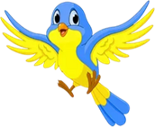
سلحفاة |  | عصفور |  | قطة |  | سمكة |  | كلب
كنغر |  | باندا |  | نمر |  | أسد |  | أرنب

 |  | حيوانات أليفة |  | حيوانات |  | جمل |  | صقر

Turtle |  | Bird |  | Cat |  | Fish |  | Dog
Kangaroo |  | Panda |  | Tiger |  | Lion |  | Rabbit

 |  | Pets |  | Animals |  | Camel |  | Falcon

Resource 2 – animal body parts flashcards
شوارب |  | ريش |  | كفوف |  | أسنان
أجنحة |  | فرو |  | أنف |  | مخالب

ذيل |  | عيون |  | منقار |  | آذان

whiskers |  | feathers |  | paws |  | teeth
wings |  | fur |  | nose |  | claws

tail |  | eyes |  | beak |  | ears

Resource 3 – adjective flashcards
This resource can be used to teach multiple languages. Use the resource link to tailor it to your preferred language.
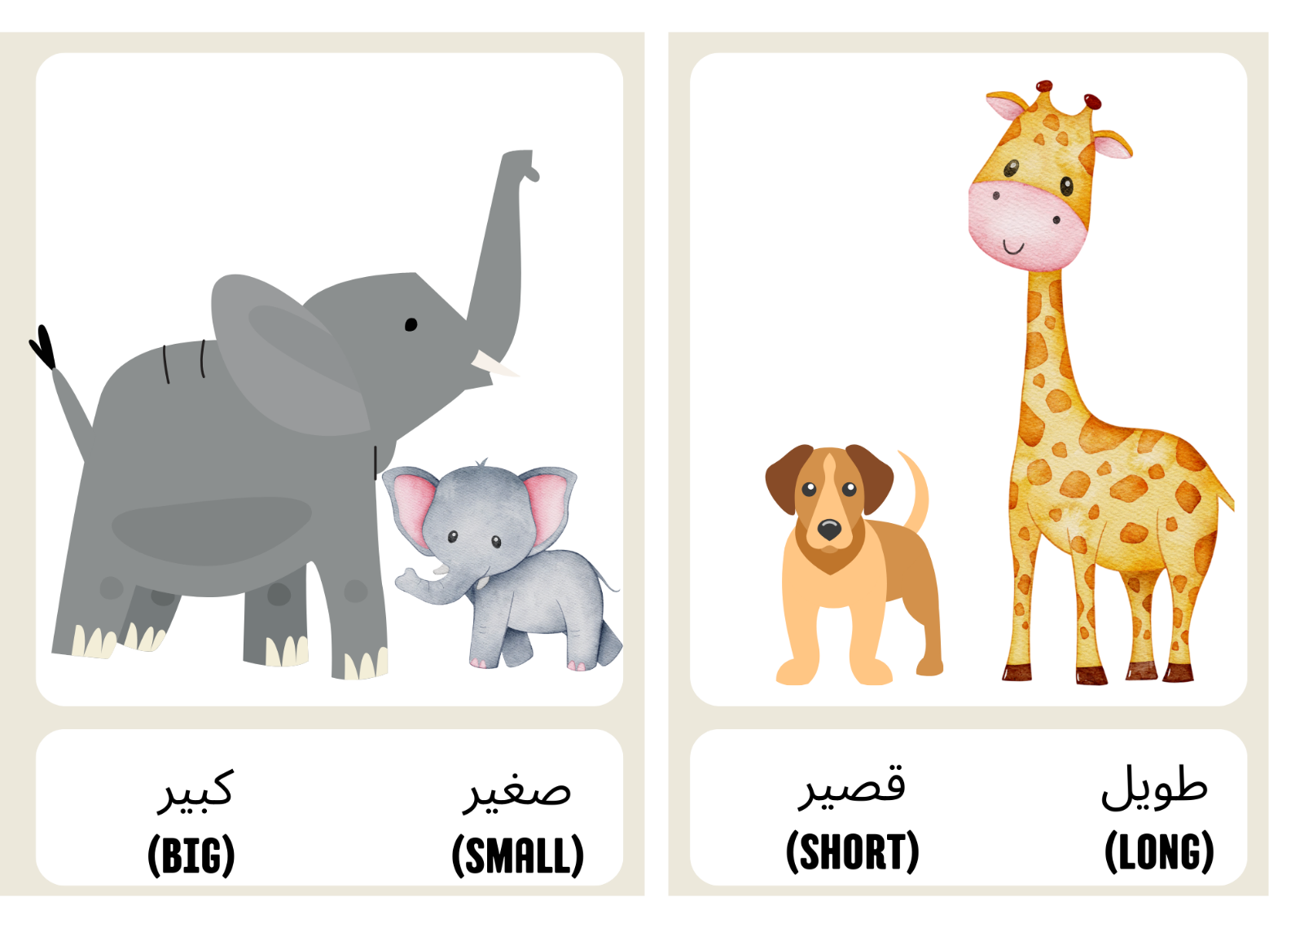
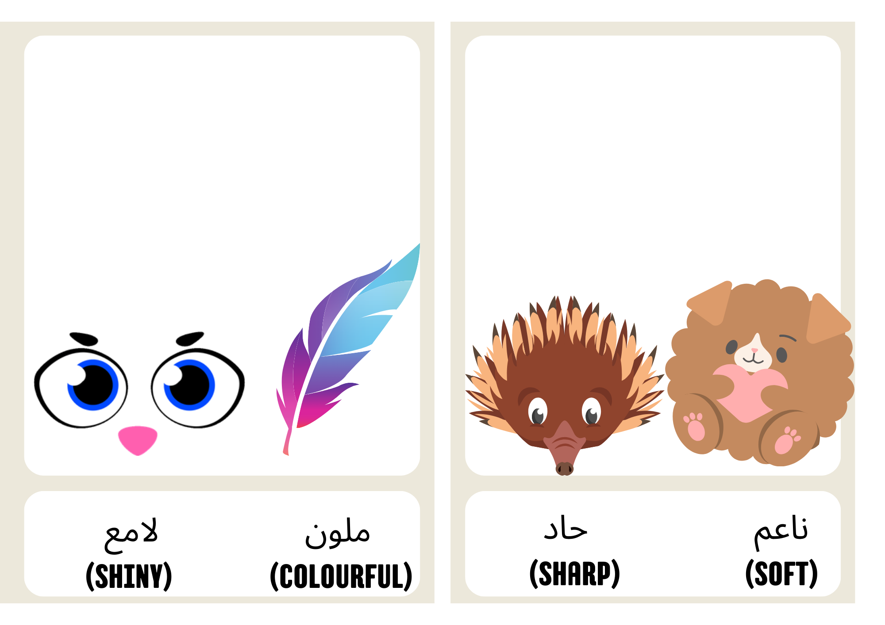

Resource 4 – my lost dog short story
This resource can be used to teach multiple languages. Use the resource link to tailor it to your preferred language.
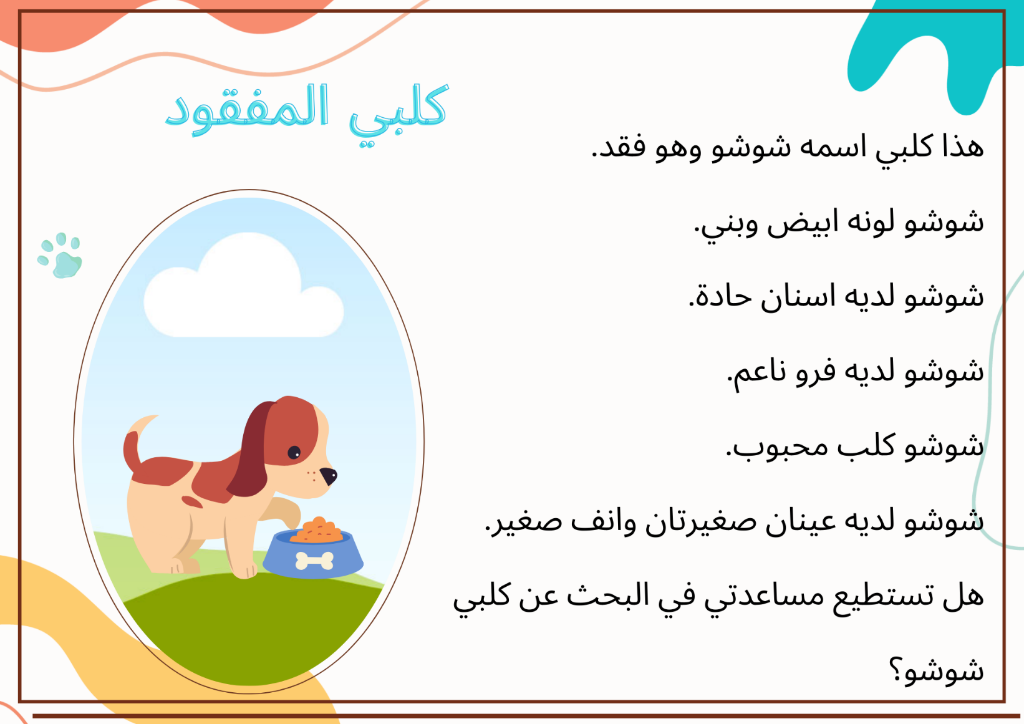
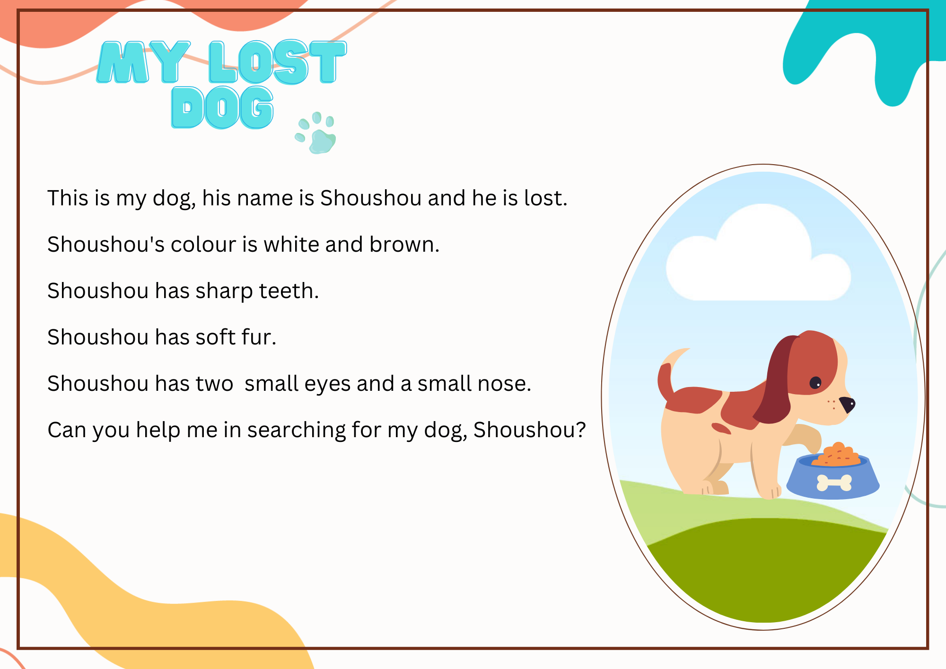

Resource 5 – my lost dog profile
This resource can be used to teach multiple languages. Use the resource link to tailor it to your preferred language.
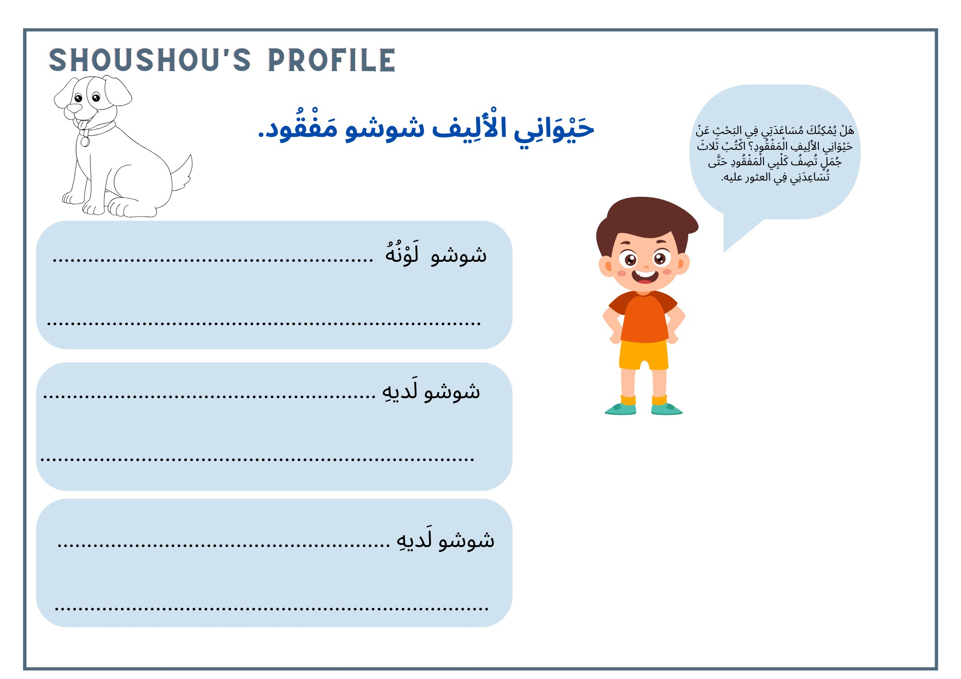
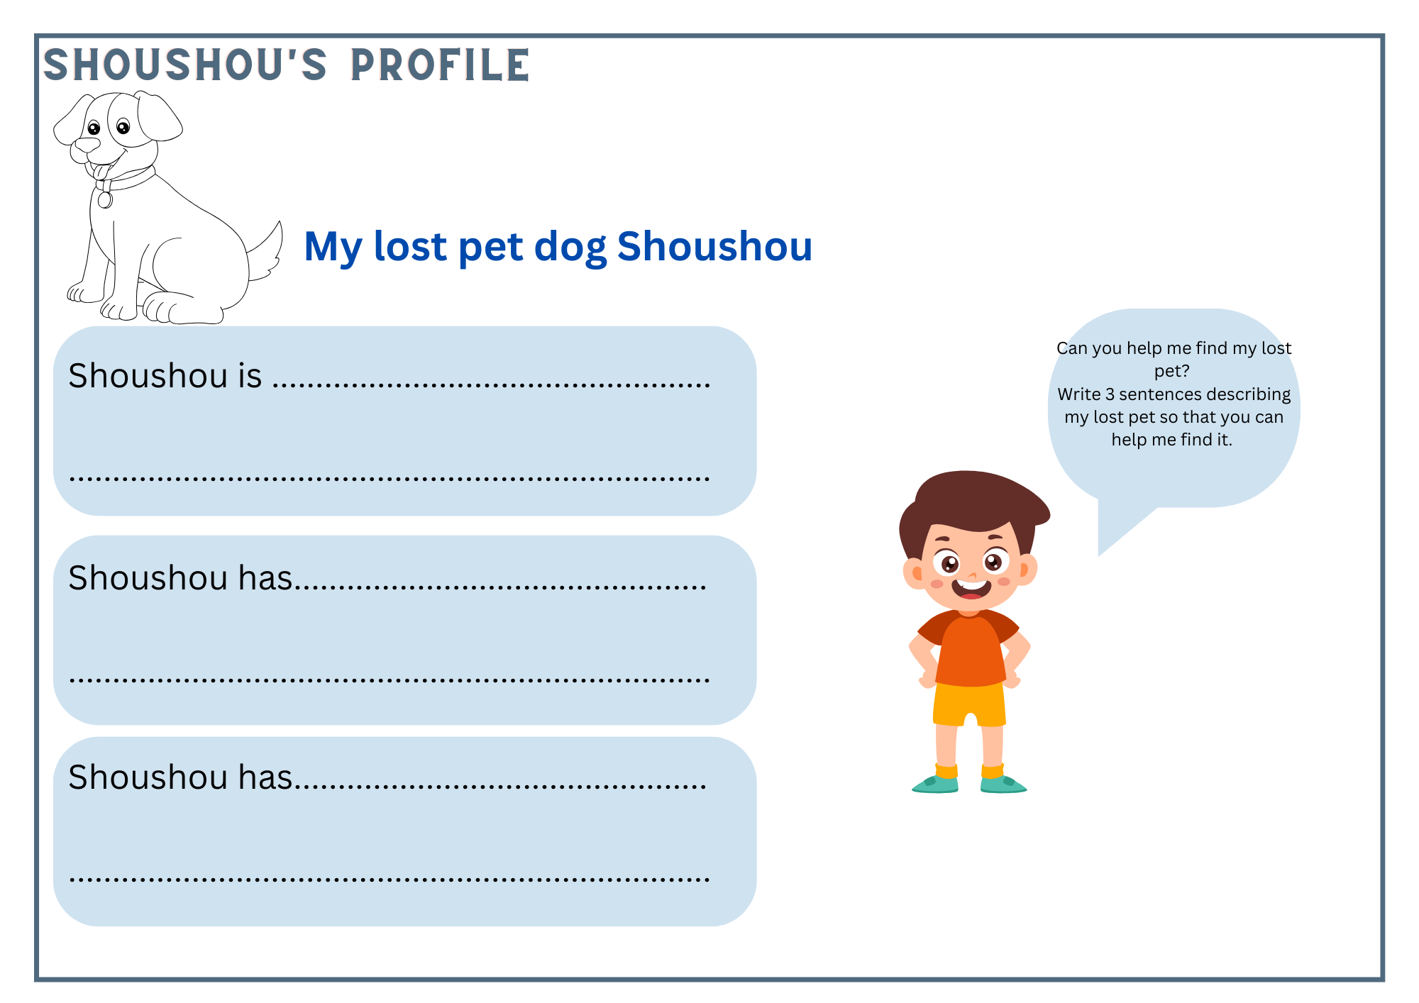

Resource 6 – my lost dog scaffold card
This resource can be used to teach multiple languages. Use the resource link to tailor it to your preferred language.
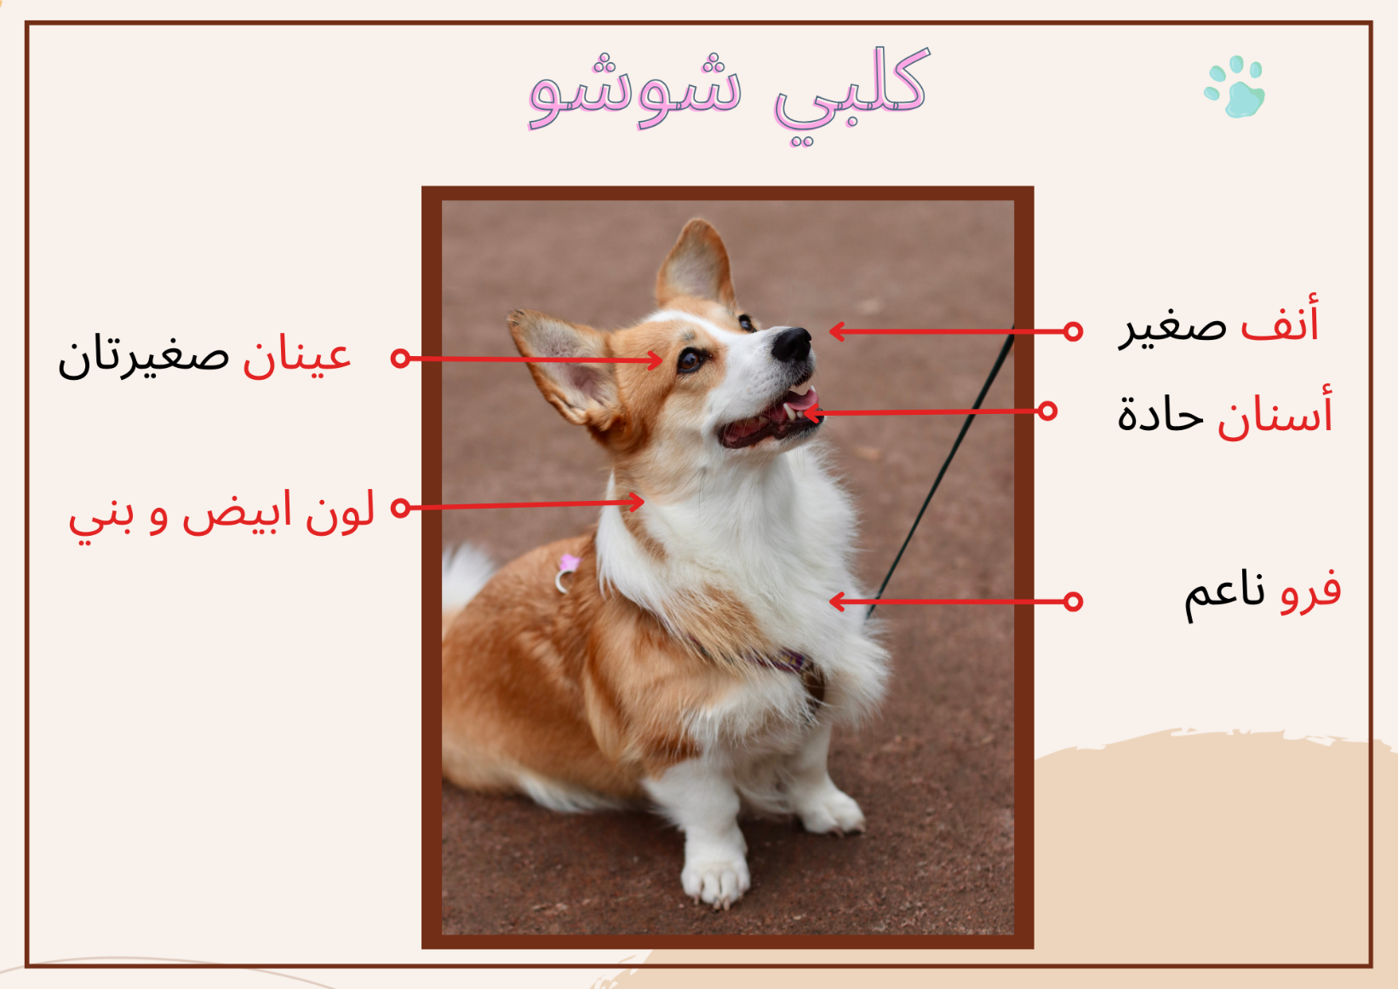
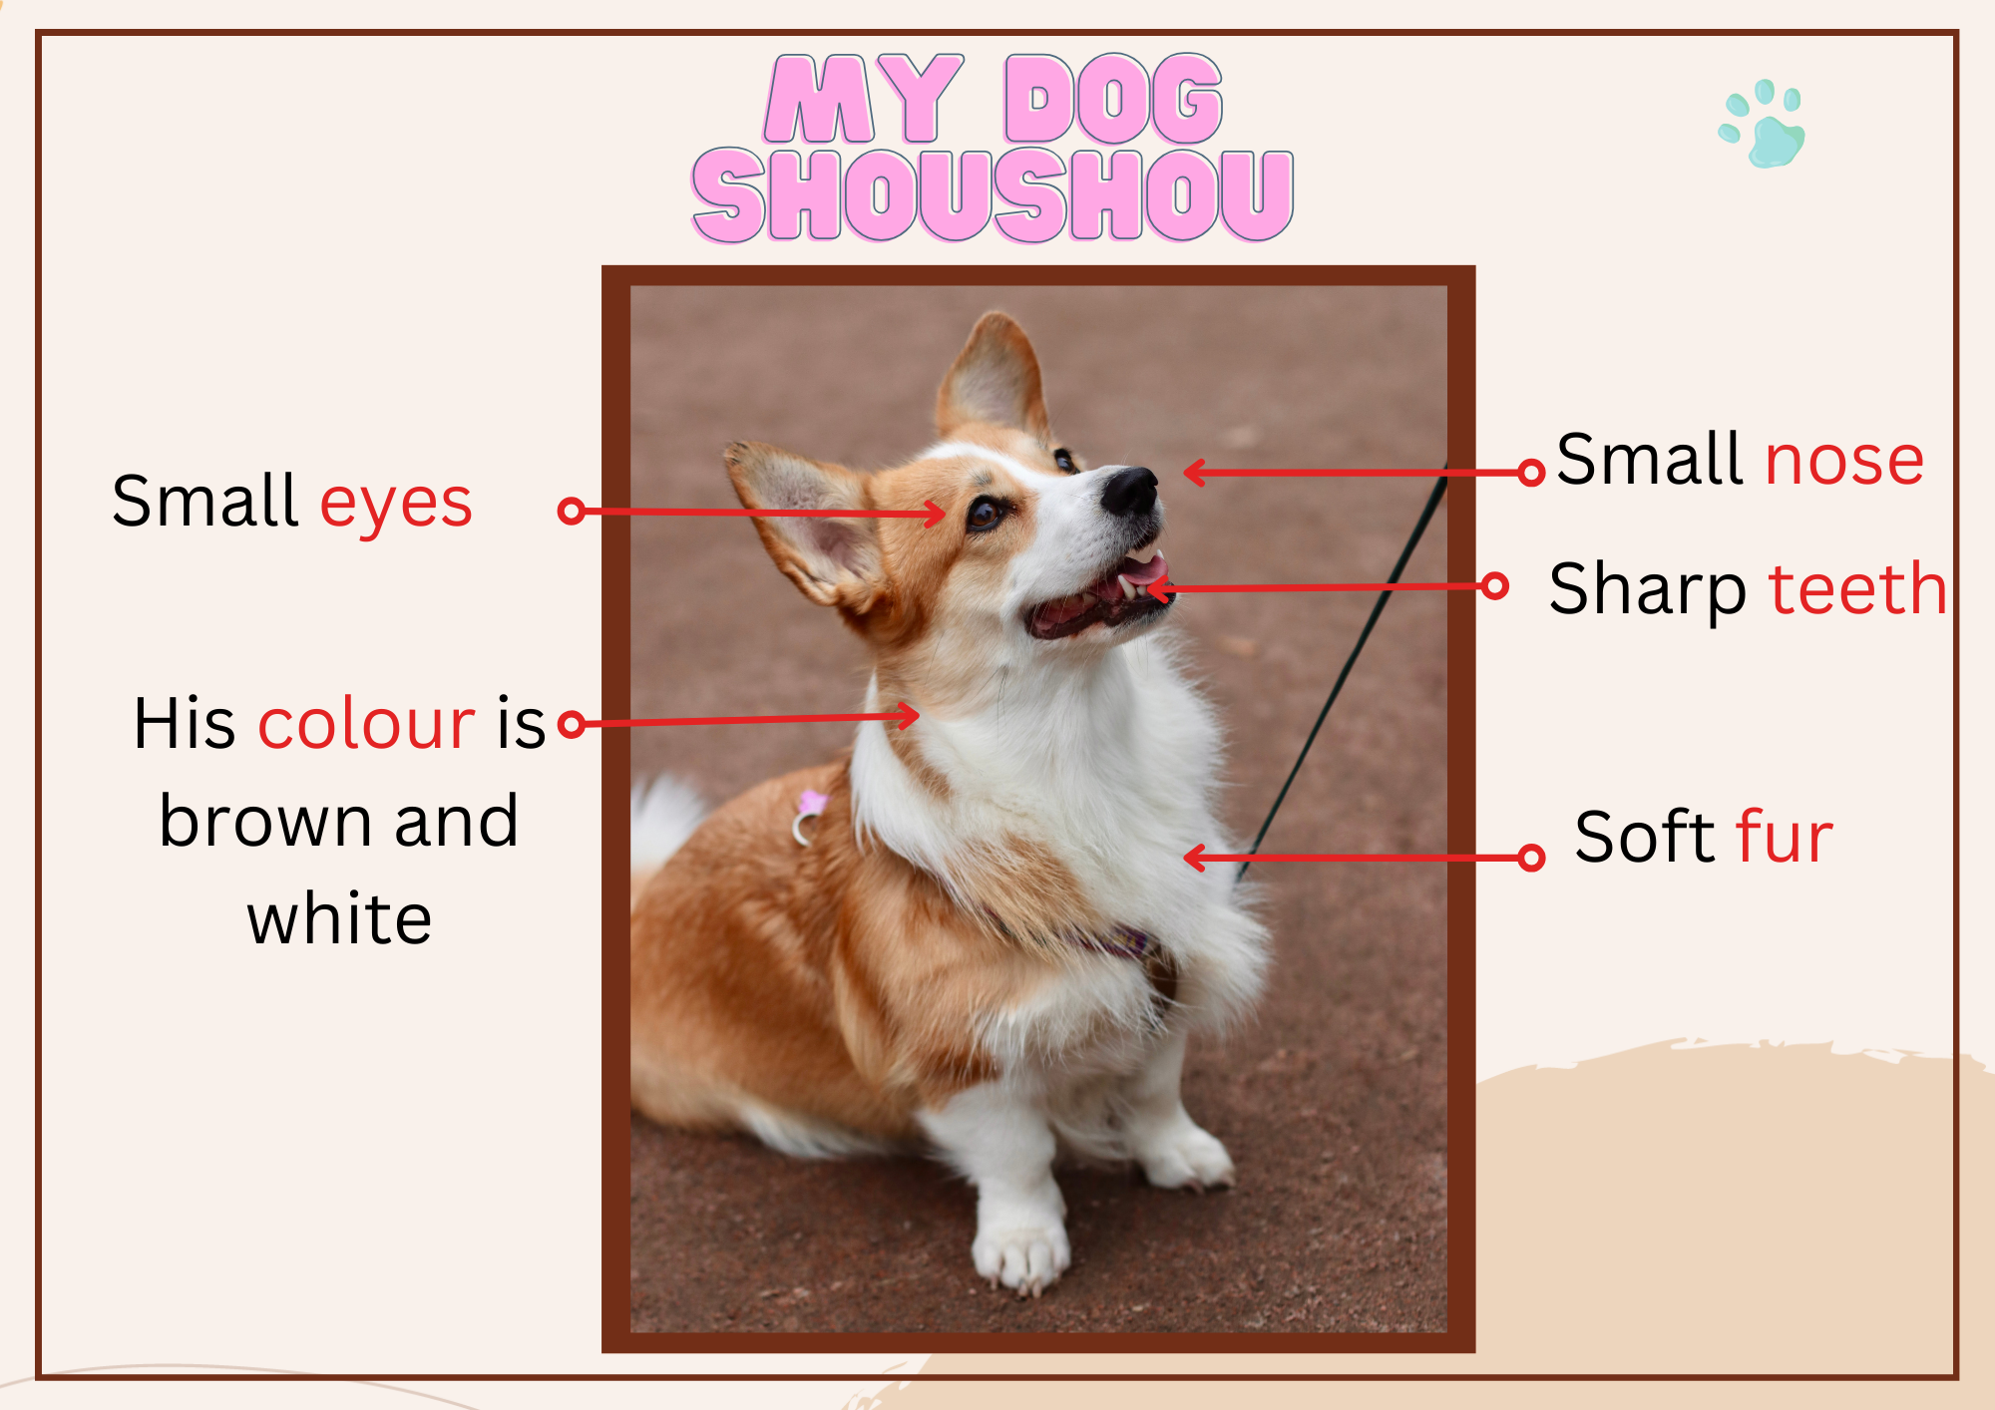

Resource 7 – bingo mat

Resource 8 – my lost pet flyer
This resource can be used to teach multiple languages. Use the resource link to tailor it to your preferred language.
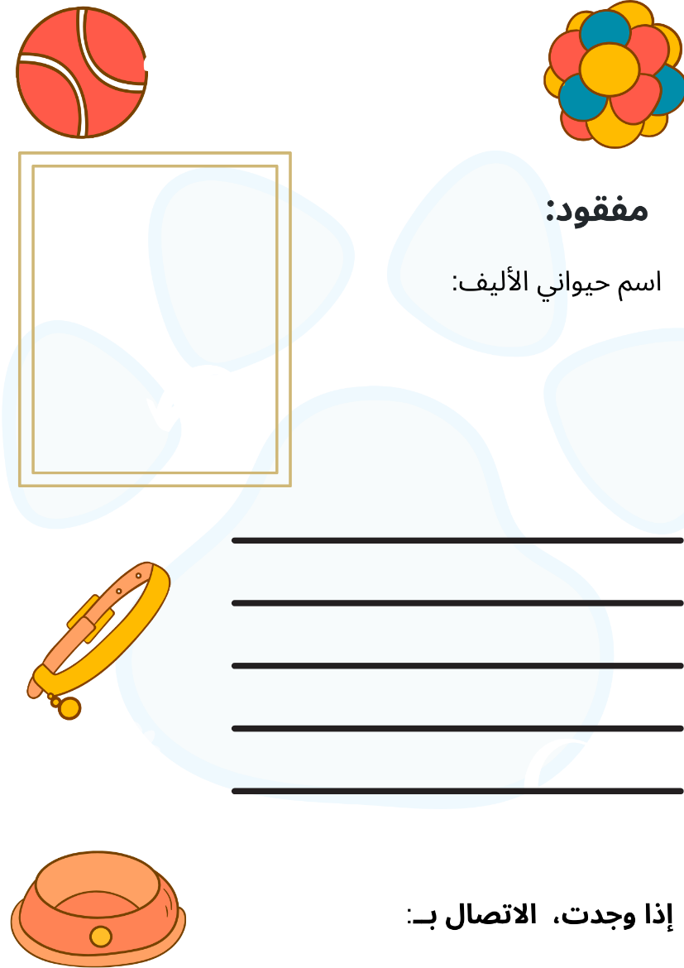
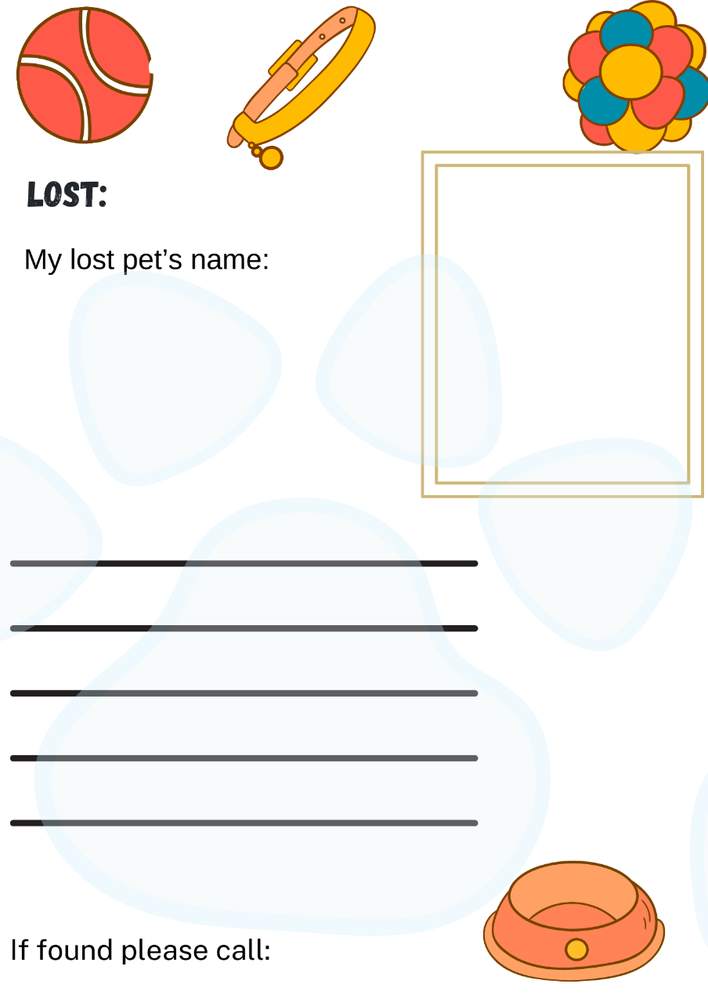

Resource 9 – question cards
This resource can be used to teach multiple languages. Use the resource link to tailor it to your preferred language.
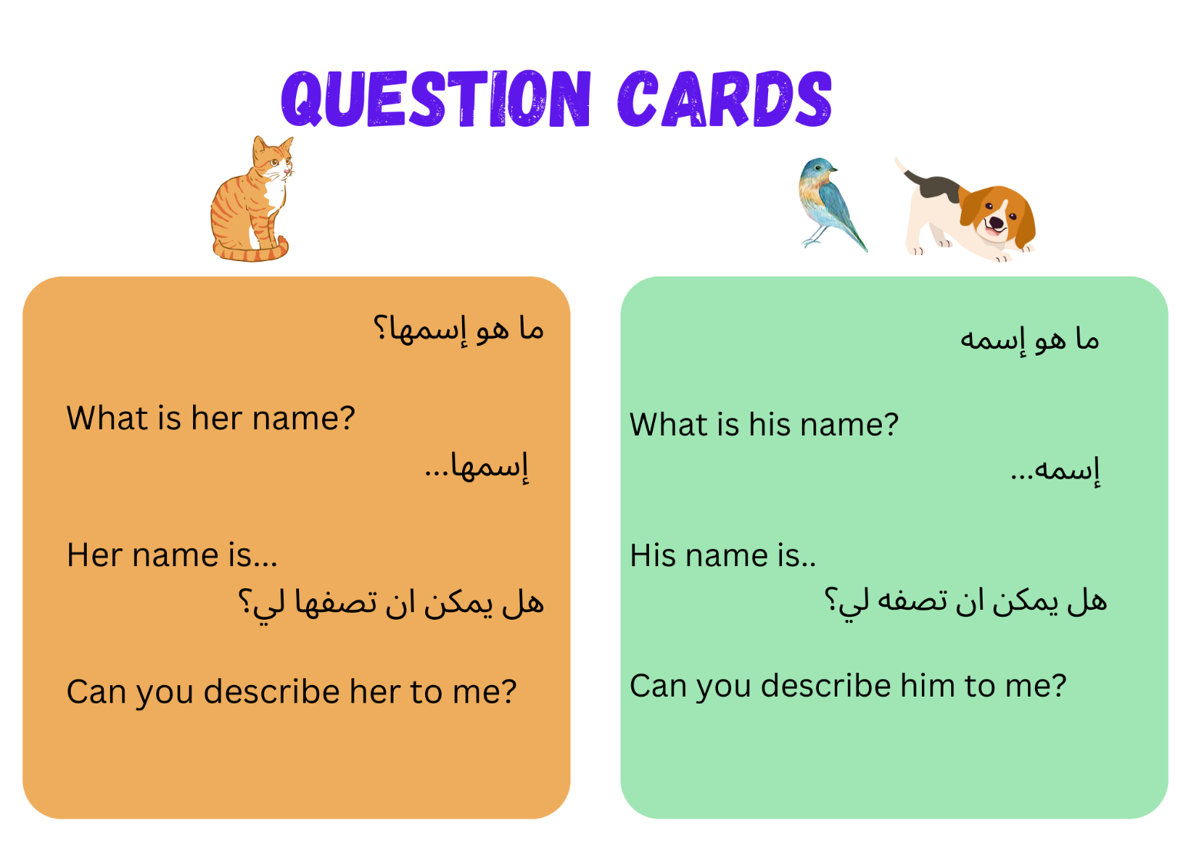

Resource 10 – assessment task – My pet is lost!

Outcomes
You will be assessed on how well you:
- exchange information in familiar contexts by selecting culturally appropriate modelled language.

Task
You have recently moved into a new neighbourhood and have lost your pet. Describe your pet in Arabic to a neighbour so they can help you find it. In your description, include details such as the name, type of animal, size, colour, and other physical features.
The table below outlines the communicative task students will need to complete.
Too hard? | Too easy?
My pet is lost!  Tell your neighbour the type of animal you have lost and its name. | My pet is lost!  Describe your lost pet in detail. Include the type of animal it is, its name, colour, size, physical features, and personality traits.

Learning intention
Students will role-play being a pet owner, describing their lost pet's name, type of animal, size, colour, and other physical features to a neighbour in Arabic.
Advanced learners
Students will provide a detailed description of their lost pet, including its name, type of animal, colour, size, other physical characteristics, and personality traits.

Success criteria
You will pretend to be an owner of a lost pet. Your task is to give a short description of your pet to a neighbour in Arabic to ask for their help in finding it.
You will be successful if you can:
- describe your pet including its name, type of animal, colour, size, and other physical features
- use grammatically correct sentences with
- the correct order of words
- correct gender agreement of nouns and adjectives
- pronounce the words correctly
- speak in a well-paced manner without long pauses.

Task instructions
For this task, you will work in groups of 3 and take turns in the following roles:
- Pet owner: describes their lost pet to the neighbour
- Neighbour: asks questions about the lost pet, such as ‘What is his/her name?’ and ‘Can you describe him/her to me?’
- Camera operator and peer assessor: record the interaction.
Following the task, you will watch a recording of yourself completing the task. You can self-assess by marking yourself on the ‘My pet is lost! assessment rubric’. Then compare the self-assessed rubric and the teacher marked rubric.
Reflect on your performance and identify areas for improvement. Use this information to set a learning goal for the next stage of your learning journey.

Resource 11 – rubric – My pet is lost!
Name:
Table 1 – marking criteria
Criteria | Excellent | Got it | Sort of | Not yet | Limited
Communication | Your audience, the neighbour, clearly understands what you want to communicate.  Successfully and thoroughly complete all of the following aspects of the task:  - describe your lost pet, including:  - its name  - type of animal  - colour  - size  - other physical features. | Your audience, the neighbour, can understand what you want to communicate.  Successfully complete all of the following aspects of the task:  - describe your lost pet, including:  - its name  - type of animal  - colour  - size  - other physical features. | Your audience, the neighbour can mostly understand what you want to communicate.  Successfully complete most of the following aspects of the task:  - describe your lost pet, including:  - its name  - type of animal  - colour  - size  - other physical features. | Your audience, the neighbour struggles to understand what you want to communicate. However, communication is successful.  Do not complete all aspects of the task. | Your audience, the neighbour is unable to understand what you want to communicate.  Unable to complete any aspect of the task.
Grammar | Always say Arabic words in the correct order when speaking:  - gender of nouns and adjectives agree. | Usually say Arabic words in the correct order when speaking:  - gender of nouns and adjectives agree. | Make some grammatical mistakes when speaking in Arabic:  - gender of nouns and adjectives agree. | Rarely make sense when speaking in Arabic. | Unable to be understood.
Pronunciation | Pronounce all words correctly. | Pronounce most words correctly. | Pronounce only a few words correctly. | Consistently make pronunciation errors. | Unable to be understood.
Fluency | Speak Arabic with ease in a well-paced manner without long pauses. | Speak confidently with appropriate speed and expression. | Usually speak confidently with appropriate speed and expression. | Does not speak confidently. | Unable to be understood.
Vocabulary | Use the full range of vocabulary correctly and use relevant words to expand on the task. | Use expected vocabulary correctly to complete the task. | Make some mistakes when trying to use expected vocabulary. | Make many mistakes when trying to use expected vocabulary. | Unable to use vocabulary in appropriate context.

Resource 12 – peer feedback strategy – Two stars and a wish
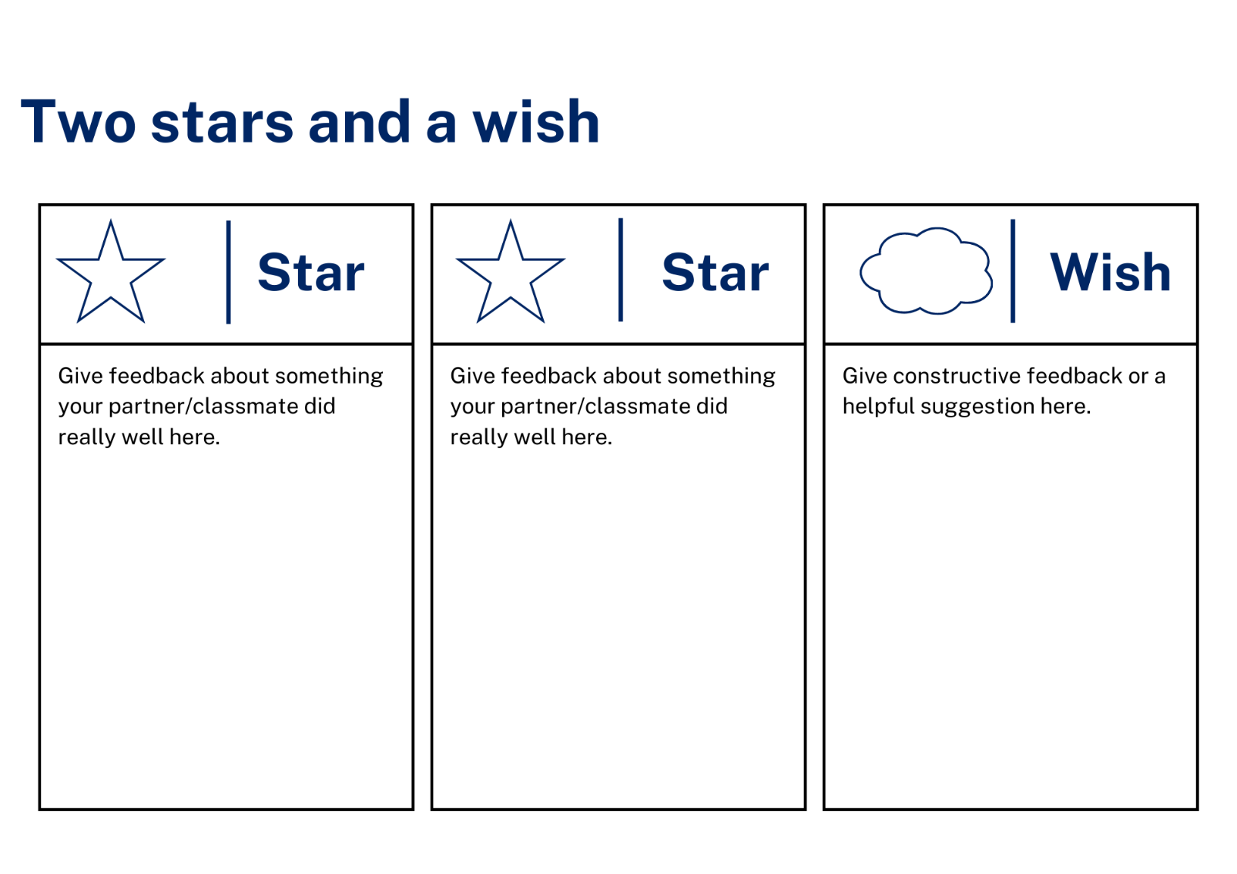

Resource 13 – roll and read card
This resource can be used to teach multiple languages. Use the resource link to tailor it to your preferred language.
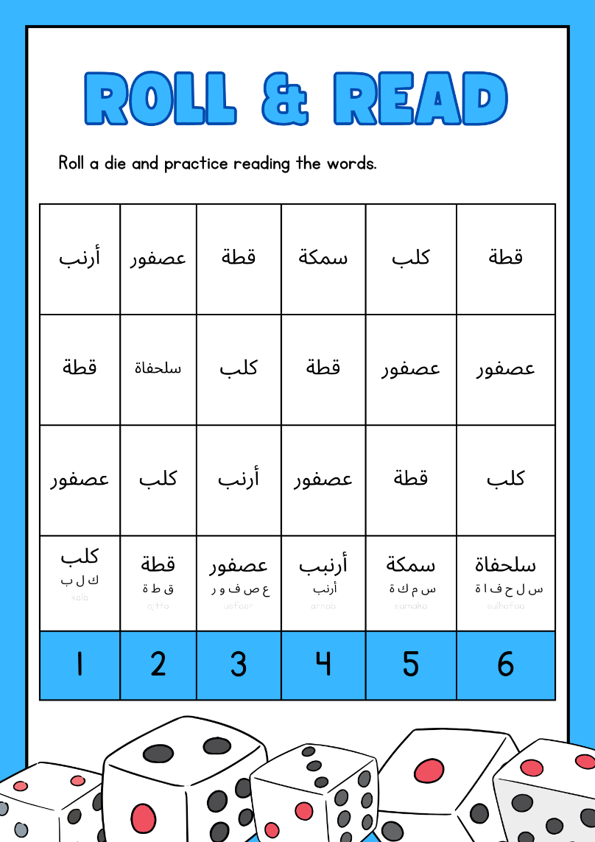
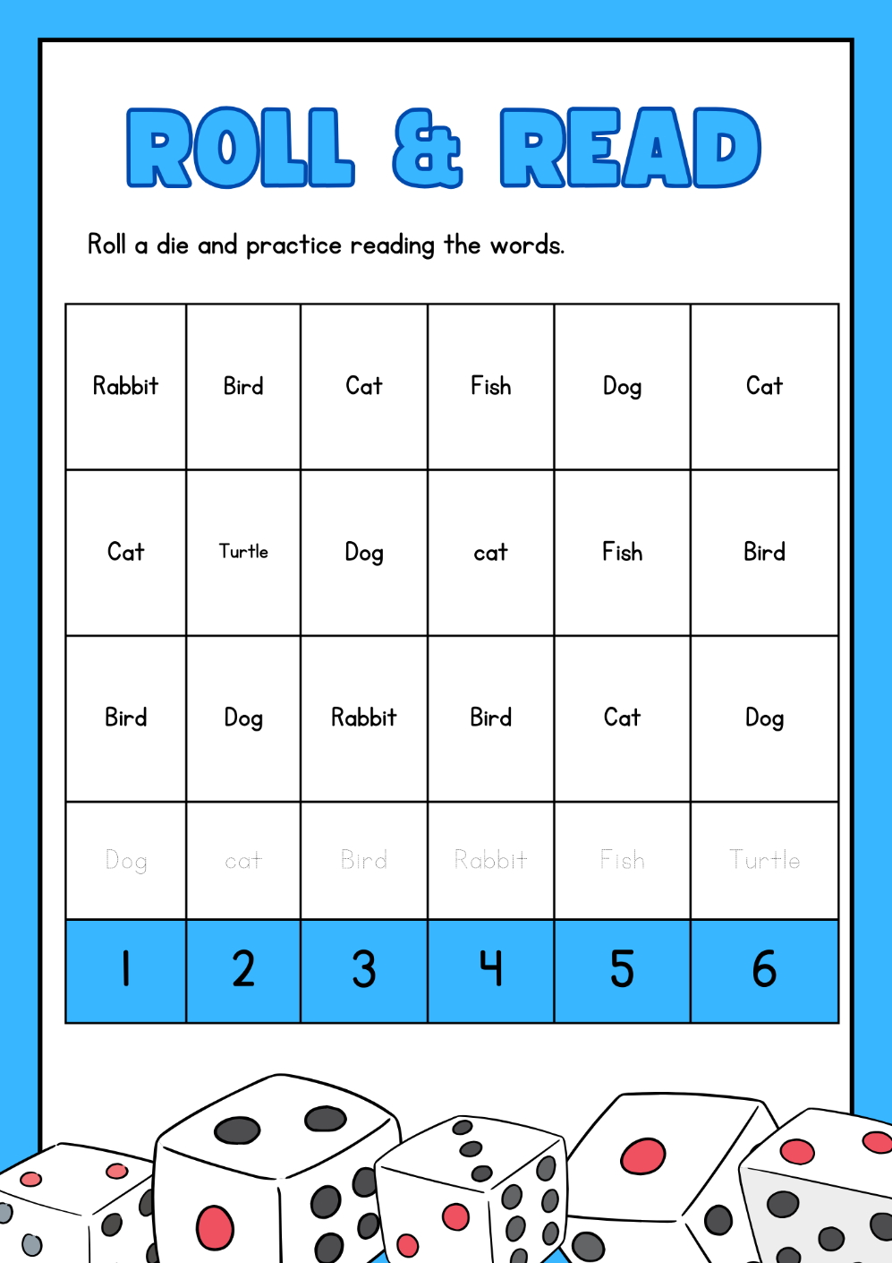

Resource 14 – roll and write card
This resource can be used to teach multiple languages. Use the resource link to tailor it to your preferred language.
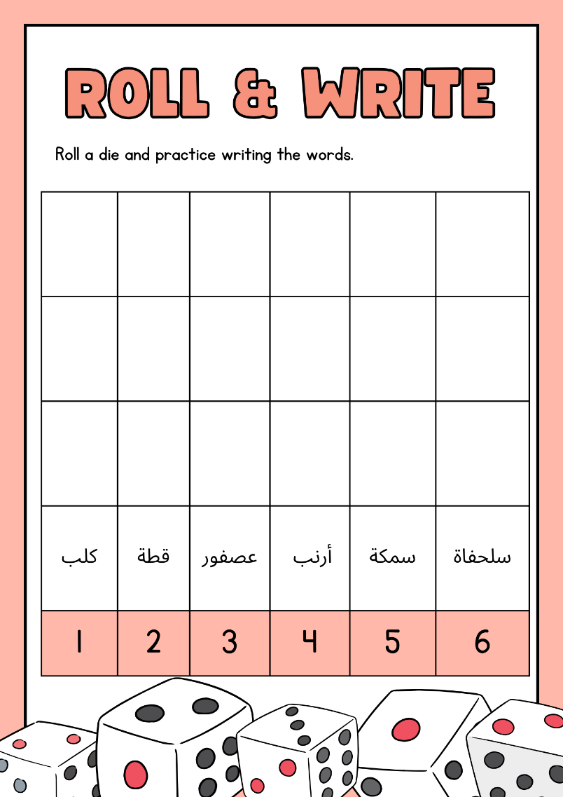
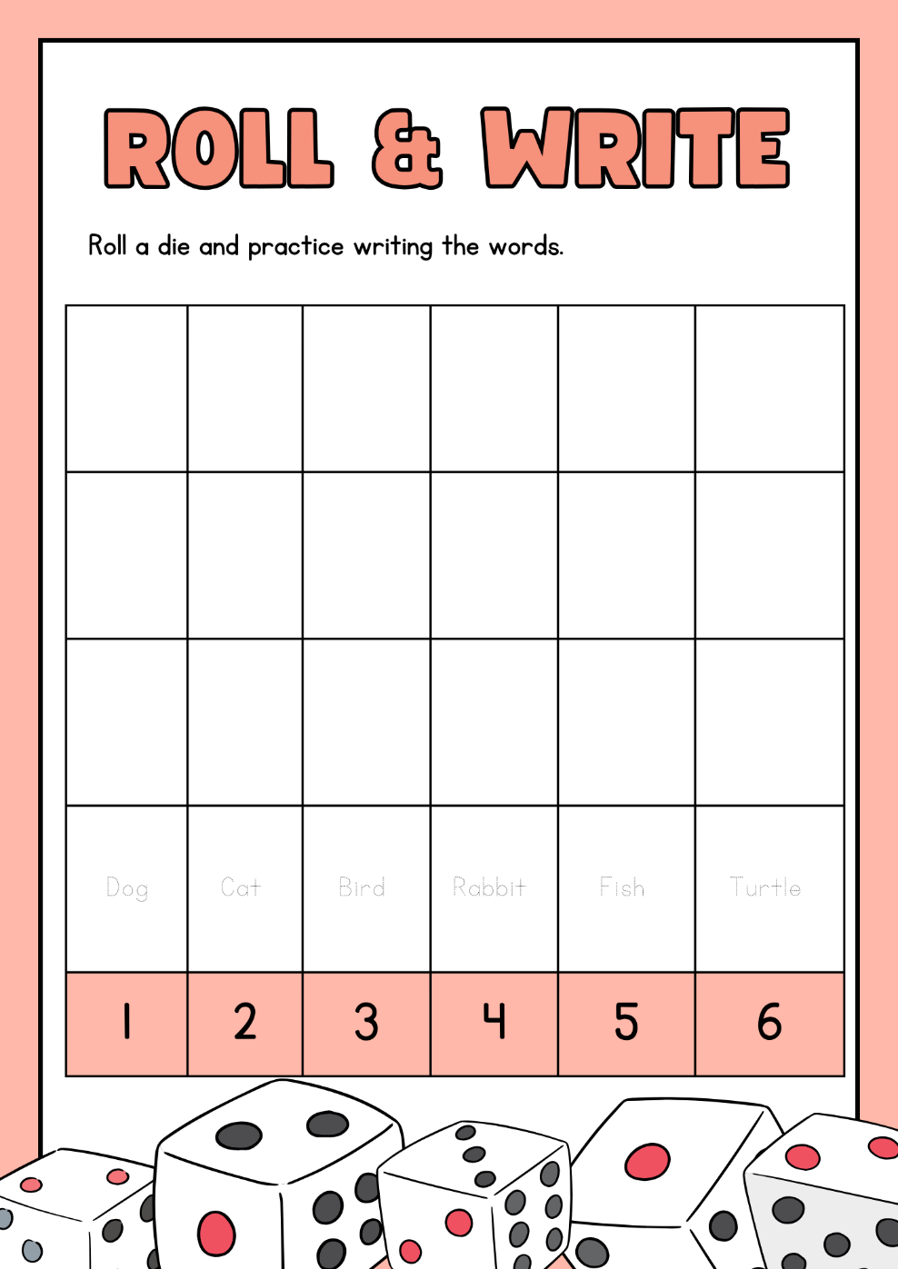

Support and alignment
Resource evaluation and support: all curriculum resources are prepared through a rigorous process. Resources are periodically reviewed as part of our ongoing evaluation plan to ensure currency, relevance, and effectiveness. For additional support or advice, contact the Primary Languages team by emailing primlang@det.nsw.edu.au.
Alignment to system priorities and/or needs: School Excellence Policy, School Success Model
Alignment to the School Excellence Framework: this resource supports the School Excellence Framework elements of curriculum (curriculum provision, teaching and learning programs) and effective classroom practice (lesson planning).
Alignment to Australian Professional Teaching Standards: this resource supports teachers to address Australian Professional Teaching Standards 2.2.2, 3.2.2.
Consulted with: Curriculum, Secondary Learners, school-based staff and NESA subject matter experts. Advice from Aboriginal Outcomes and Partnerships, EAL/D, HPGE and Inclusive Education for Modern Languages Stage 3 Italian Mangiare in Ristorante has been considered in preparing this document.
NSW syllabus: Modern Languages K–10 Syllabus
Syllabus outcomes: ML2-INT-01, ML2-UND-01, ML2-CRT-01
Author: Primary Curriculum
Publisher: State of NSW, Department of Education
Resource: unit
Related resources: further resources to support Stage 2 Modern Languages can be found on the Languages K-6 curriculum page.
Professional learning: relevant professional learning is available through Primary Languages Networks on Teams (staff only).
Universal Design for Learning: support the diverse learning needs of students using inclusive teaching and learning strategies. Some students may require more specific adjustments to allow them to participate on the same basis as their peers. For further advice see Inclusive practice resources for primary school.
Differentiation: when using these resources in the classroom, it is important for teachers to consider the needs of all students in their class, including:
- Aboriginal and Torres Strait Islander students. Targeted strategies can be used to achieve outcomes for Aboriginal students in K-12 and increase knowledge and understanding of Aboriginal histories and cultures. Teachers should use students’ Personalised Learning Pathways to support individual student needs and goals.
- EAL/D learners. EAL/D learners may require scaffolding to support them to gain content knowledge, while providing extra time and assistance to master the English language required to engage with texts or complete classroom tasks. View some samples of differentiating through scaffolding.
- Students with additional learning needs. Learning adjustments enable students with disability and additional learning and support needs to access syllabus outcomes and content on the same basis as their peers. Teachers can use a range of adjustments to ensure a personalised approach to student learning.
- High potential and gifted learners. Assessing and identifying high potential and gifted learners will help teachers decide which students may benefit from extension and additional challenge. In addition, the Differentiation Adjustment Tool can be used to support the specific learning needs of high potential and gifted students.
Creation date: 12 October 2023
Rights: © State of New South Wales, Department of Education

References
This resource contains NSW Curriculum and syllabus content. The NSW Curriculum is developed by the NSW Education Standards Authority. This content is prepared by NESA for and on behalf of the Crown in right of the State of New South Wales. The material is protected by Crown copyright.
Please refer to the NESA Copyright Disclaimer for more information https://educationstandards.nsw.edu.au/wps/portal/nesa/mini-footer/copyright.
NESA holds the only official and up-to-date versions of the NSW Curriculum and syllabus documents. Please visit the NSW Education Standards Authority (NESA) website https://educationstandards.nsw.edu.au/ and the NSW Curriculum website https://curriculum.nsw.edu.au/home.
Modern Languages K–10 Syllabus © NSW Education Standards Authority (NESA) for and on behalf of the Crown in right of the State of New South Wales, 2022.
8 Ways (n.d.) 8 Aboriginal Ways of Learning [website], accessed 13 December 2022.
AITSL (Australian Institute for Teaching and School Leadership (2017) ‘Feedback Factsheet’, AITSL, accessed 21 March 2023.
Brookhart SM (2011) How to Assess Higher-Order Thinking Skills in Your Classroom, Hawker Brownlow Education, Victoria.
CESE (Centre for Education Statistics and Evaluation) (2020a) What works best: 2020 update, NSW Department of Education, accessed 21 March 2023.
CESE (Centre for Education Statistics and Evaluation) (2020b) What works best in practice, NSW Department of Education, accessed 21 March 2023.
Conti G (28 September 2015) ‘16 tips for effective grammar teaching in the foreign language classroom’, The Language Gym, accessed 21 March 2023.
Conti G (28 May 2017) From Target Language to Model Language – the mind shift that has transformed my teaching, The Language Gym, accessed 10 March 2023.
Henshaw FG and Hawkins MD (2022) Common Ground: Second Language Acquisition Theory Goes to the Classroom, Focus, Indianapolis, accessed 10 March 2023.
Jones J and Wiliam D (2014) Modern Foreign Languages Inside the Black Box: Assessment for Learning in the Modern Foreign Languages Classroom (Black P, Harrison C, Marshall B and Wiliam D, eds), Learning Sciences International, United States.
NESA (NSW Education Standards Authority) (2020) ‘NSW Curriculum Review – final report’, NESA, accessed 10 March 2023.
Rosenshine B (2012) ‘Principles of Instruction: Research-Based Strategies That All Teachers Should Know’, American Educator, 36(1):12–19, 39, accessed 10 March 2023.
Smith S (2022) Becoming an Outstanding Languages Teacher, 2nd edn, Routledge, United Kingdom.
Wisniewski B, Zierer K and Hattie J (2020) ‘The Power of Feedback Revisited: A Meta-Analysis of Educational Feedback Research’, Frontiers In Psychology, 10(3087), doi:10.3389/fpsyg.2019.03087, accessed 10 March 2023.
Wiliam D (2013) ‘Assessment: The Bridge between Teaching and Learning’, Voices from the Middle, 21(2):15–20, accessed 10 March 2023.
Wiliam D and Leahy S (2015) Embedding Formative Assessment: Practical Techniques for K–12 Classrooms, Learning Sciences International, United States.

© State of New South Wales (Department of Education), 2023
The copyright material published in this resource is subject to the Copyright Act 1968 (Cth) and is owned by the NSW Department of Education or, where indicated, by a party other than the NSW Department of Education (third-party material).
Copyright material available in this resource and owned by the NSW Department of Education is licensed under a Creative Commons Attribution 4.0 International (CC BY 4.0) license.
This licence allows you to share and adapt the material for any purpose, even commercially. Attribution should be given to © State of New South Wales (Department of Education), 2023.
Material in this resource not available under a Creative Commons licence:
- the NSW Department of Education logo, other logos and trademark-protected material
- material owned by a third party that has been reproduced with permission. You will need to obtain permission from the third party to reuse its material.
Links to third-party material and websites
Please note that the provided (reading/viewing material/list/links/texts) are a suggestion only and implies no endorsement, by the New South Wales Department of Education, of any author, publisher, or book title. School principals and teachers are best placed to assess the suitability of resources that would complement the curriculum and reflect the needs and interests of their students.
If you use the links provided in this document to access a third-party's website, you acknowledge that the terms of use, including licence terms set out on the third-party's website apply to the use which may be made of the materials on that third-party website or where permitted by the Copyright Act 1968 (Cth). The department accepts no responsibility for content on third-party websites.

