Hindi Stage 1
मैंने जंगल में क्या देखा? (Who did I see at the zoo?)

Contents
Assessment opportunities 14
Week 1 – animals 15
Activity 1 – Learning map 16
Vocabulary 1 – animals 16
Activity 2 – animals – pre-assessment 17
Activity 3 – bingo 18
Activity 4 – cultural significance of animals 18
Activity 5 – recording new language 19
Week 2 – colours and size of animals 20
Vocabulary 2 – colours 21
Vocabulary 3 – size 22
Activity 1 – introduce vocabulary 23
Activity 2 – four corners 23
Activity 3 – what’s this? 24
Activity 4 – jumble up! 25
Activity 5 – trace and write 25
Week 3 – sentence builder 26
Activity 1 – make a sentence 26
Activity 2 – pass the parcel 28
Activity 3 – do you remember? 28
Week 4 – questions and answers 30
Activity 1 – what did you see? 31
Activity 2 – puppet pals explore the zoo 31
Activity 3 – recording new language 32
Activity 4 – exit ticket 32
Week 5 – assessment criteria and practice task 34
Activity 1 – discuss the assessment task 34
Activity 2 – success criteria 35
Activity 3 – colourful creatures 35
Activity 4 – practice task – jumbled up modelled sentence 36
Week 6 – communicative task – write a page for the book Who did I see at the zoo? 37
Activity 1 – vocabulary race 37
Activity 2 – communicative task – write a page for the book Who did I see at the zoo? 38
Activity 3 – peer feedback 38
Week 7 – feedback and goal setting 39
Activity 1 – draw and guess 39
Activity 1 – self-assessment 40
Activity 2 – set learning goals 40
Activity 3 – read the class book Who did I see at the zoo? 41
Week 8 – language review 42
Activity 1 – student questions 43
Activity 2 – animals 43
Activity 3 – colours and size 44
Activity 4 – let’s build 44
Activity 5 – reading corner 44
Resource 1 – animal flashcards 45
Resource 2 – bingo mat 47
Resource 3 – colours flashcards 48
Resource 4 – size flashcards 50
Resource 5 – trace and write 51
Resource 6 – sentence builder 55
Resource 7 – student rubric 56
Resource 8 – peer feedback strategy – Two stars and a wish 57

Unit overview
Stage: 1
Title: मैंने जंगल में क्या देखा? (Who did I see at the zoo?)
Description: In this unit, students create a page describing an animal in the class book, ‘Who did I see at the zoo?’
Duration: This lesson sequence is designed to be completed over approximately 8 weeks.
Student proficiency levels: It is assumed that most Stage 1 students have been learning Hindi since Kindergarten and their proficiency level will still be Beginner. The assessment tasks in this scope and sequence are aimed at beginner students. Every classroom will be different and teachers will need to adapt to their context. Many classes may include a combination of Beginner, Intermediate and Advanced students with varying skills and abilities within these proficiency levels. Assessment tasks and opportunities in this unit can be differentiated using the ‘Too hard?’ and ‘Too easy?’ suggestions.

Stage 1 outcomes and content to be addressed
The table below outlines the focus area, outcomes and content points for Stage 1 students.
Focus area and outcome | Content points
Interacting  A student:  - exchanges meaning by selecting culturally appropriate modelled language ML1-INT-01 | Exchanging meaning in oral interactions in the target language  - Exchange greetings, farewells and simple information to describe people or objects  - Answer common questions about themselves and their personal world in a guided conversation  - Express simple emotions and preferences  - Interact in classroom routines using familiar language  - Interact by selecting modelled language in games or scenarios using imagination  Reproducing oral language to interact in the target language  - Recognise and reproduce modelled sounds, including pronunciation and intonation patterns to interact  - Reproduce familiar vocabulary and short formulaic phrases to interact  Applying knowledge of the target language culture(s) to interact  - Use familiar verbal and nonverbal communication that is appropriate to cultural practices
Understanding texts  A student:  - recognises and responds to information in simple texts to demonstrate understanding ML1-UND-01 | Understanding and responding to target language texts  - Follow instructions  - Listen to, read and/or view simple texts such as stories, songs, charts, rhymes or lists on familiar themes  - Use auditory cues, gestures, visuals and other forms of nonverbal communication to support comprehension  - Associate vocabulary on familiar themes with known actions, people, places, objects and ideas  - Recognise information in simple texts and respond to simple questions in the target language and/or English to show understanding of texts  - Demonstrate understanding when responding to texts using actions, drawing, singing or simple exchanges in the target language and/or English  Applying knowledge of language systems to understand and respond to target language texts  - Recognise and use sounds of modelled vocabulary and phrases to understand and respond to texts  - Recognise sound–symbol correspondences in modelled words and phrases to understand and respond to texts  - Recognise and use knowledge of modelled vocabulary, high-frequency words and formulaic phrases on familiar themes to understand and respond to texts  - Use simple grammar patterns to understand and respond to texts  - Recognise that the target language has features that may be similar to or different from English  - Recognise and reproduce symbols or modelled vocabulary and phrases of the writing system to understand and respond to texts  Developing intercultural understanding through target language texts  - Notice that language is used in ways that reflect cultural practices and reflect on their own language and cultural practices
Creating texts  A student:  - creates simple texts by selecting culturally appropriate modelled language ML1-CRT-01 | Creating spoken, written and multimodal texts in the target language  - Create texts using familiar vocabulary, phrases and visuals to express meaning  - Create a simple sentence about themselves and their personal world to express ideas and/or give descriptive information  - Label or describe objects and images  Applying knowledge of language systems to create texts in the target language  - Use pronunciation patterns to create spoken texts  - Use familiar sound–symbol correspondences to create written texts  - Use familiar vocabulary and formulaic phrases to create texts  - Use simple modelled sentence structures to create texts  - Reproduce modelled features of the target language writing system to create written texts  Reproducing how target language speakers communicate to create texts  - Reproduce language appropriate to cultural practices to create texts
Modern Languages K–10 Syllabus © NSW Education Standards Authority (NESA) for and on behalf of the Crown in right of the State of New South Wales, 2022.

Learning map
The creation of maps for learning is a planning process that incorporates Aboriginal intellectual tradition. Learning maps are a visual pathway of what students will learn.
Share the learning map with your students, briefly explaining the learning that will happen in each lesson. Provide students with a copy of the learning map or display the learning map in the classroom. This learning map can be adapted to Hindi by accessing a copy of Learning map – Who did I see at the zoo? (Stage 1).

Figure 1 – Who did I see at the zoo? learning map
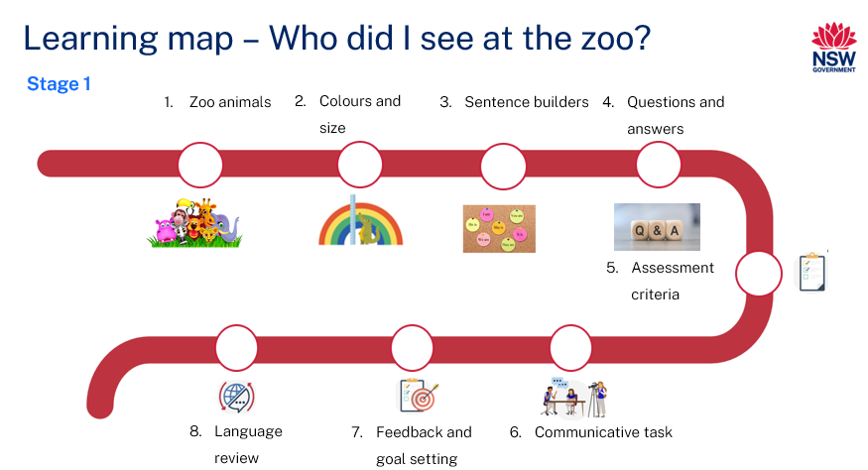
Figure 2 – मैंने जंगल में क्या देखा? learning map
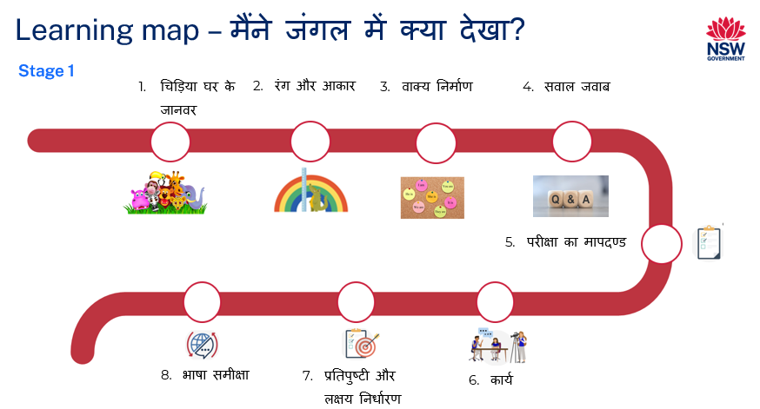

Assessment
Stage 1 communicative task: Your class is writing a book called ‘Who will I see at the zoo?’ Create a page describing an animal in the book. The book will be read aloud to Kindergarten students.
Too hard?
Write the name of and illustrate a zoo animal.
Too easy?
Include descriptions of more than one zoo animal on your page.
Context: students contribute to a class book on animals in Hindi
Audience: Kindergarten students
Purpose: to support language learning for Kindergarten

Assessment opportunities
The table below details assessment opportunities and differentiation ideas.
Assessment opportunities | Too hard? | Too easy?
Week 2 – what’s this?  Students respond to a question using ‘this is a…’ phrase and name the animal and its size. | What’s this?  Respond by saying the size and the name of an animal. | What’s this?  Show pictures of 2 animals at a time. Students include the size and names of 2 animals in a compound sentence.
Week 3 – make a sentence  Students make a sentence using Resource 6 – sentence builder. | Make a sentence  Write a simple sentence to include a phrase and the name of an animal. | Make a sentence  Write sentences using all phrases in Resource 6 – sentence builder and use conjunctions.
Week 4 – puppet pals explore the zoo  Students practise sentence structures using puppets to ask and answer questions about what they saw in the zoo. | Puppet pals explore the zoo  Respond by naming the animal and its colour. | Puppet pals explore the zoo  Use conjunctions to include names of 2 animals, their size and colour in one sentence.

Teaching and learning activities

Week 1 – animals
The table below outlines the learning intention and success criteria of the lesson, and materials that the teacher and students will need to complete the teaching and learning activities.
Learning intention and success criteria | Materials
Students will communicate words and phrases related to animals in Hindi.  Students can:  - name animals in Hindi  - say and write words in Hindi. | - Resource 1 – animal flashcards  - Resource 2 – bingo mat  - Who did I see in the jungle? PowerPoint book (Hindi)  - Who did I see in the jungle? PowerPoint book (English)  - Counters  - Language exercise books  - Writing and drawing materials

Activity 1 – Learning map
Explain and display the Learning map to give students a more detailed breakdown of lessons during the unit. Point out that the Learning map is a plan that may need to change.

Vocabulary 1 – animals
The table below outlines suggested vocabulary for this learning sequence. It includes the original Hindi script, a Romanised version of the Hindi script, and the corresponding English translations.
English | Romanised Hindi | Hindi
lion | sher | शेर
elephant | hathi | हाथी
deer | hiran | हिरन
monkey | bandar | बंदर
cheetah | cheetah | चीता
peacock | mor | मोर
tiger | bagh | बाघ
giraffe | giraffe | जिराफ़
bear | bhaaloo | भालू
crocodile | magarmachh | मगरमच्छ

Activity 2 – animals – pre-assessment
Have students sit on the floor and read the PowerPoint book Who did I see in the jungle? Ask the following questions to assess students’ prior knowledge, answering by responding or showing thumbs up at their chests:
- Can you tell me what this story is about?
- Do you know the names of all the animals in Hindi?
- Do you know most of them?
- Do you know some of them?
- Do you know any of them?
In pairs, students Think-Pair-Share the words they know.
Point to different animals students can see in the book. Display the images in Resource 1 – animals flashcards on one side of the board. As a class, match words to pictures one at a time. After each match, model and drill the correct pronunciation of vocabulary.
Note: display vocabulary on the wall. Add new and known words in Hindi as required.

Activity 3 – bingo
- Play a communicative language learning game such as ‘Bingo!’ to practise using animal names in Hindi. Display Resource 1 – animal flashcards and have students create a bingo card by writing names of 6 animals in Hindi on Resource 2 – bingo mat.
- Lead a whole class game by reading aloud the names of animals in Hindi, demonstrating the correct pronunciation.
- Provide a handful of counters to each student. Every time you call the name of an animal in Hindi, students place a counter on that animal. The students listen to the words being called. If the word called is on their bingo card, they cover or mark the word with a counter. The winner is the first to get a whole row of counters.
- Students then play in groups of 5 or 6, taking turns to be the bingo caller. Some students may need assistance with pronunciation.

Activity 4 – cultural significance of animals
Note: access ‘Panchatantra stories’ online if a hard copy of the book is not available.
Have students sit in a circle. Discuss the cultural and national significance of certain animals, such as monkeys, tigers, peacocks, cows and so on in India. For example, the peacock is the national bird, the tiger (Royal Bengal tiger) is the national animal. Explain that cultural values and lessons were traditionally taught through Panchatantra stories. Read a story from the book or play an animated version of the story online.

Activity 5 – recording new language
Students record Vocabulary 1 – animals in their Hindi exercise books.

Week 2 – colours and size of animals
The table below outlines the learning intention and success criteria of the lesson, and materials that the teacher and students will need to complete the teaching and learning activities.
Learning intention and success criteria | Materials
Students will communicate words and phrases related to colours and size of animals in Hindi.  Students can:  - say and write colours in Hindi  - say and write the size of an animal in Hindi. | - Resource 1 – animal flashcards  - Resource 3 – colours flashcards  - Resource 4 – size flashcards  - Resource 5 – trace and write  - Who did I see in the jungle? book  - Hindi exercise books  - Glue stick  - Writing and drawing materials

Vocabulary 2 – colours
The table below outlines suggested vocabulary for this learning sequence. It includes the original Hindi script, a Romanised version of the Hindi script, and the corresponding English translations.
English | Romanised Hindi | Hindi
red | laal | लाल
green | hara | हरा
blue | neela | नीला
yellow | peela | पीला
pink | gulabi | गुलाबी
orange | narangi | नारंगी
purple | baingani | बैंगनी
black | kaala | काला
white | safed | सफ़ेद
grey | saleti | सलेटी

Vocabulary 3 – size
The table below outlines suggested vocabulary for this learning sequence. It includes the original Hindi script, a Romanised version of the Hindi script, and the corresponding English translations.
English | Romanised Hindi | Hindi
big | barra | बड़ा
small | chhota | छोटा
tall | lambaa | लंबा
short | thhigana | ठिगना

Activity 1 – introduce vocabulary
- To pre-assess students’ vocabulary before teaching new words, ask students to turn to a partner and tell them any colours they know in Hindi using the Think-Pair-Share strategy.
- Display Resource 3 – colours flashcards on the board. Call out each word on the board and ask students to show thumbs up at their chest when they are familiar with a colour. Do the same with Resource 4 – size flashcards to pre-assess students’ vocabulary for size.
- Read aloud the Hindi colours using Resource 3 – colours flashcards and have students repeat each word after you call them out.
- Read aloud the size vocabulary using Resource 4 – size flashcards and have students repeat each word after you call them out. Model and drill the correct pronunciation for colours and size of animals.

Activity 2 – four corners
Choose any 4 colours and name each corner of the classroom with a colour. For example, corner 1 is लाल (red), corner 2 is हरा (green) and so on. Stick names of colours in Hindi around the 4 corners and play some music. When the music stops, call out the colour and students go to the called-out colour corner. Continue the game with different colours and play it for 3 to 4 minutes.
Note: this activity can be differentiated by reading the book Who did I see in the jungle? When students hear a colour that is called out, they move to the right colour corner. This game can also be used to revise Vocabulary 1 – animals and Vocabulary 2 – colours. Ensure there is enough room for students to move and play this game.

Activity 3 – what’s this?
Show pictures of an animal using Resource 1 – animal flashcards. Use Vocabulary 1 – animals and Vocabulary 3 – size to model correct pronunciation to describe the animal, for example, बड़ा हाथी (big elephant), छोटा बंदर (small monkey), and लंबा गिराफ़ (tall giraffe). Students repeat the phrases and practise correct pronunciation.
Read Who did I see in the jungle? and ask students about the size of an animal featured in the text. While reading, model and drill the correct pronunciation and vocabulary of animals and sizes. Display pictures of Resource 1 – animal flashcards one at a time. Display Resource 4 – size flashcards on the board. Tell students that, when you ask them a question about the displayed animal (for example, यह क्या है? What is this?), they should respond by saying यह एक (आकार) (जानवर) है । (This is a [size] [animal]). Introduce ‘this is a’ phrase and practise the interaction with the first couple of animals.
Suggested interaction:
- Teacher: यह क्या है? What is this? (Show picture of an elephant)
- Student: यह एक बड़ा हाथी है। This is a big elephant.
- Teacher: यह क्या है? What is this? (Show picture of a monkey)
- Student: यह एक छोटा बंदर है। This is a small monkey.
Divide the class into pairs. Students practise the conversation with each other using Resource 1 – animal flashcards.

Activity 4 – jumble up!
Note: create jumbled words using Vocabulary 2 – animals and Vocabulary 3 – size lists prior to the lesson.
Display jumbled up letters for colour and size on the board and explain that each of these words are a colour or a size of the animals students have seen in the text. Explain that the letters are all jumbled up.
Give students a strip of one word and ask them to cut each letter. Once all the letters are cut, students unjumble the letters to make the correct word. After students unjumble the letters, their partner checks their work. Students then paste the words in their books.

Activity 5 – trace and write
Students use Resource 5 – trace and write to practise their writing.

Week 3 – sentence builder
The table below outlines the learning intention and success criteria of the lesson, and materials that the teacher and students will need to complete the teaching and learning activities.
Learning intention and success criteria | Materials
Students write a simple sentence to describe an animal.  Students can:  - write simple sentences  - describe the colour and size of an animal. | - Resource 1 – animal flashcards  - Resource 3 – colours flashcards  - Resource 5 – trace and write  - Resource 6 – sentence builder  - Who did I see in the jungle? book  - Hindi exercise books  - Writing and drawing materials

Activity 1 – make a sentence
- Read the book Who did I see in the jungle? and have a look at each sentence carefully. Ask students if they can identify any patterns on each page. Anticipated responses include the colours and sizes of different animals.
- Emphasise how each sentence is getting longer when you add in adjectives (size and colour) to describe the animal. For example:
- यह एक हाथी है । (This is an elephant).
- यह एक बड़ा हाथी है। (This is a big elephant).
- यह एक बड़ा सलेटी हाथी है। (This is a big grey elephant).
- Explain that in the last sentence the elephant is described as ‘big’ and ‘grey’. Tell them that these words are adjectives, which describe the elephant. Tell students that a sentence in Hindi always ends in a ‘verb’. In this example, ‘is’ is a verb which translates to है (hai) in Hindi. Point to the last word in Hindi sentence है (hai). Tell them that it is a verb. Demonstrate the order of words in Hindi using the above examples. The order of words to form a sentence in Hindi is Subject (S) + Object (O) + Verb (V). The suggested acronym to remember the order is SOV. Adjectives are added before object (usually a noun) to describe the object.
- Discuss the similarities and differences between sentence structures in English and Hindi.
- Revise यह एक … (this is a…) phrase from the previous lesson. Model and drill the correct pronunciation of the phrase followed by the name of an animal. Demonstrate making a sentence using Resource 6 – sentence builder. Add on to the sentence by including the size of the animal and then colour. For example:
- यह एक बंदर है । (This is a monkey).
- यह एक छोटा बंदर है । (This is a small monkey).
- यह एक छोटा भूरा बंदर है। (This is a small brown monkey).
- In pairs, students use Resource 6 – sentence builder to make and say their own sentences starting with the phrase and then choosing an appropriate size and colour which matches the chosen animal. They take turns to tell their sentence to each other.
- Students write the sentences that they have made in their Hindi exercise books.
Note: allow students to create silly sentences using the correct word order.

Activity 2 – pass the parcel
Note: Resource 5 – trace and write can be used as flashcards for this activity.
Cut Resource 5 – trace and write and mix the cards up. Have students describe the animal by its colour and name. Place all the flashcards in a box. Play the music and pass the box. When the music stops, the student holding the box must pick out a flashcard and say the phrase.

Activity 3 – do you remember?
- Demonstrate the activity as a whole class. Have 3 students come to the front of the class to demonstrate the game to the whole class. Give 2 of these students a picture of an animal each from Resource 1 – animal flashcards. Revise ‘यह एक… (this is a…)’ and have students practise the phrase by saying what they are holding including its size and colour, for example:
- Student 1 – यह एक बड़ा सलेटी हाथी है। (This is a big grey elephant).
- Student 2 – यह एक लंबा पीला गिराफ़ है। (This is a tall yellow giraffe).
- Ask Students 1 and 2 to hide the cards and have Student 3 try to recall who has what by repeating the other players’ cards. For example, Student 1 has बड़ा सलेटी हाथी (big grey elephant), Student 2 has लंबा पीला गिराफ़ (tall yellow giraffe). Student 3 recalls their cards.
- Split the class into groups of 3 students. Have them play the game in their groups. Students start the game by recalling and saying the name of the animal. After 2 minutes, ask students to include the colour of the animal. For example, यह एक पीला गिराफ़ है । (This is a yellow giraffe), यह एक सलेटी हाथी है । (This is a grey elephant), यह एक भूरा बंदर है । (This is a brown monkey). Students play the game for another 2 minutes.
- Ask the students to include the size and colour of the animal on their card. For example, यह एक लंबा पीला गिराफ़ है। (This is a tall yellow giraffe), यह एक बड़ा सलेटी हाथी है। (This is a big grey elephant), यह एक छोटा भूरा बंदर है । (This is a small brown monkey).

Week 4 – questions and answers
The table below outlines the learning intention and success criteria of the lesson, and materials that the teacher and students will need to complete the teaching and learning activities.
Learning intention and success criteria | Materials
Students will answer questions about animals in Hindi.  Students can:  - answer Hindi questions correctly  - respond to the question using correct word order in Hindi. | - Resource 1 – animal flashcards  - Resource 3 – colours flashcards  - Who did I see in the jungle?  - Bean bags  - Glue sticks  - Hand puppets  - Language exercise books  - Writing and drawing materials

Activity 1 – what did you see?
Have students sit in a circle. Hold one of the flashcards from Resource 1 – animal flashcards in front of the students. Point to the flashcard and then turn it over. Ask the question तुमने क्या देखा? (What did you see?) Ask students to repeat the question. Model the answer by saying मैंने एक (जानवर) देखा । (I saw a [name of the animal on the flashcard]). Have students repeat the response. Model and drill the correct pronunciation. Pull out another animal flashcard and students begin by asking तुमने क्या देखा? (What did you see?) Model the answer by saying मैंने एक बंदर देखा । (I saw a monkey). Gently toss a bean bag to a student in the circle and ask (What did you see?). The student with the bean bag says मैंने एक (जानवर) देखा । (I saw a [animal on the flashcard]) before tossing the bean bag to another student and asking (What did you see?). Once everyone has had a turn, add चिड़ियाघर में (in the zoo) to the question. For example, तुमने चिड़ियाघर में क्या देखा? (What did you see in the zoo?) Model answer again by saying, मैंने चिड़ियाघर में एक (जानवर) देखा । (I saw [animal] in the zoo). Repeat the process, with students saying a different animal every time.

Activity 2 – puppet pals explore the zoo
Introduce hand puppets and explain that students will use them to practise the vocabulary. Model how to use a hand puppet and review phrases in Resource 6 – sentence builder. In pairs, students practise asking and responding to questions in Hindi. Ask each pair to use their puppet to ask their partner a question, तुमने चिड़ियाघर में क्या देखा? (What did you see in the zoo?) and the other student answers by saying, मैंने चिड़ियाघर में एक बड़ा पीला शेर देखा । (I saw a big yellow lion in the zoo). Students swap roles to make sure that each student has a turn to ask and answer a question. Students use the learned from Vocabulary 2 and Vocabulary 3 to expand on their responses.
Suggested interactions:
- Student 1 – तुमने चिड़ियाघर में क्या देखा? (What did you see in the zoo?)
- Student 2 – मैंने चिड़ियाघर में एक बड़ा पीला शेर देखा । (I saw a big yellow lion in the zoo.)
Note: this activity can be differentiated for students with Advanced proficiency levels by asking students to include 2 animals in their sentence and use conjunctions. For example, मैंने चिड़ियाघर में एक बड़ा सलेटी हाथी और लंबा पीला गिराफ़ देखा । (I saw a big grey elephant and a tall yellow giraffe in the zoo).

Activity 3 – recording new language
Students record the sentences in their language exercise books using Vocabulary 1 – animals, Vocabulary 2 – colours and Vocabulary 3 – size and Resource 6 – sentence builder.

Activity 4 – exit ticket
To assess students’ understanding of sentence structure, divide the board into 4 sections and ask students to write a phrase, colour, size, and an animal on 4 different sticky notes.
As students leave the class, have them stick their note in the correct order to make a simple sentence on the board. For example, यह एक लंबा पीला गिराफ़ है । (This is a tall, yellow giraffe); मैंने चिड़ियाघर में एक छोटा भूरा हिरण देखा । (I saw a small, brown deer in the zoo).
Figure 3 – exit ticket example
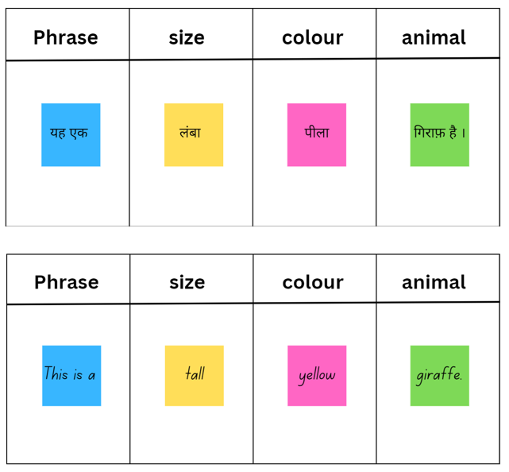

Week 5 – assessment criteria and practice task
The table below outlines the learning intention and success criteria of the lesson, and materials that the teacher and students will need to complete the teaching and learning activities.
Learning intention and success criteria | Materials
Students will develop an understanding of the requirements of the assessment task.  Students can:  - say what they need to do to be successful in the task  - ask questions if they don't understand the requirements of the assessment task. | - Learning map  - Paper  - Writing materials

Activity 1 – discuss the assessment task
To prepare students for the final task, review the Learning map and discuss the language that has been taught each week. Point out that, according to the learning map, the final task will be completed in Week 6. Explain to students that they will be writing a page in the story Who did I see at the zoo? Explain that students will describe the animal they saw at the zoo using colour and size. All the pages will be collated into a class book which will be read to Kindergarten Hindi students.

Activity 2 – success criteria
After looking at the assessment task, students Think-Pair-Share and suggest appropriate success criteria, such as:
I will be successful if I can:
- write a simple sentence in Hindi
- describe an animal in Hindi
- use the correct order of words when speaking and writing a sentence in Hindi
- say and write the words for animals, colours and size in Hindi.

Activity 3 – colourful creatures
Students play a communicative game of ‘colourful creatures’ to practise saying sentences in Hindi. Explain that they will be guessing the name of the animal described. Demonstrate the game to the whole class. Have one student come to the front and pick a card from Resource 1 – animals flashcards. The student describes the animal on the flashcard by saying its colour and size in Hindi. For example, ‘This animal is green and long’. The rest of the students listen to the description and guess the animal that is being described. The first student to correctly guess the animal wins a point and gets to describe the next animal.
Students then play this game in small groups.

Activity 4 – practice task – jumbled up modelled sentence
- Write each of the words in the following example sentences on card.
- मैंने चिड़ियाघर में एक बड़ा पीला शेर देखा । (I saw a big yellow lion at the zoo).
- मैंने चिड़ियाघर में एक छोटा भूरा हिरण देखा । (I saw a small brown deer at the zoo).
- Using one example, mix the words up on the board and put the sentence back together as a class.
- In pairs, students put the other sentence together in pairs. Students write their own sentence and share with a classmate.

Week 6 – communicative task – write a page for the book Who did I see at the zoo?
The table below outlines the learning intention and success criteria of the lesson, and materials that the teacher and students will need to complete the teaching and learning activities.
Learning intention and success criteria | Materials
Students will write a page for the class book Who did I see at the zoo?  Students can:  - write a simple sentence using size and colour of an animal  - use Hindi grammar to write the words in the correct order. | - Resource 1 – animal flashcards  - Resource 3 – colours flashcards  - Resource 4 – size flashcards  - Resource 6 – sentence builder  - Resource 7 – student rubric  - Resource 8 – peer feedback strategy – Two stars and a wish

Activity 1 – vocabulary race
Divide the class into 2 teams. Place Resource 1 – animal flashcards, Resource 3 – colours flashcards and Resource 4 – size flashcards face down in a pile at the front of the class. One student from each team comes forward at a time. Set a timer for 30 seconds and say ‘Go’. The 2 students pick a flashcard from the pile. They must correctly say the name on the flashcard in Hindi and using यह (‘this is a…’) phrase in a sentence. For example, if the flashcard shows a picture of a शेर (lion), they may say, यह शेर है । (This is a lion). The team that correctly names and says the sentence wins a point for their team.

Activity 2 – communicative task – write a page for the book Who did I see at the zoo?
Students access, create or are provided with an image of an animal from Vocabulary 1 – animals that they choose to describe. Remind students to use Resource 6 – sentence builder to write a sentence using Hindi grammar correctly. The sentence should include the size, colour and name of the animal. Students write their sentence on a page with the picture of an animal they have chosen.
When students have written their sentence, remind them to check their work for spelling and grammar errors and to check their work against Resource 7 – student rubric.
Student read the sentence to their peers.

Activity 3 – peer feedback
Note: this may be the first time students have engaged in peer assessment. As a result, you may need to provide further explanation on why this is important and what students should and should not do while giving and receiving peer assessment. Explain that it is important students check not only their own work, but also provide feedback to their classmates regarding their work. Remind students that they need to be respectful to each other when giving and receiving feedback. Co-construct ‘ground rules’ for peer feedback. It may be helpful for students to provide sentence starters to prompt them. For example, ‘I like the way…’, ‘You did an excellent job of…’, ‘My favourite part was…’, ‘I didn’t understand…’ Emphasise that the peer feedback should be related to the visual rubric provided in this task.
Students will pair up and give each other feedback on their sentence for the class book Who did I see at the zoo? using the thumbs up thumbs sideways strategy or Resource 8 – peer feedback strategy – Two stars and a wish.

Week 7 – feedback and goal setting
The table below outlines the learning intention and success criteria of the lesson, and materials that the teacher and students will need to complete the teaching and learning activities.
Learning intention and success criteria | Materials
Students will reflect on feedback to set suitable learning goals.  Students can:  - reflect on the feedback provided to establish new learning goals. | - Resource 7 – student rubric  - Writing materials
Note: prior to this lesson, read and make notes on each student’s page for the class book Who did I see at the zoo? to determine whether they have met all the key components required to complete the task successfully. These components include task completion, grammar, and vocabulary.

Activity 1 – draw and guess
Note: prepare flashcards without the images of animals for the below activity. Use Resource 1 – animal flashcards by deleting the images of animals from the cards. Alternatively, write names of animals in Hindi on a piece of paper.
Split the class into small groups and have one student from a team come to the whiteboard. Ask the student to draw a flashcard. Set a timer for 1 minute and have the student draw a representation of the word on the flashcard. The team members try to guess the word within the set time. If they guess the word, the team wins a point. If not, the next team gets a chance to guess the word.

Activity 1 – self-assessment
Students look at their task and mark themselves using the visual rubric.
Students then compare both the teacher completed rubric and the one they completed.

Activity 2 – set learning goals
To foster student ownership of their learning, facilitate a class discussion to help students reflect on their marked rubric, peer and self-assessment and set their own personalised learning goals for the next phase. During the discussion, provide age-appropriate suggestions for learning goals, such as improving their ability to speak the language, adding more detail or creativity to their instructions, or building confidence in their abilities. Use simplified language to ensure that the students can understand and engage with the discussion effectively.
Teacher suggested learning goals include:
- I will be confident when saying words in Hindi.
- I will try to say Hindi words in the correct order.
- I will practise saying tricky sounds in Hindi, for example…
- I will practise writing Hindi letters especially…
- I will not be worried about making a mistake when speaking Hindi.
Present these suggestions and encourage students to raise their hands when they hear a goal that resonates with them. By doing so, students will understand their options and select a learning goal that is most relevant and suitable for their needs.
Students record their learning goals in Hindi notebooks.
Evaluation: students set appropriate learning goals.

Activity 3 – read the class book Who did I see at the zoo?
As a culminating activity, collate all the pages from the communicative task and read aloud the class book, Who did I see at the zoo?

Week 8 – language review
The table below outlines the learning intention and success criteria of the lesson, and materials that the teacher and students will need to complete the teaching and learning activities.
Learning intention and success criteria | Materials
Students will reflect on and ask questions about the language taught in this unit.  Students can:  - ask questions about vocabulary, grammar, or pronunciation they have used in this unit  - use Hindi words and phrases they have learned to communicate with classmates. | - Resource 3 – colours flashcards  - Resource 4 – size flashcards  - Who did I see at the zoo? class book  - Who did I see in the jungle? book  - Hand puppets  - Hindi exercise books  - Paper for jumbled words  - Writing materials
Note: over the course of the unit, gaps in student knowledge, misconceptions and misuse of language will have been identified. These observations are addressed using engaging and interactive activities and strategies. The activities below are examples and will need to be supplemented with activities to address your observations.

Activity 1 – student questions
Remind students of the activities and tasks they have completed over the course of the unit. Give students time to Think-Pair-Share any questions they may have about any aspect of the language taught.
Note: set up different language stations for activities 2–5 that focus on reinforcing word work, grammar, listening and responding. These activities can be adapted to suit students’ needs. After a set time, students rotate in groups to different stations to complete activities with a different focus.

Activity 2 – animals
Note: create and print enlarged and jumbled up words on cardboard prior to the lesson.
Jumble up: Students are given the name of a zoo animal. They cut up the letters in a word and jumble them up for another student. Then, students rearrange the letters to name a zoo animal.

Activity 3 – colours and size
Swat it: Have students sit in a circle. Spread Resource 3 – colours flashcards and Resource 4 – size flashcards in the circle. Students take turns to call out words. The first student to swat or take the card with the word that is called out keeps the card. The student with the most cards at the end is the winner.

Activity 4 – let’s build
Hand puppets: Students use Resource 6 – sentence builder to ask and respond to questions about what they saw at the zoo using hand puppets.

Activity 5 – reading corner
Extensive reading: Set up a reading corner with copies of Who did I see in the jungle? and the class book of Who did I see at the zoo? Students take turns to read a page from the books in pairs or small groups.

Student resources

Resource 1 – animal flashcards
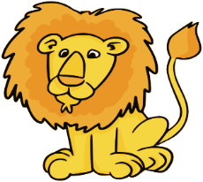  This Photo by Unknown Author is licensed under CC BY |  |  |  | 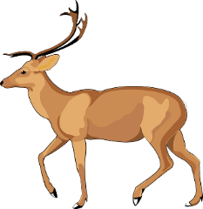 |  | 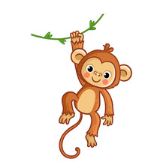 |  | 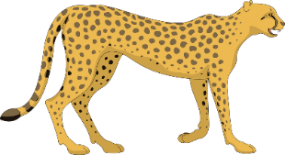
शेर |  | हाथी |  | हिरन |  | बंदर |  | चीता
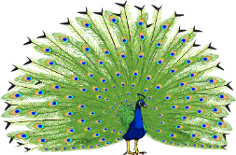  This Photo by Unknown Author is licensed under CC BY-NC |  |  |  | 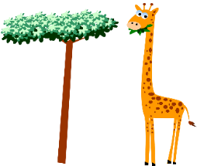
मोर |  | बाघ |  | गिराफ़ |  | भालू |  | मगरमछ

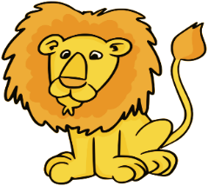  This Photo by Unknown Author is licensed under CC BY |  |  |  | 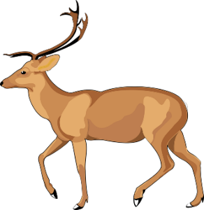 |  |  |  | 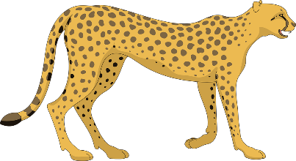
lion |  | elephant |  | deer |  | monkey |  | cheetah
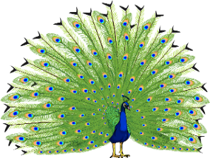  This Photo by Unknown Author is licensed under CC BY-NC |  |  |  | 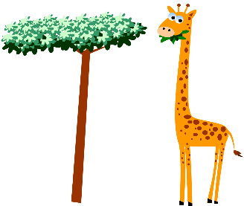
peacock |  | tiger |  | giraffe |  | bear |  | crocodile

Resource 2 – bingo mat

Resource 3 – colours flashcards
 |  |  |  |  |  |  |  | This Photo by Unknown Author is licensed under CC BY-NC
लाल |  | हरा |  | नीला |  | पीला |  | गुलाबी
 |  |  |  |  |  |  |  | This Photo by Unknown Author is licensed under CC BY-NC
नारंगी |  | बैंगनी |  | काला |  | सफ़ेद |  | सलेटी

 |  |  |  |  |  |  |  | This Photo by Unknown Author is licensed under CC BY-NC
red |  | green |  | blue |  | yellow |  | pink
 |  |  |  |  |  |  |  | This Photo by Unknown Author is licensed under CC BY-NC
orange |  | purple |  | black |  | white |  | grey

Resource 4 – size flashcards
This resource can be used to teach multiple languages. Use the resource link to tailor it to your preferred language.
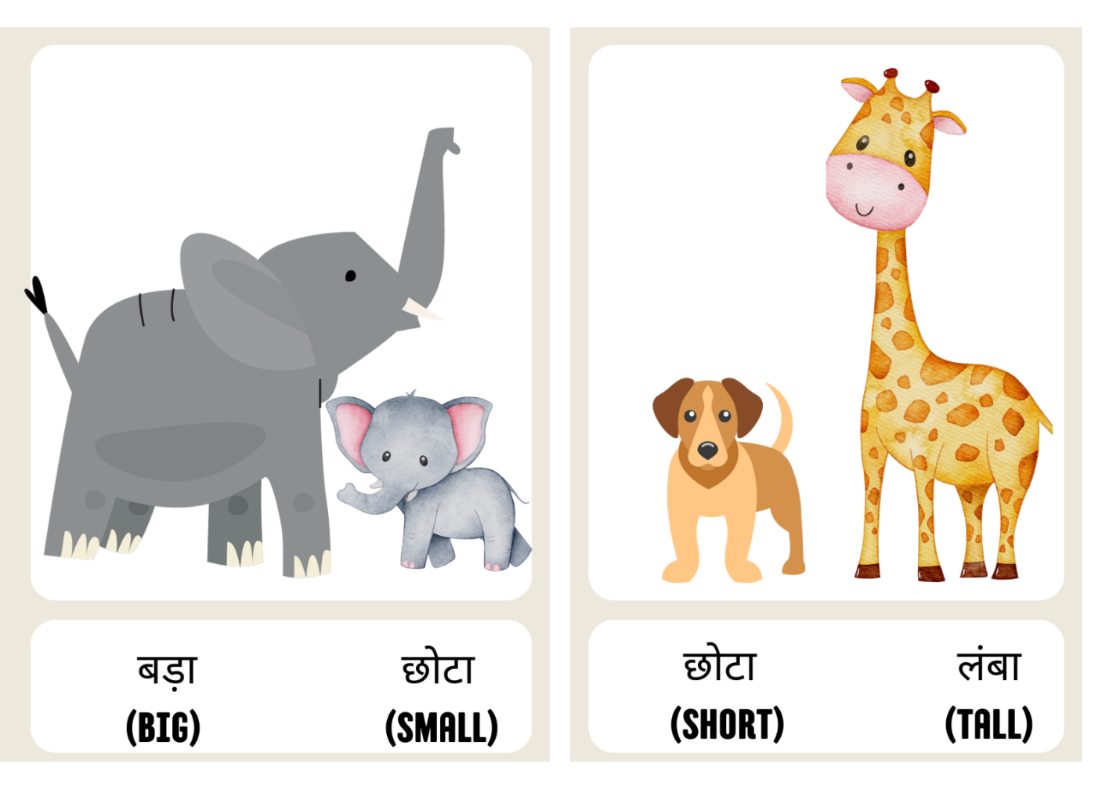

Resource 5 – trace and write
Animal | Trace | Write
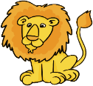  This Photo by Unknown Author is licensed under CC BY | पीला शेर
 | भूरा भालू
 | हरा मगरमछ
 | पीला चीता
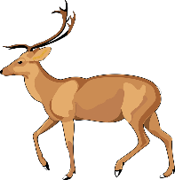 | भूरा हिरन
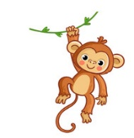 | भूरा बंदर
 | पीला बाघ
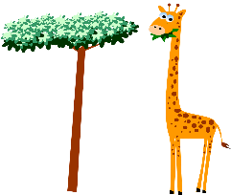 | पीला गिराफ़
 | सलेटी हाथी
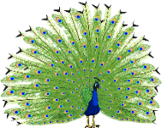  This Photo by Unknown Author is licensed under CC BY-NC | बैंगनी मोर

Animal | Trace | Write
This Photo by Unknown Author is licensed under CC BY | yellow lion
 | brown bear
 | green crocodile
 | yellow cheetah
 | brown deer
 | brown monkey
 | yellow tiger
 | yellow giraffe
 | grey elephant
This Photo by Unknown Author is licensed under CC BY-NC | purple peacock

Resource 6 – sentence builder
Phrase | Size | Colour | Animal
यह एक (This is a)  मैंने एक (I saw a)  चिड़ियाघर में (in the zoo) | बड़ा (big)  छोटा (small)  लंबा (tall)  ठिगना (short) | लाल (red)  हरा (green)  नीला (blue)  पीला (yellow)  गुलाबी (pink)  नारंगी (orange)  बैंगनी (purple)  काला (black)  सफ़ेद (white)  सलेटी (grey) | शेर (lion)  हाथी (elephant)  हिरन (deer)  बंदर (monkey)  चीता (cheetah)  मोर (peacock)  बाघ (tiger)  जिराफ़ (giraffe)  भालू (bear)  मगरमच्छ (crocodile)

Resource 7 – student rubric
I can write a simple sentence in Hindi.
I can describe an animal in Hindi.
I can use the correct order of words when speaking and writing a sentence in Hindi.
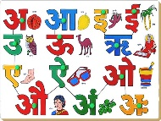 I can say and write the words for animals, colours and size in Hindi.

Resource 8 – peer feedback strategy – Two stars and a wish
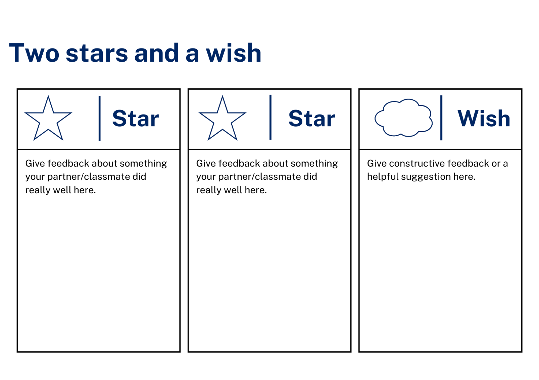

Support and alignment
Resource evaluation and support: all curriculum resources are prepared through a rigorous process. Resources are periodically reviewed as part of our ongoing evaluation plan to ensure currency, relevance, and effectiveness. For additional support or advice, contact the Primary Languages team by emailing primlang@det.nsw.edu.au.
Alignment to system priorities and/or needs: School Excellence Policy, School Success Model
Alignment to the School Excellence Framework: this resource supports the School Excellence Framework elements of curriculum (curriculum provision, teaching and learning programs) and effective classroom practice (lesson planning).
Alignment to Australian Professional Teaching Standards: this resource supports teachers to address Australian Professional Teaching Standards 2.2.2, 3.2.2.
Consulted with: Curriculum, Secondary Learners, school-based staff and NESA subject matter experts. Advice from Aboriginal Outcomes and Partnerships, EAL/D, HPGE and Inclusive Education for Modern Languages Stage 3 Italian Mangiare in Ristorante has been considered in preparing this document.
NSW syllabus: Modern Languages K–10 Syllabus
Syllabus outcomes: ML1-INT-01, ML1-UND-01, ML1-CRT-01
Author: Primary Curriculum
Publisher: State of NSW, Department of Education
Resource: unit
Related resources: further resources to support Stage 1 Modern Languages can be found on the Languages K-6 curriculum page.
Professional learning: relevant professional learning is available through Primary Languages Networks on Teams (staff only).
Universal Design for Learning: support the diverse learning needs of students using inclusive teaching and learning strategies. Some students may require more specific adjustments to allow them to participate on the same basis as their peers. For further advice see Inclusive practice resources for primary school.
Differentiation: when using these resources in the classroom, it is important for teachers to consider the needs of all students in their class, including:
- Aboriginal and Torres Strait Islander students. Targeted strategies can be used to achieve outcomes for Aboriginal students in K-12 and increase knowledge and understanding of Aboriginal histories and cultures. Teachers should use students’ Personalised Learning Pathways to support individual student needs and goals.
- EAL/D learners. EAL/D learners may require scaffolding to support them to gain content knowledge, while providing extra time and assistance to master the English language required to engage with texts or complete classroom tasks. View some samples of differentiating through scaffolding.
- Students with additional learning needs. Learning adjustments enable students with disability and additional learning and support needs to access syllabus outcomes and content on the same basis as their peers. Teachers can use a range of adjustments to ensure a personalised approach to student learning.
- High potential and gifted learners. Assessing and identifying high potential and gifted learners will help teachers decide which students may benefit from extension and additional challenge. In addition, the Differentiation Adjustment Tool can be used to support the specific learning needs of high potential and gifted students.
Creation date: 12 October 2023
Rights: © State of New South Wales, Department of Education

References
This resource contains NSW Curriculum and syllabus content. The NSW Curriculum is developed by the NSW Education Standards Authority. This content is prepared by NESA for and on behalf of the Crown in right of the State of New South Wales. The material is protected by Crown copyright.
Please refer to the NESA Copyright Disclaimer for more information https://educationstandards.nsw.edu.au/wps/portal/nesa/mini-footer/copyright.
NESA holds the only official and up-to-date versions of the NSW Curriculum and syllabus documents. Please visit the NSW Education Standards Authority (NESA) website https://educationstandards.nsw.edu.au/ and the NSW Curriculum website https://curriculum.nsw.edu.au/home.
Modern Languages K–10 Syllabus © NSW Education Standards Authority (NESA) for and on behalf of the Crown in right of the State of New South Wales, 2022.
8 Ways (n.d.) 8 Aboriginal Ways of Learning [website], accessed 13 December 2022.
AITSL (Australian Institute for Teaching and School Leadership (2017) ‘Feedback Factsheet’, AITSL, accessed 24 August 2023.
Brookhart SM (2011) How to Assess Higher-Order Thinking Skills in Your Classroom, Hawker Brownlow Education, Victoria.
CESE (Centre for Education Statistics and Evaluation) (2020a) What works best: 2020 update, NSW Department of Education, accessed 24 August 2023.
CESE (Centre for Education Statistics and Evaluation) (2020b) What works best in practice, NSW Department of Education, accessed 24 August 2023.
Conti G (28 September 2015) ‘16 tips for effective grammar teaching in the foreign language classroom’, The Language Gym, accessed 24 August 2023.
Conti G (28 May 2017) From Target Language to Model Language – the mind shift that has transformed my teaching, The Language Gym, accessed 24 August 2023.
Henshaw FG and Hawkins MD (2022) Common Ground: Second Language Acquisition Theory Goes to the Classroom, Focus, Indianapolis, accessed 24 August 2023.
Jones J and Wiliam D (2014) Modern Foreign Languages Inside the Black Box: Assessment for Learning in the Modern Foreign Languages Classroom (Black P, Harrison C, Marshall B and Wiliam D, eds), Learning Sciences International, United States.
NESA (NSW Education Standards Authority) (2020) ‘NSW Curriculum Review – final report’, NESA, accessed 24 August 2023.
Rosenshine B (2012) ‘Principles of Instruction: Research-Based Strategies That All Teachers Should Know’, American Educator, 36(1):12–19, 39, accessed 24 August 2023.
Smith S (2022) Becoming an Outstanding Languages Teacher, 2nd edn, Routledge, United Kingdom.
Wisniewski B, Zierer K and Hattie J (2020) ‘The Power of Feedback Revisited: A Meta-Analysis of Educational Feedback Research’, Frontiers In Psychology, 10(3087), doi:10.3389/fpsyg.2019.03087, accessed 24 August 2023.
Wiliam D (2013) ‘Assessment: The Bridge between Teaching and Learning’, Voices from the Middle, 21(2):15–20, accessed 24 August 2023.
Wiliam D and Leahy S (2015) Embedding Formative Assessment: Practical Techniques for K–12 Classrooms, Learning Sciences International, United States.

© State of New South Wales (Department of Education), 2023
The copyright material published in this resource is subject to the Copyright Act 1968 (Cth) and is owned by the NSW Department of Education or, where indicated, by a party other than the NSW Department of Education (third-party material).
Copyright material available in this resource and owned by the NSW Department of Education is licensed under a Creative Commons Attribution 4.0 International (CC BY 4.0) license.
This license allows you to share and adapt the material for any purpose, even commercially. Attribution should be given to © State of New South Wales (Department of Education), 2023.
Material in this resource not available under a Creative Commons license:
- the NSW Department of Education logo, other logos and trademark-protected material
- material owned by a third party that has been reproduced with permission. You will need to obtain permission from the third party to reuse its material.
Links to third-party material and websites
Please note that the provided (reading/viewing material/list/links/texts) are a suggestion only and implies no endorsement, by the New South Wales Department of Education, of any author, publisher, or book title. School principals and teachers are best placed to assess the suitability of resources that would complement the curriculum and reflect the needs and interests of their students.
If you use the links provided in this document to access a third-party's website, you acknowledge that the terms of use, including licence terms set out on the third-party's website apply to the use which may be made of the materials on that third-party website or where permitted by the Copyright Act 1968 (Cth). The department accepts no responsibility for content on third-party websites.

