Modern Languages K–10 Syllabus (2022) – programming guidelines
Contents
Introduction 2
Programming 2
Elements of a program 3
Scope and sequence 3
Units of work 6
Assessment 11
Register 13
Appendix A – scope and sequence checklist 14
Appendix B – unit of work checklist 15
Appendix C – summative assessment task and notification checklist 17
Support and alignment 19
Evidence base 20
Note: This document provides advice only. It is the responsibility of individual school executive and teaching staff to ensure programming documents are compliant with both NSW Education Standards Authority (NESA) and departmental requirements and policies.

Introduction
This document supports teachers of modern languages 7–10, their supervisors and the educational teams who provide universal support to schools.
For more detailed advice on designing units of work for modern languages 7–10 (including the department’s template), please access the unit of work guidelines and template document from our Planning, programming and assessing languages 7–10 web page. For detailed advice on assessment in modern languages 7–10, access the assessment guidelines on the same page.

Programming
Programming is the process through which teachers select and sequence teaching, learning and assessment experiences which cater for the diversity of learners in a particular year or Stage.
A program is all of the documents involved in the overall planning for each language and year or Stage.
Effective programs enable teachers to:
- plan for the delivery of syllabus outcomes and content
- improve student learning outcomes
- respond to student learning needs, school context, self-reflection and evaluation
- record planned learning experiences of how syllabus requirements are met.
Programs are evidence of compliance in NESA’s registration process for schools.
The department also sets additional requirements, outlined in the Curriculum Planning and Programming, Assessing and Reporting to Parents K–12 Policy. (Note: If the link does not open, you can access via the policy library in the portal.)
A program also allows for continuity of quality learning for students, by allowing other teachers to continue teaching students if required, for example during periods of absence.
The Modern Languages K–10 Syllabus (2022) states that ‘communication is the central goal of language learning’. As such, all the teaching, learning and assessment activities you design for your program should focus on developing students’ ability to communicate in the target language.
This document guides you through the elements of a program, and links each element to the Modern Languages K–10 Syllabus within the context of language teaching 7–10.

Elements of a program
For each language and year or Stage, you need to have a program that includes the elements listed below.
Figure 1 – elements of a program
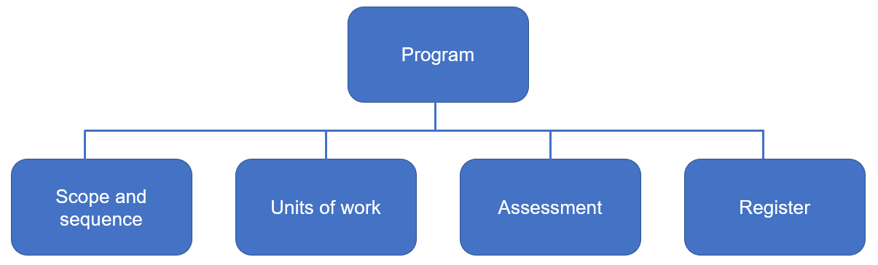
In this document, you can find more information about each element, as well as checklists to help you program, including NESA requirements and other considerations.

Scope and sequence
A scope and sequence summarises what is to be taught and the sequence in which it will be taught within a year or Stage. For example, you may have one unit for each term of learning, which looks at a particular theme or topic.
NESA requires that a scope and sequence includes the title of each unit, the sequence of each unit for the year or Stage, the duration of each unit and syllabus outcomes included in each unit (as outcomes codes).
While not required by NESA for school registration, the department recommends including the following in your scope and sequence, for each unit:
- the skills students will develop
- a short description of the summative assessment task.
These inclusions support a backward mapping approach and provide a succinct reminder of what skills are important for students to successfully demonstrate achievement of the outcomes and content in the context of the unit.
Take a look at the example below.
Table 1 – sample scope and sequence
Term/  duration | Learning overview | Outcomes | Skills | Assessment
Term 1  10 weeks | My SELFie  Students learn to introduce themselves and meet new people in the target language. Students explore different ways to greet people, learn what they have in common and what makes them unique. | ML4-INT-01  exchanges information and opinions in a range of familiar contexts by using culturally appropriate language  ML4-UND-01  interprets and responds to information, opinions and ideas in texts to demonstrate understanding  ML4-CRT-01  creates a range of texts for familiar communicative purposes by using culturally appropriate language | - Greet different people at various times of day in a range of contexts.  - Understand the nature of greetings and introductions in the target language, including meeting someone for the first time.  - Exchange information about themselves, including name, age, birthday, where they live, likes and dislikes.  - Describe physical appearances, for example, eye and hair colour, and facial features if applicable.  - Join sentences with the conjunctions and and but. | Part A: Creating texts (ML4-CRT-01)  Your class is sending profiles to students in [target country] to introduce yourselves. Create a ‘selfie’ that includes stickers, annotations or backgrounds which capture your identity. Add captions in [language], including:  - a greeting  - your name, age, birthday  - where you come from and where you live  - something you like and something you don’t like  - a description of yourself.  Part B: Understanding texts (ML4-UND-01)  Your teacher has received profiles from students in [target country] who would like to correspond with you. Read the profiles and choose:  - 2 students who would be a suitable match for you  - one student who would not be a good match.  In English, justify reasons for your choices, with reference to the texts.
Communication is the central goal of language learning in the syllabus. For communication to be meaningful, students need to understand the context, purpose and audience. These elements need to be clear when describing the summative assessment task for each unit on your scope and sequence.
With only 3 outcomes per Stage, all units on your scope and sequence should address all outcomes. When designing your summative assessment task for each unit, avoid targeting the same outcomes and content each time. By assessing all outcomes (and a range of their related content) across a year or Stage, you are allowing opportunities for students to demonstrate their achievement more broadly.
When designing your scope and sequence, embed the spiral approach to learning. The acquisition of a language is a cumulative process, therefore a continuous and sequenced approach is essential when developing your units of work. This allows students to develop their skills gradually, reinforcing and building vocabulary and structures over time. By providing opportunities to revisit and build upon what they have learned, they can use their language skills to participate in increasingly complex situations. It also supports the shift of new content into students’ long-term memory, lightening cognitive load. Students’ knowledge is deepened and broadened, and they experience a feeling of success by building on prior learning.
Finally, the department recommends providing a ‘student-friendly’ copy to students at the start of the year, written and presented in a way that is appropriate to them. This gives students a sense of what they may be able to achieve by the end of each year or Stage, which can be motivating. Students will also be able to see how all their learning links and builds, enhancing engagement and supporting students to reflect on areas for growth.
When planning your scope and sequence, use the checklist provided in Appendix A.

Units of work
Units of work summarise the teaching and learning strategies, resources and assessment (both formative and summative) for a particular set of outcomes and content in the syllabus. They also include adjustments to meet the learning needs of students, where required, and a section for reflection and evaluation.
NESA requires that a unit of work includes: a unit description; syllabus outcomes; duration; year or Stage; integrated teaching and learning activities; differentiation catering to the range of student abilities and interests; opportunities to collect evidence of student achievement; subject-specific requirements (where relevant); resources; reflection and evaluation; and adjustments for students with disability, where appropriate.

While not required by NESA for school registration, the department recommends the following:
- designing your summative assessment task first, and then backward mapping your unit, including your teaching and learning activities and formative assessment opportunities for students. It is important the students receive ongoing feedback and time for reflection as the unit progresses, so they are engaged with and involved in their learning journey and can identify their individual learning goals (learn more in the assessment section below)
- organising your unit into sequences of learning which break down aspects of the final summative task, with clear learning intentions and success criteria for each sequence. By ‘chunking’ the learning in this way, with each sequence of learning building towards a particular aspect of the final task, students are supported to develop the necessary skills to succeed at the summative task.
For example, if your summative task for Stage 5 requires students to write a travel blog on sightseeing experiences, including accommodation and activities, you may consider breaking your unit into the following sequences, learning intentions and success criteria. (Note: this is a condensed example only, to provide a snapshot of the process.)
Table 2 – sample learning sequence
Learning sequence focus | Learning intentions | Success criteria | Mini task – progress checkpoint
What’s to see in [country]? | Students learn about:  - common destinations in [country]  - the activities available at each site. | Students:  - identify 5 places of interest in [country]  - name a range of common activities for tourists, for example shopping, eating at restaurants, hiking, skiing. | Students listen to/read a review of a tourist destination and complete a table. (ML5-UND-01)  Students then create 2–3 sentences describing one of the sightseeing experiences described in the text, in the format of a text message to a friend. (ML5-CRT-01)
Where can we stay? | Students learn:  - about accommodation types in [country]  - how to book a room online. | Students:  - understand key information on a booking website. | Students voice record a request for an accommodation type of their choice, with reasons. (ML5-CRT-01)
In the Modern Languages K–10 Syllabus (2022), students apply knowledge of language systems and develop intercultural capability as they communicate across 3 focus areas:
- Interacting
- Understanding texts
- Creating texts.
Language systems include the sounds, vocabulary, grammar and script/alphabet of the language. Intercultural capability is the capacity to exchange, understand and create meaning between people and across languages and cultures.
Each focus area has 3 Stage-based outcomes:
- ML4-INT-01, ML4-UND-01 and ML4-CRT-01 in Stage 4
- ML5-INT-01, ML5-UND-01 and ML5-CRT-01 in Stage 5.
The content in the syllabus is represented through content groups and dot points.
Figure 2 – syllabus content groups and content
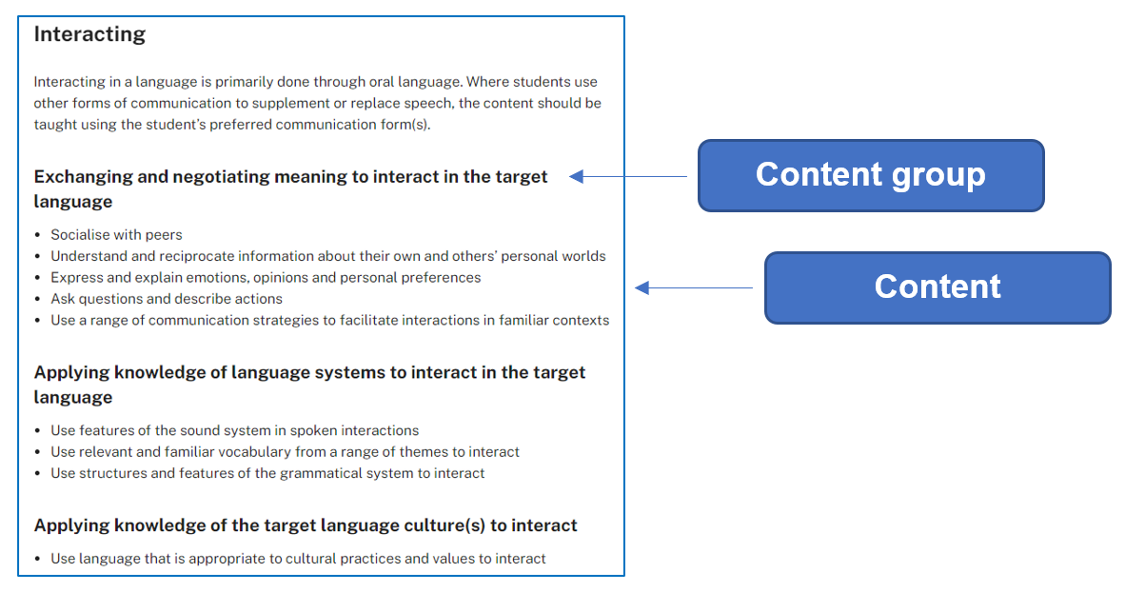
Modern Languages K–10 Syllabus © 2022 NSW Education Standards Authority (NESA) for and on behalf of the Crown in right of the State of New South Wales.
All of the content is considered ‘essential learning’ in order for students to demonstrate achievement of the outcome. As such, when designing our units of work, we program for all the content, adjusting the time required for attainment, depending on student ability and proficiency. While each of your units of work should address all outcomes, each unit does not need to cover all the content dot points for each outcome. These can be covered across a year or Stage of learning.
The examples in the digital curriculum and the teaching advice provide guidance on how the outcomes and content are to be interpreted and applied. They also provide examples of themes you could include in your units of work. By ascertaining students’ existing prior knowledge, including their existing target language skills and their interests, we can design learning which is more engaging.
In reviewing and planning for the content, the following diagram may assist you to understand the layout of the syllabus:
Figure 3 – organisation of content groups
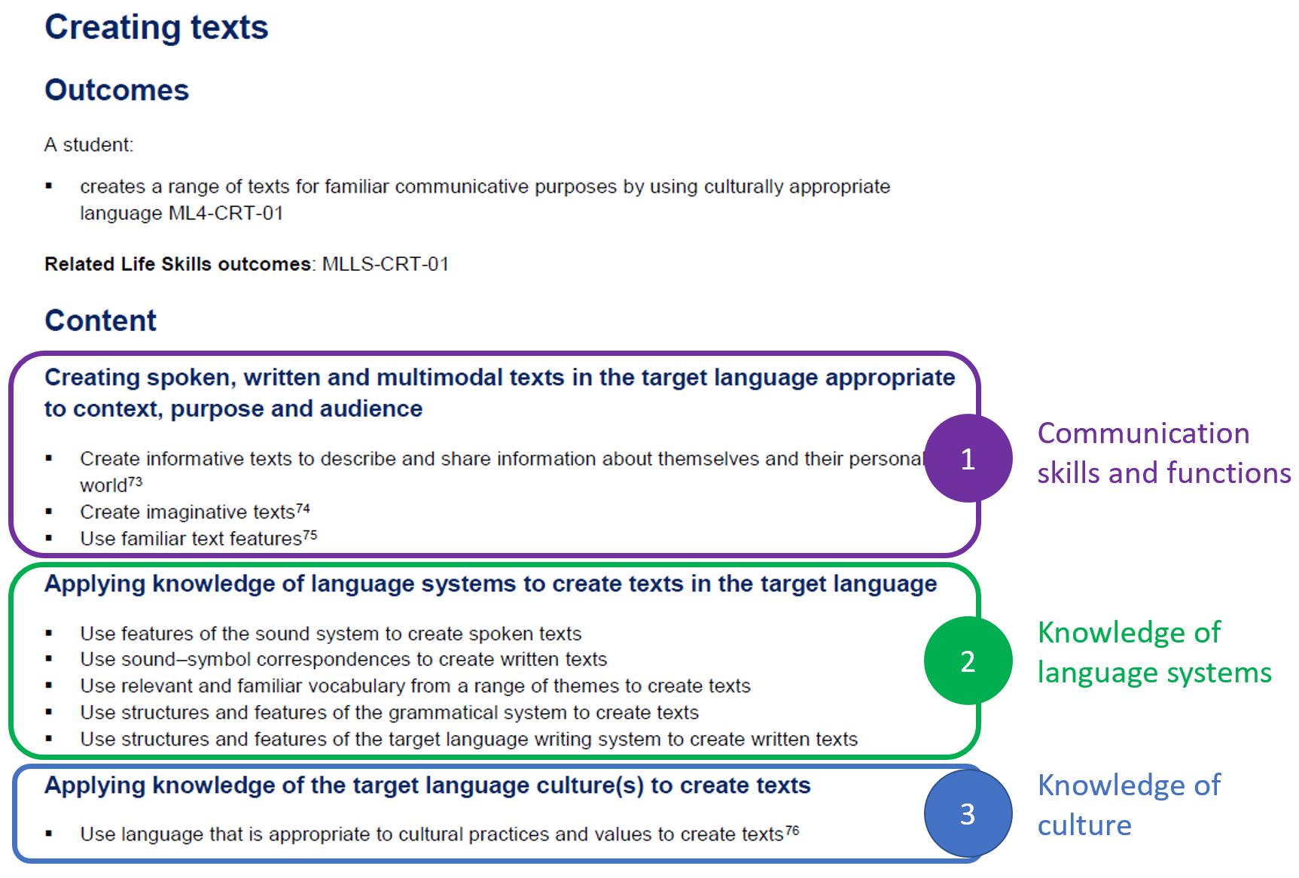
Modern Languages K–10 Syllabus © 2022 NSW Education Standards Authority (NESA) for and on behalf of the Crown in right of the State of New South Wales.
The syllabus also identifies which macro skills (known as language modes) are addressed in each focus area. When designing your teaching and learning activities across the unit as a whole, all 4 macro skills should be addressed, through a range of contexts.
Figure 4 – macro skills
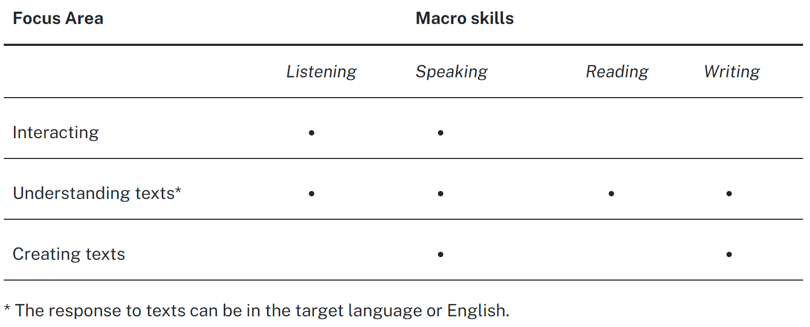
Modern Languages K–10 Syllabus © 2022 NSW Education Standards Authority (NESA) for and on behalf of the Crown in right of the State of New South Wales.
When planning your unit of work, use the checklist provided in Appendix B.

Assessment
Assessment provides opportunities for teachers to gather evidence about student achievement in relation to syllabus outcomes, including a range of student work samples.
NESA states:
‘The primary role of assessment is to establish where students are in their learning so that teaching can be differentiated and further learning progress can be monitored over time. It provides information that assists teachers to target their teaching at the point of student need. Assessment is most effective when it is an integral part of teaching and learning programs.
Assessment involves:
- establishing where students are in their learning
- ongoing monitoring
- formative and summative tasks
- providing feedback about student progress.’
Modern Languages K–10 Syllabus © 2022 NSW Education Standards Authority (NESA) for and on behalf of the Crown in right of the State of New South Wales.

Formative assessment
Formative assessment aims to close the gap between where a student is now and where they need to be, in order to successfully demonstrate their achievement of the outcomes. Teachers use evidence of students' knowledge, understanding and skills to inform their teaching and to provide feedback to students about their learning and how to improve.
It is important to plan opportunities which allow for students to discover where they are now and enable them to plan how to move to the next stage of their learning.

For example:
- pre-testing for prior knowledge prior to starting a unit of work (Are you aware of what students already know and can do? Does your unit ‘tap into’ areas of student interest and acknowledge their cultural and background knowledge?)
- activities and quizzes to monitor learning
- mini tasks which allow opportunities for students to practise new vocabulary and skills, and receive feedback, to support their success in the summative assessment task (progress checkpoints)
- effective feedback, including peer feedback and self-reflection opportunities.

Summative assessment
Summative assessment allows teachers to gather evidence of achievement of learning intentions and outcomes against standards, thus measuring student success at a point in time. Like all assessment, it provides an opportunity to provide feedback to students on their progress.
Provide your students with the assessment task notification, including a clear task description, marking criteria and marking guidelines, at the start of the unit to help them plan and link their learning. Allow time to discuss the task, and then revisit the task at various points throughout your teaching of the unit, so students are reminded of why each sequence of learning is relevant.
With communication the central goal of language learning in the syllabus, summative assessment takes the form of real-world or simulated real-world tasks, which articulate the context, purpose and audience of the communicative act.
For example: ‘Imagine you have become separated from your tour group in Indonesia. Ring the tour leader and negotiate where and when you can meet the group to re-join the tour. Your teacher will play the role of the tour leader.’
In this task it is clear the students are conducting a conversation. The context is they are travelling in Indonesia as part of a tour group. The audience is the tour leader and the purpose is to re-join the group and no longer be lost.
By designing your summative assessment first, then backward mapping your teaching, learning and formative assessment opportunities, you are supporting your students to develop the skills required for effective communication.
Assessment opportunities are required to be inclusive of and accessible for all students. It is important to consider how you will support the needs of all students, for example by:
- providing a scaffold
- allowing the use of assistive technology to communicate
- negotiating a plan to prepare students for a summative assessment task.
When planning your summative assessment task, use the checklist provided in Appendix C.

Register
A register is a document which tracks the progress of each unit of work, including any variations made, and allows for evaluation of the strategies and activities used. Teachers and schools may approach this differently. For example, some teachers may annotate units of work, indicating when activities and tasks were completed by each class and noting any adjustments which were required, including a self-reflection. Other teachers may have their register as a separate document. It will depend on the requirements of your faculty and/or school.

Appendix A – scope and sequence checklist
My scope and sequence includes:
☐ the NESA requirements
☐ title of each unit
☐ sequence of each unit for the year or Stage
☐ duration of each unit
☐ syllabus outcomes included in each unit (as outcomes codes)
☐ communication as the central goal
☐ the skills students will develop in each unit
☐ a short description of the summative assessment task for each unit, which focuses on real-world communication, with a purpose, context and audience
☐ a range of assessment opportunities for each year or Stage, assessing different outcomes and content
☐ opportunities for students to revisit language from previous units, building on existing knowledge and skills, in new contexts.
I have:
☐ shared my scope and sequence with students, using student-friendly language.

Appendix B – unit of work checklist
My unit of work includes:
☐ the NESA requirements
☐ unit description
☐ syllabus outcomes
☐ duration
☐ year or Stage
☐ integrated teaching and learning activities
☐ differentiation catering to the range of student abilities and interests
☐ opportunities to collect evidence of student achievement (through formative and summative assessment)
☐ resources
☐ reflection and evaluation
☐ adjustments for students with disability, where appropriate
☐ opportunities to ascertain students’ prior knowledge
☐ communication as the central goal
☐ opportunities for students to develop knowledge of language systems (including sounds, vocabulary, grammar and, where required, script)
☐ opportunities to develop intercultural capability by using culturally-appropriate language
☐ a good balance of macro skills – listening, speaking, reading and writing
☐ learning intentions and success criteria for each sequence of learning within the unit, supporting student engagement and success
☐ opportunities for feedback and student reflection for deeper understanding and identification of individual learning goals.

Appendix C – summative assessment task and notification checklist
My summative assessment task includes:
☐ the NESA requirements
☐ based on syllabus outcomes
☐ valid (assesses what it is designed to assess)
☐ criteria which clarifies for students what aspects of learning are being assessed
☐ reliable, measuring what the task intends to assess, and providing accurate information on each student's achievement
☐ free from bias and providing evidence that accurately represents a student's knowledge, understanding and skills
☐ enables students and teachers to use feedback effectively and reflect on the learning process
☐ inclusive of and accessible for all students
☐ part of an ongoing process where progress is monitored over time through a range of task types
☐ communicating as the central goal, through a real-world or simulated real-world context, with a clear purpose and audience
☐ relevant support for all students to succeed.

I have:
☐ shared the assessment task with students at the start of the unit, and discussed it with them, supporting them to see the relevance of the upcoming learning
☐ planned opportunities for students to revisit the assessment task throughout the unit of work, so they can see if they are on track and plan their next steps.
My assessment task notification includes:
☐ a clear task description
☐ marking criteria (‘You will be assessed on your ability to…’)
☐ marking guidelines (descriptions of achievement across a range of marks/grades)
☐ how feedback will be provided.

Support and alignment
Resource evaluation and support: All curriculum resources are prepared through a rigorous process. Resources are periodically reviewed as part of our ongoing evaluation plan to ensure currency, relevance, and effectiveness. For additional support or advice, contact the Languages and Culture team by emailing languagesnsw@det.nsw.edu.au.
Alignment to system priorities and/or needs: Curriculum Planning and Programming, Assessing and Reporting to Parents K–12 Policy
Alignment to the School Excellence Framework: This resource supports the School Excellence Framework elements of curriculum (teaching and learning programs).
Alignment to Australian Professional Teaching Standards: This resource supports teachers to address Australian Professional Teaching Standards 2.2.2, 2.3.2, 3.2.2.
Consulted with: Curriculum and Reform and subject matter experts
NSW syllabus: Modern Languages K–10 Syllabus
Author: Languages and Culture
Publisher: State of NSW, Department of Education
Resource: Programming guidelines
Related resources: Further resources to support Modern Languages can be found on the Languages curriculum page.
Professional learning: Relevant professional learning is available through the Languages statewide staffroom (entry survey link for staff only).
Creation date: 1 April 2023
Rights: © State of New South Wales, Department of Education

Evidence base
Modern Languages K–10 Syllabus © 2022 NSW Education Standards Authority (NESA) for and on behalf of the Crown in right of the State of New South Wales.
NESA (NSW Education Standards Authority) (2022) ‘Advice on scope and sequences’, Programming, NESA website, accessed 14 March 2022.
NESA (NSW Education Standards Authority) (2022) ‘Advice on units’, Programming, NESA website, accessed 14 March 2022.
NESA (NSW Education Standards Authority) (2022) ‘Proficient Teacher: Standard descriptors’, The Standards, NESA website, accessed 21 December 2022.
© State of New South Wales (Department of Education), 2023
The copyright material published in this resource is subject to the Copyright Act 1968 (Cth) and is owned by the NSW Department of Education or, where indicated, by a party other than the NSW Department of Education (third-party material).
Copyright material available in this resource and owned by the NSW Department of Education is licensed under a Creative Commons Attribution 4.0 International (CC BY 4.0) licence.
This licence allows you to share and adapt the material for any purpose, even commercially.
Attribution should be given to © State of New South Wales (Department of Education), 2023.
Material in this resource not available under a Creative Commons licence:
- the NSW Department of Education logo, other logos and trademark-protected material
- material owned by a third party that has been reproduced with permission. You will need to obtain permission from the third party to reuse its material.
Links to third-party material and websites
Please note that the provided (reading/viewing material/list/links/texts) are a suggestion only and implies no endorsement, by the New South Wales Department of Education, of any author, publisher, or book title. School principals and teachers are best placed to assess the suitability of resources that would complement the curriculum and reflect the needs and interests of their students.
If you use the links provided in this document to access a third-party's website, you acknowledge that the terms of use, including licence terms set out on the third-party's website apply to the use which may be made of the materials on that third-party website or where permitted by the Copyright Act 1968 (Cth). The department accepts no responsibility for content on third-party websites.

Students complete the task individually. Students may write or voice record their response.

