[Language] Early Stage 1 – Teacher for the day
Contents
Unit overview 3
Early Stage 1 outcomes and content to be addressed 4
Learning map 7
Assessment 9
Assessment opportunities 10
Teaching and learning activities 13
Week 1: Classroom objects 13
Week 2: Action verbs 17
Week 3: Action verbs and classroom objects 20
Week 4: Classroom instructions 22
Week 5: Assessment criteria and practice task 24
Week 6: Communicative task – Give instructions to your students 28
Week 7: Feedback and goal setting 31
Week 8: Language review 33
Student resources 35
Resource 1: Bingo cards 35
Resource 2: Classroom objects vocabulary worksheet 38
Resource 3: Action verb pictures 39
Resource 4: Student rubric – Teacher for the day 40
Resource 5: Thumbs up and thumbs sideways strategy 41
Resource 6: Peer feedback strategy – Two stars and a wish 42
Support and alignment 43
References 46

Unit overview
Stage: Early Stage 1
Title: Teacher for the day
Description: In this unit, students give simple classroom instructions in the language. They use basic nouns and action verbs when giving basic classroom instructions to their classmates.
Duration: This lesson sequence is designed to be completed over approximately 8 weeks.
Student proficiency levels: It is assumed that most Early Stage 1 students are beginner learners of [Language]. Some Early Stage 1 students may be intermediate or advanced users of [Language] if it is the background language of their family or it is their mother tongue. The assessment tasks in this scope and sequence are aimed at beginner students. Every classroom will be different and teachers will need to adapt to their context. Many classes may include a combination of Beginner, Intermediate and Advanced students with varying skills and abilities within these proficiency levels.
Note: teachers should start each lesson with their typical classroom routine, which may include culturally greeting students, singing songs, and reviewing basic language concepts such as colours, numbers, and letters in [Language].

Early Stage 1 outcomes and content to be addressed
The table below outlines the focus area, outcomes and content points for Early Stage 1 students.
Focus area and outcome | Content points
Interacting  A student:  - exchanges meaning through play and actions by reproducing culturally appropriate modelled language MLE-INT-01 | Exchanging meaning in oral interactions in the target language  - Greet and farewell others  - Introduce themselves  - Interact in classroom routines reproducing modelled language with actions and gestures  - Interact in games and imaginative play  Reproducing oral language to interact in the target language  - Reproduce modelled vocabulary and formulaic phrases on familiar themes to interact  - Recognise and reproduce modelled sounds to interact  Reproducing how target language speakers communicate in interactions  - Reproduce verbal and nonverbal communication that is appropriate to cultural practices
Understanding texts  A student:  - responds to information in simple texts in a variety of ways to demonstrate understanding MLE-UND-01 | Understanding and responding to target language texts  - Follow simple instructions  - Use auditory cues, gestures, visuals and other forms of nonverbal communication to understand texts  - Associate vocabulary on familiar themes with known actions, people, places and objects  - Respond to simple texts using actions, drawing and singing in the target language and/or English  - Reproduce vocabulary seen or heard in texts to demonstrate understanding
Creating texts  A student:  - creates simple texts by reproducing culturally appropriate modelled vocabulary MLE-CRT-01 | Creating multimodal texts in the target language  - Create texts reproducing modelled vocabulary with visuals and other forms of nonverbal communication to express meaning  - Represent an idea or information about themselves using modelled vocabulary, formulaic phrases and visuals  - Label objects and caption images  Reproducing vocabulary to create texts  - Reproduce modelled vocabulary and formulaic phrases on familiar themes to create texts  - Use modelled sound–symbol correspondences to create written texts  - Reproduce modelled features of the target language writing system to create simple written texts  Reproducing how target language speakers communicate to create texts  - Reproduce language appropriate to cultural practices to create texts
Modern Languages K–10 Syllabus © NSW Education Standards Authority (NESA) for and on behalf of the Crown in right of the State of New South Wales, 2022.

Learning map
The creation of maps for learning is a planning process that incorporates Aboriginal intellectual tradition. Learning maps are a visual pathway of what students will learn.
Share the learning map with your students, briefly explaining the learning that will happen in each lesson. Provide students with a copy of the learning map or display the learning map in the classroom. This learning map can be adapted to [Language] by accessing a copy of Learning map –Teacher for the day (Early Stage 1).
Figure 1 – Teacher for the day learning map
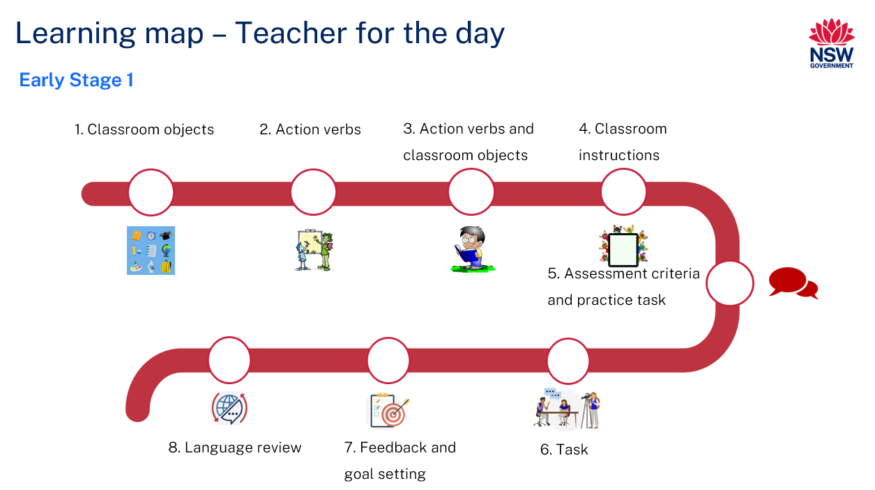

Assessment
Early Stage 1 communicative task: You are the teacher. Give your students from [Country] instructions so you can teach your lesson.
Too hard?
Student gives one class instruction using action verbs.
Too easy?
Students to give a set detailed of instruction including action verbs, classroom objects, adjectives and numbers.
Context: teacher teaching a class
Audience: your students
Purpose: to give students a small set of instructions

Assessment opportunities
The table below details assessment opportunities and differentiation ideas.
Assessment opportunities | Too hard? | Too easy?
Week 2: Simon Says  Split the class into groups. In each group, every student will take a turn at being Simon and give their classmates at least 2 class instructions using action verbs in [Language]. For example, ‘Simon says, hands up’. However, if the student playing Simon instructs without saying, ‘Simon says,’ then any student who follows that instruction given sits out. After each student in the group has had a turn being Simon, the game is complete. | Simon Says  Students give one simple class instruction using just an action verb. For example, ‘Simon says, stand up.’ | Simon Says  Students give 3 class instructions using action verbs and a classroom object. For example, ‘Simon says open a book’. ‘Simon says stand up’ and ‘Simon says sit down.’
Week 3: Sentence mimes  Play a class game of sentence mimes using the text from the My classroom PowerPoint book. Select one student to come to the front to mime a sentence from the book. The first student to guess the whole sentence gets to be the next student to mime another sentence from the book. Play this a few times until most of the classroom instructions from the book have been mimed and said. Divide students into pairs. Each pair will take a turn to mime an instruction from the book, and a turn to guess an instruction mimed by their partner. Allow enough time for the students to have mimed as many class instructions from the book as possible. | Sentence mimes  Students are given a copy of the images from the book to help them remember the vocabulary when miming a sentence. | Sentence mimes  Students can mime different classroom instructions not from the book.
Week 4: Hand puppets  Introduce the hand puppets to the students and explain that they will use them to practice the new language. Model to the students how to use a hand puppet and review all the instructions from the My Classroom PowerPoint book. Divide the students into pairs and assign them a hand puppet.  Ask each pair to use their puppet to give the instructions to their peers, using the new language they have learned. Once each pair has had a chance to practice with each other, have them perform their puppet show in front of the class. | Hand puppets  Provide a visual list of action verbs to help students give simple class instructions using action verbs. | Hand puppets  Students give detailed class instructions to each class member using an action and a classroom object. For example, ‘Open a book and get a pencil.’

Teaching and learning activities

Week 1: Classroom objects
The table below outlines the learning intention and success criteria of the lesson, and materials that the teacher and students will need to complete the teaching and learning activities.
Learning intention and success criteria | Materials
Students will identify and communicate the names of classroom objects in [Language].  Students can:  - correctly identify and pronounce the names of classroom objects in the [Language]. | - Resource 1: Bingo cards  - Resource 2: Classroom object vocabulary worksheet  - A3 Learning map  - Classroom objects such as a pencil, book, ruler, rubber, crayon, glue-stick and so on  - Images of classroom objects  - Interactive whiteboard  - Counters  - Butcher’s paper  - Writing materials  - Language exercise books  - Chairs

Activity 1: Learning map
Show the students the Learning map and break down what they will be learning about each week. Remind students that the learning map is a plan, and some changes may happen along the way.

Activity 2: Introduce vocabulary
Note: before the lesson, print real life images of different classroom objects from around the classroom.
To pre-assess students’ vocabulary before teaching new words, display some common classroom items, such as a pencil, book, and glue stick. Hold up each object, call out its name in English and ask the students to give a thumbs up if they know the name of the object in [Language], or a thumbs down if they do not know the name in [Language]. For instance, if you hold up a pencil, you can ask the students to give a thumbs up if they know how to say ‘pencil’ in [Language]. Continue to do this with other pre-selected classroom objects until all objects have been named.
Vocabulary to be included: book, pencil, bag, rubber, glue stick, sharpener, crayon, book and ruler.
Display images of classroom objects on the board and call out their names in both [Language] and English. Divide the students into pairs and ask them to take turns naming all the objects on the board in [Language] with their partner. Afterwards, have students report back to the class on how many objects they were able to name and discuss if there were any objects that were easier to remember than others in [Language]. Write down any new words on a piece of butcher’s paper in [Language] and display them on the wall throughout the unit. Read each word out loud and ask the students to repeat them.

Activity 3: Bingo!
Provide each student with counters and a copy of Resource 1: Bingo cards. Play a game of bingo with the class. Draw out one flash card at a time and call the classroom object on the card out loud. Students listen to the called word and only place a counter on their card if they have that same classroom object on their bingo card. Continue to draw flashcards until a student calls ‘Bingo!’

Activity 4: Labelling classroom objects
Provide students with a copy of Resource 2: Classroom objects vocabulary worksheet. Students will label each classroom object in [Language].

Activity 5: Fruit salad!
Assign each student the name of a different classroom object, such as pencil, book, desk, chair and so on. Have all the students stand in a circle. Explain to the students that when you call out the name of an object, they need to quickly find a chair and sit down. Start the game by calling out the name of an object, such as ‘pencil’. All the students who were assigned the name ‘pencil’ need to quickly find a chair and sit down. The student who doesn't have a seat is out. Keep playing the game by calling out different object names until only one student is left in the game.
Note: you must remove a chair each time you call out a classroom object.

Week 2: Action verbs
The table below outlines the learning intention and success criteria of the lesson, and materials that the teacher and students will need to complete the teaching and learning activities.
Learning intention and success criteria | Materials
Students will use action verbs and give class commands in [Language].  Students can:  - say action verbs correctly in [Language]  - give clear commands and respond correctly to commands in [Language]. | - Resource 3: Action verb pictures  - Word wall  - Interactive whiteboard  - Language exercise books  - Writing materials

Activity 1: Introduce vocabulary
To pre-assess new language, randomly hand out picture cards of different action verbs to each student. Explain that students will walk around the room and find the other student with the same card. Once students find their partner, they should sit together as a pair. Then, ask each pair of students to describe the action in the picture to their classmates.
Show the class Resource 3: Action verb pictures on the interactive whiteboard and name each action in English. Next, split the students into pairs and ask them to name as many actions as possible in [Language]. Give students a couple of minutes to Think-Pair-Share. As students share their responses with the rest of the class, add new vocabulary words to the existing class word wall. Finally, read the vocabulary list aloud to the class and have students repeat it. Students copy these words into their language books if they have the writing skills.

Activity 2: Action verbs drills
Display Resource 3: Action verb pictures on the interactive whiteboard. Call out the action verb in [Language] while pointing to the corresponding picture. Ask students to demonstrate the actions as you call them out. For example, if you call out ‘stand up’, the students stand up. Repeat this process until all actions have been called out in different orders each time.
Suggested action verbs to be included: sit down, stand up, line up, hand up, open your hands, close your hands.
Note: to challenge students, call out the actions at a faster pace and mix up the order of the actions each time.

Activity 3: Simon says
Vocabulary to be included: stand up, sit down, line up, hands up, get your bag, open your books, close your books.
Split the class into groups. In each group, every student will take a turn at being Simon and give their group at least 2 class instructions using action verbs in [Language]. For example, ‘Simon says, hands up’. However, if the student playing Simon instructs without saying, ‘Simon says’, then any student who follows that instruction sits out. After each student in the group has had a turn being Simon, the game is complete.

Week 3: Action verbs and classroom objects
The table below outlines the learning intention and success criteria of the lesson, and materials that the teacher and students will need to complete the teaching and learning activities.
Learning intention and success criteria | Materials
Students will use action verbs and classroom objects when giving instructions in [Language].  Students can:  - give instructions using action verbs and classroom objects in [Language] correctly. | - My Classroom PowerPoint book  - Interactive whiteboard  - Printed images from the My Classroom PowerPoint book without the words  - Language exercise books  - Coloured pencils
Note: prior to this activity, translate the My Classroom PowerPoint book into [Language]. Make any necessary adjustments to ensure correct grammar and meaning.

Activity 1: Review action verbs and classroom objects
Introduce the My Classroom PowerPoint book. Prior to reading the book, discuss the title and the picture on the first slide. Ask students to predict what they think the story could be about. To identify student prior knowledge on action verbs and classroom objects, prompt the students with suggested questions, such as:
- What classroom objects do you think will be included in this story?
- What are some of the things that we do in the classroom?
After this discussion, read the My Classroom PowerPoint book to your students, asking questions throughout to ensure that they are following the storyline. For example, ask students what the teacher has asked the students to do in the book so far.

Activity 2: Sentence mimes
Play a class game of sentence mimes using the text from the My Classroom PowerPoint book. Select one student to come to the front and mime a sentence from the book. The first student to guess the whole sentence gets to be the next student to mime another sentence from the book. Play this a few times until most of the classroom instructions from the book have been mimed and spoken aloud. Divide students into pairs. Each pair will take a turn to mime an instruction from the book, and a turn to then guess the instruction mimed by their partner. Allow enough time for students to mime as many class instructions from the book as possible.

Activity 3: Look, write and check
Model writing each class instruction or individual action verb words on the board. Read each word or instruction again and have students repeat the phrase. Students then copy the word or instruction into their language book and self-edit any mistakes they have made after comparing with the board. Students can use a coloured pencil to make their corrections.
Evaluation: students record the words or phrases accurately.

Week 4: Classroom instructions
The table below outlines the learning intentions and success criteria of the lesson, and materials that the teacher and students will need to complete the teaching and learning activities.
Learning intentions and success criteria | Materials
Students will:  - give and receive class instructions in [Language] using a hand puppet  - learn about classrooms in [Country].  Students can:  - use a hand puppet to give and follow instructions in the target language  - share what they've learned about classrooms in [Country]. | - Hand puppets  - Picture of classroom in [Country]  - Writing materials  - Crayons or coloured pencils  - Language exercise books

Activity 1: Vocabulary drills – ‘Get a…’
To review taught language, give students a prompt in [Language] and have them make a simple adjustment each time to the same prompt. For example, if you say, ‘Get a…’ students say ‘ruler’. Repeat the same prompt until all the classroom objects have been named.
Suggested vocabulary to be included: get a rubber, get a ruler, get a pencil, get a book, get a glue stick.

Activity 2: Hand puppets
Introduce the hand puppets and explain that students will use them to practice the new language. Model how to use a hand puppet and review all the instructions from the My Classroom PowerPoint book.
Divide students into pairs and assign each pair a hand puppet. Ask each pair to use their puppet to give instructions to their peers, using the new language they have learned. Once each pair has had a chance to practice with each other, have them perform their puppet show in front of the class.
Suggested vocabulary to be included: get a pencil, get a book, get a ruler, get a glue stick, stand up, sit down, open your book, close your book, hand up, line up.

Activity 3: Classrooms in [Country]
Show the students an image of a classroom in [Country] and ask them to observe the picture carefully. Divide the students into pairs and ask them to share one or 2 things that they notice about the classroom with each other. Allow students a few minutes to Think-Pair-Share, then create a class list in [Language] of the different things they noticed in the classroom in [Country]. Students copy the class list into their language books and draw a picture of what they liked most about the classroom in [Country].

Week 5: Assessment criteria and practice task
The table below outlines the learning intention and success criteria of the lesson, and materials that the teacher and students will need to complete the teaching and learning activities.
Learning intention and success criteria | Materials
Students will develop an understanding of the requirements of the assessment task.  Students can:  - say what they need to do to be successful in the task  - ask questions if they don't understand the requirements of the assessment task. | - Resource 4: Student rubric – Teacher for the day  - Resource 5: Thumbs up and thumbs sideways strategy  - Interactive whiteboard  - A3 Learning map  - Teacher dress-up props  - Classroom objects such as pencils, glue sticks, books, rulers

Activity 1: Discuss the assessment task
To prepare students for the final task, review the Learning map and discuss the language that has been taught each week. Point out that, according to the learning map, the final task will be completed in Week 6. Explain that students will pretend to be a teacher and will need to give a clear set of instructions in [Language]. Classmates will pretend to be from [Country] and only understand [Language].
Note: some students with Advanced proficiency may be from [Country]. These students can complete the ‘Too easy’ adjustment of the task and include adjectives and numbers in their instructions.

Activity 2: Success criteria
After you have explained the assessment task, students Think-Pair-Share and suggest appropriate success criteria, such as:
I will be successful if I can:
- give instructions to the class
- speak loudly and clearly
- say words correctly
- say words in the right order.

Activity 3: Discuss the rubric
To help students understand the rubric for the final task, start the lesson by showing them Resource 4: Student rubric – Teacher for the day. It is important to note that this rubric can be adapted if the class has decided on different success criteria. Explain that the rubric has been written using ‘I can’ statements to help students understand each component of the task. Introduce the concept of a thumb signal for each level of achievement. A thumbs up means students have achieved the task completion objectives, while a thumbs sideways signal means they still need work on it. Go through each component of the rubric and explain what is expected at each level of achievement.

Activity 4: Discuss peer assessment
Note: this may be the first time students are engaging in peer assessment. As a result, teachers may need to provide further explanations on why this is important and what students should and should not do while giving and receiving peer assessment.
Explain that, as part of the task, peer feedback will be incorporated. To help with this, use the thumbs up or thumbs sideways strategy as the scale of understanding. Explain that students will use this strategy to help provide feedback to the student who is role-playing as the teacher. A thumbs up signal means students ‘get it’ and a thumb sideways signal means that they ‘kind of get it’.
Note: print Resource 5: Thumbs up and thumbs sideways strategy and have your students read it themselves or explain this strategy verbally to the students.

Activity 5: Practice task
Note: distribute the props to each group. Props can include dress-up neckties, wigs, fake glasses and teacher pointers. Encourage students to use the props during role-playing activities to help them feel that they are really the teacher.
Tell the students they will now use the props to role-play being the teacher and practice giving class instructions. Split the class into equal groups. Students take turns being the teacher in each group. As the teacher, students give 3 classroom instructions to their classmates, such as ‘stand up’ or ‘get your bag’. Classmates must follow each instruction before the next student can take a turn as the teacher. The game continues until all students in a group have had a chance to be the teacher.
Note: for students with Beginner language proficiency, provide a visual list of action verbs to help them give an instruction.

Week 6: Communicative task – Give instructions to your students
The table below outlines the learning intention and success criteria of the lesson, and materials that the teacher and students will need to complete the teaching and learning activities.
Learning intention and success criteria | Materials
Students will role-play being a teacher of the class and giving class instructions in [Language].  Students can:  - give instructions to the class  - speak loudly and clearly  - say words correctly  - say words in the right order. | - Resource 6: Peer feedback strategy – Two stars and a wish  - Recording device  - Pencils  - Rubbers  - Books  - Glue sticks  - Rulers

Activity 1: Task set-up
Students split up into equal groups of 4. Give groups a few minutes to ensure everybody knows the order in which they will be performing each role. Students then takes turns giving 3 classroom instructions to all the members of their group.
Suggested rotations:
- Role-play 1: Student 1 – Teacher, Student 2 – Peer assessor, Student 3 – Classmate, Student 4 – Camera operator
- Role-play 2: Student 1 – Camera operator, Student 2 – Teacher, Student 3 – Peer assessor Student 4 – Classmate
- Role-play 3: Student 1 – Classmate, Student 2 – Camera operator, Student 3 – Teacher, Student 4 – Peer assessor
- Role-play 4: Student 1 – Peer assessor, Student 2 – Classmate, Student 3 – Camera operator, Student 4 – Teacher

Activity 2: Task instructions
Note: before recording interactions, check if any students do not have permission to be filmed. Alternatives to video recording include audio recording or the teacher watching the interactions while taking notes and marking the rubric.
For this task, students will work in groups of 4 and take turns in the following roles:
- student (receiving instructions)
- teacher (giving instructions)
- camera operator (recording the ‘teacher’ giving instructions)
- peer assessor (providing peer assessment by giving feedback to the ‘teacher’).
The student playing the ‘teacher’ and giving the instructions is completing the communicative task and will only be assessed on task completion playing this role.
The camera operator will record the ‘teacher’ giving the instructions to the group.

Activity 3: Peer assessment
The student providing the peer assessment will provide feedback to the student playing the teacher by using the thumbs up, thumbs sideways strategy or Two stars and a wish (Resource 6).

Week 7: Feedback and goal setting
Note: if there is insufficient time to mark the videos before Week 8, Weeks 7 and 8 can be swapped.
The table below outlines the learning intention and success criteria of the lesson, and materials that the teacher and students will need to complete the teaching and learning activities.
Learning intention and success criteria | Materials
Students will reflect on feedback to set suitable learning goals.  Students can:  - understand the feedback received  - reflect on the feedback provided to establish new learning goals. | - Resource 4: Student rubric – Teacher for the day  - Interactive whiteboard  - Recorded student videos  - Writing materials
Note: prior to this lesson, review each video and make notes on each student to determine whether they have met all the key components required to complete the task successfully. These components include task completion, fluency, grammar, pronunciation and vocabulary.

Activity 1: Self-assessment
Students watch the video of themselves completing the task and mark themselves using Resource 4: Student rubric – Teacher for the day.

Activity 2: Set learning goals
To foster student ownership of their learning, facilitate a class discussion to help students reflect on their marked rubric, peer- and self-assessment, and set their own personalised learning goals for the next phase. Use simplified language to ensure that students can understand and engage with the discussion effectively.
Suggest learning goals, such as:
- I will be confident when saying words in [Language]
- I will try to say [Language] words in the correct order
- I will practise saying tricky sounds in [Language], for example…
Present suggestions such as these and others appropriate to the context of your class. Encourage students to raise their hands when they hear a goal that resonates with them. By doing so, students will understand their options and select a learning goal that is most relevant and suitable for their needs. Students record their learning goals.
Evaluation: Students set appropriate learning goals based on previous learning goals and teacher, peer- and self-assessment.

Week 8: Language review
Note: if there is insufficient time to mark the videos before Week 8, Weeks 7 and 8 can be swapped.
The table below outlines the learning intention and success criteria of the lesson, and materials that the teacher and students will need to complete the teaching and learning activities.
Learning intention and success criteria | Materials
Students will review the language learnt during this unit.  Students can:  - ask questions about vocabulary, grammar, or pronunciation they have used in this unit  - use the [Language] they have learned to communicate with classmates. | - My Classroom PowerPoint book  - Classroom scavenger hunt PowerPoint book  - Pencils  - Rubbers  - Books  - Glue sticks  - Rulers  - Language exercise books
Note: over the course of the unit, gaps in student knowledge, misconceptions and misuse of language will have been identified. These observations are addressed using engaging and interactive activities and strategies.

Activity 1: Student questions
Remind students of the activities and tasks they have completed over the course of the unit. Give students time to Think-Pair-Share any questions they may have about aspects of the language taught.

Activity 2: Classroom scavenger hunt
Play the Classroom scavenger hunt PowerPoint. Play each slide for the students, reading out each instruction and having students follow or act it out. After the game is completed, ask students to hold up each classroom object as you call it out. For example, ask students to show you a pencil. Students then hold up the pencil. Read each instruction again and have students repeat the instruction. Students then copy the instructions into their language books.

Activity 3: Oral gap reading
Read the My Classroom PowerPoint book again and engage in an oral gap activity with the students. Read the first half of each sentence and have the students complete the second half. For example, if you say, ‘sit…’, students say ‘down’; if you say, ‘open your…’, students say ‘book’.

Student resources

Resource 1: Bingo cards
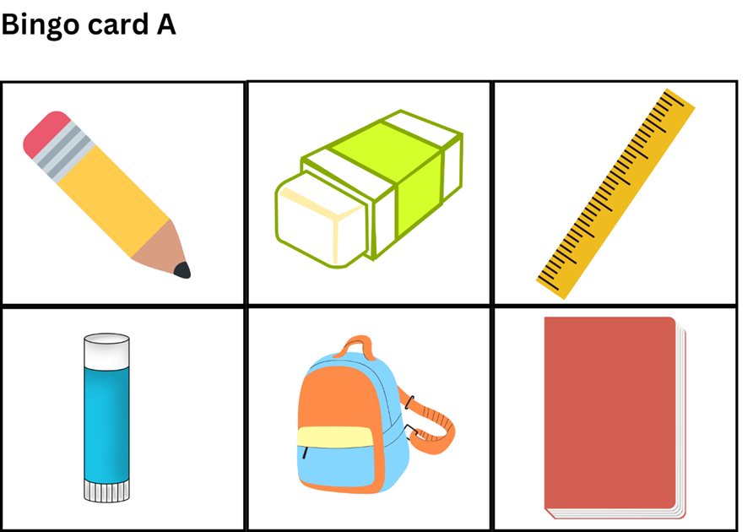
Images sourced from Canva and used in accordance with the Canva Content License Agreement.
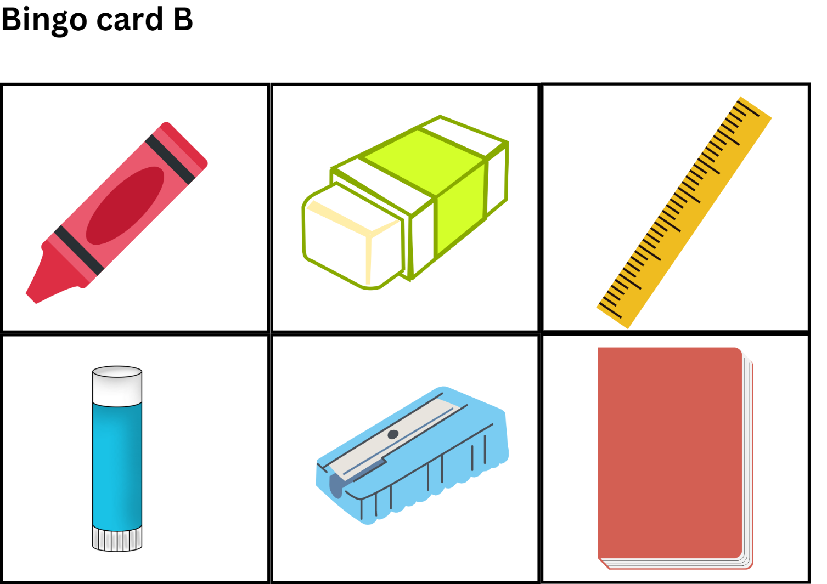
Images sourced from Canva and used in accordance with the Canva Content License Agreement.
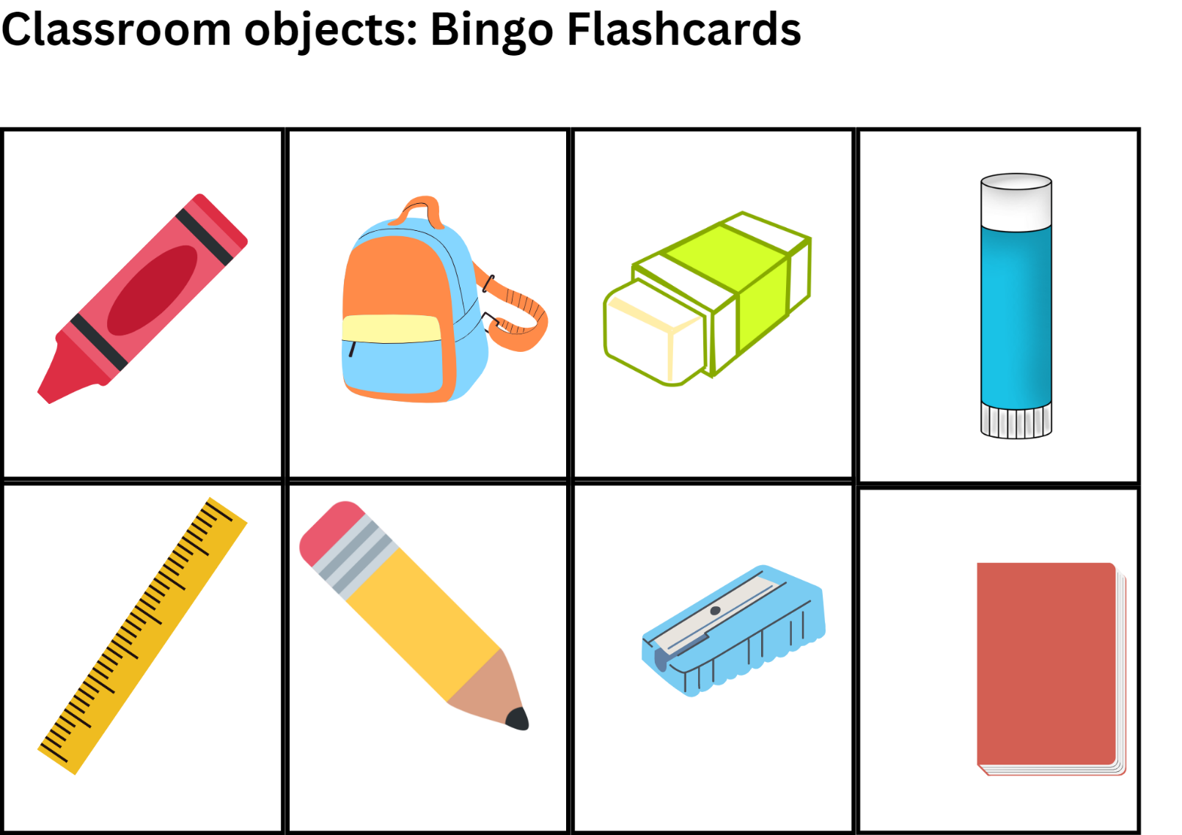
Images sourced from Canva and used in accordance with the Canva Content License Agreement.

Resource 2: Classroom objects vocabulary worksheet
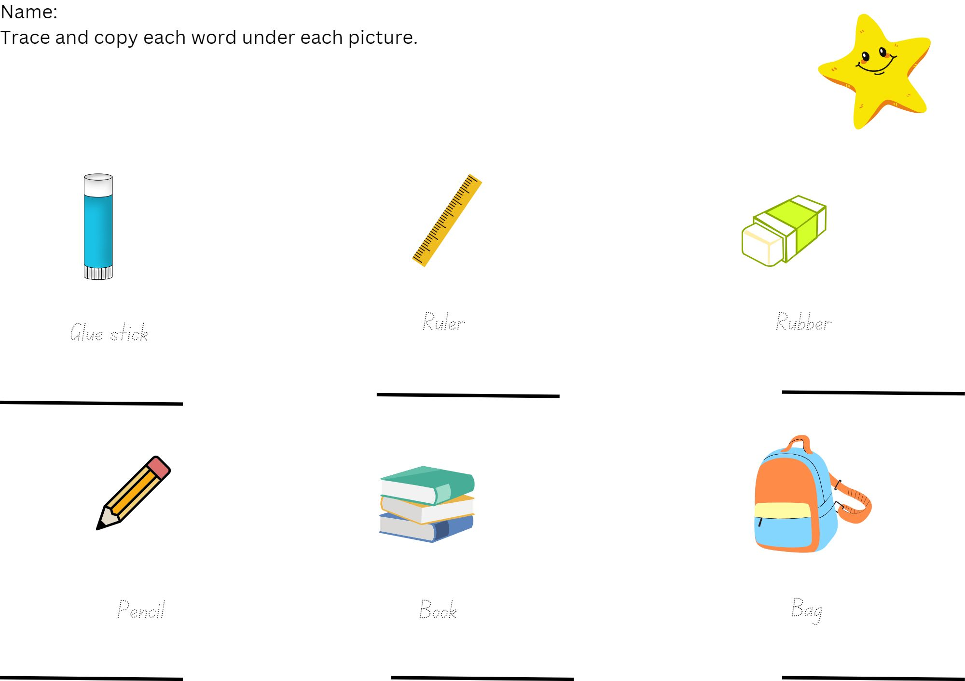
Images sourced from Canva and used in accordance with the Canva Content License Agreement.

Resource 3: Action verb pictures
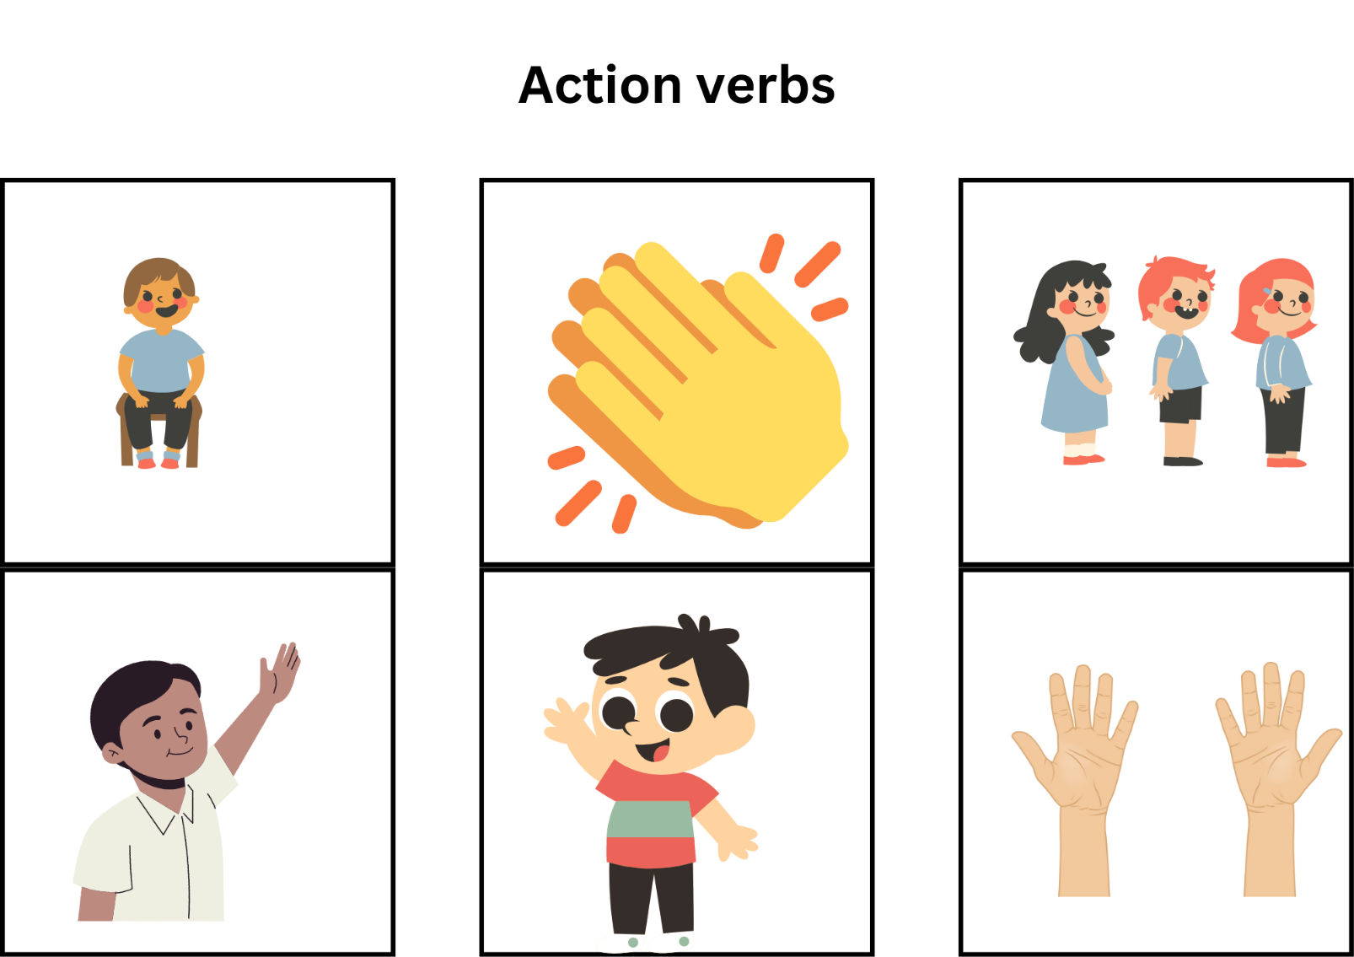
Images sourced from Canva and used in accordance with the Canva Content License Agreement.

Resource 4: Student rubric – Teacher for the day
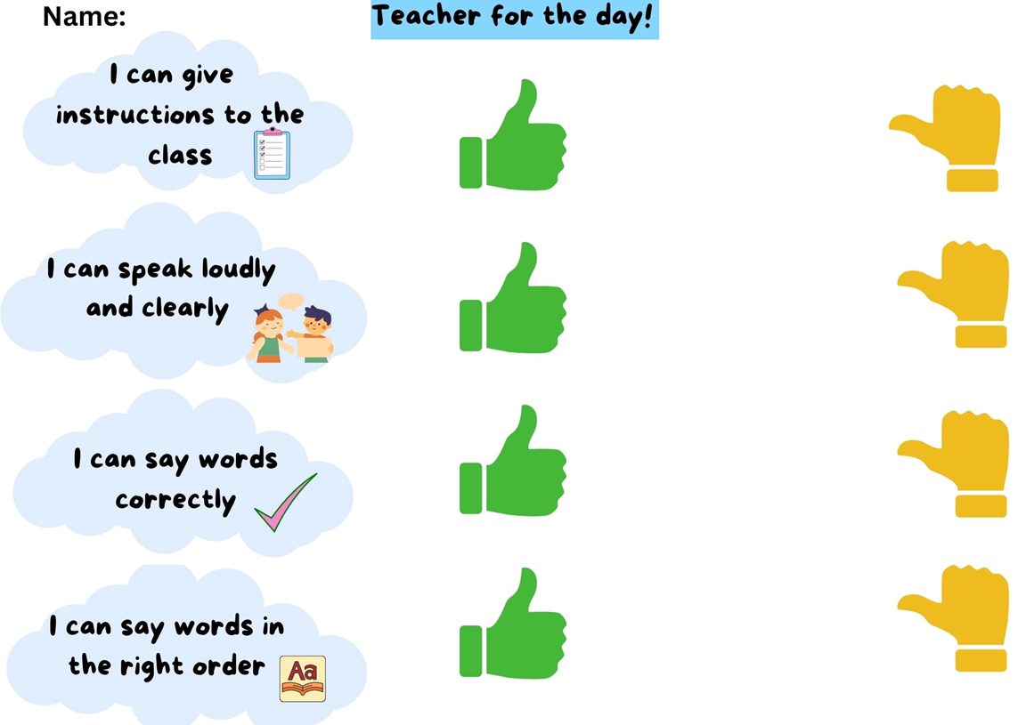
Images sourced from Canva and used in accordance with the Canva Content License Agreement.

Resource 5: Thumbs up and thumbs sideways strategy
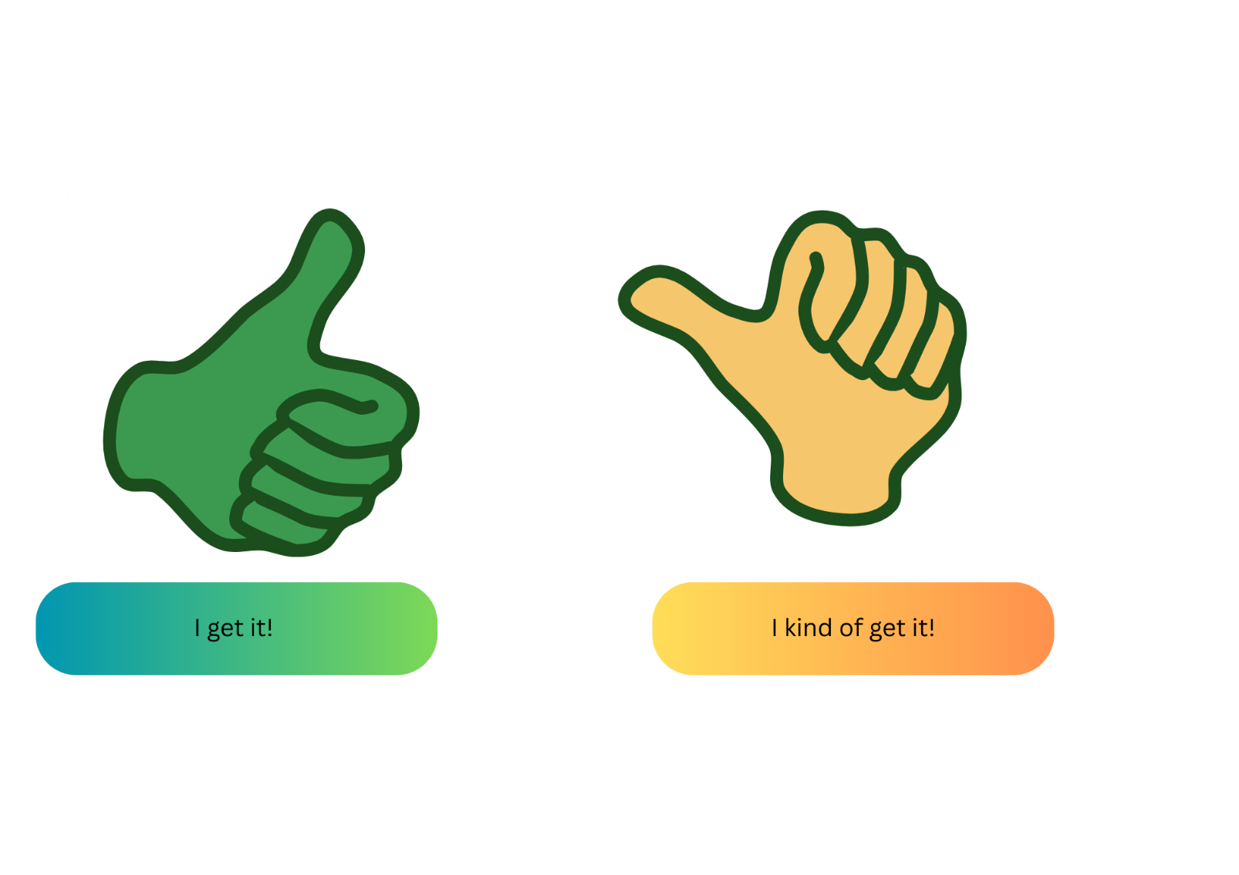
Images sourced from Canva and used in accordance with the Canva Content License Agreement.

Resource 6: Peer feedback strategy – Two stars and a wish
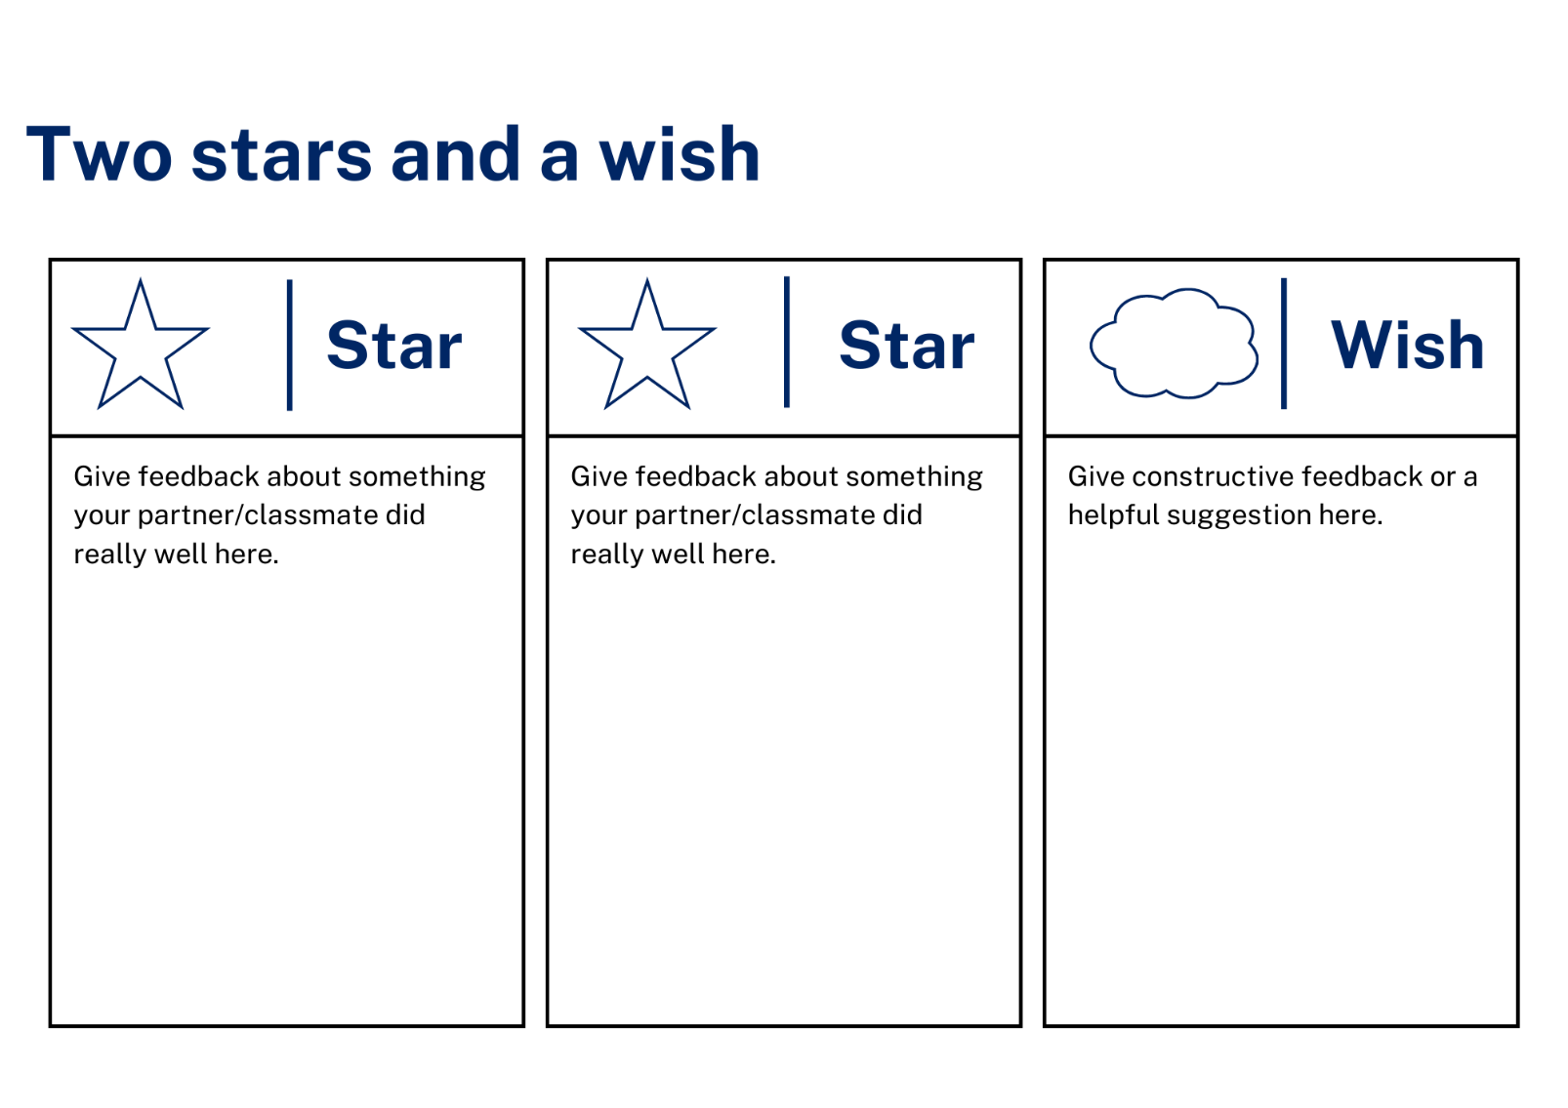

Support and alignment
Resource evaluation and support: all curriculum resources are prepared through a rigorous process. Resources are periodically reviewed as part of our ongoing evaluation plan to ensure currency, relevance, and effectiveness. For additional support or advice, contact the Primary Languages team by emailing primlang@det.nsw.edu.au.
Alignment to system priorities and/or needs: School Excellence Policy, School Success Model
Alignment to the School Excellence Framework: this resource supports the School Excellence Framework elements of curriculum (curriculum provision, teaching and learning programs) and effective classroom practice (lesson planning).
Alignment to Australian Professional Teaching Standards: this resource supports teachers to address Australian Professional Teaching Standards 2.2.2, 3.2.2.
Consulted with: Curriculum, Secondary Learners, school-based staff and NESA subject matter experts. Advice from Aboriginal Outcomes and Partnerships, EAL/D, HPGE and Inclusive Education for Modern Languages Stage 3 Italian Mangiare in Ristorante has been considered in preparing this document.
NSW syllabus: Modern Languages K–10 Syllabus
Syllabus outcomes: MLE-INT-01, MLE-UND-01, MLE-CRT-01
Author: Primary Curriculum
Publisher: State of NSW, Department of Education
Resource: Unit
Related resources: further resources to support Early Stage 1 Modern Languages can be found on the Languages K-6 curriculum page.
Professional learning: relevant professional learning is available through Primary Languages Networks on Teams (staff only).
Universal Design for Learning: support the diverse learning needs of students using inclusive teaching and learning strategies. Some students may require more specific adjustments to allow them to participate on the same basis as their peers. For further advice see Inclusive practice resources for primary school.
Differentiation: when using these resources in the classroom, it is important for teachers to consider the needs of all students in their class, including:
- Aboriginal and Torres Strait Islander students. Targeted strategies can be used to achieve outcomes for Aboriginal students in K-12 and increase knowledge and understanding of Aboriginal histories and cultures. Teachers should use students’ Personalised Learning Pathways to support individual student needs and goals.
- EAL/D learners. EAL/D learners may require scaffolding to support them to gain content knowledge, while providing extra time and assistance to master the English language required to engage with texts or complete classroom tasks. View some samples of differentiating through scaffolding.
- Students with additional learning needs. Learning adjustments enable students with disability and additional learning and support needs to access syllabus outcomes and content on the same basis as their peers. Teachers can use a range of adjustments to ensure a personalised approach to student learning.
- High potential and gifted learners. Assessing and identifying high potential and gifted learners will help teachers decide which students may benefit from extension and additional challenge. In addition, the Differentiation Adjustment Tool can be used to support the specific learning needs of high potential and gifted students.
Creation date: 28 March 2023
Rights: © State of New South Wales, Department of Education

References
This document contains NSW Curriculum and syllabus content. The NSW Curriculum is developed by the NSW Education Standards Authority. This content is prepared by NESA for and on behalf of the Crown in right of the State of New South Wales. The material is protected by Crown copyright.
Please refer to the NESA Copyright Disclaimer for more information. https://educationstandards.nsw.edu.au/wps/portal/nesa/mini-footer/copyright
NESA holds the only official and up-to-date versions of the NSW Curriculum and syllabus documents. Please visit the NSW Education Standards Authority (NESA) website https://educationstandards.nsw.edu.au/ and the NSW Curriculum website https://curriculum.nsw.edu.au/home.
Modern Languages K–10 Syllabus © NSW Education Standards Authority (NESA) for and on behalf of the Crown in right of the State of New South Wales, 2022.
8 Ways (n.d.) 8 Aboriginal Ways of Learning [website], accessed 13 December 2022.
AITSL (Australian Institute for Teaching and School Leadership) (n.d) ‘Feedback Factsheet’, AITSL, accessed 21 March 2023.
Brookhart SM (2011) How to Assess Higher-Order Thinking Skills in Your Classroom, Hawker Brownlow Education, Victoria.
CESE (Centre for Education Statistics and Evaluation) (2020a) What works best: 2020 update, NSW Department of Education, accessed 10 March 2023.
CESE (Centre for Education Statistics and Evaluation) (2020b) What works best in practice, NSW Department of Education, accessed 10 March 2023.
Conti G (28 September 2015) ‘16 tips for effective grammar teaching in the foreign language classroom’, The Language Gym, accessed 21 March 2023.
Conti G (28 May 2017) From Target Language to Model Language – the mind shift that has transformed my teaching, The Language Gym, accessed 20 March 2023.
Harmer J (2014) The Practice of English Language Teaching, 5th edn, Pearson Education, United Kingdom, accessed 21 March 2023
Henshaw FG and Hawkins MD (2022) Common Ground: Second Language Acquisition Theory Goes to the Classroom, Focus, Indianapolis, accessed 14 March 2023.
Jones J and Wiliam D (2014) Modern Foreign Languages Inside the Black Box: Assessment for Learning in the Modern Foreign Languages Classroom (Black P, Harrison C, Marshall B and Wiliam D, eds), Learning Sciences International, United States, accessed 14 March 2023
NESA (NSW Education Standards Authority) (2022) ‘Proficient Teacher: Standard descriptors’, The Standards, NESA website, accessed 21 December 2022.
Smith S (2022) Becoming an Outstanding Languages Teacher, 2nd edn, Routledge, United Kingdom.
Wiliam D and Leahy S (2015) Embedding Formative Assessment: Practical Techniques for K–12 Classrooms, Learning Sciences International, United States, accessed 14 March 2023.

© State of New South Wales (Department of Education), 2023
The copyright material published in this resource is subject to the Copyright Act 1968 (Cth) and is owned by the NSW Department of Education or, where indicated, by a party other than the NSW Department of Education (third-party material).
Copyright material available in this resource and owned by the NSW Department of Education is licensed under a Creative Commons Attribution 4.0 International (CC BY 4.0) licence.
This licence allows you to share and adapt the material for any purpose, even commercially. Attribution should be given to © State of New South Wales (Department of Education), 2023.
Material in this resource not available under a Creative Commons licence:
- the NSW Department of Education logo, other logos and trademark-protected material
- material owned by a third party that has been reproduced with permission. You will need to obtain permission from the third party to reuse its material.
Links to third-party material and websites
Please note that the provided (reading/viewing material/list/links/texts) are a suggestion only and implies no endorsement, by the New South Wales Department of Education, of any author, publisher, or book title. School principals and teachers are best placed to assess the suitability of resources that would complement the curriculum and reflect the needs and interests of their students.
If you use the links provided in this document to access a third-party's website, you acknowledge that the terms of use, including licence terms set out on the third-party's website apply to the use which may be made of the materials on that third-party website or where permitted by the Copyright Act 1968 (Cth). The department accepts no responsibility for content on third-party websites.

