Italian Early Stage 1
Ciao, buongiorno (Hello)

Contents
Unit overview 4
Early Stage 1 outcomes and content to be addressed 5
Learning map 8
Assessment 11
Assessment opportunities 12
Teaching and learning activities 13
Week 1 – Ciao, buongiorno 13
Vocabulary 1 – song lyrics and classroom greetings 13
Activity 1 – introduction 15
Activity 2 – Learning map 15
Activity 3 – introducing Italy 15
Activity 4 – ‘Ciao, Buongiorno’ song 16
Activity 5 – choral repetition 17
Week 2 – Come stai? (How are you?) 18
Activity 1 – sing ‘Ciao, Buongiorno’ 18
Activity 2 – Come stai? (How are you?) 19
Activity 3 – La passeggiata 20
Activity 4 – draw how you feel 20
Week 3 – feelings 21
Vocabulary 2 – feelings 21
Activity 1 – sing ‘Ciao, Buongiorno’ 22
Activity 2 – feelings 22
Activity 3 – Il gioco della pallina (ball game) 24
Activity 4 – feelings card game 24
Week 4 – practice task 26
Activity 1 – sing ‘Ciao, Buongiorno’ 26
Activity 2 – mime how you feel 27
Activity 3 – sequencing 27
Activity 4 – practice task 28
Activity 5 – vocabulary relay 29
Week 5 – communicative task – greet and thank your classmates 30
Activity 1 – sing ‘Ciao, Buongiorno’ 30
Activity 2 – task set-up 31
Activity 3 – communicative task – greet and thank your classmates 32
Activity 4 – self-assessment 32
Week 6 – feedback and language review 34
Activity 1 – sing ‘Ciao, Buongiorno’ 35
Activity 2 – student questions 35
Activity 3 – flashcard match 35
Activity 4 – making Ciao, buongiorno 36
Activity 5 – puppets 36
Activity 6 – set learning goals 36
Student resources 38
Resource 1 – song flashcards 38
Resource 2 – Come stai? face 40
Resource 3 – feelings flashcards 42
Resource 4 – student rubric – Ciao, buongiorno 43
Support and alignment 44
References 47

Unit overview
Stage: Early Stage 1
Title: Ciao, Buongiorno (Hello)
Description: In this unit, students sing a greeting song in Italian. They learn the language in the song through call and response singing. Students also learn different ways to say, ‘How are you?’. They greet a classmate, ask them how they are, thank them and say goodbye.
Duration: This unit is designed to be taught in the first term of Kindergarten. It has a shorter timeframe than other units to accommodate procedures and processes related to starting school. As such, this unit is to be completed over approximately 6 weeks.
Student proficiency levels:
It is assumed that most Early Stage 1 students are beginner learners of Italian. Some Early Stage 1 students may be intermediate or advanced users of Italian if it is the background language of their family or is their mother tongue. The assessment task in this scope and sequence are aimed at Beginner students. Every classroom will be different and teachers will need to adapt to their context. Many classes may include a combination of Beginner, Intermediate and Advanced students with varying skills and abilities within these proficiency levels. Assessment tasks and opportunities in this unit can be differentiated using the ‘Too hard?’ and ‘Too easy?’ suggestions.

Early Stage 1 outcomes and content to be addressed
The table below outlines the focus area, outcomes and content points for Early Stage 1 students.
Focus area and outcome | Content points
Interacting  A student:  - exchanges meaning through play and actions by reproducing culturally appropriate modelled language MLE-INT-01 | Exchanging meaning in oral interactions in the target language  - Greet and farewell others  - Answer common questions about themselves in simple conversations  - Interact in classroom routines reproducing modelled language with actions and gestures  - Interact in games and imaginative play  Reproducing oral language to interact in the target language  - Reproduce modelled vocabulary and formulaic phrases on familiar themes to interact  - Recognise and reproduce modelled sounds to interact  Reproducing how target language speakers communicate in interactions  - Reproduce verbal and nonverbal communication that is appropriate to cultural practices
Understanding texts  A student:  - responds to information in simple texts in a variety of ways to demonstrate understanding MLE-UND-01 | Understanding and responding to target language texts  - Follow simple instructions  - Listen to, read and/or view simple texts such as stories or songs by participating in shared activities  - Use auditory cues, gestures, visuals and other forms of nonverbal communication to understand texts  - Associate vocabulary on familiar themes with known actions, people, places and objects  - Respond to simple texts using actions, drawing and singing in the target language and/or English  - Reproduce vocabulary seen or heard in texts to demonstrate understanding  Developing knowledge of language systems to understand and respond to target language texts  - Recognise the meaning of modelled vocabulary on familiar themes to understand and respond to texts  - Recognise and reproduce sounds to understand and respond to texts  Developing intercultural understanding through target language texts  - Understand that there are many languages and cultural practices that are used by peers, family and community
Creating texts  A student:  - creates simple texts by reproducing culturally appropriate modelled vocabulary MLE-CRT-01 | Creating multimodal texts in the target language  - Create texts reproducing modelled vocabulary with visuals and other forms of nonverbal communication to express meaning  Reproducing vocabulary to create texts  - Reproduce modelled vocabulary and formulaic phrases on familiar themes to create texts  Reproducing how target language speakers communicate to create texts  - Reproduce language appropriate to cultural practices to create texts
Modern Languages K–10 Syllabus © NSW Education Standards Authority (NESA) for and on behalf of the Crown in right of the State of New South Wales, 2022.

Learning map
The creation of maps for learning is a planning process that incorporates Aboriginal intellectual tradition. Learning maps are a visual pathway of what students will learn.
Share the learning map with your students, briefly explaining the learning that will happen in each lesson. Provide students with a copy of the learning map or display the learning map in the classroom. This learning map can be adapted to any language by accessing a copy of Learning map – Hello (Early Stage 1).

Figure 1 –Hello learning map
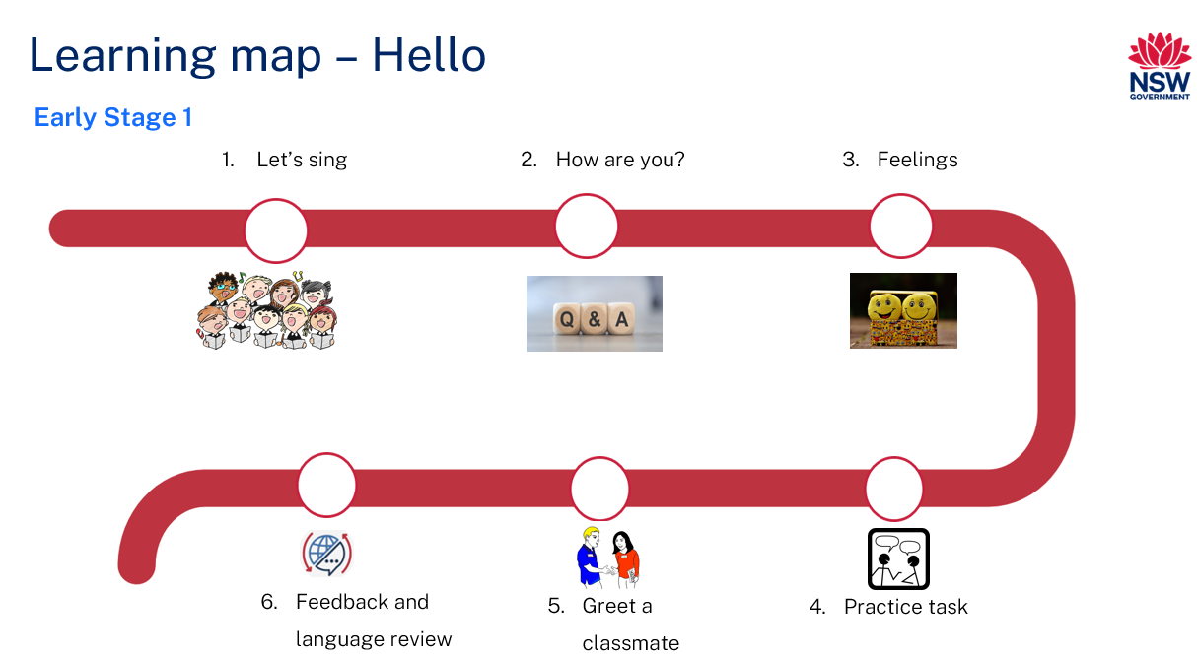
Figure 2 – Ciao, buongiorno learning map
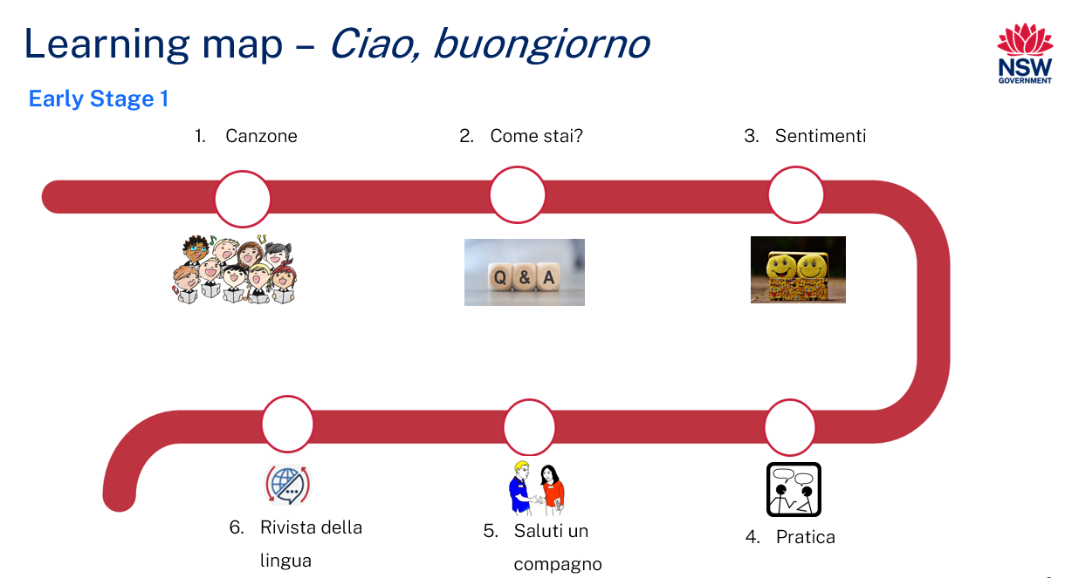

Assessment
Early Stage 1 communicative task: Greet and thank your new Italian speaking classmates.
Too hard?
Students can use gestures and facial expressions to respond.
Too easy?
Students can use different greetings and vary their responses.
Context: pretend you are a new Italian speaking student in your class
Audience: your new classmates
Purpose: greet and thank your new classmates

Assessment opportunities
The table below details assessment opportunities and differentiation ideas.
Assessment opportunities | Too hard? | Too easy?
Week 2 – La passeggiata  Students walk around the classroom, greeting up to 5 classmates and asking Come stai? (‘How are you?’). | Students greet classmates with ciao or buongiorno. | Students also thank and use ciao to say goodbye to classmates.
Week 3 – feelings card game  Call out feelings in Italian one at a time. The students who have the appropriate cards stand up and say the feeling in English. | Use gesture and facial expressions to support meaning. | Call out feelings in English and students say the feeling in Italian.
Week 4 – sequencing  Students sequence the song cards in the correct order. | Students view the display to sequence the song cards in order. | Sequence song words without images.

Teaching and learning activities

Week 1 – Ciao, buongiorno
The table below outlines the learning intention and success criteria of the lesson, and materials that the teacher and students will need to complete the teaching and learning activities.
Learning intention and success criteria | Materials
Students will sing the song ‘Ciao, Buongiorno’.  Students can:  - pronounce the words of the song correctly in Italian  - say what the words mean in English. | - Resource 1 – song flashcards  - Images of Italy  - Maps of the world and Italy  - Puppet of Pinocchio

Vocabulary 1 – song lyrics and classroom greetings
The table below outlines the suggested vocabulary used throughout this learning sequence. It includes the Italian words and phrases and their corresponding English translations.
English | Italian
children | bambini
Miss/Mrs | Maestra
Mr | Maestro
hello | ciao
good day/good morning | buongiorno
How are you? | Come stai?
very | molto
well | bene
thanks | grazie
to you | a te

Activity 1 – introduction
Say ‘Buongiorno’ (hello) to greet students in Italian, then introduce yourself in English. Introduce yourself using the appropriate Italian title, for example, Maestra or Maestro (teacher). Say ‘Buongiorno’ to Pinocchio puppet. Have Pinocchio respond with, ‘Buongiorno Maestra/Maestro’. Ask the class if they heard what was said to Pinocchio and if they can repeat it. If not, ask students to listen carefully, then say ‘Buongiorno’ to Pinocchio again and ask them to also say ‘Buongiorno’ to Pinocchio. Have Pinocchio respond with, ‘Buongiorno bambini!’ Explain to students that ‘buongiorno’ means ‘hello’ and bambini means ‘children’. Ask students to repeat ‘Buongiorno!’
Say ‘Buongiorno’ again to Pinocchio. Have Pinocchio respond with ‘Buongiorno Maestra/Maestro’. Ask students to repeat ‘Buongiorno Maestra/Maestro’. Explain that this means ‘Hello teacher’ and that ‘Buongiorno bambini!’ and ‘Buongiorno Maestra/Maestro’ will be the greetings used at the start of Italian lessons.
Note: in Italy, people are commonly addressed with their job title, Maestra/Maestro (teacher) rather than Signora, Signorina or Signore/Signor (Mrs, Miss or Mr).

Activity 2 – Learning map
Explain and display the Learning map to give students a more detailed breakdown of lessons during the unit. Point out that the Learning map is a plan that may need to change.

Activity 3 – introducing Italy
- Show students a map of Italy. Ask what country this is and what shape does the country resemble.
- Show students a map of the world. Ask students to find Australia. Help them to find Italy. Ask if Italy is far from Australia. Ask how they know.
- Ask students if they know any Italian words. If there are no answers, prompt students to think about Italian food that they may know.
Note: if time permits, also share and display images of the Italian flag, typical foods and iconic monuments.

Activity 4 – ‘Ciao, Buongiorno’ song
Note: view the ABC recording of Ciao, Buongiorno (0:40) if you are not familiar with the song. The song uses the tune of Frère Jacques. Each line is sung twice. The lyrics are:
Ciao, buongiorno (Hi, hello) × 2
Come stai? (How are you?) × 2
Molto, molto bene (Very, very well) × 2
Grazie a te (Thank you (to you)) × 2
- Sing the song ‘Ciao, Buongiorno’ using gestures and facial expressions to demonstrate meaning where possible.
- Sing the song again and ask students if they know any of the words in the song or can guess what any of the words mean. They should know buongiorno from Activity 1.
- Sing the song again one line at a time. Ask students to repeat each line after you. Ask if they can work out the meaning of the line in English, before telling them the English translation.
- Sing the song again with the English translation as every second line, rather than repeating the Italian lyrics, for example Ciao, buongiorno! (Hi, hello!). Repeat this version as a class.

Activity 5 – choral repetition
- Display images of the words of the song from Resource 1 – song flashcards. Point to the images as the class sings the song again in Italian.
- Select images in a random order and ask students to Think-Pair-Share the meaning of the Italian words by looking at the flashcards as prompts.
- Say each of the Italian words or phrases one at a time, modelling correct pronunciation. Ask students to repeat each of the words and phrases a number of times, focusing on pronouncing the Italian sounds correctly.
- Divide the class in half and ask half to stand and half to sit. The students that are standing start singing ‘Ciao Buongiorno’, the other half echo back in Italian. The students that are standing sing again, and this time the sitting students echo back in English. Students change positions and repeat.
- Point to the Learning map and remind students that they will be using the language from this song to communicate in Italian.

Week 2 – Come stai? (How are you?)
The table below outlines the learning intention and success criteria of the lesson, and materials that the teacher and students will need to complete the teaching and learning activities.
Learning intention and success criteria | Materials
Students will ask classmates how they are and respond appropriately in Italian.  Students can:  - ask their classmates how they are in Italian  - respond with molto, molto bene (very, very well)  - say grazie. | - Resource 1 – song flashcards  - Resource 2 – Come stai? face

Activity 1 – sing ‘Ciao, Buongiorno’
- Have Pinocchio say ‘Buongiorno bambini’. Students respond with ‘Buongiorno Pinocchio’ (Hello Pinocchio), ‘Buongiorno Maestra/Maestro’ (Hello teacher).
- Sing the song ‘Ciao Buongiorno’ one line at a time and ask students to repeat after you.
- Sing the song one line at a time again. After each line, ask students to whisper to a partner what they think the lyrics mean in English. As students share their ideas, refer to Resource 1 – song flashcards.
- Sing the song together as a class.

Activity 2 – Come stai? (How are you?)
Note: students who are reluctant or shy to talk may be encouraged if you give them a soft toy or a finger puppet to hold for comfort, when it’s their turn to speak.
- Ask students how they’re feeling in Italian using the question ‘Come stai?’ Ask if students can provide an appropriate answer from the song. Elicit the response ‘Molto, molto bene’ and ask students to Think-Pair-Share the English meaning. Encourage students to use a thumbs up gesture when saying ‘Molto, molto bene’.
- Tell students to listen carefully to your conversation with Pinocchio, especially the responses to ‘Come stai?’ Ask Pinocchio ‘Come stai, Pinocchio?’ Have Pinocchio respond with ‘Molto bene Maestra/Maestro’ (very well teacher). Have Pinocchio ask you ‘Come stai, Maestra/Maestro?’ Respond with ‘Bene’ (well).
- Ask students to Think-Pair-Share the different responses in your conversation with Pinocchio to ‘Come stai?’ Point out that ‘Bene, Molto bene’ and ‘Molto, molto bene’ are acceptable answers.
- Ask the students to ask a partner ‘Come stai?’ Tell students they can respond that they are well with any of the acceptable answers and encourage them to use a thumbs up gesture when answering.

Activity 3 – La passeggiata
Note: explain the Italian tradition of La passeggiata, where people gather for an evening stroll through the main street.
Tell the students that they will now have a passeggiata (a stroll along the main street) in the classroom and practice asking and responding to the question ‘Come stai?’
Students walk around the classroom. When a bell rings, students greet a nearby classmate with ‘ciao’ or ‘buongiorno’, then ask ‘Come stai?’ Students respond appropriately when asked the question. Repeat this 5–10 times.
Evaluation: use Intentional observation checklist for communicative activities to make notes about student understanding of the target language and their pronunciation.

Activity 4 – draw how you feel
Using Resource 2 – Come stai? face, students draw how they feel when they answer ‘Molto, molto bene’.
Note: students can also trace Come stai? and Molto, molto bene if time and their tracing skills permit.

Week 3 – feelings
The table below outlines the learning intention and success criteria of the lesson, and materials that the teacher and students will need to complete the teaching and learning activities.
Learning intention and success criteria | Materials
Students will learn different ways of responding to ‘Come stai?’ (How are you?)  Students can:  - ask someone how they are in Italian  - respond appropriately according to how they are feeling in Italian. | - Resource 1 – song flashcards  - Resource 3 – feelings flashcards  - Intentional observation checklist for communicative activities

Vocabulary 2 – feelings
The table below outlines the suggested vocabulary used throughout this learning sequence. It includes the Italian words and phrases and their corresponding English translations.
English | Italian
very well | molto bene
so so | così così
not good | (sto) male

Activity 1 – sing ‘Ciao, Buongiorno’
- Have Pinocchio say ‘Buongiorno bambini’. Students respond with ‘Buongiorno Pinocchio, Buongiorno Maestra/Maestro’.
- Sing the song all the way through and ask students to sing it all the way through after you.
- Show Resource 1 – song flashcards one at a time in random order. Ask students to think about the previous lessons and to whisper to their partner what they think the words mean before calling out as a class.
- Sing the song all together as a class.

Activity 2 – feelings
- Ask students to turn to a nearby classmate and greet them with ‘Ciao’ or ‘Buongiorno’, then ask ‘Come stai?’ Students respond appropriately when asked the question by their partner. Repeat with another classmate.
- Tell students that people don’t always feel molto, molto bene (very, very well). Ask students for other feelings people might have when they are asked ‘How are you?’ Possible answers include wonderful, okay, bad, sad, sick.
- Show students the images from Resource 3 – feelings flashcards. Ask them to whisper to a partner what each of the feelings are in English. Ask them if they can say any of the feelings in Italian. They should know molto, molto bene. Have students repeat each phrase after you in Italian when displaying each image.
- Show the sad face and say male or sto male using appropriate gesture, facial expression and tone of voice. Model the correct pronunciation several times and ask students to repeat after you. Ask students what they think male means. Possible answers include bad, sad, sick. Explain that male can mean ‘bad’ or ‘sick’ and sto means ‘I am’.
Note: discuss the importance of using gestures when speaking and communicating in Italian. Demonstrate the hand movement for così, così (so so). Students can practice this as they say the word. Students can propose appropriate gestures or facial expressions for molto, molto bene and sto male. Also, demonstrate how tone of voice can impact meaning by using the same tone of voice when saying molto, molto bene and sto male.
- Show the straight face without a smile or a frown. Say ‘così, così’ using the appropriate hand moving from side-to-side gesture. Model the correct pronunciation, together with the gesture, several times and ask students to repeat after you. Ask students how to say this feeling in English. Possible answers include not bad, okay, alright or so so. Explain that così means ‘so’, which means così, così means so so. Point out that all the other possible answers are also a suitable way to say così, così in English.
- Display the 4 faces from Resource 3 – feelings flashcards and randomly number them from 1–4. Say a feeling and ask students to whisper what number they think the feeling is to their partner. Say each number and ask students to raise their hands if they think that is the right answer. With each feeling, reinforce the English meaning then model and drill the Italian pronunciation.

Activity 3 – Il gioco della pallina (ball game)
Demonstrate interactions with Pinocchio by asking ‘Ciao Pinocchio, come stai?’ (Hi Pinocchio, how are you?) Try to have Pinocchio use appropriate gesture, facial expression and tone of voice when he responds differently each time with molto, molto bene (very very well); bene (well); così, così (okay); and male (not good).
Students sit in a circle and take turns throwing a soft ball or small bean bag to each other. The thrower asks ‘Ciao, come stai?’ The catcher uses appropriate gesture, facial expression and tone of voice, answering with molto, molto bene; bene; così, così or male. The thrower responds with ‘grazie’ (thank you). The catcher then throws to another student. Continue until each student has had a chance to interact. If students keep giving the same response, remind them to use the other possible answers.
Note: explain to students that grazie, rather than grazie a te, is usually used in conversations to mean ‘thank you’.
Evaluation: use Intentional observation checklist for communicative activities to make notes about student understanding of the target language, their pronunciation and use of gesture, facial expression and tone to support communication.

Activity 4 – feelings card game
- Copy enough sets of Resource 3 – feelings flashcards to have one set per group of 4 students. Give each student one card.
- Call out the feelings in Italian, one at a time. The student in each group who has the appropriate card puts their hand up, then tells their group the name of the feeling in English. When all feelings have been called and all students have had a chance to speak, students rotate the cards so everyone has a different card.
- Call out the feelings in English one at a time. The student in each group who has the appropriate card puts their hand up and tells their group the name of the feeling in Italian using appropriate gesture, facial expression and tone of voice.
- Groups continue the game with the cards turned over in the middle. Students take turns at turning over cards and saying the feeling in Italian.

Week 4 – practice task
The table below outlines the learning intention and success criteria of the lesson, and materials that the teacher and students will need to complete the teaching and learning activities.
Learning intention and success criteria | Materials
Students will greet their classmates, ask ‘Come stai?’ (How are you?) and say how they feel.  Students can:  - correctly say hello and ask a classmate ‘How are you?’ in Italian  - respond with a feeling from Resource 3 – feelings flashcards  - say ‘thank you’ in Italian. | - Resource 1 – song flashcards

Activity 1 – sing ‘Ciao, Buongiorno’
- Have Pinocchio say ‘Buongiorno bambini’. Students respond with ‘Buongiorno Pinocchio, Buongiorno Maestra/Maestro’.
- Sing the song together as a class.
- Set the class up in 2 rows, seated opposite each other. Row 1 sings in Italian and Row 2 sings back in English. Swap over.
- This time, Row 1 sings in Italian and Row 2 responds with gestures and facial expressions only. Swap over.

Activity 2 – mime how you feel
- Prompt students to ask you ‘Come stai?’ (How are you?). Use mime and gesture to indicate how you feel. Invite students to say how they feel in Italian.
- Tell students you will ask some of them ‘Come stai?’ and you want them to answer without using words.
- After a few students have demonstrated their responses, arrange students into small groups where they take turns asking ‘Come stai?’, miming the answer and guessing the answer.

Activity 3 – sequencing
- Print enough Resource 1 – song flashcards so that there is one set of jumbled up image cards for groups of 2 or 3 students.
- In groups, students sequence the images, saying the words of the song as they go.
- Ask groups to sing or say a line of the song, showing the picture they have used to represent that line.
- Groups take a photo of their completed sequence.
Evaluation: use photos of the sequenced images to check student understanding of the language.

Activity 4 – practice task
- Tell students that, in the next lesson, they will be completing a task where they need to communicate in Italian and that you will be listening to the conversations to see if students can:
- ask ‘Come stai?’ and say how they’re feeling in Italian
- pronounce Italian words correctly
- use gesture, expression and tone to help them communicate.
- Explain that students will pretend they have just moved from Italy and have joined the class. They don’t speak English, but luckily everyone in the class is learning Italian so the student can talk to them.
- Tell students they will practise this task. They will need to:
- say ‘ciao’ or ‘buongiorno’ to a classmate
- ask ‘Come stai?’
- say ‘grazie’ when a classmate shares how they are feeling.
- Students talk to a partner they are sitting next to, taking turns to start the conversation. When they have finished, students practise the conversation a few more times with different partners.

Activity 5 – vocabulary relay
- Divide the class into 3 teams and display the images from Resource 1 – song flashcards.
- One team acts as callers and score keepers while the other 2 play the game. A student calls out an Italian word or phrase from the song. One student from each of the competing teams runs to the board and touches the image to match the word called out. The first player to touch the correct image and repeat the word or phrase wins a point. The next students go when the next word is called out. The team with the most correct touches wins.
- Play 3 times so that each team gets a chance at scoring and calling.

Week 5 – communicative task – greet and thank your classmates
The table below outlines the learning intention and success criteria of the lesson, and materials that the teacher and students will need to complete the teaching and learning activities.
Learning intention and success criteria | Materials
Students will greet and thank their classmates in Italian.  Students can:  - have a short conversation with a classmate in Italian. | - Resource 1 – song flashcards  - Resource 4 – student rubric – Ciao, buongiorno

Activity 1 – sing ‘Ciao, Buongiorno’
- Have Pinocchio say ‘Buongiorno bambini’ (Hello children). Students respond with ‘Buongiorno Pinocchio, Buongiorno Maestra/Maestro’ (Hello Pinocchio, Hello teacher).
- Lead students in whisper-singing the song together as a class.
- Students then sing the song as loudly as they can.

Activity 2 – task set-up
- Tell students that they will pretend to be a student who has just moved from Italy and has joined the class. They don’t speak English, but luckily, everyone in the class is learning Italian so the student can talk to them.
- Students will need to:
- say ‘ciao’ or ‘buongiorno’ to a classmate
- ask ‘Come stai?’
- say ‘grazie’ when a classmate shares how they are feeling.
- Arrange the class into groups of 3. Suggested rotations are:
- Role-play 1: Student 1 – ‘You’, Student 2 – camera operator, Student 3 – classmate
- Role-play 2: Student 1 – classmate, Student 2 – ‘You’, Student 3 – camera operator
- Role-play 3: Student 1 – camera operator, Student 2 – classmate, Student 3 – ‘You’.

Activity 3 – communicative task – greet and thank your classmates
Note: when recording the interaction/task, make sure to space students apart when filming. Demonstrate how to film using a recording device. Use microphones, if possible, to maximise sound quality. Highlight the importance of holding the recording device still by using a tripod or resting it on a table.
Example interaction:
- Student 1: ‘Ciao, come stai?’ (Hi, how are you?)
- Student 2: ‘Buon giorno! Molto, molto bene, grazie!’ (Hello! I’m very, very well, thanks)
- Student 1: ‘Grazie!’ (Thank you)
Note: before recording the interactions, check if any students do not have permission to be filmed. Alternatives to video recording include audio recording or watching students’ interactions while taking notes and marking the rubric.

Activity 4 – self-assessment
- Read each line in Resource 4 – student rubric – Ciao, buongiorno to the class. Ask students to watch the recording of their conversation and circle the thumbs up if they agree with the sentence and a sideways thumb if they don’t agree.
- Students watch the video of themselves completing the task and mark themselves using Resource 4 – student rubric – Ciao, buongiorno
- When students are not viewing the recording, they can use Resource 2 – Come stai? face and draw how they feel when they answer ‘sto male’ (I’m not well) or ‘così, così’ (I’m okay).

Week 6 – feedback and language review
The table below outlines the learning intention and success criteria of the lesson, and materials that the teacher and students will need to complete the teaching and learning activities.
Learning intention and success criteria | Materials
Students will reflect on feedback to set suitable learning goals and review the language learnt during this unit.  Students can:  - ask questions about vocabulary, grammar, or pronunciation they have used in this unit  - use Italian words and phrases they have learned to communicate with classmates. | - Resource 4 – student rubric – Ciao, buongiorno  - Recorded student videos  - Writing materials
Note: over the course of the unit, gaps in student knowledge, misconceptions and misuse of language will have been identified. These observations are addressed using engaging and interactive activities and strategies. The activities below are examples and will need to be supplemented with activities to address your observations.

Activity 1 – sing ‘Ciao, Buongiorno’
- Have Pinocchio say ‘Buongiorno bambini’. Students respond with ‘Buongiorno Pinocchio, Buongiorno Maestra/Maestro’.
- Sing the song together as a class.
- Try several fun ways of singing the song. For example, half the class can whisper the song, while the other half shout the echo. Or, half the class can sing in opera style, while the other half rap the echo.

Activity 2 – student questions
Remind students of the activities and tasks they have completed over the course of the unit. Give students time to Think-Pair-Share any questions they may have about aspects of the language taught.
Note: set up different language stations for Activities 3–5 that focus on reinforcing the language taught during the unit. If possible, arrange to have an SLSO to support you with these activities, which can be adapted to suit students’ needs. While students are engaged with these activities, briefly speak to each student individually. Congratulate them on completing their first Italian task and give them the marked visual rubric. Offer some additional feedback if appropriate.

Activity 3 – flashcard match
Prepare 2 sets of Resource 3 – feelings flashcards. Lay them face down and let the students take turns flipping one card at a time to find matching pairs. Before a student flips a card, the group asks ‘Come stai?’ Students receive a point for calling out the correct Italian word or phrase for each card flipped over.

Activity 4 – making Ciao, buongiorno
Display the words of the song. Students use modelling clay to model the shapes of the letters for ciao, buongiorno. Students take a photo of their work.
If time permits, students can ‘write’ the rest of the words using modelling clay.

Activity 5 – puppets
Students use or make finger puppets to greet other students’ puppets, ask how they are and thank them. Students use a different voice when the puppet is speaking.

Activity 6 – set learning goals
- To foster student ownership of their learning, facilitate a class discussion to help students reflect on their marked rubrics and teacher feedback, to set their own personalised learning goals for the next phase of learning. Use simplified language to ensure that students can understand and engage with the discussion effectively.
- Suggest learning goals, such as:
- I will be confident when saying words in Italian
- I will practise saying tricky sounds in Italian, for example the ‘z’ in grazie.
- Present suggestions like these, appropriate to the context of your class. Encourage students to raise their hands when they hear a goal that resonates with them. By doing so, students will understand their options and select a learning goal that is relevant and suitable for their needs. Student learning goals are recorded.

Student resources

Resource 1 – song flashcards
Ciao |  | Buongiorno |  | Come stai?
Molto, molto bene |  | Grazie |  | a te
Hi |  | Good morning |  | How are you?
Very, very well |  | Thank you |  | to you

Resource 2 – Come stai? face
This resource can be used to teach multiple languages. Use the resource link to tailor it to your preferred language.
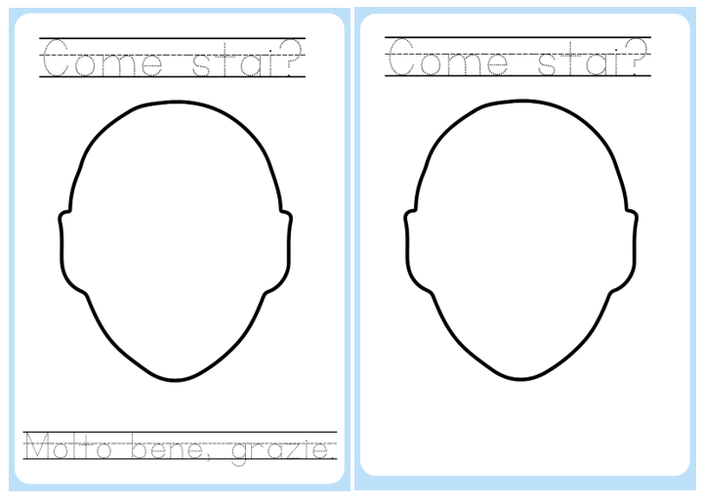
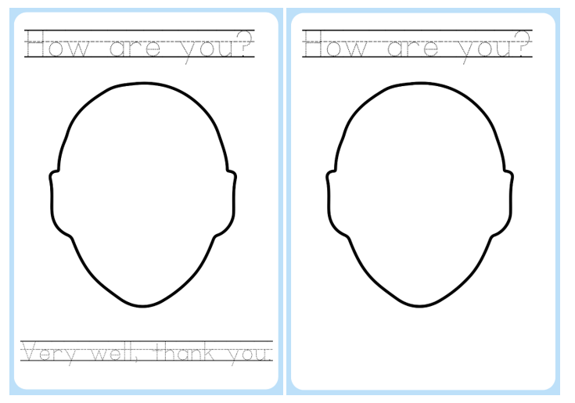

Resource 3 – feelings flashcards
Male |  | Così, così |  | Bene |  | Molto, molto bene
Not good |  | Okay |  | Well |  | Very, very well

Resource 4 – student rubric – Ciao, buongiorno
I can say hello in Italian
I can ask someone how they are in Italian
I can say how I’m feeling in Italian
I can thank people by saying ‘thank you’ in Italian

Support and alignment
Resource evaluation and support: all curriculum resources are prepared through a rigorous process. Resources are periodically reviewed as part of our ongoing evaluation plan to ensure currency, relevance, and effectiveness. For additional support or advice, contact the Primary Languages team by emailing primlang@det.nsw.edu.au.
Alignment to system priorities and/or needs: School Excellence Policy, School Success Model
Alignment to the School Excellence Framework: this resource supports the School Excellence Framework elements of curriculum (curriculum provision, teaching and learning programs) and effective classroom practice (lesson planning).
Alignment to Australian Professional Teaching Standards: this resource supports teachers to address Australian Professional Teaching Standards 2.2.2, 3.2.2.
Consulted with: Curriculum, Secondary Learners, school-based staff and NESA subject matter experts. Advice from Aboriginal Outcomes and Partnerships, EAL/D, HPGE and Inclusive Education for Modern Languages Stage 3 Italian Mangiare in Ristorante has been considered in preparing this document.
NSW syllabus: Modern Languages K–10 Syllabus
Syllabus outcomes: MLE-INT-01, MLE-UND-01, MLE-CRT-01
Author: Primary Curriculum
Publisher: State of NSW, Department of Education
Resource: unit
Related resources: further resources to support Early Stage 1 Modern Languages can be found on the Languages K-6 curriculum page.
Professional learning: relevant professional learning is available through Primary Languages Networks on Teams (staff only).
Universal Design for Learning: support the diverse learning needs of students using inclusive teaching and learning strategies. Some students may require more specific adjustments to allow them to participate on the same basis as their peers. For further advice see Inclusive practice resources for primary school.
Differentiation: when using these resources in the classroom, it is important for teachers to consider the needs of all students in their class, including:
- Aboriginal and Torres Strait Islander students. Targeted strategies can be used to achieve outcomes for Aboriginal students in K-12 and increase knowledge and understanding of Aboriginal histories and cultures. Teachers should use students’ Personalised Learning Pathways to support individual student needs and goals.
- EAL/D learners. EAL/D learners may require scaffolding to support them to gain content knowledge, while providing extra time and assistance to master the English language required to engage with texts or complete classroom tasks. View some samples of differentiating through scaffolding.
- Students with additional learning needs. Learning adjustments enable students with disability and additional learning and support needs to access syllabus outcomes and content on the same basis as their peers. Teachers can use a range of adjustments to ensure a personalised approach to student learning.
- High potential and gifted learners. Assessing and identifying high potential and gifted learners will help teachers decide which students may benefit from extension and additional challenge. In addition, the Differentiation Adjustment Tool can be used to support the specific learning needs of high potential and gifted students.
Creation date: 25 August 2023
Rights: © State of New South Wales, Department of Education

References
This resource contains NSW Curriculum and syllabus content. The NSW Curriculum is developed by the NSW Education Standards Authority. This content is prepared by NESA for and on behalf of the Crown in right of the State of New South Wales. The material is protected by Crown copyright.
Please refer to the NESA Copyright Disclaimer for more information https://educationstandards.nsw.edu.au/wps/portal/nesa/mini-footer/copyright.
NESA holds the only official and up-to-date versions of the NSW Curriculum and syllabus documents. Please visit the NSW Education Standards Authority (NESA) website https://educationstandards.nsw.edu.au/ and the NSW Curriculum website https://curriculum.nsw.edu.au/home.
Modern Languages K–10 Syllabus © NSW Education Standards Authority (NESA) for and on behalf of the Crown in right of the State of New South Wales, 2022.
8 Ways (n.d.) 8 Aboriginal Ways of Learning [website], accessed 13 December 2022.
AITSL (Australian Institute for Teaching and School Leadership (2017) ‘Feedback Factsheet’, AITSL, accessed 13 December 2022.
Brookhart SM (2011) How to Assess Higher-Order Thinking Skills in Your Classroom, Hawker Brownlow Education, Victoria.
CESE (Centre for Education Statistics and Evaluation) (2020a) What works best: 2020 update, NSW Department of Education, accessed 13 December 2022.
CESE (Centre for Education Statistics and Evaluation) (2020b) What works best in practice, NSW Department of Education, accessed 13 December 2022.
Conti G (28 September 2015) ‘16 tips for effective grammar teaching in the foreign language classroom’, The Language Gym, 13 December 2022.
Conti G (28 May 2017) From Target Language to Model Language – the mind shift that has transformed my teaching, The Language Gym, accessed 13 December 2022.
Henshaw FG and Hawkins MD (2022) Common Ground: Second Language Acquisition Theory Goes to the Classroom, Focus, Indianapolis, accessed 13 December 2022.
Jones J and Wiliam D (2014) Modern Foreign Languages Inside the Black Box: Assessment for Learning in the Modern Foreign Languages Classroom (Black P, Harrison C, Marshall B and Wiliam D, eds), Learning Sciences International, United States accessed 13 December 2022.
NESA (NSW Education Standards Authority) (2020) ‘NSW Curriculum Review – final report’, NESA, accessed 13 December 2022.
Rosenshine B (2012) ‘Principles of Instruction: Research-Based Strategies That All Teachers Should Know’, American Educator, 36(1):12–19, 39, accessed 13 December 2022.
Smith S (2022) Becoming an Outstanding Languages Teacher, 2nd edn, Routledge, United Kingdom, accessed 13 December 2022.
Wisniewski B, Zierer K and Hattie J (2020) ‘The Power of Feedback Revisited: A Meta-Analysis of Educational Feedback Research’, Frontiers In Psychology, 10(3087), doi:10.3389/fpsyg.2019.03087, accessed 13 December 2022.
Wiliam D (2013) ‘Assessment: The Bridge between Teaching and Learning’, Voices from the Middle, 21(2):15–20, accessed 13 December 2022.
Wiliam D and Leahy S (2015) Embedding Formative Assessment: Practical Techniques for K–12 Classrooms, Learning Sciences International, United States, accessed 13 December 2022.

© State of New South Wales (Department of Education), 2023
The copyright material published in this resource is subject to the Copyright Act 1968 (Cth) and is owned by the NSW Department of Education or, where indicated, by a party other than the NSW Department of Education (third-party material).
Copyright material available in this resource and owned by the NSW Department of Education is licensed under a Creative Commons Attribution 4.0 International (CC BY 4.0) license.
This license allows you to share and adapt the material for any purpose, even commercially. Attribution should be given to © State of New South Wales (Department of Education), 2023.
Material in this resource not available under a Creative Commons license:
- the NSW Department of Education logo, other logos and trademark-protected material
- material owned by a third party that has been reproduced with permission. You will need to obtain permission from the third party to reuse its material.
Links to third-party material and websites
Please note that the provided (reading/viewing material/list/links/texts) are a suggestion only and implies no endorsement, by the New South Wales Department of Education, of any author, publisher, or book title. School principals and teachers are best placed to assess the suitability of resources that would complement the curriculum and reflect the needs and interests of their students.
If you use the links provided in this document to access a third-party's website, you acknowledge that the terms of use, including licence terms set out on the third-party's website apply to the use which may be made of the materials on that third-party website or where permitted by the Copyright Act 1968 (Cth). The department accepts no responsibility for content on third-party websites.

