Leading Languages 7–12

For teachers and head teachers who lead Languages faculties
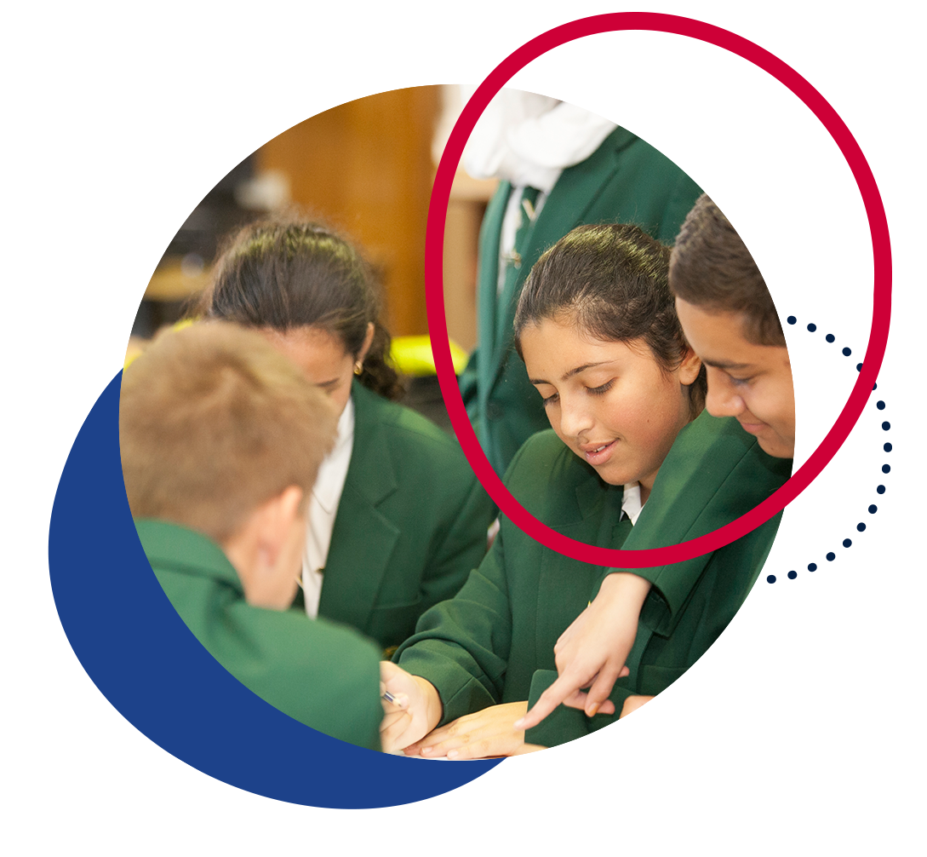

Contents
Introduction 3
New K–10 syllabuses 3
Why is the study of a language important? 4
Advocating for languages 4
Resourcing 6
Additional considerations for modern languages 6
Additional considerations for classical languages 7
An overview of languages education in NSW 7
Languages K–6 8
Community languages program K–6 9
Bilingual Schools Program 9
Relief from face-to-face programs 9
Languages 7–12 10
Secondary College of Languages (Years 5–12) 10
NSW School of Languages (Years 9–12) 10
Distance education schools (Years 9–12) 11
Community Languages Schools Program 11
Supporting language pathways from Stage 4 to Stage 6 11
Curriculum K–10 12
Modern Languages K–10 12
Syllabus organisation 12
Proficiency levels and differentiation in modern languages 7–10 13
Classical Languages K–10 14
Syllabus organisation 14
Aboriginal Languages K–10 15
Syllabus organisation 15
Content and differentiation in Aboriginal Languages 7–10 17
Assessment and reporting in 7–10 18
Life Skills 18
Curriculum 11–12 19
Modern languages 19
HSC courses 19
Eligibility 19
Assessment 20
Curriculum structure 21
Classical languages 27
HSC courses 27
Eligibility 27
Assessment 27
Curriculum structure 28
Support from the Languages and Culture team 30
Languages statewide staffroom 31
Website 31
Professional learning opportunities 32
Language teacher networks 32
Virtual Languages Mentoring Network 32
Nihongo Tanken Centre 33
Contacts 33

Note: This document provides advice only. It is the responsibility of individual school executive and teaching staff to ensure record keeping is compliant with both NSW Education Standards Authority (NESA) and departmental requirements and policies.

Introduction
In NSW public schools, the majority of language teachers 7–12 are supervised by a head teacher without a language-teaching background. Many language teachers are also the only language teacher at their school and so may not have colleagues with whom they can engage in professional dialogue relating to language teaching.
This guide has been developed by the Languages and Culture team (Curriculum Secondary Learners – Curriculum and Reform Directorate) for teachers and head teachers who lead Languages faculties, to ensure a common understanding of the Languages KLA.
The guide aims to:
- raise awareness of the importance of languages education
- provide an overview of languages K–10 syllabuses
- provide an overview of Board-developed Stage 6 language syllabuses and eligibility requirements
- outline the support available to language teachers.
The information contained in this document is correct as at April 2023.

New K–10 syllabuses
In 2022, NESA published new syllabuses for:
- Modern Languages K–10
- Classical Languages K–10
- Aboriginal Languages K–10.
The Auslan K–10 Syllabus is due to be released in 2023.
Curriculum implementation, using the relevant new syllabus(es), commences from 2024.
In 2023, teachers continue to teach using the language-specific K–10 syllabuses.
The decision regarding which language(s) to offer is made at school level, based on available resources, including access to qualified languages teachers.
To learn more about each syllabus, visit Leading languages 7–12 – Syllabus information on the department’s website.

Why is the study of a language important?
Through learning languages, students engage in purposeful communication and reflect on the heritage, culture and identity of themselves and others. Students may benefit from learning additional language(s) by:
- being able to positively transfer literacy skills between languages, as they learn about grammatical structures and broaden their vocabulary
- improving communication skills
- developing more open and curious attitudes to other cultures.

Advocating for languages
A key component of growing a successful languages program at your school is building staff capacity to design and deliver engaging teaching and learning programs. This is especially critical if you lead an individual or small group of language teachers, whose opportunities for collaboration and professional growth may be minimalised without a faculty of language-teaching colleagues. Figure 1 unpacks the key steps in growing a languages program.
Figure 1 – your role in supporting languages
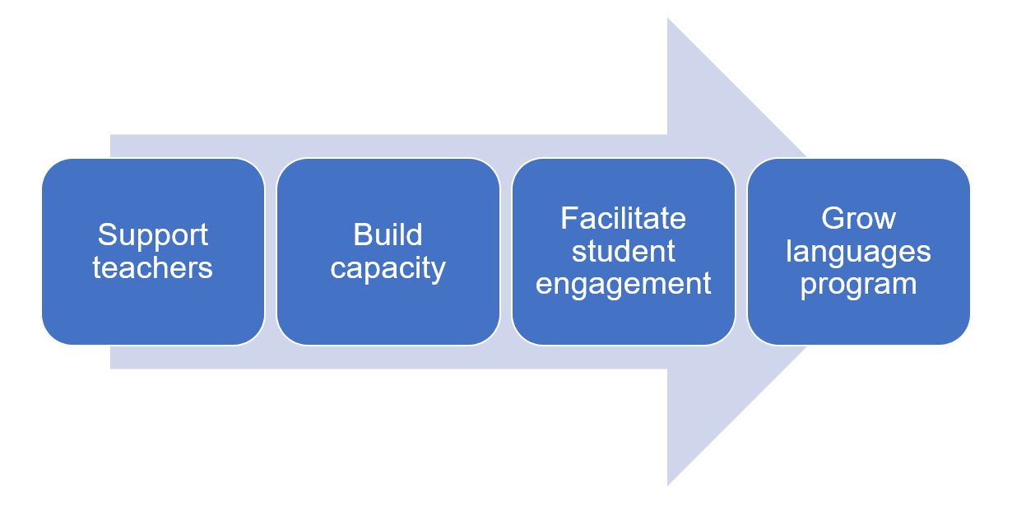
There is a range of opportunities for building staff capacity, including:
- professional learning
- statewide staffroom interactions
- language teacher networks
- membership of language teacher associations.
When timetabling occurs each year, it is important to be aware that, for modern languages:
- communication in the target language is the central goal in language learning
- spoken interactions are prioritised in the ‘Interacting’ focus area.
This is an important consideration if classes have to be split, as your languages teacher(s) may need to develop lesson content even for the periods being taught by another teacher.
You can also help raise the profile of languages in your school, and grow community awareness of the benefits of language learning, with students, parents and other teachers. Suggestions include:
- including a languages section in the newsletter
- displaying student work in the front office
- ensuring languages curriculum information on your school’s website is up to date
- supporting a range of incursions and excursions, which can motivate and engage students.
If you’re a head teacher without a language-teaching background, you could consider creating a self-introduction in the language students are learning. Platforms such as Voki can create online avatars which speak a range of languages, or you could use a real or character image (for example Bitmoji) and work with your language teacher to write the introduction.
If you are in a school with a large number of students from language backgrounds other than English, you can also advocate for the benefits of bilingualism and the impact it can have on student performance.

Resourcing
Your language teacher(s) may need your support to ensure that they are resourced in a way that best meets the needs of the subject and the students.
Considerations include:
- high-quality texts provide stronger opportunities for student engagement
- language learning is often collaborative in nature. Classroom environments should allow enough space for students to move around
- access to appropriate technology and software can assist student engagement, particularly in activities supporting vocabulary learning and grammar drills. Technology can also support differentiated learning
- regular, reliable access to technology (computer labs, laptop trolleys or tablets) can increase the teacher’s ability to engage students in creative and productive language tasks, such as filmmaking or music making.

Additional considerations for modern languages
The Modern Languages K–10 Syllabus has a strong focus on communication, with the aim of empowering students to become effective communicators in the target language through the development of linguistic competence and intercultural capability.
As such, students need to engage with a wide range of authentic resources, including written and digital texts, audio texts, music, film and realia. Sourcing authentic resources may require funding – budget allowances for online subscriptions, magazines, books, films, posters and realia are an important support for teachers. If a teacher prefers to use a textbook, it will need to be regularly updated to ensure that content and cultural information are relevant and current.
Access to technology facilitates communication and collaboration with target-language speaking students from around the world, enabling meaningful communication.
Teachers may also require special equipment for assessing modern languages, including recording devices and audio-visual equipment.

Additional considerations for classical languages
Classical languages are no longer regularly spoken and are studied primarily to gain access to their literary products and, through those, to the culture, philosophy, religion, law and science of our own past.
‘New’ texts are rarely discovered in classical languages, and the texts which have been discovered are considered well above the reading level of students in all but Stage 6. As such, classical language students rely on readings written or adapted by educators rather than authentic materials from the culture being studied.

An overview of languages education in NSW
In primary schools, the study of a language is an optional component of the curriculum, and there is no Languages key learning area (KLA) in primary.
In secondary schools, there is a Languages KLA, with mandatory curriculum requirements. Please note that the KLA is ‘Languages’ (not ‘Languages Other Than English’, or ‘LOTE’, which are both outdated).
The study of a language is mandatory for 100 hours over a continuous 12-month period in Stage 4 or Stage 5, but preferably in Stage 4 (ACE manual 4007 – mandatory curriculum requirements for the Record of School Achievement).
Almost all schools offer the mandatory 100 hours in Stage 4, with the following options commonly found in NSW public schools:
- a 100 hours course in Year 7 only
- a 100 hours course in Year 8 only
- a ‘taster’ course in Year 7, with a different language offered each term or semester, combined with the mandatory 100 hours in Year 8, in which students have the option to choose their language from those studied in Year 7.
Schools then offer elective language courses in Stage 5, which can be 100 hours or 200 hours in length. Keep in mind that students are better equipped to choose Continuers courses in Stage 6 if they have access to the full 200 hours in Stage 5.
In Stage 6, a wide variety of languages is offered in NSW schools, catering for beginning students to students with a heritage in a particular language and/or a range of prior language experiences.
Local factors often determine the nature of language learning in schools. These factors relate to teachers’ qualifications, proficiency and passion; and schools’ support for languages, including high expectations and community engagement.

Languages K–6
Approximately 17% of primary schools offer a languages program through government-funded initiatives or through individual school resources. As such, students enrolling at your school may or may not have had prior experience learning a language at primary school.
A summary of the types of language programs available for students K–6 is provided below.
High schools can develop close links with their community of feeder primary schools which offer languages and explore continuity pathways for language learners.

Community languages program K–6
Primary schools with a significant number of students from a particular language background are allocated teachers to acquire, maintain and develop a community language, which is taught for a minimum of 2 hours per week in the course of the normal school day.
The program is delivered by specialist community language teachers through various modes including whole class groups and withdrawal.

Bilingual Schools Program
This program aims to achieve a greater level of fluency in priority Asian languages among a cohort of students at 4 government primary schools. The schools and their corresponding languages are:
- Campsie Public School – Korean
- Murray Farm Public School – Japanese
- Rouse Hill Public School – Chinese
- Scotts Head Public School – Indonesian.
Students experience immersion for up to 1.5 hours every school day through direct language teaching, and content and language integrated learning (CLIL).

Relief from face-to-face programs
Some primary schools offer a language program as part of the school’s relief from face-to-face (RFF) program. These programs typically run for between 30–120 minutes per week.
RFF programs provide an opportunity for flexibility in using staffing resources to best advantage the school and its students. The school may organise their RFF timetable around teachers with particular skills and interests in specialist areas of the curriculum, such as the community languages program, to teach across a grade or the whole school.

Languages 7–12
A range of languages is offered in NSW public secondary schools, dependent on staff availability and student numbers.
There are other options available to study a language for NSW public school students, if it is not available for study in their local school. These are summarised below.

Secondary College of Languages (Years 5–12)
Secondary College of Languages, formerly known as Saturday School of Community Languages, offers students from government and non-government high schools the opportunity to study their background language if it is not available for study in their weekday school. These languages are accessible as part of Stage 4, Stage 5 and Stage 6 studies. Some languages are also offered in Stage 3.
The college operates on Saturdays during the school term in 13 campuses located in Sydney, Wollongong and Newcastle, with approximately 2,700 students enrolled.

NSW School of Languages (Years 9–12)
NSW School of Languages is a distance education language specialist school, offering courses in 12 languages. Subject to satisfying certain guidelines, students in NSW secondary and central schools may enrol to study a language course not available to them at their home school.
Face-to-face lessons are held once per term, and telephone or video lessons are held once per week. The students’ home schools must provide their students with the required resources such as phone, computer, internet and video conferencing access, as well as supervision and a safe learning space.

Distance education schools (Years 9–12)
Distance education is an equity program for geographically-isolated students or students whose circumstances prevent them from regularly attending school in NSW. Students can be enrolled full-time, or single and multiple course enrolments are also available for students in Years 9–12 when the home school cannot provide the required breadth and flexibility of curriculum.
Secondary distance education centres which offer languages are Camden Haven High School in Laurieton, Dubbo School of Distance Education in Dubbo, Finigan School of Distance Education in Queanbeyan and Southern Cross School of Distance Education in Ballina.

Community Languages Schools Program
The NSW Community Languages Schools Program offers classes in more than 60 different community languages. Classes are held outside normal school hours, usually at local government schools, and families may be asked to pay a small fee to enrol their child. They are open to any school-aged student attending a NSW government, Catholic or independent school who wishes to maintain their background or heritage language. Community languages schools are also open to students who wish to learn a language other than their heritage language. In NSW more than 36,000 students attend every year. Further information can be found on the Community Languages Schools website.

Supporting language pathways from Stage 4 to Stage 6
Schools need to consider the following in relation to their languages programs.
- Careful planning is required to ensure a clear curriculum learning pathway is available for language learners from Stage 4 through to Stage 6.
- Offering fewer than the mandated 100 hours does not meet the mandatory curriculum requirements set by NESA for the Record of School Achievement (RoSA). This also impacts a student’s ability to succeed as a language learner.
- Offering more than 100 hours in the mandatory course will render students ineligible for the Stage 6 Beginners course in that language. However, it can provide a good foundation if learners continue the study of the language into Stage 5 and then into Stage 6 Continuers.
- The perceived value of language learning in a school context is enhanced by clear pathways to access Stage 5 electives and Stage 6 language courses.
- Not providing a clear learning pathway from Stage 4 onwards usually results in a school not being able to offer any languages at Continuers level in Stage 6.
Decisions made in relation to Stage 5 elective classes are crucial, as they determine the future language learning pathway for students. The availability of language electives in Stage 5 determines whether a school is able to offer Stage 6 Continuers courses.
Year 9 and/or 10 electives courses can be either 100 or 200 hours, although 200 hours is a significantly better preparation for Continuers courses.

Curriculum K–10

Modern Languages K–10
In 2023, teachers continue to teach using the appropriate language-specific K–10 syllabus.
From 2024, teachers use the Modern Languages K–10 Syllabus (2022). The information provided below relates to this syllabus. We also recommend reviewing our programming guidelines.

Syllabus organisation
The diagram below (Figure 2) is an overview of the Modern Languages K–10 Syllabus. It shows that:
- communication is the central goal in language learning
- the 3 focus areas are Interacting, Understanding texts and Creating texts
- knowledge of language systems is applied in all focus areas and is an essential part of communication
- intercultural capability is the capacity to exchange, understand and create meaning between people and across languages and cultures and is developed in all focus areas.
Figure 2 – overview of Modern Languages K–10 Syllabus structure
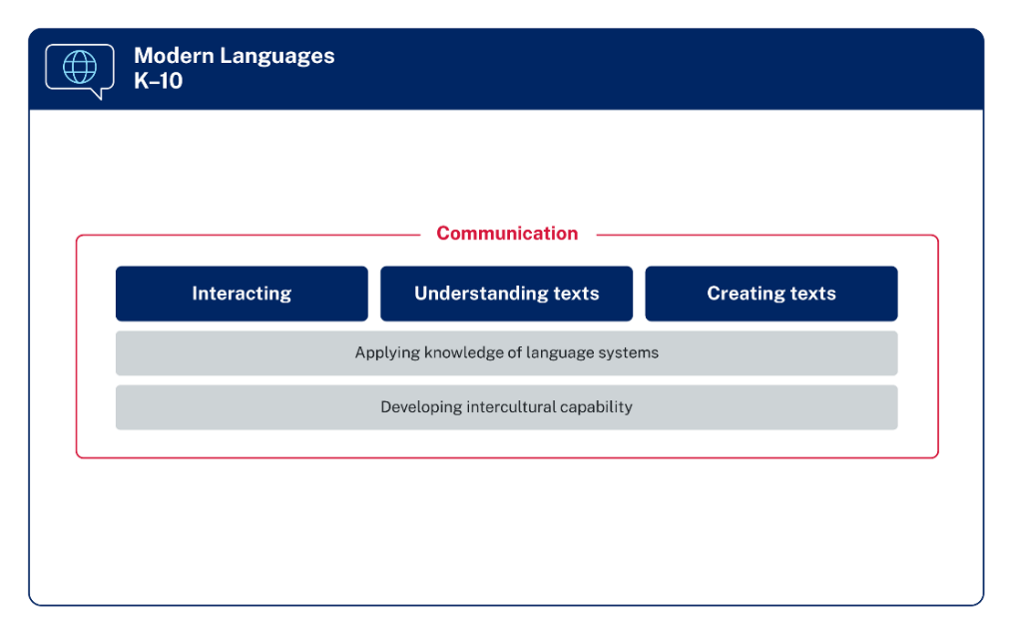
Modern Languages K–10 Syllabus © 2022 NSW Education Standards Authority (NESA) for and on behalf of the Crown in right of the State of New South Wales.

Proficiency levels and differentiation in modern languages 7–10
The Modern Languages K–10 Syllabus acknowledges that students come to the learning of languages with diverse linguistic and cultural profiles. Examples have been provided in the syllabus for each stage to support students learning the language at the Beginner, Intermediate and Advanced levels.
Differentiation can be a challenge for teachers in every KLA. In languages, there is an additional layer – in modern languages, teachers program not only for students with a disability, EAL/D students, students experiencing difficulties with learning and gifted and high potential students, they may also need to differentiate for students with widely varying levels of proficiency in the target language. Even students with a background in the language may have varying skills, including:
- students who are completely literate in the language
- those who have strong oral skills but cannot read or write the language
- those who have some language skills across all 4 macro skills of reading, writing, listening and speaking.
For this reason, language teachers need to either create or access a very broad range of authentic target language resources.

Classical Languages K–10
In 2023, teachers continue to teach using the appropriate language-specific K–10 syllabus – Classical Greek K–10 Syllabus (2003) or Latin K–10 Syllabus (2003).
From 2024, teachers use the Classical Languages K–10 Syllabus (2022). The information provided below relates to this syllabus.

Syllabus organisation
The diagram below (Figure 3) is an overview of the Classical Languages K–10 Syllabus. It shows that:
- understanding texts is necessary to access classical languages and cultures. Students apply knowledge of language systems to understand texts
- translation is a core skill in the study of a classical language. By translating texts, the analysis of languages reinforces meaning
- intercultural understanding involves learning about the classical world, making connections and comparisons, and reflecting on language, culture and identify.
Figure 3 – overview of Classical Languages K–10 Syllabus structure
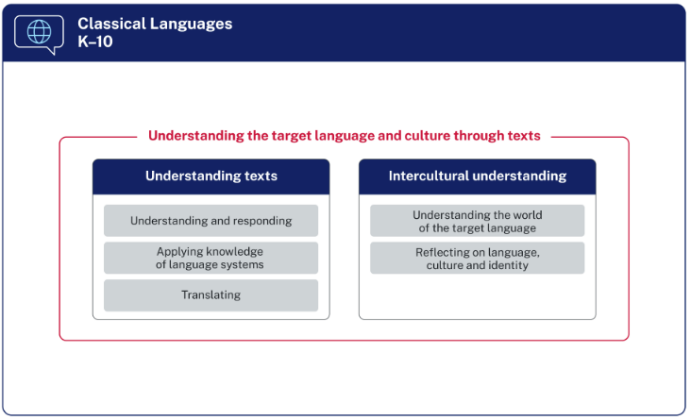
Classical Languages K–10 Syllabus © 2022 NSW Education Standards Authority (NESA) for and on behalf of the Crown in right of the State of New South Wales.

Aboriginal Languages K–10
In 2023, teachers continue to teach using the Aboriginal Languages K–10 Syllabus (2003).
From 2024, teachers use the Aboriginal Languages K–10 Syllabus (2022). The information provided below relates to this syllabus.

Syllabus organisation
The diagram (Figure 4) is an overview of the Aboriginal Languages K–10 Syllabus.
Figure 4 – overview of Aboriginal Languages K–10 Syllabus structure
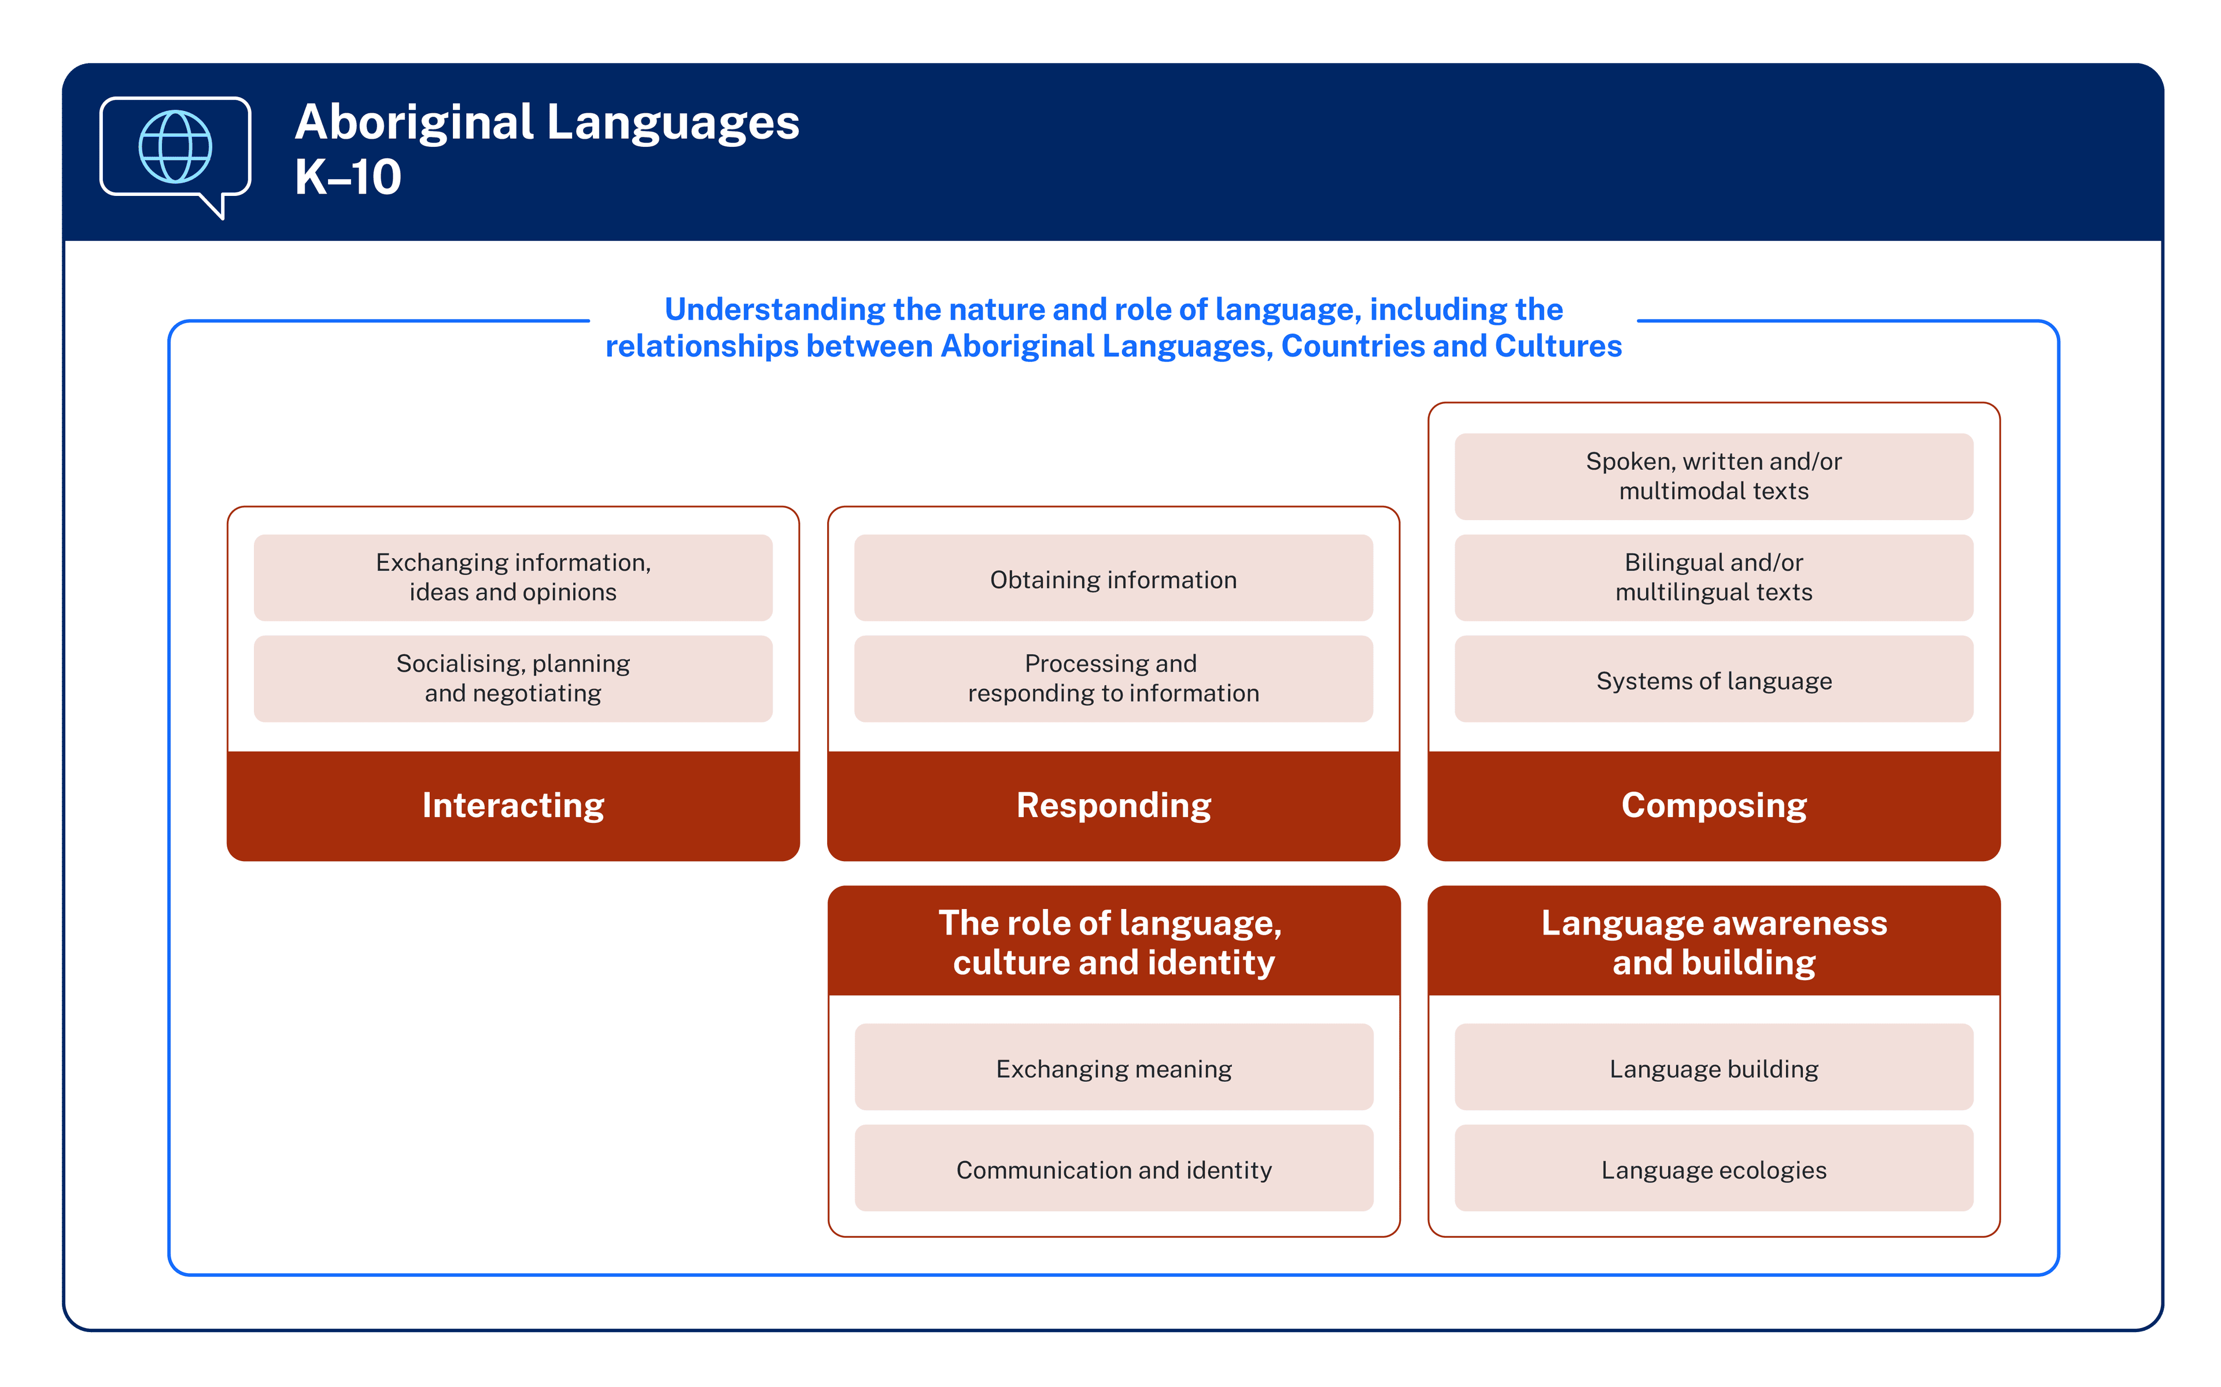
Aboriginal Languages K–10 Syllabus © 2022 NSW Education Standards Authority (NESA) for and on behalf of the Crown in right of the State of New South Wales.

The Languages
The languages to be studied and assessed are the Aboriginal Languages of Australia, with priority given to the language of Country where the school is located.
Students should learn to communicate in the target language, including formal and informal language used in daily life, and an awareness of dialectal and/or regional differences. Students may also learn that the target language has corresponding sign and restricted language.

The learners of Aboriginal Languages
Students come to the learning of languages with diverse linguistic, cultural and personal profiles, including a range of prior language experiences. Students start school as mono-, bi- or plurilingual.
Syllabus content is designed to accommodate the range of student entry points and range of learners, some of whom may have significant prior learning, experience or background in the target language and/or other Aboriginal Languages.
In Kindergarten to Year 6, content is developed for 2 broad student groups:
- students who are studying the target language as Language Revival learners
- students who are studying the target language as First Language learners.
In Year 7 to Year 10, content is developed and presented in 3 ways:
- students who are studying the target language as Language Revival learners
- students who are studying the target language as First Language learners
- students undertaking a course based on Life Skills outcomes and content.

Community consultation
The local Aboriginal Community of the school is an important partner and should be the first contact regarding the introduction of Aboriginal Languages into school-based teaching and learning programs. For full details, please see ‘Community consultation’ in the course overview section of the Aboriginal Languages K–10 Syllabus.

Content and differentiation in Aboriginal Languages 7–10
The Aboriginal Languages K–10 Syllabus acknowledges that students come to the learning of languages with diverse linguistic and cultural profiles. The syllabus provides the following content.
- Additional: Language Revival – students learning the target language as an additional language
- Prior: Language Revival – students with significant prior learning and/or experience in the target language
- First: students continuing to learn their First Language as the target language.
As with modern languages, teachers of Aboriginal Languages may need to differentiate based on a student’s prior learning and/or experience in the language.

Assessment and reporting in 7–10
Schools follow the department’s Curriculum planning and programming, assessing and reporting to parents K–12 policy for all subjects.
In both Modern Languages K–10 and Aboriginal Languages K–10, communicating in the target language is critical. For communication to be meaningful, students need to understand the purpose and audience of the communicative act, within a real-world or simulated real-world context. Schools which hold a formal examination period in 7–10 may need to plan carefully to meet this requirement.
For classical languages, assessment of students is more traditional, usually consisting of formal examinations rather than the skills-based approach used for modern languages.
In Years 7–10, teachers develop marking guidelines which align with the Common Grade Scale, contextualised to the task and the related syllabus outcomes and content.
When grading student achievement at the end of a Stage 5 course (100 or 200 hours) for the Record of School Achievement, teachers use the relevant course performance descriptors:
- Course performance descriptors for Modern Languages K–10 Syllabus
- Course performance descriptors for Classical Languages K–10 Syllabus
- Course performance descriptors for Aboriginal Languages K–10 Syllabus.

Life Skills
NESA recognises that a small percentage of students with special education needs may best fulfil the mandatory curriculum requirements for languages by undertaking Life Skills outcomes and content.
Life Skills outcomes for Years 7–10 are included in all K–10 languages syllabuses.
Schools with eligible students can develop a School Developed Board Endorsed Course for a Stage 6 Life Skills course in any language. Applications for these courses are submitted to NESA via Schools Online.
For more details, including timelines for applications, refer to the NESA website.

Curriculum 11–12
The information provided below relates to Board-developed courses.

Modern languages
There are 55 modern language courses available as HSC subjects. The language(s) offered in each school is determined by the school’s priorities, staffing and student preferences. Eligibility criteria apply for some courses.

HSC courses
There are 5 types of HSC modern languages courses:
- Beginners – for students with little or no prior language knowledge (for example no prior study, or study of the mandatory 100 hours in Stage 4 only)
- Continuers – most commonly for students who have studied the language in Stage 5
- Extension – a course for students also studying the Continuers course, and who seek a high degree of language competence and fluency
- In some Asian languages, 2 additional courses are available, which affect eligibility rules:
- [Language] in Context for heritage students
- [Language] and Literature for students with a background in the language.

Eligibility
Eligibility criteria apply to the following courses:
- Beginners
- Continuers, where a [Language] in Context and/or a [Language] and Literature course exists
- [Language] in Context where a [Language] and Literature course exists.
Eligibility criteria do not apply to the following Year 11 and Year 12 courses:
- any course which is the highest proficiency level available
- Extension (these courses may only be studied concurrently with, or after completing, the Continuers course in the same language).
Students need to apply to their school principal for an eligibility determination, if possible during Term 3 of Year 10. To be deemed eligible for a course, a student must meet all of the eligibility criteria for that course at the time of entry to the course. The principal's eligibility determination should be provided to the student in writing at least 10 school weeks prior to the commencement of the course.
Eligibility forms, including a statutory declaration, are kept at the school. They do not have to be submitted to NESA but NESA officers may request copies of these forms.
For further information, refer to the eligibility for Stage 6 Languages courses section on the NESA website and ACE manual 8008 – entry requirements for Stage 6 Languages courses where eligibility criteria apply.

Assessment
- New assessment and reporting guidelines for Stage 6 modern languages were released in July 2017 for implementation with Year 11 in 2018. These are available on the NESA website, under the relevant course. These include the mandatory components and weightings for school-based assessment in Year 11 and Year 12.
- Language courses must assess 4 macro skills: listening, speaking, reading and writing.
- School-based assessment requirements specify that tasks should assess macro skills in a holistic and authentic way, combining skills rather than testing them in isolation. As such, school-based assessment tasks should differ in structure and style to HSC examinations, which assess the 4 macro skills separately.
- Timetabling for in-school examinations must take into consideration the listening and oral component of languages examinations – they cannot run at the same time as other subjects or language levels.
- Teachers may require special equipment for language assessments, including recording devices and audio equipment.
- Unannotated monolingual or bilingual print dictionaries may be used in all Beginners, Continuers, [Language] in Context, [Language] and Literature and Extension HSC examinations. As such, schools should support students in understanding how to effectively use dictionaries. Digital and kanji dictionaries are not permitted.
- HSC oral examinations are held separately to the written examinations, usually in August or September. Oral examination centres vary from year to year, but are often centralised off-site due to the small number of candidates and availability of markers.
- The final written examination takes place on the date specified in the HSC written examinations timetable, at the student’s day school, regardless of where the language is studied.

Curriculum structure

Beginners courses
The aim of the Stage 6 Beginners modern language syllabuses is to enable students to develop:
- skills in effective communication
- knowledge of the nature of language
- understanding of the interdependence of language and culture.
Beginners courses are offered in Chinese, French, German, Indonesian, Italian, Japanese, Korean, Modern Greek and Spanish.
These courses are designed for students with little to no prior spoken or written knowledge or experience of the language and eligibility criteria apply.

Objectives
Objective 1: Interacting
Students will develop the linguistic and intercultural knowledge, understanding and skills to communicate actively in [Language] in interpersonal situations.
Objective 2: Understanding texts
Students will interpret and respond to texts, applying their knowledge and understanding of language and culture.
Objective 3: Producing texts
Students will create and present texts in [Language] for specific audiences, purposes and contexts, incorporating their linguistic and intercultural knowledge, understanding and skills.

Content
The prescribed topics in Stage 6 Beginners courses should be studied from 2 interdependent perspectives:
- the personal world
- the [Language]-speaking communities.
These topics are taught across Year 11 and Year 12. In these 2 perspectives, the topics studied include:
- family life, home and neighbourhood
- people, places and communities
- education and work
- friends, recreation and pastimes
- holidays, travel and tourism
- future plans and aspirations.
The syllabus provides a comprehensive outline of the grammar knowledge required, which can be useful for program registration purposes.
There are no prescribed vocabulary lists – vocabulary is taught according to the topics studied, although it is generally expected that students will know the vocabulary used in the grammar outline. Some Asian languages have prescribed character lists.

Continuers courses
The aim of the Stage 6 Continuers modern language syllabuses is to develop students’:
- ability to use [Language] to communicate with others
- understanding and appreciation of the cultural contexts in which [Language] is used
- ability to reflect on their own culture(s) through the study of other cultures
- understanding of language as a system
- ability to make connections between [Language] and English and/or other languages
- cognitive, learning and social skills
- potential to apply [Language] to work, further study, training or leisure.
Continuers courses are generally designed for students who are learning the language as an additional language and eligibility criteria may apply. Typically, the students would have studied the language for 200–400 hours before starting the Stage 6 Continuers course.

Objectives
Objective 1 – exchange information, opinion and experiences in [Language]
Objective 2 – express ideas through the production of original texts in [Language]
Objective 3 – analyse, process and respond to texts that are in [Language]
Objective 4 – understand aspects of the language and culture of [Language]-speaking communities
Meeting these objectives will involve using the skills of listening, speaking, reading and writing, either individually or in combination, and being able to move between [Language] and English.

Content
Stage 6 Continuers courses focus on 3 prescribed themes:
- the individual
- the [Language]-speaking communities
- the changing world.
Each language has a list of prescribed topics and suggested sub-topics. These are listed in the individual syllabuses.
The syllabus provides a comprehensive outline of the grammar knowledge required, which can be useful for program registration purposes.
There are no prescribed vocabulary lists – vocabulary is taught according to the themes and topics prescribed in the syllabus. It is expected that students will be familiar with a range of vocabulary and idiomatic expressions.
Chinese and Japanese have prescribed character lists.

Extension courses
Extension modern language courses are available for study in Year 12 only and commence in Term 4.
Extension courses are available in the following languages:
- Arabic
- Chinese
- French
- German
- Indonesian
- Italian
- Japanese
- Modern Greek
- Spanish.
The Stage 6 Extension syllabuses aim to enhance students’ knowledge and understanding of a range of issues as reflected in contemporary target language texts.
Extension courses enable students to extend their ability to use and appreciate the target language as a medium for communication, creative thought and expression.
Students engage with the theme ‘the individual and contemporary society’ through course prescriptions (study of a prescribed text, prescribed issues and a range of relevant related texts).
The course prescriptions change approximately every 5 years; new course prescriptions began in 2020.
The emphasis of assessment in Extension courses is productive language (speaking and writing) and text analysis.

[Language] in Context courses
[Language] in Context courses were previously known as Heritage courses. The courses are available in Chinese, Japanese and Korean.
[Language] in Context courses aim to develop students’ ability to:
- use [Language] to communicate in a range of contexts
- understand how language works as a system
- appreciate their [Language] linguistic and cultural heritage
- understand how culture and identity are created and expressed through language
- make linguistic connections between [Language] and English, and/or other languages
- apply [Language] to work, further study, vocational training or leisure.
Most students undertaking these courses come from homes where the language is used, and have a connection to the culture. Typically, they have some understanding and knowledge of the language, although their spoken language is generally much stronger than their written language skills. These students have most likely completed the majority of their schooling in English. Eligibility criteria apply.
Students engage with themes from personal, community and international perspectives in the context of social and community settings, contemporary literature and the arts, and media. Students complete a Personal Investigation which allows students to reflect on their own personal and cultural identity by making links with their heritage.
The syllabuses provide extensive prescriptions for grammar, and character lists are provided for Chinese and Japanese.

[Language] and Literature courses
[Language] and Literature courses were previously known as Background Speaker courses.
The courses are available in Chinese, Korean and Indonesian.
[Language] and Literature courses demand a higher level of language competence than [Language] in Context courses. Assessment emphasises written rather than oral language skills, with reading and writing being the most heavily weighted assessment components.
[Language] and Literature courses aim to develop students’:
- ability to use [Language] to communicate with others
- understanding and appreciation of the cultural contexts in which [Language] is used
- ability to reflect on their own and other cultures
- understanding of language as a system
- opportunities to make connections between [Language] and English and or other languages
- cognitive, learning and social skills
- potential to apply [Language] to work, further study, training or leisure.
[Language] and Literature syllabuses are designed for students with a cultural and linguistic background in the language – students who are first-language speakers, or who have completed a significant part of their formal education in the target language.
Students study 4 prescribed themes that are linked to contemporary issues and explored through a range of texts:
- prescribed texts change every 5 years; new course prescriptions began in 2019
- the syllabuses provide lists of text types plus extensive prescriptions for grammar.

Classical languages
Latin, Classical Greek and Classical Hebrew are available in Stage 6. The language(s) offered in each school is determined by the school’s priorities, staffing and student preferences.

HSC courses
There are 2 types of HSC classical languages courses:
- Continuers – for students who, typically, will have studied Latin for 400–500 hours at the completion of Year 12
- Extension – a course for students also studying the Continuers course, and who seek a high degree of language competence.

Eligibility
Eligibility criteria do not apply to classical language courses. However, it is strongly advised that students have a sound Stage 5 preparation in the classical language.

Assessment
Each classical language course has its own assessment and reporting requirements: Latin Continuers, Latin Extension, Classical Greek Continuers, Classical Greek Extension, Classical Hebrew Continuers and Classical Hebrew Extension although there are significant parallels between them.
- Unannotated monolingual and/or bilingual print dictionaries may be used in Latin exams. No dictionaries may be used in classical Greek or classical Hebrew exams. Digital dictionaries are not permitted.
- The final written examination takes place on the date specified in the HSC written examinations timetable, at the student’s day school, regardless of where the language is studied.

Curriculum structure

Continuers courses
The aim of the Stage 6 Continuers classical language syllabuses is to develop students’:
- ability to understand [classical language] texts
- ability to understand how language works, including at the grammatical level
- ability to recognise connections between [classical language] and English or other languages
- ability to recognise stylistic features of [classical language] texts and understand their literary effects
- ability to assimilate the ideas contained in a [classical language] text
- ability to explore the ideas of a [classical language] text in its social, cultural, historical and religious context
- ability to explore their own culture(s) through the study of the ancient culture
- ability to recognise how ideas and beliefs of the classical period have influenced subsequent societies
- enjoyment of the study of [classical language] through the reading of [classical language] texts
- general cognitive, analytical and learning skills.

Target candidature
The Continuers level syllabus is designed for students who, typically, have studied [classical language] for 400–500 hours at the completion of Year 10.

Objectives
The students will achieve the following objectives:
Objective 1 – understand seen and unseen texts written in the original [classical language]
Objective 2 – understand the linguistic and stylistic features and the cultural references in prescribed [classical language] texts
Objective 3 – understand the prescribed text as a work of literature in terms of the author’s purpose.

Structure
Stage 6 Continuers is split into 2 year-long components:
- Preliminary course (120 indicative hours)
The Preliminary course is structured to provide students with opportunities to read original [classical language] texts, developing the skills needed to study the prescribed texts for the HSC course and to translate unseen texts. Students extend their vocabulary, consolidate their language skills and study additional linguistic features not prescribed in the Years 7–10 syllabus. Students also begin to appreciate the purpose and point of view of different authors and their effective use of language.
It is a requirement that the Preliminary course not teach texts which will be prescribed for the following year in either the Continuers or Extension courses.
- HSC course (120 indicative hours)
The HSC course is designed to allow students to apply and extend the knowledge and skills gained through a wider reading of authors in the Preliminary course to a detailed study and analysis of 2 prescribed texts, one verse and one prose. Students apply their linguistic skills and their familiarity with [classical language] literature in the independent translation of unseen passages of original [classical language] text.
The prescribed texts are found in the Course prescriptions for Latin Continuers, Course prescriptions for Classical Greek Continuers and Course prescriptions for Classical Hebrew Continuers. The texts are prescribed quite a long time in advance, and have overlapping timeframes which means a teacher should only need to prepare at most one new text per year across both Continuers and Extension courses in the language.

Assessment
Continuers course assessment requirements were updated and released in July 2017 and came into effect in Term 1 2018 (with Year 11). There are similar documents for each classical language: Assessment and reporting in Latin Continuers Stage 6, Assessment and reporting in Classical Greek Continuers Stage 6 and Assessment and reporting in Classical Hebrew Continuers Stage 6.

Extension courses
Extension classical language courses are available in Latin, Classical Greek and Classical Hebrew for study in Year 12 only and commence in Term 4.
The Extension syllabuses aim to increase students’ enjoyment and knowledge of classical literature, to develop students’ linguistic competence, to extend their analytical skills and to refine their ability to respond critically to literature.
The Extension course leads students into an area of classical literature that is not explored in the Continuers course.
For the Extension courses:
- the Preliminary course is a prerequisite
- the Continuers course is a co-requisite
- 60 indicative hours are required to complete the courses.

Assessment
Extension course assessment requirements were updated and released in July 2017 and came into effect in Term 4 2018. There are similar documents for each classical language: Assessment and reporting in Latin Extension Stage 6, Assessment and reporting in Classical Greek Extension Stage 6 and Assessment and reporting in Classical Hebrew Extension Stage 6.

Support from the Languages and Culture team
The Languages and Culture team offers a range of support to language teachers and their head teachers.
Our role is to support the effective implementation of language programs 7–12 in NSW public schools, including:
- designing and delivering relevant and innovative projects and professional learning
- providing expert curriculum advice and support related to syllabus implementation.

Languages statewide staffroom
All teachers of modern and classical languages 7–12, and their head teachers, should be members of the Languages statewide staffroom, which is housed in Microsoft Teams. To join, complete the short entry survey, which automatically adds you to the staffroom. There are currently over 1,000 members.
For Aboriginal Languages, there is also the Aboriginal Education statewide staffroom.
For primary teachers, there is the Primary Languages Networks.
View the full list of statewide staffrooms on the department’s website.

Website
Our website is education.nsw.gov.au/teaching-and-learning/curriculum/languages.
Our support includes:
- programming resources, for example, sample scope and sequence documents and units of work
- advice documents for HSC modern and classical languages students
- practice speaking questions for Stage 6 Beginners and Continuers modern languages courses
- the HSC hub for Languages
- sample listening and reading resources for a range of Stage 6 courses.

Professional learning opportunities
As all teachers are working towards their accreditation or maintenance of accreditation, there is a need for relevant, KLA-specific, professional learning.
The Languages and Culture team offers a range of professional learning opportunities for language teachers 7–12, including:
- statewide staff meetings in Week 4 each term
- language teacher network meetings held in Week 7 or 8 each term
- eCourses
- online webinars.
View professional learning.

Language teacher networks
There are 19 geographically-based language teacher networks operating across NSW, as well as a virtual network for language teachers who are geographically remote from their nearest network.
Networks offer targeted professional learning, tailored to meet local needs, and provide an invaluable opportunity for teachers to collaborate with other languages teachers.
View the full list of language teacher networks locations and contacts.

Virtual Languages Mentoring Network
The Virtual Languages Mentoring Network (VLMN) is a structured, 2-year mentoring program for beginning teachers of languages. A beginning teacher is one in their first 5 years of teaching languages.
Each participant (mentee) is assigned an experienced, language-specific teacher mentor. Each mentor works with up to 2 mentees, ensuring relationships are central to the mentoring journey.
To learn more, contact evia.kyriacou@det.nsw.edu.au or shanelle.ingram@det.nsw.edu.au.

Nihongo Tanken Centre
If your school offers a Japanese program, you may consider accessing the support offered by the Nihongo Tanken Centre. The Nihongo Tanken Centre is a purpose-built Japanese immersion centre, located on the grounds of Kirrawee High School in southern Sydney.
Schools can:
- bring students for an immersion experience in the Japanese language and culture
- attend an online speaking session (subject to availability)
- access our virtual visit for Year 10 (available from Term 2 2022, for rural and remote students).
The centre also offers holiday workshops for Stage 6 students, which run online.

Contacts
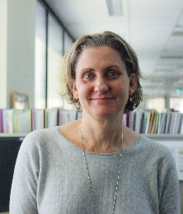 | Elisabeth Robertson  Coordinator, Languages and Culture  elisabeth.robertson@det.nsw.edu.au
Evia Kyriacou
Languages Advisor
evia.kyriacou@det.nsw.edu.au
Coreena Allen
Language Officer
coreena.allen@det.nsw.edu.au
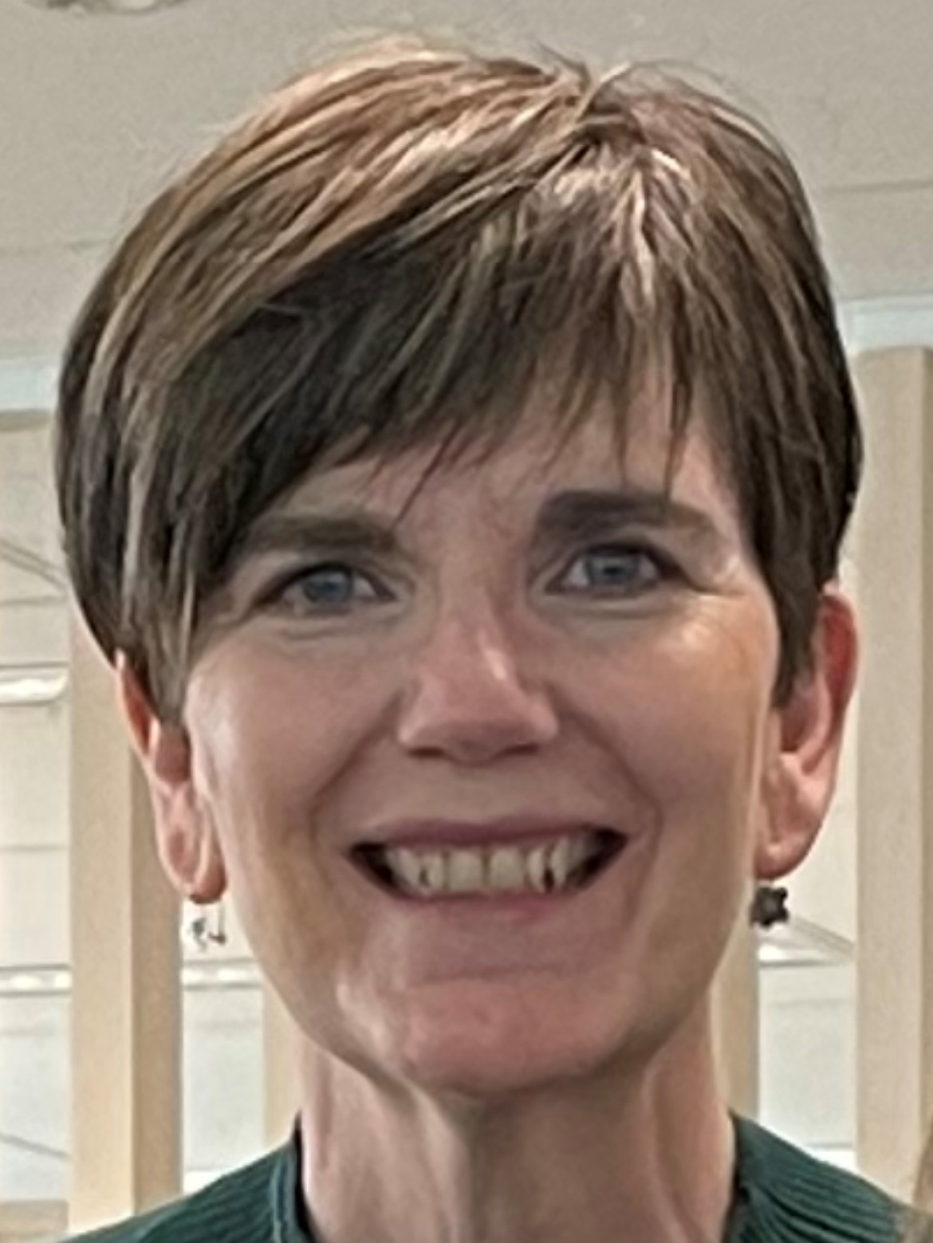 | Victoria Hay  Language Officer  victoria.hay@det.nsw.edu.au
Shanelle Ingram
Language Officer
shanelle.ingram@det.nsw.edu.au
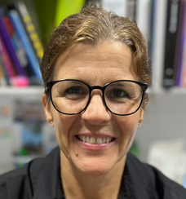 | Kristen Faraday  R/Language Officer  kristen.p.smith@det.nsw.edu.au
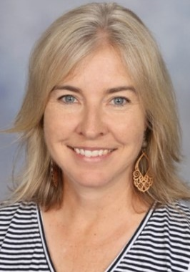 | Renetta Wolfe  Languages Curriculum Implementation Officer 7–12  renetta.wolfe@det.nsw.edu.au

© State of New South Wales (Department of Education), 2023
The copyright material published in this resource is subject to the Copyright Act 1968 (Cth) and is owned by the NSW Department of Education or, where indicated, by a party other than the NSW Department of Education (third-party material).
Copyright material available in this resource and owned by the NSW Department of Education is licensed under a Creative Commons Attribution 4.0 International (CC BY 4.0) licence.
This licence allows you to share and adapt the material for any purpose, even commercially.
Attribution should be given to © State of New South Wales (Department of Education), 2023.
Material in this resource not available under a Creative Commons licence:
- the NSW Department of Education logo, other logos and trademark-protected material
- material owned by a third party that has been reproduced with permission. You will need to obtain permission from the third party to reuse its material.
Links to third-party material and websites
Please note that the provided (reading/viewing material/list/links/texts) are a suggestion only and implies no endorsement, by the New South Wales Department of Education, of any author, publisher, or book title. School principals and teachers are best placed to assess the suitability of resources that would complement the curriculum and reflect the needs and interests of their students.
If you use the links provided in this document to access a third-party's website, you acknowledge that the terms of use, including licence terms set out on the third-party's website apply to the use which may be made of the materials on that third-party website or where permitted by the Copyright Act 1968 (Cth). The department accepts no responsibility for content on third-party websites.

