Geography 11–12 – Earth’s natural systems resource booklet
Contents
Rationale 2
Purpose, audience and suggested timeframes 2
Using this resource booklet 3
Activity 1 – wildlife migration 4
Activity 2 – latitude and longitude 5
Activity 3 – mapping 6
Activity 4 – scatter graphs 7
Activity 5 – climate graphs 9
Activity 6 – graphing 12
Activity 7 – global circulations 13
Activity 8 – climate data 14
Activity 9 – water storage 15
Activity 10 – water storage case study 16
Activity 11 – catchment story 17
Activity 12 – plate tectonics 18
Activity 13 – soil identification 19
Activity 14 – mind map 20
Activity 15 – coastal processes 21
Activity 16 – thematic map 22
Activity 17 – land use map 23
Quality assurance alignment 24
References 25

Rationale
This resource booklet is not a standalone resource. It has been designed for use by teachers in connection to Year 11 Geography: Earth’s natural systems sample program. The material in this resource booklet is a sample and is intended to support teachers as they develop contextually appropriate teaching and learning resources for their students’ needs. It is not intended to be taught exactly as is presented in its current format. There are instructions for the teacher and instructions for the student throughout the resources and activities. Teachers using this resource should edit and refine these to suit their students’ needs, interests, abilities and the texts selected.
The content in this resource booklet has been prepared by the HSIE curriculum team, unless otherwise credited. The HSIE curriculum team have created a series of other support resources for Year 11 Geography, including sample assessment schedules, scope and sequences and assessment tasks. Planning, programming and assessing geography 11-12 contains key information to complement this resource.
Some of the information in this resource booklet is collated from relevant NESA and department documentation. It is important that all users re-read and cross-reference the relevant syllabus, assessment and reporting information hyperlinked throughout. This ensures the content is an accurate reflection of the most up-to-date syllabus content. Links contained within this resource were correct as of 30 March 2023.

Purpose, audience and suggested timeframes
The Year 11 Geography: Earth’s natural systems sample program is intended to foster students' curiosity and wonder about the Earth's diverse landscapes and unique physical features by immersing them in the study of the Earth’s interconnected systems. Through the exploration of cycles, circulations, interconnections, and spatial patterns, students develop an understanding of the Earth's integrated systems and the natural processes that shape its land and water coverage. Their geographical journey encourages them to examine the intricate relationships between various components, cultivating a sense of awareness and appreciation for the complexities of the Earth's interdependent systems. The timeframe is suggested as a 10-week program of approximately 3 to 4 lessons per week. Earth’s natural systems focus area is allocated 40 indicative hours of teaching time.

Using this resource booklet
The program has been designed to align with the Year 11 sample scope and sequence which indicates this focus area is for delivery in Term 1. Short, engaging materials have been selected to encourage the exploration of various Earth processes, cycles, circulations, and spatial patterns. This approach enables students to develop a strong foundation in geography 11–12 while helping the teacher assess their comprehension and skills. The following is an outline of some of the ways this resource booklet can be used by teachers:
- use the resources and/or activities as samples and models, tailoring them to address contextual needs and specific learning objectives
- review the resources and activities during faculty meetings and/or planning days, refining them collaboratively to align with faculty or school goals
- discuss the resources and activities during faculty meetings or planning days, jointly planning opportunities for team teaching, mentoring, lesson observation, and sharing of student samples
- utilise the resources and/or activities as samples with students, to foster a deeper understanding of Earth's cycles, process and systems
- employ the examples of resources and/or activities as a blueprint for designing student-specific tasks that cater to individual learning styles and needs
- assign resources/activities independently or as flipped learning, preparing students for class collaboration and/or revision activities
- leverage the strategies, texts, assessment practices, pedagogical practices, and/or syllabus planning as an opportunity to backward map Years 7–10, ensuring a cohesive and comprehensive learning experience in geography.

Activity 1 – wildlife migration
In the final stage of the jigsaw activity, complete the following table.
Table 1 – wildlife migration
Task | Assigned animal information
Description of where the animal migrates
How far the animal migrates and over what period
Purpose of migration
What geopolitical regions the animal migrates through
Climatic regions or biomes the animal migrates through
Potential impact of humans on the migratory pattern

Activity 2 – latitude and longitude
The diagram should follow these steps:
- Begin with a blank piece of paper or use a drawing tool or software like Adobe Illustrator, Inkscape, or Microsoft PowerPoint.
- Draw a large circle to represent the Earth. You can use the circle or ellipse tool in your chosen software or a compass if you're drawing by hand.
- Divide the circle into 2 equal parts, to represent the northern and southern hemispheres, by drawing a horizontal line across the middle. This line represents the equator at 0 degrees latitude.
- Label the top point of the circle as the ‘North Pole (90°N)’ and the bottom point as the ‘South Pole (90°S)’. These points represent the poles at 90 degrees north and south.
- To show the difference in concentration of the Earth's rays at the equator and at higher altitudes, draw a series of parallel lines at an angle from left to right, representing sunlight coming from the sun.
- To represent the curvature of the Earth, make the parallel lines slightly curved. This will demonstrate that the sunlight strikes the Earth's surface at different angles, depending on the latitude.
- At the equator, the sunlight should be perpendicular (90 degrees) to the surface. At higher latitudes, the sunlight will strike the surface at more oblique angles. You can use arrows to show the angle at which sunlight hits the Earth's surface at various latitudes.
- Label the area near the equator as ‘High concentration of Earth's rays’ or ‘Direct sunlight’ and label the area near the poles as ‘Low concentration of Earth's rays’ or ‘Indirect sunlight’.
- If you want to add more detail, you can use colours to represent the intensity of sunlight. For example, use a warm colour, like red or orange, at the equator to indicate high solar radiation, and cooler colours, like blue or purple, near the poles to represent lower solar radiation.
- Submit and save or export your diagram in the desired format, and review it to ensure all the elements are accurately represented.

Activity 3 – mapping
Figure 1 – blank world map
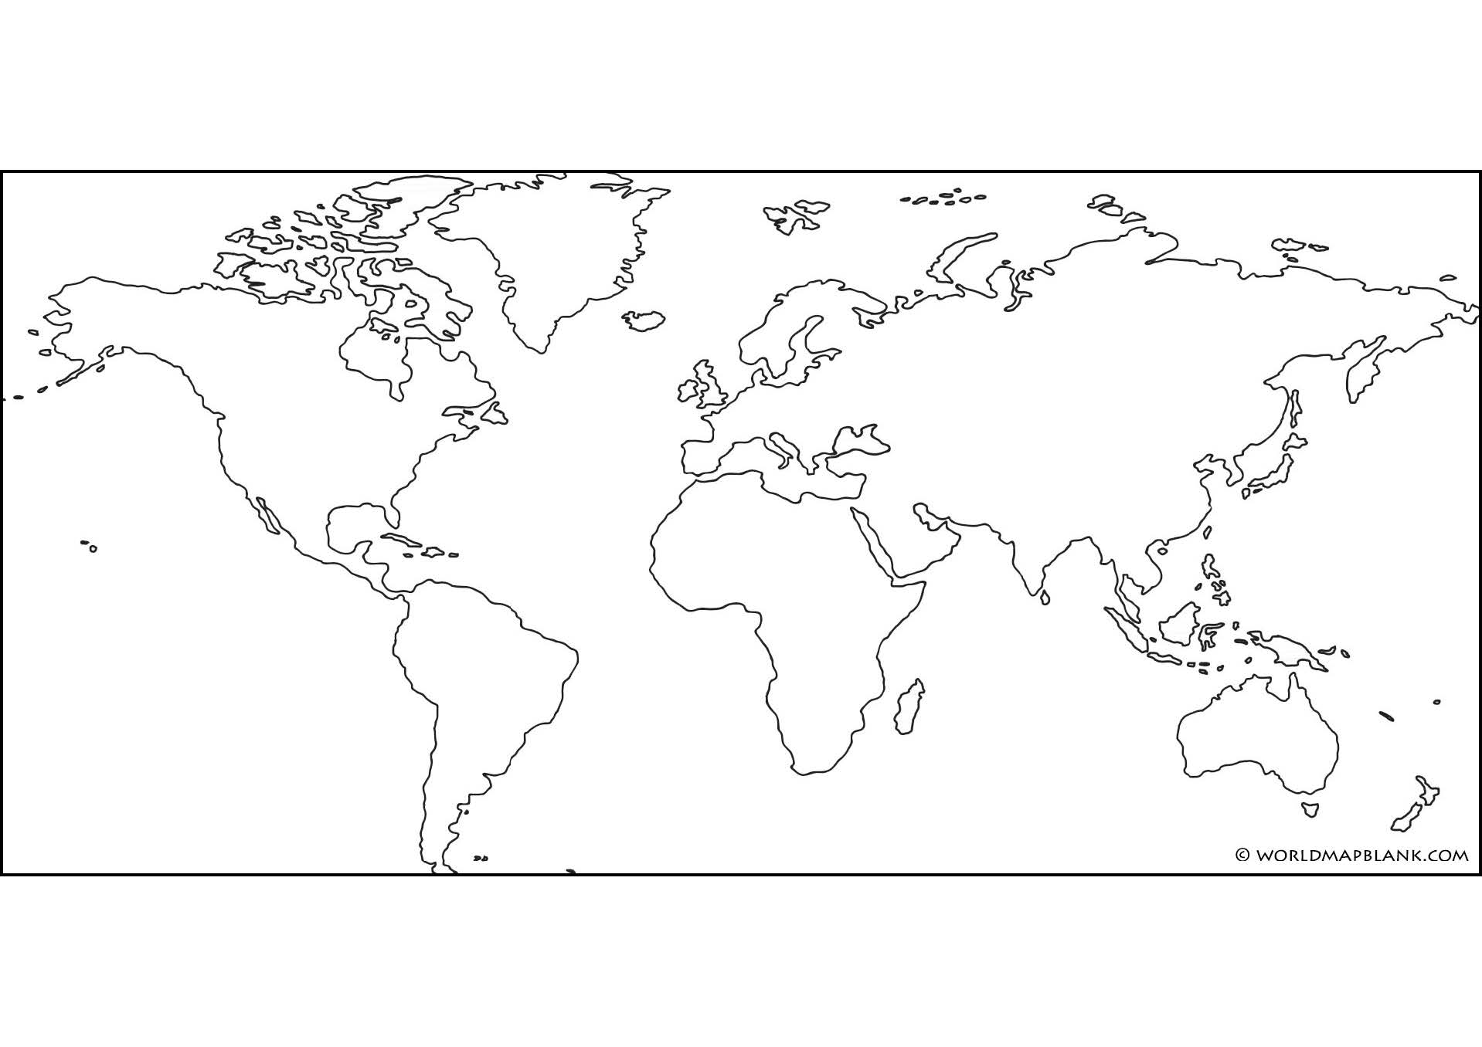

Activity 4 – scatter graphs
A scatter graph, also known as a scatter plot or scatter diagram, is a type of data visualisation that displays the relationship between 2 numerical variables. Each data point on the graph represents a pair of values, one from each variable, plotted on a Cartesian coordinate system. Scatter graphs are widely used in geography including in statistics, data analysis, and scientific research, to explore relationships, trends, and potential causality between variables. The main characteristics and features of a scatter graph include:
- Axes: scatter graphs have 2 axes, the horizontal (x-axis) and the vertical (y-axis). Each axis represents one of the 2 variables being compared.
- Data points: data points are plotted as individual points or markers on the graph, with their positions determined by the values of the 2 variables. Each data point represents an observation from the dataset.
- Distribution: scatter graphs can reveal the distribution of the data points, providing insight into the concentration, spread, or outliers within the data.
- Trend: a scatter graph can help identify trends or patterns in the data, such as positive or negative correlations, or the lack of a relationship between the 2 variables.
- Correlation: the degree to which the 2 variables are related can be visually assessed in a scatter graph. A positive correlation indicates that as one variable increases, the other tends to increase as well; a negative correlation means that as one variable increases, the other tends to decrease. No correlation suggests that there is no observable relationship between the 2 variables.
- Line of best fit: a line of best fit, or regression line, can be added to the scatter graph to quantify the relationship between the 2 variables. This line may be linear or nonlinear, depending on the nature of the relationship.

Create a scatter graph illustrating data presented in Table 2.
Table 2 – Ecuador cities summary
Location | Latitude | Altitude | Highest daily temperature
Cotopaxi
Quito
Latacunga
Ibarra
Esmeraldas
Guayaquil
The following instructions will support this learning activity:
- Label the x-axis in meters from 0 to 7,000 m and the y-axis in Celsius from -15°C to 35°C.
- Plot the data for altitude and temperature.
- Add a linear trend line (line of best fit) through the data in the scatter plot. A trend line will not cross every point but rather there should be approximately the same number of points below the line as above it.
- Look at the trend line. Estimate the approximate change in temperature for every increase of 1,000 m in elevation.

Activity 5 – climate graphs
Table 3 – seasons
Months | Southern Hemisphere | Northern Hemisphere
Dec – Feb
Mar – May
June – Aug
Sept – Nov
Figure 2 – climate graph of Kathmandu airport, Nepal
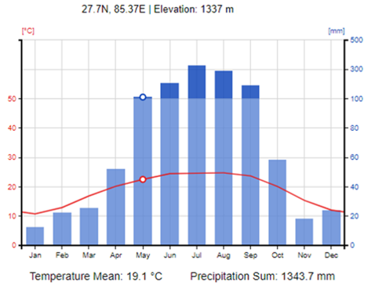

Figure 3 – climate graph of Kuwait airport, Kuwait
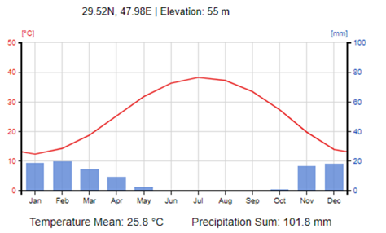
Figure 4 – climate graph of Sydney airport, Australia
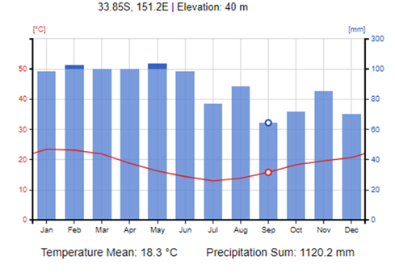

Figure 5 – climate graph of Darwin airport, Australia
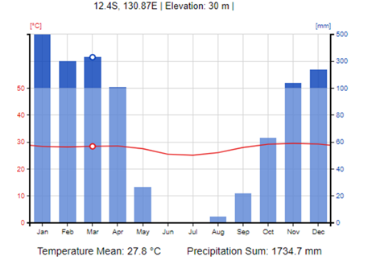
Table 4 – climate graphs
 | Kathmandu | Kuwait | Sydney | Darwin
Latitude
Altitude
Hottest month
Wettest season
Describe the main geographic features that influence climate
Note: climate graphs created by ClimateCharts.net under CC BY 4.0. Teachers may wish to change the examples to suit locations more suitable to school context.

Activity 6 – graphing
Support resource: Earth's Atmosphere: A Multi-layered Cake
Graph the temperature changes in each layer of the atmosphere. The graph should include each layer in kilometres (altitude above sea level) on the y-axis (vertical) and temperature on the x-axis (horizontal).

Activity 7 – global circulations
In groups, use the information from What is global circulation? | Part Two | The three cells (3:35), and further research, to create a diagram or model of the global atmospheric circulation system. The diagram or model should include the 3 different cells and their characteristics, for example, prevailing winds.
Each group will present their diagram or model and answer the following questions:
- How do semi-permanent areas of high- and low-pressure result from the circulation cells, and how do they influence the formation of climatic zones?
- How does the Hadley cell at the equator influence the climate in regions around the world? What is the effect on Australia and NSW?
- How does the rotation of the Earth affect the global atmospheric circulation?
- What are some of the factors that can influence the strength and stability of the global atmospheric circulation system over time?
- How do ocean currents interact with the global atmospheric circulation system, and what effects can they have on regional climates?

Activity 8 – climate data
Use the State of the Climate 2022 report (pages 6–7) rainfall information, graphs, choropleth maps and data, to answer the following questions:
- What is the trend in rainfall in the south-west of Australia since 1970?
- Which months have seen the largest decrease in rainfall in the south-west of Australia since 1970?
- What is the trend in rainfall in the south-east of Australia since the late 1990s?
- How has rainfall in northern Australia changed since the 1970s?
- What are some drivers that influence Australian rainfall?
- Despite natural variability, what long-term trend is evident in Australia's rainfall records?
- How many years out of the past 22 have had below-average rainfall in southern Australia between April and October?
- What factors are responsible for the decrease in rainfall in southern Australia?
- What is the significance of rainfall in the cooler months for southern Australia?
Using State of the Climate 2022 report (page 8) heavy rainfall information and data, answer the following questions:
- What was the main observation regarding heavy rainfall events in Australia?
- What is the relationship between short-duration extreme rainfall events and flash flooding?
- What weather systems typically cause heavy rainfall events in Australia?
- What has happened to the number of low-pressure systems in southern Australia in recent decades and what are the implications?
- How does the relationship between atmospheric moisture and global temperature increases affect the likelihood and intensity of heavy rainfall events in Australia?

Activity 9 – water storage
Use the Water in Australia 2019–20 report and Energy Education to identify the percentage of water stored in Australia and worldwide. Complete the following table.
Table 5 – water storage
Water resources | Australia | Worldwide
Freshwater systems
Oceans
Groundwater
Icecaps and glaciers
Lakes
Swamps
Rivers
Access Water Cycle – Stores and Flows (7:11) to complete the following table.
Table 6 – water cycle, stores and flows
Inputs | Processes | Outputs | Stores

Activity 10 – water storage case study
Provide each group with ONE case study of a water storage project. For example:
- Snowy Hydro 2.0: this is a proposed expansion of the existing Snowy Mountains Hydroelectric Scheme in New South Wales. The project aims to increase the capacity of the hydroelectric system by building a network of tunnels and dams to store and release water to generate electricity.
- Murray-Darling Basin Plan: this is a government initiative aimed at managing the water resources of the Murray-Darling Basin, which spans across New South Wales, Victoria, South Australia, Queensland, and the Australian Capital Territory. The plan involves reducing water consumption by irrigators, increasing environmental flows, and improving water efficiency.
- Tasmanian Hydroelectric Scheme: this is a network of hydroelectric power stations located across Tasmania. The scheme utilises the island's abundant rainfall and rugged terrain to generate electricity by storing and releasing water from dams and reservoirs.
- Brisbane's water grid: this is a network of dams, pipelines, and treatment plants that supply water to the city of Brisbane and surrounding regions. The water grid includes several dams, including the Wivenhoe, Somerset, and North Pine dams, which store water for drinking, irrigation, and industrial use.
Each group must complete a report on their assigned case study that includes:
- the benefits and drawbacks of the project
- impacts on the environment
- measures taken to mitigate these impacts.
Groups should use a combination of geographical tools to support their report findings, including:
- maps (for example, topographic, land use and hydrological maps, cadastral/zoning maps)
- aerial photography (for example, satellite, historical)
- statistical analysis (for example, total water storage and flow)
- Geographic Information Systems (GIS).

Activity 11 – catchment story
In groups, research and present a catchment story. A catchment story will outline how one NSW catchment has formed, including its key physical and human features.
For example, Warragamba Dam is the main water storage for Sydney's drinking water supply. The proposed dam raising project aims to increase the dam's capacity by 14 metres to provide additional water storage for the city. Inspiration for the catchment story may be sourced from QLD examples at Queensland Government Wetland Info – Catchment stories.
In researching the catchment, the following aspects should be considered:
- geological and geographical overview of the catchment
- natural features of the catchment – topography and geology
- natural features of the catchment – rainfall
- natural features of the catchment – vegetation
- significant modification to natural features of the catchment – dams, weirs
- any relevant sub catchment details and interactions.
Once completed, groups swap and review catchment stories.
Groups design an infographic on the factors that impact catchment functioning at different locations across NSW. The infographic should visually display the information mentioned above in a clear and concise manner. The infographic should be visually appealing, easy to understand, and should provide a clear understanding of the factors that impact catchment functioning.

Activity 12 – plate tectonics
Use Plate Tectonic Types and Plate Boundaries to complete Table 7.
Table 7 – plate tectonics
Plate boundary | Type of movement | Examples | Landforms created
Transform
Convergent
Divergent
Table 8 – questions about tectonic plates
Questions about tectonic plates
What are tectonic plates and how are they formed?
What evidence supports the theory of plate tectonics? What is seafloor spreading and how does it support the theory of plate tectonics?
How do tectonic plates move and what causes these movements?

Activity 13 – soil identification
Materials required: soil sample(s), set of Grain size cards [PDF 461 KB], magnifying glass or microscope, ruler or calliper, tray or container for sorting soil particles.
Complete a sediment analysis exercise to identify and characterise the size and shape of soil materials in a given sample area(s) using Grain size card [PDF 461 KB].
Use the following procedure.
- Collect soil sample(s) from the field or a designated area.
- Place the soil sample(s) in a tray or container and remove any visible rocks or debris.
- Divide the soil sample(s) into different fractions based on their grain size using the grain size cards as a reference. For example, separate the soil into sand, silt, and clay fractions.
- Use Grain size card [PDF 461 KB], magnifying glass and/or microscope to examine the size and shape of the soil particles in each fraction. Measure the diameter of individual particles using a ruler or calliper.
- Classify the soil particles based on their shape using a sphericity chart. Sphericity refers to the degree of roundness of a particle, with perfectly spherical particles having a sphericity value of 1.0 and irregular particles having a lower value.
- Record the size and shape characteristics of each fraction in a table or spreadsheet and calculate the percentage of each fraction in the overall soil sample.
Post sediment analysis exercise:
- Compare the grain size distribution of the soil sample(s) to typical soil types, such as sand, loam, or clay.
- Discuss the potential implications of the soil grain size distribution for soil properties, such as water retention, nutrient availability, and compaction.
- Compare the sphericity values of the soil particles to typical values for different sedimentary environments, such as river or beach sediments.

Activity 14 – mind map
Collate information from each group presentation in the mind map provided.
Figure 6 – mind map
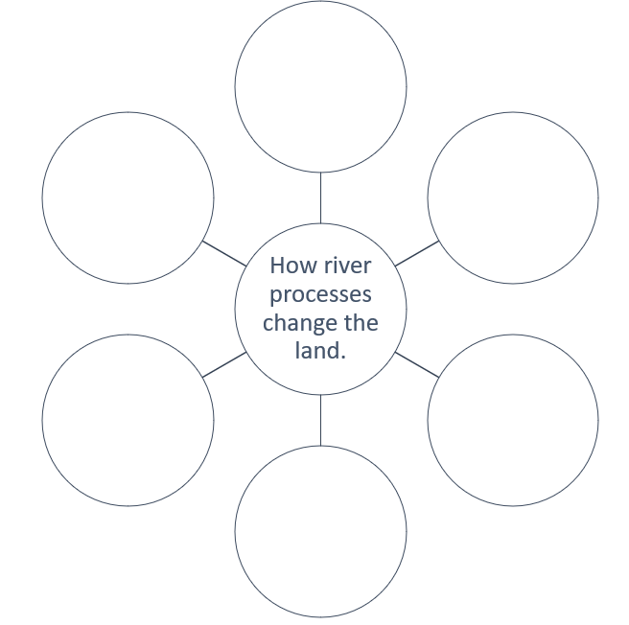

Activity 15 – coastal processes
During the class gallery walk, use the information displayed to complete the table below.
Table 9 – coastal processes
Coastal process | Description | Example of a landscape created by this process
Erosion
Transportation
Deposition

Activity 16 – thematic map
When developing a thematic map, it is important to:
- determine the species' range. before creating a migration map, it's important to understand the species' range, or the area where the species is found throughout the year. This will help identify where the species migrates from and to.
- gather data. there are different types of data that can be used to create a migration map, such as bird banding records, satellite tracking data, citizen science observations, and climate data. Choose the data source that is most appropriate for your species and your research question.
- choose a visualisation method. there are different ways to visualise migration patterns, such as heat maps, flow maps, dot maps, and animation. Choose the method that best represents the data and makes it easy to understand.
- identify migration routes. once you have gathered data, you can start identifying migration routes. You can do this by plotting the data on a map and looking for patterns. This will help you see where the species is moving from and to.
- consider environmental factors. environmental factors such as weather patterns, food availability and breeding grounds can influence migration patterns. Consider incorporating this information into your map to provide a more comprehensive view of the species' movements.
- label and include a legend. to make the map easy to read, include a legend that explains the colours, symbols and labels used. Use clear labels to identify key migration routes and important locations.
- add context. consider adding additional information to your map, such as geographic features, habitat types or human population areas. This can help provide context for the species' movements and help viewers understand why certain migration routes may be more challenging than others.

Activity 17 – land use map
Access Google My Maps to construct a land use map illustrating land cover in a suburb or regional area. Include the following spatial data on the map:
- Earth’s physical/natural features, (for example, forested areas, wetlands, water bodies)
- anthropogenic elements that are derived from human activity and influence the environment. (for example, plantations, crops and built environments).
Types of maps could include:
- Topographic maps: these maps show the physical features of the land, including elevation and contour lines. They can also show water bodies, vegetation, and built environments.
- Land use maps: these maps are specifically designed to show how land is being used in a particular area. They can show the different land use categories, such as residential, commercial, industrial, agricultural, and open space.
- Précis maps: these maps are created using precise measurements and provide detailed information on the location, shape, and size of natural and man-made features. They may include topographic data as well as information on boundaries, land ownership, and other cadastral details.
- Cadastral maps: these maps show the boundaries and ownership of land parcels within a particular area. They may include information on land use, zoning, and other regulatory data.

Quality assurance alignment
NSW Syllabus: Geography 11-12 Syllabus © NSW Education Standards Authority (NESA) for and on behalf of the Crown in right of the State of New South Wales, 2022.
Author: Curriculum Secondary Learners
Related resources:
Year 11 Geography, including sample assessment schedules, scope and sequences and assessment tasks:
- Planning, programming and assessing geography 11-12
- Geography Year 11: Sample scope and sequence (DOCX 76.55 KB)
- Geography Year 11: Sample assessment schedule (DOCX 74.0 KB)
Creation date: 30 March 2023
Review date: 30 March 2024
Rights: © State of New South Wales, (Department of Education), 2023

References
This resource contains NSW Curriculum and syllabus content. The NSW Curriculum is developed by the NSW Education Standards Authority. This content is prepared by NESA for and on behalf of the Crown in right of the State of New South Wales. The material is protected by Crown copyright.
Please refer to the NESA Copyright Disclaimer for more information https://educationstandards.nsw.edu.au/wps/portal/nesa/mini-footer/copyright.
NESA holds the only official and up-to-date versions of the NSW Curriculum and syllabus documents. Please visit the NSW Education Standards Authority (NESA) website https://educationstandards.nsw.edu.au/ and the NSW Curriculum website https://curriculum.nsw.edu.au/home.
Geography 11-12 Syllabus © NSW Education Standards Authority (NESA) for and on behalf of the Crown in right of the State of New South Wales, 2022.
AITSL (Australian Institute for Teaching and School Leadership Limited) (n.d) Learning intentions and success criteria [PDF 251KB], AITSL, accessed 2 June 2022.
Brookhart S (2011) How to Assess Higher-Order Thinking Skills in Your Classroom, Hawker Brownlow Education, Victoria.
CESE (Centre for Education Statistics and Evaluation) (2020a) What works best in practice, NSW Department of Education, accessed 2 June 2022.
CESE (Centre for Education Statistics and Evaluation) (2020b) What works best: 2020 update, NSW Department of Education, accessed 2 June 2022.
Rosenshine B (2012) 'Principles of Instruction: Research-Based Strategies That All Teachers Should Know', American Educator, 36(1):12-19, 39, accessed 2 June 2022.
Wiliam D (2013) 'Assessment: The bridge between teaching and learning', Voices from the Middle, 21(2):15–20, accessed 10 June 2022.
Wiliam D (2017) Embedded Formative Assessment, 2nd ed, Solution Tree Press, Bloomington, IN.
Wisniewski B, Zierer K and Hattie J (2020) 'The Power of Feedback Revisited: A Meta-Analysis of Educational Feedback Research', Frontiers In Psychology, 10:3087, doi.org/10.3389/fpsyg.2019.03087, accessed 7 June 2022.
© State of New South Wales (Department of Education), 2023
The copyright material published in this resource is subject to the Copyright Act 1968 (Cth) and is owned by the NSW Department of Education or, where indicated, by a party other than the NSW Department of Education (third-party material).
Copyright material available in this resource and owned by the NSW Department of Education is licensed under a Creative Commons Attribution 4.0 International (CC BY 4.0) licence.
This licence allows you to share and adapt the material for any purpose, even commercially.
Attribution should be given to © State of New South Wales (Department of Education), 2023.
Material in this resource not available under a Creative Commons licence:
- the NSW Department of Education logo, other logos and trademark-protected material
- material owned by a third party that has been reproduced with permission. You will need to obtain permission from the third party to reuse its material.
Links to third-party material and websites
Please note that the provided (reading/viewing material/list/links/texts) are a suggestion only and implies no endorsement, by the New South Wales Department of Education, of any author, publisher, or book title. School principals and teachers are best placed to assess the suitability of resources that would complement the curriculum and reflect the needs and interests of their students.
If you use the links provided in this document to access a third-party's website, you acknowledge that the terms of use, including licence terms set out on the third-party's website apply to the use which may be made of the materials on that third-party website or where permitted by the Copyright Act 1968 (Cth). The department accepts no responsibility for content on third-party websites.

