Ancient History – Features of ancient societies – Greece (weapons and warfare)
This resource has been designed to support teachers by providing a range of tasks based on syllabus content. Tasks can be incorporated into context driven teaching and learning programs in full or can be used to supplement existing programs. All content is textbook non-specific to ensure equity.
Contents
Key inquiry questions 3
Outcomes 4
Subject concepts and skills 5
Learning sequence 1 – context 6
Learning activities 6
Learning sequence 2 – weapons and warfare 8
Learning activities 8
Learning sequence 3 – the military and society 11
Learning activities 11
Learning sequence 4 – one key military encounter 21
Learning activities 21
Learning sequence 5 – the impact of warfare and conquest 22
Learning activities 22
Assessment task 24
Outcomes 24
Syllabus content 24
Task 24
Marking criteria 26
References 28

Key inquiry questions
Studies of features of ancient societies are concerned with seeking explanations to the ‘how’ and ‘why’ questions of history: how people lived in the past, why they may have lived that way, and how and why their life circumstances changed. This study provides students with opportunities to develop an understanding of:
- the social history of a people through an investigation of the remains of their material culture
- the key developments and forces that may have shaped the selected feature(s)
- the nature of the available sources.

Outcomes
A student:
- AH11-1 describes the nature of continuity and change in the ancient world
- AH11-2 proposes ideas about the varying causes and effects of events and developments
- AH11-3 analyses the role of historical features, individuals and groups in shaping the past
- AH11-4 accounts for the different perspectives of individuals and groups
- AH11-5 examines the significance of historical features, people, places, events and developments of the ancient world
- AH11-6 analyses and interprets different types of sources for evidence to support an historical account or argument
- AH11-7 discusses and evaluates differing interpretations and representations of the past
- AH11-8 plans and conducts historical investigations and presents reasoned conclusions, using relevant evidence from a range of sources
- AH11-9 communicates historical understanding, using historical knowledge, concepts and terms, in appropriate and well-structured forms
Related Life Skills outcomes: AHLS6-1, AHLS6-2, AHLS6-3, AHLS6-4, AHLS6-5, AHLS6-6, AHLS6-7, AHLS6-8, AHLS6-9, AHLS6-10, AHLS6-11, AHLS6-12
Ancient History Stage 6 Syllabus © NSW Education Standards Authority (NESA) for and on behalf of the Crown in right of the State of New South Wales, 2017.

Historical concepts and skills
- Explain the meaning and value of sources for an historical inquiry
- Analyse sources to identify and account for the different perspectives of individuals and groups in the past
- Analyse and synthesise evidence from different types of sources to develop reasoned claims
- Identify and analyse problems relating to sources in the investigation of the past
- Analyse the extent and nature of continuity and change over time
- Form judgements about historical significance, recognising that significance may be attributed for different purposes
- Analyse and evaluate contested interpretations and representations of the past
- Develop texts, particularly historical accounts and arguments, supported by relevant evidence from sources
- Communicate historical understanding, using historical knowledge, concepts and terms, in forms appropriate to purpose and audience
Ancient History Stage 6 Syllabus © NSW Education Standards Authority (NESA) for and on behalf of the Crown in right of the State of New South Wales, 2017.

Learning sequence 1 – context
Students investigate:
- the chronological and geographical context of the society within the ancient world
- an overview of the key social, economic, religious and political features of the society.

Learning activities
Teacher note: it is important to explore the multicultural nature of the ancient Greek world at the beginning of this topic while highlighting that it is impractical to study a large variety of poleis (city-states). This program will focus on Athens due to its intermittent roles as military and cultural leaders and the syllabus requirement to avoid significantly overlapping topics to be attempted for the HSC.
- Work with a partner to discuss what you already know about ancient Greece. Make a Jamboard together and use different coloured sticky notes to represent what you know and what you would like to know.
- Read An Era-by-Era Timeline of Ancient Greece. Identify and briefly describe the major eras in ancient Greek chronology using your own words.
- Create a document with a suitable map of ancient Greece in the centre of your page. Research and annotate the geographical features that may have influenced how societies developed. Examples may include rivers and mountain ranges. Resources to assist with this task may include:
- Geography of Ancient Greece (3:09)
- The Geography of Ancient Greece
Teacher note: Academia is an online repository of academic resources in PDF format, one of which is mentioned below. Create a free account to access Social , Economic and Political Aspect of Ancient Greece. Use Ancient Greece 101 (4:11), Classical Greek society, and Social, Economic and Political Aspects of Ancient Greece to complete the following summary table of the social, economic, religious and political features of the ancient Greek world circa the late archaic and classical periods.
Table 1– features of the ancient Greek world
Theme | Characteristics and features
Social and economic
Religious and political
- View A day in the life of an ancient Athenian (5:01). Have a class discussion that addresses the following questions:
- How important was geography in shaping the way of life in each polis? Would geography have had a big impact on the nature of Greek militaries?
- How common do you think conflict was between poleis? Why?
- Though Greek city-states operated independently with their own distinct cultures, what key features of Hellenic society might unite these city-states when under foreign threat?
- Look back at your Jamboards and consider the following questions:
- Was your existing knowledge accurate?
- Were any of your questions answers?
- Do you have any new questions to add?

Learning sequence 2 – weapons and warfare
Students investigate:
- the nature of the sources for weapons and warfare
- the composition and role of armies and/or navies and changes in forms of weapons and military tactics
- evidence of continuity and/or change

Learning activities
Teacher note: there are a variety of free online platforms students can use to present the source portfolio outlined below. These include Microsoft PowerPoint Online, Google Docs, or Google Sites.
Students may find the American School of Classical Studies website useful for this task.
- Work with a small group to complete research and create a source portfolio that showcases the nature of sources for weapons and warfare in ancient Athens. Your portfolio should:
- identify the nature of ancient sources available to historians
- refer to at least 3 types of sources
- include one specific example relevant to ancient Athens for each type of source identified. For written sources, this should be an excerpt.
- include a brief annotation of each source of 100 to 150 words. In your annotation, explain the meaning and value of the source and account for the perspective of the source.
- cite the resources used in your research through a bibliography.
- Suggested resources:
- Warfare in Ancient Greece
- Archaeologists Uncover Massive Naval Bases of the Ancient Athenians
- Warfare in ancient Greek art
- Athenian Trireme
- Herodotus and Thucydides: Inventing History.
- With a partner, design a soldier for the Athenian army. Draw an annotated diagram that identifies how the soldier attacks and defends in battle; and how he manages and carries his equipment. In your planning, you should consider:
- the materials available at the time
- the weight of the materials
- the geographical challenges or advantages of ancient Greece.
- Display your designs around the classroom or online. With a small group, conduct a gallery walk to examine the designs. Your group should discuss the following prompts:
- What do the designs have in common?
- What was different?
- Have a class discussion around the following questions:
- How much did you draw from your source portfolio in the design of your soldiers?
- What challenges could there be for a member of the Athenian army?
- In what ways do you think weapons and armour would have changed over time in Athens and why?
- Read Athenian Hoplites: An Overlooked Part of Athens’ Success in The Ancient World and complete the activities below.
- Define the following terms: hoplite, phalanx, polemarch, hippeis, peltast and trireme.
- Identify and briefly describe the equipment used by an Athenian hoplite.
- Outline the potential advantages and disadvantages of hoplites fighting in a phalanx formation.
- Suggest reasons that the phalanx would have marched to the beat of music.
- In Athens, who could be enlisted to fight during times of war?
- Explain how the Athenian cavalry was able to evolve after the wars against Persia.
- Explain the major changes that occurred regarding the Athenian navy.
- Outline the main naval tactics used by Athenians and explain the advantages and disadvantages of the triremes.
- Read 6.1 overview from Public Finance and War in Ancient Greece with a partner, focusing on the notion of continuity and or change. Annotate this paragraph with notes about the meaning of key words or historical details you need to look up to better understand the text.
- On your own, read the remainder of Public Finance and War in Ancient Greece. Create a list of 5 Very Important Points (VIPs) about continuity and change as relevant to weapons and warfare. Compare these with your partner for the previous task. Were your VIPs similar? Why or why not?

Learning sequence 3 – the military and society
Students investigate:
- the life of soldiers, their training and the conditions of service
- the significance of the military within society

Learning activities
- As a class, discuss Sources 1 through 4. Create a table to make notes about what these sources suggest about education, training and historical perspectives.
Source 1 – Plato, The Republic
‘And what shall be their [Athenian] education? Can we find a better division than the traditional sort?... Gymnastics for the body, and music for the soul... the beginning is the most important part of any work, especially in the case of a young and tender thing; for that is the time at which the character is being formed and the desired impression is more readily taken.’
Source 1 comes from Plato’s The Republic. Plato was an Athenian philosopher who grew up during the Peloponnesian War (431–404) and came of age around the time of Athens' defeat by Sparta. After this defeat, the democracy of Athens waned and people were unsure how to move forward as a polis. Plato largely critiques the factors that he believes led to Athens losing a war against Sparta, particularly elements of democracy and education.
Source 2 – Plutarch, Life of Lycurgus
‘…as soon as they [Spartans] were seven years old they were to be enrolled in certain companies and classes, where they all lived under the same order and discipline, doing their exercises, and taking their play together… Reading and writing they gave them, just enough to serve their turn; their chief care was to make them good subjects, to endure pain and conquer in battle… They taught them, also, to speak with a natural and graceful raillery, and to comprehend much matter of thought in few words… as their swords were short and sharp, so, it seems to me, were their sayings’
This extract comes from Plutarch’s Life of Lycurgus, outlining laws and practices believed to be introduced to Sparta by Lycurgus. Plutarch was a philosopher and scholar. He wrote this source more than 300 years after Sparta and Athens had experienced their golden ages.
Source 3 – Aristotle, Politics
‘No one will doubt that the [Athenian] legislator should direct his attention above all to the education of youth; for the neglect of education does harm to the constitution. The citizen should be moulded to suit the form of government under which he lives. For each government has a peculiar character which originally formed and which continues to preserve it. The character of democracy creates democracy, and the character of oligarchy creates oligarchy; and always the better the character, the better the government… And since the whole city has one end, it is manifest that education should be one and the same for all, and that it should be public, and not private – not as at present, when everyone looks after his own children separately, and gives them separate instruction of the sort which he thinks best; the training in things which are of common interest should be the same for all. Neither must we suppose that any one of the citizens belongs to himself, for they all belong to the state, and are each of them a part of the state, and the care of each part is inseparable from the care of the whole. In this particular, as in some others, the Lacedaemonians* are to be praised, for they take the greatest pains about their children, and make education the business of the state… The customary branches of education are in number four; they are- (1) reading and writing, (2) gymnastic exercises, (3) music, to which is sometimes added (4) drawing…’
* Lacedaemonians are the peoples of Laconia. Aristotle refers to the Spartans who implemented a state-run militaristic style of education for all citizens.
Source 4 – Aristotle, Athenian Constitution
‘The present form of the [Athenian] constitution is as follows. Citizenship belongs to persons of citizen parentage on both sides, and they are registered on the rolls of their demes at the age of eighteen… their fathers hold meetings by tribes and after taking oath elect three members of the tribe of more than forty years of age, whom they think to be the best and most suitable to supervise the cadets, and from them the people elects by show of hands one of each tribe as disciplinary officer, and elects from the other citizens a marshal over them all. These take the cadets in a body, and after first making a circuit of the temples then go to Peiraeus, and some of them garrison Munichia, others the Point…The people elect two athletic trainers and instructors for them, to teach them their drill as heavy-armed soldiers and to use the bow, javelin, and sling... . They go on in this mode of life for the first year; in the following year an assembly is held in the theatre, and the ephebes give a display of drill before the people and receive a shield and spear from the state and they then serve on patrols in the country and are quartered at the guard-posts. Their service on patrol goes on for two years; the uniform is a mantle; they are exempt from all taxes.... When the two years are up, they now are members of the general body of citizens.’
Aristotle was a student at Plato’s Academy in Athens between 367 and 347 BCE after which he travelled extensively, studying and teaching. He experienced the twilight years of the Athenian golden age; there had been much growth of democracy and philosophy during his time and that of his teacher, Plato. Aristotle proposed a system of voting where the democratic principle of ‘1 voter, 1 vote’ combines with the oligarchic ‘merit-weighted voting’. He generally argued that the purpose of a city-state was to ensure that as many people as possible could live a good life and become virtuous people.
- Use Sources 1 through 3 to write short responses to the following questions:
- How were the Spartan and Athenian systems of training youth different?
- Which of these 2 city-states would have had the stronger army and why?
- According to Aristotle, how should education have been changed in his time?
- What aspects of Spartan society does Aristotle admire and why?
- Compare and account for the perspectives of Plato and Aristotle.
- As historians, what other sources can we now examine to fill in some of our knowledge gaps about the lives, conditions, and training of Athenian soldiers and seamen?
- Read and annotate Source 4 independently. Your annotations should include researched definitions of new terminology and emphasise details about the training of Athenian soldiers.
- Outline the conditions of service for Athenian soldiers in your own words.
Teacher note: Sources 5 through 9 were retrieved from the Agora Excavations website, which provides access to collections maintained in the libraries, excavations and archives of the American School of Classical Studies at Athens (ASCSA). These digital resources have been made available free-of-charge for teaching and research purposes.
- With a small group, examine Source 5 through 9. Discuss and annotate the meaning and value of these sources. Discuss what the collection of sources suggests about:
- the life of soldiers, their training and the conditions of service
- the significance of the military within society.
- Which of the 5 sources is most valuable to an historian investigating the role of the Athenian military? Write one paragraph to justify your choice.
Source 5 – Attic red-figure lekythos, late 6th c. B.C., attributed to the Roundabout Painter from Agora Image: 2004.02.0089
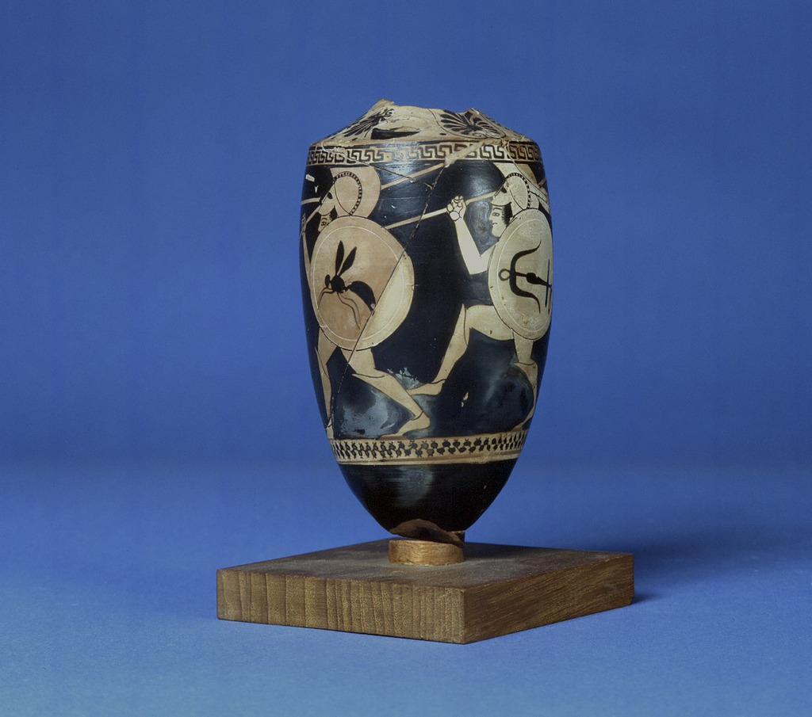
‘Attic red-figure lekythos, late 6th c. B.C., attributed to the Roundabout Painter’ by Craig Mauzy and used in accordance with American School of Classical Studies at Athens (ASCSA) Digital Collections.
Agora Image: 2004.02.0089. Athenian (Attic) red-figure lekythos (oil container), late 6th century B.C., attributed to the Roundabout Painter. H.: 0.138 m. Athens, Agora Museum P 24061. The Roundabout Painter was named for this vase, which shows 3 warriors and a trumpeter running around the body of the jug. The warriors wear helmets and greaves, and carry shields ornamented with various devices: an anchor, insect, or serpent.

Source 6 – inscribed lead strip from the cavalry records, 4th c. B.C. from Agora Image: 2004.02.0070
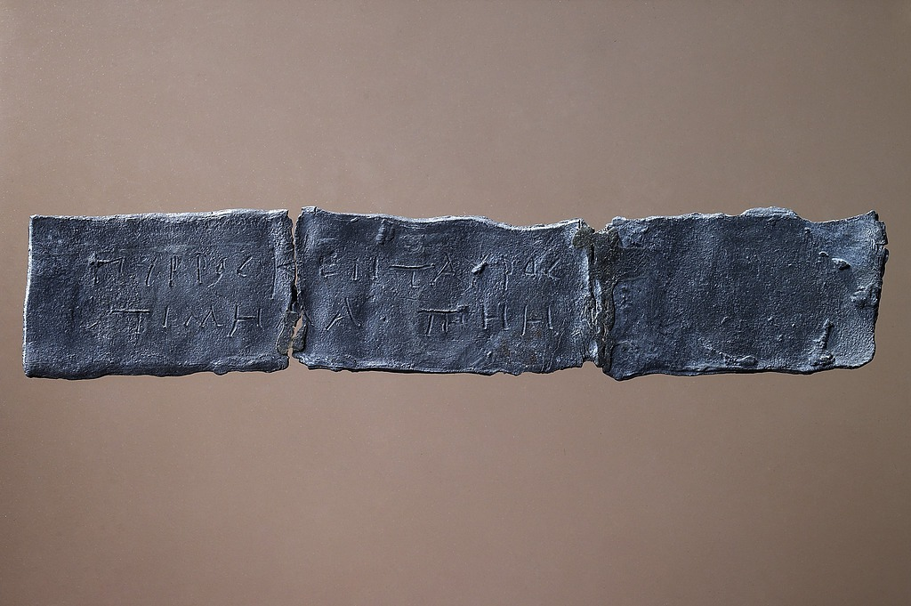
‘Inscribed lead strip from the cavalry records, 4th c. B.C.’ by Craig Mauzy and used in accordance with American School of Classical Studies at Athens (ASCSA) Digital Collections.
Agora Image: 2004.02.0070. Inscribed lead strip from the cavalry records, 4th century B.C. Athens, Agora Museum IL 1563. Recovered from a well in the northwest corner of the Agora, this lead strip carries an inscription recording the registration of a horse. On one side is the name of the owner, Konon; on the other a description of the horse, a chestnut, with a centaur brand, as well as its price, 700 drachmas. Such strips were clearly used for the annual assessment of the cavalry and would then form the basis of a reimbursement by the state should the horse be lost in battle. At the end of the year these records would become obsolete and could be reused or discarded, as in the case of this example found in a well. From the series of similar strips recovered in Athens we learn that the maximum assessment of a horse was 1,200 drachmas, well below the value of many horses and representing the maximum limit of the state's responsibility; the minimum amount was 500 drachmas.

Source 7 – clay tokens stamped with the names of Athenian military commanders from Agora Image: 2000.02.1077
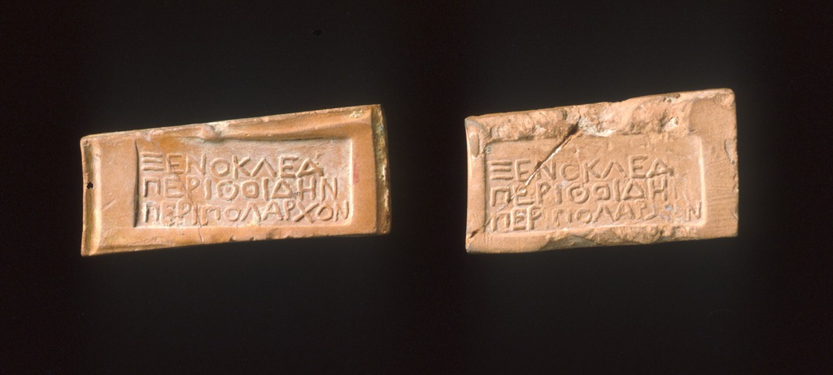
‘Clay tokens stamped with the names of Athenian military commanders (left, MC 1245; right, SS 8080). Magistrate’s token of Xenokles Perithoidai, peripolarch (border commander). 4th c. B.C.’ and used in accordance with American School of Classical Studies at Athens (ASCSA) Digital Collections.
Agora Image: 2000.02.1077. Clay tokens or passports of a border commander, 4th century B.C. D.: 0.039-0.04 m. Athens, Agora Museum SS 8080, MC 1245. The tokens were inscribed with the name of Xenokles, his deme, Perithoidai and his title, Peripolarch. The peripolarch was the military officer responsible for the frontier garrisons and the border patrols. These tokens were probably used as passports and for messengers reporting to and from military headquarters.

Source 8 – lead armor tokens (from Well J 5:1) stamped on both sides from Agora Image: 2004.02.0071
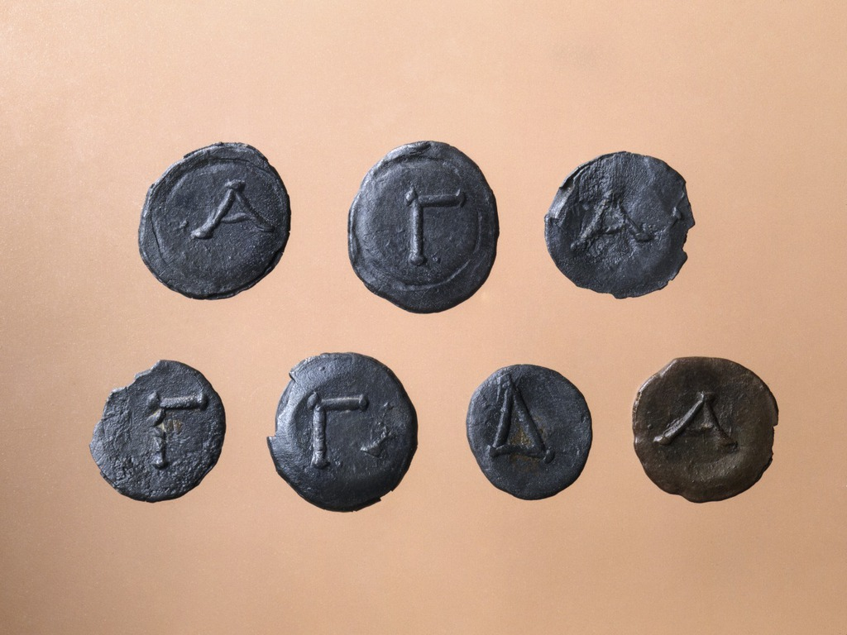
‘Lead armor tokens (from Well J 5:1) stamped on both sides, one side a piece of armor and on the other side a letter: IL 1575 (helmet), IL 1573-1574 (breastplate), IL 1579 (shield) and IL 1572, IL 1576-1577 (greave). 3rd c. B.C.’ by Craig Mauzy and used in accordance with American School of Classical Studies at Athens (ASCSA) Digital Collections.
Agora Image: 2004.02.0071. Lead armour tokens, 3rd century B.C. D.: 0.018-0.021 m. Athens, Agora Museum IL 1575 (helmet), 1573-1574 (breastplate), 1579 (shield), and 1572, 1576-1577 (greave). Each token is stamped on both sides. On one side a piece of armour is shown: a helmet, breastplate, shield, or greave, and on the other side, the letter alpha, gamma, or delta. These tokens might have been used as exchanges for state-owned armour. The letters may have designated sizes for the armour pictured on the other side. Public armour was most likely kept on hand for the arming of irregulars, thetes, and perhaps even slaves, at the time of mobilization, whereas Athenians on the official hoplite register were legally responsible for procuring their own military equipment. By the 3rd century B.C. there was only a small standing army, so the number of irregulars must have grown to include much of the city's middle-class population.
Source 9 – Xenophon, Constitution of the Athenians 1.1-2
‘And as for the fact that the Athenians have chosen the kind of constitution that they have, I do not think well of their doing this inasmuch as in making their choice they have chosen to let the worst people be better off than the good. Therefore, on this account I do not think well of their constitution. But since they have decided to have it so, I intend to point out how well they preserve their constitution and accomplish those other things for which the rest of the Greeks criticize them.
First I want to say this: there the poor and the people generally are right to have more than the highborn and wealthy for the reason that it is the people who man the ships and impart strength to the city; the steersmen, the boatswains, the sub-boatswains, the look-out officers, and the shipwrights -- these are the ones who impart strength to the city far more than the hoplites, the high-born, and the good men. This being the case, it seems right for everyone to have a share in the magistracies, both allotted and elective, for anyone to be able to speak his mind if he wants to.’
Xenophon’s Constitution of the Athenians explores the Athenian government and society of Classical Athens. Here, he discusses the fleet. The fleet was made up of triremes, wooden warships that carried 170 rowers manning three banks of oars. At her peak, Athens had a fleet of 400 ships, a force requiring close to 80,000 men. These rowers, mainly drawn from Athens' poorer citizens, were paid and were seldom slaves. These citizen oarsmen were recognized as early as the 5th century B.C. as a significant force in the maintenance of the democracy.
Teacher note: when examining the historical interpretation in Source 10, explicitly identify the difference between a perspective and an interpretation to ensure student understanding. It may be useful to project this extract to make a collection of shared notes based on student responses to prompts and questions. Support students to explore the notion of a ‘social phenomenon’ and draw links between the argument about the social context and the ancient evidence examined in the previous activities.
Note that the extract has been provided in line with the publisher, Data Persée's, terms and Conditions, which grants ‘a right to use any Data set transmitted to You by the Site for strictly non-commercial and/or non-profit purposes, such as educational, research, academic or private use.’
Source 10 – Ronald Thomas Ridley, The Hoplite as Citizen: Athenian military Institutions in their social Context
‘The ancient Greek art of war has been extensively studied…But our concentration has been solely on war as a technique. We have neglected the fundamental point that the Athenian hoplite was a citizen, and that war was a social phenomenon. We have forgotten to ask how far the technique was in fact simply a product of the social context. We have forgotten to ask what it was like to be an ordinary — or wealthy and important — citizen called upon to serve in the phalanx…It has been completely overlooked that we are here dealing with something far from a simple technical matter. We are talking about yet another aspect of the working of the Athenian democracy…’
- Have a class discussion about the historical interpretation provided in Source 10, guided by your teacher.
Teacher note: there are a number of online support scaffolds and guides for students to assist with the following extended writing task. The University of Adelaide offers discipline specific writing guides. Western Sydney University offers guides to planning, writing and reviewing essays.
- Write a response of 700 to 800 words to the following question: ‘Assess the significance of the military within Athenian society’. Your response must refer to Ridley’s interpretation and use at least 2 ancient sources as evidence.

Learning sequence 4 – one key military encounter
Students investigate:
- the evidence for at least ONE key military encounter, including military strategy

Learning activities
Teacher note: this component of the topic will be explicitly addressed in the assessment task. The task could be adapted to operate as a class-based group task dependant on context and assessment planning.

Learning sequence 5 – the impact of warfare and conquest
Students investigate:
- the political, economic and social impact of warfare and conquest
- evidence of continuity and/or change

Learning activities
- Read Teeth of fallen soldiers hold evidence that foreigners fought alongside ancient Greeks, challenging millennia of military history and answer the following questions.
- What evidence is there the bodies at Himera belong to soldiers?
- Briefly outline how teeth can identify an individual’s origins.
- Explain how the study of these ancient human remains has challenged previous interpretations of the first Battle of Himera, while supporting previous interpretations of the second.
- Explain why it is important for historians to draw from diverse sources of evidence. Refer to the article in your answer.
- Outline the potential political, economic and/or social impact that the inclusion of foreign soldiers by Greek colonies and cities could have had. Here, you are asserting your own interpretation of knowledge and evidence from the ancient world.
- Read 6.2 and 6.3 from Public Finance and War in Ancient Greece. Focus on ideas relevant to continuity and change and the impact of warfare. Complete a Claim, Support, Question for each of the 2 sections. This requires you to:
- make a claim about the topic
- identify evidence to support your claim
- ask a question related to your claim. What needs further clarification or investigation?
- Have a class discussion to share and justify your responses to the Claim, Support, Question.

Assessment task
Teacher note: when using this task, ensure it is placed on the school template and follows all assessment requirements. Students can access Microsoft PowerPoint or, for those with stronger information and communications technology (ICT) skills, Adobe Premier to create a narrated video presentation.

Outcomes
- AH11-6 analyses and interprets different types of sources for evidence to support an historical account or argument
- AH11-8 plans and conducts historical investigations and presents reasoned conclusions, using relevant evidence from a range of sources
- AH11-9 communicates historical understanding, using historical knowledge, concepts and terms, in appropriate and well-structured forms

Syllabus content
- the nature of the sources for weapons and warfare
- the evidence for at least ONE key military encounter, including military strategy

Task
- Choose one of the military encounters listed below:
- Battle of Salamis, 480 BCE
- Battle of Plataea, 479 BCE
- Battle of Aegospotami, 405 BCE
- Battle of Chaeronea, 336 BCE.
- Investigate your chosen military encounter and create a narrated video presentation between 2:30 and 3:00 minutes long that examines what the sources reveal about the battle.
- Your video must analyse and interpret:
- the evidence available for your chosen encounter
- the military strategy used by the Athenians as revealed by the sources.

Marking criteria
Table 2 – marking criteria
Mark | Criteria
A | - Effectively identifies, analyses and interprets different types of sources to support a comprehensive historical account of a relevant military encounter  - Plans and conducts an effective historical investigation to present reasoned and supported conclusions about a relevant military encounter  - Effectively communicates historical understanding, using historical knowledge, concepts, and terms in a cohesive and logical narrated video
B | - Clearly identifies, analyses and interprets different types of sources to support a detailed historical account of a relevant military encounter  - Plans and conducts an historical investigation to present reasoned and/or supported conclusions about a relevant military encounter  - Clearly communicates historical understanding, using historical knowledge, concepts and terms in a logical narrated video
C | - Identifies, analyses and interprets sources to support an historical account of a relevant military encounter  - Plans and conducts an historical investigation to present conclusions about a relevant military encounter  - Communicates historical understanding, using historical knowledge, concepts and terms in a narrated video
D | - Identifies and/or analyses and/or interprets sources related to a relevant military encounter  - Conducts an historical investigation to present ideas about a relevant military encounter  - Communicates some historical understanding
E | - May identify sources related to a military encounter  - May present limited ideas about a military encounter  - May communicate some historical understanding

References
This resource contains NSW Curriculum and syllabus content. The NSW Curriculum is developed by the NSW Education Standards Authority. This content is prepared by NESA for and on behalf of the Crown in right of the State of New South Wales. The material is protected by Crown copyright.
Please refer to the NESA Copyright Disclaimer for more information https://educationstandards.nsw.edu.au/wps/portal/nesa/mini-footer/copyright.
NESA holds the only official and up-to-date versions of the NSW Curriculum and syllabus documents. Please visit the NSW Education Standards Authority (NESA) website https://educationstandards.nsw.edu.au/ and the NSW Curriculum website https://curriculum.nsw.edu.au/home.
Ancient History Stage 6 Syllabus © NSW Education Standards Authority (NESA) for and on behalf of the Crown in right of the State of New South Wales, 2017.
American School of Classical Studies at Athens (ASCSA) (n.d.) ‘Athenian Agora Excavations’, Fieldwork, ASCSA website, accessed 14 June 2022.
Aristotle (1994–2009) Politics: Book Eight (Jowett B trans), Massachusetts Institute of Technology (MIT) The Internet Classics Archive, accessed 28 July 2022 (original work published 350 B.C.E).
Aristotle (1952) ‘Vol. 20: Athenian Constitution’ (Rackham H trans), Aristotle in 23 Volumes, Harvard University Press, Cambridge, Massachusetts and William Heinemann Ltd, London, accessed 28 July 2022 (original work published 325 B.C.E).
Blackman D (1969) ‘The Athenian Navy and Allied Naval Contributions in the Pentecontaetia’, Greek, Roman, and Byzantine Studies, 10(3):179–216, accessed 14 June 2022.
Britannica, T. Editors of Encyclopaedia (2015) Athenian Trireme, Encyclopedia Britannica website, accessed 27 February 2023.
Constitutional Rights Foundation (2009) ‘Herodotus and Thucydides: Inventing History’, Bill of Rights in Action, 24(3), accessed 26 February 2023.
Daley J (17 June 2016) ‘Archaeologists Uncover Massive Naval Bases of the Ancient Athenians’, Smithsonian Magazine, accessed 27 February 2023.
Department of Greek and Roman Art, Metropolitan Museum of Art (October 2000) ‘Warfare in Ancient Greece’, Heilbrunn Timeline of Art History, accessed 27 February 2023.
Garland R (16 March 2018) ’A Day in the Life of an Ancient Athenian’ [video], Ted-Ed, YouTube, accessed 14 June 2022.
Gill NS (25 October 2018) ‘An Era-by-Era Timeline of Ancient Greece’, ThoughtCo, accessed 14 June 2022.
Gupta P (2021) ‘Social, Economic and Political Aspects of Ancient Greece’, Academia, accessed 7 July 2022.
Hiltz M (9 July 2021) ‘Athenian Hoplites: An Overlooked Part Of Athens’ Success In The Ancient World’, War History Online, accessed 19 July 2022
Inspire Education (26 May 2021) ’Geography of Ancient Greece’ [video], Inspire Education, YouTube, accessed 9 June 2022.
Khan Academy (2013) ‘Classical Greek Society’, World History, Khan Academy website, accessed 7 July 2022.
National Geographic (23 April 2018) ’Ancient Greece 101’ [video], National Geographic, YouTube, accessed 9 June 2022.
Plato (2003–2012) The Republic (Jowett B trans), The Literature Page, accessed 26 July 2022 (original work published 360 B.C.E).
Plutarch (1914) Parallel Lives (Perrin B trans), Loeb Classical Library edn, William Heinemann Ltd, London and Harvard University Press, Cambridge, Massachusetts, accessed 26 July 2022 (original work published 1470).
Pritchard DM (2018) ‘Public Finance and War in Ancient Greece’, Athenian Democracy at War, Cambridge University Press, 169–179, doi:10.1017/9781108525572.008, accessed 19 July 2022.
Reinberger K (13 May 2021) ‘Teeth of Fallen Soldiers Hold Evidence that Foreigners Fought Alongside Ancient Greeks’, The Conversation, accessed 28 July 2022.
Ridley RT (1979) ‘The Hoplite as Citizen: Athenian Military Institutions in their Social Context’, L'Antiquité Classique, 48(2):508–548, accessed 9 June 2022.
Stearns Davis W (1913) ‘Plutarch: The Spartan Discipline For Youths’, Readings in Ancient History, vol I: Greece and the East, Allyn and Bacon, Boston, accessed 14 June 2022.
Wikipedia contributors (2022) Warfare in ancient Greek art, Wikipedia, The Free Encyclopedia website, accessed 26 February 2023.
Xenophon (1984) ‘Pseudo-Xenophon (Old Oligarch), Constitution of the Athenian’ (Marchant EC trans), Xenophon in Seven Volumes, Harvard University Press, Cambridge, Massachusetts and William Heinemann Ltd, London, accessed 28 July 2022 (original work published circa 80).

© State of New South Wales (Department of Education), 2023
The copyright material published in this resource is subject to the Copyright Act 1968 (Cth) and is owned by the NSW Department of Education or, where indicated, by a party other than the NSW Department of Education (third-party material).
Copyright material available in this resource and owned by the NSW Department of Education is licensed under a Creative Commons Attribution 4.0 International (CC BY 4.0) license.
This license allows you to share and adapt the material for any purpose, even commercially.
Attribution should be given to © State of New South Wales (Department of Education), 2023.
Material in this resource not available under a Creative Commons license:
- the NSW Department of Education logo, other logos and trademark-protected material
- material owned by a third party that has been reproduced with permission. You will need to obtain permission from the third party to reuse its material.
Links to third-party material and websites
Please note that the provided (reading/viewing material/list/links/texts) are a suggestion only and implies no endorsement, by the New South Wales Department of Education, of any author, publisher, or book title. School principals and teachers are best placed to assess the suitability of resources that would complement the curriculum and reflect the needs and interests of their students.
If you use the links provided in this document to access a third-party's website, you acknowledge that the terms of use, including licence terms set out on the third-party's website apply to the use which may be made of the materials on that third-party website or where permitted by the Copyright Act 1968 (Cth). The department accepts no responsibility for content on third-party websites.

