English Stage 3 – Unit 9
Contents
Unit overview and instructions for use 4
Teacher notes 6
Outcomes and content 8
Resources 14
Week 1 16
Component A teaching and learning 16
Component B teaching and learning 27
Lesson 1: Expectations and features of narratives 28
Lesson 2: Identifying figurative language in an orientation 30
Lesson 3: Describing setting using figurative language 33
Lesson 4: Rich character descriptions 35
Week 2 39
Component A teaching and learning 39
Component B teaching and learning 49
Lesson 5: Writing an orientation 50
Lesson 6: Identifying subjective language to build tension 52
Lesson 7: Understanding how temporal connectives and modal words build tension 54
Lesson 8: Character development and relationship building 58
Week 3 60
Component A teaching and learning 60
Component B teaching and learning 71
Lesson 9: Using modal words to enhance writing 72
Lesson 10: Building tension through character dialogue 74
Lesson 11: Identifying a major complication using adjectival clauses 75
Lesson 12: Identifying a subverted narrative ending 77
Week 4 80
Component A teaching and learning 80
Component B teaching and learning 91
Lesson 13: Identifying models of behaviour and key messages in a text 92
Lesson 14: Analysing key ideas and multimodal features of a text 93
Lesson 15: Analysing and assessing the illustrator’s authority 94
Lesson 16: Planning a narrative 96
Week 5 98
Component A teaching and learning 98
Component B teaching and learning 109
Lesson 17: Drafting an orientation 110
Lesson 18: Drafting a series of events and complication 111
Lesson 19: Drafting a subverted resolution and editing writing 112
Lesson 20: Editing and publishing a narrative 113
Resource 1: Fluency and close reading passage analysis 116
Resource 2: Freytag’s pyramid 118
Resource 3: Freytag’s pyramid planning template 119
Resource 4: Frayer diagram example 120
Resource 5: Dialogue checklist 121
Resource 6: Fluency and close reading passage analysis 122
Resource 7: Storm Boy analysis 124
References 125

Unit overview and instructions for use
In this 5-week unit, students will learn how authors create engaging narratives through the development of descriptive settings, characters and developing action. They identify common narrative conventions and patterns and recognise when these patterns are subverted. Students make connections to Storm Boy through their own personal and common lived experiences and write a sequel to the narrative.
Outcomes and content in this unit are organised into Component A and Component B. The components are connected, with learning in Component A complementing learning in Component B.
Note: the duration of this unit can be adapted to suit individual school contexts. For example, learning could occur across 5 days rather than 4.
The table below highlights the focus areas and preparation required for Component A and Component B.
Teaching and learning | Component A | Component B
Suggested duration | 60 minutes × 4 days/week or equivalent | 60 minutes × 4 days/week or equivalent
Explicit teaching focus areas | Component A addresses content from the focus areas:  - Vocabulary  - Reading comprehension  - Creating written texts  - Spelling  - Handwriting and digital transcription  It centres on the development of foundational skills and knowledge through regular, systematic and repeated practice. | Component B addresses content from the focus areas:  - Oral language and communication  - Vocabulary  - Reading comprehension  - Creating written texts  - Understanding and responding to literature  It centres on the conceptual understandings of English and exemplifies the importance of learning about and enjoying literature through the study of quality texts.
Preparing for teaching and learning | - Specific teaching and learning activities need to be developed by the teacher. When planning for these activities, please refer to the Component A outcomes and content, teaching guides and planning frameworks.  - Plan and document how you will sequence teaching and learning in whole-class and targeted-groups across the 5-week cycle as required. This should be based on student needs identified through ongoing assessment data. | - Familiarise yourself with the mentor and supporting texts and textual concepts, and the teaching and learning sequence.  - Determine how you will support students in whole-class and targeted-groups across the 5-week cycle as required. This should be based on student needs identified through ongoing assessment data.
English K–10 Syllabus © NSW Education Standards Authority (NESA) for and on behalf of the Crown in right of the State of New South Wales, 2022.

Teacher notes
- Narrative is an account of events or experiences, which are real or imagined. In English literary theory, narrative includes a story (what is narrated) and a discourse (how it is narrated). Narrative can present as an explicit sequencing of events (type of text), or it can be an implied or inferred component in a text (NESA Glossary).
- Understanding of narrative can be supported through watching the department’s video: Narrative (3:51).
- While narrative is the mentor concept for the conceptual component of this unit, the supporting concept of characterisation is explored within the relevant section(s) of the mentor and/or supporting texts.
- For information on conventions, authority, paragraphs, modality, temporal connectives, adjectival clauses, multimodal texts, voice and tense, refer to the NESA Glossary.
- In addition to the resources listed, students will require access to short passages of the mentor and/or supporting texts. Teachers can copy extracts from texts in reliance on the Statutory Text and Artistic Works Licence. Teachers need to attribute the extracts and include the following notice: ‘This material has been copied [and communicated to you] in accordance with the statutory licence in section 113P of the Copyright Act. Any further reproduction or communication of this material by you may be the subject of copyright protection under the Act. Do not remove this notice’.
- This unit could enhance student learning towards the achievement of creative arts outcomes.
- Consider prior student knowledge of narrative structures, type of sentences, tense, nouns, verbs, adjectives and adverbs.
- Reflect on student learning and engagement in activities and record differentiation and adjustments within the unit to inform future teaching and learning. One way of doing this could be to add comments to the digital file.
- Storm Boy includes some unacceptable language when referring to Aboriginal and/or Torres Strait Islander peoples. Students should be made aware that this language was common when the text was originally published but is no longer acceptable to Aboriginal and/or Torres Strait Islander peoples.
- In NSW classrooms there is a diverse range of students including Aboriginal and/or Torres Strait Islander students, students learning English as an additional language or dialect, high potential and gifted students and students with disability. Some students may identify with more than one of these groups, or possibly all of them. Refer to Advice on curriculum planning for every student K-12 for further information.
- Content points are linked to the National Literacy Learning Progression version (3).
Levels and indicators sourced from National Literacy Learning Progression © Australian Curriculum, Assessment and Reporting Authority (ACARA), (accessed 11 September 2023) and was not modified. See references for more information.

Outcomes and content
The table below outlines the outcomes and content for this unit. The letters ‘A’ and ‘B’ in the header refer to Components A and B. The numbers 1 to 5 refer to weeks. The use of ‘x’ in these columns indicates where the content points are intended to be addressed and in which week.
Focus area and outcome, content points and National Literacy Learning Progression | A | B | 1 | 2 | 3 | 4 | 5
Oral language and communication
EN3-OLC-01 communicates to wide audiences with social and cultural awareness, by interacting and presenting, and by analysing and evaluating for understanding
- Identify varying social conventions that influence interactions across wide audiences (lis6) |  | x | x | x | x
- Interact in a range of contexts and deliberately adjust language and style (int6) |  | x | x
- Respond to questions with elaboration and detail (int5) |  | x | x | x | x
- Deliver presentations suited to purpose and audience (spk6) |  | x | x | x
Vocabulary
EN3-VOCAB-01 extends Tier 2 and Tier 3 vocabulary through interacting, wide reading and writing, morphological analysis and generating precise definitions for specific contexts
- Extend knowledge of literal and non-literal word meanings through idiom or metaphor (unt9, crt9) | x | x | x | x | x | x | x
- Describe multiple meanings of words, including their metaphorical uses (unt8) | x | x | x |  |  | x
- Evaluate the effectiveness of modal words used in texts to intensify or soften emotional responses (crt9) | x | x |  | x | x |  | x
Reading comprehension
EN3-RECOM-01 fluently reads and comprehends texts for wide purposes, analysing text structures and language, and by monitoring comprehension
- Adjust reading rate to suit the purpose for reading and the complexity of the text (fly6) | x |  | x | x | x | x | x
- Bring subject vocabulary, technical vocabulary, background knowledge and conceptual knowledge to new reading tasks (unt8) | x |  | x |  | x | x | x
- Analyse use of multimodal features to enhance meaning within texts |  | x |  |  |  | x
- Use morphology and etymology to work out the meaning of unfamiliar words (spg11, unt9) | x |  | x | x |  |  | x
- Describe how own mental model is adjusted as new words and information deepen understanding during reading | x | x | x | x | x | x
- Recognise that personal narratives contain more subjective language, but factual accounts of events contain more objective language |  | x |  | x
- Reflect on personal connections with a text and identify how interests and experiences can influence understanding and appreciation of ideas presented |  | x | x | x
- Generate, monitor and adjust own goals for improving oral reading fluency and silent reading fluency | x |  |  | x | x | x | x
Creating written texts
EN3-CWT-01 plans, creates and revises written texts for multiple purposes and audiences through selection of text features, sentence-level grammar, punctuation and word-level language
- Make creative choices about temporal and spatial settings, character profiles and motives to enhance reader engagement (crt9) |  | x | x |  |  |  | x
- Choose and control narrative voice across a text |  | x |  |  |  |  | x
- Control tense across a text according to purpose, shifting between past, present and future tense if required (gra6, crt9) | x | x |  |  | x | x | x
- Experiment with figurative language for effect and to engage the reader, including metaphor, hyperbole, oxymoron and allusion (crt8) |  | x | x | x |  |  | x
- Create written texts that include multiple paragraphs with clear, coherent transition of ideas (crt9) |  | x | x | x |  | x | x
- Experiment with embedding adjectival clauses with the subject and/or object of other clauses, to modify the meaning or to add detail to a noun or noun group (gra6) | x | x | x | x | x | x | x
- Use a comma to separate a subordinate clause or a phrase from the main clause, or to separate information within a sentence, or to separate items in a list (crt8, pun4, pun6) | x | x |  | x | x | x | x
- Use quotation marks consistently across a text to distinguish words that are spoken by characters in dialogue or words authored by others (pun5, pun7) | x | x |  | x | x | x | x
- Assess the reliability and authority of sources, including digital sources, when researching and acknowledging texts |  | x | x |  |  | x
Spelling
EN3-SPELL-01 automatically applies taught phonological, orthographic and morphological generalisations and strategies when spelling in a range of contexts, and justifies spelling strategies used to spell unfamiliar words
- Segment unfamiliar multisyllabic words into syllables and phonemes as a strategy when spelling | x |  | x | x | x | x | x
- Apply and explain graphemes identified by their etymology (spg11) | x |  |  |  | x | x | x
- Recognise that the same grapheme can represent different phonemes (spg10) | x |  | x | x | x | x | x
- Explain and use spelling conventions to add derivational suffixes such as -ion, -ian, -ence, -ous to base words or roots (spg10) | x |  | x | x | x | x | x
- Explain the etymology of taught roots and apply this knowledge when creating written texts (spg10) | x |  |  |  | x | x | x
Handwriting and digital transcription
EN3-HANDW-01 sustains a legible, fluent and automatic handwriting style
EN3-HANDW-02 selects digital technologies to suit audience and purpose to create texts
- Sustain writing with a legible, fluent and personal handwriting style across a text (hwk8) | x |  | x | x | x | x | x
- Understand that the position of the device in relation to the user can affect posture and glare | x |  |  | x |  |  | x
Understanding and responding to literature
EN3-UARL-01 analyses representations of ideas in literature through narrative, character, imagery, symbol and connotation, and adapts these representations when creating texts
EN3-UARL-02 analyses representations of ideas in literature through genre and theme that reflect perspective and context, argument and authority, and adapts these representations when creating texts
- Recognise that narratives reflect both personal and common lived experiences and offer models of behaviour, which may be rejected or accepted |  | x | x | x | x | x
- Describe how patterns in narratives set up expectations and notice when those patterns are subverted |  | x | x | x | x | x
- Analyse attributes of character and use similar attributes when creating texts |  | x | x |  |  |  | x
- Recognise how character archetypes and stereotypes are represented in literature |  | x | x
English K–10 Syllabus © NSW Education Standards Authority (NESA) for and on behalf of the Crown in right of the State of New South Wales, 2022.

Resources
The resources in the table below are referred to in this unit. Letters ‘A’ and ‘B’ in the header refer to Component A and B respectively, and the numbers 1 to 5 indicate weeks. The use of ‘x’ in these columns indicate whether the resources are required in Component A, B or both, and in which week.
Resource | A | B | 1 | 2 | 3 | 4 | 5
Thiele C (1974) Storm Boy (R Ingpen illus) New Holland Publishers, Wahroonga. ISBN: 9781741101874. | x | x | x | x | x | x | x
Website: Return of a Native – Colin Thiele’s Storm Boy (only read ‘Inception of Storm Boy’ section) |  | x |  | x
Website: The Sydney Morning Herald – Storm Boy illustrator Robert Ingpen on bringing Colin Thiele's classic book to life, and seeing it adapted for the stage |  | x |  |  |  | x
Video: Storm Boy (2019) – Official trailer (1:55) |  | x |  |  |  | x
Website: Government of South Australia – Traditional Owners (optional) |  | x | x
Resource 1: Fluency and close reading passage analysis (First chapter) | x |  | x
Sticky notes |  | x | x |  | x
Resource 2: Freytag’s pyramid |  | x |  | x
Resource 3: Freytag’s pyramid planning template (enlarged copy and individual copies for each student) |  | x |  | x | x | x | x
Resource 4: Frayer diagram example | x | x |  | x
Resource 5: Dialogue checklist | x | x |  |  | x
Mini whiteboards |  | x |  |  |  | x
Resource 6: Fluency and close reading passage analysis | x |  |  |  |  | x
Resource 7: Storm Boy analysis (one copy per student pair or group) |  | x |  |  |  | x

Week 1

Component A teaching and learning
Component A focuses on the development of foundational skills and knowledge through regular, systematic and repeated practice. The mentor and supporting texts used in Component B of this unit will support the effective implementation of Component A teaching and learning.

Teaching guide
Guidance for explicit teaching, teaching notes, resources and examples for the related outcomes and content points have been provided in the table below.
Focus areas and teaching notes | Resources and examples
Reading comprehension  Reading fluently  - Adjust reading rate to suit the purpose for reading and the complexity of the text  - The purpose of reading this passage is to begin forming a mental model of where the narrative is set.  - Reading rate may need to be adjusted when encountering unfamiliar language and to allow time for comprehending the detailed description. | Reading comprehension  Reading fluently  - Resource 1: Fluency and close reading passage analysis – Page 7, from ‘Storm Boy lived...’ to ‘...like snakes of salt.’ (135 words)  Note: the passage from the text will need to be a teacher-created resource.  - Unfamiliar language may include  - snout, tussocky, writhes.  - Suggested sentences that may require reading rate to be adjusted to assist comprehension  - ‘A wild wind strip...Southern Ocean on the other’.
Reading for interest and wide purposes  - Bring subject vocabulary, technical vocabulary, background knowledge and conceptual knowledge to new reading tasks  - Background knowledge and vocabulary support comprehension, particularly inference. Background knowledge provides a framework for building a mental model.  - Activating background knowledge, introducing necessary content knowledge and the explicit teaching of vocabulary are effective strategies to support comprehension. | Reading for interest and wide purposes  - Background knowledge that may assist in comprehension of the passage  - ‘Murray’ refers to Australia’s longest river that runs across New South Wales, Victoria and South Australia. The mouth of the river is in South Australia.  - ‘Coorong’ refers to Coorong National Park, a wetland known for its migratory birds.  - Vocabulary that may assist in the comprehension of the passage includes tussocky, writhes.
Comprehending language  - Use morphology and etymology to work out the meaning of unfamiliar words  - Understanding the units of meaning within words (prefixes, suffixes, base words and roots) assists readers in determining overall word meaning.  - Understanding the etymology of words assists in explaining the origins of, and changes to, words in relation to meaning. | Comprehending language  - Suggested etymology from the passage  - writhes: ‘wr’ spelling is German in origin. This spelling is often used at the beginning of words that imply twisting. For example, wring, wrist, wrap, wrestle. This information may assist students in determining the meaning of the word ‘writhes’.
Vocabulary  Learning and using words  - Extend knowledge of literal and non-literal word meanings through idiom or metaphor  - A metaphor is a figure of speech used for effect that implies one thing by referring to another (NESA Glossary). | Vocabulary  Learning and using words  - Suggested metaphorical language from the passage  - ‘long snout of sandhill and scrub’: the use of the word ‘snout’ implies that the land is long and skinny, similar to the snout of an animal.  - Suggested metaphorical language from Week 1 reading material  - hermit (p 10), black glass barred with red hot coals (p 12), soft as dusk (p 16), cold flat pebbles (p 20)
Defining and analysing words  - Describe multiple meanings of words, including their metaphorical uses  - Words can have multiple meanings, with the meaning being dependent on the context in which they are used.  - Multiple meanings of words can be addressed when introducing a word that has a meaning that students already know.  - Metaphorical meaning of a word arises when a word is used that implies one thing by referring to another (NESA Glossary). | Defining and analysing words  - As above  - Suggested words from the passage with multiple meanings  - mouth: the opening of a river into the sea, rather than the common meaning of the opening in the face of a person or animal  - pitch: to move suddenly, rather than meaning a sports field.
Spelling  Phonological component  - Segment unfamiliar multisyllabic words into syllables and phonemes as a strategy when spelling  - Introduced across Early Stage 1 to Stage 2, revise segmenting multisyllabic words into syllables and phonemes. This is a phonological skill that should be practised regularly. | Spelling  Note: each week of learning contains a phonological, orthographic and morphological focus. These focuses are intended to be taught simultaneously through linguistic inquiry. Suggested words have been selected to show how phonological, orthographic and morphological content can be integrated. In addition to words selected from the mentor and/or supporting text, additional sample words for inquiry are provided.  Phonological component  - Suggested words from Week 1 reading material: terrible, tumble, little, wrinkled  - Sample words for inquiry: throttle, muddle, ladle, gentle, crumple, chuckle, dazzle, grapple, temple, adjust-adjustable, enjoy-enjoyable, bear-bearable, edit-editable, note-notable, value-valuable, believe-believable, comfort-comfortable, move-moveable, consider-considerable, horrible, possible, terrible, visible, access-accessible, digest-digestible, response-responsible, sense-sensible.
Orthographic component  - Recognise that the same grapheme can represent different phonemes  - The grapheme [le] represents the phonemes /l/ and /ul/.  - The phoneme /l/ often follows the graphemes [t, d] (battle).  - The grapheme [le] is pronounced as the syllable /ul/ following graphemes other than [t, d] (drizzle). | Orthographic component  - As above
Morphological component  - Explain and use spelling conventions to add derivational suffixes, such as -ion, -ian, -ence, -ous to base words or roots  - Derivational suffixes are added to a base word or root to change part of speech.  - Revise roots as words or word parts that form new words when prefixes or suffixes are added to them.  - Understanding the meanings of common roots assists students in reading multisyllabic words and in understanding the meaning of unfamiliar words that are particularly common in academic subjects, including the sciences and mathematics.  - Introduce derivational suffix ‘-able’ (revision), ‘-ible’ meaning ‘capable of’  - attaches to verbs to form adjectives  - ‘-able’ is more common and usually attached to complete root words: enjoy-enjoyable  - ‘-ible’ is generally attached to incomplete root words: horr-horrible  - explore the ‘drop the final e’ rule and exceptions: believe-believable, move-movable/moveable. | Morphological component  - As above
Creating written texts  Sentence-level grammar  - Use simple, compound and complex sentences of varying lengths for variation and readability (Revision: Stage 2 content)  - Understand the different sentence types: simple, compound and complex.  - A simple sentence is a complete message that contains a subject and predicate, forming a single independent clause (NESA 2023).  - A compound sentence is a sentence comprising 2 or more independent clauses joined by a coordinating conjunction (NESA 2023).  - A complex sentence is formed by adding one or more dependent (subordinate) clauses to a main (independent) clause using subordinating conjunctions and/or relative pronouns (NESA 2023).  - Experiment with embedding adjectival clauses with the subject and/or object of other clauses, to modify the meaning or to add detail to a noun or noun group  - Revise nouns and noun groups.  - A noun is a word used to represent people, places, ideas and things (NESA 2023).  - A noun group is a group of words that provide rich or detailed information about the noun (NESA 2023).  - Revise descriptive adjectives.  - Adjectives provide more information about the noun or pronoun. They help to add details about the noun they are modifying. Different types of adjectives include possessive, descriptive, quantifying, comparative, superlative, classifying. | Creating written texts  Sentence-level grammar  - Example sentences from the passage  - Simple: ‘Storm Boy lived between Coorong and the sea.’  - Compound: ‘When the wind rises up it whips the sand up the beach and the white spray darts and writes in the air like snakes of salt.’  - Example nouns and noun groups from the passage  - Common nouns: sea, scrub, water, wind, beach, snakes, salt  - Proper nouns: Coorong, Murray, Southern Ocean  - Compound noun: underbelly  - Noun groups: long, long snout, flat shallow water, wet underbelly, white water, white spray  - Example adjectives from the passage  - Descriptive: long, windswept, tussocky, wild, flat, shallow, endless, thousands, cold, terrible  - Classifying: Ninety mile, Murray
Handwriting and digital transcription  Handwriting legibility and fluency  - Sustain writing with a legible, fluent and personal handwriting style across a text  - Revise diagonal joins from the baseline to short letters. These are sometimes referred to as baseline joins.  - Diagonal joins come from letters with exits near the baseline, including a, c, d, e, h, i, k, l, m, n, t, u and z.  - Diagonal joins to short letters continue the exit hook diagonally upwards to the start of the next letter.  - Most diagonal joins meet the next letter at the top of the letter’s body at a 45-degree angle.  - When a diagonal join meets the letter s the letter shape may stay the same or change to the speed cursive alternative.  - Revise diagonal joins from the baseline to tall letters, including b, d, h, k, l and t. These are sometimes referred to as neckline joins.  - Loops can be used with tall letters so that the top of the letter does not need to be retraced.  - Loops cross the letter at the ascender (or neckline).  - The tall letters d and t do not usually include a loop.  - Personal stylistic choices may be included in different contexts, such as the use of cursive loops.  - Letter shapes and spacing should be even. Every letter can be formed within a parallelogram which tilts slightly to the right.  - Students may only require the baseline when practising handwriting skills.  - It may be more appropriate for some students to consolidate a cursive handwriting style rather than introducing a cursive looped style. | Handwriting and digital transcription  Handwriting legibility and fluency  - Suggested fluency pattern  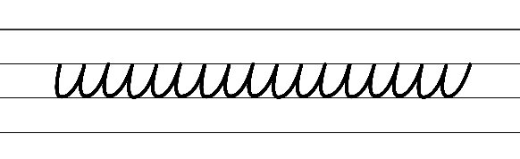  - Example diagonal joins to short letters, including Foundation and Speed Cursive options for the letter s  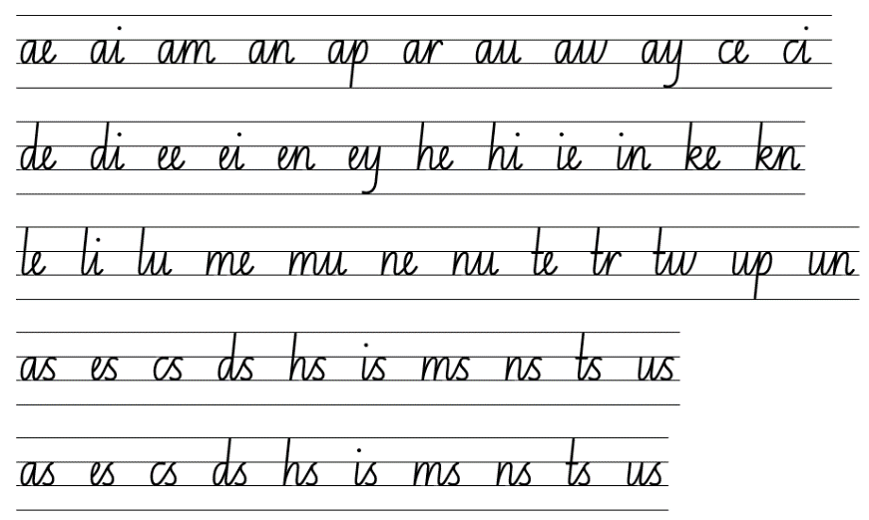  - Example diagonal joins to tall letters (with and without loops)  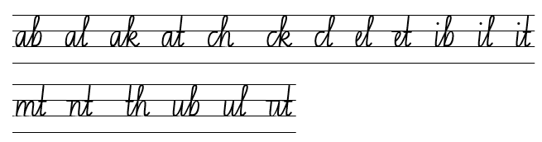  - Suggested handwriting practice passage from the text  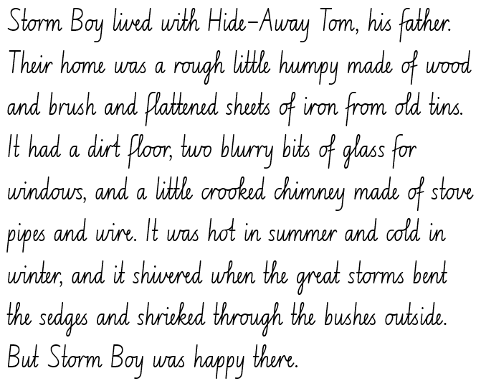

Planning framework
To plan and document Component A teaching and learning, a planning scaffold is provided. To support you in your planning, a link to a detailed example of a one-week teaching and learning cycle is included in the scaffold. Additional resources to support teaching and learning in each focus area can be found at Lesson advice guides.

Component B teaching and learning
The following teaching and learning sequence has been designed to address Component B outcomes and content and develops conceptual understandings of English through the study of quality texts. Adapt the sequence as required to best meet the needs of your students.

Learning intentions and success criteria
Learning intentions and success criteria are best co-constructed with students.

Learning intention
Students are learning to identify and understand the features of a narrative orientation.

Success criteria
Students can:
- recognise and describe key features and patterns of narratives
- use information from a text to visualise characters and settings
- create descriptions of settings using figurative language
- write a character summary that includes figurative language.

Lesson 1: Expectations and features of narratives
- Explore the importance of interacting as a learning strategy. This may include the use of ‘Talk moves’ to help retain important information by revoicing, reasoning and repeating to clarify understanding and make connections. Explain that listening allows people to understand different perspectives and learn new ideas.
- Develop a shared criteria for successful learning interactions, as a speaker and listener, for small group and whole class contexts. Display the criteria and explain that these will be used to guide learning interactions throughout the unit.
- Open Google Maps and search ‘Coorong National Park’. View the photographs uploaded for this area and discuss what students see and think about the images. Optional: visit Government of South Australia – Traditional Owners, to discover information about the Coorong area.
- Explain that students will be reading a text over the next 5 weeks set in Coorong National Park. Ask students how they would describe this setting.
- Reveal the front cover of Storm Boy.
- Flick through the pages, showing students the visual layout of the text, illustrations and the back cover. Allow students to make and share personal connections.
- Provide time for students to share what they know about narratives, including an author’s purpose. Promote connections to prior learning. Draw on student responses to highlight key features of narratives. For example:
- structural elements including orientation, complication, rising action (series of events), climax, falling action and resolution
- use of familiar and imagined characters
- use of real and imagined settings
- use of real or imagined events or experiences
- the purpose (often to entertain)
- usually contain a moral or message.
- Remind students that narratives follow predictable patterns. These patterns set up audience expectations and help them to find meaning in and through texts. Discuss what the audience expects at the beginning of a narrative.
- Students Think-Pair-Share the key features of an orientation. For example, introducing main and supporting characters, describing the setting, indicating time, foreshadowing a potential problem and using engaging details to draw the reader in.
- Read from the beginning of the text to page 11, up to ‘...everyone called him Storm Boy.’ Encourage students to consider the images they have viewed of Coorong National Park as they listen to excerpts from the first chapter.
- Provide time for students to discuss the section read. Ask:
- What did you notice? What stood out to you?
- What language features did you notice? Why do you think Colin Thiele used them?
- Highlight and explain how the author uses a variety of rich, descriptive language in the orientation to create vivid imagery to build the reader’s mental model. Re-read the excerpt from the first chapter (as above). Provide students with a sticky note to record interesting and descriptive language from the excerpt. Ask:
- How do the vocabulary choices add meaning to the orientation?
- Why has Colin Thiele used this language? What effect do they have on the reader?
- Why are language choices important in narrative?
- Students place sticky notes on a vocabulary wall. As a class, categorise vocabulary under the headings ‘Nouns’, ‘Adjectives’, ‘Verbs’ and ‘Adverbs’. Note: this will be referred to and built upon throughout the unit.
- Students sketch the mental model they developed from the description of the setting (Storm Boy’s home environment) and the images of the Coorong area, demonstrating their comprehension and analysis of what they have read.
- After sketching, students share and explain their drawings in small groups. Their sharing should focus on why they drew what they did and what they attempted to represent.
Too hard? Students draw and then orally describe the setting.
Too easy? Students write a paragraph comparing their own home setting and the setting described in the story.

Lesson 2: Identifying figurative language in an orientation
Note: Storm Boy includes some unacceptable language when referring to Aboriginal and/or Torres Strait Islander peoples. Students should be made aware that this language was common when the text was originally published but is no longer acceptable to Aboriginal and/or Torres Strait Islander peoples. The traditional owners of the Coorong are the Ngarrindjeri people.
- Explain that narratives can reflect both personal lived experiences (personal connections from own lives) and common lived experiences (home life, family structure, schooling, pets).
- View Return of a Native – Colin Thiele’s Storm Boy and read the section from ‘Inception of Storm Boy’. Ask:
- Why do you think Colin Thiele wrote Storm Boy?
- Is Colin Thiele an authority on the subject matter of the text? Provide reasons why or why not.
Note: avoid reading the entire webpage as the first section is a summary of the story and includes several spoilers. Authority of a text refers to how trustworthy, authentic or valid an audience may find the ideas, experiences, perspectives and arguments represented.
- Continue reading the first chapter from page 11, ‘The only other man who...’ to ‘...black glass and slid away’ (p 12). Discuss the features of an orientation used by the author. For example, an introduction to additional characters, a deeper analysis of established characters and their behaviour, more information about the setting, building a potential problem.
- Provide time for students to notice, think about and analyse the figurative language features used by the author.
- Discuss the figurative language features used to bring meaning to characters, events and settings in the orientation. Explore how Colin Thiele uses simile to create vivid descriptions of characters, events and settings in the orientation.
- Revise simile. Identify similes in the first chapter. For example, ‘He was a wiry, wizened man with a flash of white teeth and a jolly black face as screwed-up and wrinkled as an old boot’ (p 11); ‘When a tiger snake came sliding through the grass to the shore like a thin stream of black glass barred with red hot coals’ (p 12). Ask:
- How do similes add meaning to the orientation? Consider characters and setting.
- Why has the author used this literary device?
- What effect does it have on the reader?
- Revise metaphor. Explore how Colin Thiele used metaphor to bring meaning to actions, characters and the setting in the orientation.
- Identify metaphors in the first chapter. For example, ‘...every stick he saw melted slowly into black glass’ (p 12); ‘And when the two chicks hatched out they were little bundles of dark down’ (p 16). Ask:
- How do metaphors add meaning to the orientation? Consider characters and setting.
- What effect do these have on the reader?
- How do metaphors support the description of setting and character?
- Display the passage from ‘The only other man...’ to ‘Coorong about a mile away’ (p 11). Highlight the section that describes Fingerbone Bill. Analyse the structure of the description. For example:
- the first sentence identifies who the person is and their cultural background
- the second sentence describes physical appearance using simile, noun groups and descriptive language
- the third sentence describes the home and its location.
- Model recreating a description of Fingerbone Bill. Use the same structure with alternative descriptive and figurative language. For example:
The only other person who lived near them was Fingerbone Bill, the Ngarrindjeri Elder. He was a tall, thin man with teeth that gleamed like pearls and a joyful, shining face that was as lined and creased as an old, much-loved book. His cosy cabin was nestled on the fringe of Coorong about a kilometre away.
- Students create their own descriptive paragraph of Fingerbone Bill, including details of his physical appearance and attributes, using similes and metaphors.
Too hard? Students use sentence stems to create similes and metaphors. For example, Fingerbone Bill was as __ as a __.
Too easy? Students also include a metaphor in their description.
- Exit ticket: students respond to the question: ‘How has Colin Thiele used his personal experiences to create a description of the Coorong area?’

Lesson 3: Describing setting using figurative language
- Remind students that narratives reflect both personal lived experiences and common lived experiences. Explain that Storm Boy is a narrative text.
- Read page 12 from, ‘At first, Hide-Away was afraid’ to page 21 ‘...an ibis or a pelican’.
- Review the figurative language features discussed in Lesson 2. Revise personification. Explore how Colin Thiele uses personification to create vivid descriptions of actions, characters and settings in the orientation.
- Identify the use of personification to describe the setting in the first chapter of Storm Boy. For example, ‘He could paint it in his mind’ (p 17); ‘But when the winter wind came sweeping up from Antarctica with ice on its tongue, licking and smoothing his cheeks’ (p 20). Ask:
- How does personification add meaning to the orientation?
- What effect does it have on the reader? Does it support visualisation?
- How does personification add description to setting and characters?
- Display an image of a setting relative to your school context that requires protection, such as a local area or natural environment. For example, the Never Never River near Bellingen. Brainstorm vocabulary to describe the setting. Encourage students to consider what they might see, hear, smell, taste and touch. Record and display vocabulary using an online tool such as Mentimeter. Explain that the chosen setting will be built on and become part of an orientation written in Lesson 5.
- Co-construct examples of simile, personification and metaphor using words from the class that describe the chosen setting.
- Display page 7 of Storm Boy. Analyse the structure of the description. For example:
- the first 2 sentences describe the location, from ‘Storm Boy lived’ to ‘...from the Murray mouth’
- the third sentence is a description of the location, from ‘A wild strip it is’ to ‘...Southern Ocean on the other’
- the fourth sentence is the name of the setting
- the remainder of the description uses figurative language to add detail, from ‘From thousands of miles’ to ‘...like snakes of salt’.
- Model writing a rich description of the chosen setting using figurative language that follows the structure Colin Thiele used in Storm Boy. Use the think aloud strategy to select vocabulary brainstormed in activity 5. For example:
We live on the Never Never River in the shadow of the Dorrigo Plateau. Our home is the cool, secluded rainforest that hugs the river’s edge. They call it the Promised Land. Cool water runs for hundreds of kilometres and finally reaches us, crisp and clear, whispering secrets along the way. Stones worn smooth by the gentle caress of the river line the banks, standing guard between the water and the trees.
- Students write a description of a chosen setting that requires protection using simile, metaphor and personification. Note: this writing will be used in Lesson 5 to write an orientation.
Too hard? Students write a description of the chosen setting using sentence stems.
- In pairs, students share their description. Encourage students to use appropriate pace, volume and intonation when reading aloud. As each description is read, partners describe the mental model built in their mind.
- Exit slip: Students respond to the questions:
- Has the author used expected patterns in the text so far? What are they?
- What do you expect to read in the next chapter?
Assessment task 1 – Observations and work samples from this lesson allow students to demonstrate achievement towards the following syllabus outcomes and content points:
EN3-VOCAB-01 – extends Tier 2 and Tier 3 vocabulary through interacting, wide reading and writing, morphological analysis and generating precise definitions for specific contexts
- extend knowledge of literal and non-literal word meanings through idiom or metaphor
- describe multiple meanings of words, including their metaphorical uses.
EN3-RECOM-01 – fluently reads and comprehends texts for wide purposes, analysing text structures and language, and by monitoring comprehension
- describe how own mental model is adjusted as new words and information deepen understanding during reading.

Lesson 4: Rich character descriptions
- Revise the supporting concept, characterisation. Provide time for students to share, discuss and evaluate existing knowledge.
- Explain that in narratives, characters can be fictional people, objects or ideas. A character is given an identity with a personality, wants, emotions and feelings. They include a complex interrelationship of appearances, actions, attitudes and beliefs.
- Define and discuss character stereotypes or archetypes. For example:
- a character stereotype is a simple representation of a particular group that assumes all members of that group share similar traits. For example, in fairytales young women are often portrayed as the damsel-in-distress; old women are portrayed as the evil, conniving witch; young men are portrayed as the handsome, brave saviour
- a character archetype is someone that represents a universal pattern of behaviour. For example, the hero, the villain, the rebel or the mentor.
- Revise and summarise the first chapter of Storm Boy. Discuss language features used, including simile, metaphor and personification, as well as the structural elements presented, such as the orientation to the characters and settings.
- Draw attention to the characters in the text, including Storm Boy, Hide-Away and Fingerbone Bill. Ask:
- How have the characters been represented? How has the author encouraged the audience to visualise them?
- Do the characters represent any stereotypes? What makes you think that?
- Do the characters represent any archetypes? What makes you think that? For example, Hide-Away is an outcast; Fingerbone Bill is a wise, old man.
- What connections can you make with characters in other texts? Why?
- How has the author drawn on familiar attributes when developing characters to engage with the audience?
- Discuss how the author used descriptive language features, such as adjectives, similes and metaphor to help the reader visualise the characters.
- Select excerpts from the text that highlight the descriptive language used to help the reader to visualise the character, Storm Boy. For example, ‘He grew up to be supple and hardy. Most of the year he wore nothing but shorts, a shirt, and a battered old Tom Sawyer hat’ (p 20). Ask:
- How do you visualise Storm Boy?
- How does the descriptive language support you to create a mental model?
- Identify other examples of descriptive and figurative language that Colin Thiele uses to create rich and vivid character descriptions that support readers to visualise them.
- Add new words to the vocabulary wall. Students use the think aloud strategy to explain why and how words are categorised, for example, adjectives, nouns, verbs, adverbs. Prompt students to draw on the vocabulary wall when writing and speaking.
- Explain that students will apply their understanding of characterisation to create and describe their own character. This character will live in the setting described in Lesson 3.
- Review the modelled description of setting from Lesson 3. As a class, create a character to live in that setting. For example, Wildwood Wren. Brainstorm and record character attributes. Prompt students to consider how the character might act, think, feel and communicate.
- Model writing a character description. Think aloud to choose ideas from the brainstorm in activity 11 and use figurative language. For example:
Wildwood Wren is quiet and fierce. She treads lightly through the rainforest, nurturing and protecting the lives nestled in its arms. Her compassion and kindness are known far and wide. Wildwood Wren is strong like the roots that anchor the ancient forest trees deep in the earth. She loves the song of the river constantly filling her mind, soothing her soul with its timeless rhythm. She knows that her home is special, untouched by the arrogance and greed of others. She will fight to protect her sacred place, for Wildwood Wren is wild.
- Students brainstorm and record attributes for a character that lives in the setting they created in Lesson 3. Students consider how they might act, think, feel and communicate. Optional: students draw their character, then record attributes.
- Students independently write a character description. Encourage students to use figurative language, such as, simile, metaphor and personification to create rich descriptions. Note: this writing will be built on in Lesson 5.
Assessment task 2 – Observations and work samples from this lesson allow students to demonstrate achievement towards the following syllabus outcomes and content points:
EN3-OLC-01 – communicates to wide audiences with social and cultural awareness, by interacting and presenting, and by analysing and evaluating for understanding
- identify varying social conventions that influence interactions across wide audiences
- interact in a range of contexts and deliberately adjust language and style.
EN3-CWT-01 – plans, creates and revises written texts for multiple purposes and audiences through selection of text features, sentence-level grammar, punctuation and word-level language
- experiment with figurative language for effect and to engage the reader, including metaphor, hyperbole, oxymoron and allusion.
EN3-UARL-01 – analyses representations of ideas in literature through narrative, character, imagery, symbol and connotation, and adapts these representations when creating texts
- recognise how character archetypes and stereotypes are represented in literature.

Week 2

Component A teaching and learning
Component A focuses on the development of foundational skills and knowledge through regular, systematic and repeated practice. The mentor and supporting texts used in Component B of this unit will support the effective implementation of Component A teaching and learning.

Teaching guide
Guidance for explicit teaching, teaching notes, resources and examples for the related outcomes and content points have been provided in the table below.
Focus areas and teaching notes | Resources and examples
Reading comprehension  Reading fluently  - Adjust reading rate to suit the purpose for reading and the complexity of the text  - The purpose of reading is reading for enjoyment, and to understand Storm Boy’s relationship with the birds in his environment. This passage introduces the 3 small pelicans. These characters will play a major role in the text.  - Reading rate may need to be adjusted to accommodate the extended sentences, pausing for the use of commas and semi-colons. Reading rate may also need to be adjusted when encountering unfamiliar language. | Reading comprehension  Reading fluently  - Fluency and close reading passage – page 25 from ‘When Storm Boy went walking’ to ‘...hurried back to Hide-Away with them’ (253 words)  Note: the passage from the text will need to be a teacher-created resource.  - Unfamiliar vocabulary may include paunches, moorhens, quills, blunderbuss.
Comprehending language  - Use morphology and etymology to work out the meaning of unfamiliar words  - Understanding the units of meaning within words (prefixes, suffixes, base words and roots) assists readers in determining overall word meaning.  - Understanding the etymology of words assists in explaining the origins of, and changes to, words in relation to meaning. | Comprehending language  - Suggested etymology and morphology from the passage  - Sanctuary: this word has been formed from the base word ‘sanctum’ and the suffix ‘-ary’. Sanctum is a Latin word meaning ‘a sacred place or shrine’, with the suffix ‘-ary’ meaning ‘for the purpose of’. The word ‘sanctuary’ was first used to describe a place for the purpose of religious worship and was later used to describe a place set aside for plants and animals to breed and live.
Monitoring comprehension  - Generate, monitor and adjust own goals for improving oral reading fluency and silent reading fluency.  - Support students to identify an area for improvement when reading silently and aloud, to create personal goals. Areas for improvement might include reading automaticity, reading rate, stamina or prosody. | Monitoring comprehension  - Students may keep their goals on hand, or you may display them in the classroom for students to refer to when reading fluency passages. For example  - Use punctuation to assist reading fluently and with expression.  - Apply appropriate tone to represent characters’ emotion.
Vocabulary  Learning and using words  - Extend knowledge of literal and non-literal word meanings through idiom or metaphor  - An idiom is a commonly used phrase or expression, usually figurative or non-literal, that has an understood meaning specific to a language or dialect (NESA Glossary). | Vocabulary  Learning and using words  - Suggested idiom from the Week 2 reading material  - ‘Look at that fellow sitting up as if he owns the place’ (p 29) ‘As if he owns the place’ is an idiom meaning to act in an extremely confident way. The phrase ‘own the place’ has a non-literal meaning.
Defining and analysing words  - Evaluate the effectiveness of modal words used in texts to intensify or soften emotional responses  - Modal words indicate probability, occurrence, obligation and inclination. For example  - Probability: certainly, surely, definitely  - Occurrence: always, never, consistently  - Obligation: ought to, should, may  - Inclination: want, wish, would like to (NESA 2023).  - The effectiveness of modal words used in texts can be achieved through comparison. For example, determining which word is more effective in these sentences: ‘He always spoke cruelly to her’, or ‘He occasionally spoke cruelly to her’ (NESA 2023). | Defining and analysing words  - Suggested modal words from the Week 2 reading material  - ‘He was so weak that he couldn’t even hold up his head to be fed...’ (p 28)  - ‘“He mustn’t die!” Storm Boy said desperately’ (p 28)  - ‘Grandfather Pelican had better go and catch some fish or there won’t be any tea for the three Mr P’s’ (p 29).
Spelling  Phonological component  - Segment unfamiliar multisyllabic words into syllables and phonemes as a strategy when spelling  - Introduced across Early Stage 1 to Stage 2, revise segmenting multisyllabic words into syllables and phonemes. This is a phonological skill that should be practised regularly. | Spelling  Phonological component  - Suggested words from the Week 2 reading material: respectable (p 31), rattled (p 25), little (p 28), chuckle, startled (p 36)  - Sample words for inquiry: spectacles, respect-respectable-disrespect, inspect-inspector, perspective, aspect, spectator, spectacular, spectacle, spectrum
Orthographic component  - Recognise that the same grapheme can represent different phonemes  - The grapheme [le] represents the phonemes /l/ and /ul/.  - The phoneme /l/ often follows the graphemes [t, d] (battle).  - The grapheme [le] is pronounced as the syllable /ul/ following graphemes other than [t, d] (drizzle). | Orthographic component  - As above
Morphological component  - Explain and use spelling conventions to add derivational suffixes, such as -ion, -ian, -ence, -ous to base words or roots  - Introduce Latin root ‘spect’ meaning ‘to look’.  - Revise known prefixes and derivational suffixes and their meaning. Explore how prefixes and suffixes can be attached to roots to form words. For example, inspector has the prefix ‘in’, meaning inside; root spect, meaning to look; derivational suffix ‘or’, meaning the person who does the verb. | Morphological component  - As above
Creating written texts  Sentence-level grammar  - Use simple, compound and complex sentences of varying lengths for variation and readability (Revision: Stage 2 content)  - Understand the different sentence types: simple, compound and complex.  - A simple sentence is a complete message that contains a subject and predicate, forming a single independent clause (NESA 2023).  - A compound sentence is a sentence comprising 2 or more independent clauses joined by a coordinating conjunction (NESA 2023).  - A complex sentence is formed by adding one or more dependent (subordinate) clauses to a main (independent) clause using subordinating conjunctions and/or relative pronouns (NESA 2023).  - Experiment with embedding adjectival clauses with the subject and/or object of other clauses, to modify the meaning or to add detail to a noun or noun group  - Adjectival clause: A type of dependent clause that operates as an adjective to give more information to a noun or pronoun in a sentence (NESA Glossary)  - Adjectival clauses are commonly used in English to provide additional information and detail about nouns and noun groups. They can be used with both the subject and object of other clauses.  - Adjectival clauses can be found at the beginning or end of sentences. They can also be embedded. By embedding adjectival clauses within other clauses, writers can create more complex and sophisticated sentence structures and provide a richer and more detailed description of the subject of the sentence. For example, the man, who was wearing a red shirt and black pants, walked into the store. | Creating written texts  Sentence-level grammar  - Example sentence types from the passage  - Simple  - ‘They knew he was a friend.’  - ‘Three or four young men had gone into the sanctuary.’  - Compound  - ‘They had found some pelican nests – wide, rough nests of sticks, grass, and pelican feathers as big as turkey quills – and they had killed two of the big birds resting there.’  - ‘Storm Boy picked them up carefully and (he) hurried back to Hideaway with them.’  - Complex  - ‘Then, just as he was about to run back to tell Fingerbone to fill his blunderbuss with salt, he heard faint rustling or crying.’  - ‘When Storm Boy went walking along the beach, or over the sandhills, or in the sanctuary, the birds were not afraid.’  - Example sentences from the passage featuring adjectival clauses  - ‘The pelicans sat in a row, like a lot of important old men with their heavy paunches sagging, and rattled their beaks drily in greeting.’  - ‘They had found some pelican nests- wide, rough nests of sticks, grass, and pelican feathers as big as turkey quills- and they had killed two of the big birds resting there.’
Punctuation  - Use a comma to separate a subordinate clause or a phrase from the main clause, or to separate information within a sentence, or to separate items in a list  - Commas are a punctuation marker used to show separation between parts of a sentence, such as clauses or phrases, where separation is important to the meaning. Commas are also used to separate words, phrases or numbers in a series (NESA Glossary). | Punctuation  - Example sentences from the passage featuring commas  - See above
Handwriting and digital transcription  Handwriting legibility and fluency  - Sustain writing with a legible, fluent and personal handwriting style across a text  - Revise horizontal joins to short letters. The letters o, r, v, w and x join the following on line 2 (or the neckline).  - There is a slight dip in a horizontal join to a short letter.  - Revise horizontal joins to tall letters. These join the tall letter just below the ascender (or neckline). If the letter has a cursive loop, it begins at the ascender.  - Encourage students to evaluate their own handwriting after practising. For example, asking them to circle well-formed horizontal joins that are consistent in size, spacing and slope. | Handwriting and digital transcription  Handwriting legibility and fluency  - Suggested fluency pattern:  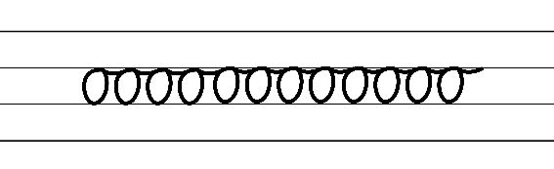  - Example horizontal joins to short letters in cursive style:  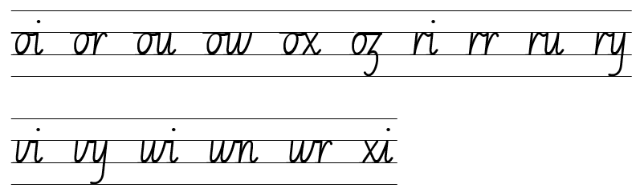  - Example horizontal joins to tall letters in cursive style:  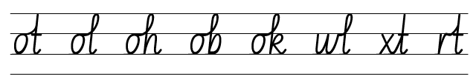  - Suggested practice text from the passage:  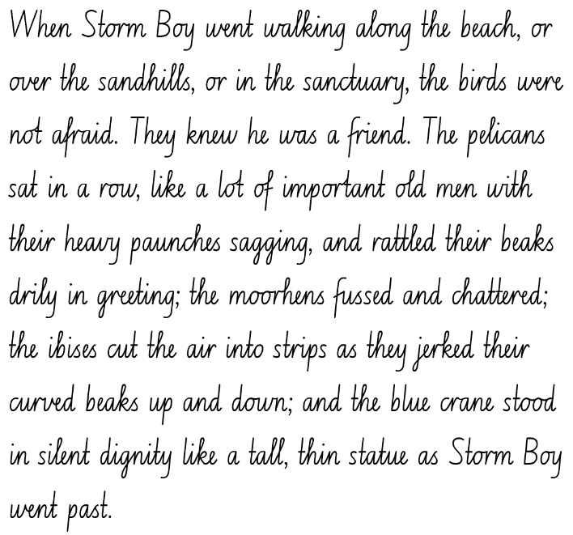
Software functionalities and typing  - Position a device for best use to avoid glare and postural issues  - Consider light and glare when using technology to type.  - Maintain correct posture when using technology to type. | Software functionalities and typing  - It is recommended to select technology appropriate for your school context.

Planning framework
To plan and document Component A teaching and learning, a planning scaffold is provided. To support you in your planning, a link to a detailed example of a one-week teaching and learning cycle is included in the scaffold. Additional resources to support teaching and learning in each focus area can be found at Lesson advice guides.

Component B teaching and learning
The following teaching and learning sequence has been designed to address Component B outcomes and content and develops conceptual understandings of English through the study of quality texts. Adapt the sequence as required to best meet the needs of your students.

Learning intentions and success criteria
Learning intentions and success criteria are best co-constructed with students.

Learning intention
Students are learning to recreate a text using language features to enhance the reader’s understanding of characters and setting.

Success criteria
Students can:
- describe how language features inform creative choices when describing setting
- identify subjective language, modal words and temporal connectives used in a text
- analyse and use attributes of characters
- make connections to a text, identifying personal and common lived experiences.

Lesson 5: Writing an orientation
- Revisit the textual concept ‘narrative’ and discuss the features of an orientation. For example, detailed information about settings and introduction of characters.
- Revise that narratives have patterns that set up expectations. Discuss how patterns support readers to find meaning in texts and to make a text’s purpose identifiable. Explain that when a text does not follow the expected pattern, the pattern has been subverted. Ask students to consider what narrative elements have been represented in the orientation of Storm Boy and whether expected narrative patterns have been followed.
- Explain that authors use a range of language features to convey deep meaning about the setting and characters to support the reader in making a mental model.
- Revise simile, metaphor and personification. Ask students how Colin Thiele used language features to promote visualisation.
- In pairs or small groups, students share their description of the local setting from Lesson 3 and character description from Lesson 4.
- Students provide peer feedback, focusing on the use of descriptive and figurative language to promote visualisation. Remind students of the agreed protocols for successful learning interactions.
- Display an enlarged copy of Resource 3: Freytag’s pyramid planning template. Explain that students will write an orientation, building on the setting described in Lesson 3 and the character developed in Lesson 4.
- Revise the class setting and character from Lesson 3 and 4. Use the enlarged copy of Resource 3: Freytag’s pyramid planning template to model planning an orientation. Think aloud to identify details to include in the orientation. For example, additional characters, foreshadowing an event. This modelled planning template will be added to throughout the unit.
- Using their own copy of Resource 3: Freytag’s pyramid planning template, students plan an orientation using their setting from Lesson 3 and character from Lesson 4.
- Co-construct a new orientation using the modelled plan. Emphasise the importance of using descriptive and figurative language to create rich descriptions of the settings, characters and events. For example:
Wildwood Wren lived on the Never Never River in the shadow of the Dorrigo Plateau. Her home was the cool secluded rainforest that hugged the river’s edge. They call it the Promised Land. Cool water runs for hundreds of kilometres to find its way to Wren, crisp and clear, whispering secrets along the way. Stones worn smooth by the gentle caress of the river line the banks, standing guard between the water and the trees.
The wild girl lived with Jarrah, her mother. Jarrah’s family had been part of the forest for as long as anyone could remember. Their home was a cosy cabin, hidden amongst the towering trees tucked deep in the heart of the rainforest. Day after day, Jarrah strove to protect the river and the rainforest from the hordes of tourists that would descend every summer, polluting the water and trampling the trees.
Wildwood Wren was quiet and fierce. She loved the rainforest like it was family, protecting and nurturing the lives nestled in its arms as brothers and sisters. Her devotion was known far and wide, her strength like the roots of the ancient forest trees, anchoring them to the earth. Wildwood Wren knew that her home was special, an untouched and sacred place. She would fight to keep it that way. For Wildwood Wren was wild.
- Students use their completed plan, setting described in Lesson 3 and character developed in Lesson 4 to write an orientation. Encourage students to include additional examples of figurative language to enhance their work. Note: this writing will be built on in Lesson 7.
Too hard? Students work in pairs to rewrite an orientation.
Too easy? Students introduce an event that occurs during their alternate orientation.
- In pairs, students share their orientation and provide peer feedback using the Tell, Ask, Give (TAG) strategy.

Lesson 6: Identifying subjective language to build tension
- Remind students that narratives have predictable patterns that set up audience expectations. These patterns support readers to find meaning in texts. When a text does not follow a predictable pattern, it is called a subverted pattern.
- Ask students what typically follows an orientation in narratives. Explain that authors include actions and events in a plot to create tension. The tension builds gradually, leading to either one (climax) or a series of problems and complications. Tension moves the plot forward and promotes an emotional and/or intellectual response from the reader.
- Read the second chapter, from page 24 to 29. Provide time for students to think about and analyse the rising tension, leading to complications that are evident in the chapter. Ask:
- What did you notice?
- Were there any problems presented? If so, how did they impact the characters?
- How have the problems had an impact on you (emotionally or intellectually) as a reader?
Note: subjective language refers to words used to communicate based on opinions, feelings or personal biases.
- Display the passage from ‘But sometimes Storm Boy saw’ to ‘...innocently by the shore’ (p 24). Ask students to identify subjective language used by the author. For example, ‘...they crept out again quickly and secretly’; ‘visitors went trampling about’; ‘...bet one another that they could hit an egret or a moorhen or a heron standing innocently by the shore’.
- Analyse the bold words in the examples above and assess how each incites emotions, feelings and opinions. Ask:
- Why has the author used subjective language in this chapter? (For example, to indicate how a character is acting or feeling)
- What effect does subjective language have on the reader as the story builds tension? How do you know?
- How does subjective language support the complication in this chapter and audience engagement?
- Add words to the vocabulary wall and discuss what categories they fit into. For example, ‘secretly’ and ‘innocently’ are adverbs.
- Model completing a Frayer diagram for the word ‘secretly’ to show students how to generate precise definitions of subjective vocabulary. See Resource 4: Frayer diagram example for support.
- Students independently complete a Frayer diagram using a chosen subjective word from the vocabulary wall. For example, ‘innocently’ (p 24).
- Students recreate the passage from ‘Storm Boy crept forward’ to ‘...three tiny pelicans – still alive’ (p 28) using alternative subjective language, such as adverbs, to build tension/rising action and help convey character feelings and emotions.
- In pairs, students read their recreated passage and explain what they think the next events might be following the tension building. Encourage students to use appropriate presentation techniques suitable for the audience and purpose.
Assessment task 3 – Observations from this lesson allow students to demonstrate achievement towards the following syllabus outcomes and content points:
EN3-OLC-01 – communicates to wide audiences with social and cultural awareness, by interacting and presenting, and by analysing and evaluating for understanding
- deliver presentations suited to purpose and audience.
EN3-RECOM-01 – fluently reads and comprehends texts for wide purposes, analysing text structures and language, and by monitoring comprehension
- recognise that personal narratives contain more subjective language, but factual accounts of events contain more objective language.

Lesson 7: Understanding how temporal connectives and modal words build tension
- Revise that narratives follow patterns leading the reader to expect the main character will face a problem. The purpose of building tension/rising action in narratives is to increase the impact on the reader.
- Remind students that time and place play a significant role in narratives to help create tension. Explain that Colin Thiele made creative choices about temporal and spatial settings to enhance reader engagement by using temporal connectives (words that indicate when something is happening).
- Discuss and list the key events and details that have occurred in the first and second chapter of Storm Boy.
- Brainstorm a list of known temporal connectives. For example, first, next, finally, before, after, then, suddenly, meanwhile.
- Read the third chapter (pp 30–34). Identify temporal connectives used in the text and add these to the vocabulary wall under a new category heading. For example, before long, time went on, at last, when it came to. Discuss how these indicate a shift in time and ideas in the text.
- Explain that the author uses modal words in this chapter to bring meaning to problems and characters, as well as build tension in the complication (following narrative patterns). Remind students that modal words are used in texts to intensify or soften emotional responses from the audience, as taught in Component A.
- Re-read the third chapter (pp 30–34) and identify examples of modal words. For example, would say, will have to, just can’t, he always knew; he didn’t want. Ask:
- Why do you think Colin Thiele used words with high modality in the complication of the narrative? How do these language choices add tension?
- What effect does this language have on the reader? What sort of emotional response does it evoke?
- What connections can you make from own personal experiences?
- How do your own interests impact on your response to the events taking place?
- Encourage students to ask questions to deepen their understanding of the language choices used in the text.
- Add words to the vocabulary wall categories. Remind students to refer to the vocabulary wall when writing.
- Discuss what section of a narrative has been presented in the second and third chapters. For example, the complication has been introduced and is followed by rising action.
- Display the modelled Resource 3: Freytag’s pyramid planning template and ideas planned in Lesson 5.
- Explain that students will plan and write an event to follow their orientation, written in Lesson 5. Discuss how temporal connectives and modal words can build tension when introducing a complication.
- Display the modelled orientation written in Lesson 5. Brainstorm possible complications and events that the class character could face. Provide time for sharing and discussion.
- Model planning an event that introduces the complication. Record in the ‘complication’ section on the modelled Resource 3: Freytag’s pyramid planning template Think aloud to refer to ideas recorded in activity 12.
- Students use their own copy of Resource 3: Freytag’s pyramid planning template to plan an event that introduces a complication for the orientation written in Lesson 5. Ideas should be planned in the ‘complication’ section.
- In small groups, students share their plan. Students ask and respond to questions about the additional event included in their peers’ planning template and discuss how it builds tension.
- Model writing an event that introduces the complication using the ideas planned in activity 13. Think aloud to select temporal connectives and modal words, and reinforce that narratives follow certain patterns that set up audience expectations. For example:
Wildwood Wren loved to explore the rainforest. From sunup to sundown, she roamed. Wildwood Wren trod carefully and took delight at the beauty she encountered. The fairy ring nestled in the heart of the ferns; the rope swings made by the strangler fig. Sometimes Wildwood Wren noticed things that made her angry. Plastic bottles discarded and thrown in the river, branches broken from trunks, leaves plucked and shredded like confetti, long forgotten rubbish left by careless picnickers. After all of Jarrah’s hard work, the signs, the reminders, were for nothing. People still came and destroyed.
One morning while she was walking, Wildwood Wren stumbled upon two young boys crouched over something on the ground. They were holding sticks, laughing and prodding at a small, grey ball of fluff. Wildwood Wren yelled and ran forward. She protected the rainforest and all the lives in it like family. The boys turned and fled. On the ground, Wildwood Wren saw a ringtail possum. It had fallen from its drey, a tree hollow high above the forest floor. After making sure the boys were gone, Wildwood Wren carefully picked up the possum. She wrapped it in her jumper and hurried back to the cosy cabin. She knew that Jarrah would know what to do.
- Using ideas planned on Resource 3: Freytag’s pyramid planning template, students independently write an event that introduces the complication to follow their orientation. Prompt students to use temporal connectives and modal words. Note: this writing will be built on in Lesson 9.
Assessment task 4 – Observations from this lesson allow students to demonstrate achievement towards the following syllabus outcomes and content points:
EN3-OLC-01 – communicates to wide audiences with social and cultural awareness, by interacting and presenting, and by analysing and evaluating for understanding
- respond to questions with elaboration and detail
EN3-VOCAB-01 – extends Tier 2 and Tier 3 vocabulary through interacting, wide reading and writing, morphological analysis and generating precise definitions for specific contexts
- evaluate the effectiveness of modal words used in texts to intensify or soften emotional responses
EN3-RECOM-01 – fluently reads and comprehends texts for wide purposes, analysing text structures and language, and by monitoring comprehension
- reflect on personal connections with a text and identify how interests and experiences can influence understanding and appreciation of ideas presented.

Lesson 8: Character development and relationship building
- Discuss what the purpose and role of the main character is in narrative. Provide time for students to think, analyse and share their knowledge about the function and purpose of characters in narratives. Outline that the main character in a narrative drives the action and plot and acts as a way of engaging the reader and to represent the key messages of a text.
- Prior to reading the fourth chapter, ask students to think about the main character, Storm Boy, and his relationship with Mr Percival.
- While reading the chapter, ask students to consider what key messages or themes the author has included and why. For example, friendship is the most important thing in the world, as the bond gained from others will always give one strength.
- Read the fourth chapter (pp 35–37).
- Revisit student ideas about the key messages in the text. Display pages 36 and 37 for students to reference and locate evidence to support their thinking. For example, ‘It was a happy reunion that night’ (p 36); ‘He refused even to leave Storm Boy’s side’ (p 37). Ask:
- Why did the author write this chapter about Storm Boy and Mr Percival?
- What role does the relationship between Storm Boy and Mr Percival play in the narrative?
- Does this chapter follow a familiar narrative pattern? What evidence do you have?
- Do you think the friendship between Storm Boy and Mr Percival will change and/or evolve as the story plot continues? Why?
- Explain that students will write a paragraph based on a personal lived experience and a connection they have to the key message of ‘friendship’ from Storm Boy. For example:
I remember when I got my first pet and how it made me feel. On my seventh birthday, Roger came bursting into my bedroom and my parents told me he was my very own pet dog to love and care for. From that day, Roger and I were inseparable. I loved the responsibility of caring for and playing with him, also making sure he was walked, fed and socialised. I can understand the bond between Storm Boy and Mr Percival as I shared that same bond with my dog, Roger.
- Students independently write their paragraph. Remind them to refer to the vocabulary wall when writing.
- Students read their response to a partner before sharing with the class. Remind the students of the agreed protocols for oral language and communication conventions.

Week 3

Component A teaching and learning
Component A focuses on the development of foundational skills and knowledge through regular, systematic and repeated practice. The mentor and supporting texts used in Component B of this unit will support the effective implementation of Component A teaching and learning.

Teaching guide
Guidance for explicit teaching, teaching notes, resources and examples for the related outcomes and content points have been provided in the table below.
Focus areas and teaching notes | Resources and examples
Reading comprehension  Reading fluently  - Adjust reading rate to suit the purpose for reading and the complexity of the text  - The purpose of reading is reading for enjoyment, and to understand the strong bond that has formed between Storm Boy and Mr Percival. This passage is a key moment in the narrative where Storm Boy releases the 3 pelicans into the sanctuary.  - Reading rate may need to be adjusted to accommodate the extended sentences, pausing for the use of commas. Reading rate may also need to be adjusted to allow for the characters’ emotions within this passage to be shown. | Reading comprehension  Reading fluently  - Fluency and close reading passage – page 34 from ‘But when it came to Mr Percival’s turn’ to ‘...and look after yourself’ (209 words)  Note: the passage from the text will need to be a teacher-created resource.
Reading for interest and wide purposes  - Bring subject vocabulary, technical vocabulary, background knowledge and conceptual knowledge to new reading tasks  - Background knowledge and vocabulary support comprehension, particularly inference. Background knowledge provides a framework for building a mental model.  - Activating background knowledge, introducing necessary content knowledge and the explicit teaching of vocabulary are effective strategies to support comprehension. | Reading for interest and wide purposes  - Background knowledge that may assist in comprehension of the passage  - ‘5 miles’ is equivalent to 8 kilometres. This understanding is important as it shows how far Storm Boy and Hideaway travelled to release the birds. Consider why they travelled this distance. This knowledge assists in comprehension of the following chapter, when Mr Percival returns to Storm Boy.
Comprehending language  - Describe how their own mental model is adjusted as new words and information deepen understanding during reading  - A mental model is a mental representation of the information in a real or an imaginary world. A student develops a mental model as the text progresses. It may include information derived from inferences and from background knowledge as well as from what is explicitly stated in the text itself (NESA Glossary). | Comprehending language  - In this passage, the mental model of Storm Boy’s bond with Mr Percival develops. Information that contributes to this development includes  - Mr Percival sitting in Storm Boy’s lap, rather than in a fishing basket  - The text which states that Mr Percival is Storm Boy’s favourite  - Mr Percival being released last, with the inference that it was hard for Storm Boy to say goodbye  - Storm Boy’s actions and words in saying farewell to Mr Percival, ‘clearing his throat’ indicating that he was about to cry.
Monitoring comprehension  - Generate, monitor and adjust own goals for improving oral reading fluency and silent reading fluency  - Support students to monitor their personal fluency goals, generated in Week 2. Areas for improvement might include reading automaticity, reading rate, stamina or prosody. | Monitoring comprehension  - Students may keep their goals on hand, or you may display them in the classroom for students to refer to when reading fluency passages.  - Strategies for monitoring personal goals may differ, based on the goals selected. Strategies may include timing fluency passage reading or use of a rubric to self-assess prosody.
Vocabulary  Learning and using words  - Extend knowledge of literal and non-literal word meanings through idiom or metaphor.  - An idiom is a commonly used phrase or expression, usually figurative or non-literal, that has an understood meaning specific to a language or dialect (NESA Glossary). | Vocabulary  Learning and using words  - Suggested idioms from the Week 3 reading material  - ‘Every morning they...flew three or four times round the humpy and the beach nearby to make sure everything was in order’ (p 30). ‘Everything was in order’ is an idiom, meaning that everything was ready and organised. The phrase ‘in order’ has a non-literal meaning.  - ‘Storm Boy couldn’t bear to see him shut up too’ (p 34). ‘Couldn’t bear to see him’ is an idiom, meaning to be unable to tolerate or accept something. The phrase ‘bear to see’ has a non-literal meaning.
Defining and analysing words  - Evaluate the effectiveness of modal words used in texts to intensify or soften emotional responses  - Modal words indicate probability, occurrence, obligation and inclination. For example  - Probability: certainly, surely, definitely  - Occurrence: always, never, consistently  - Obligation: ought to, should, may  - Inclination: want, wish, would like to (NESA 2023).  - The effectiveness of modal words used in texts can be achieved through comparison. For example, determining which word is more effective in these sentences: ‘He always spoke cruelly to her’, or ‘He occasionally spoke cruelly to her’ (NESA 2023). | Defining and analysing words  - Suggested modal words from the passage  - ‘Storm Boy couldn’t bear to see him shut up too.’  - ‘He was always quieter, more gentle, and more trusting than his two brothers.’  - ‘“I’ll hold Mr Percival,” he said. “Can I, Dad?”  - Discuss how modal words impact upon the understanding of the relationship between Storm Boy and Mr Percival.
Spelling  Phonological component  - Segment unfamiliar multisyllabic words into syllables and phonemes as a strategy when spelling  - Introduced across Early Stage 1 to Stage 2, revise segmenting multisyllabic words into syllables and phonemes. This is a phonological skill that should be practised regularly. | Spelling  Phonological component  - Suggested words from the Week 3 reading material: especially (p 45)  - Sample words for inquiry: suspect, suspicious, suspicion, special, species, specify, specimen, speculate, auspices, auspicious, conspicuous, despicable
Orthographic component  - Apply and explain graphemes identified by their etymology  - The grapheme [ci] represents /sh/.  - Explore that words with the /sh/ phoneme represented as the digraph [ci] are usually Latin in origin. | Orthographic component  - As above
Morphological component  - Explain and use spelling conventions to add derivational suffixes, such as -ion, -ian, -ence, -ous to base words or roots  - Revise root ‘spect’ meaning ‘to look’  - Introduce Latin root: ‘spec’, ‘spic’  - Spec and spic also meaning ‘to look, watch, observe’  - Revise known prefixes and derivational suffixes and their meaning. Explore how prefixes and suffixes can be attached to roots to form words. For example, inspector has the prefix ‘in’, meaning inside; root ‘spect’, meaning to look; derivational suffix ‘or’, meaning the person who does the verb. | Morphological component  - As above
Creating written texts  Text features for multiple purposes  - Control tense across a text according to purpose, shifting between past, present and future tense if required.  - Tense is the form of the verb that indicates when something is happening in relation to the speaker’s time (past, present or future) (NESA Glossary). | Creating written texts  Text features for multiple purposes  - See sentences below. Verbs which indicate tense are highlighted in bold.
Sentence-level grammar  - Experiment with embedding adjectival clauses with the subject and/or object of other clauses, to modify the meaning or to add detail to a noun or noun group  - Adjectival clause: A type of dependent clause that operates as an adjective to give more information to a noun or pronoun in a sentence (NESA Glossary).  - Adjectival clauses are commonly used in English to provide additional information and detail about nouns and noun groups. They can be used with both the subject and object of other clauses.  - Adjectival clauses can be found at the beginning or end of sentences. They can also be embedded. By embedding adjectival clauses within other clauses, writers can create more complex and sophisticated sentence structures and provide a richer and more detailed description of the subject of the sentence. For example, the man, who was wearing a red shirt and black pants, walked into the store. | Sentence-level grammar  - Example sentences from the Week 3 reading material featuring adjectival clauses  - ‘Three great storms swept out of the south, the third one so terrible that it gathered up the sea in mountains, mashed it into foam, and hurled it against the shore’ (p 44).  - ‘When morning came over the world at last they could see the tugboat clearly, (which was) lying like a wounded whale.’ (p 45).
Punctuation  - Use a comma to separate a subordinate clause or a phrase from the main clause, or to separate information within a sentence, or to separate items in a list  - A comma is a punctuation marker used to show separation between parts of a sentence, such as clauses or phrases, where separation is important to the meaning. Commas are also used to separate words, phrases or numbers in a series (NESA 2023).  - A dependent clause (also known as subordinate clause) is a group of words that cannot stand alone as a sentence (NESA 2023).  - A subordinating clause can be placed at the beginning of the sentence.  - A comma can be used to separate information using appositives, or an adjectival clause/phrase.  - Use quotation marks consistently across a text to distinguish words that are spoken by characters in dialogue or words authored by others  - Quotation marks are used at the beginning and end of what is spoken by characters in dialogue or words authored by others.  - For dialogue with more than one character speaking, a change of line for each new speaker is used. | Punctuation  - Examples of comma usage from the passage, separating the subordinate clause from the main clause  - ‘But when it came time for Mr Percival’s turn, Storm Boy couldn’t bear to see him shut up too.’  - ‘Ever since the miracle of Mr Percival’s rescue, he had been Storm Boy’s favourite.’  - Examples of dialogue from the passage  - ‘“Poor Mr Percival,” he said gently. He looked up at his father. “I’ll hold Mr Percival,” he said. “Can I, Dad?”  “Oh, all right,” Hide-Away said, taking up the two baskets. “Come on, it’s time we started.”’
Handwriting and digital transcription  Handwriting legibility and fluency  - Sustain writing with a legible, fluent and personal handwriting style across a text  - Revise horizontal joins to anticlockwise letters, including to a, c, d, g, o and q.  - When a horizontal join is made to an anti-clockwise letter, the top of the letter is retraced to join the previous letter.  - Revise horizontal joins to the letter e.  - When a horizontal join is made to the letter e, the exit dip needs to be dropped lower to start the entry to the letter in its usual position.  - Revise horizontal joins to the letter s.  - When writing the letter s, the formation and join can change depending on its position in a word. It can have a diagonal join, a horizontal join or no join. | Handwriting and digital transcription  Handwriting legibility and fluency  - Suggested fluency pattern  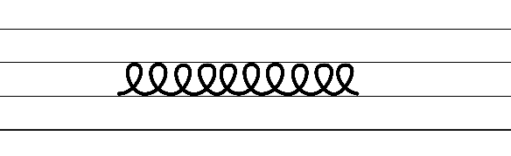  - Example horizontal joins to anticlockwise letters  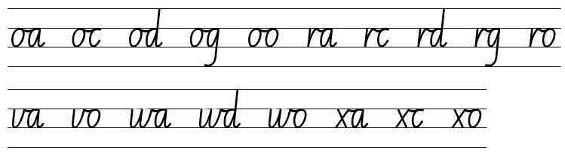  - Example horizontal joins to the letter e  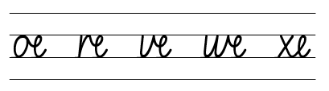  - Example horizontal joins to the letter s  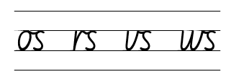  - Suggested practice text from the passage  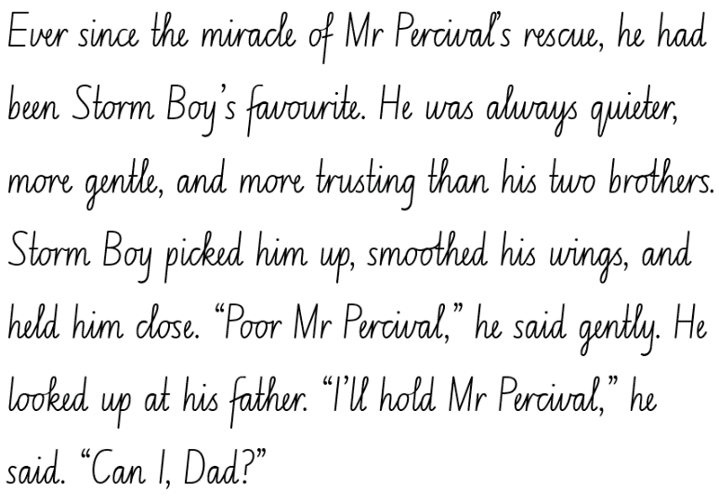

Planning framework
To plan and document Component A teaching and learning, a planning scaffold is provided. To support you in your planning, a link to a detailed example of a one-week teaching and learning cycle is included in the scaffold. Additional resources to support teaching and learning in each focus area can be found at Lesson advice guides.

Component B teaching and learning
The following teaching and learning sequence has been designed to address Component B outcomes and content and develops conceptual understandings of English through the study of quality texts. Adapt the sequence as required to best meet the needs of your students.

Learning intentions and success criteria
Learning intentions and success criteria are best co-constructed with students.

Learning intention
Students are learning to identify rising action in a narrative that leads to a subverted resolution.

Success criteria
Students can:
- add modal words in tension building events
- use dialogue to move the plot forward, reveal character traits and create tension
- include adjectival clauses to provide more information
- identify the features of a subverted narrative pattern
- explore how an author uses foreshadowing in a text.

Lesson 9: Using modal words to enhance writing
- Revise that narratives use temporal connectives and modal words (taught in Component A and Lesson 7) to add meaning and create emotive responses when reading a text.
- Re-read the fourth chapter (pp 35–37). While reading, pause to identify and discuss modal words. For example, ‘Yes, I suppose he can stay’; ‘...we can’t cope with three’; ‘...hoping very much that they would stay away’.
- Discuss what section of a narrative is presented in the fourth chapter. For example, the series of events with rising action. Discuss the events and any tension created in the fourth chapter. For example, Hide-Away and Storm Boy spend the day fishing, feeling sad and reflecting; Mr Percival returns home to Storm Boy’s humpy and refuses to leave Storm Boy’s side. Explain that tension is created by focusing on the strong bond between Storm Boy and Mr Percival.
- Ask students to consider the narrative conventions (patterns) and models of behaviour presented in Storm Boy so far. Students predict what major complication might occur in the story.
- Students write their complication prediction on sticky notes and share their idea in small groups. Remind students of the agreed protocols for oral language and communication conventions.
- Each group selects one prediction that is the most plausible to share with the class. List the predictions, discussing any similarities and how tension might develop to see each prediction occur as the major complication. Note: the predictions will be revisited in Lesson 11.
- Explain that students will plan and write an event to follow the complication, as introduced in Lesson 7.
- Brainstorm and list modal words students could use in their writing. For example, will, would, must, may, might, can, could, shall, should, ought to.
- Display the modelled Resource 3: Freytag’s pyramid planning template and the modelled class narrative from Lesson 5 and Lesson 7.
- Brainstorm events that could follow the introduction of the complication. Provide time for sharing, questioning and discussion. Record ideas.
- Model using the ‘rising action’ section of the class Resource 3: Freytag’s pyramid planning template to plan and organise ideas. Use think-alouds to select ideas recorded in activity 7.
- Students plan ideas using the ‘rising action’ section of their own Resource 3: Freytag’s pyramid planning template.
- Model writing the next event. Think aloud to refer to ideas from the planning template, and to select temporal connectives, modal words, figurative and subjective. For example:
The ringtail possum was desperately sick. Wildwood Wren held her breath as Jarrah carefully inspected the possum, gently turning it over in her hands and feeling for injuries. Jarrah gasped. She turned to Wildwood Wren and smiled, ‘There’s a joey here, and he's going to need some looking after. Do you think you’re up for a challenge?’. The joey was tiny. He was covered in the softest grey fur with a tiny splash of white on his chest. ‘I’ll call him Orion,’ breathed Wildwood Wren ‘because he is a star in the darkness that lights the way.’
Jarrah showed Wildwood Wren how to care for the joey. Orion slept in an old pillowcase that hung from the back of a chair by the fireplace, where it was warm as toast. Wildwood Wren fed him with a special bottle and milk that Jarrah helped her mix up. Each evening, as night’s dark fingers wrapped around the fading light, Wildwood Wren pulled a mattress next to the fireplace. There she slept, checking on Orion all through the night.
After a few days, Wildwood Wren remembered the mother possum. She asked Jarrah what had happened. Jarrah sighed deeply and shook her head. Wildwood Wren was furious. How dare those boys come into her rainforest and hurt the things she loved? Wildwood Wren vowed to keep Orion safe and protect the forest.
- Students independently write the event based on ideas planned in the ‘rising action’ section of their planning template.
- Students share their writing with a peer and use Tell, Ask, Give (TAG) strategy to provide feedback and refine their work.

Lesson 10: Building tension through character dialogue
- Revise dialogue as taught in Component A.
- Review the chapters previously read, recalling main events, characters and key messages from the orientation, series of events and complication. Reinforce that the complication and series of events that follow build suspense and tension to enhance readers’ interest and engagement.
- Explain that authors use dialogue in narratives to move the plot forward, reveal character traits and create tension. Dialogue contains subjective language as it represents how characters think, behave, speak and feel.
- Read the fifth chapter, from page 38 up to ‘He shook his head. Poor fellows!’ (p 45). During the read, pause at the following examples of dialogue:
- ‘Oh, you’re a grand’ to ‘...Sunday school lessons’ (pp 38–39). Ask what the dialogue reveals about the character.
- ‘If he can bring’ to ‘...that’s the fellow’ (p 40). Ask how the dialogue helps to move the plot forward.
- ‘Storm Boy put on two’ to ‘Poor fellows!’ (pp 44–45). Ask how the dialogue adds to the building tension in the plot.
- Revisit the concept of characterisation from Lesson 4. Discuss how Storm Boy, Hide-Away and Fingerbone Bill are represented in the text.
- Explain that students will create a passage of dialogue between the 3 characters. Brainstorm conversation topics that may occur between these characters. Discuss types of spoken language conventions used by each character.
- Model the conventions when writing dialogue, including speech marks and starting a new line for each speaker change. Encourage students to think about the purpose and/or impact of the dialogue.
- In groups of 3, students imagine they are the characters Storm Boy, Fingerbone Bill or Hide-Away.
- Students create a written passage using dialogue between the 3 characters that could be included in the fifth chapter. Students refer to Resource 5: Dialogue checklist, to ensure appropriate conventions for dialogue are used.
- Remind students of the agreed protocols for oral language and communication conventions. Student groups share their dialogue passage with the class using appropriate expression.

Lesson 11: Identifying a major complication using adjectival clauses
- Revise that narratives follow certain patterns, so the audience can expect the main character to face a major complication. Revise the list of predicted major complications from Lesson 9. Explain that Colin Thiele builds suspense leading to a major complication in the fifth chapter.
- Read the fifth chapter, from page 45, ‘When morning came over’, to the end of the chapter (p 52).
- Discuss if any of the student predictions for the major complication were accurate or how they were different. Ask students if the pattern of Storm Boy has remained predictable.
- Discuss and co-construct a list summarising the tension building events leading to the major complication that occurred in the fifth chapter.
- Revise the use of adjectival clauses, taught in Component A.
- Revisit the fifth chapter (pp 38–52) to identify the use of adjectival clauses and the use of a comma. For example, ‘After him came a third, who staggered feebly up the beach’ (p 48); ‘He was a big man who weighed down the rope’ (p 49).
- Students explain the meaning of the adjectival clauses identified. Ask:
- How do these examples provide additional information about characters and their actions?
- What effect do these examples have on the reader?
- How do these examples support the text’s purpose?
- Explain that students will add adjectival clauses to a section of text from the fifth chapter. Model rewriting a passage of text to include adjectival clauses. For example, from ‘Storm Boy gave a great shout’ to ‘...gave it to Mr Percival’ (p 46):
Storm Boy, who had just had a brilliant idea, gave a great shout and raced towards Hide-Away. “Mr Percival can fly a line to the sailors, he can save them!”
When Hide-Away realised what Storm Boy meant, he sprinted to the humpy to fetch a line. Hide-Away, who was brilliantly clever, began to tie the lines around a rock that lay upon a patch of dry sand. He gave the line to Mr Percival, who initially seemed confused, but then realised what his job would be. The tugboat, which had begun to drift out to sea, was groaning under the strain of the ocean’s tide.
- Provide students with a passage from the fifth chapter. Students rewrite the passage, adding adjectival clauses.
Too hard? Students work in pairs to rewrite the passage to include adjectival clauses.
Too easy? Students create adjectival clauses that exist at the beginning or in the middle of the sentence. For example, ‘When Hide-Away realised what Storm Boy meant, he sprinted...’; ‘He gave the line to Mr Percival, who initially seemed confused, but then realised what his job would be’.
- Students share their writing and discuss how the vocabulary choices help to engage readers and achieve the purpose of the text.

Lesson 12: Identifying a subverted narrative ending
- Promote student engagement by discussing their predictions for how Storm Boy might conclude. Revise that authors use patterns, often called narrative conventions, to set up the readers’ expectations in narratives.
- Students complete a new blank copy of Resource 3: Freytag’s pyramid planning template, listing the key events from Storm Boy. Explain that students will complete the template up to the ‘climax’ section as an additional major climax occurs in the final chapter.
- Explicitly teach how the author has set up expectations for the audience based on the patterns used so far.
- Using sticky notes, students write a prediction for the impending final climax and resolution to Storm Boy.
- Read the sixth chapter (pp 53–61). Provide time for students to discuss the climax and resolution of the narrative. Ask:
- How did the narrative end?
- Were the problems resolved?
- Did the audience expect this ending? Why/why not?
- What type of pattern did Colin Thiele use to conclude the story? (Subverted pattern)
- What models of behaviour were represented at the conclusion of the text? (Hide-Away was responsible and sent Storm Boy away to school.)
- Revise the meaning of a subverted narrative pattern.
Note: a subverted pattern is to compose and respond to a text that is different to the widely accepted reading or different from the conventional genre.
- Analyse how the ending of Storm Boy is subverted. Ask students what effect the subverted ending has on the reader and why.
- Discuss how the characters were resolved in terms of their behaviour and whether students accept or reject the models of behaviour presented by the author.
- Students reflect on their personal prediction and identify if it followed a conventional narrative pattern or a subverted pattern. Students identify similarities and differences between their predictions and Colin Thiele’s ending.
- Explicitly teach that foreshadowing is a technique authors use to help a reader make connections throughout a story to create uneasiness or demonstrate a negative result to a situation. Explain that Colin Thiele used foreshadowing in the text to reveal Mr Percival’s fate before the event in the sixth chapter.
- Identify examples in the text to analyse the impact of foreshadowing on a reader. For example, ‘From the start, Mr Percival hated the shooters. He harried them whenever he could’ (p 53); ‘We’ll never shoot any ducks while he’s about’ (p 54); ‘The men shouted with rage. One of them leapt out, swung up his gun, and aimed at Mr Percival’ (p 54).
- Ask:
- Why did Colin Thiele use foreshadowing in the narrative?
- What effect does this foreshadowing have on the reader?
- What other examples of foreshadowing did you notice in the text?
- Students finalise the remaining sections on their copy of Resource 3: Freytag’s pyramid planning template, started in activity 2.
- In small groups, students reflect on the subverted resolution in the text and whether they agree or disagree with the author’s choices. Encourage students to use evidence from the text to support their opinion and to ask their peers questions to ensure elaboration and detail.
Assessment task 5 – Observations from this lesson allow students to demonstrate achievement towards the following syllabus outcomes and content points:
EN3-UARL-01 – analyses representations of ideas in literature through narrative, character, imagery, symbol and connotation, and adapts these representations when creating texts
EN3-UARL-02 – analyses representations of ideas in literature through genre and theme that reflect perspective and context, argument and authority, and adapts these representations when creating texts
- describe how patterns in narratives set up expectations and notice when those patterns are subverted.

Week 4

Component A teaching and learning
Component A focuses on the development of foundational skills and knowledge through regular, systematic and repeated practice. The mentor and supporting texts used in Component B of this unit will support the effective implementation of Component A teaching and learning.

Teaching guide
Guidance for explicit teaching, teaching notes, resources and examples for the related outcomes and content points have been provided in the table below.
Focus areas and teaching notes | Resources and examples
Reading comprehension  Reading fluently  - Adjust reading rate to suit the purpose for reading and the complexity of the text  - The purpose of reading is reading for enjoyment. This passage is a key event in the narrative where Mr Percival is shot by shooters.  - Reading rate may need to be adjusted to accommodate the extended sentences, pausing for the use of commas. Reading rate may also need to be adjusted to allow for the characters’ emotions within this passage to be shown. | Reading comprehension  Reading fluently  - Resource 6: Fluency and close reading passage analysis – page 54 from ‘The men shouted with rage...’ to page 55 ‘...and driven off’ (253 words)  Note: the passage from the text will need to be a teacher-created resource.
Reading for interest and wide purposes  - Bring subject vocabulary, technical vocabulary, background knowledge and conceptual knowledge to new reading tasks  - Background knowledge and vocabulary support comprehension, particularly inference. Background knowledge provides a framework for building a mental model.  - Activating background knowledge, introducing necessary content knowledge and the explicit teaching of vocabulary are effective strategies to support comprehension. | Reading for interest and wide purposes  - Vocabulary that may assist in the comprehension of the passage includes headlong, tussocks, hollows, humpy, splayed  - Background knowledge that may assist in comprehension of the passage  - An understanding that hunters visit the reserve and are only approved to shoot ducks.  - Prior knowledge that Mr Percival never liked the shooters and would swoop to warn other wildlife to their presence.
Comprehending language  - Describe how their own mental model is adjusted as new words and information deepen understanding during reading.  - A mental model is a mental representation of the information in a real or an imaginary world. A student develops a mental model as the text progresses. It may include information derived from inferences and from background knowledge as well as from what is explicitly stated in the text itself (NESA Glossary). | Comprehending language  - In this passage, a mental model of the action that takes place can be formed. Information that contributes to a mental model includes  - The text which states that one of the men aimed his gun at Mr Percival  - The inference that Mr Percival has been shot as developed through Storm Boy being cut off mid-sentence, the ‘roar of the gun’ and ‘Mr Percival seemed to shudder’  - The verbs which state the action that takes place following the shooting: ran, tripping, falling, stumbling, jumping, racing, panting, crying out, gulping. These action verbs show Storm Boy’s desperation in trying to reach Mr Percival.
Monitoring comprehension  - Generate, monitor and adjust own goals for improving oral reading fluency and silent reading fluency  - Support students to monitor their personal fluency goals, generated in Week 2. Areas for improvement might include reading automaticity, reading rate, stamina or prosody. | Monitoring comprehension  - Students may keep their goals on hand, or you may display them in the classroom for students to refer to when reading fluency passages.  - Strategies for monitoring personal goals may differ, based on the goals selected. Strategies may include timing fluency passage reading or use of a rubric to self-assess prosody.
Vocabulary  Learning and using words  - Extend knowledge of literal and non-literal word meanings through idiom or metaphor.  - A metaphor is a figure of speech used for effect that implies one thing by referring to another (NESA Glossary). | Vocabulary  Learning and using words  - Suggested metaphorical language from the passage  - ‘he’d flown into a wall of glass’: the use of the phrase ‘wall of glass’ implies that Mr Percival had stopped mid-air after being shot and that he was unable to see what had stopped him.  - Suggested metaphorical language from Week 4 reading material  - ‘cumbersome old aeroplane on patrol’ (p 54), ‘clear and pure as ice’ (p 56).
Defining and analysing words  - Describe multiple meanings of words, including their metaphorical uses.  - Words can have multiple meanings, with the meaning being dependent on the context in which they are used.  - Multiple meanings of words can be addressed when introducing a word that has a meaning that students already know.  - Metaphorical meaning of a word arises when a word is used that implies one thing by referring to another (NESA Glossary). | Defining and analysing words  - Suggested words from the passage  - ‘drowned’: Storm Boy’s words were covered by the sound of the gun, not physically submerged in water  - ‘roar’: The gun did not roar as a lion can, but the volume and sound of it was as loud as a lion’s roar.  - As above
Spelling  Phonological component  - Segment unfamiliar multisyllabic words into syllables and phonemes as a strategy when spelling  - Introduced across Early Stage 1 to Stage 2, revise segmenting multisyllabic words into syllables and phonemes. This is a phonological skill that should be practised regularly. | Spelling  Phonological component  - Sample words for inquiry: social, special, equal, general, glacier-glacial, ethic-ethical, emotion-emotional, deny-denial, revive-revival, remove-removal, reverse-reversal, appraise-appraisal
Orthographic component  - Apply and explain graphemes identified by their etymology.  - The grapheme [ci] represents /sh/.  - Teach that words with the /sh/ phoneme represented as the digraph [ci] are usually Latin in origin. | Orthographic component  - As above
Morphological component  - Explain and use spelling conventions to add derivational suffixes, such as -ion, -ian, -ence, -ous to base words or roots.  - Introduce derivational suffix ‘-al’ meaning ‘having characteristics of; like’ (equal, general).  - The suffix ‘-al’ attaches to verbs to form nouns: dismiss-dismissal.  - The suffix ‘-al’ attaches to nouns to form adjectives: logic-logical, ethic-ethical.  - Explore dropping the ‘e’ and changing the ‘y’ to ‘i’ generalisation: arrive-arrival, deny-denial.  - Explore ‘dropping the e’ generalisation when adding the derivational suffix ‘-al’: nature-natural, spine-spinal. | Morphological component  - As above
Creating written texts  Text features for multiple purposes  - Control tense across a text according to purpose, shifting between past, present and future tense if required.  - Tense is the form of the verb that indicates when something is happening in relation to the speaker’s time (past, present or future) (NESA Glossary). | Creating written texts  Text features for multiple purposes  - See sentences below. Verbs which indicate tense are highlighted in bold.
Sentence-level grammar  - Experiment with embedding adjectival clauses with the subject and/or object of other clauses, to modify the meaning or to add detail to a noun or noun group  - Adjectival clause: A type of dependent clause that operates as an adjective to give more information to a noun or pronoun in a sentence (NESA Glossary)  - Adjectival clauses are commonly used in English to provide additional information and detail about nouns and noun groups. They can be used with both the subject and object of other clauses.  - Adjectival clauses can be found at the beginning or end of sentences. They can also be embedded. By embedding adjectival clauses within other clauses, writers can create more complex and sophisticated sentence structures and provide a richer and more detailed description of the subject of the sentence. For example, the man, who was wearing a red shirt and black pants, walked into the store. | Sentence-level grammar  - Example sentences featuring adjectival clauses from the Week 4 reading material  - ‘All along the Coorong the shooters went, the blast of their guns echoing up and down the water, and the stench of their gunpowder hanging on the still air like a black fog of rotting smoke.’ (p 53).  - Example sentences featuring adjectival clauses innovated from the Week 4 reading material  - The shooters sat still and waited for the six ducks, who were swimming serenely, to come a little nearer.  - The shooters, who were afraid and ashamed of their actions, had driven off.
Punctuation  - Use a comma to separate a subordinate clause or a phrase from the main clause, or to separate information within a sentence or to separate items in a list.  - A comma is a punctuation marker used to show separation between parts of a sentence, such as clauses or phrases, where separation is important to the meaning. Commas are also used to separate words, phrases or numbers in a series (NESA 2023).  - A dependent clause (also known as subordinate clause) is a group of words that cannot stand alone as a sentence (NESA 2023).  - A subordinating clause can be placed at the beginning of the sentence.  - A comma can be used to separate information using appositives, or an adjectival clause/phrase.  - Use quotation marks consistently across a text to distinguish words that are spoken by characters in dialogue or words authored by others  - Quotation marks are used at the beginning and end of what is spoken by characters in dialogue or words authored by others.  - For dialogue with more than one character speaking, a change of line for each new speaker is used. | Punctuation  - Examples of comma usage from the passage, separating 2 clauses in compound sentences  - ‘When Storm Boy reached him he was trying to stand up and walk, but he fell forwards helplessly with one wing splayed out.’ (p 55)  - ‘Blood was moistening his white chest feathers, and he was panting as if he’d just played a hard game.’ (p 55)  - Examples of comma usage from the passage, separating information  - ‘Storm Boy ran headlong towards the spot, tripping, falling...his heart pumping wildly.’ (p 54)  - Examples of dialogue from the passage  - ‘Don’t! Don’t shoot! It’s Mr Perc-’ (p 54)  - ‘“Mr Percival! They’ve shot Mr Percival!” he kept screaming.’ (p 55).
Handwriting and digital transcription  Handwriting legibility and fluency  - Sustain writing with a legible, fluent and personal handwriting style across a text  - Revise cursive loops from descenders, including from the letters g, j and y. These are sometimes known as baseline loops.  - Baseline loops for letters with descenders can increase fluency and add to a personal writing style.  - The loop on the descender crosses at the baseline and joins the letter in its usual position. | Handwriting and digital transcription  Handwriting legibility and fluency  - Suggested fluency pattern  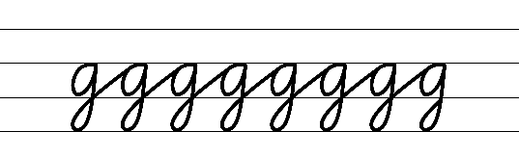  - Example cursive loops from descenders  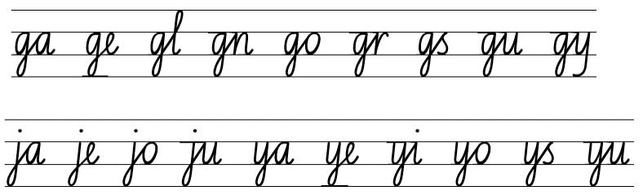  - Suggested practice text from the passage  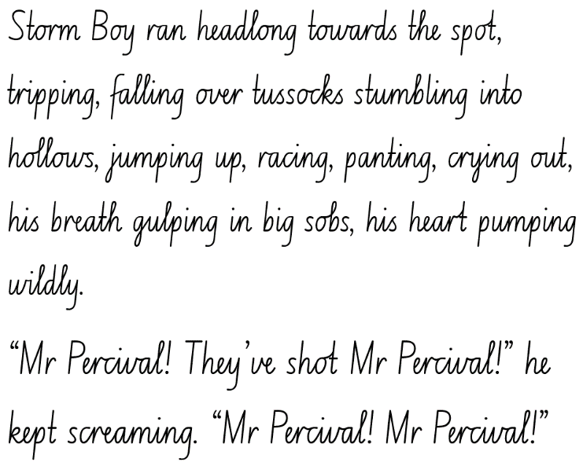

Planning framework
To plan and document Component A teaching and learning, a planning scaffold is provided. To support you in your planning, a link to a detailed example of a one-week teaching and learning cycle is included in the scaffold. Additional resources to support teaching and learning in each focus area can be found at Lesson advice guides.

Component B teaching and learning
The following teaching and learning sequence has been designed to address Component B outcomes and content and develops conceptual understandings of English through the study of quality texts. Adapt the sequence as required to best meet the needs of your students.

Learning intentions and success criteria
Learning intentions and success criteria are best co-constructed with students.

Learning intention
Students are learning to analyse how models of behaviour, key messages and multimodal features contribute to a narrative.

Success criteria
Students can:
- identify models of behaviour presented by characters in a text
- summarise key messages presented by an author
- analyse multimodal features and the authority of an illustrator
- use knowledge of narrative conventions to plan a narrative.

Lesson 13: Identifying models of behaviour and key messages in a text
- Revise that authors embed models of behaviour through characters, which the audience may reject or accept based on their own ideas and experiences.
- Discuss the models of behaviour presented in the text by the main characters. For example, Hide-Away is a father but does not provide core safety for Storm Boy; the town’s folk reject this ‘model of behaviour’ presented by Storm Boy and Hide-Away because they perceive this as unusual.
- In small groups, students explore the models of behaviour presented by Storm Boy, Hide-Away and Fingerbone Bill throughout the text. Students write their ideas on mini whiteboards.
- Allow time for groups to share their ideas with the class. Discuss if the models of behaviour presented by the characters change throughout the text and why/why not. Ask students if they accept or reject the models presented and why.
- Remind students that main characters drive the plot and often represent key messages or morals within a text. Reflect upon the key messages identified by students in Lesson 8. Ask:
- What are possible overall messages or morals in the text? What clues are in the text to support this?
- How do the characters interact with each other to display attributes and qualities the audience can respond to? What does this tell the reader about their relationship?
- What language does the author use to convey the key messages?
- Students write about the key messages or morals identified in the text. Encourage students to explain how the characters have been developed and their models of behaviour strengthen the key messages.
Too hard? Students select and write about one key message or moral from the text.
- Students share their writing in pairs, before moving into small groups to allow for a more detailed analysis and comparison of ideas.
Assessment task 6 – Observations from this lesson allow students to demonstrate achievement towards the following syllabus outcomes and content points:
EN3-UARL-01 – analyses representations of ideas in literature through narrative, character, imagery, symbol and connotation, and adapts these representations when creating texts
- recognise that narratives reflect both personal and common lived experiences and offer models of behaviour, which may be rejected or accepted.

Lesson 14: Analysing key ideas and multimodal features of a text
- Revise that a multimodal text combines 2 or more expressive modes to communicate. Discuss different modes of expression, for example, images, illustrations, audio, video. Explain that Colin Thiele wrote Storm Boy and Robert Ingpen created illustrations to complement the written words making Storm Boy a multimodal text.
- Analyse the multimodal features used in Storm Boy. For example:
- illustrations are used sporadically and highlight key ideas and evoke an emotional response from the reader
- the visual features within illustrations use size (pp 8–9 the humpy is small in comparison to the vast landscape) and colour (pp 42–43 the body of the recently deceased shark is juxtaposed against the barren landscape)
- the use of dull colours throughout depicts a sombre mood and could be used as foreshadowing of a subverted narrative ending
- gestural features of gaze (p 37, Storm Boy looking up at Mr Percival as he returns) and position (p 37, Mr Percival placed high above Storm Boy, appearing like an angel).
- Remind students of the agreed protocols for oral language and communication conventions. In small groups, students brainstorm how the illustrations add meaning to the text. Groups record their ideas and share with the class.
- Students write a paragraph explaining how the multimodal features (illustrations) in Storm Boy add meaning to the text.
- Revise the sixth chapter (pp 53–61) and the ending of Storm Boy.
- Introduce Resource 7: Storm Boy analysis to the students. Explain each section of the analysis and the key features students should aim to analyse in relation to Storm Boy. For example:
- Purpose – discuss the author and illustrator’s purpose for the text, and the intended audience response
- Language features – state the language features used and provide examples from the text
- Key messages – revise key messages or morals
- Multimodal features – use of illustrations to display the concepts of narrative and characterisation and to add deeper meaning.
- Students complete Resource 7: Storm Boy analysis in pairs or small groups before sharing with the class.

Lesson 15: Analysing and assessing the illustrator’s authority
- Revise how multimodal features, including illustrations, add meaning to a text.
- Read The Sydney Morning Herald – Storm Boy illustrator Robert Ingpen on bringing Colin Thiele's classic book to life, and seeing it adapted for the stage. As the article is read, ask students to take notes to identify the key points.
- Revise the meaning of author’s authority from Lesson 2.
- Recall what authority Colin Thiele had to write descriptively about the setting within Storm Boy. Discuss and record student responses.
- Referencing authors’ authority, assess Robert Ingpen’s authority to create the illustrations for the text. Students seek examples and key points from the article to support their arguments.
- View the illustrations in Storm Boy and analyse their meaning in relation to the text within the chapters. Refer to the examples from Lesson 14 to support.
- Discuss how Robert Ingpen’s personal experiences strengthened the authority of the text.
- Students write an ‘I believe’ statement summarising whether they think Robert Ingpen and Colin Thiele’s experiences strengthened the authority of Storm Boy and why.
Too easy? Students explain the impact of the text’s authority on readers.
Assessment task 7 – Observations and work samples from this lesson allow students to demonstrate achievement towards the following syllabus outcomes and content points:
EN3-RECOM-01 – fluently reads and comprehends texts for wide purposes, analysing text structures and language, and by monitoring comprehension
- analyse use of multimodal features to enhance meaning within texts
EN3-CWT-01 – plans, creates and revises written texts for multiple purposes and audiences through selection of text features, sentence-level grammar, punctuation and word-level language
- assess the reliability and authority of sources, including digital sources, when researching and acknowledging texts.

Lesson 16: Planning a narrative
- Explain that students will write a narrative sequel to Storm Boy. Students will plan the orientation, complication, rising action/series of events, climax, falling action and a subverted resolution using narrative conventions and language features explored in this unit.
- View Storm Boy (2019) – Official trailer (1:55) to promote interest, engagement and ideas for writing.
- Compare and contrast the Storm Boy movie trailer to the narrative text. Discuss the setting, depiction of characters, when the movie is set, possible series of events and any differences to the print text.
- Co-construct success criteria for writing. For example:
- include all structural elements and a resolution that follow a subverted pattern
- use characterisation to introduce and develop characters
- use varied sentence structures
- use figurative language, such as simile, metaphor and personification
- use temporal connections, modal words and subjective language to build tension
- use dialogue to drive the plot forward, reveal character traits or build tension
- use adjectival clauses for effect
- use foreshadowing to provide clues for the reader.
- Revisit how Colin Thiele demonstrated structural elements (including tense, taught in Component A), language features and characterisation in Storm Boy. Discuss how the narrative elements help to achieve the purpose of the text and create an emotional response from the audience.
- Display an enlarged copy of Resource 3: Freytag’s pyramid planning template. Explain that students will use the template to plan their sequel to Storm Boy.
- Co-construct ideas for each section of the planning template, including vivid character descriptions. Encourage students to use similar character attributes identified in previous lessons to build upon existing and create new characters.
- Students use a blank copy of Resource 3: Freytag’s pyramid planning template to plan their Storm Boy sequel.
Too hard? Provide students with visual stimulus prompts to support their planning.
- In pairs, students share their narrative plans and provide and apply feedback.

Week 5

Component A teaching and learning
Component A focuses on the development of foundational skills and knowledge through regular, systematic and repeated practice. The mentor and supporting texts used in Component B of this unit will support the effective implementation of Component A teaching and learning.

Teaching guide
Guidance for explicit teaching, teaching notes, resources and examples for the related outcomes and content points have been provided in the table below.
Focus areas and teaching notes | Resources and examples
Reading comprehension  Reading fluently  - Adjust reading rate to suit the purpose for reading and the complexity of the text  - The purpose of reading is reading for enjoyment. This passage provides the resolution to the story, with Storm Boy deciding to go to boarding school after having buried Mr Percival.  - Reading rate may need to be adjusted to accommodate the extended sentences, pausing for the use of commas and semi-colons. Reading rate may also need to be adjusted to suit the dialogue used. | Reading comprehension  Reading fluently  - Fluency and close reading passage – page 61, from ‘All right,’ he said...’ to ‘...birds like Mr Percival do not really die’ (257 words)  Note: the passage from the text will need to be a teacher-created resource.
Reading for interest and wide purposes  - Bring subject vocabulary, technical vocabulary, background knowledge and conceptual knowledge to new reading tasks  - Background knowledge and vocabulary support comprehension, particularly inference. Background knowledge provides a framework for building a mental model.  - Activating background knowledge, introducing necessary content knowledge and the explicit teaching of vocabulary are effective strategies to support comprehension. | Reading for interest and wide purposes  - Background knowledge that may assist in comprehension of the passage  - The distance between Coorong and Adelaide is approximately 190 kilometres or a 2 hour drive each way.  - Vocabulary that may assist in the comprehension of the passage includes scud, scribblings.
Comprehending language  - Use morphology and etymology to work out the meaning of unfamiliar words  - Understanding the units of meaning within words (prefixes, suffixes, base words and roots) assists readers in determining overall word meaning.  - Understanding the etymology of words assists in explaining the origins of, and changes to, words in relation to meaning. | Comprehending language  - Suggested etymology from the passage  - Goolwa: The name ‘Goolwa’ means ‘elbow’ in Ngarrindjeri, the local Aboriginal language. Looking at a map of the area, consider why the area was named ‘Goolwa’.
Monitoring comprehension  - Generate, monitor and adjust own goals for improving oral reading fluency and silent reading fluency  - Support students to monitor their personal fluency goals, generated in Week 2. Goals can be adjusted as required. | Monitoring comprehension  - Students may keep their goals on hand, or you may display them in the classroom for students to refer to when reading fluency passages.  - Strategies for monitoring personal goals may differ, based on the goals selected. Strategies may include timing fluency passage reading or use of a rubric to self-assess prosody.
Vocabulary  Learning and using words  - Extend knowledge of literal and non-literal word meanings through idiom or metaphor.  - A metaphor is a figure of speech used for effect that implies one thing by referring to another (NESA Glossary). | Vocabulary  Learning and using words  - Suggested metaphorical language from the passage  - ‘Everything lives on in their hearts’ – this figure of speech implies that they will remember Coorong and the events that took place there with love and fondness.
Defining and analysing words  - Evaluate the effectiveness of modal words used in texts to intensify or soften emotional responses.  - Modal words indicate probability, occurrence, obligation and inclination. For example:  - Probability: certainly, surely, definitely  - Occurrence: always, never, consistently  - Obligation: ought to, should, may  - Inclination: want, wish, would like to (NESA 2023).  - The effectiveness of modal words used in texts can be achieved through comparison. For example, determining which word is more effective in these sentences: ‘He always spoke cruelly to her’, or ‘He occasionally spoke cruelly to her’ (NESA 2023). | Defining and analysing words  - Suggested modal words from the passage  - ‘I’m ready to go now if you like.’  - ‘Hide-Away knew then that without Mr Percival Storm Boy wouldn’t be able to live there.’
Spelling  Phonological component  - Segment unfamiliar multisyllabic words into syllables and phonemes as a strategy when spelling  - Introduced across Early Stage 1 to Stage 2, revise segmenting multisyllabic words into syllables and phonemes. This is a phonological skill that should be practised regularly. | Spelling  Phonological component  - Consolidate previous 4 weeks of learning.
Orthographic component  - Recognise that the same grapheme can represent different phonemes  - Revise the different phonemes represented by the grapheme [le]. For example, /l/ and /ul/.  - Apply and explain graphemes identified by their etymology.  - Revise the grapheme [ci] representing /sh/.  - Teach that words with the /sh/ phoneme represented as the digraph [ci] are usually Latin in origin. | Orthographic component  - As above
Morphological component  - Explain and use spelling conventions to add derivational suffixes, such as -ion, -ian, -ence, -ous to base words or roots.  - Revise the derivational suffixes -able, -ible, -al.  - Explain the etymology of taught roots and apply this knowledge when creating written texts.  - Revise the Latin roots: spect, spec, spic.  - Apply taught knowledge of etymology when writing texts, including spect, spec and spic. | Morphological component  - As above
Creating written texts  Text features for multiple purposes  - Control tense across a text according to purpose, shifting between past, present and future tense if required  - Tense is the form of the verb that indicates when something is happening in relation to the speaker’s time (past, present or future) (NESA Glossary).  - This passage is notable as it begins in past tense, and then shifts into present tense. This gives the reader the sense that Storm Boy is currently at school and that Hide-Away is waiting for him to return to Coorong. | Creating written texts  Text features for multiple purposes  - See sentences below. Verbs which indicate tense are highlighted in bold.
Sentence-level grammar  - Experiment with embedding adjectival clauses with the subject and/or object of other clauses, to modify the meaning or to add detail to a noun or noun group  - Adjectival clause: A type of dependent clause that operates as an adjective to give more information to a noun or pronoun in a sentence (NESA Glossary).  - Adjectival clauses are commonly used in English to provide additional information and detail about nouns and noun groups. They can be used with both the subject and object of other clauses.  - Adjectival clauses can be found at the beginning or end of sentences. They can also be embedded. By embedding adjectival clauses within other clauses, writers can create more complex and sophisticated sentence structures and provide a richer and more detailed description of the subject of the sentence. For example, the man, who was wearing a red shirt and black pants, walked into the store. | Sentence-level grammar  - Example sentences featuring adjectival clauses innovated from the passage  - Storm Boy, who was filled with sadness, wouldn’t be able to live at Coorong for a while.  - And everything, the wind talk and the wave talk and the scribblings on the sand, lives on in their hearts.
Punctuation  - Use a comma to separate a subordinate clause or a phrase from the main clause, or to separate information within a sentence or to separate items in a list  - A comma is a punctuation marker used to show separation between parts of a sentence, such as clauses or phrases, where separation is important to the meaning. Commas are also used to separate words, phrases or numbers in a series (NESA 2023).  - A dependent clause (also known as subordinate clause) is a group of words that cannot stand alone as a sentence (NESA 2023).  - A subordinating clause can be placed at the beginning of the sentence.  - A comma can be used to separate information using appositives, or an adjectival clause/phrase.  - Use quotation marks consistently across a text to distinguish words that are spoken by characters in dialogue or words authored by others  - Quotation marks are used at the beginning and end of what is spoken by characters in dialogue or words authored by others.  - For dialogue with more than one character speaking, a change of line for each new speaker is used. | Punctuation  - Examples of comma usage from the passage, separating 2 clauses in compound sentences  - ‘By day, Fingerbone comes to talk to him, but at night he stands alone beside the Lookout Post...’  - Examples of comma usage from the passage, separating information within a sentence  - ‘And always, above them, in their mind’s eye, they can see the shape of two big wings in the storm clouds...’  - Examples of dialogue from the passage  - ‘All right,’ he said, ‘I’m ready to go now if you like.’  ‘Go? Where to?’  ‘To school! Like the sailors said.’  ‘Oh! Oh, yes…Very well, then.’
Handwriting and digital transcription  Handwriting legibility and fluency  - Sustain writing with a legible, fluent and personal handwriting style across a text  - Revise cursive loops for the letter f.  - Loops can be included as part of the ascender and the descender.  - Descender loops for the letter f can support fluency and developing a personal handwriting style. | Handwriting and digital transcription  Handwriting legibility and fluency  - Suggested fluency pattern  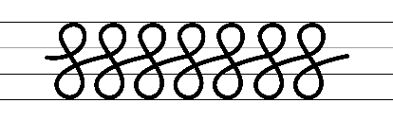  - Example of ascender and descender cursive loops for the letter f:  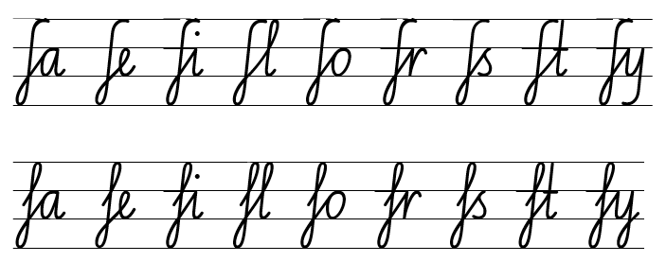  - Suggested practice text from the passage:  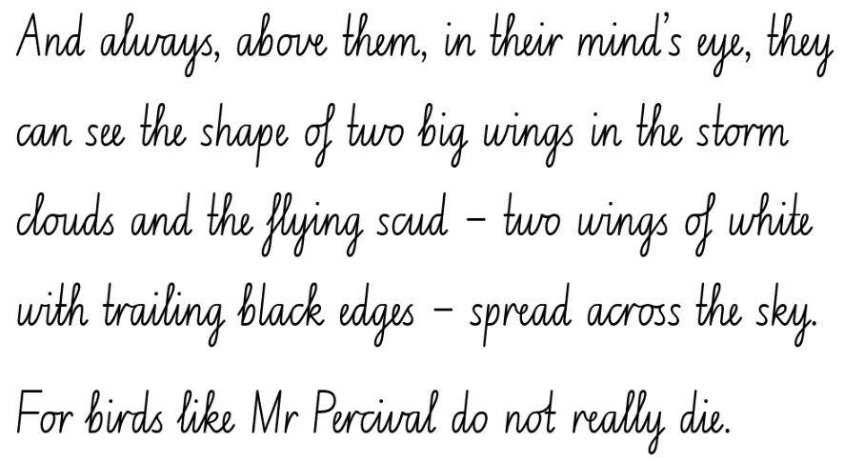
Software functionalities and typing  - Understand that the position of the device in relation to the user can affect posture and glare  - Consider light and glare when using technology to type.  - Maintain correct posture when using technology to type. | Software functionalities and typing  - It is recommended to select technology appropriate for your school context.

Planning framework
To plan and document Component A teaching and learning, a planning scaffold is provided. To support you in your planning, a link to a detailed example of a one-week teaching and learning cycle is included in the scaffold. Additional resources to support teaching and learning in each focus area can be found at Lesson advice guides.

Component B teaching and learning
The following teaching and learning sequence has been designed to address Component B outcomes and content and develops conceptual understandings of English through the study of quality texts. Adapt the sequence as required to best meet the needs of your students.

Learning intentions and success criteria
Learning intentions and success criteria are best co-constructed with students.

Learning intention
Students are learning to use their knowledge of narrative and characterisation to create a sequel text.

Success criteria
Students can:
- use a plan to draft a sequel text
- write an engaging narrative with multiple paragraphs
- use language features and dialogue to enhance a text
- revise and edit writing against agreed criteria.

Lesson 17: Drafting an orientation
- Explain that students will be using their narrative planning from Lesson 16 to write a sequel to Storm Boy.
- Revise the structural elements of an orientation from Lesson 5. For example:
- introducing main and supporting characters (characterisation)
- describing the setting
- indicating time
- foreshadowing a potential problem
- using engaging details to draw the reader in.
- Explicitly teach the importance of maintaining narrative voice across a text. Discuss and list pronouns for each voice type. For example:
- First voice: I, me, we, us
- Second voice: you
- Third voice: she, her, he, him, his, they, them, it.
Note: narrative voices are first voice – I travelled on the train; second voice – you travelled on the train; third voice – Pierre travelled on the train.
- Revise tense and how to maintain it across a text, as taught in Component A.
- Use a student’s plan from Lesson 16 to model writing an orientation and display for future reference. Include the following details:
- Characters: Storm Boy, Hide-Away Tom, Fingerbone Bill and any new characters
- Indication of time: written in present or past tense
- Foreshadowing a potential problem: destruction of the sanctuary, pollution, climate change, housing development
- Engaging details: similes, metaphors, personification, adjectival clauses
- Sentence level: maintaining voice.
- Revise the co-constructed success criteria from Lesson 16.
- Students refer to their completed plan and modelled example from activity 5 to write an orientation for their narrative sequel.
- Students edit their orientation referring to the co-constructed success criteria from Lesson 16.

Lesson 18: Drafting a series of events and complication
- Explain that students will use their plan from Lesson 16 to draft a complication, series of events and climax, for their sequel to Storm Boy.
- Review the complications from Storm Boy. Explore the ways Colin Thiele engaged the audience through minor and major complications using a series of events, tension and suspense, and various attempts to solve a problem.
- Using the orientation written in Lesson 17, model how to continue the story. Write a complication and series of small events that lead to a climax.
Note: this can be done as an interactive writing session. Guide students to apply their knowledge from Component A content with adjectival clauses, rich vocabulary and figurative language.
- Identify and discuss how the series of events helps to build tension. Explore ways to add elements of foreshadowing to provide clues for the reader.
- Students use their completed plan to continue their Storm Boy sequel, writing a series of events that build tension leading to a climax.
- Students revise and edit their writing using the co-constructed success criteria from Lesson 16.

Lesson 19: Drafting a subverted resolution and editing writing
- Explain that students will use their plan from Lesson 16 to draft the falling action and subverted resolution to their Storm Boy sequel.
- Revise the purpose of a resolution and the use of a subverted ending in Storm Boy.
- Discuss how the ending to the text is different from a conventional narrative pattern and generate ideas for a subverted resolution.
- Using the modelled writing from Lesson 17 and Lesson 18, demonstrate how to write a resolution to conclude the story.
Note: this can be done as an interactive writing session. Guide students to write using a variety of sentences and punctuation, including quotation marks for dialogue.
- Revise the co-constructed success criteria from Lesson 16.
- Students use their completed plan to write the falling action and a subverted resolution for their sequel.
- Students edit their ending referring to the co-constructed success criteria from Lesson 16.
- Display guiding questions for students to refer to when revising and editing. For example:
- Are you meeting your purpose? (revising)
- Is there a better way to structure your writing? (revising)
- Where do you need to add more detail? (revising)
- Is your spelling accurate? (editing)
- Does your writing contain a variety of correct punctuation and sentences? (editing)
- Will the reader be able to understand what you have written? (editing)
- In pairs, students begin to provide peer feedback using the ‘TAG strategy’ on the narrative draft, referring to the guiding questions and the co-constructed success criteria.

Lesson 20: Editing and publishing a narrative
- Provide time for student pairs to continue revising and editing their draft writing. Encourage students to refer to the guiding questions from Lesson 19 and the co-constructed success criteria from Lesson 16.
- Explain that students will publish their sequel narrative. Discuss the purpose of publishing a text.
- Students complete a final edit of their writing and apply any additional feedback as required.
- Provide time for students to publish their narrative sequel to Storm Boy, adding illustrations to create a multimodal text. Note: select technology that is suitable to your school context. Additional success criteria can be co-constructed to guide students in their development of illustrations.
Assessment task 8 – Collecting work samples from this lesson allows students to demonstrate achievement towards the following syllabus outcomes and content points:
EN3-CWT-01 – plans, creates and revises written texts for multiple purposes and audiences through selection of text features, sentence-level grammar, punctuation and word-level language
- make creative choices about temporal and spatial settings, character profiles and motives to enhance reader engagement
- choose and control narrative voice across a text
- control tense across a text according to purpose, shifting between past, present and future tense if required
- create written texts that include multiple paragraphs with clear, coherent transition of ideas
- experiment with embedding adjectival clauses with the subject and/or object of other clauses, to modify the meaning or to add detail to a noun or noun group
- use a comma to separate a subordinate clause or a phrase from the main clause, or to separate information within a sentence, or to separate items in a list
- use quotation marks consistently across a text to distinguish words that are spoken by characters in dialogue or words authored by others
EN3-UARL-01 – analyses representations of ideas in literature through narrative, character, imagery, symbol and connotation, and adapts these representations when creating texts
- analyse attributes of character and use similar attributes when creating texts.

Resource 1: Fluency and close reading passage analysis
Focus | Notes
Passage | Storm Boy: Page 7, from ‘Storm Boy lived...’ to ‘...like snakes of salt’ (135 words).
Synopsis | This passage is the opening to the book. The passage briefly introduces the character, Storm Boy before describing the setting in which he lives. Colin Thiele uses rich descriptive language to describe the coast region of Coorong in South Australia, setting the expectation for the reader that the area is isolated and often subject to extreme weather. It is part of the orientation to the narrative.
Passage structure | This passage is structured into:  - Brief introduction to character  - Introduction to the setting  - Description of the location  - Physical description  - Names the place  - Environmental details.
Language features | Descriptive language  The author uses descriptive and classifying adjectives to express the isolation of Coorong and the extreme weather experienced there. Noun groups include:  - Descriptive adjectives: ‘long, long snout of sandhill’, ‘windswept and tussocky’, ‘flat, shallow water’, ‘cold, wet underbelly of the world’, ‘terrible ruin of white water and spray’.  - Classifying adjectives: ‘Murray mouth’, ‘South Australian Coorong’.  Action verbs used show the intense natural environment in which Storm Boy lives. Verb groups include ‘sweeping in’, ‘pitch down’, ‘tumble and thunder’, ‘whips’, ‘darts and writhes’.  Figurative language  The description of the setting is further brought to life using figurative language:  - ‘long, long snout of sandhill’ – the use of a metaphor implies that the land is long and skinny, similar to the snout of an animal.  - ‘cold, wet underbelly of the world’ – the use of the metaphor ‘underbelly’ indicates that this place is rarely seen, similar to the underbelly of an animal.  - ‘darts and writhes in the air like snakes of salt’ – this simile shows the movement of the sand in the air due to the strong wind.

Resource 2: Freytag’s pyramid
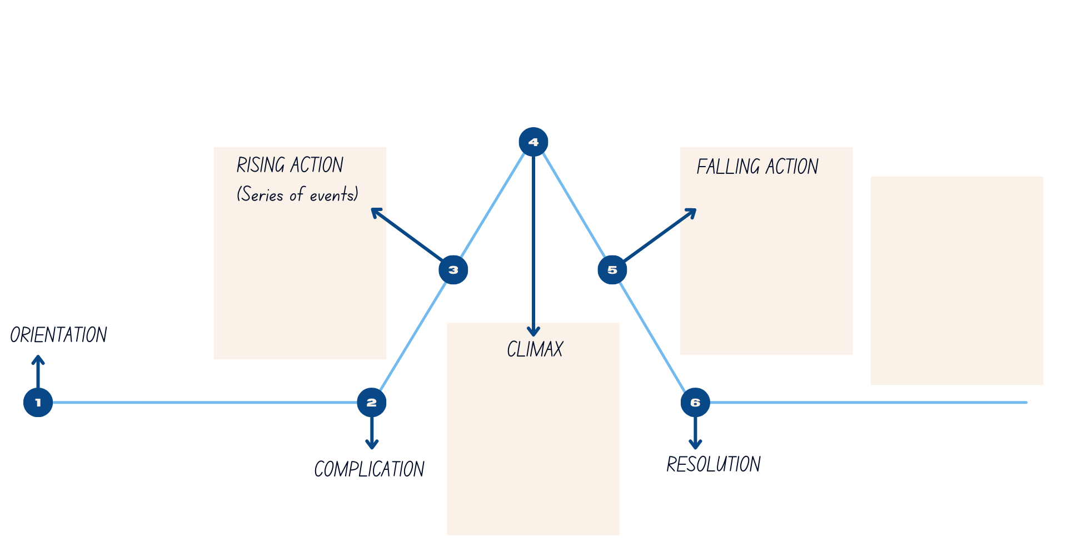

Resource 3: Freytag’s pyramid planning template
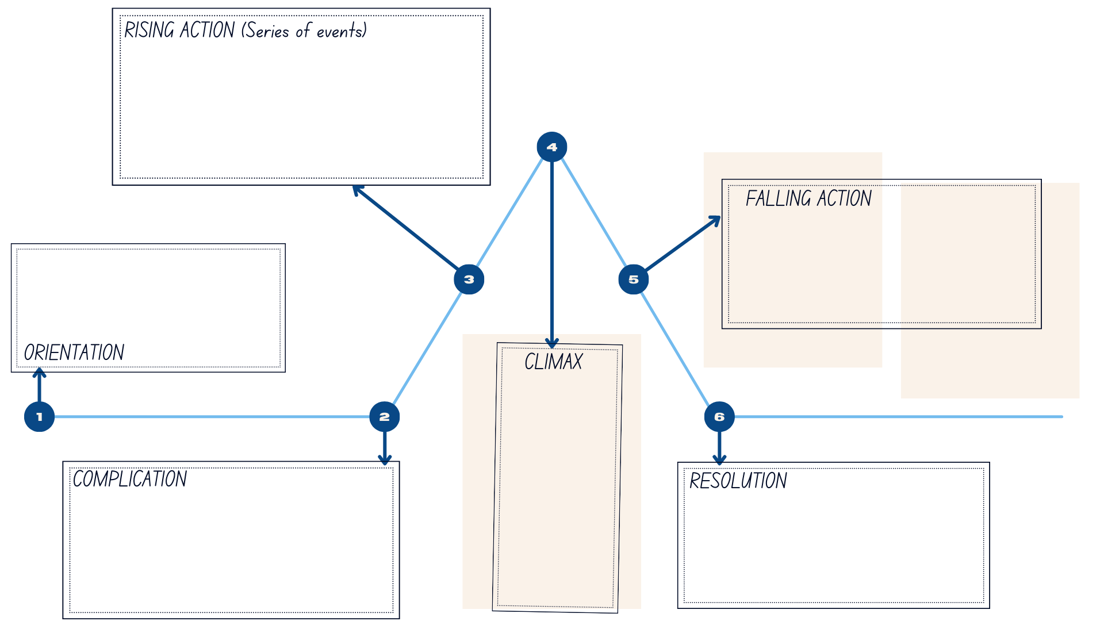

Resource 4: Frayer diagram example
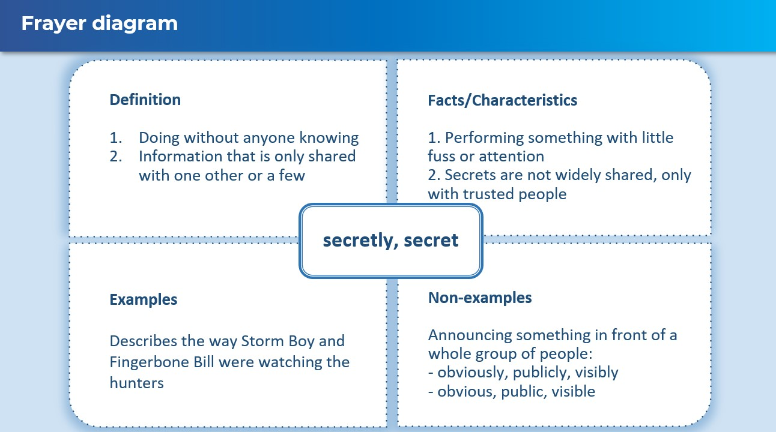

Resource 5: Dialogue checklist
Dialogue Checklist | Dialogue Checklist
- Speech marks go around exactly what is spoken.  - A capital letter is used at the start of what is spoken.  - There is a piece of punctuation before the close of quotation marks.  - ‘Saying verbs’ are used to describe how the speech is spoken.  - A new line is used when each new character speaks. | - Speech marks go around exactly what is spoken.  - A capital letter is used at the start of what is spoken.  - There is a piece of punctuation before the close of quotation marks.  - ‘Saying verbs’ are used to describe how the speech is spoken.  - A new line is used when each new character speaks.

Resource 6: Fluency and close reading passage analysis
Focus | Notes
Passage | Storm Boy: page 54 from ‘The men shouted with rage...’ to page 55 ‘...and driven off’ (253 words).
Synopsis | This passage describes a key event in the narrative Storm Boy. It details the shooting of Mr Percival by some shooters, and the reaction of Mr Percival, Storm Boy, Hideaway and the shooters. The shooters have been growing increasingly frustrated with Mr Percival as he warned the other birds of the shooters’ presence.  This moment was foreshadowed in the opening sentence of the chapter, ‘For the rest of the year, everyone was happy’. This sentence gives the reader a clue that something might be about to go wrong.
Passage structure | The text structure can be described as follows:  - The shooters are angry and one shooter takes aim at Mr Percival  - Mr Percival is shot  - Characters in the text react to the shooting  - Storm Boy runs to save Mr Percival  - Mr Percival is injured and in pain  - Hide-Away tries to find the shooters  - The shooters have departed.
Language features | Pacing  The choice of vivid action verbs highlights Storm Boy’s desperation in getting to Mr Percival and then trying to save him by taking him home to Hide-Away. Verbs such as ‘tripping’, ‘falling’, ‘stumbling’ and ‘racing’ show the desperation in his actions, and the extended sentence which describes these movements highlights the speed with which he moved. The action verbs ‘sprang’, ‘startled’, ‘threw’ and ‘ran’ also show the fast speed at which Hide-Away moved to find the shooters.  Dialogue  The author uses dialogue to allow the characters to express their thoughts, emotions and reactions directly. The dialogue ‘It’s Mr Perc-’ shows that Storm Boy was cut off mid-sentence as Mr Percival was shot. The repetition of Storm Boy saying ‘Mr Percival! They’ve shot Mr Percival!’ shows his disbelief and distress in the situation.  Figurative language  The author uses figurative language to sharpen descriptions.  - ‘Mr Percival seemed to shudder in flight as if he’d flown into a wall of glass’: the use of the phrase ‘wall of glass’ implies that Mr Percival had stopped mid-air after being shot and that he was unable to see what had stopped him.  - ‘His voice was drowned by the roar of the gun’: the use of the word ‘drowned’ illustrates that Storm Boy’s words were covered by the sound of the gun, not physically submerged in water. The word ‘roar’ is used to show that the volume and sound of the gun was as loud as a lion’s roar.

Resource 7: Storm Boy analysis
Purpose  Does it inform, persuade or entertain? What is the author and illustrator’s purpose? | Language features  What are the language features used? Provide examples.
Key messages  What are the key messages or morals presented by the author? | Multimodal features  How are the illustrations used to enhance the plot and deepen the audience’s understanding?

References
This resource contains NSW Curriculum and syllabus content. The NSW Curriculum is developed by the NSW Education Standards Authority. This content is prepared by NESA for and on behalf of the Crown in right of the State of New South Wales. The material is protected by Crown copyright.
Please refer to the NESA Copyright Disclaimer for more information. https://educationstandards.nsw.edu.au/wps/portal/nesa/mini-footer/copyright
NESA holds the only official and up-to-date versions of the NSW Curriculum and syllabus documents. Please visit the NSW Education Standards Authority (NESA) website https://educationstandards.nsw.edu.au/ and the NSW Curriculum website https://curriculum.nsw.edu.au/home.
English K–10 Syllabus © NSW Education Standards Authority (NESA) for and on behalf of the Crown in right of the State of New South Wales, 2022.
National Literacy Learning Progression © Australian Curriculum, Assessment and Reporting Authority (ACARA) 2010 to present, unless otherwise indicated. This material was downloaded from the Australian Curriculum website (National Literacy Learning Progression) (accessed 11 September 2023) and was not modified.
Good Deed Entertainment (28 February 2019) ‘Storm Boy (2019) – Official trailer’ [video], Storm Boy, YouTube, accessed 11 May 2023.
Government of South Australia (2023) ‘Traditional Owners’, Department of Environment and Water, Government of South Australia, accessed 14 June 2023.
Harford S (2015) Storm Boy illustrator Robert Ingpen on bringing Colin Thiele's classic book to life, and seeing it adapted for the stage, The Sydney Morning Herald, accessed 7 June 2023.
Hoyt L (2008) Revisit, Reflect, Retell: Time-Tested Strategies for Teaching Reading Comprehension, Heinemann US, Florida.
Return of a Native – Landscapes of Literature, Art and Song (2023), Colin Thiele’s Storm Boy – Coorong National Park South Australia, Return of a Native, accessed 6 June 2023.
Thiele C (1974) Storm Boy (R Ingpen illus) New Holland Publishers, Wahroonga.
© State of New South Wales (Department of Education), 2023
The copyright material published in this resource is subject to the Copyright Act 1968 (Cth) and is owned by the NSW Department of Education or, where indicated, by a party other than the NSW Department of Education (third-party material).
Copyright material available in this resource and owned by the NSW Department of Education is licensed under a Creative Commons Attribution 4.0 International (CC BY 4.0) license.
This license allows you to share and adapt the material for any purpose, even commercially.
Attribution should be given to © State of New South Wales (Department of Education), 2023.
Material in this resource not available under a Creative Commons license:
- the NSW Department of Education logo, other logos and trademark-protected material
- material owned by a third party that has been reproduced with permission. You will need to obtain permission from the third party to reuse its material.
Links to third-party material and websites
Please note that the provided (reading/viewing material/list/links/texts) are a suggestion only and implies no endorsement, by the New South Wales Department of Education, of any author, publisher, or book title. School principals and teachers are best placed to assess the suitability of resources that would complement the curriculum and reflect the needs and interests of their students.
If you use the links provided in this document to access a third-party's website, you acknowledge that the terms of use, including licence terms set out on the third-party's website apply to the use which may be made of the materials on that third-party website or where permitted by the Copyright Act 1968 (Cth). The department accepts no responsibility for content on third-party websites.

