English Stage 3 – Unit 2
Contents
Unit overview and instructions for use 4
Teacher notes 7
Outcomes and content 9
Resources 14
Week 1 17
Component A teaching and learning 17
Component B teaching and learning 27
Lesson 1: Understanding genre 28
Lesson 2: Examining a text that has multiple purposes and genres 30
Lesson 3: The author’s message (perspective and persuasion) 33
Lesson 4: Navigating texts to locate information and identifying new words 36
Week 2 38
Component A teaching and learning 38
Component B teaching and learning 49
Lesson 5: Planning a multimodal text with more than one genre 50
Lesson 6: Drafting a multimodal text with elements that entertain 54
Lesson 7: Adding multimodal features and publishing a text with elements that entertain 56
Lesson 8: Drafting a multimodal text with elements that inform 57
Week 3 61
Component A teaching and learning 61
Component B teaching and learning 69
Lesson 9: Adding multimodal features and publishing a text that informs 70
Lesson 10: Drafting a multimodal text with elements that persuade 71
Lesson 11: Revising and publishing a multimodal text that persuades 74
Lesson 12: Publishing or broadcasting a multimodal text and reflecting on genre 75
Week 4 78
Component A teaching and learning 78
Component B teaching and learning 87
Lesson 13: Comparing the genre and purpose of texts 88
Lesson 14: Cultural protocols and the author’s message 91
Lesson 15: Exploring figurative language 93
Lesson 16: Drafting an informative text using figurative language 95
Week 5 98
Component A teaching and learning 98
Component B teaching and learning 105
Lesson 17: Organising information into paragraphs 106
Lesson 18: Adding multimodal features to a text (illustrations) 108
Lesson 19: Adding multimodal features to a text (maps) 109
Lesson 20: Publishing a multimodal text 110
Resource 1: Fluency and close reading passage 1 113
Resource 2: Fluency and close reading passage 4 115
Resource 3: Text analysis 117
Resource 4: Information report 118
Resource 5: Genre analysis 119
Resource 6: Research template 120
Resource 7: Planning scaffold 1 122
Resource 8: Writing cycle 125
Resource 9: Dedication and message 126
Resource 10: Five senses 127
Resource 11: Planning scaffold 2 128
References 129

Unit overview and instructions for use
In this 5-week unit, students will learn about the textual concept of genre. They will examine and experiment with texts that cross genres. For example, informative texts that entertain, persuade and inform. Students will have the opportunity to create their own texts for different purposes that do not follow the form and function of a single genre. They will use the mentor text, Bright New World, and the supporting text, Dry to Dry, as a stimulus for writing informative and entertaining texts. Students will enhance their written texts by selecting appropriate multimodal features, including illustrations, maps, graphs and audio.
Outcomes and content in this unit are organised into Component A and Component B. The components are connected, with learning in Component A complementing learning in Component B.
Note: the duration of this unit can be adapted to suit individual school contexts. For example, learning could occur across 5 days rather than 4.
The table below highlights the focus areas and preparation required for Component A and Component B.
Teaching and learning | Component A | Component B
Suggested duration | 60 minutes × 4 days/week or equivalent | 60 minutes × 4 days/week or equivalent
Explicit teaching focus areas | Component A addresses content from the focus areas:  - Vocabulary  - Reading comprehension  - Creating written texts  - Spelling  - Handwriting and digital transcription  It centres on the development of foundational skills and knowledge through regular, systematic and repeated practice. | Component B addresses content from the focus areas:  - Oral language and communication  - Vocabulary  - Reading comprehension  - Creating written texts  - Understanding and responding to literature  It centres on the conceptual understandings of English and exemplifies the importance of learning about and enjoying literature through the study of quality texts.
Preparing for teaching and learning | - Specific teaching and learning activities need to be developed by the teacher. When planning for these activities, please refer to the Component A outcomes and content, teaching guides and planning frameworks.  - Plan and document how you will sequence teaching and learning in whole-class and targeted-groups across the 5-week cycle as required. This should be based on student needs identified through ongoing assessment data. | - Familiarise yourself with the mentor and supporting texts and textual concepts, and the teaching and learning sequence.  - Determine how you will support students in whole-class and targeted-groups across the 5-week cycle as required. This should be based on student needs identified through ongoing assessment data.
English K–10 Syllabus © NSW Education Standards Authority (NESA) for and on behalf of the Crown in right of the State of New South Wales, 2022.

Teacher notes
Aboriginal and Torres Strait Islander peoples should be aware that this resource may contain images, voices or names of deceased persons in photographs, film, audio recordings or printed material.
At the NSW Department of Education, we recognise the traditional custodians of the lands and waterways where we work and live. We celebrate Aboriginal and Torres Strait Islander peoples’ unique cultural and spiritual relationship to Country and acknowledge the significance of their cultures in Australia. We pay respect to Ancestors and Elders past, present and future.
The department recognises that by acknowledging our past, we are laying the groundwork for a future that embraces all Australians; a future based on mutual respect and shared responsibility.
- Genre is the categories into which texts are grouped based on similarities in premise, structure and function. The ‘genre’ of a text describes larger recurring patterns of subject matter and textual structures observable between texts, such as typical plots, characters and setting. ‘Genre’ can also describe categories of form and structure in texts (NESA Glossary).
- Understanding of genre can be supported through watching the department’s video: Understanding genre (3:00).
- While ‘genre’ is the mentor concept for the conceptual component of this unit, the supporting concept of ‘perspective and context’ can be also be explored. Additional textual concepts may be included based on individual school context and student needs.
- For information on appositives, declarative, exclamatory, interrogative and imperative sentences refer to the NESA Glossary.
- In addition to the resources listed, students will require access to short passages of the mentor and/or supporting texts. Teachers can copy extracts from texts in reliance on the Statutory Text and Artistic Works Licence. Teachers need to attribute the extracts and include the following notice: ‘This material has been copied [and communicated to you] in accordance with the statutory licence in section 113P of the Copyright Act. Any further reproduction or communication of this material by you may be the subject of copyright protection under the Act. Do not remove this notice’.
- This unit could enhance student learning towards the achievement of science and technology and mathematics outcomes.
- Consider prior student knowledge and insert information on required prior learning.
- Teachers will need to pre-prepare a range of print and digital texts with information about some natural local places that are under environmental threat. This will be required from Lesson 4.
- For information, definitions and terminology related to Aboriginal education, refer to the NSW Aboriginal Education Consultative Group (AECG), Aboriginal Outcomes and Partnerships and Diversity of learners resources, and to the Australian Government’s Style Manual.
- Reflect on student learning and engagement in activities and record differentiation and adjustments within the unit to inform future teaching and learning. One way of doing this could be to add comments to the digital file.
- In NSW classrooms there is a diverse range of students including Aboriginal and Torres Strait Islander students, students learning English as an additional language or dialect, high potential and gifted students and students with disability. Some students may identify with more than one of these groups, or possibly all of them. Refer to Curriculum planning for every student – advice for further information.
- Content points are linked to the National Literacy Learning Progression version (3).
Levels and indicators sourced from National Literacy Learning Progression © Australian Curriculum, Assessment and Reporting Authority (ACARA), (accessed 20 August 2023) and was not modified. See references for more information.

Outcomes and content
The table below outlines the outcomes and content for this unit. The letters ‘A’ and ‘B’ in the header refer to Components A and B. The numbers 1 to 5 refer to weeks. The use of ‘x’ in these columns indicates where the content points are intended to be addressed and in which week.
Focus area and outcome, content points and National Literacy Learning Progression | A | B | 1 | 2 | 3 | 4 | 5
Oral language and communication
EN3-OLC-01 communicates to wide audiences with social and cultural awareness, by interacting and presenting, and by analysing and evaluating for understanding
- Respond to questions with elaboration and detail (InT5) |  | x | x | x | x | x | x
- Analyse how audio elements in texts integrate with linguistic, visual, gestural and spatial elements to create meaning and impact (SpK6) |  | x | x | x | x | x
- Describe ways of interacting with cultural protocols or practices used by Aboriginal and/or Torres Strait Islander Peoples |  | x |  |  |  | x
Vocabulary
EN3-VOCAB-01 extends Tier 2 and Tier 3 vocabulary through interacting, wide reading and writing, morphological analysis and generating precise definitions for specific contexts
- Identify newly encountered words from interactions and wide reading, and use them in writing, discussions and presentations | x |  | x | x | x | x | x
- Identify and use words derived from other languages, including Aboriginal and Torres Strait Islander Languages, and know that the pronunciation and spelling of words may reflect their etymology (UnT9) | x | x |  |  |  | x | x
- Analyse morphemic structures of Tier 2 and Tier 3 words to determine their meaning (SpG10, SpG11) | x |  | x | x | x
Reading comprehension
EN3-RECOM-01 fluently reads and comprehends texts for wide purposes, analysing text structures and language, and by monitoring comprehension
- Efficiently follow signposting features to navigate print and digital texts | x |  | x | x | x | x | x
- Use knowledge of text structure to navigate the text to locate specific information (UnT8) | x | x | x | x | x | x | x
- Compare purposes for different texts and consider why authors and illustrators have structured texts in particular ways (UnT8) |  | x | x | x | x | x | x
- Categorise information or ideas and create hierarchies to aid recall and support summarisation |  | x | x | x
- Adjust reading approach to suit the purpose for reading (UnT8) | x |  | x | x | x | x | x
Creating written texts
EN3-CWT-01 plans, creates and revises written texts for multiple purposes and audiences through selection of text features, sentence-level grammar, punctuation and word-level language
- Choose and control narrative voice across a text |  | x |  | x | x
- Develop informative texts that include headings, ideas grouped into paragraphs that include a topic sentence, and a paragraph with concluding information (CrT9) |  | x |  | x |  | x | x
- Choose multimodal features suited to a target audience and purpose, to reinforce and extend ideas |  | x |  | x | x |  | x
- Include appositives to provide details to nouns and to vary sentence structures suited to text purpose (CrT8) | x | x |  | x |  | x | x
- Make choices about the use of declarative, exclamatory, interrogative and imperative sentences to suit text purpose, and for meaning and effect (GrA6) | x | x | x | x | x | x | x
- Use capital letters at the beginning of a sentence, to indicate proper nouns, for headings and subheadings, to indicate the beginning of a poetry line, for emphasis, and when using acronyms (PuN7) | x |  | x | x
- Use a comma to separate a subordinate clause or a phrase from the main clause, or to separate information within a sentence, or to separate items in a list (CrT8, PuN6) | x |  |  | x | x
- Re-read, proofread and edit own and other’s writing, and use criteria and goals in response to feedback |  | x | x | x | x | x | x
Spelling
EN3-SPELL-01 automatically applies taught phonological, orthographic and morphological generalisations and strategies when spelling in a range of contexts, and justifies spelling strategies used to spell unfamiliar words
- Segment unfamiliar multisyllabic words into syllables and phonemes as a strategy when spelling | x |  | x | x | x | x | x
- Recognise that the same grapheme can represent different phonemes (SpG10) | x |  | x | x | x | x | x
- Proofread written texts to correct misspellings, making use of spelling reference tools where required | x |  | x | x | x | x | x
- Explain and use spelling conventions to add derivational suffixes such as -ion, -ian, -ence, -ous to base words or roots (SpG10) | x |  | x | x | x | x | x
Handwriting and digital transcription
EN3-HANDW-01 sustains a legible, fluent and automatic handwriting style
EN3-HANDW-02 selects digital technologies to suit audience and purpose to create texts
- Sustain writing with a legible, fluent and personal handwriting style across a text (HwK8) | x |  |  | x |  | x
- Navigate the keyboard with efficiency and accuracy when typing words, numerals, punctuation and other symbols (HwK8) | x |  |  |  | x |  | x
- Understand that the position of the device in relation to the user can affect posture and glare | x |  | x |  | x
Understanding and responding to literature
EN3-UARL-01 analyses representations of ideas in literature through narrative, character, imagery, symbol and connotation, and adapts these representations when creating texts
EN3-UARL-02 analyses representations of ideas in literature through genre and theme that reflect perspective and context, argument and authority, and adapts these representations when creating texts
- Examine and experiment with elements in literature that do not follow the form and function of a single genre |  | x | x | x | x | x | x
- Identify how perspective is made evident through authorial choices (UnT8) |  | x | x | x | x | x | x
English K–10 Syllabus © NSW Education Standards Authority (NESA) for and on behalf of the Crown in right of the State of New South Wales, 2022.

Resources
The resources in the table below are referred to in this unit. Letters ‘A’ and ‘B’ in the header refer to Component A and B respectively, and the numbers 1 to 5 indicate weeks. The use of ‘x’ in these columns indicate whether the resources are required in Component A, B or both, and in which week.
Resource | A | B | 1 | 2 | 3 | 4 | 5
Forde C (2022) Bright New World (Lord B, illus) Welbeck Editions, Great Britain. ISBN13: 9781913519841 | x | x | x | x | x
Freeman P (2020) Dry to Dry: The Seasons of Kakadu (Anelli L, illus) Walker Books, Australia. ISBN13: 9781760650285 | x | x | x |  |  | x | x
Brown P (2016) The Wild Robot Hachette Book Group, United States of America. ISBN13: 9781848127272 |  | x | x
Resource 1: Fluency and close reading passage 1 | x |  | x
Resource 2: Fluency and close reading passage 4 | x |  |  |  |  | x
Resource 3: Text analysis |  | x | x
Resource 4: Information report | x | x | x
Resource 5: Genre analysis |  | x | x
Resource 6: Research template |  | x | x
Resource 7: Planning scaffold 1 |  | x |  | x
Resource 8: Writing cycle |  | x |  | x | x | x | x
Resource 9: Dedication and message |  | x |  |  |  | x
Resource 10: Five senses |  | x |  |  |  | x
Resource 11: Planning scaffold 2
A large selection of print and digital texts |  | x | x
Print and digital texts with information about natural local places that are under environmental threat |  | x | x
Art paper, paint and other art materials, such as textured paper and laundry detergent |  | x |  | x |  |  | x
Venn diagram |  | x |  |  | x
Photos and illustrations of local places that are under environmental threat |  | x |  |  |  |  | x

Week 1

Component A teaching and learning
Component A focuses on the development of foundational skills and knowledge through regular, systematic and repeated practice. The mentor and supporting texts used in Component B of this unit can support the effective implementation of Component A teaching and learning.

Teaching guide
Guidance for explicit teaching, teaching notes, resources and examples for the related outcomes and content points have been provided in the table below.
Focus areas and teaching notes | Resources and examples
Reading comprehension  Reading fluently  - Efficiently follow signposting features to navigate the text to locate specific information  - Signposting features refer to elements within a text that guide the reader through structure and content of a text. These features serve as ‘signposts’ that indicate the direction the text is taking and help the reader follow along.  - Signposting features could include headings and sub-headings, homepages and subpages, hyperlinks and hypertext. | Reading comprehension  Reading fluently  - Resource 1: Fluency and close reading passage 1 – Bright New World: Introduction: (pp 6–7) from ‘Beautiful isn’t it...’ to ‘...in the years to come’ (254 words).  Note: the passage from the text will need to be a teacher-created resource.  - Using signposting features in the passage  - navigate the text using the heading ‘Introduction’ and sub-heading ‘A World that Works for Everyone’  - read the text boxes going vertically down the page  - note the label and arrow pointing to Earth on the illustration of the solar system  - use hyperlinks on websites to research information about a local place (Lesson 4).
Reading for interest and wide purposes  - Adjust reading approach to suit the purpose for reading  - Adjusting the reading approach to suit the purpose for reading is crucial as different reading purposes require different strategies and skills.  - Close reading may be used for the analysis of texts, skimming could be used to locate key information, scanning might be used to identify key vocabulary, and note-taking could be undertaken for summarisation (NESA 2023). | Reading for interest and wide purposes  - Purpose for reading: reading to analyse, skim and scan text for key information and vocabulary.  - Suggested examples from the passage  - Humans face serious problems like climate change, species extinction, global pandemics, diminishing rainforests... (p 6)  Note: bold text highlights key information and vocabulary.
Comprehending text structures and features  - Use knowledge of text structure to navigate the text to locate specific information  - Text structure provides a ‘roadmap’ for readers, helping them make predictions, understand relationships between ideas and locate specific information.  - When reading a text, readers could predict patterns (structure) and vocabulary that might be encountered (for example, Tier 3 words associated with a particular subject). | Comprehending text structures and features  - Text structure in the passage:  - Before reading, ask students to predict:  - what the passage might be about by reading the heading (Introduction) and sub-heading (A World that Works for Everyone)  - how the illustration (of the solar system) might support the information being presented  - what vocabulary they think they might encounter and why.
Vocabulary  Learning and using words  - Identify newly encountered words from interactions and wide reading, and use them in writing, discussions and presentations  - Assist students to identify newly encountered or unfamiliar words in texts and from interactions with peers. | Vocabulary  Learning and using words  - Suggested vocabulary from the passage  - solar system, universe, extinction, diminishing, poverty, inequality (p 6), United Nations, sustainable (p 7).
Defining and analysing words  - Analyse morphemic structures of Tier 2 and Tier 3 words to determine their meaning  - Morphemes are the smallest unit of meaning in a word. They can be categorised as: free morphemes and bound morphemes. Free morphemes stand alone as words. For example, walk, read. Bound morphemes are attached to a free morpheme. For example, -ed (suffix) in walked, re- (prefix) in re-read. Multiple suffixes and/or prefixes can be affixed to a base word or root.  - Tier 2 words are general academic words that can be used across a variety of domains. They are of high utility for mature language users and are commonly used in written language. For example, contradict, precede, stale, awful, snuggle.  - Tier 3 words that are used rarely (low frequency) and only in highly specific situations. For example, decibel, cataclysm, atom (NESA 2023). | Defining and analysing words  - Tier 2 word from the passage  - sustainable: sustain + able  - ‘-able’ is a bound morpheme (prefix) meaning ‘capable of’ or ‘able to be’.  - ‘sustain’ is the free morpheme (base word) meaning to support, maintain or keep something going over time.  - Meaning: sustainable means something that can be maintained or supported over time.  - Tier 3 word from the passage  - extinction: extinct + ion  - ‘-ion’ is a bound morpheme (suffix) meaning an action, process, state or condition.  - ‘extinct’ is the free morpheme (base word) meaning to be no longer in existence, referring to a species that has died out.  - Meaning: Extinction means no longer in existence, referring to a species that has died out.  - Students may create word sums or word matrixes as a method of analysing morphemic structures of words.
Spelling  Phonological component  - Segment unfamiliar multisyllabic words into syllables and phonemes as a strategy when spelling  - Revise segmenting multisyllabic words into syllables and phonemes. This is a phonological skill that should be practised regularly. | Spelling  Note: each week of learning contains a phonological, orthographic and morphological focus. These focuses are intended to be taught simultaneously through linguistic inquiry. Suggested words have been selected to show how phonological, orthographic and morphological content can be integrated. In addition to words selected from the mentor and/or supporting text, additional sample words for inquiry are provided.  Phonological component  - Suggested words from Week 1 reading material  - citizens (p 8), cities (p 9), protection, interconnected, climate, clouds, century, factories, coal, acidic, space (p 10), reflect-reflection (p 11), cycle, recycled, increasing, condensation, precipitation (p 13), hurricanes, cyclones, effects, displaced, consequences (p 15).  - Sample words for inquiry  - celebrate-celebration, construct-construction generate-generation, populate-population, prevent-prevention, educate-education, distribute-distribution, innovate-innovation, invent-invention, extinct-extinction, habitat-habitation, ignite-ignition, oppress-oppression.
Orthographic component  - Recognise that the same grapheme can represent different phonemes  - Single letter grapheme [c] represents /k/ and /s/.  - Highlight the different phonemes that are represented by the grapheme [c]. [c] can be used to represent /k/ as in ‘kid’ and /s/ as in ‘city’. Consider the grapheme’s position within base words. | Orthographic component  - As above
Morphological component  - Explain and use spelling conventions to add derivational suffixes such as -ion, -ian, -ence, -ous to base words or roots  - Derivational suffix: -ion  - Introduce suffix:  - ‘-ion’ meaning ‘act’ or ‘process’  - Explore adding -ion to verbs to form nouns: educate-education, discuss-discussion, mot-motion  - Explore the ‘drop the e’ generalisation: educate-education. | Morphological component  - As above
Creating written texts  Sentence-level grammar  - Make choices about the use of declarative, exclamatory, interrogative and imperative sentences to suit text purpose, and for meaning and effect  - Review declarative sentences – A statement presented as a complete sentence to provide fact, evidence or detail. Declarative sentences can be used to inform, persuade and describe.  - Review exclamatory sentences – A statement expressing a strong emotion, formed as a complete sentence, and often ending with an exclamation mark. Exclamatory sentences can be used to create dramatic or suspenseful effects.  - Review interrogative sentences – A sentence that asks a direct or indirect question.  - Review imperative sentences – A complete sentence conveying a direct command, request, invitation, warning or instruction, typically directed to an implied person. Imperative sentences can be used to convey a variety of text purposes. The subject is often implied. | Creating written texts  Sentence-level grammar  - Examples from the passage  - Declarative: ‘Our tiny planet, in our enormous solar system, contains the only known life in the whole universe’ (p 6)  - Interrogative: ‘So what if we turned the things that have caused the problems into solutions?’ (p 7)
Punctuation  - Use capital letters at the beginning of a sentence, to indicate proper nouns, for headings and subheadings, to indicate the beginning of a poetry line, for emphasis and when using acronyms  - Review sentence boundary punctuation, including capital letters to indicate the beginning of a sentence and to indicate proper nouns. | Punctuation  - As above  - Examples of proper nouns from the passage: Earth, United Nations.
Handwriting and digital transcription  Software functionalities and typing  - Understand that the position of the device in relation to the user can affect posture and glare  - Review setting up a device to reduce glare. Strategies can include  - angle the screen to minimise reflections from overhead lights or windows  - position the device perpendicular to the primary source of light  - use an anti-glare screen protector or adjust the device’s screen settings to reduce brightness  - consider using curtains or blinds to control natural light if it causes glare on the screen  - place the device at eye level to reduce the need to tilt the screen, which can create glare. | Handwriting and digital transcription  Software functionalities and typing  - Device positioning practices can be applied in Lesson 4.

Planning framework
To plan and document Component A teaching and learning, a planning scaffold is provided. To support you in your planning, a link to a detailed example of a one-week teaching and learning cycle is included in the scaffold. Additional resources to support teaching and learning in each focus area can be found at Lesson advice guides.

Component B teaching and learning
The following teaching and learning sequence has been designed to address Component B outcomes and content and develops conceptual understandings of English through the study of quality texts. Adapt the sequence as required to best meet the needs of your students.

Learning intentions and success criteria
Learning intentions and success criteria are best co-constructed with students.

Learning intention
Students are learning to examine texts with features that do not follow the form and function of a single genre.

Success criteria
Students can:
- respond to questions with elaboration and detail
- identify and categorise the genre(s) of a text
- understand how perspective is shown by the features of a text (structure, language, form)
- navigate print and digital texts to find information and identify new words
- analyse how audio elements in texts add meaning and effect.

Lesson 1: Understanding genre
- Select a range of different texts and place them around the classroom. For example, fiction and non-fiction picture books and novels, posters, letters. Include digital texts to display on devices or provide printed photographs of them. For example, podcasts, websites, audiobooks and videos.
- In small groups, ask students to select several of the displayed texts and experiment with grouping them into different categories. For example, fiction and non-fiction, print and digital or according to subject or purpose. Students can record their ideas using tables, charts or graphic organisers. Ask students to elaborate on how they have categorised their texts. Use prompting questions including:
- Why have you categorised the texts in this way?
- Are there other ways these texts could be categorised?
- Was it difficult to categorise the texts? Why or why not?
- Why is it important to categorise text in different ways? (Genre.)
- Explain and or revise the textual concept of genre. Remind students that genre is a term used to categorise texts according to similarities in form (how a text is presented) and function (purpose). This includes texts that are fiction (imaginative) and non-fiction (informative and persuasive). Explain that by identifying the genre of text, readers will be able to:
- know what to expect before and during reading
- predict patterns (structure) and vocabulary they might encounter (for example, Tier 3 words associated with a particular subject)
- select texts based on need or interest (reading to research or for enjoyment).
- Display an enlarged copy of Resource 3: Text analysis. Explain that analysing a text can help categorise and identify genre. Use the guiding questions on the resource and model using these to analyse a familiar text, such as The Wild Robot.
- Provide students with a copy of Resource 3: Text analysis. In pairs, students walk around the classroom to select and analyse several of the printed and digital texts on display. Students discuss the guiding questions, listening to each other’s ideas and recording their joint responses.
- As a class, share student responses to the text analysis activity. Ask:
- Were some texts easier to analyse than others? Why do you think that?
- What similarities and differences did you notice across the texts?
- Did the analysis help you identify the genre of the text?
- Did any of the texts fall into more than one genre? Can you explain how?
- In pairs or small groups, ask students to write a definition for the term ‘genre’. Collate these definitions to co-construct an agreed upon class definition. Display this in the classroom. For example:
Genre is a way to sort and categorise texts based on what they are about and how they are written (the form and structure). Genre helps readers see patterns in texts so they can find the text they enjoy and understand them.
- Explain that students will be examining and experimenting with the textual concept of genre in this unit.

Lesson 2: Examining a text that has multiple purposes and genres
- Provide small groups of students with Resource 4: Information report. The information on these cards will provide frontloading of content before reading the mentor text Bright New World. The information report will also be used to compare the genre of texts. In pairs, students read the information then discuss the subject matter, purpose and function (how it is organised and structured), mode and medium.
- Ask students, if they were to categorise the information report, what genre it would be. Provide time for students to elaborate and explain their thinking.
- Introduce the text, Bright New World by Cindy Forde, examining the front cover. Ask students to predict:
- what the text will be about
- what the purpose of the text is
- what genre the text is.
- Model using signposting features to navigate the text. For example, the contents page to locate the page numbers for the chapter ‘The Future is Bright’. Read pages 8 to 15, paying attention to the form of the text. For example, it is structured with headings and sub-headings, illustrations support the text, information presented in graphs and diagrams.
- Allow students to compare the text and the information report from activity 1 by asking:
- What similarities do the text and the cards have? (subject matter, purpose to inform, printed text)
- How is the information presented differently? (illustrations that would appeal to children, use of graphs and diagrams)
- Do you think Bright New World aligns with a single genre or more than one? What evidence do you have to support your thinking? (Guide students to notice that the text has informative and entertaining elements.)
- Has your thinking changed from your initial predictions about the text’s genre? Why?
- Ensure that students have an understanding that texts do not always follow the form and function of a single genre; this is the overarching textual concept for this unit.
- Discuss how, over time, texts have become more fluid and tend to cross genres. For example, videos and podcasts use audio and visual elements that can serve the purposes of both informing and entertaining.
- Display an enlarged copy of Resource 5: Genre analysis. Use it to model a deep analysis of the text’s genre. Discuss the mode (printed) and medium (published picture book) of the text. Then analyse pages 8 to 15 to find and record evidence that one of the text’s purposes is to entertain and record in the ‘To entertain’ section. Explain that the purpose of a text influences the visual features, language choices and structure (function). For example:
- Visual features: illustrations are bright and colourful, shows Earth in an imagined ideal future (solar panels attached to trees), elements of humour are used (cow burping, graph with rollercoaster).
- Language choices: apply learning from Component A for example:
- Exclamatory sentences: ‘Hi, and welcome to the future!’ (p 8)
- Declarative sentences: ‘Our farms are vertical, and our cities grow health and happiness’ (p 9)
- Imperative sentences: ‘Read on and find out what life could be like in the years to come...’ (p 8).
- Structure: the text is interactive it calls for audience participation in the way that it uses a character to guide the reader on a journey through the book with the use of dialogue (speech marks). ‘Hi, and welcome to the future!’ (p 8).
- Repeat the above activity with the same pages, this time model finding evidence that the text has another purpose, to inform. Record in the section ‘To inform’. Remind students that the purpose of a text influences how it is structured and organised. For example:
- Visual features: illustrations support and add meaning to the text (diagrams pp 12–13 and graphs p 11).
- Language features:
- Declarative sentence: ‘The oceans are absorbing so much CO2 that some waters are becoming too acidic’ (p 15)
- Imperative sentence: ‘Use and waste less water’ (p 13)
- Tier 2 vocabulary – climate, temperature, atmosphere
- Tier 3 vocabulary – gigatons, carbon dioxide, methane.
- Structure: contents page and index. Some of the text is chunked into paragraphs with topic sentences, headings and sub-headings to help readers navigate the text to locate information.
Note: the section for analysing ‘To persuade’ will be covered in Lesson 3.
- Provide students with the chapter ‘Rainforests regenerated’ (pp 46–51) and Resource 5: Genre analysis. In pairs, students analyse the pages from the text, finding evidence that the text has more than one genre (informative and entertaining) as modelled in activities 8 and 9. Students apply their knowledge from Component A to identify types of sentences (declarative, imperative, exclamatory) that support the categorisation of different genres (entertaining and informative).
Too hard: students work in a teacher supported group to analyse Bright New World using Resource 3: Text analysis.
- As a class, discuss the genre analysis for the entertaining and informative categories. The resource sheet will be used again in Lesson 3.
- Optional: listen to a short podcast for children about the environment, such as Snarling Saltwater Crocodiles (8:00). Ask students:
- What similarities the text and podcast have? (subject matter, purposes to inform and entertain)
- How is the information presented differently (mode and medium)? (printed picture book and a broadcasted podcast)
- How has technology changed how texts are presented (mode and medium)? Do you think this has had an impact on modern texts not fitting into a single genre?
Too easy: students analyse the podcast using Resource 5: Genre analysis.

Lesson 3: The author’s message (perspective and persuasion)
- Refer to the author and illustrator of Bright New World, Cindy Forde and Bethany Lord. Read the dedication statement on the inside cover: ‘Dedicated to all the children out there inspired to make change!’ (Bethany Lord). Ask students:
- What do you think of the statement? Does it tell you who the intended audience is?
- What is the intended message of the text? How do you know?
- Discuss how an author’s perspective and context can influence what they write about and the messages they convey in their texts.
- Go to Cindy Forde’s website. Model using signposting features to navigate the website and locate specific information. For example, selecting the hyperlinks to read and discuss:
- The author’s biography: How has the author’s life influenced what she has written about in the text?
- The section ‘Bright New World’: Does this blurb support the thinking that the text can be categorised as both informative and entertaining? How? What is the evidence?
- The reviews: What is the purpose of these quotes? Do you think it makes people want to read the text? Why?
- As a class, co-construct a statement that summarises the message of the text. For example:
If the world acts now and reduces the impact human beings are having on the environment, then climate change and other environmental disasters will be avoided.
- Go to chapter ‘Destination Happy Planet’ and read pages 44 to 45. Look for evidence in the text that supports the author’s message. Ask students to consider this evidence and ask if it adds another purpose to the text? (It is persuasive.)
- Model finding evidence that the text has a third purpose, to persuade. Record this on Resource 5: Genre analysis in the section ‘To persuade’. Remind students that the purpose of a text influences how it is structured and organised. For example:
- Visual features: colours – what do the red and green traffic lights symbolise (pp 44–45), the presentation of compelling data in a table that shows electric vehicles and car sharing will solve many environmental issues (p 45).
- Language choices:
- Exclamatory sentences: ‘Around 60% of car or van journeys only have one person in the vehicle!’ (p 44)
- Interrogative sentences: ‘Do we really need one car each?’ (p 44), ‘What kind of machine would you design for the future?’ (p 45)
- Structure: text is chunked into paragraphs with information providing solutions for cleaner transport that elicit a ‘call to action’. Notice the page ends with interrogative sentences in a green circle – a persuasive call to action.
- Reiterate that the text does not fit into a single genre – it has elements of informative, entertaining and persuasive devices.
- Display pages 78 to 79 of the text. In pairs, students use Resource 5: Genre analysis to find evidence that the text is also persuasive, as modelled in activity 6. Students apply their knowledge from Component A to identify types of sentences (declarative, imperative, exclamatory and interrogative) used to suit different genres.
Too hard: students identify, discuss and label parts of the chapter that are persuasive. For example, red and green lights, facts and questions.
Too easy: students write a short text to explain how authorial choices can influence how a text is entertaining, informative and/or persuasive.
- As a class, discuss the genre analysis for the persuasive elements of the text. Reflect how the author’s perspective and context is conveyed throughout the text using persuasive elements.
- Review the chapters that the class have read so far (‘The Future is Bright’, ‘Rainforests Regenerated’ and ‘Destination Happy Planet’). Ask students if they notice a pattern in the way chapters are structured. The chapters are largely following the pattern of an introductory page that is interactive (a character inviting the reader to come on a journey through the book), followed by at least 2 pages presenting facts, concluding with a page with a call to action. This idea will be revisited in Lesson 5.
- Watch the video Kids Meet an Environmental Activist (9:35). Ask students:
- What similarities the text and video have? (subject matter, purposes to inform, entertain and persuade)
- How is the information presented differently? (mode and medium – printed picture book, video on the internet)
- Do you think that the mode and medium of texts in the future will continue to evolve? Why do you think that? What do you envision?
Too easy: students analyse the video using Resource 5: Genre analysis.

Lesson 4: Navigating texts to locate information and identifying new words
Note: you will need to pre-prepare a range of print and digital texts with information about some natural local places that are under environmental threat.
- Explain that students will be working in groups of 3 to compose a text that can be categorised as informative, entertaining and persuasive, like the text Bright New World. Students will draw on their perspective and context to research a local place that is under environmental threat. This could be within the state of NSW, area or local community.
- At the end of Week 3 students will publish and present their work as a multimodal text that is entertaining and informative and persuades the local community to ‘take action’ and preserve this place.
- This lesson will focus on students working in groups to choose and research a local place. Students will demonstrate their knowledge of locating information using both digital and print texts.
- Display an enlarged copy of Resource 6: Research template. Model using print and digital texts to locate information about Kakadu National Park on the first page of the resource. Using Kakadu as the modelling stimulus will provide students with background knowledge before being introduced to the supporting text, Dry to Dry.
- The following websites and text can be used:
- Welcome to Kakadu National Park
- Kakadu National Park
- Kakadu Threatened Species Strategy
- Conserving Kakadu
- Green Kids Guide to Threatened Species: 9 Ways You Can Help
- Page 28 of Dry to Dry (this is the supporting text which will be introduced in Week 4).
- Apply the learning in Component A about vocabulary. Model identifying newly encountered words from the websites and text. Record and categorise by writing a definition or noting the origin of the word on page 2 of the research template. If required, demonstrate how to use a dictionary or online dictionary to find more information about the word. For example, ecological, diverse, plateau, Wurrengeng (Aboriginal word for cold weather season), terminalia ferdinandiana (scientific word for Kakadu plum).
- In groups of 3, provide students with a range of texts (print and digital) to research a chosen local place. For example, the Three Sisters, the Murray River, the Brewarrina fish traps in the Darling River. Students complete Resource 6: Research template. The information on this template will be used in Lesson 5.
- Students share the information they have researched about their chosen local place. Prepare students to think about creating a multimodal text that does not fit the form or function of a single genre. Discuss the following questions:
- How can the information about our local place be represented in different ways? (for example, as a narrative)
- How can we present our text? (printed, spoken, written texts with sound, music, illustrations)
- Why would we present a text in different ways?
- How does our perspective and context (where we come from and what we know) influence what we write about?

Week 2

Component A teaching and learning
Component A focuses on the development of foundational skills and knowledge through regular, systematic and repeated practice. The mentor and supporting texts used in Component B of this unit can support the effective implementation of Component A teaching and learning.

Teaching guide
Guidance for explicit teaching, teaching notes, resources and examples for the related outcomes and content points have been provided in the table below.
Focus areas and teaching notes | Resources and examples
Reading comprehension  Reading fluently  - Efficiently follow signposting features to navigate the text to locate specific information  - Signposting features refer to elements within a text that guide the reader through structure and content of a text. These features serve as ‘signposts’ that indicate the direction the text is taking and help the reader follow along.  - Signposting features could include headings and sub-headings, homepages and subpages, hyperlinks and hypertext. | Reading comprehension  Reading fluently  - Fluency and close reading passage – Bright New World: Oceans under Threat (p 30) from ‘Oceans cover almost…’ to ‘... oxygen-breathing humans’ (269 words).  Note: the passage from the text will need to be a teacher-created resource.  - Using signposting features in the passage and text  - navigate the text in the coloured boxes reading vertically down the page starting from the left box first followed by the right box  - understand the information presented on the map (p 30) using the key (numbers aligned to the oceans of the world)  - understand the information presented in the table (‘High and Dry’ page 31) by navigating the vertical and horizontal table headings  - use hyperlinks on websites to research information about the author (Lesson 7).
Reading for interest and wide purpose  - Adjust reading approach to suit the purpose for reading  - Adjusting the reading approach to suit the purpose for reading is crucial as different reading purposes require different strategies and skills.  - Close reading may be used for the analysis of texts, skimming could be used to locate key information, scanning might be used to identify key vocabulary, and note-taking could be undertaken for summarisation (NESA 2023). | Reading for interest and wide purpose  - Adjust reading approach in the passage and text  - Purpose for reading: reading to analyse, skim and scan for key information or vocabulary.
Comprehending text structures and features  - Use knowledge of text structure to navigate the text to locate specific information  - Text structure provides a ‘roadmap’ for readers, helping them make predictions, understand relationships between ideas and locate specific information.  - When reading a text, readers could predict patterns (structure) and vocabulary that might be encountered (for example, Tier 3 words associated with a particular subject). Readers may identify structural or stylistic components of the text that contribute to the text purpose. | Comprehending text structures and features  - Text structure in the passage  - information is presented and structured in chunks of text both with and without the use of headings and sub-headings  - maps, tables and illustrations will support the presentation of information about the topic (oceans under threat).
Vocabulary  Learning and using words  - Identify newly encountered words from interactions and wide reading, and use them in writing, discussions and presentations  - Assist students to identify newly encountered or unfamiliar words in texts and from interactions with peers. | Vocabulary  Learning and using words  - Suggested vocabulary from the passage  - combatting, produce, oxygen, atmosphere, epic, industrial revolution, absorb, emissions, endangering, plankton, acid, phytoplankton (p 30).
Defining and analysing words  - Analyse morphemic structures of Tier 2 and Tier 3 words to determine their meaning  - Morphemes are the smallest unit of meaning in a word. They can be categorised as: free morphemes and bound morphemes. Free morphemes stand alone as words. For example, walk, read. Bound morphemes are attached to a free morpheme. For example, -ed (suffix) in walked, re- (prefix) in re-read. Multiple suffixes and/or prefixes can be affixed to a base word or root. | Defining and analysing words  - Tier 2 word from the passage  - Endangering: en + danger + ing  - ‘en-’ is a bound morpheme (prefix) meaning to cause to be in a certain condition  - ‘danger’ is a free morpheme (base word) meaning harm, risk or threat  - ‘-ing’ is a bound morpheme (suffix) that creates the present participle form of the verb  - Meaning: Endangering is the present participle form of the verb ‘endanger’. It means putting someone or something at risk or harm.  - Tier 3 word from the passage  - Atmosphere: atmos- + -phere  - ‘atmos-’ is a prefix but, in this case, it functions as part of the base word ‘atmosphere’  - ‘-phere’ is a suffix that refers to a sphere or ball  - Meaning: Atmosphere refers to the gaseous envelope surrounding a planet, such as the Earth. It can also mean the mood or feeling in an environment.  - Students may create word sums or word matrixes as a method of analysing morphemic structures of words.
Spelling  Phonological component  - Segment unfamiliar multisyllabic words into syllables and phonemes as a strategy when spelling  - Revise segmenting multisyllabic words into syllables and phonemes. This is a phonological skill that should be practised regularly. | Spelling  Phonological component  - Suggested words from the passage  - climate, epic, Arctic, Pacific, cities, acid, declining, ice, glaciers, revolt-revolution, emit-emission, expand-expansion.  - Sample words for inquiry  - deduce-deduction, induce-induction, introduce-introduction, produce-production, reduce-reduction, ascend-ascension, decide-decision, erode-erosion, include-inclusion, provide-provision, prescribe-prescription, describe-description, transcribe-transcription.
Orthographic component  - Recognise that the same grapheme can represent different phonemes  - Single-letter grapheme [c] represents /k/ and /s/.  - Highlight the different phonemes that are represented by the grapheme [c]. [c] can be used to represent /k/ as in ‘kid’ and /s/ as in ‘city’. Consider the grapheme’s position within base words.  - Proofread written texts to correct misspellings, making use of spelling reference tools where required  - Proofreading texts to correct misspellings should be practised regularly.  - Spelling reference tools may include word walls, print or online dictionaries and assistive technologies. | Orthographic component  - As above  - Developing proofreading  - Writing produced in Component B could be used, or a passage featuring target morphology or orthography.
Morphological component  - Explain and use spelling conventions to add derivational suffixes such as -ion, -ian, -ence, -ous to base words or roots  - Derivational suffixes: -tion and -sion  - Introduce suffixes:  - ‘-tion’ and ‘-sion’ meaning ‘act’ or ‘process’  - Attaches to verbs to form nouns  - Explore that ‘-tion’ is more common than ‘-sion’ which often follows when a word ends in a ‘-d’, ‘-de’, ‘-se’, ‘-t’: decide-decision  - Explore that, when a word ends in ‘be’, replace with a ‘p’ and add ‘-tion’. For example, prescribe, prescription. | Morphological component  - As above
Creating written texts  Sentence-level grammar  - Include appositives to provide details to nouns and to vary sentence structures suited to text purpose  - Appositives can be words, phrases or clauses that affect or enhance the meaning of a noun or pronoun. They can be placed beside a noun to explain it more fully (NESA 2023).  - Appositives can be descriptive, identifying or explanatory.  - Appositive word/phrases can follow the noun it describes. For example, Sydney, the capital of NSW, is the largest city in Australia.  - Appositive word/phrases can precede the noun it describes. For example, The capital of NSW, Sydney, is the largest city in Australia.  - Make choices about the use of declarative, exclamatory, interrogative and imperative sentences to suit text purpose, and for meaning and effect  - Review declarative, exclamatory, interrogative and imperative sentences. | Creating written texts  Sentence-level grammar  - Suggested examples of appositives from the text  - ‘Dr. Beth Tennyson and Dr. Stuart McPherson, post graduate researchers at Cambridge University’s Stranks Lab, have set up the Primary School Energy Mapping Challenge’ (p 21).  - Examples from the passage and text  - Declarative: ‘Oceans produce more than half of the world’s oxygen’ (p 30)  - Interrogative: ‘Some governments agreed to protect 30%, but we said why stop there?’ (p 29)  - Exclamatory: ‘We got so many back from the brink that we still sing and dance about it!’ (p 29)  - Imperative: ‘If we help the oceans to thrive, we could make this future happen...’ (p 28).
Punctuation  - Use capital letters at the beginning of a sentence, to indicate proper nouns, for headings and subheadings, to indicate the beginning of a poetry line, for emphasis and when using acronyms  - Review sentence boundary punctuation, including capital letters to indicate the beginning of a sentence and to indicate proper nouns.  - Review use of capital letters for headings and subheadings.  - Review the use of capital letters for acronyms and initialisms  - Initialisms are a shortened form of a group of words. Initialisms use capital letters to identify the first letters of each word. For example, New South Wales – NSW.  - Acronyms are initialisms that make a new word. For example, Australian and New Zealand Army Corps – ANZAC.  - Use a comma to separate a subordinate clause or a phrase from the main clause, to separate information within a sentence or to separate items in a list  - Commas are a punctuation marker used to show separation between parts of a sentence, such as clauses or phrases, where separation is important to the meaning. Commas are also used to separate words, phrases or numbers in a series (NESA 2023). | Punctuation  - Suggested examples from the passage  - Sentence boundary punctuation: as above  - Proper nouns: Arctic Ocean, South China Sea  - Subheadings: Meltdowns, Food chain wipeouts  - Acronym: CO2 .  - Suggested examples from the passage  - ‘When it comes to combatting climate change, our oceans are fighting this epic battle for us like titans.’ (comma used to separate a subordinate clause from the main clause)  - Suggested examples from the text  - 'Blue whales are back – as well as right whales, vaquitas, manatees, hawksbill turtles, Maui dolphins, bluefin tuna, Maltese rays, Galapagos penguins, and more’ (p 29) (comma used to separate items in a list).
Handwriting and digital transcription  Handwriting legibility and fluency  - Sustain writing with a legible, fluent and personal handwriting style across a text  - Revise forming horizontal joins to short, tall and anticlockwise letters.  - Horizontal joins are formed when joining from the letters o, r, v, w and x.  - Revise forming horizontal joins to the letters e, f and s.  - Horizontal joins to the letter e need the exit dip a little lower to allow the e to form from its usual starting point.  - Horizontal joins to the letter f meet the letter near the neckline (or Line 2). The crossbar is added last.  - Horizontal joins to the letter s need some retracing at the top of the letter. | Handwriting and digital transcription  Handwriting legibility and fluency  - Suggested fluency pattern  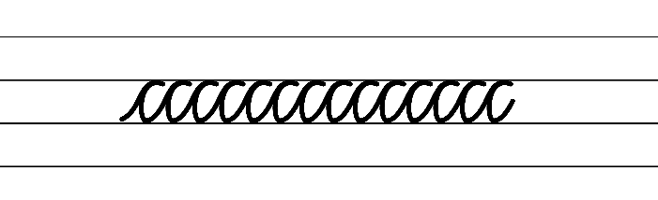  - Example horizontal joins to the letters e, f and s  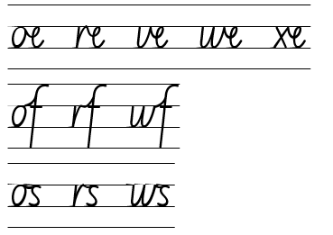  - Suggested passage from the text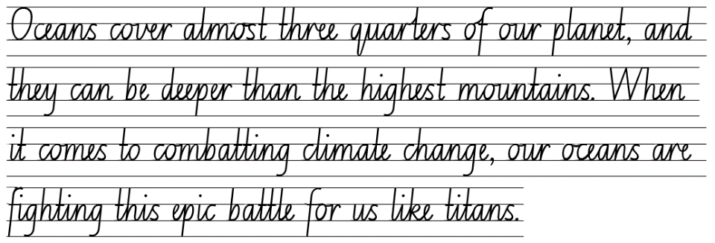

Planning framework
To plan and document Component A teaching and learning, a planning scaffold is provided. To support you in your planning, a link to a detailed example of a one-week teaching and learning cycle is included in the scaffold. Additional resources to support teaching and learning in each focus area can be found at Lesson advice guides.

Component B teaching and learning
The following teaching and learning sequence has been designed to address Component B outcomes and content and develops conceptual understandings of English through the study of quality texts. Adapt the sequence as required to best meet the needs of your students.

Learning intentions and success criteria
Learning intentions and success criteria are best co-constructed with students.

Learning intention
Students are learning to experiment with genre by drafting a multimodal text with features that do not follow the form and function of a single genre.

Success criteria
Students can:
- experiment with elements in literature that do not follow the form and function of a single genre
- use tiered vocabulary and a range of sentence types for effect and to suit the purpose of the text
- choose and control narrative voice across a text
- use headings and paragraphs to write informative texts
- use appositives to add detail in informative texts
- choose multimodal features to suit the purpose of a text.

Lesson 5: Planning a multimodal text with more than one genre
- Revise student knowledge of genre by reading the chapter ‘Power of the Oceans’ on pages 28 to 33 of Bright New World. While reading, use prompting questions to revise the structure of the text. For example:
- Is there a pattern in the way the chapters are structured?
- Who is the audience of Bright New World? How do you know?
- What is the purpose of Bright New World?
- Does the author’s perspective influence the text? How?
- Remind students that they will be working in small groups to compose a multimodal text that does not fit into a single genre. Their text will have informative, entertaining and persuasive elements, just like Bright New World. At the end of Week 3, students will publish and present their multimodal text that informs, entertains and persuades the local community to ‘take action’ and preserve their chosen local area (as researched in Lesson 4).
- Refer to the section of the text with the heading ‘Saved by the Sea’ on pages 28 to 29 and revise how to identify entertaining, informative and persuasive elements (by analysing the visual features, language choice and structure).
- Display the completed teacher Resource 6: Research template about Kakadu National Park from Lesson 4 and Resource 7: Planning scaffold 1. Using Kakadu National Park as the stimulus, model how to plan for writing a text with entertaining, informative and persuasive elements, in the same structure as Bright New World.
- Begin with modelling the opening sentences that are interactive and follow the same structure of the text. Include appositives to provide details to nouns to revise the learning from Component A. Record this on page one of Resource 7: Planning scaffold 1. For example:
‘Psst...hey you! Come a little closer and check this place out!’
‘Welcome to Kakadu National Park, located in the Northern Territory, this is an enormous and biodiverse nature reserve.’
- Using ideas from the completed teacher Resource 6: Research template, model writing 3 ideas to describe what Kakadu National Park could look like in a future, idealistic world. Add illustrations to support the ideas. Record this on page 2 of Resource 7: Planning Scaffold 1 For example:
- Thriving, regenerated wetlands.
- Abundance of native fauna, that were once threatened.
- The Bininj and Mungguy People lead the government in making important conservation decisions for Kakadu National Park, using traditional ways to maintain the flora and fauna.
- Using ideas from the completed teacher Resource 6: Research template model writing 3 environmental threats to Kakadu National Park. Add illustrations to support the ideas. Record this on page 2 of Resource 7: Planning Scaffold 1. For example:
- Devastated habitats due to saltwater intrusion.
- Threatened species/introduced species (cane toad, cats, foxes, weeds).
- Increased natural disasters because of climate change, including floods and drought.
- Using ideas from the completed teacher Resource 6: Research template model writing 3 solutions to some of the current environmental threats to Kakadu National Park. Add illustrations to support the ideas. Record this on page 3 of Resource 7: Planning Scaffold 1. For example:
- Act on weed control, fire management, feral animal management, habitat protection, from the Stone Country to the lowland woodlands.
- Actively contribute to the conservation of the unique plants that can only be found in the Kakadu National Park. Seed banking and propagation is a powerful way to safeguard the irreplaceable treasures of our natural world.
- Raise awareness about the importance of preserving Kakadu National Park. Engage traditional owners of Kakadu, the Bininj ad Mungguy, to teach others how to conserve and restore the park. Guided tours and cultural workshops can promote a sense of ownership and responsibility for the park’s conservation.
- Revise how the structure of Bright New World guides and supports the overall message of the text. Read the call to action on page 33. Discuss the impact of the call to action by asking questions, such as:
- How does it make the reader feel?
- What does it make the reader want to do?
- What type of sentences have been used?
- Model writing a call to action for Kakadu National Park. For example:
Protect our natural species before it’s too late! What can you do to help conserve Kakadu National Park?
- Students work in groups, established in Lesson 4, to complete Resource 7: Planning Scaffold 1 about their chosen local place. This will become the plan for their published multimodal text at the end of Week 3.
- Ask students to rate how they worked in their groups. Discuss what worked well and what could be improved next time. For example, establishing interacting protocols, such as listening and responding to each other’s questions.

Lesson 6: Drafting a multimodal text with elements that entertain
- Revisit pages 28 to 29 of Bright New World and analyse the techniques used by the author that are designed to entertain. For example:
- Narrative voice (written in first person).
- Dialogue (shows the character is speaking to the audience directly). What effect does this have on the reader?
- Are the statements about the ocean in the ‘idealistic, future world’ fact or fiction?
- How do each of these elements support the author’s purpose?
- Explain that in this lesson students will use their planning scaffolds (from Lesson 5) to draft the first section of their multimodal text focusing on entertaining elements. The focus will be on revising the first page to draft, edit and revise the:
- opening sentences for the first section of the text (group co-construct)
- three short texts to describe their local place in an idealistic, future world (independent).
- Display the enlarged copy of Resource 7: Planning scaffold 1 created in Lesson 5 about Kakadu National Park. Review the points on the first page of the plan and model the process of re-reading, revising and editing. Consider the success criteria, display Resource 8: Writing cycle and discuss how good writers revise and edit their work throughout the writing process.
- Model adding on or editing the opening sentences to intentionally use second person narrative voice. For example:
“If we take action now Kakadu National Park will flourish once again”. Together, we can make this future happen!
- Discuss the effect first person narrative voice has on the reader.
- Revise the 4 types of sentences – declarative, exclamatory, imperative and interrogative. Choose one of the idealistic, future world points on Kakadu National Park from Resource 7: Planning Scaffold 1 created in Lesson 5. Model writing an exclamatory sentence ending with an exclamation mark. Add a declarative sentence and an appositive to provide details of what Kakadu could like. For example:
Kakadu’s flora and fauna are thriving! Here in the future, we’ve finally stabilised the world’s climate and Kakadu is no longer under environmental threat. Kakadu, a protected national treasure, is once again teeming with wildlife. Species including the Gouldian Finch, Northern Quoll and saltwater crocodiles are back from the brink of extinction.
- Keep the modelled texts from this lesson to review in Lesson 7.
- Using the modelled text in activities 4 and 5 co-construct a success criteria for the first section of a multimodal text. For example:
- use first person narrative voice
- include appropriate punctuation, including speech marks, commas and exclamation marks
- write using a range of sentence types (exclamatory sentences and declarative sentences)
- use appositives to provide more detail
- use capital letters for proper nouns (places and names, including species of flora and fauna)
- re-read, proofread and edit own and other’s writing.
- Provide students with a second copy of the first page of Resource 7: Planning scaffold 1 to record their drafts and edits.
- Students work in groups to review their planning scaffold from Lesson 5. As a group students draft, revise and edit their introductory sentences for the first section of the multimodal text using the co-constructed success criteria from activity 7.
- Students independently draft a short text about the idea from the first page of the planning scaffold. Remind students to refer to the success criteria and the modelled text from activity 5 for support.
- Model using the COPS strategy to revise and edit writing. For example:
- Capitalise: Capitalise the first word of the sentence and any proper nouns.
- Organise: Organise your writing so it is easy to read. Use complete sentences, neat handwriting and correct spacing.
- Punctuation: Punctuate your sentences and check you have used full stops, commas, exclamation marks or quotation marks correctly or when needed.
- Spelling: Check you have spelt words correctly. Use a dictionary, website or word wall for any tricky words you are unsure about.
- Groups share their writing and provide each other with feedback based on the success criteria. Further editing is encouraged after giving and receiving peer feedback.
Note: the co-created opening sentences and 3 individually written short texts will be collated to form the first section of the multimodal texts.

Lesson 7: Adding multimodal features and publishing a text with elements that entertain
- Revisit pages 28 to 29 of Bright New World to analyse the techniques used by the author to entertain a reader. For example:
- How do the illustrations contribute to the purpose of the text? (Bright, colourful, depict nature thriving, cartoon like.)
- What effect do they have on the reader?
- Revisit the co-constructed writing success criteria from Lesson 6 and add the following:
- use multimodal features, such as illustrations, to suit the purpose of entertaining.
- Discuss how the illustrator, Bethany Lord, has created illustrations to suit the purpose of the text (to entertain). Visit Bethany Lord’s website to discover how her experience with travelling influences her artworks and how she achieves her style (bold colours and layering techniques to create depth and detail).
- Display the modelled text about Kakadu National Park from activity 4 and 5 in Lesson 6. Sketch some ideas for illustrations that would support the text, in the same style as the illustrator, Bethany Lord.
- Discuss that by adding illustrations to a text, the text becomes multimodal. Ask students to state other modes that can be added to a text, for example sound, music or gestures. Remind students about the podcast and video from Lesson 2 and Lesson 3.
- Students review their drafted texts from Lesson 6 to design illustrations that will support their writing. Provide art paper and paint for students to create illustrations in the same style as Bethany Lord.
- Students publish the opening sentence, 3 short texts and the illustrations to complete the first section of their multimodal text.
- Provide students with a range of tools and resources to publish their texts. For example, digitally using word processing software or applications such as Book Creator (students can upload photos of their illustrations and overlay with sound and or music to experiment with other modes).

Lesson 8: Drafting a multimodal text with elements that inform
- Revisit pages 30 to 31 of Bright New World to analyse the techniques used by the author that are informative. For example:
- Are the statements on these pages fictional or true? How do you know? (Discuss the credibility of information based on what is known about the author, Cindy Forde.)
- What is the subject matter? (Oceans under environmental threat.)
- What is the purpose of this part of the text? (To inform.)
- How do the language choices support the text’s purpose? (Use of Tier 2 and 3 vocabulary, declarative sentences, narrative voice.)
- How does the structure of this part of the text support the information being presented? (Information about the subject matter are grouped into paragraphs, use of headings.)
- Explain that students will continue working in groups to compose the second section of their multimodal text which will focus on elements that inform. In this lesson, students will use their ideas from the second page of their planning scaffold (environmental threats to their local area) to independently develop informative texts that include headings and ideas grouped into paragraphs.
- Display the enlarged copy of the second page of Resource 7: Planning Scaffold 1 created in Lesson 5 about Kakadu National Park. Review the points about environmental threats (facts).
- Choose one of the facts from the plan about Kakadu National Park to model writing an informative paragraph with a heading. Explicitly teach how to structure paragraphs with a topic sentence, details and a concluding sentence. Include declarative sentences and appositives. Model the use of tiered vocabulary that is specific to the subject matter and revise how to use commas to separate items in a list. For example:
Wildlife Under Threat
Kakadu National Park’s native birds and animals are under serious threat from introduced species such as cane toads, foxes and cats. These non-native pests cause significant problems within the unique ecosystems of the park. Cane toads (also known as Bufos marinus) release toxins that kill native species, disrupting the natural food chain. Foxes and cats, also introduced to Australia, are responsible for the declining population of small ground dwelling mammals, birds and reptiles. Despite efforts to control introduced pests, protecting the park’s wildlife is still a challenge.
- Using the modelled text from activity 11, co-construct a success criteria for the second section of the multimodal text. For example:
- organise information with headings
- organise information into paragraphs that include a topic and concluding sentence
- use a range of sentence types
- use appositives to add detail
- use tiered vocabulary that is specific to the subject matter
- use a comma to separate items in a list.
- Provide students with a new copy of the second page of Resource 7: Planning scaffold 1 to record their drafts and make edits.
- Students work independently to draft a short text about an environmental threat (fact) using the success criteria and the modelled text from activity 11 for support.
- Groups share their writing and provide each other with peer feedback based on the success criteria. Select a peer feedback strategy from the Universal Resource Hub to scaffold the feedback process. Further editing is encouraged after giving and receiving peer feedback.
Note: each group member’s writing will be collated to form the second section of the multimodal text.
Assessment task 1 – Observations and work samples from this lesson allow students to demonstrate achievement towards the following syllabus outcomes and content points:
EN3-OLC-01 – communicates to wide audiences with social and cultural awareness, by interacting and presenting, and by analysing and evaluating for understanding
- respond to questions with elaboration and detail
- analyse how audio elements in texts integrate with linguistic, visual, gestural and spatial elements to create meaning and impact.
EN3-RECOM-01 – fluently reads and comprehends texts for wide purposes, analysing text structures and language, and by monitoring comprehension
- use knowledge of text structure to navigate the text to locate specific information
- categorise information or ideas and create hierarchies to aid recall and support summarisation.
EN3-CWT-01 – plans, creates and revises written texts for multiple purposes and audiences through selection of text features, sentence-level grammar, punctuation and word-level language
- choose and control narrative voice across a text
- develop informative texts that include headings, ideas grouped into paragraphs that include a topic sentence, and a paragraph with concluding information
- include appositives to provide details to nouns and to vary sentence structures suited to text purpose
- make choices about the use of declarative, exclamatory, interrogative and imperative sentences to suit text purpose, and for meaning and effect.

Week 3

Component A teaching and learning
Component A focuses on the development of foundational skills and knowledge through regular, systematic and repeated practice. The mentor and supporting texts used in Component B of this unit can support the effective implementation of Component A teaching and learning.

Teaching guide
Guidance for explicit teaching, teaching notes, resources and examples for the related outcomes and content points have been provided in the table below.
Focus areas and teaching notes | Resources and examples
Reading comprehension  Reading fluently  - Efficiently follow signposting features to navigate the text to locate specific information  - Signposting features refer to elements within a text that guide the reader through structure and content of a text. These features serve as ‘signposts’ that indicate the direction the text is taking and help the reader follow along.  - Signposting features could include headings and sub-headings, homepages and subpages, hyperlinks and hypertext. | Reading comprehension  Reading fluently  - Fluency and close reading passage 3 – Bright New World: Power of The Oceans, from ‘Make marine protected areas...’ to ‘...many small actions make a difference too.’ (p 33) (212 words)  Note: the passage from the text will need to be a teacher-created resource.  - Using signposting features in the passage:  - use the headings and sub-headings to navigate the text and find specific information. For example, the information about the Indonesian ocean heroes  - navigate the text with the dot points and understand how this can be an effective way to present information.
Reading for interest and wide purpose  - Adjust reading approach to suit the purpose for reading  - Adjusting the reading approach to suit the purpose for reading is crucial as different reading purposes require different strategies and skills.  - Close reading may be used for the analysis of texts, skimming could be used to locate key information, scanning might be used to identify key vocabulary, and note-taking could be undertaken for summarisation (NESA 2023). | Reading for interest and wide purpose  - Adjust reading approach in the passage and text  - Purpose for reading: reading to analyse, skim and scan for key information or vocabulary.
Comprehending text structures and features  - Use knowledge of text structure to navigate the text to locate specific information  - Text structure provides a ‘roadmap’ for readers, helping them make predictions, understand relationships between ideas and locate specific information.  - When reading a text, readers could predict patterns (structure) and vocabulary that might be encountered (for example, Tier 3 words associated with a particular subject).  - Structural or stylistic components of the text that contribute to the text purpose. | Comprehending text structures and features  - Text structure in the passage  - information is presented and structured in chunks of text both with and without the use of headings and sub-headings  - maps, tables and illustrations will support the presentation of information about the topic.
Vocabulary  Learning and using words  - Identify newly encountered words from interactions and wide reading, and use them in writing, discussions and presentations  - Assist students to identify newly encountered or unfamiliar words in texts and from interactions with peers. | Vocabulary  Learning and using words  - Suggested vocabulary from the passage  - habitats, dredging, trawling, marine, fertilisers, sewage, ecosystems, military, explosions, politicians (p 33).
Defining and analysing words  - Analyse morphemic structures of Tier 2 and Tier 3 words to determine their meaning  - Morphemes are the smallest unit of meaning in a word. They can be categorised as: free morphemes and bound morphemes. Free morphemes stand alone as words. For example, walk, read. Bound morphemes are attached to a free morpheme. For example, -ed (suffix) in walked, re- (prefix) in re-read. Multiple suffixes and/or prefixes can be affixed to a base word or root. | Defining and analysing words  - Tier 2 word from the text  - collection: collect + -ion (p 13)  - ‘collect’ is a base word meaning bring or gather together  - ‘-ion’ is the suffix meaning the result of doing something  - Meaning: Collection means the result of gathering objects or materials.  - Tier 3 word from the text  - transpiration: trans- + spir- + -ation (p 13)  - ‘trans-’ is a prefix meaning across or through  - ‘spir-’ is a root word meaning breathe  - ‘-ation’ is a suffix used to form a noun indicating an action or process  - Meaning: Transpiration is the process by which moisture or water vapour is released from plants through tiny pores (stomata) in their leaves.  - Students may create word sums or word matrixes as a method of analysing morphemic structures of words.
Spelling  Phonological component  - Segment unfamiliar multisyllabic words into syllables and phonemes as a strategy when spelling  - Revise segmenting multisyllabic words into syllables and phonemes. This is a phonological skill that should be practised regularly. | Spelling  Phonological component  - Suggested words from the passage  - tons, carbon, contributed, conserving-conservation, protected, oceans, co-founded, explosions, comes, recover.  - Suggested words from the text  - civilise-civilisation, explore-exploration (p 42) transform-transformation, transport-transportation, destiny-destination (p 45)  - Sample words for inquiry  - conserve-conservation, form-formation, oppose-opposition, occupy-occupation.
Orthographic component  - Recognise that the same grapheme can represent different phonemes  - Single-letter grapheme [o] represents /o/, /oa/, /u/.  - Highlight the different phonemes represented by the grapheme [o].  - [o] can be used to represent /o/ as in ‘on’, /oa/ as in ‘own’ and /u/ as in ‘come’. Consider the grapheme’s position within base words. | Orthographic component  - As above
Morphological component  - Explain and use spelling conventions to add derivational suffixes such as -ion, -ian, -ence, -ous to base words or roots  - Derivational suffix: -ation, -ition  - Introduce suffix:  - ‘-ation’ and ‘-ition’ meaning ‘act’ or ‘process’  - attaches to verbs to form nouns  - there is no strict generalisation for when to use ‘-ation’ or ‘-ition’: starve-starvation, compete-competition. | Morphological component  - As above
Creating written texts  Sentence-level grammar  - Make choices about the use of declarative, exclamatory, interrogative and imperative sentences to suit text purpose, and for meaning and effect  - Review declarative, exclamatory, interrogative and imperative sentences. | Creating written texts  Sentence-level grammar  - Examples from the passage (p 33)  - Declarative: ‘We must respect marine habitats, and the people who depend on them.’  - Exclamatory: ‘You can think big, and remember, many small actions make a difference too!’  - Interrogative: ‘How would you help?’  - Imperative: ‘Talk to your parents and teachers.’
Punctuation  - Use a comma to separate a subordinate clause or a phrase from the main clause, to separate information within a sentence or to separate items in a list  - Commas are a punctuation marker used to show separation between parts of a sentence, such as clauses or phrases, where separation is important to the meaning. Commas are also used to separate words, phrases or numbers in a series (NESA 2023). | Punctuation  - Suggested examples from the passage  - ‘When we fish, we need to leave enough in the oceans for species to recover.’ (comma used to separate a subordinate clause from the main clause)  - Suggested examples from the text  - 'Coastal and marine plants like saltmarsh, sea grass and mangrove absorb carbon super fast – even faster than tropical rainforests.’ (p 32) (comma used to separate items in a list)
Handwriting and digital transcription  Software functionalities and typing  - Navigate the keyboard with efficiency and accuracy when typing words, numerals, punctuation and other symbols  - Revise device positioning to reduce glare.  - Revise touch typing skills including the home, top and bottom rows. | Handwriting and digital transcription  Software functionalities and typing  - Provide students with the opportunity to publish their texts using word processing software (Lesson 11).

Planning framework
To plan and document Component A teaching and learning, a planning scaffold is provided. To support you in your planning, a link to a detailed example of a one-week teaching and learning cycle is included in the scaffold. Additional resources to support teaching and learning in each focus area can be found at Lesson advice guides.

Component B teaching and learning
The following teaching and learning sequence has been designed to address Component B outcomes and content and develops conceptual understandings of English through the study of quality texts. Adapt the sequence as required to best meet the needs of your students.

Learning intentions and success criteria
Learning intentions and success criteria are best co-constructed with students.

Learning intention
Students are learning to experiment with genre by publishing a multimodal text with features that do not follow the form and function of a single genre.

Success criteria
Students can:
- choose multimodal features to suit the purpose of a text
- choose and control narrative voice across a text
- use headings and paragraphs to write informative texts.

Lesson 9: Adding multimodal features and publishing a text that informs
- Revisit pages 24, 25 and 31 of Bright New World to analyse other techniques that the author has used to present and reinforce information about environmental threats. For example:
- The graphs about greenhouse gas emissions needed to produce food and for agriculture (pp 24–25).
- The table showing the impact of rising temperatures (p 31).
- Revisit the co-constructed writing success criteria from Lesson 8 and add new criterion based on the text analysis in activity 1. For example:
- Use multimodal features, such as graphs and tables, to suit the purpose of informing.
- Display the modelled text about Kakadu National Park from activity 11 in Lesson 8. Create a graph or table that would support the information presented in the modelled text. For example, data on a graph or table showing the decline of native species or an increase of introduced pests.
Note: additional research might be required to gather enough data to be presented on a graph or table.
- Reinforce the idea that by adding a graph or table to a text, the text becomes multimodal.
- Students review their drafted texts from Lesson 8 and create a graph or table that would support the information presented.
- Students publish their informative texts with the graph or table to complete the second section of their multimodal text.
- Provide students with a range of tools and resources to publish their texts. For example, digitally using word processing software or applications such as Book Creator (students can upload photos of their illustrations and overlay with sound and or music to experiment with other modes).

Lesson 10: Drafting a multimodal text with elements that persuade
- Revisit page 33 of Bright New World to analyse the techniques used by the author that are persuasive. For example:
- What is the subject matter and purpose of this part of the text? (Provides solutions to protecting the oceans and persuades readers to take action.)
- Explore how the language choices support this. For example:
- Tiered vocabulary (conserving, blue carbon ecosystems, marine).
- Declarative sentences with data and statistics. For example, ‘90% of Earth’s big fish are gone’ and ‘2 million tons of plastic get into the ocean every year’. What is the impact of this?
- Imperative sentences using second person voice and verbs (Note that some are modal verbs). For example, ‘Ditch the plastic’, ‘Write to your politicians’. Ask why the author changes back to second person narrative voice in this part of the text.
- Interrogative sentences. For example, ‘How would you help?’ Ask what the purpose of ending each chapter with a thought-provoking question might be. Re-visit more of these questions at the end of other chapters of the text to discuss and reinforce this technique.
- Ask how the text structure supports this. (Headings to clearly identify and provide global solutions, dot points suggesting how readers can help).
- Explain that students will continue working in groups to compose the third section of their multimodal text which will focus on elements that persuade. In this lesson, students will use their ideas from the third page of their planning scaffold (solutions to environmental threats) to independently write texts that will persuade the community to act and protect the local place.
- Display the enlarged copy of the second page of Resource 7: Planning scaffold 1 created in Lesson 5 about Kakadu National Park. Review the points about possible solutions in this section of the plan.
- Choose one of the solutions from this section of the plan about Kakadu National Park to model writing a short text with persuasive elements, showing how narrative voice can change in a text. Include declarative and imperative sentences. Model the use of tiered vocabulary that is specific to the subject matter. For example:
Protecting Kakadu National Park
Kakadu National Park is home to 75 threatened species. In 2009 there was a 75% decline in the number of small native mammals. It is believed this is due to introduced species, including feral cats. It is estimated there are about 3300 feral cats living in Kakadu. Installing cat enclosures in parts of the park have doubled the reptile populations in those areas.
Attention, conservation champions!
- If you have a cat, make sure it does not catch native wildlife
- Your cat must be kept indoors, especially at night
- Attach bells to its collar to warn animals that is it coming.
- Co-construct a concluding statement (call to action) using persuasive devices. For example:
Kakadu is a timeless place. It has been home to the Bininj and Mungguy people for thousands of years. It is home to unique ecosystems, that if lost, we cannot replace. What do you think we can do to preserve this national treasure?
- Using the modelled texts from activity 4 and 5, co-construct a success criteria for the third section of the multimodal text. For example:
- use a range of sentence types, including declarative sentences with data or statistics, imperative sentences that tell a reader what to do and interrogative sentences to prompt a reader to think about the topic
- use tiered vocabulary that is specific to the subject matter
- use high modality verbs as a persuasive device
- choose and control narrative voice to suit the purpose of a text.
- Provide students with a new copy of the third page of Resource 7: Planning scaffold 1 to record their drafts and edits.
- Students work independently to draft a text providing a solution to the environmental threat (fact) written in Lesson 8. Remind students to refer to the success criteria and the modelled text from activity 4 for support.
- In small groups, students co-construct the concluding statement for their multimodal text referring to the success criteria to monitor and self-evaluate their work.
- Students share their work with another group and apply feedback based on the success criteria.
Note: the 3 individually written persuasive texts and co-constructed concluding statement (call to action) will be collated to form the third and final section of the multimodal text.
- Provide feedback to each group for students to apply in Lesson 11.

Lesson 11: Revising and publishing a multimodal text that persuades
- Revise and discuss how the text, Bright New World, does not fit the form and function of a single genre. Discuss the visual features, languages choices and text structure that the author has used to entertain, inform and persuade readers. The author’s context and perspective has influenced what she has written and the message in the text.
- Ask students to reflect on the multimodal text they have created. Ask if their text:
- has more than one purpose? (to entertain, inform and persuade)
- has a range of sentence types to suit the intended purposes?
- uses a range of modes? (written text, illustrations, tables, graphs or maps)
- uses subject specific vocabulary?
- Remind students about the cyclical writing process and how good writers re-read, revise and edit their writing. Refer to Resource 8: Writing cycle.
- Using the guiding questions from activity 2, students work in groups to finalise their multimodal text. Encourage students to apply further feedback, including teacher feedback from Lesson 10, and to think about how their text can be strengthened or improved. For example, using more effective vocabulary, editing for basic punctuation and sentence structure and adding more visual features.
- Groups publish all their work into a completed multimodal text. They will need their completed multimodal texts for Lesson 12.
- Provide students with a range of tools and resources to publish their texts. For example, digitally using word processing software or applications such as Book Creator (students can upload photos of their illustrations and overlay with sound and or music to experiment with other modes).

Lesson 12: Publishing or broadcasting a multimodal text and reflecting on genre
- Revise author Cindy Forde’s message to readers in her text Bright New World. Ask students to share the message they were trying to portray in their multimodal texts (the protection or conservation of a local place).
- Introduce students to inspiring stories of individuals or groups who have had a positive impact on environmental conservation. Read the passage ‘Climate Hero’ on page 69 of Bright New World.
- Watch Greta's passionate UN speech (2:25). Discuss the power of Greta Thunberg’s voice in the media across the world.
- Brainstorm ways students can publish or broadcast their completed multimodal texts from Lesson 12 to share with the school or local community. For example, groups could:
- present their work at a school assembly
- make a video of themselves presenting their work and upload on the school website
- turn their work into a podcast upload on the school website
- print copies of their work to be displayed in public places, such as the local library
- email digital copies of their work and send to local organisations or members of parliament.
- Reflect on the textual concept of genre. Ask students what they have learnt about genre. Invite them to elaborate on their understanding of genre by asking how:
- texts have evolved over time
- some texts cross multiple genres, for example, Bright New World
- technology has had an impact on the mode and medium of texts and how this can influence genre.
- Ask students if they would approach the task differently, if they were to repeat the categorising activity from Lesson 1. Prompt students to share why or why not.
Assessment task 2 – Observations and work samples from this lesson allow students to demonstrate achievement towards the following syllabus outcomes and content points:
EN3-CWT-01 – plans, creates and revises written texts for multiple purposes and audiences through selection of text features, sentence-level grammar, punctuation and word-level language
- choose multimodal features suited to a target audience and purpose, to reinforce and extend ideas
- re-read, proofread and edit own and other’s writing, and use criteria and goals in response to feedback.
EN3-UARL-02 – analyses representations of ideas in literature through genre and theme that reflect perspective and context, argument and authority, and adapts these representations when creating texts
- examine and experiment with elements in literature that do not follow the form and function of a single genre
- identify how perspective is made evident through authorial choices.

Week 4

Component A teaching and learning
Component A focuses on the development of foundational skills and knowledge through regular, systematic and repeated practice. The mentor and supporting texts used in Component B of this unit can support the effective implementation of Component A teaching and learning.

Teaching guide
Guidance for explicit teaching, teaching notes, resources and examples for the related outcomes and content points have been provided in the table below.
Focus areas and teaching notes | Resources and examples
Reading comprehension  Reading fluently  - Efficiently follow signposting features to navigate the text to locate specific information  - Signposting features refer to elements within a text that guide the reader through structure and content of a text. These features serve as ‘signposts’ that indicate the direction the text is taking and help the reader follow along.  - Signposting features could include headings and sub-headings, homepages and subpages, hyperlinks and hypertext. | Reading comprehension  Reading fluently  - Resource 2: Fluency and close reading passage 4 – Dry to Dry: The Seasons of Kakadu (pp 4–5) (102 words).  Note: the passage from the text will need to be a teacher-created resource.  - Using signposting features in the passage  - follow and keep track of the directionality of the text as it changes (p 4)  - read the pages from left to right, using the font to guide which part to read first  - read the informative section on page 5 (even though it is located at the top of the page).
Reading for interest and wide purpose  - Adjust reading approach to suit the purpose for reading  - Adjusting the reading approach to suit the purpose for reading is crucial as different reading purposes require different strategies and skills.  - Close reading may be used for the analysis of texts, skimming could be used to locate key information, scanning might be used to identify key vocabulary, and note-taking could be undertaken for summarisation (NESA 2023). | Reading for interest and wide purpose  - Purpose is reading for enjoyment.  - Read the text in its entirety (as opposed to parts of it like Bright New World).  - Notice how prosody changes when reading the narrative and informative sections of the text.
Comprehending text structures and features  - Use knowledge of text structure to navigate the text to locate specific information  - Text structure provides a ‘roadmap’ for readers, helping them make predictions, understand relationships between ideas and locate specific information.  - When reading a text, readers could predict patterns (structure) and vocabulary that might be encountered (for example, Tier 3 words associated with a particular subject). | Comprehending text structures and features  - Text structure in the passage  - the passage structure clearly shows that the text’s purpose is to both entertain and inform; the narrative section of the text is the main part of the text and the informative section compliments it  - the font, style, size and directionality helps to define the 2 sections of the text (entertaining and informative)  - the illustrations support the visualisation of the place – Kakadu and the wildlife and plants found there.
Vocabulary  Learning and using words  - Identify newly encountered words from interactions and wide reading, and use them in writing, discussions and presentations  - Assist students to identify newly encountered or unfamiliar words in texts and from interactions with peers.  - Identify and use words derived from other languages, including Aboriginal and Torres Strait Islander Languages, and know that the pronunciation and spelling of words may reflect their etymology  - The English language is made up of words derived from many other languages including Latin, French, Greek, German and Aboriginal and Torres Strait Islander Languages.  - The pronunciation and spelling of words can reflect the etymology. For example, the French spelling of the /sh/ phoneme is ‘ch’. This is seen in the words chef, parachute and chaperone. | Vocabulary  Learning and using words  - Suggested vocabulary from the passage  - flock, curlews, snipes, godwits, sandpipers (p 4), Pityrodia, moulting (p 5).  - Suggested vocabulary from the Kundjeyhmi/Gundjeihmi language in the text (p 29)  - Wurreng – cold weather season  - Gurrung – hot, dry weather  - Gunumeleng – pre-monsoon storm season  - Gudjewg – monsoon season  - Banggerreng – ‘Knock ’em down’ storm season  - Yegge – dry and cooler, but still humid.
Spelling  Phonological component  - Segment unfamiliar multisyllabic words into syllables and phonemes as a strategy when spelling  - Revise segmenting multisyllabic words into syllables and phonemes. This is a phonological skill that should be practised regularly. | Spelling  Phonological component  - Suggested words from Dry to Dry  - flocks, godwits (p 4), strong, November (p 5), most, grove, kilometres (p 6), other (p 4), sometimes (p 8), recede-recession (26).  - Sample words for inquiry  - permit-permission, emit-emission, omit-omission, admit-admission, submit-submission, transmit-transmission.
Orthographic component  - Recognise that the same grapheme can represent different phonemes  - Graph [o] representing /o/, /oa/, /u/.  - Highlight the different phonemes represented by the grapheme [o].  - [o] can be used to represent /o/ as in ‘on’, /oa/ as in ‘own’ and /u/ as in ‘come’. Note the grapheme’s position within base words. | Orthographic component  - As above
Morphological component  - Explain and use spelling conventions to add derivational suffixes such as -ion, -ian, -ence, -ous to base words or roots  - Derivational suffix: -ssion  - Introduce suffix:  - ‘-ssion’ meaning ‘act’ or ‘process’  - attaches to verbs to form nouns  - the suffix ‘-ssion’ follows when a verb ends in ‘mit’: permit-permission. | Morphological component  - As above
Creating written texts  Sentence-level grammar  - Include appositives to provide details to nouns and to vary sentence structures suited to text purpose  - Appositives can be words, phrases or clauses that affect or enhance the meaning of a noun or pronoun. They can be placed beside a noun to explain it more fully (NESA 2023).  - Appositives can be descriptive, identifying or explanatory.  - Appositive word/phrases can follow the noun it describes. For example, Sydney, the capital of NSW, is the largest city in Australia.  - Appositive word/phrases can precede the noun it describes. For example, The capital of NSW, Sydney, is the largest city in Australia.  - Make choices about the use of declarative, exclamatory, interrogative and imperative sentences to suit text purpose, and for meaning and effect  - Review declarative, exclamatory, interrogative and imperative sentences. | Creating written texts  Sentence-level grammar  - Suggested examples of appositives from the text  - ‘Kakadu’s native species have been endangered by the introduced cane toad (which is poisonous if eaten) and feral predators such as cats and foxes’ (p 28)  - Suggested examples from the passage and text  - Declarative: ‘Other birds are coming too: snipes, godwits, sharp-tailed sandpipers and more’ (p 4)  - Exclamatory: ‘Lightning and thunder!’ (p 7)
Handwriting and digital transcription  Handwriting legibility and fluency  - Sustain writing with a legible, fluent and personal handwriting style across a text  - Revise forming letters that do not join, including b, g, j, p, s and y.  - Letters that finish in a clockwise direction do not join.  - The letter f does not join to the letter e.  - Capital letters do not join.  - Revise writing punctuation marks.  - Exclamation marks and questions marks are full height. They are the same height as capital letters.  - Speech marks and apostrophes are positioned to rest below the top line (Line 1). | Handwriting and digital transcription  Handwriting legibility and fluency  - Suggested fluency pattern  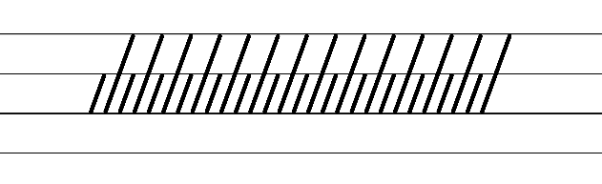  - Example letters that do not join, including b, g, j, p, s and y, the letter f to the letter e and capital letters  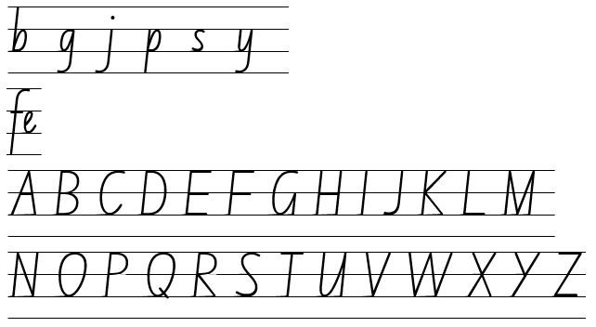  - Example punctuation marks  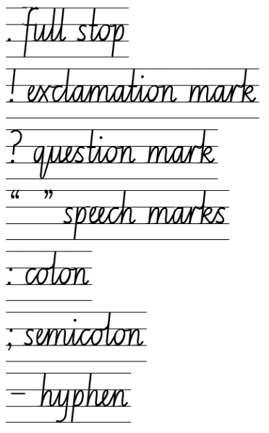  - Example passages from the text:  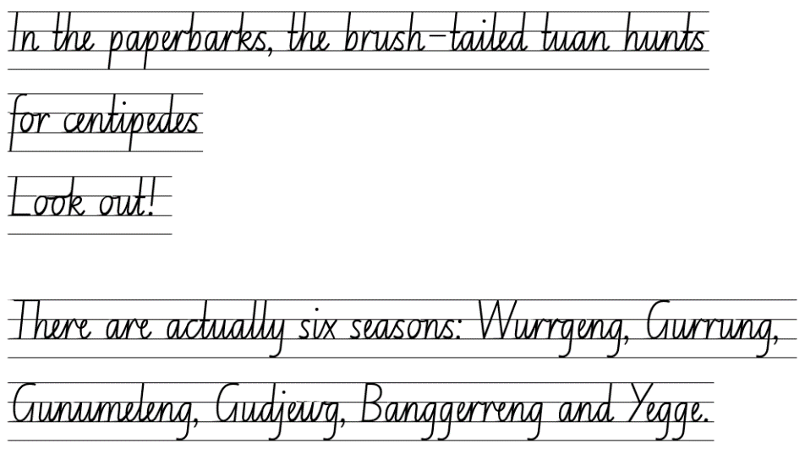

Planning framework
To plan and document Component A teaching and learning, a planning scaffold is provided. To support you in your planning, a link to a detailed example of a one-week teaching and learning cycle is included in the scaffold. Additional resources to support teaching and learning in each focus area can be found at Lesson advice guides.

Component B teaching and learning
The following teaching and learning sequence has been designed to address Component B outcomes and content and develops conceptual understandings of English through the study of quality texts. Adapt the sequence as required to best meet the needs of your students.

Learning intentions and success criteria
Learning intentions and success criteria are best co-constructed with students.

Learning intention
Students are learning to examine and experiment with elements in literature that do not follow the form and function of a single genre.

Success criteria
Students can:
- adjust reading approach to suit the purpose for reading
- compare the purpose of different texts
- consider why authors and illustrators structure texts in particular ways
- explore the etymology of words from different languages, including Aboriginal and/or Torres Strait Islander Languages
- experiment with figurative language.

Lesson 13: Comparing the genre and purpose of texts
- Set the scene for the supporting text, Dry to Dry, by listening to the podcast Stop 1: Mamukala wetlands, South Alligator River (9:26). Students may like to close their eyes while listening or sketch illustrations of what they are listening to. Ask students:
- How did the audio elements (sound, music and voice) help you build a mental model of Kakadu?
- What is the purpose of the podcast and how does its mode and medium support this?
- Introduce the text, Dry to Dry by Pamela Freeman, by examining the front cover. Ask students to predict:
- what the text will be about
- the text’s purpose
- what genre is the text.
- Before reading, look at the features of the text. For example, illustrations, text font, index page and map. Discuss why the approach to reading this text would be different to Bright New World. Ask if this is because the genre, purpose or structure of the texts are different.
- Refer to Component A learning about the etymology of words and re-read pages 28 to 29 to identify some of the words that derive from other languages, including Aboriginal and Torres Strait Islander Languages. For example, plateau, kilometres, centuries and Gurrung. Discuss how these words support the subject matter of the text.
- Read Dry to Dry using prosodic reading to contrast reading the narrative and informative sections of the text.
- Ask students what they notice about the genre of the text. Ask:
- Does it fit the form and function of a single genre? Why or why not?
- What evidence do you have to support your thinking?
- Has your thinking changed from your initial predictions about the text’s genre?
- Display an enlarged copy of Resource 5: Genre analysis. As a class, analyse the text’s features (visual, language and structure) and record on the analysis sheet for the sections ‘To inform’ and ‘To entertain’. The ‘To persuade’ section will be completed in Lesson 14. For example:
- Visual features: illustrations are detailed and realistic (depicting a real place), transparent illustrations of human impact in the background (shelters and picnic table on page 13, the introduced buffalo on pages 9 and 11), maps are used to show the location of Kakadu (pp 30–31), the font style, size and direction changes in the narrative and informative sections.
- Language choices:
- Exclamatory sentences: ‘Some fly more than 5000 kilometres!’ (p 5)
- Declarative sentences: ‘In northern Australia, there are two main seasons: wet and dry’ (p 3)
- Imperative sentences: ‘Look closer: there is a northern long-necked turtle…’ (p 3)
- Use of appositives: ‘Over the plains and cliffs and rivers of Kakadu, in northern Australia, the air hangs heavy’ (p 2)
- Descriptive, figurative, poetic language: ‘The first kiss of rain on the blazingly dry grasslands’ (p 7)
- Tiered vocabulary to support the subject matter: species, billabongs, pandanus, mosquito larvae.
- Structure: the text is written using both a narrative and informative structure, it is cyclical (starts and ends in the dry season), there are elements of the text being interactive (‘Look! A gecko has found shelter from the hot summer sun’ from page 12).
- Reflect on how authors and illustrators structure texts in a particular way to suit the purpose using familiar texts to make this point. Use familiar texts, such as The Wild Robot and Bright New World to reflect on how authors and illustrators structure texts in a particular way to suit the purpose. Discuss some of the similarities and differences between these texts. Model recording these on a Venn diagram.
- Provide students with a Venn diagram to record the similarities and differences between Dry to Dry and Bright New World. Students can refer to the genre analysis from activity 7 and the modelled example in activity 8 for support.
Too hard: students identify, discuss and label parts of Dry to Dry that are entertaining and informative. For example, illustrations, descriptive sentences, maps and facts.
Too easy: provide students with a triple Venn diagram to compare the podcast from activity 1 with Dry to Dry and Bright New World.
- Share student responses. Prompt with questions such as:
- What similarities do the 2 texts have? (subject matter, purpose to inform and entertain)
- How is the information presented differently? (illustrations, text layout, fonts, data displays)
- Does the text fit into a single genre? What evidence do you have to support your thinking? (Students should notice that the text has informative and entertaining elements.)
- Reflect on the different styles used in each of the texts. Ask students which text they preferred and why.

Lesson 14: Cultural protocols and the author’s message
- Go to the Kakadu National Park website and read the information about ‘Respecting Culture’. Discuss the cultural protocols that the Bininj and Mungguy people practice. Ask students why this information is important to know and how it would influence the way they interact if they were visiting Kakadu. Explore and discuss other cultural protocols practised on-Country.
- Refer to the author of Dry to Dry, Pamela Freeman. Remind students that context and perspective influences what they know and what they can write about. Visit Pamela Freeman’s website to learn more about the author’s context. Model using signposting features to navigate the website and locate specific information. For example, selecting the hyperlinks to read and discuss:
- About Pamela – Biography: How has the author’s life influenced what she has written? (She is Australian and has written about Australian places that are environmentally and culturally significant, Kakadu and Lake Eyre.)
- Pamela’s Books – Dry to Dry: Is there any evidence that identifies the text’s genre?
- We’re celebrating! – Do you think this section of the website makes people want to read the text? Why?
- Revise that the author has structured Dry to Dry to both inform and entertain. Ask students if the text can also be viewed as persuasive. Prompt students to explain why or why not.
- Guide students to notice the subtle persuasive elements in the text. Ask if the visually appealing illustrations, literary descriptions and the factual information presented in the text might raise awareness about Kakadu and make readers care about protecting it from environmental degradation. Record these on the enlarged copy of Resource 5: Genre analysis from activity 7, Lesson 13.
- Display the last page of the text and read the dedication statement ‘To the native water rats who have figured out how to safely eat cane toads’ (Pamela Freeman). Ask students:
- What do you think about the dedication statement? Why isn’t the text dedicated to people? What does this make you think?
- How does the dedication statement make you think about what the intended message of the text might be?
- Explain that students will be working independently to compose another multimodal text with elements that inform, entertain and persuade, in the same style as Dry to Dry. They will use the local place under environmental threat (that they researched and wrote about in the previous weeks of this unit) as the stimulus for writing the next multimodal text. For example, the Three Sisters, the Murray River, the Brewarrina fish traps. In this lesson, students will compose an author’s dedication and message for their own text that they will draft and publish by the end of this unit.
- As a class, co-construct what the message of the text could be. For example:
The shifting seasons of Kakadu move from dry to wet and back to dry, intricately shaping the life cycles of the wonderous plants and wildlife. It is crucial to heed the environmental warning that our actions can impact this delicate balance, reminding us of the urgent need to preserve and protect this precious ecosystem for future generations.
- Students use Resource 9: Dedication and message to write a dedication and message for the text they will produce about the local place published in Lesson 12.
- Students share their writing. Discuss how the dedication and message reflects their perspective and context and how it will help to structure the text that they compose.

Lesson 15: Exploring figurative language
- Revisit the completed Resource 5: Genre analysis from Lesson 14 to revise the entertaining, informative and persuasive elements of Dry to Dry.
- Remind students that they will be composing another multimodal text in the same style as Dry to Dry. These texts will be collated into a class book at the end of the unit.
- Display pages 14 and 15 of Dry to Dry and identify the narrative and informative sections of the page. Analyse how facts about the monsoon season have been transformed into a short text using figurative language.
- Use the 5 senses to deconstruct the figurative language describing the monsoon season on page 14. Record this on an enlarged copy of Resource 10: Five senses. For example:
- Sight: pelting down
- Sound: Crack! Hiss! (onomatopoeia)
- Touch: Warm summer rain.
- Brainstorm ideas for taste and touch and record on Resource 10: Five senses. Co-construct sentences using figurative language, in the same style as Dry to Dry. For example:
- Smell: earthy – Filling the air with an earthy scent
- Taste: nature’s sweet nectar – Tasting like nature’s sweet nectar, lingering on the lips (simile and alliteration).
- Model adding these to the text on page 14. For example:
Crack!
Hiss!
The monsoon begins, pelting down warm summer rain for hours.
Wetlands spread across the low-lying grounds.
Filling the air with an earthy scent.
Tasting like nature’s sweet nectar, lingering on the lips.
This is the wet.
- Discuss the effect of the figurative language used in this passage and how real information about monsoons has been transformed into a literary text.
- Explain that in this lesson students will plan their multimodal text. Refer to Resource 8: Writing cycle and discuss how the planning phase is a critical step before writing.
- Students use Resource 11: Planning scaffold 2, and their research to independently record facts about the local place they wrote about in Week 3. For example, the weather or seasons, plants or wildlife. Students use the 5 senses to add details and vivid descriptions to the facts recorded on the planning scaffold. Students can also refer to the modelled example in activity 4 and 5 for support.
Too hard: students use Resource 10: Five senses to record ideas describing the place they wrote about in Week 3.
- In small groups students participate in peer conferencing to share their writing plans and how they will use figurative language to describe their local place.
Assessment task 3 – Observations from this lesson allow students to demonstrate achievement towards the following syllabus outcome and content point:
EN3-OLC-01 – communicates to wide audiences with social and cultural awareness, by interacting and presenting, and by analysing and evaluating for understanding
- describe ways of interacting with cultural protocols or practices used by Aboriginal and/or Torres Strait Islander Peoples.

Lesson 16: Drafting an informative text using figurative language
- Re-read Dry to Dry, pausing to draw attention to the descriptive and figurative language used to present information about Kakadu. Record some of the techniques the author has used to achieve this style. For example, onomatopoeia, alliteration, adjectives, verbs and adverbs.
- Display the modelled text from activity 6 in Lesson 15 and co-construct a success criteria. For example:
- use figurative language (such as onomatopoeia, alliteration and similes)
- use interesting verbs and adverbs
- use interesting adjectives.
- Display a digital illustration of the storm from Dry to Dry (without any text). As a class, brainstorm and record interesting verbs and adjectives using the 5 senses that could be used to describe the image. For example, screeching cockatoos scatter hurriedly, dark clouds grow heavy, hot lightning strikes loudly.
- Invite students to use the quick write strategy to write a short text about the storm illustration. They use the words recorded in the brainstorm and the success criteria from activity 2 to support them.
- Display page 6 and 7 of the text (storm illustration with text). Have students compare their writing from the quick write in activity 4. Ask:
- Like the author, Pamela Freeman, what techniques have you used in your writing? What is the effect of these techniques?
- How might you improve what you have written? Would you apply more of the techniques the author has used?
- What information would a reader learn from the narrative section on pages 6 and 7 of the text?
- What information would a reader learn from reading what you have written?
- Students use their plans from Lesson 15 to draft the narrative section of their text. They will use the ideas recorded on their plan (in Lesson 15) to write 3 descriptive texts using figurative language in the same style as Dry to Dry. Students can use the modelled example from activity 3 and the success criteria from activity 4 for support. The texts produced in this lesson will be placed alongside the informative texts that will be developed in Lesson 17 and published in Lesson 20.
- In small groups, students participate in peer conferencing to share their writing, give and receive feedback, proofread and edit their work as per Resource 8: Writing cycle.
- Discuss the effect of the figurative language in student’s writing and how real information has been transformed into a literary text, just like in Dry to Dry.
Assessment task 4 – Observations and work samples from this lesson allow students to demonstrate achievement towards the following syllabus outcomes and content points:
EN3-VOCAB-01 – extends Tier 2 and Tier 3 vocabulary through interacting, wide reading and writing, morphological analysis and generating precise definitions for specific contexts
- identify and use words derived from other languages, including Aboriginal and Torres Strait Islander Languages, and know that the pronunciation and spelling of words may reflect their etymology.
EN3-RECOM-01 – fluently reads and comprehends texts for wide purposes, analysing text structures and language, and by monitoring comprehension
- use knowledge of text structure to navigate the text to locate specific information
- compare purposes for different texts and consider why authors and illustrators have structured texts in particular ways.

Week 5

Component A teaching and learning
Component A focuses on the development of foundational skills and knowledge through regular, systematic and repeated practice. The mentor and supporting texts used in Component B of this unit can support the effective implementation of Component A teaching and learning.

Teaching guide
Guidance for explicit teaching, teaching notes, resources and examples for the related outcomes and content points have been provided in the table below.
Focus areas and teaching notes | Resources and examples
Reading comprehension  Reading fluently  - Efficiently follow signposting features to navigate the text to locate specific information  - Signposting features refer to elements within a text that guide the reader through structure and content of a text. These features serve as ‘signposts’ that indicate the direction the text is taking and help the reader follow along.  - Signposting features could include headings and sub-headings, homepages and subpages, hyperlinks and hypertext. | Reading comprehension  Reading fluently  - Fluency and close reading passage 5 – Dry to Dry: The Seasons of Kakadu (pp 22–23) (103 words)  Note: the passage from the text will need to be a teacher-created resource.  - Using signposting features in the passage  - read the pages from left to right, using the font to guide which part to read first  - read the informative section on page 23 last.
Reading for interest and wide purpose  - Adjust reading approach to suit the purpose for reading  - Adjusting the reading approach to suit the purpose for reading is crucial as different reading purposes require different strategies and skills.  - Close reading may be used for the analysis of texts, skimming could be used to locate key information, scanning might be used to identify key vocabulary, and note-taking could be undertaken for summarisation (NESA 2023). | Reading for interest and wide purpose  - Purpose is reading for enjoyment.  - Read the text in its entirety (as opposed to parts of it like Bright New World).  - Notice how prosody changes when reading the narrative and informative sections of the text.  - The use of inferencing will help the reader to determine:  - Migratory birds leave Kakadu once the wet season ends.  - Weather becomes warmer and the pools and lakes begin to evaporate.
Comprehending text structures and features  - Use knowledge of text structure to navigate the text to locate specific information  - Text structure provides a ‘roadmap’ for readers, helping them make predictions, understand relationships between ideas and locate specific information.  - When reading a text, readers could predict patterns (structure) and vocabulary that might be encountered (for example, Tier 3 words associated with a particular subject).  - Structural or stylistic components of the text that contribute to the text purpose. | Comprehending text structures and features  - Text structure in the passage  - The passage structure clearly shows that the text’s purpose is to both entertain and inform, the narrative section of the text is the main part of the text and the informative section compliments it.  - The font, style, size and directionality helps to define the 2 sections of the text (entertaining and informative).  - The illustrations support the visualisation of the place – kakadu and the wildlife and plants found there.
Vocabulary  Learning and using words  - Identify newly encountered words from interactions and wide reading, and use them in writing, discussions and presentations  - Assist students to identify newly encountered or unfamiliar words in texts and from interactions with peers.  - Identify and use words derived from other languages, including Aboriginal and Torres Strait Islander Languages, and know that the pronunciation and spelling of words may reflect their etymology  - The English language is made up of words derived from many other languages including Latin, French, Greek, German and Aboriginal and Torres Strait Islander Languages.  - The pronunciation and spelling of words can reflect the etymology. For example, the French spelling of the /sh/ phoneme is ‘ch’. This is seen in the words chef, parachute and chaperone. | Vocabulary  Learning and using words  - Suggested vocabulary from the passage  - migratory (p 22), slender, billabong, mangroves, pandanus, agile (p 23)  - Words derived from the Latin language from the text  - October: octo means 8. October is the Latin word for the eighth month (p 3 and 29)  - November: novem means 9. November is the Latin word for the ninth month (p 7)  - December: decem means 10. December is the Latin word for the tenth month (p 7 and 29)
Spelling  Phonological component  - Segment unfamiliar multisyllabic words into syllables and phonemes as a strategy when spelling  - Revise segmenting multisyllabic words into syllables and phonemes. This is a phonological skill that should be practised regularly. | Spelling  Phonological component  - Consolidate previous 4 weeks of learning.
Orthographic component  - Recognise that the same grapheme can represent different phonemes  - Revise single-letter grapheme [c] representing /k/ and /s/).  - Revise single-letter grapheme [o] representing /o/, /oa/, /u/).  - Proofread written texts to correct misspellings, making use of spelling reference tools where required  - Proofreading texts to correct misspellings should be practised regularly.  - Spelling reference tools may include word walls, print or online dictionaries and assistive technologies. | Orthographic component  - As above  - Developing proofreading  - Writing produced in Component B could be utilised, or a passage featuring target morphology or orthography.
Morphological component  - Explain and use spelling conventions to add derivational suffixes such as -ion, -ian, -ence, -ous to base words or roots  - Revise derivational suffixes: -ion, -tion, -sion, -ation, -ition, -ssion. | Morphological component  - As above
Creating written texts  Sentence-level grammar  - Include appositives to provide details to nouns and to vary sentence structures suited to text purpose  - Appositives can be words, phrases or clauses that affect or enhance the meaning of a noun or pronoun. They can be placed beside a noun to explain it more fully (NESA 2023).  - Appositives can be descriptive, identifying or explanatory.  - Appositive word/phrases can follow the noun it describes. For example, Sydney, the capital of NSW, is the largest city in Australia.  - Appositive word/phrases can precede the noun it describes. For example, The capital of NSW, Sydney, is the largest city in Australia.  - Make choices about the use of declarative, exclamatory, interrogative and imperative sentences to suit text purpose, and for meaning and effect  - See Week 1. | Creating written texts  Sentence-level grammar  - Example appositives, innovated from the text  - Kakadu, a protected national park, is known for its 6 seasons.  - The wet season, one of the 2 main seasons in northern Australia, lasts until April.  - Examples of sentences from the passage and text  - Declarative: ‘The rain has stopped.’ (p 22)  - Exclamatory: ‘…but is still 30°C in the day!’ (p 29)  - Imperative: ‘Don’t forget to look at both kinds of words...’ (p 31)
Handwriting and digital transcription  Software functionalities and typing  - Navigate the keyboard with efficiency and accuracy when typing words, numerals, punctuation and other symbols  - Revise typing numerals using the numeral row and the numeric keypad.  - Use punctuation and symbols, including those that require the use of the shift key.  - Insert symbols, such as the degrees symbol (°) which can be accessed through the Insert>Symbol menu. | Handwriting and digital transcription  Software functionalities and typing  - Student selected passages from the mentor text Bright New World can be used to develop keyboard efficiency and accuracy when typing numerals, punctuation and symbols.  - Provide students with the opportunity to practise skills with word processing software as part of their multimodal text creation in Component B.

Planning framework
To plan and document Component A teaching and learning, a planning scaffold is provided. To support you in your planning, a link to a detailed example of a one-week teaching and learning cycle is included in the scaffold. Additional resources to support teaching and learning in each focus area can be found at Lesson advice guides.

Component B teaching and learning
The following teaching and learning sequence has been designed to address Component B outcomes and content and develops conceptual understandings of English through the study of quality texts. Adapt the sequence as required to best meet the needs of your students.

Learning intentions and success criteria
Learning intentions and success criteria are best co-constructed with students.

Learning intention
Students are learning to experiment with genre by publishing a multimodal text with features that do not follow the form and function of a single genre.

Success criteria
Students can:
- organise informative texts using paragraphs
- use tiered vocabulary and a range of sentence types for effect and to suit the purpose of the text
- use appositives to add detail to nouns
- choose multimodal features to suit the purpose of a text
- proofread and edit their own and other’s writing.

Lesson 17: Organising information into paragraphs
- Display pages 14 and 15 of Dry to Dry and revise how the author has structured the text to both inform and entertain. Compare and contrast the language features in the 2 sections of the text. For example, figurative language, font style and size, use of tiered vocabulary and sentence type.
- Identify information (facts) that a reader would learn from reading the page. For example, in the monsoon season:
- it rains approximately 2 out of every 3 days
- is also known as the ‘wet season’
- more than 8 cm of rain can fall
- humidity is high.
- Revise learning about paragraphs. Model writing a paragraph about the monsoon season in Kakadu using the facts from activity 2. Include different sentence types, appositives and tiered vocabulary. For example:
The monsoon season in Kakadu, also known as the wet season, spans from December to March. During this period, precipitation occurs two out of every three days. On some days there can be over 8 centimetres of rain! Humidity levels soar during this time, often exceeding 80% on most mornings. The monsoon season replenishes the water sources of the rivers and wetlands, supporting the biodiverse ecosystem.
- Co-construct a success criteria for the informative section of the text. For example:
- organise information into paragraphs that include a topic and concluding sentence
- use a range of sentence types
- use appositives to add detail
- use tiered vocabulary that is specific to the subject matter.
- Students use their plans from Lesson 15 to draft the informative section of their text using paragraphs referring to in the modelled example and the success criteria from activity 4 for support.
Note: the informative texts produced in this lesson will be placed alongside the narrative texts developed in Lesson 16 and will be published as a multimodal text in Lesson 20.
Too hard: provide students with writing scaffolds to support with paragraph writing.
- In small groups, students participate in peer conferencing to share their writing, give and receive feedback, proofread and edit their work as per Resource 8: Writing cycle.
- Students reflect on the 2 different styles that they have written to compare the narrative style text (using descriptive and figurative language from Lesson 16) with the informative text (organised in paragraphs from this lesson). Ask students which style they prefer to write in and why.

Lesson 18: Adding multimodal features to a text (illustrations)
Note: you will need to pre-prepare a range of photos, images or illustrations of the local places that students researched in Lesson 4.
- Discuss how the illustrator of Dry to Dry, Liz Anelli, has created illustrations to suit the purposes of the text (both informs and entertains). Remind students that by adding illustrations to a text, the text becomes multimodal. Picture books, like Dry to Dry, are categorised as multimodal texts. Ask students:
- What do you notice about the illustrations?
- How do the illustrations compliment the text?
- Do you think the illustrations support the information in the text? Why?
- Who do you think the illustrations would appeal to? Why?
- Watch Liz Anelli Takes Us Behind the Scenes of Dry to Dry (5:43). Discuss how Liz Anelli achieves her multi-media styled illustrations. For example, visiting the site, taking photos of the environment, studying objects up close, using aerial views, sketching, collaging, painting and storyboarding.
- Provide students with photos, images and illustrations of the local place they have been writing about, art paper, water colours, paper with different textures and laundry detergent. Students sketch and create illustrations to complement their texts from Lesson 16 and Lesson 17 using the same style as Liz Anelli.
- Students share their illustrations and texts in a gallery walk.

Lesson 19: Adding multimodal features to a text (maps)
- Revisit pages 30 to 31 of Dry to Dry, focusing on the illustrated maps. Ask questions, such as:
- What do you think the main purpose of a map is?
- How do the maps support the entertaining and informative elements of the text?
- How are these maps different or the same from other maps you have seen in other texts?
- How do the labels and arrows add more information to the map?
- Visit Liz Anelli’s website and navigate the ‘maps’ page. Look at the different maps that Liz Anelli has illustrated. For example, maps of an entire country, suburb or place.
- Provide students with art paper and water colours to create a map of their local place. This can be a map of Australia showing where the local place is situated or a more detailed map of the local place itself. Remind students to add labels to their map to give more information about the place.
- Discuss how by choosing different multimodal features, including maps, can support the purpose(s) of a text. Ask students if the addition of a map has enhanced their text. Prompt students to share how and why.

Lesson 20: Publishing a multimodal text
- Provide time for students to collate their multimodal text to include:
- dedication and message from Lesson 14
- texts (entertaining and informative) from Lesson 16 and Lesson 17
- illustrations from Lesson 18
- maps from Lesson 19.
Optional: students could create an index page for their multimodal text (see page 31 of Dry to Dry for support). Students may also like to add audio elements to further enhance their multimodal texts (watch the video DADIRRI (3:42) for support).
- Collate student texts into a class book, either on paper or digitally using an application such as, Book Creator.
- Collaboratively create a front cover for the class book, with an agreed title such as, ‘Our Local Landscapes’.
- Share the published class book with the school or broader local community.
- Reflect on the learning in this unit. Use exit slips to discuss:
- What have I learnt about genre?
- Why do authors use different writing techniques to suit the purpose(s) of a text?
- How does my multimodal text reflect more than one genre?
- How does my multimodal text reflect my perspective?
- Why has genre evolved overtime?
Assessment task 5 – Observations and work samples from this lesson allow students to demonstrate achievement towards the following syllabus outcomes and content points:
EN3-CWT-01 – plans, creates and revises written texts for multiple purposes and audiences through selection of text features, sentence-level grammar, punctuation and word-level language
- develop informative texts that include headings, ideas grouped into paragraphs that include a topic sentence, and a paragraph with concluding information
- choose multimodal features suited to a target audience and purpose, to reinforce and extend ideas
- include appositives to provide details to nouns and to vary sentence structures suited to text purpose
- make choices about the use of declarative, exclamatory, interrogative and imperative sentences to suit text purpose, and for meaning and effect
- re-read, proofread and edit own and other’s writing, and use criteria and goals in response to feedback.
EN3-UARL-02 – analyses representations of ideas in literature through genre and theme that reflect perspective and context, argument and authority, and adapts these representations when creating texts
- examine and experiment with elements in literature that do not follow the form and function of a single genre
- identify how perspective is made evident through authorial choices.

Resource 1: Fluency and close reading passage 1
Focus | Notes
Passage | Introduction: Bright New World (pp 6–7) (254 words)
Synopsis | Gives an overview of the global issues that humans are facing and how the text will provide solutions.
Passage structure | Introduction of the environmental topics that will be addressed crossing the genres of informative, entertaining and persuasive.
Language features | Persuasive  - Interrogative sentence used to engage the reader  - Beautiful, isn’t it?  - Narrative voice – moves between first and second voice  - Humans face serious problems...  - Our tiny planet...  - Call to action  - And just imagine how Earth will be even more beautiful...  Informative  - Describes topics that will be addressed throughout the text  - Climate change, species extinction, global pandemics, diminishing rainforests...  Entertaining  - Visual features  - Illustration of the solar system  - Author invites the reader on a journey  - We’ll explore the wonderful future we can have...

Resource 2: Fluency and close reading passage 4
Focus | Notes
Passage | Dry to Dry: The Seasons of Kakadu (p 4–5) (102 words)
Synopsis | Provides a clear example of how a text can serve more than one purpose and cross genres.
Passage structure | Contains a double page spread of a narrative type structured text with elements that entertain with an accompanying informative text.
Language features | Entertaining  - Language features  - Figurative language (a thousand strong)  - Visual features  - Detailed illustrations supporting the text (flora and fauna of Kakadu)  - Directionality of print (mimicking the movement of the flock of birds)  Informative  - Describes topics relevant to the text  - Number of bird species and their migratory patterns  Persuasive  - Subtle persuasion used (the uniqueness of Kakadu and the importance of preserving it).

Resource 3: Text analysis
Title of text | Purpose of text | Subject matter | Form | Structure | Mode | Medium
What is the title? Who is the author and/or illustrator? | To persuade, inform, entertain or multiple purposes. | What is the topic of the text? What is the message? | How is the text presented? Examples: picture book, novel, poem, letter, podcast, video. | What structural features are used? | How is the text communicated? Examples: sound, music, spoken, written, language, images, gestures. | Means of communication. For example, printed, digital, broadcast or internet.
The Wild Robot by Peter Brown | To entertain | Artificial intelligence and nature | Novel | Chapters, dialogue, narrative pattern | Written text with illustrations | Published printed text

Resource 4: Information report

Resource 5: Genre analysis
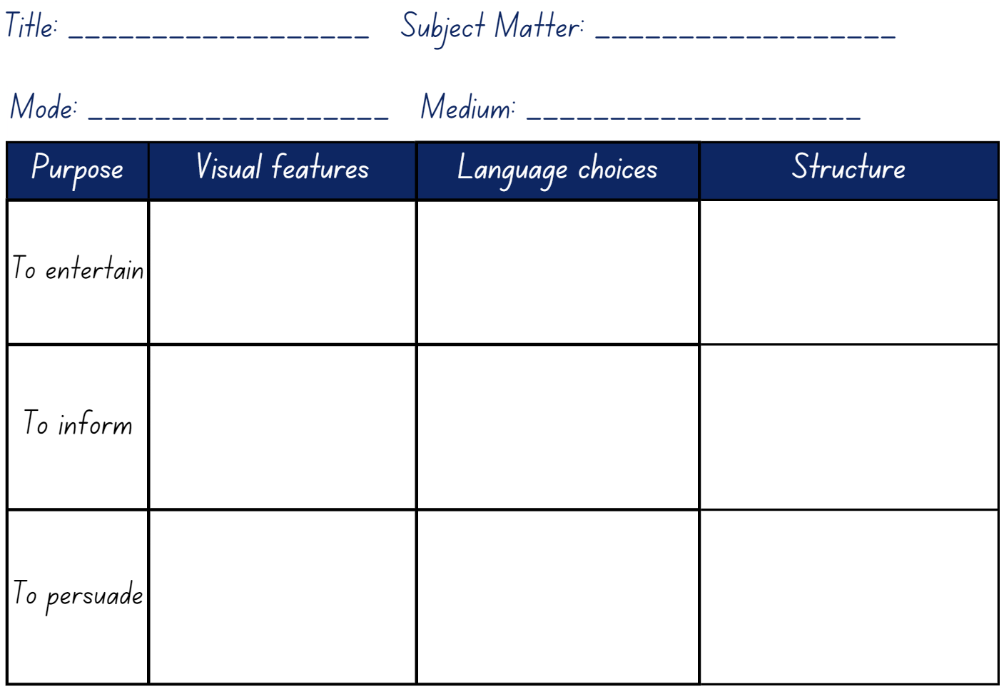

Resource 6: Research template
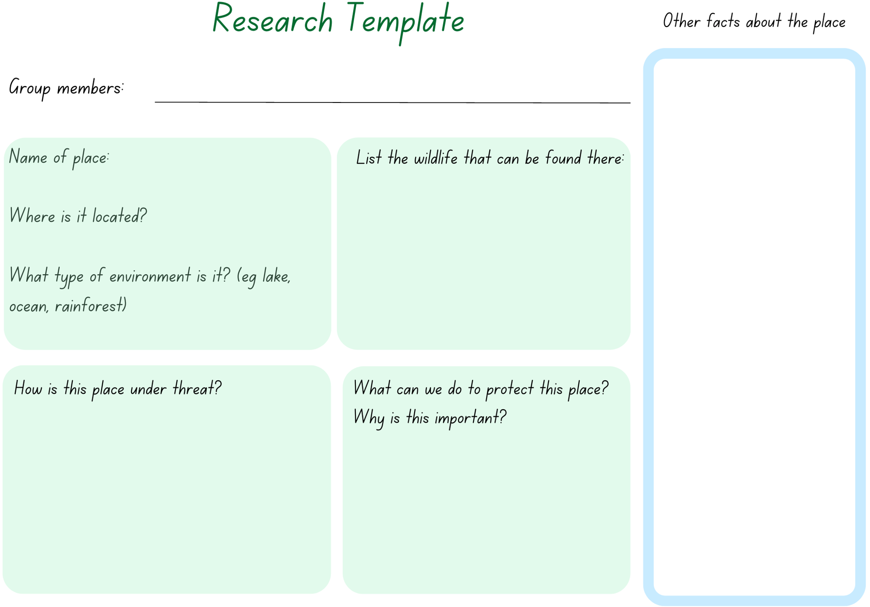
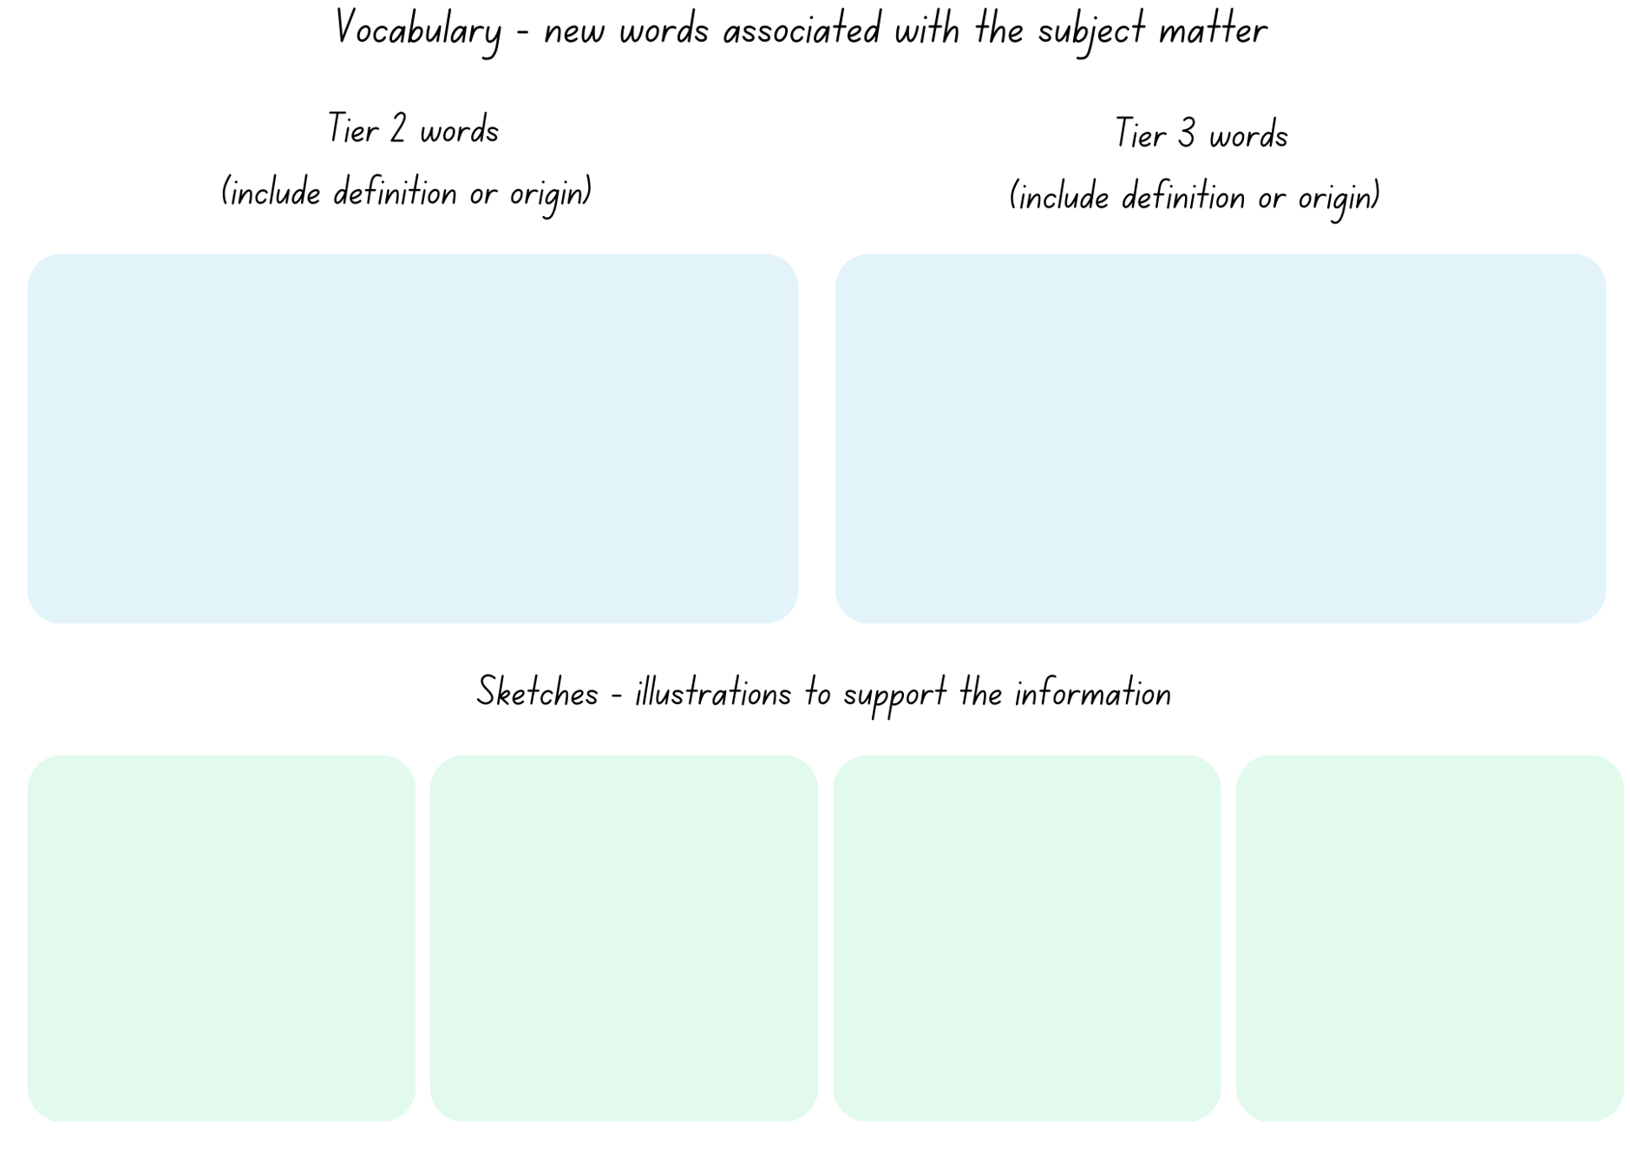

Resource 7: Planning scaffold 1
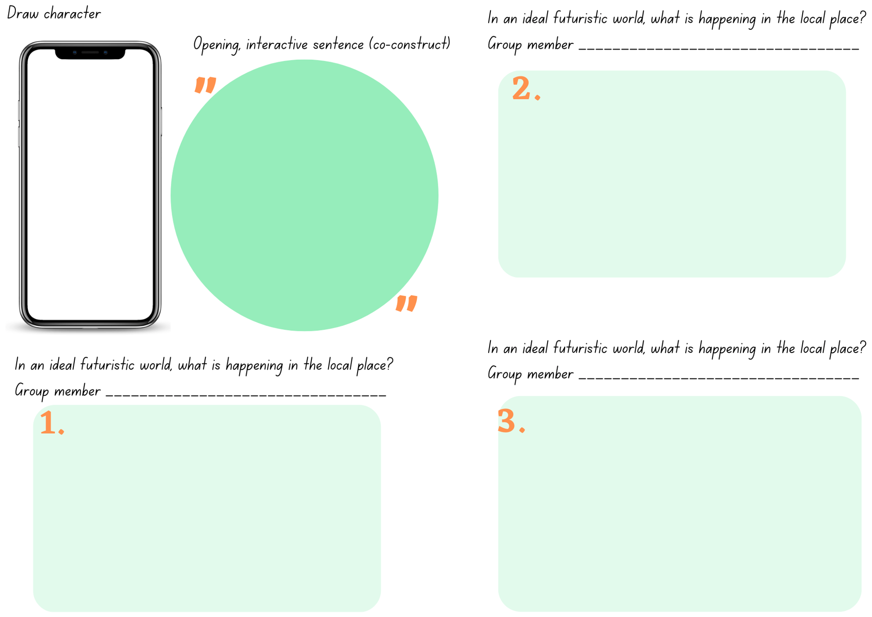
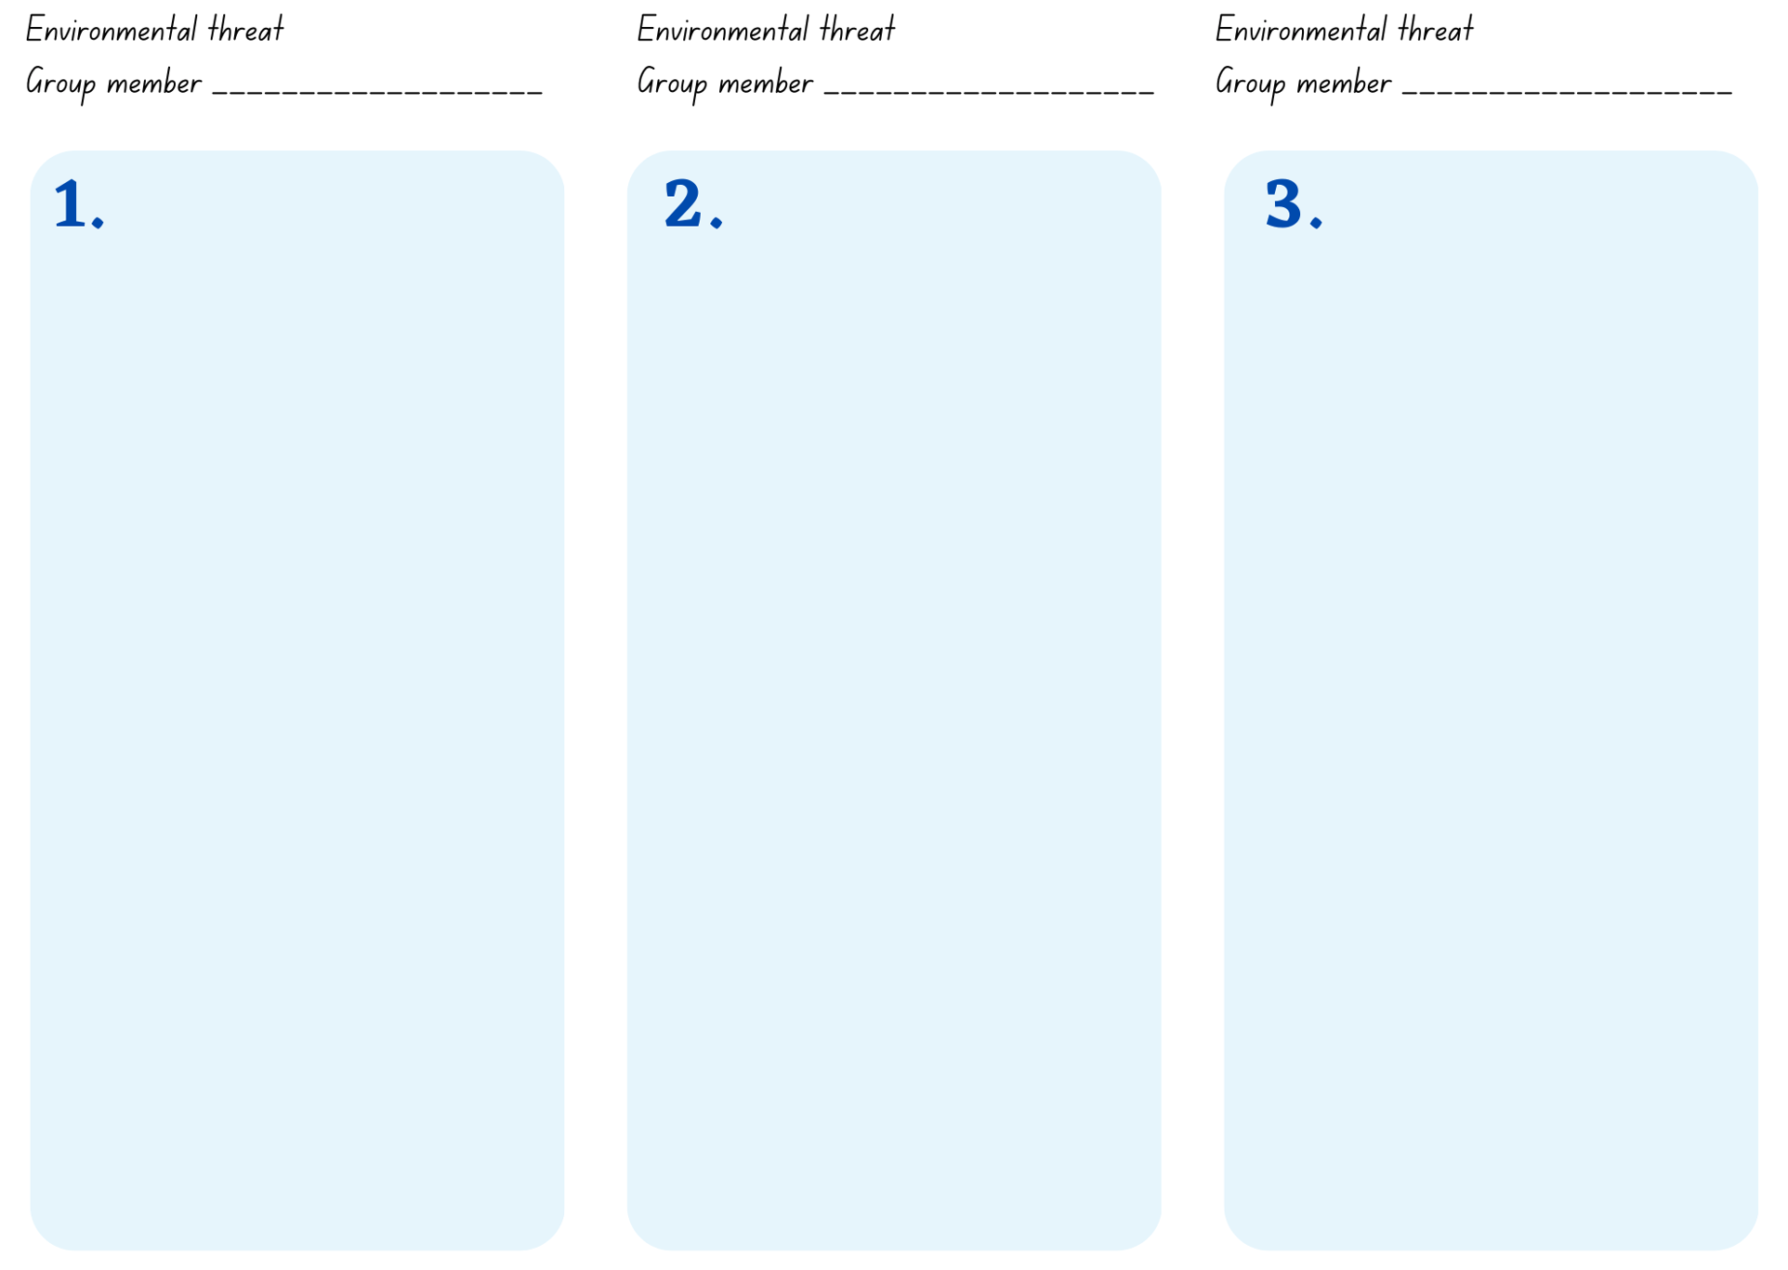
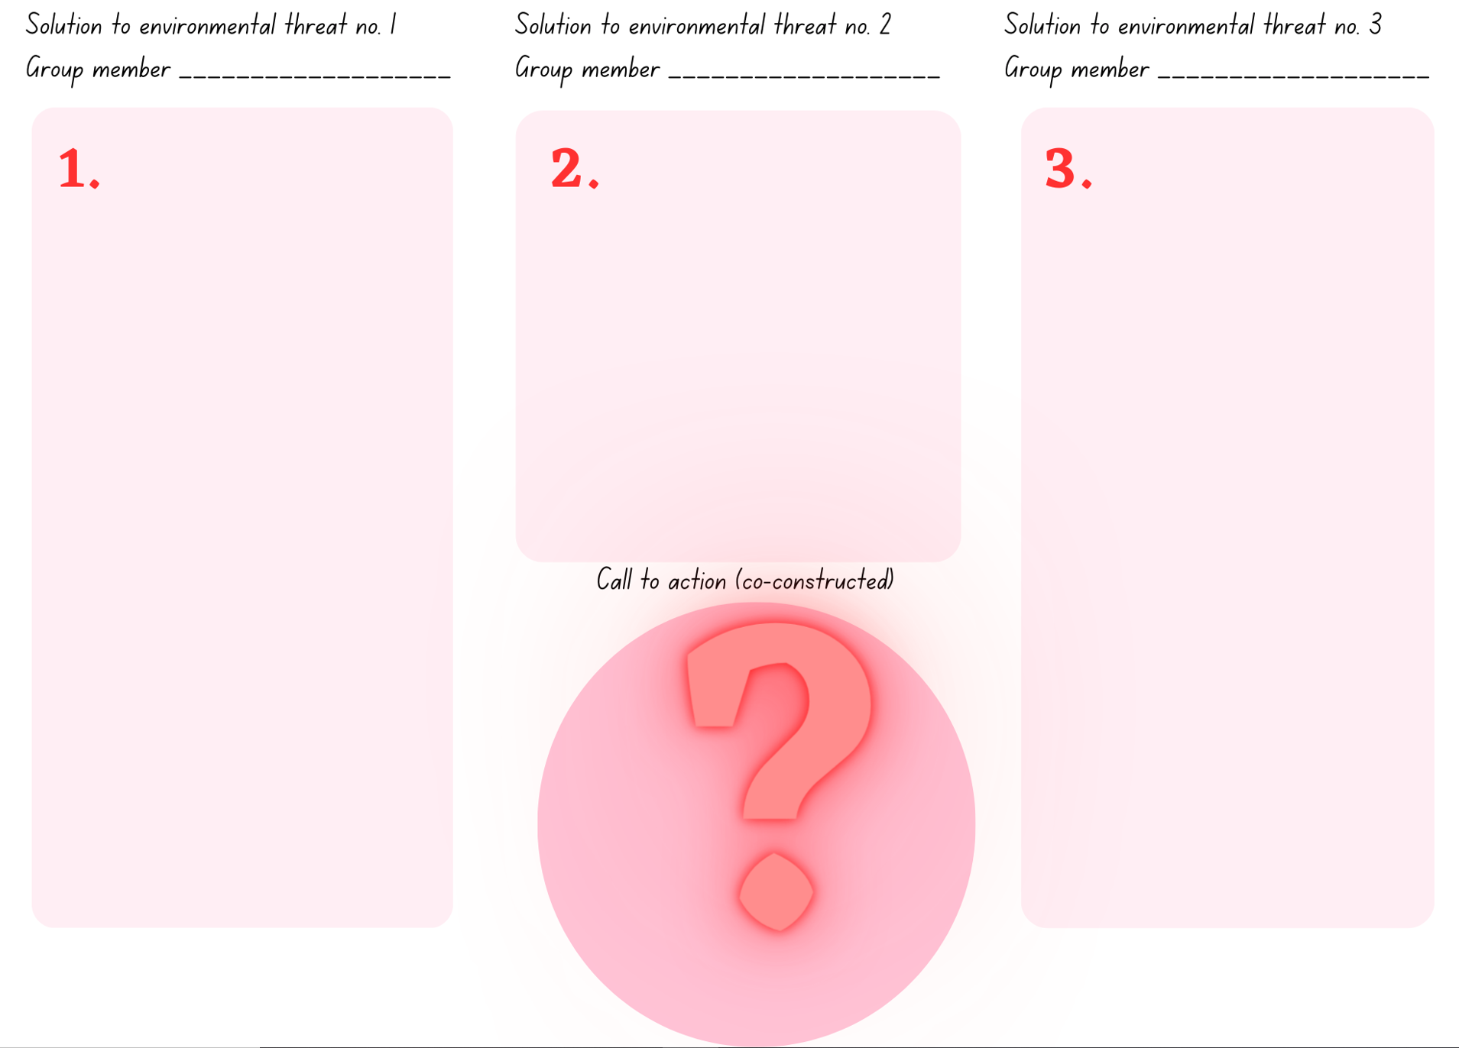

Resource 8: Writing cycle
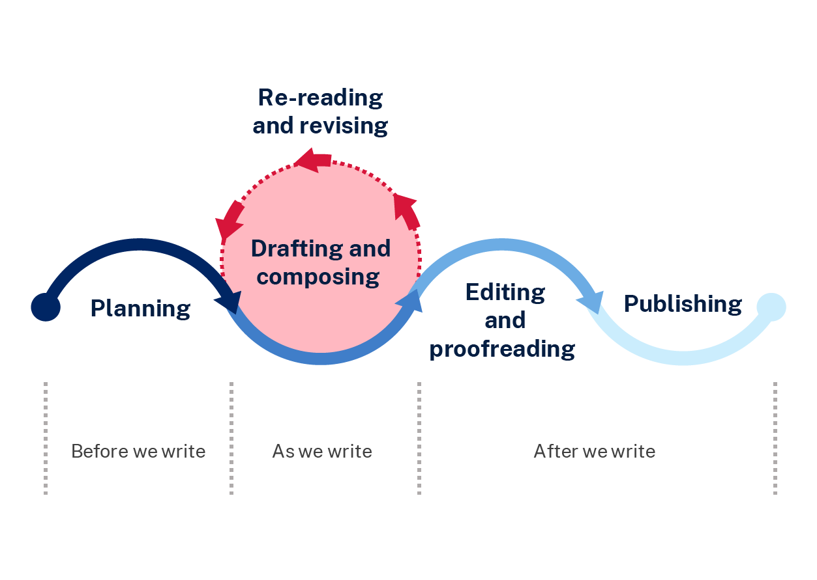

Resource 9: Dedication and message

Resource 10: Five senses
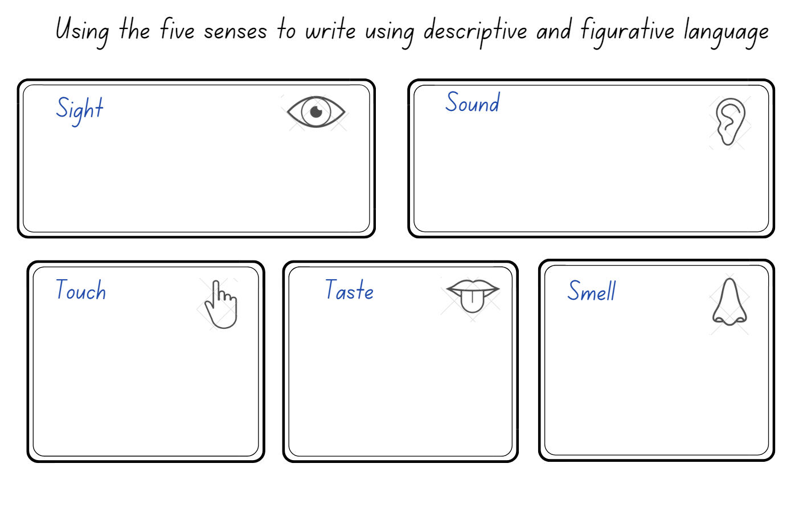

Resource 11: Planning scaffold 2
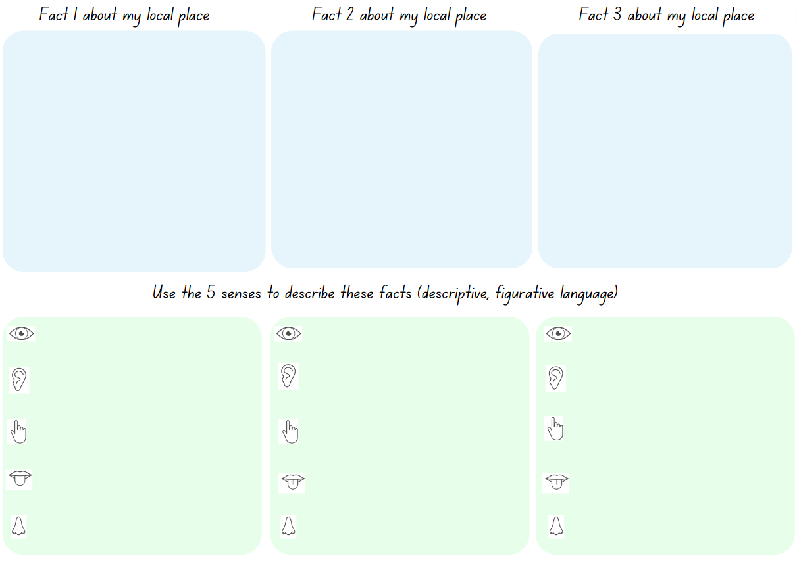

References
This resource contains NSW Curriculum and syllabus content. The NSW Curriculum is developed by the NSW Education Standards Authority. This content is prepared by NESA for and on behalf of the Crown in right of the State of New South Wales. The material is protected by Crown copyright.
Please refer to the NESA Copyright Disclaimer for more information. https://educationstandards.nsw.edu.au/wps/portal/nesa/mini-footer/copyright
NESA holds the only official and up-to-date versions of the NSW Curriculum and syllabus documents. Please visit the NSW Education Standards Authority (NESA) website https://educationstandards.nsw.edu.au/ and the NSW Curriculum website https://curriculum.nsw.edu.au/home.
English K–10 Syllabus © NSW Education Standards Authority (NESA) for and on behalf of the Crown in right of the State of New South Wales, 2022.
National Literacy Learning Progression © Australian Curriculum, Assessment and Reporting Authority (ACARA) 2010 to present, unless otherwise indicated. This material was downloaded from the Australian Curriculum website (National Literacy Learning Progression) (accessed 20 August 2023) and was not modified.
Anelli, L (2021) Liz Anelli Illustration, Liz Anelli [website], accessed 20 August 2023.
Australian Broadcasting Commission (ABC) (24 September 2019), ‘Greta’s passionate UN speech’ [video], Behind the News (BTN), ABC website, accessed 20 August 2023.
Brown P (2016) The Wild Robot, Hachette Book Group, United States of America.
Department of Climate Change, Energy, the Environment and Water (DCCEEW) (2021a) Conserving Kakadu, DCCEEW website, accessed 20 August 2023.
DCCEEW (2021b) Green Kids Guide to Threatened Species: 9 Ways You Can Help, DCCEEW website, accessed 20 August 2023.
DCCEEW (2021c) Kakadu Threatened Species Strategy, DCCEEW website, accessed 20 August 2023.
DCCEEW (2021d) Welcome to Kakadu National Park, DCCEEW website, accessed 20 August 2023.
Forde C (2022) Bright New World (Lord B, Illus), Welbeck Editions, Great Britain.
Forde C (2023) Cindy Forde: Author, Activist, and Entrepreneur, Cindy Forde website, accessed 20 August 2023.
Freeman P (2020) Dry to Dry: The Seasons of Kakadu (Anelli L, Illus), Walker Books, Australia.
Freeman P (2021) Pamela Freeman, Pamela Freeman website, accessed 20 August 2023.
HiHo Kids (16 October 2022) ‘Kids Meet an Environmental Activist’ [video], HiHo Kids, YouTube, accessed 20 August 2023.
Jones A (presenter) (6 December 2022) ‘Snarling Saltwater Crocodiles’ [radio program], Noisy by Nature, ABC Kids listen, Australia.
Miriam Rose Foundation (29 November 2017) ‘DADIRRI’ [video], MiriamRoseFoundation, YouTube, accessed 20 August 2023.
Parks Australia (Commonwealth of Australia) (2023) Kakadu National Park, Parks Australia website, accessed 20 August 2023.
Taylor A (presenter) (4 June 2010) ‘Stop 1: Mamukala wetlands, South Alligator River’ [radio program], Kakadu podtour stops, ABC Local, Australia.
Walker Books Australia (9 September 2020) ‘Liz Anelli Takes Us Behind the Scenes of Dry to Dry’ [video], WalkerBooksAus, YouTube, accessed 20 August 2023.

© State of New South Wales (Department of Education), 2023
The copyright material published in this resource is subject to the Copyright Act 1968 (Cth) and is owned by the NSW Department of Education or, where indicated, by a party other than the NSW Department of Education (third-party material).
Copyright material available in this resource and owned by the NSW Department of Education is licensed under a Creative Commons Attribution 4.0 International (CC BY 4.0) license.
This license allows you to share and adapt the material for any purpose, even commercially.
Attribution should be given to © State of New South Wales (Department of Education), 2023.
Material in this resource not available under a Creative Commons license:
- the NSW Department of Education logo, other logos and trademark-protected material
- material owned by a third party that has been reproduced with permission. You will need to obtain permission from the third party to reuse its material.
Links to third-party material and websites
Please note that the provided (reading/viewing material/list/links/texts) are a suggestion only and implies no endorsement, by the New South Wales Department of Education, of any author, publisher, or book title. School principals and teachers are best placed to assess the suitability of resources that would complement the curriculum and reflect the needs and interests of their students.
If you use the links provided in this document to access a third-party's website, you acknowledge that the terms of use, including licence terms set out on the third-party's website apply to the use which may be made of the materials on that third-party website or where permitted by the Copyright Act 1968 (Cth). The department accepts no responsibility for content on third-party websites.

