English Stage 2 – Unit 2
Contents
Unit overview and instructions for use 4
Teacher notes 6
Outcomes and content 7
Resources 12
Week 1 15
Component A teaching and learning 15
Component B teaching and learning 24
Lesson 1: Exploring genre 25
Lesson 2: Exploring a multipurpose text 27
Lesson 3: Exploring the purpose and author’s message 29
Lesson 4: Analysing structure and language choices in a text 30
Week 2 34
Component A teaching and learning 34
Component B teaching and learning 45
Lesson 5: Identifying similarities and differences between texts 46
Lesson 6: Experimenting with genre 49
Lesson 7: Using information to create descriptions 51
Lesson 8: Feedback, editing and publishing 52
Week 3 54
Component A teaching and learning 54
Component B teaching and learning 65
Lesson 9: Using descriptions to write and local inferencing 66
Lesson 10: Diagrams as a component of informative texts 69
Lesson 11: Planning and drafting an informative text 71
Lesson 12: Feedback and publishing 72
Week 4 75
Component A teaching and learning 75
Component B teaching and learning 85
Lesson 13: Analysing a text to understand its genre 86
Lesson 14: Exploring similarities and differences in informative texts 87
Lesson 15: Language choices to support a text’s purpose 89
Lesson 16: Using experiences to create written texts 90
Week 5 92
Component A teaching and learning 92
Component B teaching and learning 100
Lesson 17: Feedback and editing 101
Lesson 18: Publishing 102
Lesson 19: Reflecting on student writing 104
Lesson 20: Reflecting on textual concepts 105
Resource 1: Iceberg explanation 107
Resource 2: Text analysis 108
Resource 3: Antarctic facts 109
Resource 4: Fluency and close reading passage analysis (Week 2) 110
Resource 5: Fluency and close reading passage analysis (Week 3) 113
Resource 6: Iceberg diagram 115
Resource 7: Writing cycle 116
Resource 8: Beeswax wraps instructions 117
Resource 9: Genre analysis 118
Resource 10: Bug hotel instructions 119
Resource 11: Helping our Earth poem 120
References 121

Unit overview and instructions for use
In this 5-week unit, students will gain a deeper understanding of the textual concepts of genre and perspective and context through an analysis of the texts Iceberg and Earth’s Incredible Oceans. Throughout the unit, students will apply their understanding of genre to group texts according to their purpose, subject matter, form, structure and language choices. Students will experiment with genre to create a variety of texts using their understanding of structure and language choices to suit a text’s purpose.
Outcomes and content in this unit are organised into Component A and Component B. The components are connected, with learning in Component A complementing learning in Component B.
Note: the duration of this unit can be adapted to suit individual school contexts. For example, learning could occur across 5 days rather than 4.
The table below highlights the focus areas and preparation required for Component A and Component B.
Teaching and learning | Component A | Component B
Suggested duration | 60 minutes × 4 days/week or equivalent | 60 minutes × 4 days/week or equivalent
Explicit teaching focus areas | Component A addresses content from the focus areas:  - Vocabulary  - Reading fluency  - Reading comprehension  - Creating written texts  - Spelling  - Handwriting and digital transcription  It centres on the development of foundational skills and knowledge through regular, systematic and repeated practice. | Component B addresses content from the focus areas:  - Oral language and communication  - Vocabulary  - Reading comprehension  - Creating written texts  - Understanding and responding to literature  It centres on the conceptual understandings of English and exemplifies the importance of learning about and enjoying literature through the study of quality texts.
Preparing for teaching and learning | - Specific teaching and learning activities need to be developed by the teacher. When planning for these activities, please refer to the Component A outcomes and content, teaching guides and planning frameworks.  - Plan and document how you will sequence teaching and learning in whole-class and targeted-groups across the 5-week cycle as required. This should be based on student needs identified through ongoing assessment data. | - Familiarise yourself with the mentor and supporting texts and textual concepts, and the teaching and learning sequence.  - Determine how you will support students in whole-class and targeted-groups across the 5-week cycle as required. This should be based on student needs identified through ongoing assessment data.
English K–10 Syllabus © NSW Education Standards Authority (NESA) for and on behalf of the Crown in right of the State of New South Wales, 2022.

Teacher notes
- Genre is the mentor concept of this unit, explored using the texts Iceberg by Claire Saxby and Earth’s Incredible Oceans by Jess French. Genre refers to the categories into which texts are grouped based on similarities in premise, structure and function. The genre of a text describes larger recurring patterns of subject matter and textual structures observable between texts, such as typical plots, characters and setting. Genre can also describe categories of form and structure in texts (NESA Glossary).
- Understanding of genre can be supported through watching the department’s video: Understanding genre (3:00).
- While genre is the mentor concept for the conceptual component of this unit, the supporting concept of perspective and context is also explored. Additional textual concepts may be included based on individual school context and student needs.
- For information on mode, medium, adverbial phrases and imperative sentences refer to the NESA Glossary.
- In addition to the resources listed, students will require access to short passages of the mentor and/or supporting texts. Teachers can copy extracts from texts in reliance on the Statutory Text and Artistic Works Licence. Teachers need to attribute the extracts and include the following notice: ‘This material has been copied [and communicated to you] in accordance with the statutory licence in section 113P of the Copyright Act. Any further reproduction or communication of this material by you may be the subject of copyright protection under the Act. Do not remove this notice’.
- Reflect on student learning and engagement in activities and record differentiation and adjustments within the unit to inform future teaching and learning. One way of doing this could be to add comments to the digital file.
- In NSW classrooms there is a diverse range of students including Aboriginal and Torres Strait Islander students, students learning English as an additional language or dialect, high potential and gifted students and students with disability. Some students may identify with more than one of these groups, or possibly all of them. Refer to Advice on curriculum planning for every student K-12 for further information.
- Content points are linked to the National Literacy Learning Progression version (3).
Levels and indicators sourced from National Literacy Learning Progression © Australian Curriculum, Assessment and Reporting Authority (ACARA), (accessed 11 September 2023) and was not modified. See references for more information.

Outcomes and content
The table below outlines the outcomes and content for this unit. The letters 'A' and 'B' in the header refer to Components A and B. The numbers 1 to 5 refer to weeks. The use of 'x' in these columns indicates where the content points are intended to be addressed and in which week.
Focus area and outcome, content points and National Literacy Learning Progression | A | B | 1 | 2 | 3 | 4 | 5
Oral language and communication
EN2-OLC-01 communicates with familiar audiences for social and learning purposes, by interacting, understanding and presenting
- Contribute to discussions with peers and stay on topic, build on others' ideas and express own ideas (InT4) |  | x | x | x | x | x | x
- Listen actively to identify spoken information, acknowledging the value of others’ contributions (LiS6) |  | x | x | x | x | x | x
Vocabulary
EN2-VOCAB-01 builds knowledge and use of Tier 1, Tier 2 and Tier 3 vocabulary through interacting, wide reading and writing, and by defining and analysing words
- Build personal Tier 1, Tier 2 and Tier 3 vocabulary through social and learning interactions, reading and writing (SpK6) | x | x | x | x | x | x | x
- Understand that many words derive from other languages, including Aboriginal and Torres Strait Islander Languages, and that the pronunciation and spelling of words may reflect their etymology | x |  |  | x | x |  | x
Reading fluency
EN2-REFLU-01 sustains independent reading with accuracy, automaticity, rate and prosody suited to purpose, audience and meaning
- Demonstrate use of navigation pathways to support fluency when engaging with print, visual and multimodal texts (UnT7) | x |  |  |  | x | x
- Explain how prosodic reading involves emphasis, expression, intonation and pausing | x |  | x | x | x |  | x
- Recognise that there are different purposes and audiences for reading and adjust reading rate to suit a text’s purpose (FlY5) | x |  | x | x | x | x | x
Reading comprehension
EN2-RECOM-01 reads and comprehends texts for wide purposes using knowledge of text structures and language, and by monitoring comprehension
- Identify similarities and compare differences within and between texts by making text-to-self, text-to-text and text-to-world connections |  | x | x | x |  | x | x
- Identify different structures and features of persuasive, informative and imaginative texts | x | x | x | x | x | x | x
- Link the meanings of words and phrases across consecutive sentences to support local inferencing | x | x | x | x | x
- Identify where meaning breaks down when reading (UnT6) | x |  | x | x | x
- Ask questions to clarify meaning and promote deeper understanding of a text (LiS6, UnT6) | x |  | x | x | x |  | x
Creating written texts
EN2-CWT-02 plans, creates and revises written texts for informative purposes, using text features, sentence-level grammar, punctuation and word-level language for a target audience
- Create written texts that describe experiences and observations to connect with and inform an audience (CrT8) |  | x |  |  |  | x | x
- Create written texts that instruct, that may include a statement of purpose or goal, a list of resources and a series of steps (CrT8) |  | x |  |  |  | x | x
- Select and use multimodal features to add meaning |  | x |  |  | x |  | x
- Use adverbial phrases or clauses to add information to the verb or verb group of the main or other clauses, to provide reasons for or circumstances | x | x | x | x | x | x | x
- Use verb sentence openers to indicate action processes | x | x |  |  |  | x | x
- Use imperative sentences to advise, provide instructions, express a request or a command | x | x |  |  |  | x | x
- Use capital letters to indicate the beginning of a sentence, proper nouns, headings and subheadings, to indicate the beginning of a poetry line, for emphasis, and when using acronyms | x | x |  |  | x | x | x
- Use commas between words in a list or to separate adjectives when more than one is used (PuN4, PuN6) | x | x | x |  |  |  | x
- Use bullet points or numbering to list items or a sequence of steps | x | x |  |  |  | x | x
- Use adjectives to develop descriptive features (CrT8) | x | x | x | x | x | x | x
Spelling
EN2-SPELL-01 selects, applies and describes appropriate phonological, orthographic and morphological generalisations and strategies when spelling in a range of contexts
- Identify differences in vowel phonemes (short, long, diphthong and schwa vowels) (SpG9) | x |  | x | x | x | x | x
- Understand that some graphemes are dependent on their position in a word in English and apply this knowledge when spelling | x |  | x | x | x | x | x
- Understand that graphemes can be explained by their etymology (SpG9) | x |  |  | x |  | x
- Identify inflected suffixes, explaining when and how to treat base words when they are affixed, and apply this knowledge when spelling (SpG9) | x |  | x | x | x | x | x
Handwriting and digital transcription
EN2-HANDW-01 forms legible joined letters to develop handwriting fluency
EN2-HANDW-02 uses digital technologies to create texts
- Understand that legible handwriting is consistent in size and spacing and can support learning (HwK6) | x |  |  | x | x | x | x
- Position a chosen device in a way that facilitates efficient and sustained text creation | x |  | x |  | x |  | x
Understanding and responding to literature
EN2-UARL-01 identifies and describes how ideas are represented in literature and strategically uses similar representations when creating texts
- Understand that genre refers to texts that are grouped according to purpose, subject matter, form, structure and language choices, and that a type of text can differ in mode and medium |  | x | x | x | x | x | x
- Identify and discuss the purpose of a text, and its intended audience, mode and medium (UnT7) |  | x | x | x | x | x | x
English K–10 Syllabus © NSW Education Standards Authority (NESA) for and on behalf of the Crown in right of the State of New South Wales, 2022.

Resources
The resources in the table below are referred to in this unit. Letters 'A' and 'B' in the header refer to Component A and B respectively, and the numbers 1 to 5 indicate weeks. The use of 'x' in these columns indicate whether the resources are required in Component A, B or both, and in which week.
Resource | A | B | 1 | 2 | 3 | 4 | 5
Saxby C (2021) Iceberg (Racklyeft J, illus) Allen & Unwin, Australia. ISBN13: 9781760526047 | x | x | x | x | x |  | x
French J (2021) Earth’s Incredible Oceans (McElfatrick C, illus) Dorling Kindersley, Great Britain. ISBN13: 9780241459140 | x | x | x | x | x | x | x
Resource 1: Iceberg explanation (also Week 1 fluency passage) | x | x | x |  | x
Resource 2: Text analysis |  | x | x
Resource 3: Antarctic facts |  | x | x |  | x
T chart (one enlarged copy and one per student) |  | x | x
Resource 4: Fluency and close reading passage analysis (Week 2) | x |  |  | x
Venn diagram |  | x |  | x |  | x
Mini whiteboards |  | x |  | x
Sticky notes |  | x | x | x |  | x
Resource 5: Fluency and close reading passage analysis (Week 3) | x |  |  | x
Resource 6: Iceberg diagram |  | x |  |  | x
Writing scaffold |  | x |  |  | x
Plus, Minus, Interesting (PMI) chart |  | x |  |  |  | x
Resource 7: Writing cycle |  | x |  |  | x | x | x
Resource 8: Beeswax wraps instructions (also fluency passage) | x | x |  |  |  | x
Resource 9: Genre analysis |  | x |  |  |  | x | x
Resource 10: Bug hotel instructions |  | x |  |  |  | x
Resource 11: Helping our Earth poem (fluency passage) | x |  |  |  |  | x
Triple Venn diagram |  | x |  |  |  |  | x

Week 1

Component A teaching and learning
Component A focuses on the development of foundational skills and knowledge through regular, systematic and repeated practice. The mentor and supporting texts used in Component B of this unit can support the effective implementation of Component A teaching and learning.

Teaching guide
Guidance for explicit teaching, teaching notes, resources and examples for the related outcomes and content points have been provided in the table below.
Focus areas and teaching notes | Resources and examples
Reading fluency  Prosody  - Explain how prosodic reading involves emphasis, expression, intonation and pausing  - Emphasis is when the reader gives extra importance or focus to specific words or parts of a sentence. It helps to convey the meaning or feeling behind the text.  - Readers may emphasise words or phrases that  - Clarify important points or provide new information. | Reading fluency  Prosody  - Fluency and close reading passage- Resource 1: Iceberg explanation (233 words)  - Suggested sentences to illustrate the use of emphasis from the passage  - Important points: ‘...for up to 3,000 years.’  - New information: ‘This process is called iceberg calving.’
Monitoring reading fluency  - Recognise that there are different purposes and audiences for reading and adjust reading rate to suit a text’s purpose  - Reading rate for literary texts may depend on the use of expression, pausing, emphasis and the author’s use of phrasing.  - Reading rate for informative texts may depend on the vocabulary used. For example, Tier 3 technical and subject specific vocabulary may require the reader to slow down.  - Adjust rate when new vocabulary is introduced to maintain meaning and use punctuation. | Monitoring reading fluency  - Adjust reading rate for new vocabulary  - ‘This process is called iceberg calving.’  - Adjust reading rate to maintain meaning  - ‘ ...and becomes a floating entity.’  - Adjust reading rate for punctuation  - ‘...movement of the waves (current) start to melt...’  Note: bold text provides an opportunity for students to adjust their reading rate.
Reading comprehension  Comprehending language  - Link meaning of words and phrases across sentences to support local inferencing  - Local inferencing occurs when the reader clarifies the meaning of words and phrases by linking them to other words and phrases in the text (Five from Five 2023).  - It requires the reader to comprehend implied information from within relatively small sections of text, such as 2 adjacent sentences (NESA Glossary). | Reading comprehension  Comprehending language  - Opportunities to support local inferencing  - ‘Large pieces of ice break off from the edge of a glacier and fall into the ocean. This process is called iceberg calving.’ Inference: ‘This process is called iceberg calving’ links the explanation in the first sentence for students to understand the process of iceberg calving.  - ‘Instead, ice can exist in different forms, such as floes, rafts, and frazil ice.’ Inference: that icebergs are not the only form of ice.
Monitoring comprehension  - Identify when meaning breaks down when reading  - Meaning may break down due to use of technical vocabulary or lack of content knowledge, for example, understanding scientific processes.  - Ask questions to clarify meaning and promote deeper understanding of a text  - Model how to ask clarifying questions to clarify meaning and enhance understanding (literal and inferential questions). Support students to ask their own questions of the text. | Monitoring comprehension  - Suggested words or phrases from the passage  - Technical vocabulary: glacier, rafts, floes, entity  - Scientific processes: ‘Rafts are clusters of floes’, ‘This process is called iceberg calving.’  - Questions to clarify meaning  - How does iceberg calving occur?  - What is the difference between floes, rafts and frazil ice?  - Questions to promote deeper understanding  - What causes iceberg calving?  - What is causing changes in ocean temperatures?
Vocabulary  Learning and using words  - Build personal Tier 1, Tier 2 and Tier 3 vocabulary through social and learning interactions, reading and writing  - Tier 3 words are used rarely and only in highly specific situations (NESA 2023). | Vocabulary  Learning and using words  - Suggested Tier 3 vocabulary from the passage  - iceberg, glacier, rafts, erode, floes, frazil ice  Note: each week of learning contains a phonological, orthographic and morphological focus. These focuses are intended to be taught simultaneously through linguistic inquiry. Suggested words are selected to show how phonological, orthographic and morphological content can be integrated. In addition to words selected from the mentor and/or supporting text, additional sample words for inquiry are provided.
Spelling  Phonological component  - Identify differences in vowel phonemes (short, long, diphthong and schwa vowels)  - Identify the long vowel phoneme: /igh/ as in my within focus words.  - A schwa is a vowel sound in an unstressed/unaccented syllable, where a vowel does not make its long or short vowel sound. It usually sounds like the short /u/ sound but is shorter, softer and weaker. The suffixes -er and -est are often pronounced as a schwa (higher). | Spelling  Phonological component  - Suggested words from Week 1 reading material – iceberg, icy-icier-iciest, sizes, sun-sunny-sunniest  - Sample words for inquiry: fine-finer-finest, kind-kinder-kindest, slimy-slimier-slimiest, shiny-shinier-shiniest, bright-brighter-brightest, high-higher-highest, light-lighter-lightest, tight-tighter-tightest, big-bigger-biggest, thin-thinner-thinnest, thick-thicker-thickest, fit-fitter-fittest, dim-dimmer-dimmest
Orthographic component  - Understand that some graphemes are dependent on their position in a word in English and apply this knowledge when spelling  - The long vowel phoneme /igh/ can be represented by the vowel digraph [ie], the split digraph [i_e] and the trigraph [igh]. The graphemes [i, y] can also be used to represent the phoneme /igh/.  - [y, i_e] are often used at the end of base words.  - [igh, i, ie] are often used in middle and end of base words. | Orthographic component  - As above
Morphological component  - Identify inflected suffixes, explaining when and how to treat base words when they are affixed, and apply this knowledge when spelling  - Introduce inflected suffixes: comparative (-er) and superlative (-est)  - The inflected suffixes -er and -est usually attach to adjectives that have one syllable (fine, finer).  - Adjectives with more than one syllable often use the words ‘more’ and ‘most’ instead of using the inflected suffixes (polite, most polite).  - When an adjective has more than one syllable and ends in consonant -y, replace the y with i before adding the suffix, (happy-happier-happiest).  - For adjectives that are single syllable CVC words, the final consonant is usually doubled before adding -er or -est (big, bigger). | Morphological component  - As above
Creating written texts  Sentence-level grammar  - Use adverbial phrases or clauses to add information to the verb or verb group of the main or other clauses, to provide reasons for or circumstances  - An adverbial phrase is a group of words that modifies the verb in the main clause. Adverbial phrases do not contain both a subject and a verb. They cannot stand alone as an independent clause/sentence.  - Review different types of adverbial phrases. For example  - when (adverbial phrase of circumstance – time)  - where (adverbial phrase of circumstance – place)  - how (adverbial phrase of circumstance – manner)  - why (adverbial phrase of reason). | Creating written texts  Sentence-level grammar  - Suggested adverbial phrases from the passage  - ‘Icebergs are huge chunks of ice that float in the ocean.’ (where)  - ‘Large pieces of ice break off from the edge of a glacier...’ (where)  - ‘Instead, ice can exist in different forms...’ (how)  - ‘Scientists estimate that an iceberg can float in the ocean (where) for up to 3,000 years (when).’  Note: bold text highlights the adverbial phrases.
Punctuation  - Use commas between words in a list or to separate adjectives when more than one is used  - Commas are used in a sentence to give a short pause. They help to make the meaning clearer by separating parts of the sentence.  - Commas are used to separate items in a list. | Punctuation  - Suggested example from the passage  - ‘...floats, rafts, and frazil ice.’
Word-level language  - Use adjectives to develop descriptive features  - Adjectives are a word class that describes, identifies or quantifies a noun or a pronoun. Different types of adjectives include possessive, quantifying, descriptive, comparative, superlative and classifying. (NESA Glossary)  - Descriptive adjectives provide more information about a noun or pronoun through describing size, shape, colour, texture, taste, sound, opinions (mean), emotions/feelings (cranky). | Word-level language  - Suggested sentences with adjectives from the passage  - ‘Icebergs are huge chunks of ice...’  - ‘Icebergs begin as part of a big icy sheet...’  - ‘...the sun and warm ocean temperatures gradually melt the ice.’  Note: bold text highlights the descriptive adjectives.
Handwriting and digital transcription  Software functionalities and typing  - Position a chosen device in a way that facilitates efficient and sustained text creation  - Position device or monitor at an appropriate height and angle.  - The screen should be positioned straight in front of the user at approximately an arms-length. The device or monitor is placed so the top of the screen is at or below eye level.  - The height of the desk and chair should allow for feet to be placed flat on the floor. | Handwriting and digital transcription  Software functionalities and typing  - Students practise at tables and chairs supporting ergonomic device use and clear vision.

Planning framework
To plan and document Component A teaching and learning, a planning scaffold is provided. To support you in your planning, a link to a detailed example of a one-week teaching and learning cycle is included in the scaffold. Additional resources to support teaching and learning in each focus area can be found at Lesson advice guides.

Component B teaching and learning
The following teaching and learning sequence has been designed to address Component B outcomes and content and develops conceptual understandings of English through the study of quality texts. Adapt the sequence as required to best meet the needs of your students.

Learning intentions and success criteria
Learning intentions and success criteria are best co-constructed with students.

Learning intention
Students are learning to understand the conventions of genre and how they can be used to group texts.

Success criteria
Students can:
- identify and group texts according to their purpose, subject matter and form
- analyse a text’s language choices and explain how it supports its purpose
- identify how the structure of a text supports its purpose
- understand that texts can have multiple purposes.

Lesson 1: Exploring genre
- Students sit in a circle with a range of familiar texts in the middle. For example, fiction and non-fiction picture books, classroom posters, novels. Ask students how these texts could be grouped. Pause and provide students with wait time. Share student responses and, as a class, experiment grouping the texts. For example, according to purpose, subject matter or topic, type of text (poster, novel, picture book).
- Introduce the textual concept ‘genre’. Explain that genre is a term used to group different types of texts according to similarities in form (how a text is presented) and purpose. These could include informative, imaginative and persuasive texts. Explain that identifying genre helps readers make predictions about patterns in a text, understand the type of book they will be reading and select books they are interested in.
- Display an enlarged copy of Resource 2: Text analysis. Explain that analysing a text can help a reader to group texts and understand its genre. Read through the guiding questions on the resource. Discuss and elaborate on the examples provided. For example:
- What is the purpose of the text? For example, to persuade, to inform, to entertain or multiple purposes
- What is the subject matter? For example, friendship, volcanoes, recipes
- How is the text presented (form)? Explain that there are literary text forms and factual text forms. Literary text forms may include poetry, picture or chapter books, comics, digital movies, scripts, audiobooks. Factual text forms may include descriptive or informative books, encyclopedias, recipe books, journals or diaries, videos, podcasts.
- Make a range of texts available. For example, podcasts, books, videos, websites, audiobooks, articles, posters, poems. Display the texts around the classroom. Use electronic devices to access podcasts, websites and audiobooks.
- Review classroom expectations of respectful interactions as a strategy for learning. For example, acknowledging the contributions of others, actively listening, contributing to discussions, staying on topic during discussions.
- Provide students with a copy of Resource 2: Text analysis. In pairs, students walk around the classroom and select a variety of resources from activity 4 to analyse. Students discuss the guiding questions, building on each other's ideas and record their responses.
- As a class, share student observations and ideas. Ask:
- Were some texts easier to analyse than others? Why do you think that?
- What similarities and differences did you observe between texts? Were you able to make any text-to-text connections? If so, explain the connections you made.
- Reflect on the textual concept of genre and co-construct a class definition. Ask guiding questions to support student thinking. For example:
- Why is it important to understand genre?
- How can genre help us understand and group texts?

Lesson 2: Exploring a multipurpose text
- Provide small groups of students with Resource 3: Antarctic facts. Students take turns to read the information then discuss the subject matter, the purpose of the text and how they know. Encourage students to ask questions to support building their background knowledge. Ask students how they could sort the information provided. For example, animals in the Antarctic, weather, location, types of ice found in Antarctica. In small groups, students experiment with grouping the cards. Students share new information they learnt about Antarctica.
- Slowly reveal the front cover of the text, Iceberg by Claire Saxby. Ask students to predict the purpose of the text and justify their thinking.
- Explore what students know about the author Claire Saxby. Ask:
- What other books have you read by Claire Saxby? For example, Emu, Great White Shark, Koala.
- What subject matter or themes does she explore in her books?
- What genres does she normally write in?
- Read the text, pausing to clarify information and vocabulary.
- In pairs, students discuss the purpose of the text and provide examples to support their reasoning. Share responses, building on others’ ideas.
- Students make connections to the information explored using the Antarctic cards from activity 1. For example, ‘Seals dive deeper to twitch whisker hunt’ connects with the card that reads ‘A seal uses its whiskers to hunt for food’. Discuss how the information is presented differently. For example, in Iceberg, Claire Saxby uses vivid descriptions to inform and entertain the reader.
- Display an enlarged T-chart with the headings ‘To entertain’ and ‘To inform’. Re-read the first double page spread from the text. Link learning in Component A about adverbial phrases, adjectives and commas to separate words in a list to support a language analysis of the text. Model analysing the language choices Claire Saxby used to support the text’s purpose of ‘To entertain’. For example:
- adjectives: final, green, star-full, endless
- adverbial phrase: ‘green tails wave across a star-full sky’ provides information about ‘where’
- metaphor: ‘green tails wave across a star-full sky’ compares the green lights from Aurora Australis to green tails
- repetition: looks empty, looks closer.
- Record ideas on the T-chart.
- Re-read the paragraph and analyse the text to identify the different language choices to support the text’s purpose ‘To inform’. For example:
- adverbial phrase: ‘In the final freeze of an Antarctic winter’ provides information about where and when
- Tier 2 vocabulary: roam, penguin, farewell, roam
- Tier 3 vocabulary: orca, Antarctic.
- Provide students with a double page spread from the text. In pairs, students use a T-chart to analyse and record the language choices Claire Saxby used to support the text’s purpose (to inform and to entertain).
- As a class, share student responses and explore the variety of language choices used in the text. Ask how developing an understanding of the language choices used by authors helps the reader to understand the purpose and genre of the text. Share student responses.

Lesson 3: Exploring the purpose and author’s message
- In small groups, students play a game of headbands. One player wears a headband with a word or phrase from Iceberg. For example, ‘blue-eyed cormorants’. Students ask yes/no questions to guess the answer on their headband. For example, students could ask if it is an animal, if it describes the action of an animal or if it describes the image.
Too hard? Provide students with images of different animals from the text. Students describe the images using adjectives and verbs.
- Re-read and display the last page of Iceberg about global warming. In pairs, students explore why Claire Saxby included this page in the text. Ask:
- What do you think Claire Saxby hoped to achieve by including this page? Why do you think that?
- How could you describe the purpose of this passage? What makes you say that?
- How does the structure and language choices of this passage support its purpose?
- What is the main message explored in this passage? What makes you say that?
- As a class, co-construct an oral summary of the main message of the passage.
- Revise learning about Tier 1, Tier 2 and Tier 3 words from Component A. In pairs, students deconstruct the passage to analyse the structure and language choices. For example:
- structure: information about global warming, cause and effect, call to action
- language choices: adverbial phrases, emotive language, personal pronouns, adjectives, Tier 2 and 3 vocabulary.
- Students share responses with the class. Explore how the structure and language choices support the purpose of the passage.
- Re-read Iceberg as a class. Ask students to reflect on and consider the following questions:
- What is the purpose of the whole text? Is there more than one?
- What structure and language choices support the text’s purpose?
- Why do you think Claire Saxby created a multipurpose text? How does this influence the audience?
- How would you describe the genre of Claire Saxby’s text? Why?
- How do the language features support the message of the text?
- What words or phrases in the text convey the author’s message?
- Are there any words that stand out or are repeated? If so, why do you think the author used this technique?
- Students write a reflection and include examples from the text to support their reasoning.
- Students evaluate the purpose/s of Iceberg and how Claire Saxby successfully created a multipurpose text.
Too easy? Students explain how the text could be improved or what techniques could be used to enhance the text’s purpose.

Lesson 4: Analysing structure and language choices in a text
- View and discuss the front cover of Earth’s Incredible Oceans by Jess French. Ask guiding questions, such as:
- What type of text could this be and how do you know?
- What visual elements are used and how could they relate to the text’s purpose?
- What are other books have you read by Jess French? For example, What a Waste, The Book of Brilliant Bugs.
- Flick through the text, briefly showing a range of pages. Ask students what they notice about the text. For example, I notice there is written language and images, the layout of each page is different, there is a contents page and glossary. Share student thinking and provide time for any connections that have been made (text, self, world).
- Using the contents page, read the title ‘What is the ocean?’. Before reading, students generate and share questions about the section of text. Model navigating through the text to find page 5 and read the information. Ask students to share at least one thing they learned from the section of text. Explore how the structure and language choices supported understanding.
- Using the contents page, read the title ‘The ocean floor’. Before reading, students generate and share their questions about the section of text. Provide time for students to record their questions. Model navigating through the text to find pages 10 and 11 then read the information. In small groups, students share at least one thing they learned from the section of text and if their questions were answered. Students share how the structure and/or language choices supported their understanding of the text.
- Using the contents page, read the title ‘Ancient oceans’. Before reading, students generate and record their questions about the section of text. Model navigating through the text to find pages 14 and 15 and read the information. In small groups, students share at least one thing they learned from the section of text and if their questions were answered. Students reflect on how the structure and/or language choices supported their understanding of the text. Students record their ideas on sticky notes. For example, the use of headings and subheadings, bolded vocabulary, arrows, labels, images, explanations. Share responses and place sticky notes around the page.
- In pairs, students analyse a different double page spread from the text. Students read the information sharing any new learning. On sticky notes, students record how the structure and language choices supported their understanding of the text. Students place their sticky notes around the page.
- As a class, share ideas. Create an anchor chart of the structure and language choices used by the author and illustrator to support the texts’ purpose (to inform). Display in the classroom.
- Analyse the text to assist students to understand the text’s genre. Ask:
- What is the purpose of the text? How do you know?
- What is the text about and who is the intended audience? How do you know who the intended audience is?
- What structure and language choices are used to support the text’s purpose?
- Students record their ideas to share with the class.
- Reflect on the textual concept of genre by playing a game of ‘2 truths and a lie’. Students write 2 truths and a lie demonstrating their understanding of genre. For example:
- Understanding genre helps readers understand different types of texts (truth)
- Texts can have the same purpose but different subject matter (truth)
- All texts have one genre (lie).
- In small groups, students share their 2 truths and a lie. As one student shares their ideas, the other students actively listen and identify the truth using ‘thumbs up’ and a lie using ‘thumbs down’.
Assessment task 1 – Observations from this lesson allow students to demonstrate achievement towards the following syllabus outcomes and content points:
EN2-OLC-01 – communicates with familiar audiences for social and learning purposes, by interacting, understanding and presenting
- listen actively to identify spoken information, acknowledging the value of others’ contributions.
EN2-RECOM-01 – reads and comprehends texts for wide purposes using knowledge of text structures and language, and by monitoring comprehension
- identify similarities and compare differences within and between texts by making text-to-self, text-to-text and text-to-world connections.

Week 2

Component A teaching and learning
Component A focuses on the development of foundational skills and knowledge through regular, systematic and repeated practice. The mentor and supporting texts used in Component B of this unit can support the effective implementation of Component A teaching and learning.

Teaching guide
Guidance for explicit teaching, teaching notes, resources and examples for the related outcomes and content points have been provided in the table below.
Focus areas and teaching notes | Resources and examples
Reading fluency  Prosody  - Explain how prosodic reading involves expression, intonation and pausing and use emphasis while reading  - A pause is a short stop or break when reading. Pausing between phrases helps to segment information. | Reading fluency  Prosody  - Resource 4: Fluency and close reading analysis (Week 2)  - Double page spread from Iceberg by Claire Saxby starting at ‘The new iceberg bobs...’ to ‘...meltwater trickles past their rock-nests.’ (83 words)  Note: the passage from the text will need to be a teacher-created resource  - Line breaks create a natural comma for pausing to support fluent reading and understanding. For example  - ‘Leopard seals lurk / as a raft of penguins explode / like black and white rockets from an ice hole.’
Monitoring reading fluency  - Recognise that there are different purposes and audiences for reading and adjust reading rate to suit a text’s purpose  - Reading rate for literary texts may depend on the use of expression, pausing, emphasis and the author’s use of phrasing.  - Reading rate for informative texts may depend on the vocabulary used. For example, Tier 3 technical and subject specific vocabulary may require the reader to slow down.  - Reading rate may be adjusted to allow for appropriate phrasing, to use punctuation and to indicate line breaks. | Monitoring reading fluency  - Opportunities to demonstrate a reading pace using phrasing and punctuation  - ‘Waves ripple away, away-o, to quiver at the ice pack.’
Reading comprehension  Comprehending language  - Link meaning of words and phrases across sentences to support local inferencing  - Review: local inferencing occurs when the reader clarifies the meaning of words and phrases by linking them to other words and phrases in the text. It occurs within relatively small sections of text, such as 2 adjacent sentences. | Reading comprehension  Comprehending language  - Opportunities to support local inferencing  - ‘The new iceberg bobs in the water an unfettered island, its mountain hidden underneath.’ Inference: that the iceberg is alone and a large portion is underneath the water.  - ‘Leopard seals lurk as a raft of penguins explode like black and white rockets from an ice hole.’ Inference: that the penguins are moving out of the hole quickly, escaping the leopard seals (their predator).
Monitoring comprehension  - Identify when meaning breaks down when reading  - Meaning may break down due to limited background knowledge or understanding of Tier 2 and Tier 3 vocabulary and figurative language  - Metaphor: a figure of speech used for effect that implies one thing by referring to another (NESA 2023).  - Personification: attributing human characteristics to abstractions such as love, things or animals (NESA 2023).  - Ask questions to clarify meaning and promote deeper understanding of a text  - Model how to ask clarifying questions to clarify meaning and enhance understanding (literal and inferential questions). Support students to ask their own questions of the text. | Monitoring comprehension  - Background knowledge  - Pack ice is a large area of floating ice in the ocean  - The collective noun for a group of swimming penguins is called a raft  - Adelie and emperors are species of penguin.  - Tier 2 and Tier 3 vocabulary  - unfettered island, meltwater trickles, Adelie parents  - Figurative language  - Metaphor: ‘The new iceberg bobs in the water, an unfettered island...’  - Personification: ‘Waves ripple away, away-o, to quiver at the pack ice.’  - Questions to clarify meaning  - What does unfettered island mean?  - What does unshackle mean?  - Questions to promote deeper understanding  - How do you know the season is changing?  - Why are the under-ice krill stirring?
Vocabulary  Learning and using words  - Build personal Tier 1, Tier 2 and Tier 3 vocabulary through social and learning interactions, reading and writing  - Review: Tier 3 words are used rarely and only in highly specific situations (NESA 2023).  - Understand that many words derive from other languages, including Aboriginal and Torres Strait Islander Languages, and that the pronunciation and spelling of words may reflect their etymology  - The English language is made up of words derived from many other languages including Latin, French, Greek, German and Aboriginal and Torres Strait Islander Languages.  - The pronunciation and spelling of words can reflect the etymology. For example, the French spelling of the /sh/ phoneme is ‘ch’. This is seen in the words chef, parachute and chaperone. | Vocabulary  Learning and using words  - Suggested Tier 2 and Tier 3 vocabulary from the passage  - Tier 2: quiver, unshackle, lurk, perch, island, unfettered  - Tier 3: algae, krill, emperors, Adelie, raft  - Suggested vocabulary from the passage  - island: Old English meaning ‘thing on the water’  - algae: Latin meaning ‘seaweed’
Spelling  Phonological component  - Identify differences in vowel phonemes (short, long, diphthong and schwa vowels)  - Identify the long vowel phoneme /igh/ as in my within focus words.  - Identify consonant phoneme /s/ as in sat within focus words. | Spelling  Phonological component  - Suggested words from the Week 1 reading material – ice, island, nights, sleek, dance, iceberg, penguin(s), soften(s), suspend(ed), birth(ing)  - Related words: glass(es), lesson(s), blossom-blossoms-blossomed-blossoming, slice-slices-sliced-slicing, ice-ices-iced-icing, science, scientist(s), fascinate-fascinates-fascinating-fascinated
Orthographic component  - Understand that some graphemes are dependent on their position in a word in English and apply this knowledge when spelling  - The long vowel phoneme /igh/ as in my can be represented using [i_e, ie, i, y, igh].  - [y, i_e] are often used at the end of base words.  - [igh, i, ie] are often used in middle and end of base words.  - Quickly review some known representations for /s/- [s, ss, se, ce, c, sc].  - [sc] is a less frequently used digraph (alternative spelling) to represent the phoneme /s/. The ‘sc’ spelling is more likely to be used in the middle of a word, but not all words follow this generalisation.  - Understand that graphemes can be explained by their etymology  - Words with the /s/ phoneme represented as the consonant digraph ‘sc’ are usually Latin in origin. | Orthographic component  - As above
Morphological component  - Identify inflected suffixes, explaining when and how to treat base words when they are affixed, and apply this knowledge when spelling  - Review inflected suffixes: plural (-s, -es) tense (-s, -ing, -ed).  - An inflected suffix is a bound morpheme added to the end of a base word to assign a number to a word, to indicate possession or tense, or to provide a comparison (eg -s, -es, -ing, -ed, -er, est).  - The inflected suffixes -s and -es change a noun from singular (one) to plural (more than one).  - The inflected suffixes -s, -ing, -ed change the tense of a verb. The suffixes -s and -ing express present tense, -ed expresses past tense; -ing also expresses future tense. | Morphological component  - As above
Creating written texts  Sentence-level grammar  - Use adverbial phrases or clauses to add information to the verb or verb group of the main or other clauses, to provide reasons for or circumstances  - Review different types of adverbial phrases. For example  - when (adverbial phrase of circumstance – time)  - where (adverbial phrase of circumstance – place)  - how (adverbial phrase of circumstance – manner)  - why (adverbial phrase of reason). | Creating written texts  Sentence-level grammar  - Suggested adverbial phrases from the passage  - ‘The new iceberg bobs in the water...’ (where)  - ‘Cracks unshackle algae suspended all winter...’ (when)  - ‘...begin the inland trek to feed hungry chicks.’ (why)  - ‘...as meltwater trickles past their rock-nests.’ (where)  - ‘...as a raft of penguins explode like black and white rockets from an ice hole.’ (how)  Note: bold text highlights the adverbial phrase.
Word-level language  - Use adjectives to develop descriptive features  - Review: adjectives can be used to describe a noun or a pronoun.  - Adjective types include  - Descriptive: size, shape, colour, texture, taste, sound, opinions (mean), emotions/feelings (cranky)  - Compound: are made up of more than one word. When the words are used together in front of a noun, they are usually hyphenated. This shows that the words are acting together as a single adjective (day-old bread). | Word-level language  - Suggested sentences with adjectives from the passage  - ‘The new iceberg bobs...’ (descriptive)  - ‘…like black and white rockets...’ (descriptive)  - ‘...under-ice krill stir...’ (compound)  Note: bold text highlights the adjectives in the sentence.
Handwriting and digital transcription  Handwriting legibility and fluency  - Understand that legible handwriting is consistent in size and spacing and can support learning  - Form capital letters with consistent size and spacing, including those with vertical, horizontal and diagonal lines.  - Capitals with vertical and horizontal lines include E, F, H, I, L and T.  - Capitals with diagonal lines include A, K, M, N V W X Y Z.  - Uppercase letters are full height or ‘tall’ letters. They are twice the height of ‘short’ letters.  - Focus on the correct starting place and direction of movement for each letter shape, including pen(cil) lifts and drops. | Handwriting and digital transcription  Handwriting legibility and fluency  - Example fluency pattern  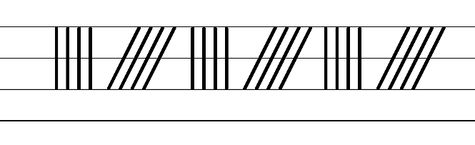  - Example capital letter formations for letters with vertical and horizontal lines  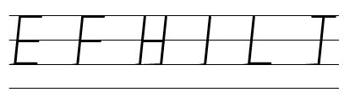  - Example capital letter formations for letters with diagonal lines  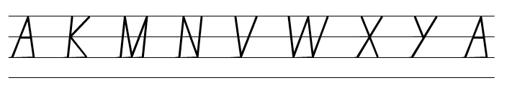  - Suggested practice text from the passage  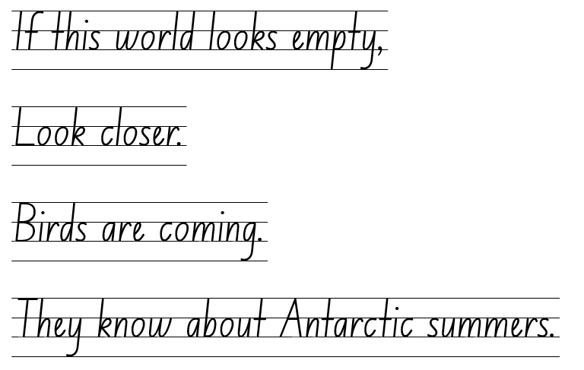  Note: some left-handers may prefer to form some letters differently. For example, cross strokes in the letters A, H and T may go from left to right, rather than right to left.

Planning framework
To plan and document Component A teaching and learning, a planning scaffold is provided. To support you in your planning, a link to a detailed example of a one-week teaching and learning cycle is included in the scaffold. Additional resources to support teaching and learning in each focus area can be found at Lesson advice guides.

Component B teaching and learning
The following teaching and learning sequence has been designed to address Component B outcomes and content and develops conceptual understandings of English through the study of quality texts. Adapt the sequence as required to best meet the needs of your students.

Learning intentions and success criteria
Learning intentions and success criteria are best co-constructed with students.

Learning intention
Students are learning to experiment with the language choices to change the genre of a text.

Success criteria
Students can:
- identify how texts can differ in mode and medium
- experiment with and change the genre of a text
- demonstrate an understanding of different genre by creating an informative description
- apply feedback to revise and edit writing.

Lesson 5: Identifying similarities and differences between texts
- Explore the interactive website, The Deep Sea. View each layer and provide time for students to make careful observations and interpretations using the See-Think-Wonder routine. Draw on learning from Component A to highlight where meaning may break down when reading the information on the website, in particular Tier 3 words. Discuss how the names of some creatures are derived from other languages and that pronunciation and spelling of words may reflect their etymology.
Optional: Provide students with devices to explore the website with a partner.
- Students Think-Pair-Share to discuss the following questions:
- What is the purpose of the website? How do you know?
- What is the website about and who is the intended audience? How do you know who the intended audience is?
- What language choices and structural features are used to support the purpose of the website?
- Encourage students to listen actively and build on their partner's ideas.
- Explain that texts may be grouped according to purpose, subject matter, form, structure and language choices and that a text can differ in mode and medium. Co-construct a definition for mode and medium. For example, mode refers to how a text is communicated (sounds, music, spoken or printed words, images). Medium refers to how a text is conveyed (linguistic, visual, gestural, spatial, audio).
- Students Think-Pair-Share to discuss the following questions:
- How is the website presented (form)?
- What are the navigation pathways and how do they enhance the text?
- How is the website communicated (mode)? Linguistic (written words), visual (diagrams, images)
- How is the text conveyed (medium)? As a website on the internet
- How does the website support readers to understand the information?
- Display ‘Layers of life’ on pages 12 and 13 of Earth’s Incredible Oceans. Explore how to navigate the page. For example:
- reading the page vertically rather than horizontally
- using the heading to help the reader know where to start reading
- using the subheadings to guide the sequence of reading.
- Read the heading and paragraph on page 13. Pause and allow students to use their knowledge of local inferencing from Component A to make inferences in the text. For example, using the sentence ‘below the surface, the ocean is split into five different zones’ to infer that the 5 different zones can be identified using the subheadings across the double page spread.
Note: local inferencing occurs when the reader clarifies the meaning of words and phrases by linking them to other words and phrases in the text (Five from Five 2023). For example, She adored her new pet. The puppy was boisterous. When identifying words and phrases in these 2 sentences, the reader can infer that a girl has a new dog (NESA Glossary).
- Continue reading the information on pages 12 and 13. Students apply their knowledge from Component A to identify and discuss the language choices made by the author. For example:
- Tier 3 vocabulary: abyssal zone, brittle stars
- Adjectives: warm, sunny, huge, crushing, cold
- Tier 2 verbs: dive, adapted
- Adverbial phrases: ‘The temperature and light changes depending on the time and season’ (how). ‘Sperm whales can dive as far as the midnight zone (where) in search for food’ (why).
- Declarative sentences: ‘The ocean is enormous’, ‘No sunlight reaches this zone.’
- Explain how Earth’s Incredible Oceans and ‘The Deep Sea’ website have the same purpose (to inform) and subject matter. Explore differences between the texts. For example, the digital text allows the viewer to scroll down highlighting how deep and dark the ocean is. The printed text is restricted to a specific size layout.
- Display an enlarged Venn diagram with the headings ‘The Deep Sea’ and ‘Layers of Life’. Explain that students will consider how these texts could be grouped in similar and different ways. On sticky notes, students record their ideas. Encourage students to consider the purpose of the text, subject matter, form, structure, mode and medium. For example, both texts have the same purpose and present information about the different layers and zones in the ocean. The medium is different, ‘The Deep Sea’ website is conveyed digitally, and Earth’s Incredible Oceans is printed.
- As a class, share student responses and discuss the genre of each text. For example, ‘The Deep Sea’ is an informative website and Earth’s Incredible Oceans is an informative (non-fiction) picture book.
- Review ‘Layers of Life’ (pp 12–13) and its purpose (to inform). Ask students how the purpose of the text could change and be grouped into a different genre. For example, adding descriptive and figurative language could change the text’s purpose to inform and entertain, creating a text with multiple purposes.
- Revise the language features Claire Saxby used in Iceberg to create vivid descriptions from Lesson 2. For example, adjectives, adverbial phrases, similes, metaphors and repetition.
- Read the information under the subheading ‘Sunlight zone’ on page 12. Display the sentence ‘It is warm and sunny here’. Model rewriting the sentence using descriptive language. For example, The golden rays of the sun kiss the crystal-clear water, the radiant sun casts a golden shadow over the translucent water. On mini whiteboards, students experiment rewriting the sentence using descriptive language.
- Re-read the phrase ‘with lots of plants.’ On mini whiteboards, students experiment rewriting the phrase using descriptive language. For example, the captivating, colourful coral dance beside the silky seaweed.
- Students share the descriptive language used and record ideas on an anchor chart to use in Lesson 6.

Lesson 6: Experimenting with genre
- Display the sentence ‘Short-tailed shearwaters feast then return to their chicks’ from Iceberg. Revise ways Claire Saxby experimented with language choices to support the purpose of the text (to inform and to entertain). In pairs, student deconstruct the sentence to identify language choices. For example:
- Adjectives: short-tailed
- Tier 2 verbs: feast
- Tier 3 vocabulary: shearwaters
- Adverbial phrases: to their chicks (where).
- Revise how Jess French’s language choices in Earth’s Incredible Oceans supports the purpose of the text (to inform). For example, Tier 3 vocabulary, declarative sentences, subject specific vocabulary (definitions).
- Explore ‘Ocean animals’ on pages 19 to 38 to build background knowledge of the animals in Iceberg.
- Explain that writers can experiment with and change the genre of texts. For example, using different language choices to create a multipurpose text. Using the anchor chart from Lesson 5, model using the information on pages 12 to 13 of Earth’s Incredible Oceans to write a description. For example:
The golden rays of the sun kiss the crystal water. In the sunlight zone, a shadow is cast over the colourful coral. As time passes, the temperature and light change. A school of fish dart through the silky, soft seaweed like shimmering bolts of lightning. Powerful sharks glide gracefully through warm waters. Playful dolphins swim to the surface and splash along the pristine, sparkling shoreline. Alongside the other animals, jellyfish drift in this sun kissed sanctuary. The colossal sperm whale descends into the deeper water. Its massive body glides with purpose and strength.
Note: keep the modelled writing to build on during Lesson 7.
- Deconstruct the modelled paragraph and identify the language choices that support the text’s purpose (to entertain, to inform). For example:
- Adjectives: silky, soft, pristine, sparkling, golden, playful, sleek, delicate, colossal
- Adverbial phrases: over the colourful coral (where), along the pristine, sparkling shoreline (where), with purpose and strength (how)
- Alliteration: colourful coral, sparkling shoreline
- Simile: a school of fish dart through the silky, soft seaweed like shimmering bolts of lightning
- Tier 2 verbs: cast, dart, glide, drift, descends
- Tier 3 vocabulary: sunlight zone, sperm whale
- Punctuation: commas to separate adjectives when more than one is used.
- Using the deconstructed paragraph from activity 5, co-construct a success criteria for writing. This will also be used in Lesson 7 and Lesson 8.
- Students use the information about the sunlight zone to write a description. Encourage students to refer to the success criteria and revise their work during the writing process.
Too hard? Students draw and label an illustration using the information from the text. Students orally share their description.

Lesson 7: Using information to create descriptions
- Read an animal name from Earth’s Incredible Oceans on pages 12 and 13. For example, a shark. Instruct students to move around the classroom as the given animal. Encourage students to consider adjectives, verbs and adverbial phrases to provide more details about the shark’s movement. Ask:
- How would a shark swim in the sunlight zone?
- How could you describe the shark moving in the water?
- How would the shark respond if they saw a school of fish?
- Why would the shark move between the zones?
- Revise the purpose for writing and the co-constructed success criteria from Lesson 6.
- Ask questions for students to consider the impact of descriptive language in understanding the genre and purpose of a text. For example:
- How does the use of descriptive language help you identify the genre and purpose of a text?
- What specific words or phrases might indicate that a text belongs to a particular genre?
- What impact does the descriptive language have on the reader's engagement with and understanding of a text?
- Read the information about the different zones on pages 12 to 13 from Earth’s Incredible Oceans. Review the modelled example from Lesson 6 and explain that students will build further descriptions using information from the text.
- Model using information from the twilight and midnight zone to write a description that builds on the modelled paragraph from Lesson 6. For example:
The majestic sperm whale continues its journey deeper into the water where the sunlight begins to fade. Sabertooth fish navigate the gloomy twilight zone with their enormous eyes. The sperm whale uses its senses to find its potential prey. Detecting movement nearby, the sperm whale inches closer and closer. The floating squid unaware of its immediate danger. One large bite. Gone!
- In pairs, students re-read their paragraph about the sunlight zone from Lesson 6. Students use the information from the twilight and midnight zone to orally share descriptive sentences that could be used in their writing.
- Using the information from the texts, students write a description that builds on their paragraph from Lesson 6. Encourage students to refer to the success criteria and revise their work.
Too hard? Co-construct a description using the information from the text and teacher sourced picture prompts.
Too easy? Students use information from the abyssal and hadal zone to build further descriptions.

Lesson 8: Feedback, editing and publishing
- Revise the purpose of editing and its importance in the writing process.
- Select a peer feedback protocol for students to use. In pairs, students provide feedback using the co-constructed success criteria from Lesson 6.
- Provide time for students to apply feedback to revise and edit their writing.
- Revise the intended audience and purpose for writing (to create a multipurpose text that informs and entertains the reader). Explore the illustrations in Iceberg and how Jess Racklyeft used colour and layout to support the text’s purpose.
- Students publish their descriptions using illustrations to support the purpose of their texts.
Note: students’ descriptions will be used to reflect on their learning in Lesson 19.

Week 3

Component A teaching and learning
Component A focuses on the development of foundational skills and knowledge through regular, systematic and repeated practice. The mentor and supporting texts used in Component B of this unit can support the effective implementation of Component A teaching and learning.

Teaching guide
Guidance for explicit teaching, teaching notes, resources and examples for the related outcomes and content points have been provided in the table below.
Focus areas and teaching notes | Resources and examples
Reading fluency  Reading automaticity and rate  - Demonstrate the use of navigation pathways to support fluency when engaging with print, visual and multimodal texts  - Navigation pathways refers to the path followed while moving through the content of a text. It involves navigating the text to support fluency in a way that doesn't disrupt the overall comprehension and allows the reader to engage with print, visual, and multimodal texts.  - Students navigate using page layout, headings and subheadings. | Reading fluency  Reading automaticity and rate  - Resource 5: Fluency and close reading passage analysis (Week 3)  - The Ocean in Motion (pp 8–9) from Earth’s Incredible Oceans (238 words)  Note: the passage from the text will need to be a teacher-created resource.  - The text is navigated from left to right, with the size of the headings and subheadings indicating the order for reading. The use of ‘thirds’ on the right-hand page indicate different sections of text to be read.  - The use of arrows may interrupt the navigation pathway. Arrows are used as a visual to support understanding and enhance meaning rather than direct the reader through the text.
Prosody  - Explain how prosodic reading involves emphasis, expression, intonation and pausing  - A pause is a short stop or break when reading.  - Commas are used in a sentence to give a short pause. They help to make the meaning clearer by separating parts of the sentence. | Prosody  - Suggested example for use of pausing  - ‘When wind blows over the surface of water, waves form.’ (p 9)
Monitoring reading fluency  - Recognise that there are different purposes and audiences for reading and adjust reading rate to suit a text’s purpose  - Reading rate for informative texts may depend on the vocabulary used. For example, Tier 3 technical and subject specific vocabulary may require the reader to slow down.  - Readers may need to adjust reading rate for each section of text. | Monitoring reading fluency  - Due to the location of the text across the 2 pages, students may need to adjust reading rate to maintain meaning.
Reading comprehension  Comprehending text structures and features  - Identify different structures and features of persuasive, informative and imaginative texts  - Informative text structures can include an introduction, body paragraphs and conclusion. Text features may include headings/subheadings, real-life examples. | Reading comprehension  Comprehending text structures and features  - Text structure  - Introduction about moving water, information grouped into sections with the use of headings and subheadings  - Text features  - Bolded words, labels, arrows, graphics visuals to support meaning.
Monitoring comprehension  - Identify where meaning breaks down when reading  - Meaning may break down due to use of technical vocabulary or lack of content knowledge, for example, understanding scientific processes.  - Ask questions to clarify meaning and promote deeper understanding of a text  - Model how to ask clarifying questions to clarify meaning and enhance understanding (literal and inferential questions). Support students to ask their own questions of the text. | Monitoring comprehension  - Suggested words or phrases from the passage  - Technical vocabulary: tsunami, earthquake, current  - Scientific processes: the process of a tsunami.  - Questions to clarify meaning  - What factors cause ocean water to move?  - What causes currents in the deeper water?  - Questions to promote deeper understanding  - What role does water temperature and depth play in the formation of ocean currents?  - What impact do tsunamis have as they change and move away from the earthquake site?
Vocabulary  Learning and using words  - Build personal Tier 1, Tier 2 and Tier 3 vocabulary through social and learning interactions, reading and writing  - Tier 3 words are used rarely and only in highly specific situations (NESA 2023).  - Understand that many words derive from other languages and that their pronunciation and spelling may reflect their etymology  - The English language is made up of words derived from many other languages including Latin, French, Greek, German and Aboriginal and Torres Strait Islander Languages.  - The pronunciation and spelling of words can reflect the etymology. For example, the French spelling of the /sh/ phoneme is ‘ch’. This is seen in the words chef, parachute and chaperone. | Vocabulary  Learning and using words  - Suggested Tier 3 vocabulary from the passage  - currents (p 8), earthquake, tsunami, gravity, tides (p 9)  - Suggested words that derive from other languages  - Tsunami: Japanese word meaning tsu ‘harbor’ + nami ‘waves’  - Ocean: from Latin oceanus meaning to ‘the great sea around the land’  - Current: Latin currere meaning ‘to move quickly’
Spelling  Phonological component  - Identify differences in vowel phonemes (short, long, diphthong and schwa vowels)  - Identify the long vowel phoneme /ow/ as in own.  - Identify the long vowel phoneme /ee/ as in me. | Spelling  Phonological component  - Suggested words from Week 3 reading material – ocean, motion, heavy (p 8), blows, gravity, quickly (p 9), shallow(er) (p 9), cold(est) (p 8)  - Sample words for inquiry: slow-slower-slowest, toasty-toastier-toastiest, nosy-nosier-nosiest, soapy-soapier-soapiest, smoky-smokier-smokiest, close-closer-closest, phony-phonier-phoniest, snowy-snowier-snowiest, floe, woe
Orthographic component  - Understand that some graphemes are dependent on their position in a word in English and apply this knowledge when spelling  - The long vowel phoneme /ow/ can be represented by the vowel digraphs [oa, ow, oe]. /ow/ can also be represented by the split digraph [o_e].  - [oa, o] are often used in the middle of words. [ow, o_e, oe] are often used at the end of base words  - The long vowel phoneme /ee/ as in me can be represented by the grapheme [y]. This representation is often used when a word ends with a long /ee/ phoneme. | Orthographic component  - As above
Morphological component  - Identify inflected suffixes, explaining when and how to treat base words when they are affixed, and apply this knowledge when spelling  - Review inflected suffixes: comparative (-er) and superlative (-est).  - The inflected suffixes -er and -est usually attach to adjectives that have one syllable (fine, finer).  - When an adjective has more than one syllable and ends in consonant -y, replace the y with i before adding the suffix, (happy-happier-happiest).  - A schwa is a vowel sound in an unstressed/unaccented syllable, where a vowel does not make its long or short vowel sound. It usually sounds like the short /u/ sound but is shorter, softer and weaker. The suffixes -er and  -est are often pronounced as a schwa (higher). | Morphological component  - As above
Creating written texts  Sentence-level grammar  - Use adverbial phrases or clauses to add information to the verb or verb group of the main or other clauses, to provide reasons for or circumstances  - Review different types of adverbial phrases. For example  - when (adverbial phrase of time)  - where (adverbial phrase of place)  - how (adverbial phrase of manner)  - why (adverbial phrase of reason). | Creating written texts  Sentence-level grammar  - Suggested adverbial phrases from the passage  - ‘...currents are created by the wind.’ (how) (p 8)  - ‘Surfers travel from all over the world (where) to ride big waves.’ (why) (p 9)  - ‘Tides change in a regular pattern...’ (how) (p 9)  Note: bold text highlights the adverbial phrases.
Punctuation  - Use capital letters to indicate the beginning of a sentence, proper nouns, headings and subheadings, to indicate the beginning of a poetry line, for emphasis, and when using acronyms  - Review: A capital is used at the beginning of a sentence.  - Review: Proper nouns are signalled by a capital letter. | Punctuation  - Capitals for proper nouns  - North pole, South pole (p 8)
Word-level language  - Use adjectives to develop descriptive features  - Review: adjectives can be used to describe a noun or a pronoun.  - Adjective types include  - Descriptive: size, shape, colour, texture, taste, sound, opinions (mean), emotions/feelings (cranky)  - Compound: are made up of more than one word. When the words are used together in front of a noun, they are usually hyphenated. This shows that the words are acting together as a single adjective (day-old bread)  - Comparative: compare 2 things and show the difference between them (bigger/smaller). Comparative adjectives can be formed by adding -er to the end of the adjective (for short adjectives) or by using ‘more’ + the adjective (for longer adjectives). For example, more interesting. | Word-level language  - Suggested sentences with adjectives from the passage  - ‘An earthquake moves a large volume of water.’ (p 9) (descriptive)  - ‘Fast-moving waves spread out...’ (p 9) (compound)  - ‘...as they reach shallower waters’ (p 9) (comparative)  - ‘Warmer, less salty water moves up to the surface.’ (p 8) (comparative)  Note: bold text highlights the adjectives in the sentence.
Handwriting and digital transcription  Handwriting legibility and fluency  - Understand that legible handwriting is consistent in size and spacing and can support learning  - Revise capital letters with horizontal, vertical and diagonal lines.  - Form capital letters with consistent size and spacing, including those with curved lines, including B, C, D, G, J, O, P, Q, R, S and U.  - Revise the height of capital letters and the need for pen(cil) lifts and drops in some letters. | Handwriting and digital transcription  Handwriting legibility and fluency  - Example fluency pattern  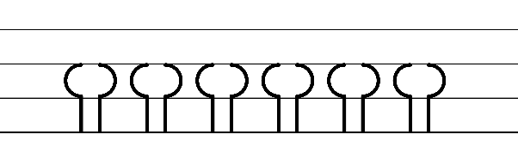  - Example capital letter formations for letters with curved lines  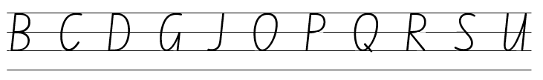  - Suggested practice text from the passage:  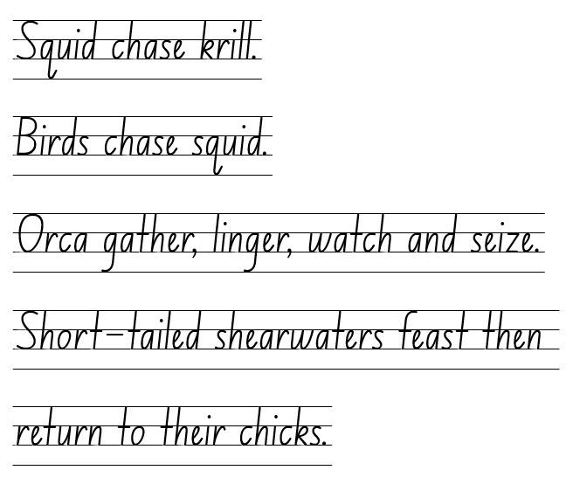
Software functionalities and typing  - Position a chosen device in a way that facilitates efficient and sustained text creation  - Review the placement of a device or monitor at an appropriate height and angle. Demonstrate good posture when using a device. For example, sitting up straight, aligning head with their spine, shoulders relaxed.  - Introduce the use of external accessories, such as a mouse. This can be positioned on either the right or left side of the keyboard. | Software functionalities and typing  - Students practise at tables and chairs supporting ergonomic device use and clear vision.

Planning framework
To plan and document Component A teaching and learning, a planning scaffold is provided. To support you in your planning, a link to a detailed example of a one-week teaching and learning cycle is included in the scaffold. Additional resources to support teaching and learning in each focus area can be found at Lesson advice guides.

Component B teaching and learning
The following teaching and learning sequence has been designed to address Component B outcomes and content and develops conceptual understandings of English through the study of quality texts. Adapt the sequence as required to best meet the needs of your students.

Learning intentions and success criteria
Learning intentions and success criteria are best co-constructed with students.

Learning intention
Students are learning to experiment with structure and language choices to change the genre of a text.

Success criteria
Students can:
- identify and describe structure and language choices used by authors in informative texts
- recognise and use diagrams as a component of informative texts
- use written language and visuals to create informative diagrams and multimodal texts
- apply feedback to revise and edit writing.

Lesson 9: Using descriptions to write and local inferencing
- Re-read Iceberg and link to learning in Component A to revise what structure and language choices support the text’s purpose. Ask students how the structure and language choices of the text could change to support the purpose ‘to inform’. For example, using headings, subheadings, diagrams, labels, arrows, Tier 3 vocabulary.
- Display the double page spread from the text beginning with ‘In the pale morning, an iceberg calves…’ Revise how writers can experiment with and change the genre of texts. Explain that students will use the descriptions from Iceberg to write an informative text. Explore the passage and ask guiding questions:
- What words or phrases could be used in an informative text? For example, Tier 3 vocabulary (iceberg, calving, glacier)
- What words or phrases support the text’s purpose to entertain? For example, ‘In the pale morning...’, ‘black ash fell like snow...’, ‘haze of sparkle frost...’.
- Ask students if the paragraph from Iceberg provides them with enough information to write an informative paragraph about icebergs. Explore what other texts could be used to assist students. For example, Resource 1: Iceberg explanation and Resource 3: Antarctic facts.
- Model using the descriptions from Iceberg to write a text with the purpose to inform. Consider the use of language choices to support the text’s purpose. For example, iceberg calving occurs when large pieces of ice break off from the edge of an icy sheet called a glacier. The floating pieces of ice become icebergs.
- As a class, identify language choices used to support the purpose ‘to inform’. For example:
- Tier 3 vocabulary: iceberg calving, glacier
- adjectives: large, icy, floating
- adverbial phrases: from the edge of an icy sheet.
- Provide small groups of students with passages from the text about the iceberg. For example, the pages starting from ‘The new iceberg bobs...’, ‘The iceberg drifts...’, ‘Seals cluster around...’, ‘Sea ice thickens...’, ‘This iceberg – every iceberg...’, ‘Spring returns...’, ‘The iceberg twists...’
- Model how to acknowledge and build on other’s ideas. Ask students to consider why building on ideas is an important part of learning.
- In small groups, students read the passage. While reading, students identify new or unknown vocabulary and link the meanings of words or phrases to support local inferencing. Using a coloured marker, students annotate the passage and explore what words or phrases could be used in an informative text. Using a different coloured marker, students annotate the passage and explore what words or phrases support the text’s purpose to entertain and could be removed. Encourage students to acknowledge and build on other’s ideas. As students identify unknown vocabulary remind them that many words are derived from other languages as discussed in Component A.
- Students experiment with using the descriptions to write information about icebergs using their annotated passage from activity 8. For example, The newly formed iceberg is carried by the ocean currents. The iceberg melts under the hot sun. Students may use Resource 1: Iceberg explanation or Resource 3: Antarctic facts to further support their writing.
Too hard? Co-construct informative sentences using the descriptions from the text.
Too easy? Students independently use the descriptions from the text to write information about icebergs.
- Provide time for each group to share their writing, reminding students how to listen attentively and value the contributions of peers. Allow groups to share in order of the pages presented in the text. For example, start with the group using the passage ‘The new iceberg bobs...’. Model how to ask questions to gain a deeper understanding of a text as a link to learning in Component A.
- Display students’ annotated work samples to support students writing in Lesson 11.
- Students complete an exit ticket to reflect and explain what language choices they used that support the text’s purpose (to inform).
Assessment task 2 – Observations from this lesson allow students to demonstrate achievement towards the following syllabus outcomes and content points:
EN2-OLC-01 – communicates with familiar audiences for social and learning purposes, by interacting, understanding and presenting
- contribute to discussions with peers and stay on topic, build on others' ideas and express own ideas.
EN2-RECOM-01 – reads and comprehends texts for wide purposes using knowledge of text structures and language, and by monitoring comprehension
- link the meanings of words and phrases across consecutive sentences to support local inferencing.

Lesson 10: Diagrams as a component of informative texts
- Ask how authors and/or illustrators support the reader to understand written language in a text. For example, using photographs or illustrations, diagrams, labels, arrows.
- Explore how diagrams are used in Earth’s Incredible Oceans to present information visually and support the reader’s understanding of the topic. Ask:
- How do the diagrams organise and structure information to support the purpose of the text?
- In what ways can diagrams help readers understand complex information more easily?
- Co-construct success criteria for creating a diagram. For example, use of images, labels and arrows, headings and subheadings, bolded words or phrases, definitions for Tier 3 vocabulary.
- Explain that students will draw and label a visual representation of information presented in Iceberg. Refer to Resource 6: Iceberg diagram as an example.
- Instruct students to draw an iceberg in the middle of their page. As sentences and/or phrases are read from the text, students draw and add labels to their diagram. For example:
- Squid chase krill, fish hunt salp, leopard seals lurk
- Krill retreat to underberg hollows
- Terns and blue-eyed cormorants fly overhead
- Penguins explode out of the ice hole into the water, penguins dive deep for fish
- Seals dive deeper to twitch-whisker hunt
- Cracks unshackle algae
- Orca gather, linger, watch and seize.
- In small groups, students share their diagrams and provide peer feedback using the co-constructed success criteria in activity 3.
- Ask students why authors include visuals in texts and how they support the text’s purpose. Discuss student responses.
- Students write an explanation about how including visuals such as diagrams and labels enhance a text and supports its purpose. For example:
Presenting information visually in an informative text supports the reader’s understanding of new and complex information. Using a diagram of the layers of an iceberg and how the animals interact helps organise the information in a visual way. Labels and arrows provide the reader with more information and explains the meaning of words they may not know. Using visuals in texts makes it easier for the reader to understand the purpose of the text.
Assessment task 3 – Observations and work samples from this lesson allow students to demonstrate achievement towards the following syllabus outcome and content point:
EN2-VOCAB-01 – builds knowledge and use of Tier 1, Tier 2 and Tier 3 vocabulary through interacting, wide reading and writing, and by defining and analysing words
- build personal Tier 1, Tier 2 and Tier 3 vocabulary through social and learning interactions, reading and writing.

Lesson 11: Planning and drafting an informative text
- Explain that students will use their understanding of texts with a purpose to inform, to create a text about Antarctica. Display and read ‘Life under the ice’ on pages 64 and 65 in Earth’s Incredible Oceans. Using these pages as an exemplar for writing, deconstruct the structure and language choices the author and illustrator used to support the text’s purpose. Ask guiding questions such as:
- What language choices did the author use?
- How is the text structured? How does this support the reader to understand the information presented?
- How is the text presented (form)?
- How is the text communicated (mode) and conveyed (medium)?
- Using 'Life under the ice’ as an exemplar, co-construct success criteria that will also be used in Lesson 12. For example:
- a variety of adjectives to enhance descriptions
- adverbial phrases to provide additional information
- Tier 2 and Tier 3 vocabulary
- capital letters for headings and subheadings
- different structures and features of an informative text (labels, arrows)
- select and use multimodal features to add meaning.
- Review information about Antarctica explored throughout the unit. For example, Iceberg by Claire Saxby, Resource 1: Iceberg explanation, Resource 3: Antarctic facts and Resource 6: Iceberg diagram.
- Display Resource 7: Writing cycle. Explore the different phases of writing. Explain that students will orally plan their ideas before writing. In pairs, students discuss:
- the information they will include in their text. For example, information about the features of Antarctica, icebergs or animals
- how the text will be structured and what visual features will support the reader. For example, headings and subheadings, paragraphs, diagrams, labels, arrows
- the mode in which they will present their information. For example, written language, visual, audio.
- Review the writing cycle and explain that students will focus on the ‘as we write’ phase. Explain that good writers take time to reflect on and revise a plan and that a plan may change as writing progresses. Explore the cyclical process of drafting and composing and the importance of re-reading and revising during this phase.
- Students use a writing scaffold to draft and compose their informative text. Encourage students to re-read and revise their writing.

Lesson 12: Feedback and publishing
- Revise the purpose for writing (to inform) and success criteria from Lesson 11.
- Review the difference between revising and editing. For example, editing involves making changes to spelling and punctuation while revising involves looking over the writing as a whole and reworking the organisation and details. Grammatical features, text structure and language choices are also considered during the revising stage.
- Display Resource 7: Writing cycle and explain that this lesson will focus on editing, proofreading and publishing.
- In pairs, students provide feedback using the co-constructed success criteria. Provide time for students to apply feedback and edit their writing.
- Review the exemplar text ‘Life under the ice’ (pp 64–65) from Earth’s Incredible Oceans. Revise ways of presenting or publishing work as a multimodal text. For example, including 2 modes, such as images, sound, written or spoken language.
- In pairs, students explore how they will publish and present their text. Ask:
- What form will you use to publish your text? (For example, poster, digital poster, slideshow)
- How will your text be communicated (mode)? (Written language, images, sound, spoken language)
- How will your text be conveyed (medium)? (Printed, digitally)
- Students choose how they will publish their text. For example, poster using craft materials, digital poster using Canva for Education, slideshow using Microsoft PowerPoint. Provide time for students to publish their text. Students’ informative text will be used to reflect on their learning in Lesson 19.
- Optional: students participate in a gallery walk.
Assessment task 4 – Collecting work samples from this lesson allows students to demonstrate achievement towards the following syllabus outcome and content points:
EN2-CWT-02 – plans, creates and revises written texts for informative purposes, using text features, sentence-level grammar, punctuation and word-level language for a target audience
- select and use multimodal features to add meaning
- use adverbial phrases or clauses to add information to the verb or verb group of the main or other clauses, to provide reasons for or circumstances
- use capital letters to indicate the beginning of a sentence, proper nouns, headings and subheadings, to indicate the beginning of a poetry line, for emphasis, and when using acronyms
- use adjectives to develop descriptive features.

Week 4

Component A teaching and learning
Component A focuses on the development of foundational skills and knowledge through regular, systematic and repeated practice. The mentor and supporting texts used in Component B of this unit can support the effective implementation of Component A teaching and learning.

Teaching guide
Guidance for explicit teaching, teaching notes, resources and examples for the related outcomes and content points have been provided in the table below.
Focus areas and teaching notes | Resources and examples
Reading fluency  Reading automaticity and rate  - Demonstrate the use of navigation pathways to support fluency  - Navigation pathways refers to the path followed while moving through the content of a text. It involves navigating the text to support fluency in a way that doesn't disrupt the overall comprehension and allows the reader to engage with print, visual, and multimodal texts. | Reading fluency  Reading automaticity and rate  - Fluency and close reading passage- Resource 8: Beeswax wraps instructions (146 words)  - Students navigate the text using headings and subheadings, bullet points and numbering.
Monitoring reading fluency  - Recognise that there are different purposes and audiences for reading and adjust reading rate to suit a text’s purpose  - Reading rate for informative texts may depend on the vocabulary used. For example, Tier 3 technical and subject specific vocabulary may require the reader to slow down.  - Readers may need to adjust reading rate for each section of text. | Monitoring reading fluency  - Adjust reading rate when transitioning through headings and subheadings, bullet points, numbered lists.
Reading comprehension  Comprehending text structures and features  - Identify different structures and features of persuasive, informative and imaginative texts  - Structure of a text with the purpose to inform (instruct) can include a statement of purpose or goal, a list of materials and a series of steps. | Reading comprehension  Comprehending text structures and features  - Text structure  - heading, statement of purpose, list of materials, series of steps  - Text features  - headings and subheadings, bullet points, numbered lists
Vocabulary  Learning and using words  - Build personal Tier 1, Tier 2 and Tier 3 vocabulary through social and learning interactions, reading and writing  - Tier 2 words: General academic words that can be used across a variety of domains. Tier 2 words add power and precision to written and spoken language, but many Tier 2 words are most commonly found in written language.  - Tier 3 words are used rarely and only in highly specific situations (NESA 2023). | Vocabulary  Learning and using words  - Suggested vocabulary from the passage  - Tier 2 vocabulary: sprinkle, scrape, excess, reusable, reduce  - Tier 3 vocabulary: compostable, biodegradable
Spelling  Phonological component  - Identify differences in vowel phonemes (short, long, diphthong and schwa vowels)  - Identify the long vowel phoneme /ow/ as in own within focus words. [oa, ow, o_e, o, oe]. | Spelling  Phonological component  - Suggested words from the Week 4 reading material: low, biodegradable, fabric, roughly, melt-melts-melted-melting  - Sample words for inquiry: fantastic, flavour(s), difficult, fluffy, cough-coughs-coughing, rough, pharmacy, elephant, telephone(s), earphone(s), photocopy(ing), photograph(s), photosynthesis, phoneme, phobia, phytoplankton
Orthographic component  - Understand that some graphemes are dependent on their position in a word in English and apply this knowledge when spelling  - The long vowel phoneme /ow/ can be represented by the vowel digraphs [oa, ow, oe]. /ow/ can also be represented by the split digraph [o_e].  - [oa, o] are often used in the middle of words. [ow, o_e, oe] are often used at the end of base words.  - Review the consonant phoneme /f/ as in fin which can be representing using [f, ff, gh, ph]. [ph] is often used at the beginning or end of the root word.  - Understand that graphemes can be explained by their etymology.  - Words with the /f/ phoneme represented by the consonant digraph ‘ph’ are usually Greek in origin. | Orthographic component  - As above
Morphological component  - Identify inflected suffixes, explaining when and how to treat base words when they are affixed, and apply this knowledge when spelling  - Review inflected suffixes: plural (-s, -es) tense (-s, -ing, -ed). | Morphological component  - As above
Creating written texts  Sentence-level grammar  - Use verb sentence openers to indicate action processes  - Verb sentence openers use action verbs that specifically indicate processes or actions involved in completing a task or achieving a specific outcome.  - They provide clear instructions on how to perform a particular action process.  - Use imperative sentences to advise, provide instructions, express a request or a command  - A complete sentence conveying a direct command, request, invitation, warning or instruction, typically directed to an implied person (NESA 2023)  - Imperative sentences provide instructions and support the purpose of a text with the purpose to instruct.  - Use adverbial phrases or clauses to add information to the verb or verb group of the main or other clauses, to provide reasons for or circumstances  - Review different types of adverbial phrases. For example  - when (adverbial phrase of time)  - where (adverbial phrase of place)  - how (adverbial phrase of manner)  - why (adverbial phrase of reason). | Creating written texts  Sentence-level grammar  - Suggested verb sentence openers from the passage  - Snip the cotton into rectangles.  - Fold the towel in half.  - Lay a large sheet of baking paper on top of the towel.  Note: bold text highlights the finite verb in the sentence.  - Suggested examples of imperative sentences  - As above  - Suggested adverbial phrases from the passage  - Snip the cotton into rectangles. (how)  - Lay a large sheet of baking paper on top of the towel. (where)  - Once the fabric is cool (when), trim the edges, to neaten them. (why)  Note: bold text highlights the adverbial phrases.
Punctuation  - Use capital letters to indicate the beginning of a sentence, proper nouns, headings and subheadings, to indicate the beginning of a poetry line, for emphasis, and when using acronyms  - Review: Capital letters at the beginning of a sentence  - Capital letters for headings and subheadings are used to organise information and support the reader.  - Use bullet points or numbering to list items or a sequence of steps  - Items in a list, or a sequence of steps, can be shown using bullet points or by numbering each item or step. | Punctuation  - Suggested examples of capital letters  - See above  - Suggested examples of punctuating list items and a sequence of steps  - Bullet points: used to list ‘Materials’ needed  - Numbering: used to sequence ‘Steps’ to create a beeswax wrap.
Handwriting and digital transcription  Handwriting legibility and fluency  - Understand that legible handwriting is consistent in size and spacing and can support learning.  - Revise all NSW Foundation Style letter and numeral formations with letters maintaining a consistent slope slightly to the right.  - Revise consistent spacing within words, between words and between lines of writing. | Handwriting and digital transcription  Handwriting legibility and fluency  - Suggested fluency pattern  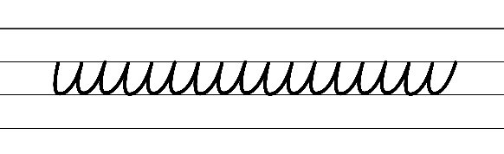  - Example of complete NSW Foundation font  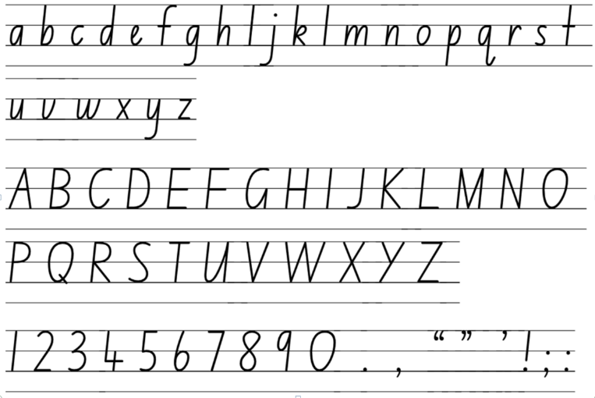  - Suggested practice text from the text Iceberg  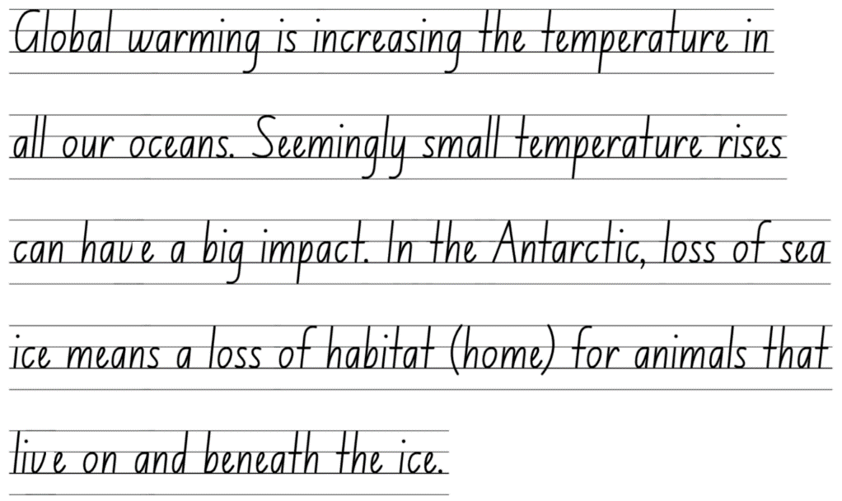

Planning framework
To plan and document Component A teaching and learning, a planning scaffold is provided. To support you in your planning, a link to a detailed example of a one-week teaching and learning cycle is included in the scaffold. Additional resources to support teaching and learning in each focus area can be found at Lesson advice guides.

Component B teaching and learning
The following teaching and learning sequence has been designed to address Component B outcomes and content and develops conceptual understandings of English through the study of quality texts. Adapt the sequence as required to best meet the needs of your students.

Learning intentions and success criteria
Learning intentions and success criteria are best co-constructed with students.

Learning intention
Students are learning to apply their understanding of a text’s purpose to create a text.

Success criteria
Students can:
- analyse a text and identify specific genre components
- identify similarities and differences between informative texts
- identify language choices authors use to support a text’s purpose (to instruct)
- use structure and language choices that support written texts to instruct.

Lesson 13: Analysing a text to understand its genre
- Provide students with a Plus, Minus, Interesting (PMI) chart. Read ‘Helping oceans’ on pages 74 and 75 from Earth’s Incredible Oceans. Provide students time to record positives, negatives and interesting thoughts about the text. Encourage students to consider how the text is presented (form), the structure and language choices, how the text is communicated (mode), and how the text is conveyed (medium). For example:
- Plus: visuals to support the reader, verb sentence openers to instruct the reader, adverbial phrases, labelled images
- Minus: navigation pathways of the page, the materials are not easily accessible to the reader
- Interesting: the inclusion of helpful tips to inform the reader (‘Be careful of the sharp edges’).
- In pairs, students explore the purpose of the text and use examples to support their reasoning. Encourage students to make connections with other texts with the same purpose (informative text to instruct). For example, recipe books, assembly instructions for furniture or toys, science experiments.
- Display Resource 9: Genre analysis. Explain that analysing a text can help the reader describe its genre. Facilitate a discussion using the guiding questions on the resource. For example:
- What is the purpose of the text? (To inform and instruct)
- What is the topic or message? (How to reuse and repurpose plastic to reduce it ending up in the ocean)
- How is the text presented (form)? (Picture book)
- What structure and language choices are used? (Headings/subheadings, labels, arrows, imperative sentences, verb sentence openers, adverbial phrases, commas to list materials)
- How is the text communicated (mode)? (Written language, images)
- How is the text conveyed (medium)? (Printed text)
- In pairs, students analyse the text on pages 74 and 75 using Resource 9: Genre analysis. Remind students to build on each other’s ideas.
- Share student responses from the text analysis.
- Students write a short paragraph describing the genre of a book read recently. Students explain why they think the book belongs to that specific genre using examples from the text.

Lesson 14: Exploring similarities and differences in informative texts
- Display Resource 8: Beeswax wraps instructions and ‘Helping oceans’ on pages 74 and 75 of Earth’s Incredible Oceans. Explore similarities and differences between the texts. Use student understanding of imperative sentences and verb sentence openers from Component A to support their thinking. For example, both texts share the same purpose (to inform and instruct) and include imperative sentences, verb sentence openers and adverbial phrases.
- Display an enlarged Venn diagram with the headings ‘Beeswax wraps instructions’ and ‘Helping oceans’. As a class, explore how the texts are similar. On sticky notes, students record how the texts are similar and place it on the enlarged Venn diagram.
- Explore how the texts are different. On sticky notes, students record how the texts are different and place it on the enlarged Venn diagram. For example, helping oceans includes visuals and helpful tips to inform the reader. The ‘Beeswax wraps instructions’ includes bullet points and numbers to help the reader navigate the text.
- Explore the genre of the texts ‘Beeswax wraps instructions’ and ‘Helping oceans’. Ask:
- How does each text’s genre support the author’s intended purpose?
- How does genre influence the structure and language choices of the texts?
- What patterns do you notice that are specific to this genre?
- Using Resource 8: Beeswax wraps instructions and ‘Helping oceans’, co-construct a success criteria for writing an informative text that instructs. For example:
- use verb sentence openers to indicate an action
- use imperative sentences to provide instructions
- use adjectives to add precision to writing
- use adverbial phrases to tell how, when, where or why an action takes place
- use commas between words in a list
- use bullet points and numbering to list items or for a series of steps
- use a capital letter to indicate the beginning of a sentence, heading or subheading
- use visuals to support the reader.
- Explain that students will recreate the text ‘Helping oceans’ by using the structure of the ‘Beeswax wraps instructions’. Students will use the instructions from the text to present it using a statement of purpose, bullet points for materials, numbered steps.
- In pairs, students use the information on pages 74 and 75 to rewrite the text and present it with different structural features.
Too easy? Students watch one clip from Ice Science Experiments for kids to do at home (6:41). Students write instructions to accompany the video. Students include a statement of purpose, bullet points for materials and numbered steps.

Lesson 15: Language choices to support a text’s purpose
- Display and read ‘Changing oceans’ on page 72 from Earth’s Incredible Oceans. Ask the guiding questions:
- Why do you think Jess French included this page in the text?
- What does she want the reader to learn? Why do you think that?
- Jess French provided information about repurposing plastic. Display a plastic bottle and ask students to generate as many possible uses for it as they can.
- Share with students that they will be making a bug hotel out of a plastic bottle and writing a text instructing someone how to make one. Explain that student will need a range of materials including a large plastic bottle, scissors, string, natural materials (twigs, bark, small stones).
- Discuss the purpose and audience for writing. For example, the purpose is to inform and instruct. The intended audience is someone who would like to know how to build a bug hotel or someone who wants to repurpose plastic to help the environment. Explore what language choices could be used to support the text’s purpose. For example, the use of imperative sentences will provide instructions for the reader to follow. The language needs to be precise so that instructions can be followed easily.
- Without displaying Resource 10: Bug hotel instructions, read the instructions on the resource. Pause at each step and provide time for students to follow the instruction.
- Students share what words or phrases helped them follow each instruction. Link to previous learning in Component A to remind students about adverbial phrases. Ask:
- What words or phrases are helpful when listening to an instruction? Students provide examples of verbs, adjectives and adverbial phrases and Tiered vocabulary.
- Were you given enough information to complete the step? If not, what could be included to provide more information?
- Take photos of each step to support students’ writing in Lesson 16. Continue reading the instructions, pausing at each step to discuss the guiding questions from activity 6.
- In small groups, students share their bug hotels to discuss similarities and differences. Ask students to consider why there may have been differences.
- Students write a reflection about the strengths and challenges of following the instructions. Ask:
- What parts of the experience were easy to understand? Why do you think it was easy to follow?
- Were there any challenges you faced understanding the instructions? For example, new vocabulary, not having visuals as a support.
- Explain that students will use this experience to write an informative text about ‘How to make a bug hotel’ using similar vocabulary.
- Display Resource 7: Writing cycle. Revise the different phases of writing. Explain that this lesson will focus on the planning phase. In pairs, students plan their informative text. Remind students to refer to their previous learning on the components of genre including purpose, structure, mode and medium. Students should also consider the use of language, diagrams and labels.

Lesson 16: Using experiences to create written texts
- Display the photos of students creating their bug hotel from Lesson 15. Review students' reflections about the strengths and challenges of following instructions. Revise the co-constructed success criteria from Lesson 14 and how language choices are used to support the text’s purpose.
- In pairs, students revise their plan from Lesson 15. Review Resource 7: Writing cycle and explain that this lesson will focus on the ‘as we write’ phase. Revise how good writers take time to reflect on and revise a plan and that a plan may change as writing progresses. Review the cyclical process of drafting and composing and the importance of re-reading and revising during this phase.
- Students begin drafting and composing an informative text that instructs someone to create a bug hotel. Encourage students to use the displayed photos and their plan for support.
Too hard? Provide students with the photos from Lesson 15 in sequential order. Students write verb sentence openers.

Week 5

Component A teaching and learning
Component A focuses on the development of foundational skills and knowledge through regular, systematic and repeated practice. The mentor and supporting texts used in Component B of this unit can support the effective implementation of Component A teaching and learning.

Teaching guide
Guidance for explicit teaching, teaching notes, resources and examples for the related outcomes and content points have been provided in the table below.
Focus areas and teaching notes | Resources and examples
Reading fluency  Prosody  - Explain how prosodic reading involves expression, intonation and pausing and use emphasis while reading  - Reading with expression involves using the appropriate tone, pitch and stresses for the text.  - Use expression to emphasise rhyme and rhythm and pause between poetry lines and stanzas. | Reading fluency  Prosody  - Fluency and close reading passage: Resource 11: Helping our Earth poem (84 words)  - Suggested examples for reading with expression  - Reduce, reuse, recycle too  - These are things that we can do  Note: bold text highlights an opportunity to demonstrate pausing, expression and emphasis.
Monitoring reading fluency  - Recognise that there are different purposes and audiences for reading and adjust reading rate to suit a text’s purpose  - Use rhyme and rhythm and line breaks at the end of a poetry line to adjust reading rate.  - Pausing can be used to attend to punctuation (commas). | Monitoring reading fluency  - Suggested examples for adjusting reading rate, as above.
Reading comprehension  Comprehending text structures and features  - Identify different structures and features of persuasive, imaginative, informative texts  - Hybrid texts can include structures and features of imaginative, persuasive and informative texts. | Reading comprehension  Comprehending text structures and features  - Text structure  - 4 stanzas with 4 lines each, AABB rhyming pattern  - Text features  - Alliteration (reduce, reuse, recycle), Tier 2 vocabulary (global warming, recycle, reusable, pollution), call to action (choose reusable items in the end)
Monitoring comprehension  - Ask questions to clarify meaning and promote deeper understanding of a text  - Model how to ask clarifying questions to clarify meaning and enhance understanding (literal and inferential questions). Support students to ask their own questions of the text. | Monitoring comprehension  - Questions to clarify meaning  - What problem is the author referring to?  - What is global warming?  - Questions to promote deeper understanding  - What is the main message of the poem?  - What suggestions is the author making to the reader?
Vocabulary  Learning and using words  - Build personal Tier 1, Tier 2 and Tier 3 vocabulary through social and learning interactions, reading and writing  - Tier 2 words add power and precision to written and spoken language but many Tier 2 words are most commonly found in written language (NESA 2023).  - Understand that many words derive from other languages and that their pronunciation and spelling may reflect their etymology  - The English language is made up of words derived from many other languages including Latin, French, Greek, German and Aboriginal and Torres Strait Islander Languages. | Vocabulary  Learning and using words  - Suggested Tier 2 vocabulary from the passage  - protect, global warming, pollution, reusable, recycle  - Suggested vocabulary from the passage  - Recycle: re (again) + cycle  - Reuse: re (again) + use  - Reduce: re (again) + duce from Old French meaning ‘to diminish’
Spelling  Phonological component  - Identify differences in vowel phonemes (short, long, diphthong and schwa vowels)  - Review identifying long vowel phonemes /igh/ and /ow/ within focus words. | Spelling  Phonological component  - Consolidate words from previous 4 weeks of learning.
Orthographic component  - Understand that some graphemes are dependent on their position in a word in English and apply this knowledge when spelling  - Consider the position of graphemes that represent /igh/ and /ow/ in words as per previous 4 weeks of learning. | Orthographic component  - As above
Morphological component  - Identify inflected suffixes, explaining when and how to treat base words when they are affixed, and apply this knowledge when spelling  - Inflected suffixes: plural (-s, -es) tense (-s, -ing, -ed), comparative (-er) and superlative (-est)  - Consolidate previous 4 weeks of learning. | Morphological component  - As above
Creating written texts  Punctuation  - Use capital letters to indicate the beginning of a sentence, proper nouns, headings and subheadings, to indicate the beginning of a poetry line, for emphasis, and when using acronyms  - Capital letters can be used to indicate the beginning of a poetry line.  - Use commas between words in a list or to separate adjectives when more than one is used  - Review: Commas are used in a sentence to give a short pause. They are used to separate items in a list | Creating written texts  Punctuation  - Suggested example from the passage  - Reduce, reuse, recycle too.  - Suggested example from the passage  - As above.
Word-level language  - Use adjectives to develop descriptive features  - Review: adjectives can be used to describe a noun or a pronoun.  - Adjective types include  - Descriptive: size, shape, colour, texture, taste, sound, opinions (mean), emotions/feelings (cranky)  - Quantifying: tell us how much of something there is or how many there are. There are 2 types of quantifying adjectives; definite quantifying adjectives tell the exact number (one, thousand) and indefinite quantifying adjectives give a general idea of the amount (some, many, a few)  - Predicate: are placed following a linking verb. They tell us more about the subject. For example, The cat looks tired (‘tired’ is the predicate adjective because it describes the subject ‘cat’). | Word-level language  - Suggested examples with adjectives from the passage  - It’s time to protect this special place (descriptive)  - Let’s plant some trees... (indefinite quantifying)  - In a world that’s round and blue (predicate)  - Pollution fills our skies so grey (predicate)
Handwriting and digital transcription  Handwriting legibility and fluency  - Understand that legible handwriting is consistent in size and spacing and can support learning  - Revise all NSW Foundation Style letter and numeral formations with letters maintaining a consistent slope slightly to the right.  - Revise pen(cil) grip, posture and paper position. | Handwriting and digital transcription  Handwriting legibility and fluency  - Suggested passage for handwriting practice  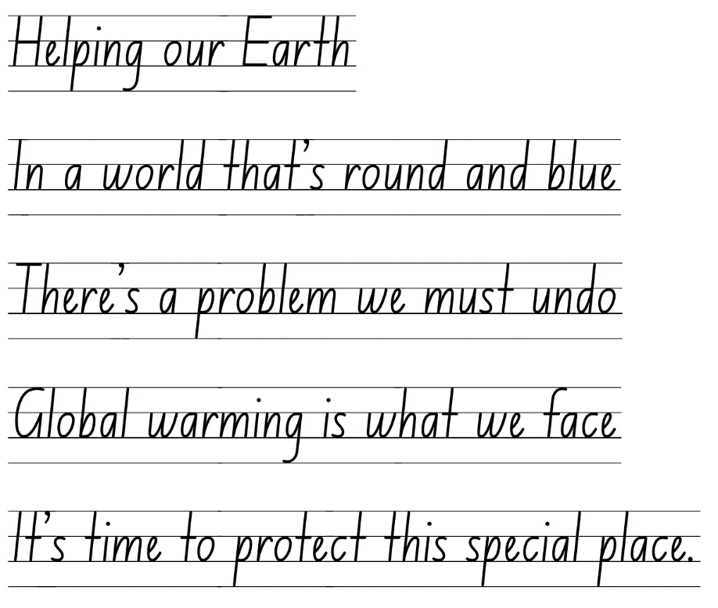  Note: additional stanzas from the poem may be included to extend legibility prior to introducing NSW Precursive.
Software functionalities and typing  - Position a chosen device in a way that facilitates efficient and sustained text creation  - Review: the position of device or monitor at height and angle and at eye level to support good posture.  - Introduce the use of external accessories to support ergonomics. | Software functionalities and typing  - Suggested examples of external accessories could include a keyboard and mouse.

Planning framework
To plan and document Component A teaching and learning, a planning scaffold is provided. To support you in your planning, a link to a detailed example of a one-week teaching and learning cycle is included in the scaffold. Additional resources to support teaching and learning in each focus area can be found at Lesson advice guides.

Component B teaching and learning
The following teaching and learning sequence has been designed to address Component B outcomes and content and develops conceptual understandings of English through the study of quality texts. Adapt the sequence as required to best meet the needs of your students.

Learning intentions and success criteria
Learning intentions and success criteria are best co-constructed with students.

Learning intention
Students are learning to group texts by applying their understanding of genre.

Success criteria
Students can:
- apply feedback to revise and edit writing
- publish informative texts, considering form, mode and medium
- compare their own written texts and describe their genre
- analyse and group texts according to their purpose, subject matter, form, structure and language choices, mode and medium.

Lesson 17: Feedback and editing
- Display Resource 7: Writing cycle and review the difference between revising and editing. For example, editing involves making changes to spelling and punctuation while revising involves looking over the writing as a whole and reworking the organisation and details. Grammatical features, text structure and language choices are also considered during the revising stage. Explain that this lesson will focus on the ‘after we write’ phase.
- Review previous learning in Component A to support editing such as the use of capital letters.
- Select a peer feedback protocol for students to use. In pairs, students share their informative text and provide peer feedback, using the co-constructed success criteria from Lesson 14. Encourage students to listen actively and ask clarifying questions if necessary.
- Provide time for students to apply feedback to edit and improve their writing.
- Explain that students will publish their work. Remind students to apply their understanding of text structures and features as learnt in Component A and B. Ask guiding questions, such as:
- What form will you use to publish your text?
- How will your text be communicated (mode)? Written language, images
- How will your text be conveyed (medium)? Printed, digitally, visually
- In pairs, students discuss and plan ways they will publish their text, building on each other’s ideas and acknowledging contributions. If needed, model how to acknowledge and value different ideas.
- Students begin publishing their work.

Lesson 18: Publishing
- Students continue publishing their informative text, continually revising their writing using the success criteria and feedback. Remind students to ensure the purpose of their text (an informative text to instruct) and intended audience are clear.
- Students share their writing with a partner and take turns asking:
- What is the purpose of the text?
- Who is the intended audience?
- What specific language or vocabulary choices were used to ensure the instructions were clear?
- Do the diagrams used support a reader to understand the instructions?
- What good ideas did you learn from someone else?
- What would you do the same or different next time you write a text that instructs?
- Explore how their text could be shared with an authentic audience. For example, in the newsletter or at an assembly, or with a buddy class following the instructions to make a bug hotel.
Note: students’ informative text will be used to reflect on their learning in Lesson 19.
Assessment task 5 – Collecting work samples from this lesson allows students to demonstrate achievement towards the following syllabus outcome and content points:
EN2-CWT-02 – plans, creates and revises written texts for informative purposes, using text features, sentence-level grammar, punctuation and word-level language for a target audience
- create written texts that describe experiences and observations to connect with and inform an audience
- create written texts that instruct, that may include a statement of purpose or goal, a list of resources and a series of steps
- use adverbial phrases or clauses to add information to the verb or verb group of the main or other clauses, to provide reasons for or circumstances
- use verb sentence openers to indicate action processes
- use imperative sentences to advise, provide instructions, express a request or a command
- use capital letters to indicate the beginning of a sentence, proper nouns, headings and subheadings, to indicate the beginning of a poetry line, for emphasis, and when using acronyms
- use commas between words in a list or to separate adjectives when more than one is used
- use bullet points or numbering to list items or a sequence of steps.

Lesson 19: Reflecting on student writing
- Provide students with their description about the layers of the ocean from Lesson 8, informative text about Antarctica from Lesson 12 and informative text about how to create a bug hotel from Lesson 18.
- Explain that students will compare and contrast their 3 texts to identify the similarities and differences. Display an enlarged Triple Venn diagram. Explain the features of a triple Venn diagram and how the 3 overlapping circles provide an opportunity to explore the similarities and differences between the texts.
- Provide students with a triple Venn diagram with the headings ‘Ocean description’, ‘Antarctica poster’, ‘Bug hotel instructions’. Students analyse their text. Model recording answers on the triple Venn diagram to the question, What is the purpose and who is the intended audience?
- Ask further guiding questions for students to independently record ideas, such as:
- What is the subject matter or main message?
- How is the text presented (form)?
- How is the text communicated (mode)?
- How is the text conveyed (medium)?
- Students record ideas on their triple Venn diagram.
Too hard? Students compare 2 texts using a Venn diagram.
- Share student responses and provide examples of how the 3 texts are similar and different. Ask students to explain why (or why not) comparing the texts helped understand and identify the genre.

Lesson 20: Reflecting on textual concepts
- Make a range of texts available, such as podcasts, books, videos, websites, audiobooks, articles, posters, poems. Display the texts around the classroom. Use electronic devices to access podcasts, websites and audiobooks.
- Provide students with Resource 9: Genre analysis. Explain that students will use their understanding of genre to explore and analyse the texts around the classroom. Students walk around the classroom analysing the texts and recording their ideas.
- Share student observations and responses.
- Use exit tickets to reflect on the textual concepts. For example:
- How does knowing the genre of a text help a reader navigate and engage with it effectively?
- How does the purpose and intended audience of a text influence its genre?
- In what ways do different genres require specific forms, structures and language choices? How do these impact the effectiveness of the text and support its purpose?
- How can some genres blend together or overlap? Can you think of examples where texts incorporate elements from multiple genres? How does this impact the overall message conveyed?
- How can an understanding of genre benefit a reader or writer?
Assessment task 6 – Observations and work samples from this lesson allow students to demonstrate achievement towards the following syllabus outcomes and content points:
EN2-RECOM-01 – reads and comprehends texts for wide purposes using knowledge of text structures and language, and by monitoring comprehension
- identify different structures and features of persuasive, informative and imaginative texts.
EN2-UARL-01 – identifies and describes how ideas are represented in literature and strategically uses similar representations when creating texts
- understand that genre refers to texts that are grouped according to purpose, subject matter, form, structure and language choices, and that a type of text can differ in mode and medium
- identify and discuss the purpose of a text, and its intended audience, mode and medium.

Resource 1: Iceberg explanation
(also Week 1 fluency passage)
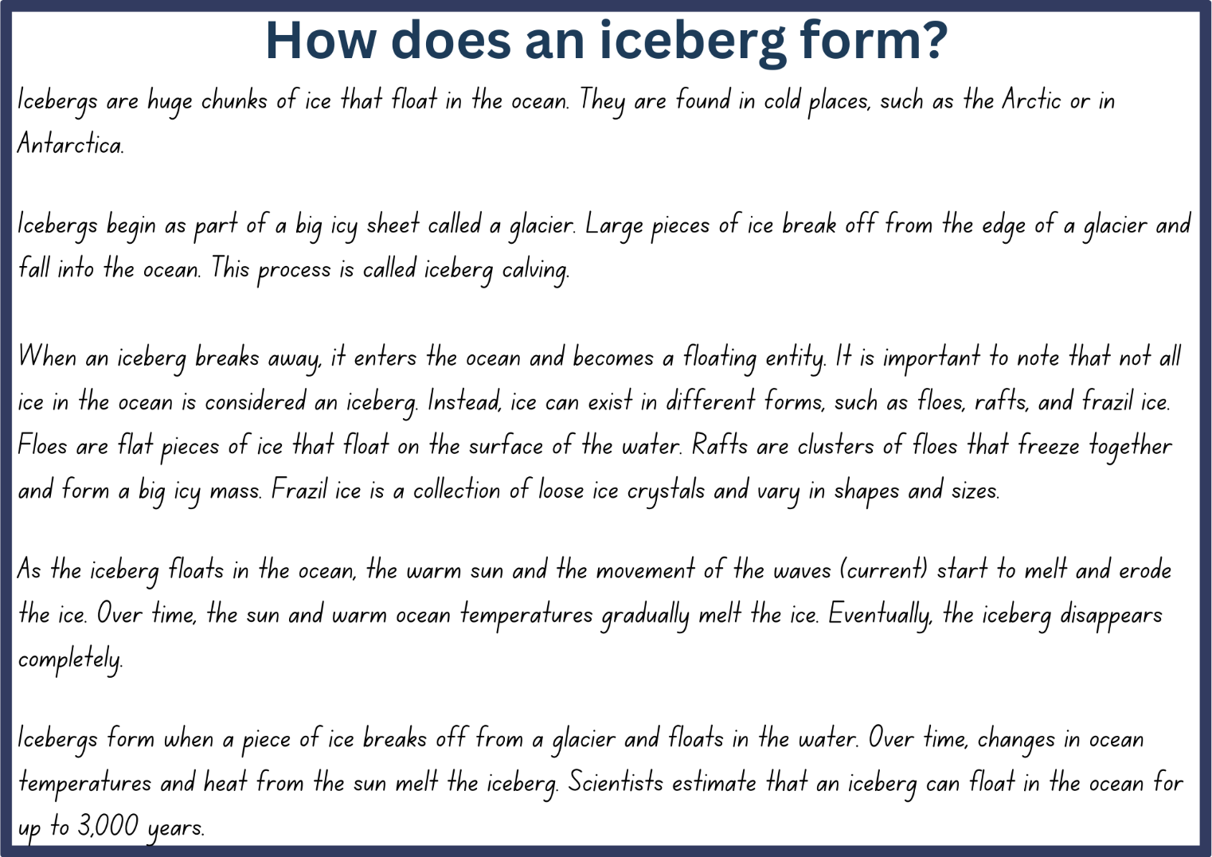

Resource 2: Text analysis
Title of text | Purpose of text | Subject matter | Form
What is the title?  Who us the author and/or illustrator? | To persuade, inform, entertain or multiple purposes | What is the topic of the text?  What is the message? | How is the text presented?  Examples: picture books, poem, letter, podcast, video
Pearl Barley and Charlie Parsley by Aaron Blabey | To entertain | Friendship ad belonging | Picture book

Resource 3: Antarctic facts
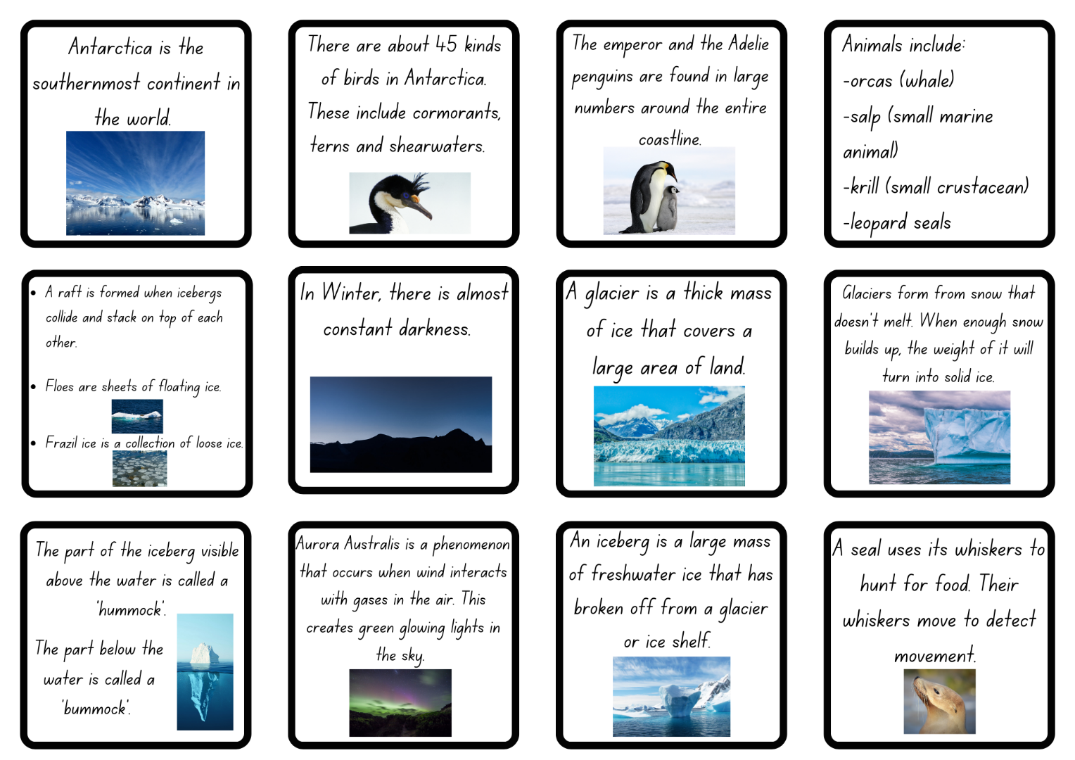

Resource 4: Fluency and close reading passage analysis (Week 2)
Focus | Notes
Passage | Iceberg double page spread from ’The new iceberg bobs...’ to ’meltwater trickles past their rock-nests.’ (83 words)
Passage structure | The text describes the changes that start to occur as the seasons change. It describes the effects the warmer weather has on the iceberg and the animals.
Background knowledge | - Pack ice is a large area of floating ice in the ocean  - ‘...a raft of penguins explode...’ – The collective noun for a group of swimming penguins is called a raft  - ‘Adelie’ and ‘emperors’ are species of penguin
Language features | Figurative language  - Metaphor: The new iceberg bobs in the water, an unfettered island, its mountain hidden underneath.  - The iceberg is being compared to an island that is not restricted or restrained  - Personification: Waves ripple away, away-o, to quiver at the pack ice.  - The waves are personified giving them the human characteristic of ‘quivering’. This indicates that the waves are moving closer to the pack ice (a large area of ice in the ocean)  Pronoun reference  - They know summer is near – ‘they’ is referring to the animals in Antarctica  Adjectives  - Compound adjectives are made up of more than one word. When the words are used together in front of a noun, they are usually hyphenated. This shows that the words are acting together as a single adjective  - under-ice, fish-fat  - Descriptive adjectives give more information about the noun or pronoun and help to add details about the noun they are modifying  - new iceberg, black and white rockets, hungry chicks  - Quantifying adjectives: tell us how much of something there is or how many there are. They give us an idea of the quantity or amount of the noun they describe. Definite quantifying adjectives give an exact number while indefinite quantifying adjectives give a general idea of the amount  - ...algae suspended all winter. (indefinite quantifying adjective)  Verbs  - ‘unshackle’, ‘suspended’, ‘quiver’, ‘lurk’, ‘trek’ – used to create vivid descriptions and convey emotions

Resource 5: Fluency and close reading passage analysis (Week 3)
Focus | Notes
Passage | The Ocean in Motion from Earth’s Incredible Oceans (pp 8–9) (238 words)
Synopsis | This passage provides information about how ocean water moves.
Passage structure | The text is structured as an informative text. It uses:  - headings and subheadings to organise information  - arrows to enhance meaning and support comprehension  - text layout (labels) to provide additional information to the reader. For example, ’low tide’ and ‘high tide’
Language features | Language  - Tier 3 subject-specific vocabulary is used to provide definitions and explanations. For example: currents, gravity, earthquake, tsunami  Adjectives  - Descriptive adjectives give more information about the noun or pronoun and help to add details about the noun they are modifying  - large volume (p 9) giant waves (p 9)  - Compound adjectives are made up of more than one word. When the words are used together in front of a noun, they are usually hyphenated. This shows that the words are acting together as a single adjective  - Fast-moving waves spread out... (p 9)  - Comparative adjectives compare 2 things and show the difference between them  - ...as they reach shallower waters. (p 9)  - Warmer, less salty water moves up to the surface. (p 8)  Adverbial phrases  - ...currents are created by the wind. (how) (p 8)  - Surfers travel from all over the world (where) to ride big waves. (why) (p 9)  - Tides change in a regular pattern... (how) (p 9)  Capital letters  - Indicate the beginning of a sentence and proper nouns  - North pole (p 8), South pole (p 8)

Resource 6: Iceberg diagram
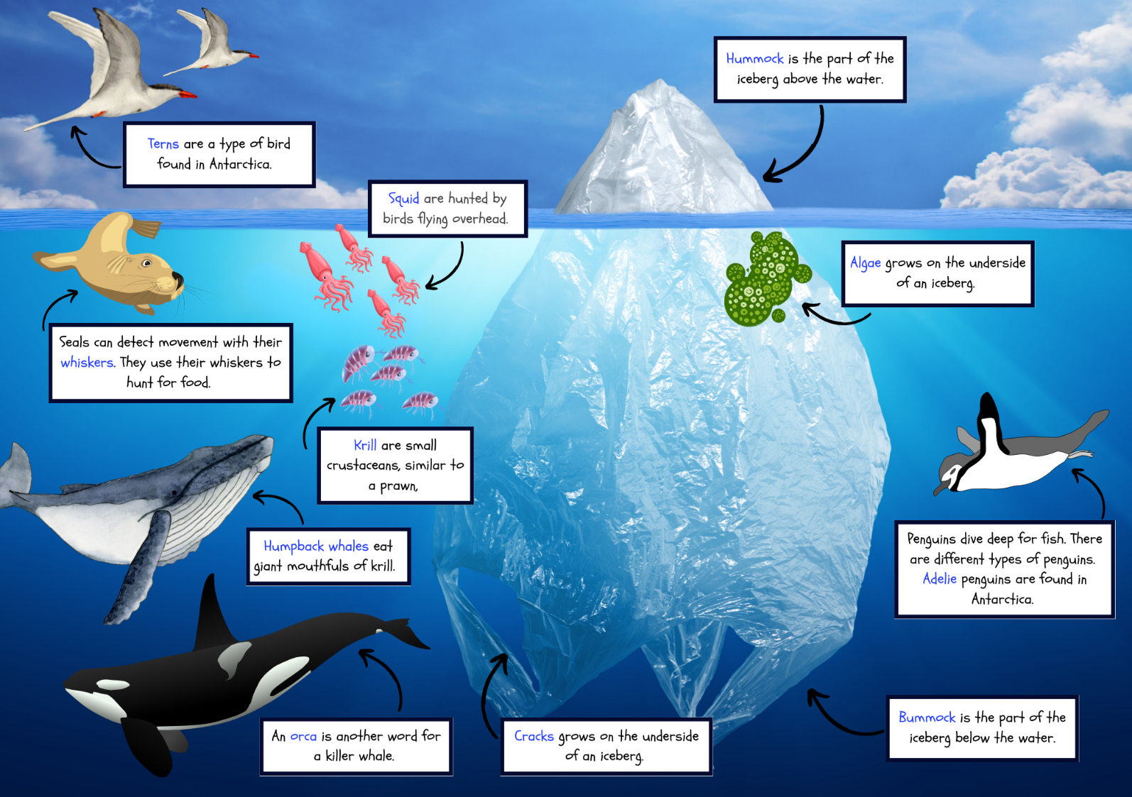

Resource 7: Writing cycle
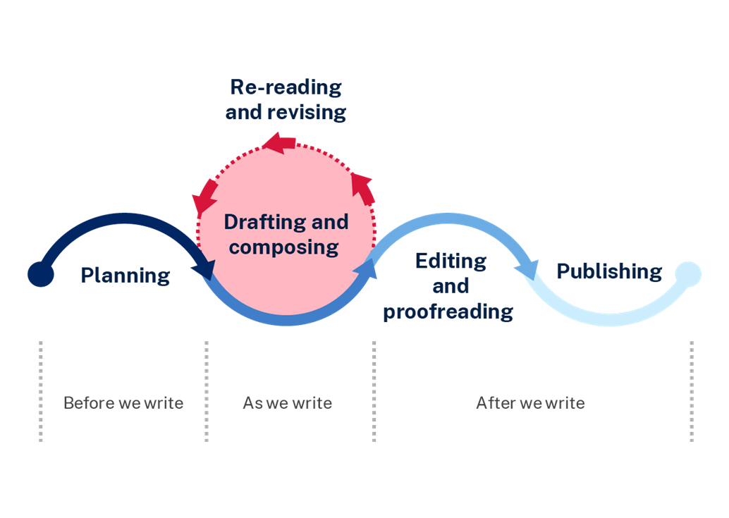

Resource 8: Beeswax wraps instructions
(also Week 4 fluency passage)
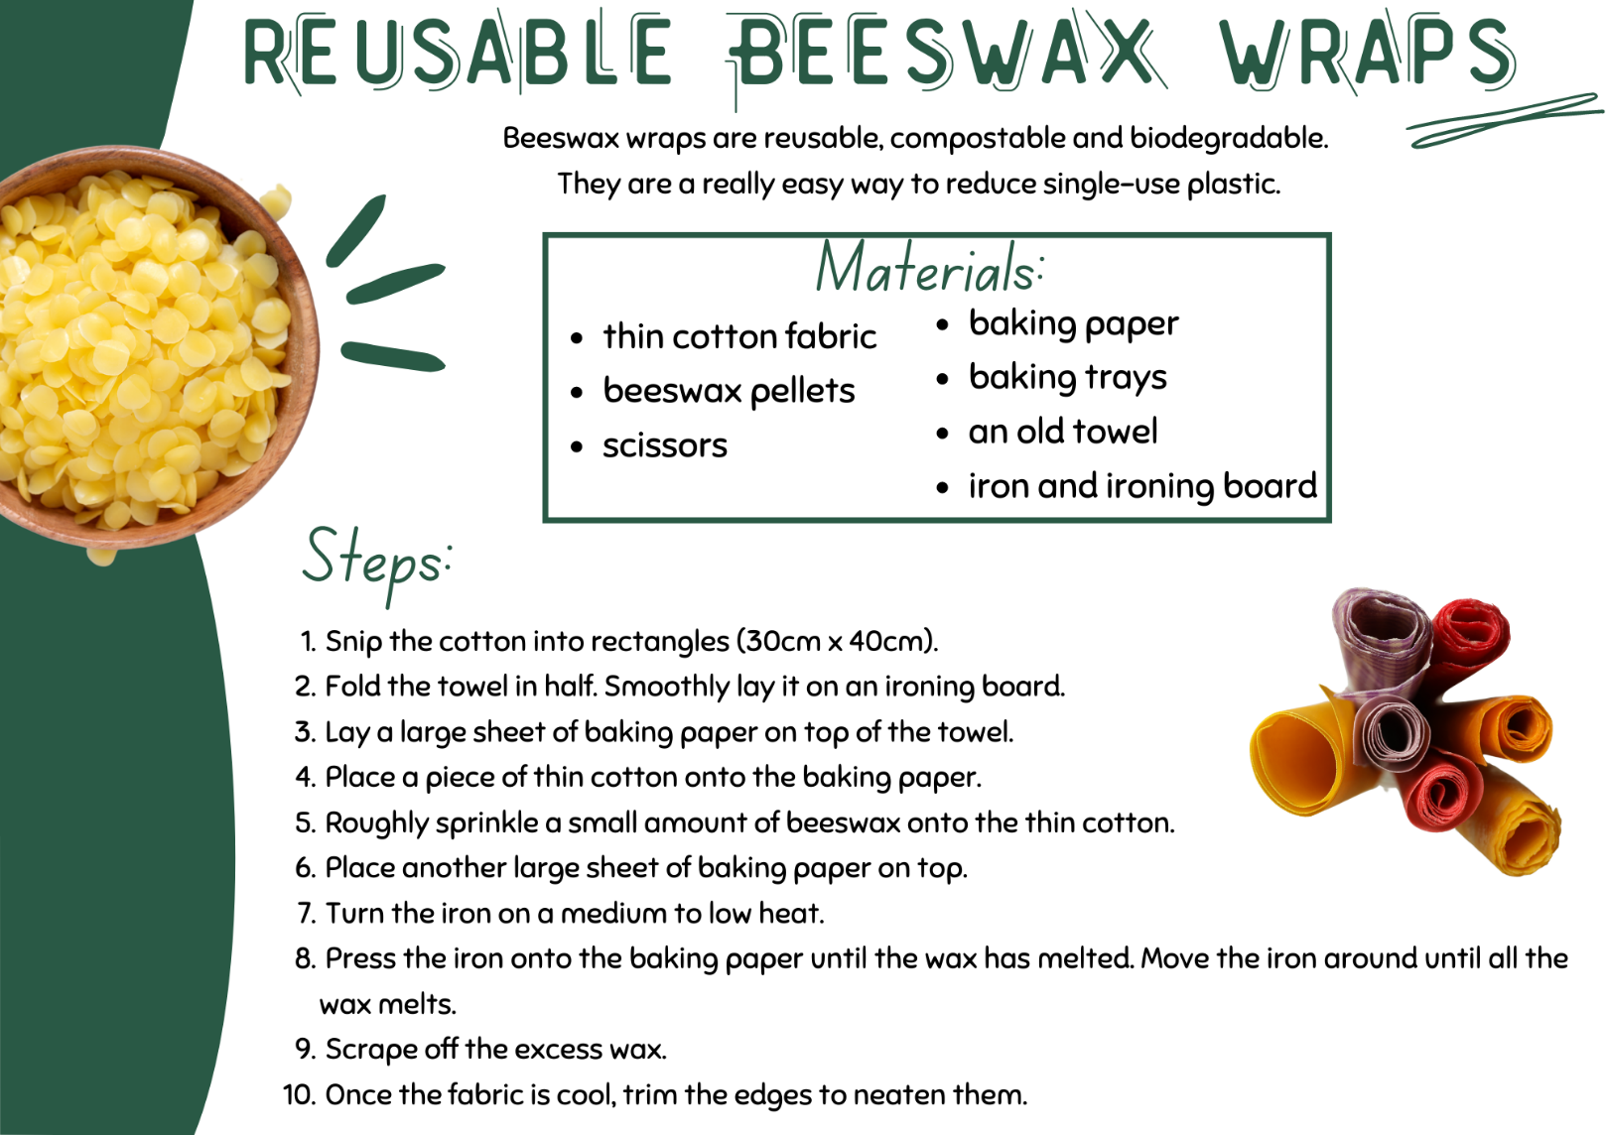

Resource 9: Genre analysis
Purpose of text | Subject matter | Form | Structure | Language choices | Mode | Medium
Examples: to persuade, inform, entertain, multiple purposes | What is the topic of the text? What is the message? | How is the text presented? Examples: picture book, poem, letter, podcast, video | What structural features are used? | What language choices did the author use? | How is the text communicated? Examples: sounds, music, spoken or written language, images | How is the text conveyed? Examples: print, digital, audio, visual

Resource 10: Bug hotel instructions
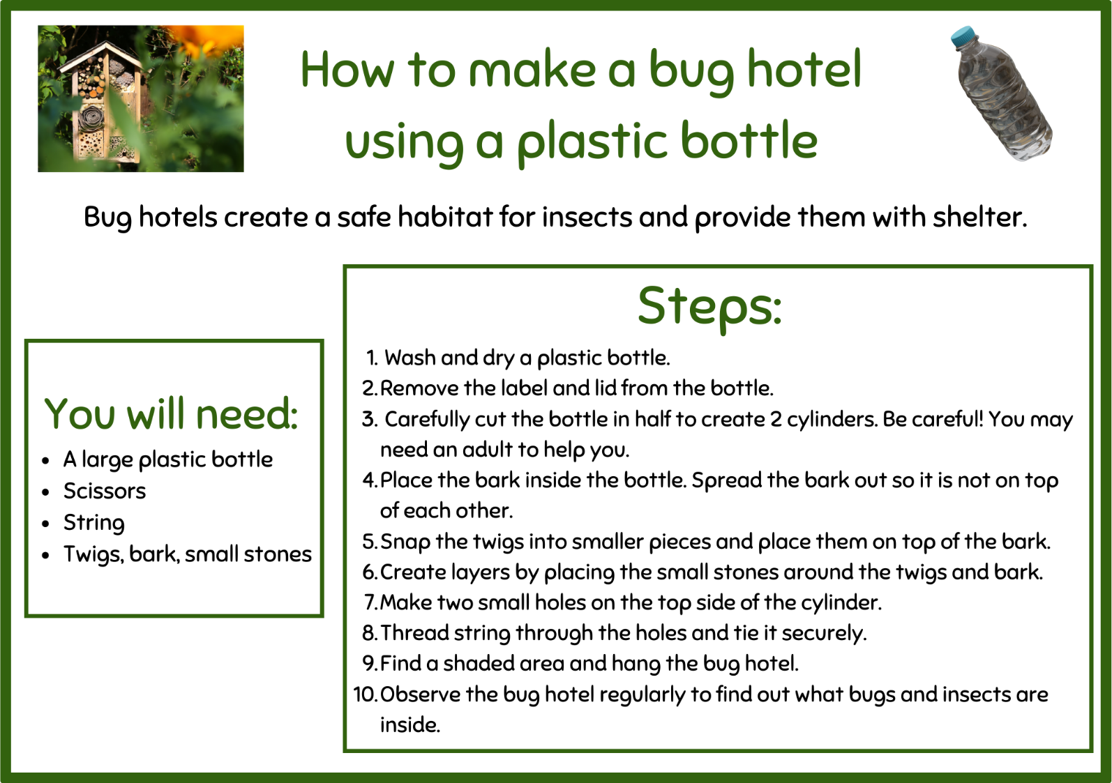

Resource 11: Helping our Earth poem
(Week 5 fluency passage)
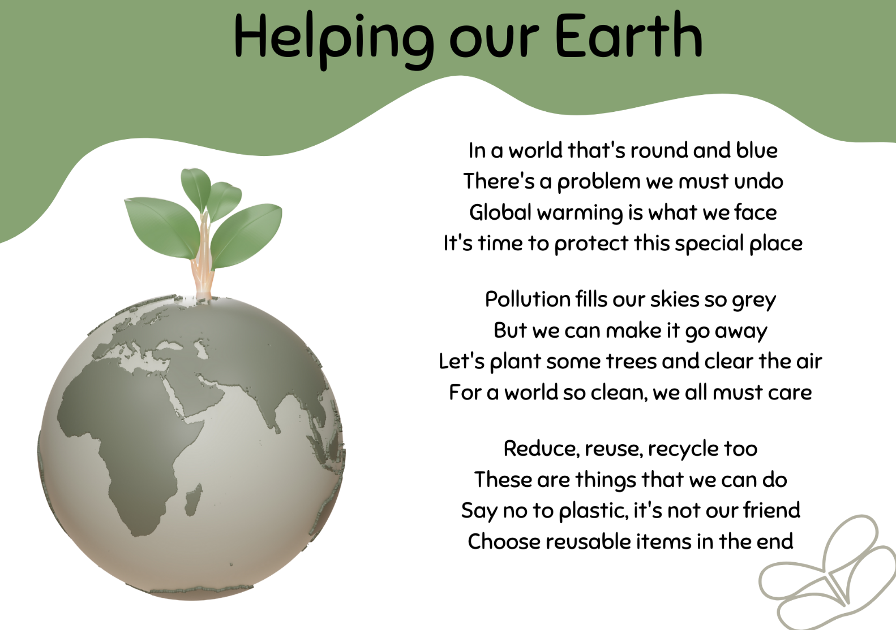

References
This resource contains NSW Curriculum and syllabus content. The NSW Curriculum is developed by the NSW Education Standards Authority. This content is prepared by NESA for and on behalf of the Crown in right of the State of New South Wales. The material is protected by Crown copyright.
Please refer to the NESA Copyright Disclaimer for more information. https://educationstandards.nsw.edu.au/wps/portal/nesa/mini-footer/copyright
NESA holds the only official and up-to-date versions of the NSW Curriculum and syllabus documents. Please visit the NSW Education Standards Authority (NESA) website https://educationstandards.nsw.edu.au/ and the NSW Curriculum website https://curriculum.nsw.edu.au/home.
English K–10 Syllabus © NSW Education Standards Authority (NESA) for and on behalf of the Crown in right of the State of New South Wales, 2022.
National Literacy Learning Progression © Australian Curriculum, Assessment and Reporting Authority (ACARA) 2010 to present, unless otherwise indicated. This material was downloaded from the Australian Curriculum website (National Literacy Learning Progression) (accessed 11 September 2023) and was not modified.
Neal Argarwal (n.d.) The Deep Sea, Neal.Fun website, accessed 16 June 2023.
Five from Five (2023) Making inferences, Five from Five website, accessed 16 June 2023.
French J (2021) Earth’s Incredible Oceans (McElfatrick C, illus), Dorling Kindersley, London.
Kitchen Science Lab (15 December 2020) ‘Ice Science Experiments for kids to do at home’ [video], Kitchen Science Lab, YouTube, accessed 3 July 2023.
NESA (NSW Education Standards Authority) (2023) ‘Glossary’, Resources, NESA website, accessed 5 September 2023.
Saxby C (2021) Iceberg (Racklyeft J, illus), Allen & Unwin, Australia.

© State of New South Wales (Department of Education), 2023
The copyright material published in this resource is subject to the Copyright Act 1968 (Cth) and is owned by the NSW Department of Education or, where indicated, by a party other than the NSW Department of Education (third-party material).
Copyright material available in this resource and owned by the NSW Department of Education is licensed under a Creative Commons Attribution 4.0 International (CC BY 4.0) license.
This license allows you to share and adapt the material for any purpose, even commercially.
Attribution should be given to © State of New South Wales (Department of Education), 2023.
Material in this resource not available under a Creative Commons license:
- the NSW Department of Education logo, other logos and trademark-protected material
- material owned by a third party that has been reproduced with permission. You will need to obtain permission from the third party to reuse its material.
Links to third-party material and websites
Please note that the provided (reading/viewing material/list/links/texts) are a suggestion only and implies no endorsement, by the New South Wales Department of Education, of any author, publisher, or book title. School principals and teachers are best placed to assess the suitability of resources that would complement the curriculum and reflect the needs and interests of their students.
If you use the links provided in this document to access a third-party's website, you acknowledge that the terms of use, including licence terms set out on the third-party's website apply to the use which may be made of the materials on that third-party website or where permitted by the Copyright Act 1968 (Cth). The department accepts no responsibility for content on third-party websites.

