English Stage 2 – Unit 10
Contents
Unit overview and instructions for use 4
Teacher notes 6
Outcomes and content 8
Resources 14
Week 1 17
Component A teaching and learning 17
Component B teaching and learning 26
Lesson 1: Categorising and identifying the genre of Our Universe 27
Lesson 2: Exploring text features in Deadly Science 29
Lesson 3: Exploring topic specific vocabulary 30
Lesson 4: Understanding and applying note taking 32
Week 2 35
Component A teaching and learning 35
Component B teaching and learning 47
Lesson 5: Different modes and mediums 48
Lesson 6: Gist and concluding statements 50
Lesson 7: Understanding text features of a specific genre 52
Lesson 8: Constructing an informative paragraph 54
Week 3 57
Component A teaching and learning 57
Component B teaching and learning 70
Lesson 9: Exploring perspective 71
Lesson 10: Genre text comparison and second person narrative voice 74
Lesson 11: Exploring timelines as a text feature 77
Lesson 12: Language choices in specific genre 80
Week 4 83
Component A teaching and learning 83
Component B teaching and learning 94
Lesson 13: Planning multimodal texts 95
Lesson 14: Creating a multimodal text 97
Lesson 15: Creating and editing a multimodal text 99
Lesson 16: Publishing a multimodal text 100
Week 5 101
Component A teaching and learning 101
Component B teaching and learning 110
Lesson 17: Using second person narrative in writing 111
Lesson 18: Writing and editing a second person narrative 113
Lesson 19: Presenting a multimodal text 113
Lesson 20: Presenting and reflecting on learning 114
Resource 1: Fluency and close reading passage analysis – Deadly Science Solar System 116
Resource 2: Four corners teacher resource 119
Resource 3: Genre jigsaw task 120
Resource 4: Genre detective 125
Resource 5: Y-chart 126
Resource 6: Vocabulary pyramid 127
Resource 7: Word mat 128
Resource 8: Stars flowchart 129
Resource 9: Gist statement scaffold 130
Resource 10: Writing scaffold 131
Resource 11: Headbands 132
Resource 12: Gist statement graphic organiser 133
Resource 13: Fluency and close reading passage analysis – Southern Cross 134
Resource 14: Planning template – Women in Space 138
Resource 15: Pluto timeline 139
Resource 16: NASA mission timeline 141
Resource 17: What’s in a name? 143
Resource 18: Vocabulary scaffold – Week 4 144
Resource 19: Writing cycle 146
Resource 20: Planning template 147
References 148

Unit overview and instructions for use
In this 5-week unit, students will explore the mentor concept of ‘genre’ and the supporting concept of ‘perspective and context’ through a deep analysis of the texts Deadly Science – The Solar System: Book 5 and Meanwhile Back on Earth. Throughout the unit, students will understand that genre refers to texts that are grouped according to purpose, subject matter, form, structure and language choices. Students will plan, create and revise texts considering perspective and context and informative purposes.
Outcomes and content in this unit are organised into Component A and Component B. The components are connected, with learning in Component A complementing learning in Component B.
Note: the duration of this unit can be adapted to suit individual school contexts. For example, learning could occur across 5 days rather than 4.
The table below highlights the focus areas and preparation required for Component A and Component B.
Teaching and learning | Component A | Component B
Suggested duration | 60 minutes × 4 days/week or equivalent | 60 minutes × 4 days/week or equivalent
Explicit teaching focus areas | Component A addresses content from the focus areas:  - Vocabulary  - Reading fluency  - Reading comprehension  - Creating written texts  - Spelling  - Handwriting and digital transcription  It centres on the development of foundational skills and knowledge through regular, systematic and repeated practice. | Component B addresses content from the focus areas:  - Oral language and communication  - Vocabulary  - Reading comprehension  - Creating written texts  - Understanding and responding to literature  It centres on the conceptual understandings of English and exemplifies the importance of learning about and enjoying literature through the study of quality texts.
Preparing for teaching and learning | - Specific teaching and learning activities need to be developed by the teacher. When planning for these activities, please refer to the Component A outcomes and content, teaching guides and planning frameworks.  - Plan and document how you will sequence teaching and learning in whole-class and targeted-groups across the five-week cycle as required. This should be based on student needs identified through ongoing assessment data. | - Familiarise yourself with the mentor and supporting texts and textual concepts, and the teaching and learning sequence.  - Determine how you will support students in whole-class and targeted-groups across the five-week cycle as required. This should be based on student needs identified through ongoing assessment data.
English K–10 Syllabus © NSW Education Standards Authority (NESA) for and on behalf of the Crown in right of the State of New South Wales, 2022.

Teacher notes
- Genre is defined as the categories into which texts are grouped based on similarities in premise, structure and function. The ‘genre’ of a text describes larger recurring patterns of subject matter and textual structures observable between texts, such as typical plots, characters and setting (NESA glossary).
- Understanding of genre can be supported through watching the department’s video: Understanding genre (3:00).
- While ‘genre’ is the mentor concept for the conceptual component of this unit, the supporting concept of ‘perspective and context’ can be also be explored. Additional textual concepts may be included based on individual school context and student needs.
- For information on adverbial phrases and clauses, temporal, conditional and causal conjunctions, use of commas in complex sentences refer to the NESA Glossary.
- In addition to the resources listed, students will require access to short passages of the mentor and/or supporting texts. Teachers can copy extracts from texts in reliance on the Statutory Text and Artistic Works Licence. Teachers need to attribute the extracts and include the following notice: ‘This material has been copied [and communicated to you] in accordance with the statutory licence in section 113P of the Copyright Act. Any further reproduction or communication of this material by you may be the subject of copyright protection under the Act. Do not remove this notice’.
- This unit could enhance student learning towards the achievement of science outcomes.
- Reflect on student learning and engagement in activities and record differentiation and adjustments within the unit to inform future teaching and learning. One way of doing this could be to add comments to the digital file.
- In NSW classrooms there is a diverse range of students including Aboriginal and Torres Strait Islander students, students learning English as an additional language or dialect, high potential and gifted students and students with disability. Some students may identify with more than one of these groups, or possibly all of them. Refer to Curriculum planning for every student – advice for further information.
- Content points are linked to the National Literacy Learning Progression version (3).
Levels and indicators sourced from National Literacy Learning Progression © Australian Curriculum, Assessment and Reporting Authority (ACARA), (accessed 11 September 2023) and was not modified. See references for more information.

Outcomes and content
The table below outlines the outcomes and content for this unit. The letters 'A' and 'B' in the header refer to Components A and B. The numbers 1 to 5 refer to weeks. The use of 'x' in these columns indicates where the content points are intended to be addressed and in which week.
Focus area and outcome, content points and National Literacy Learning Progression | A | B | 1 | 2 | 3 | 4 | 5
Oral language and communication
EN2-OLC-01 communicates with familiar audiences for social and learning purposes, by interacting, understanding and presenting
- Contribute to discussions with peers and stay on topic, build on others' ideas and express own ideas (InT4) |  | x |  |  |  |  | x
- Make notes when listening to spoken texts, asking questions to clarify or follow up on information and seeking assistance if required (LiS6) |  | x | x | x | x
- Include multimodal features in planned and delivered presentations, to expand meaning and engage an audience (SpK5) |  | x |  |  |  |  | x
- Reflect on and monitor own presentations according to given criteria |  | x |  |  |  |  | x
Vocabulary
EN2-VOCAB-01 builds knowledge and use of Tier 1, Tier 2 and Tier 3 vocabulary through interacting, wide reading and writing, and by defining and analysing words
- Understand that many words derive from other languages, including Aboriginal and Torres Strait Islander Languages, and that the pronunciation and spelling of words may reflect their etymology | x | x |  |  | x | x
- Build personal Tier 1, Tier 2 and Tier 3 vocabulary through social and learning interactions, reading and writing (SpK5) | x | x | x | x | x | x | x
- Use word associations to build word knowledge | x | x | x | x | x |  | x
Reading fluency
EN2-REFLU-01 sustains independent reading with accuracy, automaticity, rate and prosody suited to purpose, audience and meaning
- Demonstrate use of navigation pathways to support fluency when engaging with print, visual and multimodal texts (UnT7) | x |  |  | x |  | x
- Recognise that there are different purposes and audiences for reading and adjust reading rate to suit a text’s purpose (FlY5) | x |  | x | x | x | x | x
Reading comprehension
EN2-RECOM-01 reads and comprehends texts for wide purposes using knowledge of text structures and language, and by monitoring comprehension
- Locate, select and retrieve relevant information from a print or digital text and consider accuracy of information presented | x | x | x | x | x | x | x
- Determine the relevance of a text for a specific purpose (UnT7) |  | x | x | x | x
- Identify and describe how text structure, features and language work together to achieve a text’s purpose |  | x | x | x | x | x
- Understand that word contractions are a feature of informal language and that apostrophes of contraction are used to signal missing letters | x | x |  | x | x
- Reflect on own understanding of texts and monitor own goals for reading | x |  | x | x | x | x | x
Creating written texts
EN2-CWT-01 plans, creates and revises written texts for imaginative purposes, using text features, sentence-level grammar, punctuation and word-level language for a target audience
EN2-CWT-02 plans, creates and revises written texts for informative purposes, using text features, sentence-level grammar, punctuation and word-level language for a target audience
EN2-CWT-03 plans, creates and revises written texts for persuasive purposes, using text features, sentence-level grammar, punctuation and word-level language for a target audience
- Experiment using second person narrative voice for effect |  | x |  |  | x |  | x
- Create informative written texts that include headings, paragraphs beginning with topic sentences, and may conclude information in a final paragraph (CrT8) |  | x |  | x
- Create written texts that explain how or why something happens through a series of steps, including an opening statement and a conclusion (CrT8) |  | x | x
- Use temporal, conditional and causal conjunctions within sentences, and as connectives to link ideas across sentences for cohesion (CrT8) | x | x | x | x |  |  | x
- Use apostrophes for contractions, and to show singular and plural possession (PuN4, PuN5, SpG9) | x | x |  | x | x
- Use capital letters to indicate the beginning of a sentence, proper nouns, headings and subheadings, to indicate the beginning of a poetry line, for emphasis, and when using acronym (PuN5, PuN7) | x | x | x | x
- Use adverbial phrases or clauses to add information to the verb or verb group of the main or other clauses, to provide reasons for or circumstance | x | x |  |  | x | x | x
- Use a comma to separate a dependent clause before a main clause (PuN6) | x | x |  |  |  | x | x
- Research, summarise and list topic-related ideas when planning |  | x |  | x | x | x
- Plan structures and language to suit the purpose of a text (CrT7) |  | x |  | x | x | x
Spelling
EN2-SPELL-01 selects, applies and describes appropriate phonological, orthographic and morphological generalisations and strategies when spelling in a range of contexts
- Identify differences in vowel phonemes (short, long, diphthong and schwa vowels) (SpG9) | x |  | x | x | x | x | x
- Recognise stressed and unstressed syllables in multisyllabic words and apply this knowledge when spelling | x |  |  |  | x | x | x
- Understand that the schwa occurs in an unstressed syllable and apply this knowledge when spelling | x |  |  |  | x | x | x
- Apply knowledge of taught vowel graphemes when spelling (SpG9) | x |  | x | x | x | x | x
- Identify inflected suffixes, explaining when and how to treat base words when they are affixed, and apply this knowledge when spelling (SpG9) | x |  | x | x | x | x | x
Handwriting and digital transcription
EN2-HANDW-01 forms legible joined letters to develop handwriting fluency
EN2-HANDW-02 uses digital technologies to create texts
- Join letters when writing familiar words (HwK6) | x |  |  | x |  | x
- Monitor goals that build on typing accuracy and rate | x |  | x |  | x
- Select and insert visual, print and audio elements into texts | x |  |  |  |  | x | x
Understanding and responding to literature
EN2-UARL-01 identifies and describes how ideas are represented in literature and strategically uses similar representations when creating texts
- Understand that genre refers to texts that are grouped according to purpose, subject matter, form, structure and language choices, and that a type of text can differ in mode and medium |  | x | x | x | x | x | x
- Identify different text genres when a text is characterised by more than a single genre |  | x |  |  | x |  | x
- Identify and discuss the purpose of a text, and its intended audience, mode and medium (UnT7) |  | x | x | x | x | x | x
English K–10 Syllabus © NSW Education Standards Authority (NESA) for and on behalf of the Crown in right of the State of New South Wales, 2022.

Resources
The resources in the table below are referred to in this unit. Letters 'A' and 'B' in the header refer to Component A and B respectively, and the numbers 1 to 5 indicate weeks. The use of 'x' in these columns indicate whether the resources are required in Component A, B or both, and in which week.
Resource | A | B | 1 | 2 | 3 | 4 | 5
Australian Geographic (2022) Deadly Science – The Solar System: Book 5 (Tutt C, ed), Australian Geographic, Australia. ISBN13: 9781922388643 | x | x | x | x | x | x | x
Jeffers O (2022) Meanwhile Back on Earth, HarperCollins Publishers, GB. ISBN13: 9780008555450 | x | x |  |  | x | x | x
Resource 1: Fluency and close reading passage analysis – Dead Science Solar System | x | x | x
Resource 2: Four corners teacher resource |  | x | x
Resource 3: Genre jigsaw task |  | x | x
Resource 4: Genre detective |  | x | x
Resource 5: Y-chart |  | x | x
Resource 6: Vocabulary pyramid |  | x | x
Resource 7: Word mat |  | x | x
Resource 8: Stars flowchart |  | x | x
Video: Uranus Mission (3:49) |  | x |  | x
Resource 9: Gist statement scaffold |  | x |  | x
Video: Jupiter Profile (4:04) |  | x |  | x
Resource 10: Writing scaffold |  | x |  | x
Resource 11: Headbands |  | x |  | x
Resource 12: Gist statement graphic organiser |  | x |  | x
Webpage: Earth Rotation: Night and day |  | x |  | x
Resource 13: Fluency and close reading passage analysis – Southern Cross | x | x |  |  | x
Resource 14: Planning template – Women in Space |  | x |  |  | x
Resource 15: Pluto timeline |  | x |  |  | x
Resource 16: NASA mission timeline |  | x |  |  | x
Resource 17: What’s in a name? |  | x |  |  | x
Resource 18: Vocabulary scaffold – Week 4 | x | x |  |  |  | x
Resource 19: Writing cycle |  | x |  |  |  | x | x
Resource 20: Planning template |  | x |  |  |  | x

Week 1

Component A teaching and learning
Component A focuses on the development of foundational skills and knowledge through regular, systematic and repeated practice. The mentor and supporting texts used in Component B of this unit can support the effective implementation of Component A teaching and learning.

Teaching guide
Guidance for explicit teaching, teaching notes, resources and examples for the related outcomes and content points have been provided in the table below.
Focus areas and teaching notes | Resources and examples
Reading fluency  Monitoring reading fluency  - Recognise that there are different purposes and audiences for reading and adjust reading rate to suit a text’s purpose  - Reading rate for literary texts may depend on the use of expression, pausing, emphasis and the author’s use of phrasing.  - Reading rate for informative texts may depend on the vocabulary used. For example, Tier 3 technical and subject specific vocabulary may require the reader to slow down. | Reading fluency  Monitoring reading fluency  - Resource 1: Fluency and close reading passage analysis – ‘Our Solar System’ and ‘Hello, neighbour’ sections (p 6) (205 words)  Note: the passage from the text will need to be a teacher-created resource.  - Examples from the passage where reading rate may be adjusted  - ‘The outer region is home to the giant planets…also found here’.
Reading comprehension  Reading for interest and wide purposes  - Locate, select and retrieve relevant information from a print or digital text and consider accuracy of information presented  - The selection and retrieval of information requires readers to determine the relevance of the information to the topic and extract information by reading the material thoroughly, taking notes, and summarising the key points that pertain to the research question.  - Readers need to assess the accuracy and reliability of the information presented in the sources. This may involve cross-referencing with other reputable sources, checking for biases or misinformation, and verifying facts. | Reading comprehension  Reading for interest and wide purposes  - Locate and select information from a text to take notes using  - keywords  - scientific vocabulary and text features  - headings and subheadings.  - Examples of information that could be located and selected from the fluency passage  - definition of Solar System  - information about the 3 zones within the Solar System.
Monitoring comprehension  - Reflect on own understanding of texts and monitor own goals for reading  - Readers need to actively think about how well they are understanding what they have read. Comprehension may fail if a reader lacks necessary content knowledge or vocabulary, if they have poor knowledge of cohesive ties or text structures, or if they lack reading stamina.  - If a reader loses understand, they might apply relevant strategies such as re-reading, looking up a word in the dictionary or generating an inference. | Monitoring comprehension  - Support students to reflect on their understanding of a text and generate a personal goal for monitoring comprehension. For example  - Draw on background knowledge to assist in understanding an informative text.  - Identify and determine meaning of unknown vocabulary to support understanding.  - Monitoring of goals will differ, based on the goal that is set. Strategies may include the use of self-assessment rubrics, documenting the actions taken to achieve a goal, or the use of work samples created in working towards the set goal.
Vocabulary  Learning and using words  - Build personal Tier 1, Tier 2 and Tier 3 vocabulary by recognising subject specific and technical language  - Tier 1 words are basic-level, everyday words. For example, dog, baby, happy, pretty, was, come, said.  - Tier 2 words add power and precision to written and spoken language, but many Tier 2 words are most commonly found in written language. For example, contradict, precede, stale, awful, snuggle.  - Tier 3 words are words that are used rarely (low frequency) and only in highly specific situations. For example, decibel, cataclysm, atom (NESA 2023). | Vocabulary  Learning and using words  - Suggested vocabulary from the fluency passage  - Solar System, orbit, terrestrial, neighbourhood, dwarf, boulders.  - Suggested vocabulary from Week 1 reading material  - galaxy (p 2), universe (p 2), Solar System (p 2), orbiting (p 2), dwarf (p 2), asteroids (p. 4), diameter (p 4), terrestrial (p 4), scientists (p 4), zones (p 4).
Defining and analysing words  - Use word associations to build word knowledge  - Building an association between a known word and an introduced word further reinforces the meaning of the new word. Connecting words together through word association is a strategy for increasing word vocabulary.  - Word maps, word clines and explaining the relationship between words are activities that could be used for building word associations. | Defining and analysing words  - Examples from the passage  - Parts of the solar system: solar system, comets, asteroid, planet  - Planets: Mercury, Venus, Earth, Mars.
Spelling  Phonological component  - Identify differences in vowel phonemes (short, long, diphthong and schwa vowels)  - Identify the short vowel phoneme /i/ as in ‘it’ within focus words.  - Revise identifying differences in vowel phonemes (short, long, diphthong and schwa vowels). For example, the first and second syllables in the word ‘difficult’ have a short vowel and the third syllable is a long vowel phoneme. | Spelling  Note: each week of learning contains a phonological, orthographic and morphological focus. These focuses are intended to be taught simultaneously through linguistic inquiry. Suggested words have been selected are selected to show how phonological, orthographic and morphological content can be integrated. In addition to words selected from the mentor and/or supporting text, additional sample words for inquiry are provided.  Phonological component  - Suggested words from the Week 1 reading material: think-thinking (p 2), billions (p 2), universe (p 2), kilometres (p 2), discovered (p 2), loneliness (p 2), Jupiter (p 4), scientists (p 4), orbit-orbiting (p 4).  - Sample words for inquiry: difficult, thimble, physical, typical, cylinder, symbol, mystery, hit-hitting, ship-shipping-shipped, skip-skipping-skipped, kick-kicking-kicked, sit-sitting-sat, begin-beginning-began, admit-admitted-admitting.
Orthographic component  - Apply knowledge of taught vowel graphemes when spelling  - The most common graphemes that represent the short vowel phoneme /i/ as in ‘it’ are [i, y]. | Orthographic component  - As above
Morphological component  - Identify inflected suffixes, explaining when and how to treat base words when they are affixed, and apply this knowledge when spelling  - Inflected suffixes mark a distinction in tense.  - The inflected suffixes -s, -ing, -ed change the tense of a verb. The suffixes -s and -ing express present tense, -ed expresses past tense; -ing also expresses future tense.  - In single syllable CVC words, the final consonant is doubled before adding -ed or -ing (for example, shop, shopping).  - In 2 or more syllable words with a stressed final CVC syllable, the final consonant is doubled before adding -ed or -ing (for example, begin, beginning).  - In 2 or more syllable words with a stressed opening syllable, no doubling of the final consonant is needed (for example, follow, following). | Morphological component  - As above
Creating written texts  Sentence-level grammar  - Use temporal, conditional and causal conjunctions within sentences, and as connectives to link ideas across sentences for cohesion  - Temporal conjunctions are words to indicate when something is happening. Temporal conjunctions include first, next, finally.  - Conditional conjunctions are a cohesive device that describes the condition that needs to be met for something to happen. This may be in the form of a word (if) or phrase (in addition). Conditional conjunctions include however, although, if, unless provided that, in case, even if, as long as.  - Causal conjunctions are words or groups of words used as a cohesive device between sentences, when explaining how something works or why something happens. Causal conjunctions include as a result, because, due to, so, since, as, therefore. | Creating written texts  Sentence-level grammar  - Examples of conjunctions from the fluency passage  - ‘First there is the Sun…’ (temporal)  - ‘Next there is the inner region, which is home to the terrestrial planets.’ (temporal)  - Examples of conjunctions from Week 1 reading material  - ‘As giants burn up their helium, they shrink again, becoming a planetary nebula.’ (causal)  - ‘When the supergiant burns the last of the helium, the core of the star explodes.’ (temporal)  - ‘If you get too close to a black hole, you will be spaghettified.’ (conditional)
Punctuation  - Use capital letters to indicate the beginning of a sentence, proper nouns, headings and subheadings, to indicate the beginning of a poetry line, for emphasis, and when using acronym  - Review sentence boundary punctuation, including capital letters to indicate the beginning of a sentence, to indicate proper nouns, and to indicate headings and subheadings. | Punctuation  - Examples from the fluency passage of capital letter usage  - Proper nouns: Solar System, Sun, Earth, Mercury  - Subheadings: Our Solar System, Hello, neighbour!  - Examples of the use of capital letters from the Week 1 reading material  - Headings: Our Solar System, COOL FACT, BUNDJIL (label)  - Subheadings: First astronomers, What’s in a name?  - Proper nouns: Indigenous Australians Aboriginal and Torres Strait Islander People, Southern Cross.
Handwriting and digital transcription  Software functionalities and typing  - Monitor goals that build on typing accuracy and rate  - Support students to value accuracy of typing over speed when setting goals. | Handwriting and digital transcription  Software functionalities and typing  - An example of a student goal  - Type with 98% accuracy or above.

Planning framework
To plan and document Component A teaching and learning, a planning scaffold is provided. To support you in your planning, a link to a detailed example of a one-week teaching and learning cycle is included in the scaffold. Additional resources to support teaching and learning in each focus area can be found at Lesson advice guides.

Component B teaching and learning
The following teaching and learning sequence has been designed to address Component B outcomes and content and develops conceptual understandings of English through the study of quality texts. Adapt the sequence as required to best meet the needs of your students.

Learning intentions and success criteria
Learning intentions and success criteria are best co-constructed with students.

Learning intention
Students are learning to understand that genre refers to texts that are grouped according to purpose, subject matter, form, structure and language choices.

Success criteria
Students can:
- categorise and identify the genre of an informative text
- identify text features and understand the genre of the text
- explore vocabulary used in an informative text
- understand and use note taking to explain how or why something happens.

Lesson 1: Categorising and identifying the genre of Our Universe
- Use Resource 2: Four corners teacher resource to pose questions about space to engage students. Ask students to stand in the centre of the room to begin the activity. Explain that students choose either corner 1, 2, 3 or 4 based on their response to a question.
- Ask students:
- Was the subject matter the same in all the questions?
- What does the vocabulary tell us about the subject matter?
- Write the word ‘genre’ on the board and provide students with thinking time to recall what they know about genre. Brainstorm student responses.
- Reinforce that genre is the term used to group different types of texts according to similarities in form and purpose. Knowing which genre a text falls into helps readers to know what to expect as they read. Provide students with time to elaborate on their original thinking and understanding of genre.
- Revise and discuss how texts are grouped based on similarities. Co-construct a list of questions that could be used to guide a reader to identify genre in a text. For example:
- What is purpose?
- What is subject matter?
- How is the text presented (form)?
- What is the structure of the text?
- What language and features are used?
- How is the text communicated (mode)?
- How is the text conveyed (medium)? For example, as a website.
- Introduce Deadly Science Solar System, view the front cover and read the blurb.
- Students Think-Pair-Share to discuss the type of genre they think the text is and why.
- Read the first paragraph on ‘Our Universe’ page 2 and model a Think-Aloud (p.5) [PDF 704KB] to explain how the reader can identify the genre of this text through:
- the purpose – to inform
- subject matter – factual information about space
- form – informative book
- structure – layout and text features used
- language features – technical language, scientific vocabulary, key events and dates.
- Display the double page spread of ‘Our Universe’ on page 2 for students to refer to in the following activities.
- Explain that students are going to be placed into small expert groups to complete a piece of Resource 3: Genre jigsaw task.
- Assign each group a category (purpose, subject matter, structure or language choices) to complete.
- Students record what they know about their assigned category of genre and include an example from ‘Our Universe’ (pp 2–3).
- As a class, share each jigsaw piece to create a display. This display will be referred to in future lessons.
- Display a range of genre labels, for example, imaginative, historical, informative, scientific report. Ask students to decide what genre they think the text Deadly Science Solar System is. For example, informative scientific report.
- Explain that identifying and understanding genre helps readers make predictions about patterns in a text, which supports comprehension. It is also important to be able to identify and understand genre so that readers can select books they are interested in.

Lesson 2: Exploring text features in Deadly Science
- Use the jigsaw pieces from Lesson 1 to revise the categories of genre.
- Ask what genre conventions students think could be on other pages throughout the text and if there will be a pattern in the text. Encourage students to share reasons why or why not.
- Briefly skim through Deadly Science Solar System and discuss the subject matter, purpose, structure, form and language choices throughout the text. For example, the purpose is to inform, the subject matter is scientific information, the structure of the text is organised by headings and subheadings as well as real life photographs.
- Explain that there are features in the text, such as diagrams, facts, labels, headings, explanations and an experiment that help the reader to identify the genre of the text. Draw students’ attention to the:
- contents page (p 1)
- Big Bang heading and quick five page 4 and subheadings (pp 12–13)
- Did you know fact, Cool fact, Fun fact (pp 16–17)
- images, labelled diagrams, photographs, labels and captions (pp 12–13)
- use of arrows (pp 24–25)
- experiment (p 31)
- Provide each student with Resource 4: Genre detective. Flick through the text again, one page at a time, while students identify and record a tally of the different textual features they can find. Discuss the most common features and ask students to explain why they think the author chose to use repetitive components.
- Explain Resource 5: Y-chart, ensuring students answer questions using their knowledge of genre. Students complete Resource 5: Y-chart and discuss their answers with a partner.
- Students write sentences to demonstrate their understanding of genre, referring to their Y-chart.

Lesson 3: Exploring topic specific vocabulary
- View ‘Our Universe’ on pages 2 to 3, then revise target Tier 2 and Tier 3 words taught in Component A.
- Explain that authors select vocabulary based on the topic and genre they are writing. When authors use scientific vocabulary, it provides a clear understanding of what they want the reader to know. When readers can identify the genre of a text, they can predict the text purpose and some of vocabulary that will be used. For example, there is subject-specific, technical language which informs readers about the topic (space).
- Select some Tier 2 word and Tier 3 words from pages 2 to 3 and model completing Resource 6: Vocabulary pyramid. Choose one word to complete Resource 7: Word mat.
- Using the text excerpt from ‘Our Solar System’, ‘Hello, neighbour!’ (p 6), students locate and record Tier 2 and Tier 3 words on Resource 6: Vocabulary pyramid then select one word to complete Resource 7: Word mat.
Too hard? Provide students with a list of familiar Tier 2 and some Tier 3 words to add to the vocabulary pyramid.
Too easy? Students use their background knowledge or another text to add Tier 2 and Tier 3 words about the Solar System.
- In pairs, students explain the word they explored on their vocabulary mat.
- Using the 1-2-4 Strategy [PDF 53.1KB], 2 pairs join and report to the group their understanding of their original partner’s word.
- Read ‘Our Solar System’ on pages 6 and 7 in Deadly Science Solar System. Explain what is in the solar system and discuss facts about the First Astronomers.
Note: misprint on page 4 in text.
- Revisit previous learning about why authors select vocabulary based on the topic and genre they are writing. Ask: ‘How does the authors choice of vocabulary help a reader to identify the genre?’ If needed, elaborate on student answers by explaining that readers can use their knowledge of scientific vocabulary, and the context in which it is used, to identify and understand the genre of the text they are reading.
- In pairs, students list features and conventions that can be used to identify and understand the genre of a text. Prompt students to include the use of vocabulary. Refer to ‘Our Solar System’, pages 6 to 7.
- Students share their points from activity 9 and elaborate on their thinking by using their knowledge and examples from the text.
- As a class, ask:
- Why is using scientific vocabulary (Tier 2 and Tier 3) important when writing an informative text?
- How did the author’s vocabulary choices help the reader understand the purpose and meaning of the text?
Assessment task 1 – Observations and work samples from this lesson allow students to demonstrate achievement towards the following syllabus outcome and content point:
EN2-VOCAB-01 – build knowledge and use of Tier 1, Tier 2, Tier 3 vocabulary through interacting, wide reading and writing, and by defining and analysing words
- build personal Tier 1, Tier 2 and Tier 3 vocabulary through social and learning interactions, reading and writing.

Lesson 4: Understanding and applying note taking
- Revise vocabulary from Component A and co-construct a word association concept map about Stars. Ask students what other words they think of when they hear the word stars. Give students thinking time. Then prompt them to think about words used in Deadly Science. For example, constellation, super giant, supernova, gas, ball, sky, night, galaxy, Milky Way, nebulae, light, black hole.
- Refer to the jigsaw pieces created in Lesson 1. Students examine the jigsaw pieces to summarise their understanding of genre. Encourage students to identify patterns. Discuss how genre influences the purpose, subject matter, form, structure and language choices in a text.
- Introduce the skill of note taking, discuss what it is and its purpose. In pairs, students generate reasons why clear and concise note taking is important. Encourage students to consider the benefits of capturing key information. Ask why it is important to take clear and concise notes from a text, without copying them.
- Co-construct a class note taking poster to display. Students will refer to this throughout the unit.
- Revise gist statements from Unit 9 and discuss that their purpose is to capture the main ideas and essential information from a text.
- Read ‘The Stars’ on pages 8 to 9 in Deadly Science Solar System.
- Display and explain Resource 8: Stars flowchart. Re-read ‘Nurseries’ on page 8. Model referring to the co-constructed note taking poster to record gist statements under the Nurseries heading. For example, ‘stars form in nebulae; nebulae are clouds; dust, gases and turbulence join and heat up in clouds; this ignites and makes stars’.
- Distribute Resource 8: Stars flowchart. Slowly read the lifecycle of stars on pages 8 to 9. As students listen, they record gist statements under each subheading on the Stars mind map. Discuss how this information helps readers to understand the genre of the text. Students will use these notes in Weeks 4 and 5.
- View the introductory paragraph about Stars on page 8. Collaboratively deconstruct the opening statement and annotate as students identify the key features. For example, the topic, concise, accurate vocabulary. Select students to summarise the purpose of an opening statement.
- Refer to the recorded gist statements, co-construct an opening statement for the lifecycle of stars.
- Introduce conclusions and explain that they are used to restate the information readers have explored. Referring to the recorded gist statements and co-constructed conclusion, ask what the takeaway message for the audience would be. Co-construct a conclusion for the lifecycle of stars.
- Revise conditional and causal conjunctions from Component A. Students use their gist statements to write a paragraph, using an opening statement and conclusion, to explain the lifecycle of a star. Students should include subject specific vocabulary and conditional and causal conjunctions as previously learnt in Component A.
Too hard? Co-construct a paragraph with students.
Too easy? Students write a detailed text using varying conjunctions.
- In small groups, students share their paragraphs about the lifecycle of stars.
Assessment task 2 – Observations and work samples from this lesson allow students to demonstrate achievement towards the following syllabus outcome and content points:
EN2-VOCAB-01 – builds knowledge and use of Tier 1, Tier 2 and Tier 3 vocabulary through interacting, wide reading and writing, and by defining and analysing words
- use word associations to build word knowledge.
EN2-CWT-01 – plans, creates and revises written texts for imaginative purposes, using text features, sentence-level grammar, punctuation and word-level language for a target audience
EN2-CWT-02 – plans, creates and revises written texts for informative purposes, using text features, sentence-level grammar, punctuation and word-level language for a target audience
EN2-CWT-03 – plans, creates and revises written texts for persuasive purposes, using text features, sentence-level grammar, punctuation and word-level language for a target audience
- create written texts that explain how or why something happens through a series of steps, including an opening statement and a conclusion
- use temporal, conditional and casual conjunctions within sentences, and as connectives to link ideas across sentences for cohesion.

Week 2

Component A teaching and learning
Component A focuses on the development of foundational skills and knowledge through regular, systematic and repeated practice. The mentor and supporting texts used in Component B of this unit can support the effective implementation of Component A teaching and learning.

Teaching guide
Guidance for explicit teaching, teaching notes, resources and examples for the related outcomes and content points have been provided in the table below.
Focus areas and teaching notes | Resources and examples
Reading fluency  Reading automaticity and rate  - Demonstrate use of navigation pathways to support fluency when engaging with print, visual and multimodal texts  - Navigation pathways refers to the path followed while moving through the content of a text. It involves navigating the text to support fluency in a way that doesn't disrupt the overall comprehension and allows the reader to engage with print, visual, and multimodal texts. | Reading fluency  Reading automaticity and rate  - Fluency and close reading passage – Mercury (p 26) introductory ‘Mercury’ paragraph, ‘Small but mighty’ paragraph and ‘Flying by’ paragraph (179 words).  Note: the passage from the text will need to be a teacher-created resource.  - Examples of following navigation pathways  - A navigation pathway is created using headings and subheadings and bolded text.  - Surface level (p 27) The diagram to show Mercury’s surface uses arrows as a visual to support understanding and enhance the meaning of the text, the information under each heading also provides more information.
Monitoring reading fluency  - Recognise that there are different purposes and audiences for reading and adjust reading rate to suit a text’s purpose  - Reading rate for informative texts may depend on the vocabulary used. For example, Tier 3 technical and subject specific vocabulary may require the reader to slow down. | Monitoring reading fluency  - Technical vocabulary from the passage where reading rate may be adjusted  - ‘...scientists also discovered that the planet is shrinking as its interior is slowly cooling.’ (p 26)
Reading comprehension  Reading for interest and wide purposes  - Locate, select and retrieve relevant information from a print or digital text and consider accuracy of information presented  - The selection and retrieval of information requires readers to determine the relevance of the information to the topic and extract information by reading the material thoroughly, taking notes, and summarising the key points that pertain to the research question.  - Readers need to assess the accuracy and reliability of the information presented in the sources. This may involve cross-referencing with other reputable sources, checking for biases or misinformation, and verifying facts. | Reading comprehension  Reading for interest and wide purposes  - Locate and select information from a text using  - scientific vocabulary and text features  - captions and labels  - images.  - Examples of information that could be located and selected from the fluency passage  - facts about Mercury  - details about an expedition to Mercury.
Comprehending language  - Understand that word contractions are a feature of informal language and that apostrophes of contraction are used to signal missing letters  - A contraction is a shortened form of one or 2 words (one of which is usually a verb). In a contraction, an apostrophe takes the place of the missing letter or letters (NESA Glossary).  - Contractions used in Deadly Science Solar System are a feature of informal language. This informality is appropriate as it is a text aimed at children. | Comprehending language  - Suggested examples of apostrophes for contractions from the text  - they're (p 14)  - it's (p 14)  - that's (p 14)  - wasn't (p 15)  - there's (p 18)
Monitoring comprehension  - Reflect on own understanding of texts and monitor own goals for reading  - Readers need to actively think about how well they are understanding what they have read. Comprehension may fail if a reader lacks necessary content knowledge or vocabulary, if they have poor knowledge of cohesive ties or text structures, or if they lack reading stamina.  - If a reader loses understand, they might apply relevant strategies such as re-reading, looking up a word in the dictionary or generating an inference. | Monitoring comprehension  - Support students to work towards achievement of their personal goal for monitoring comprehension, generated in Week 1. For example  - Draw on background knowledge to assist in understanding an informative text.  - Identify and determine meaning of unknown vocabulary to support understanding.  - Monitoring of goals will differ, based on the goal that is set. Strategies may include the use of self-assessment rubrics, documenting the actions taken to achieve a goal, or the use of work samples created in working towards the set goal.
Vocabulary  Learning and using words  - Build personal Tier 1, Tier 2 and Tier 3 vocabulary through social and learning interactions, reading and writing  - Identify and discuss Tier 2 and Tier 3 words in the text to improve vocabulary knowledge and comprehension. | Vocabulary  Learning and using words  - Suggested vocabulary from the Week 2 reading material  - Equator (p 14), tilted (p 14), collision (p 14), faintest (p15), hydrogen (p 18), hemisphere (p 18), hydrogen (p 18), Aurora (p 19), radiation (p 22), axis (p 23), craters (p 26), terrain (p 26).
Defining and analysing words  - Use word associations to build word knowledge  - Building an association between a known word and an introduced word further reinforces the meaning of the new word. Connecting words together through word association is a strategy for increasing word vocabulary.  - Word maps, word clines and explaining the relationship between words are activities that could be used for building word associations. | Defining and analysing words  - Suggested vocabulary from the Week 2 reading material  - Sun, comets, asteroids, planet, moon  - spacecraft, orbited, space agents, launched, Mariner 10.
Spelling  Phonological component  - Identify differences in vowel phonemes (short, long, diphthong and schwa vowels)  - Identify the short vowel phoneme /i/ as in ‘it’ within focus words.  - Revise identifying differences in vowel phonemes (short, long, diphthong and schwa vowels). For example, the first and second syllables in the word ‘difficult’ have a short vowel and the third syllable is a long vowel phoneme. | Spelling  Phonological component  - Suggested words from the Week 2 reading material  - liquid (p 18), ammonia (p 19), visits-visited-visiting (p 19), discovers-discovered-discovering (p 19), crystals (p 19), Ganymede (p 19), emissions (p 19), radiation (p 22), continents (p 23), continues-continued-continuing (p 23), Mediterranean (p 23), moniker (p 26).  - Sample words for inquiry  - innocent, compliment, inquisitive, university, literacy, system, sympathy, gymnastics, rhythm, myth. inspects-inspected-inspecting, considers-considering-considered, delivers-delivered-delivering, informs-informed-informing, participates-participating-participated.
Orthographic component  - Apply knowledge of taught vowel graphemes when spelling  - The most common graphemes that represent the short vowel phoneme /i/ as in ‘it’ are [i, y]. | Orthographic component  - As above
Morphological component  - Identify inflected suffixes, explaining when and how to treat base words when they are affixed, and apply this knowledge when spelling  - Inflected suffixes mark a distinction in tense.  - The inflected suffixes -s, -ing, -ed change the tense of a verb. The suffixes -s and -ing express present tense, -ed expresses past tense; -ing also expresses future tense.  - In single syllable CVC words, the final consonant is doubled before adding -ed or -ing (For example, shop, shopping).  - In 2 or more syllable words with a stressed final CVC syllable, the final consonant is doubled before adding -ed or -ing (for example, begin, beginning).  - In 2 or more syllable words with a stressed opening syllable, no doubling of the final consonant is needed (for example, follow, following). | Morphological component  - As above
Creating written texts  Sentence-level grammar  - Use temporal, conditional and causal conjunctions within sentences, and as connectives to link ideas across sentences for cohesion  - Temporal conjunctions are words to indicate when something is happening. Temporal conjunctions include first, next, finally.  - Conditional conjunctions are a cohesive device that describes the condition that needs to be met for something to happen. This may be in the form of a word (if) or phrase (in addition). Conditional conjunctions include however, although, if, unless provided that, in case, even if, as long as.  - Causal conjunctions are words or groups of words used as a cohesive device between sentences, when explaining how something works or why something happens. Causal conjunctions include as a result, because, due to, so, since, as, therefore. | Creating written texts  Sentence-level grammar  - Examples of conjunctions from the Week 2 reading material  - ‘When the rings of Uranus were discovered, it wasn’t because someone spotted them.’ (temporal) (p 15)  - ‘Size wise, if our Earth was a grape, Jupiter would be a basketball.’ (conditional) (p 19)  - ‘These last for billions of years because there is no air or water to erode them.’ (causal) (p 27)
Punctuation  - Use capital letters to indicate the beginning of a sentence, proper nouns, headings and subheadings, to indicate the beginning of a poetry line, for emphasis and when using acronyms  - Review sentence boundary punctuation, including capital letters to indicate the beginning of a sentence, to indicate proper nouns, and to indicate headings and subheadings.  - Introduce the use of capital letters for acronyms and initialisms  - Initialisms are a shortened form of a group of words. Initialisms use capital letters to identify the first letters of each word. For example, New South Wales – NSW.  - Acronyms are initialisms that make a new word. For example, Australian and New Zealand Army Corps – ANZAC.  - Use apostrophes for contractions, and to show singular and plural possession  - Review the use of apostrophes for contractions. In a contraction, an apostrophe takes the place of the missing letter or letters.  - Introduce apostrophes to show singular and plural possession for nouns  - Apostrophes are used to indicate singular possession. For example, The dog's collar is blue. The apostrophe indicates ownership of the collar by a singular dog. The apostrophe is placed before the letter ‘s’.  - Apostrophes are used to indicate plural possession. For example, The dogs' leashes are tangled. The apostrophe indicates ownership of the leashes by 2 or more owners. The apostrophe is placed after the last letter of the owner. | Punctuation  - Examples acronyms from the passage  - ‘Two NASA spacecraft have visited Mercury.’  - ‘The second was MESSENGER (Mercury Surface, Space Environment, Geochemistry and Ranging) – which orbited the planet between March 2011 and April 2025.’  - Suggested examples of apostrophes for contractions from the Week 2 reading material  - they're (p 14)  - it's (p 14)  - that's (p 14)  - wasn't (p 15)  - there's (p 18).  - Suggested examples of apostrophes for singular and plural possession from the Week 2 reading material  - Uranus’ (p 14)  - Earth’s (p 23)  - Mercury’s (p 26).
Handwriting and digital transcription  Handwriting legibility and fluency  - Join letters when writing familiar words  - Diagonally join to the letter f, and from q and z, when writing familiar words in cursive.  - Letters join onto the f just below the neckline (or Line 2).  - The letter q joins to the letter u by continuing the tail diagonally upwards.  - When joining from the letter z, there is a little wave before joining to the next letter. | Handwriting and digital transcription  Handwriting legibility and fluency  - Suggested fluency pattern  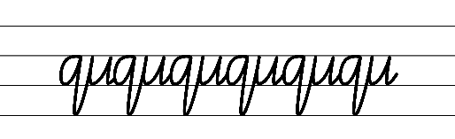  - Example cursive letter formations for diagonal joins to the letter f  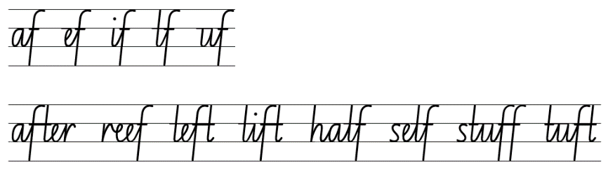  - Example cursive letter formations for diagonal joins to the letters q and z  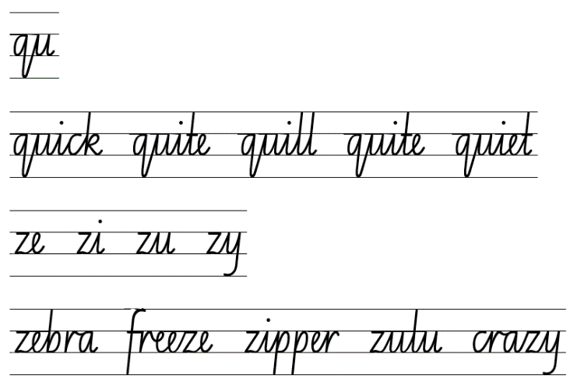  - Suggested practice text from the passage  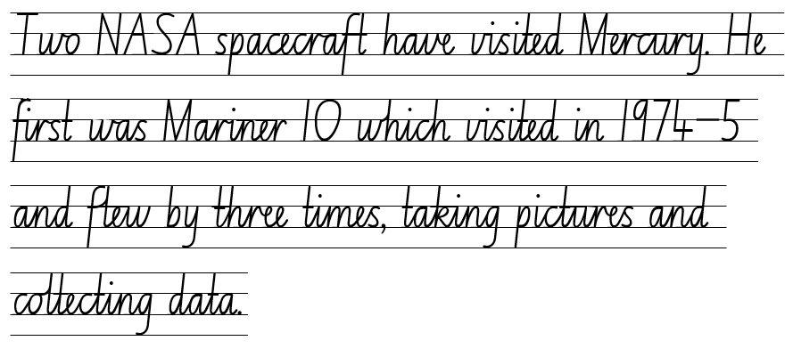

Planning framework
To plan and document Component A teaching and learning, a planning scaffold is provided. To support you in your planning, a link to a detailed example of a one-week teaching and learning cycle is included in the scaffold. Additional resources to support teaching and learning in each focus area can be found at Lesson advice guides.

Component B teaching and learning
The following teaching and learning sequence has been designed to address Component B outcomes and content and develops conceptual understandings of English through the study of quality texts. Adapt the sequence as required to best meet the needs of your students.

Learning intentions and success criteria
Learning intentions and success criteria are best co-constructed with students.

Learning intention
Students are learning to understand that a text can differ in mode and medium.

Success criteria
Students can:
- identify how the same genre can be represented in different modes
- create opening statements and conclusions to support the genre of a text
- identify text features and describe how they help a reader understand the genre of a text
- construct informative written texts that include appropriate structure.

Lesson 5: Different modes and mediums
- In pairs, students use ‘I used to think... now I think...’ strategy to compose a sentence about the universe, the solar system and the stars. For example, ‘I used to think that the universe was very small, now I think the universe is full of many solar systems and galaxies.’
- View ‘Uranus’ on pages 14 to 15 in Deadly Science Solar System. Focus on and read the ‘Cool Fact’, ‘Fact’ and ‘Did you know?’ sections of the text. Students turn and talk to answer the following questions:
- Why did the author add these facts to the pages?
- How do they add to this text and its purpose?
- What other ways could be used to present the information on the pages? Video, podcast, documentary.
- Explain to students that the same information can be communicated in different ways. This is the mode and medium. Mode refers to how a text is communicated (sounds, music, spoken or printed words, images). Medium refers to how a text is conveyed (linguistic, visual, gestural, spatial, audio).
- Watch the video: Uranus Mission (3:49).
- Compare and contrast the 2 texts (written or digital). Ask:
- What components are similar? (purpose, subject matter)
- What are the modes of the text? (print text and digital text)
- What is the medium? (internet website, published text)
- Are the genres different or the same? How do you know?
- Revisit gist statements and effective note taking from Lesson 4. Display and explain Resource 9: Gist statement scaffold and demonstrate how to write gist statements in each section.
- While listening to the video a second time, students write gist statements in each section of Resource 9: Gist statement scaffold.
- Model selecting a gist statement and writing as a ‘Cool Fact, Fact or Did you Know?’ fact, replicating the same language choices used by the author.
- Students write their own ‘Cool Fact’, ‘Fact’ and ‘Did you Know?’ using their gist statements.
Too hard? Facilitate use of text-to-speech technology or audio recording to produce the text.
Too easy? Students apply their understanding of Tier 3 vocabulary to enhance their writing.
- Students share their writing and work in small groups to brainstorm different modes and mediums that could be used to present their information. For example, Mediums: publishing, broadcasting, or the internet. Modes: sounds, music, printed or spoken words, images and gestures.
- Explain how texts that belong to the same genre, such as Deadly Science Solar System and ‘Uranus Mission’, can be represented in different modes and mediums. Texts may use similar language choices, subject matter, form and purpose. Ask students to explain which mode and medium they preferred and why.

Lesson 6: Gist and concluding statements
- Read ‘Jupiter’ on pages 18 to 19 in Deadly Science Solar System.
- Discuss the following questions:
- How do we know when the content changes in the text?
- Why do you think the layout is different to the other pages?
- Why is the image of Jupiter so big and all the text on one page?
- As a reader, what section on the pages are you drawn to? Why do you think that happened?
- Ask students to think carefully about their previous learning about genre and share what conventions of genre can be identified. For example, how the text structure helps the reader to identify the purpose and subject matter.
- Explain that students will create a mind map about Jupiter using subheadings. Remind students that subheadings are a distinctive structure of texts that are used to sign post content and inform the reader. In pairs, students decide on the subheadings that could be used on the mind map. For example, appearance.
- As a class, select 4 subheadings to use on the mind map for students to independently complete.
- Explain that students will take notes and record gist statements under each heading on the mind map, as pages 18 and 19 are re-read.
- Watch the video: Jupiter Profile (2:39–4:08). Students use information from the video to add gist statements and notes to their mind map.
- Compare and contrast the 2 mediums (text/digital) and how the information is presented. Explore the specific purpose of each medium. Ask students to consider which medium they think has the biggest impact on understanding and why.
- Display Resource 10: Writing scaffold. Revise opening statements from Lesson 4. Model writing an opening statement using general information about Jupiter. For example, Jupiter is a gas giant with distinctive features and is the largest planet in the Solar System.
- Students use Resource 10: Writing scaffold to write an opening statement about Jupiter.
- Using a student sample, model recording 2 subheadings from activity 5, to organise the informative text, sorting student gist statements into categories. For example, gist statements about the appearance of Jupiter.
- In pairs, students select the 2 headings they will include in their informative text and record on Resource 10: Writing scaffold. Students discuss how they will use their gist statements to support their writing.
- Co-construct a paragraph about Jupiter using the subheadings and gist statements from activity 11.
- Students write a paragraph about Jupiter, using Resource 10: Writing scaffold. Refer to mind maps from activity 6.
Too hard? Co-construct a paragraph with students.
- Revise conclusions from Lesson 4. Model writing a conclusion that links to the main idea and reflects the opening statement.
Note: consider using a different structure for the concluding statement, for, example using a subordinating conjunction. For example, Even though Jupiter is a gas giant, it is one of many fascinating planets in the universe.
- Students write a concluding statement about Jupiter that links to the main idea and reflects the opening statement.
- Students complete an exit ticket to answer the question, Why are subheadings important in an informative text? (subheadings are a distinctive structure of a text that inform and can help readers to understand the predictable pattern).
Assessment task 3 – Observations from this lesson allow students to demonstrate achievement towards the following syllabus outcome and content points:
EN2-RECOM-01 – reads and comprehends texts for wide purposes using knowledge of text structures and language, and by monitoring comprehension
- determine the relevance of a text for specific purposes
- locate, select and retrieve relevant information from a print or digital text and consider accuracy of information presented
- identify and describe how text structure, features and language work together to achieve a text’s purpose.

Lesson 7: Understanding text features of a specific genre
- In small groups, students play Headbands. Refer to Resource 11: Headbands.
- Read ‘Earth’ on pages 22 to 23 in Deadly Science Solar System and discuss the features used to display the information. Draw attention to the informative paragraphs, ‘Quick five’ fact box, ‘Did you know?’ fact and graphics. Discuss the following:
- What vocabulary has been used in these facts to help the reader identify genre in the text? (scientific language, factual, informative)
- Why do you think the author has used this vocabulary in the text? (to inform readers about scientific facts and identify the purpose)
- How does the vocabulary help the reader to understand the predictable patterns of genre? (scientific vocabulary used to indicate a scientific text, the use of evidence including, dates, factual information that is reliable and accurate, the reference to real locations, scientists and space companies).
- Read ‘The Sun and the seasons’ paragraph on page 23 and explain the relevance of the diagram (focus on the use of numbered labels; words for labels, such as southern spring; images).
- Explore how the labels used support readers to interpret the diagram and further our understanding of how the Earth orbits the sun.
- View the interactive resource Earth Rotation: Night and Day. Using the guided tour of space, explore Night and Day (interactive globe).
- Discuss how the interactive display and the diagram on page 23 have the same purpose. Ask students to identify any other conventions of genre that are similar. For example, language choices, such as scientific vocabulary; text features, such as captions, labels, use of images.
- Display Resource 12: Gist statement graphic organiser. Explain that students will take notes about Earth on the graphic organiser, using the subheadings to organise the notes.
- Re-read pages 22 and 23, while students write gist statements under the subheadings, recording key notes.
- Students use the recorded gist statements to write sentences and create a labelled diagram to support the information about Earth.
Too hard? Students create a diagram and write simple and compound sentences about the Earth.
Too easy? Students research additional information to add to their gist statements and sentences.
- Reiterate that including diagrams in informative texts provides a visual representation that enhances the text, making it accessible and easier to interpret. This enables readers to understand the genre. For example, purpose, subject matter and structure.

Lesson 8: Constructing an informative paragraph
- View the ‘Thin crust, thick core’ diagram page 26. Ask:
- How does this diagram help readers to interpret the purpose of the text? For example, to inform.
- Display page 27 and view the large image of the surface of Mercury. Highlight the use of arrows, headings and captions. Ask:
- Why have these features been used and how do they show the distinctive patterns of genre? For example, the purpose is to inform, the structure of the texts includes headings and arrows which are features of informative texts, the subject matter is scientific and is reflected through factual language choices.
- Display and read the double page spread on ‘Mercury’, pages 26 to 27 in Deadly Science Solar System, and discuss the text features used. For example, headings, diagrams, labels, captions and facts.
- Revise acronyms and the use of capital letters from Component A. Draw students’ attention to the acronyms on page 26, for example, NASA, MESSENGER. Discuss:
- what these acronyms stand for (NASA – National Aeronautics and Space Administration; MESSENGER – Mercury surface, space environment, geochemistry and ranging)
- why they are used in this form of text (to inform people of scientific information in a condensed way)
- how these acronyms add to our understanding of the text and genre (they show purpose, subject matter and language choices)
- Revise the structure of an informative text. Explain the following:
- opening statement – tells the reader about the topic of the text
- body – each paragraph has a subheading and a topic sentence that tells the reader what the paragraph is going to explore and includes detailed information
- conclusion – restates information written in an informative text.
- Re-read pages 26 and 27. Brainstorm and record subheadings that could be used to organise information about Mercury. For example, How Mercury got its name, size, NASA visits Mercury, Humans on Mercury, Features of Mercury, What is Mercury made of.
- Select a subheading from activity 6 to jointly construct a paragraph. Use an outline to model how to write a paragraph. For example:
- topic sentence – expresses the main idea
- point 1, point 2, point 3 – should expand on details in the topic sentence
- concluding statement – should sum up the main idea.
- Explain that students will write a paragraph using a different sub-heading from activity 6.
Too hard? Co-construct the informative text with students.
Too easy? Students write elaborating sentences using various conjunctions.
- In pairs, students share their writing and decide on what other features could be added to enhance their informative paragraph. For example, diagrams, headings, captions.

Week 3

Component A teaching and learning
Component A focuses on the development of foundational skills and knowledge through regular, systematic and repeated practice. The mentor and supporting texts used in Component B of this unit can support the effective implementation of Component A teaching and learning.

Teaching guide
Guidance for explicit teaching, teaching notes, resources and examples for the related outcomes and content points have been provided in the table below.
Focus areas and teaching notes | Resources and examples
Reading fluency  Monitoring reading fluency  - Recognise that there are different purposes and audiences for reading and adjust reading rate to suit a text’s purpose  - Reading rate for informative texts may depend on the vocabulary used. For example, Tier 3 technical and subject specific vocabulary may require the reader to slow down. | Reading fluency  Monitoring reading fluency  - Resource 13: Fluency and close reading passage analysis – Southern Cross (225 words)  - Tier 3 vocabulary from the passage where reading rate may be adjusted  - ‘The one-of-a-kind Southern Cross constellation is widely regarded as a significant symbol among indigenous communities.’
Reading comprehension  Reading for interest and wide purposes  - Locate, select and retrieve relevant information from a print or digital text and consider accuracy of information presented  - The selection and retrieval of information requires readers to determine the relevance of the information to the topic and extract information by reading the material thoroughly, taking notes, and summarising the key points that pertain to the research question.  - Readers need to assess the accuracy and reliability of the information presented in the sources. This may involve cross-referencing with other reputable sources, checking for biases or misinformation, and verifying facts. | Reading comprehension  Reading for interest and wide purposes  - Examples of information that could be located and selected from the fluency passage  - facts about Aboriginal astrology.
Comprehending language  - Understand that word contractions are a feature of informal language and that apostrophes of contraction are used to signal missing letters  - A contraction is a shortened form of one or 2 words (one of which is usually a verb). In a contraction, an apostrophe takes the place of the missing letter or letters (NESA Glossary).  - Contractions used in Deadly Science Solar System are a feature of informal language. This informality is appropriate as it is a text aimed at children. | Comprehending language  - Contractions used in the fluency passage  - isn’t = is not. ‘Earth isn't all that massive.’  - let’s = let us. .’..let's slip on our space helmets...’  - it’s = it is. ‘It's about a quarter of a million miles away’.
Monitoring comprehension  - Reflect on own understanding of texts and monitor own goals for reading  - Readers need to actively think about how well they are understanding what they have read. Comprehension may fail if a reader lacks necessary content knowledge or vocabulary, if they have poor knowledge of cohesive ties or text structures, or if they lack reading stamina.  - If a reader loses understand, they might apply relevant strategies such as re-reading, looking up a word in the dictionary or generating an inference. | Monitoring comprehension  - Support students to work towards achievement of their personal goal for monitoring comprehension, generated in Week 1. For example  - Draw on background knowledge to assist in understanding an informative text.  - Identify and determine meaning of unknown vocabulary to support understanding.  - Monitoring of goals will differ, based on the goal that is set. Strategies may include the use of self-assessment rubrics, documenting the actions taken to achieve a goal, or the use of work samples created in working towards the set goal.
Vocabulary  Learning and using words  - Build personal Tier 1, Tier 2 and Tier 3 vocabulary through social interactions, reading and writing  - Identify and discuss Tier 2 and Tier 3 words in the text to improve vocabulary knowledge and comprehension.  - Understand that many words derive from other languages, including Aboriginal and Torres Strait Islander Languages, and that the pronunciation and spelling of words may reflect their etymology  - The English language is made up of words derived from many other languages including Latin, French, Greek, German and Aboriginal and Torres Strait Islander Languages.  - The pronunciation and spelling of words can reflect the etymology. For example, the French spelling of the /sh/ phoneme is ‘ch’. This is seen in the words chef, parachute and chaperone. | Vocabulary  Learning and using words  - Suggested vocabulary from the Week 3 reading material  - Deadly Science Solar System: universe (p 2), astronomers (p 3), microscopic (p 4), Bundjil (p 7), Pluto (p 11)  - Meanwhile Back on Earth: Ceres, Egyptian, conquest, empire.  - Words derived from other languages from the passage  - For the Kulin Nation People of Victoria, around Melbourne, the Southern Cross represents Bundjil, an eagle-like sky god.
Defining and analysing words  - Use word associations to build word knowledge  - Building an association between a known word and an introduced word further reinforces the meaning of the new word. Connecting words together through word association is a strategy for increasing word vocabulary.  - Word maps, word clines and explaining the relationship between words are activities that could be used for building word associations. | Defining and analysing words  - Suggested vocabulary from the Week 3 reading material  - helmets, car, driving, windows  - Southern Cross, constellations, stars, Nebula.
Spelling  Phonological component  - Identify differences in vowel phonemes (short, long, diphthong and schwa vowels)  - Schwa /ə/  - Revise schwa. A schwa is a vowel sound in an unstressed or unaccented syllable, where a vowel does not make its long or short vowel sound. It usually sounds like the short /u/ sound but is shorter, softer and weaker.  - Recognise stressed and unstressed syllables in multisyllabic words and apply this knowledge when spelling  - Words with more than one syllable have both stressed (strong) and unstressed (weak) syllables. Stressed syllables are often louder and higher pitched. Unstressed syllables are usually said faster and at a lower volume.  - Understand that the schwa occurs in an unstressed syllable and apply this knowledge when spelling  - The vowel in the weak syllable is often schwa. For example, in the word ‘doctor’ the first syllable ‘doc’ is stressed and is clearly articulated. The second syllable ‘tor’ is unstressed and is pronounced as ‘tuh’, giving us ‘doctuh’. | Spelling  Phonological component  - Suggested words from the Week 3 reading material  - Deadly Science Solar System: enormous (p 28), gas-gaseous (p 29)  - Meanwhile Back on Earth: riot-riotous.  - Sample words for inquiry  - trouble, southern, countries, joy-joyous, wonder-wonderous, danger-dangerous, courage-courageous, fame-famous, nerve-nervous, glory-glorious, mystery-mysterious, vary-various.
Orthographic component  - Apply knowledge of taught vowel graphemes when spelling  - Identify the vowel graphemes that are pronounced as schwa, instead of their common pronunciation.  - The vowel grapheme [ou] in the suffix -ous is often pronounced as a schwa. | Orthographic component  - As above
Morphological component  - Identify inflected suffixes, explaining when and how to treat base words when they are affixed, and apply this knowledge when spelling  - Derivational suffix: -ous  - Revise derivational suffixes. Derivational suffixes are added to a base word or root to change part of speech. The suffix -ous can be added to nouns to form adjectives.  - Introduce the suffix -ous  - ‘-ous’ meaning ‘having qualities of, full of’.  - Explore adding ‘-ous’ to nouns to make adjectives: danger-dangerous, mountain-mountainous.  - Explore the ‘drop the e’ generalisation: fame-famous.  - Explore the ‘change the y to i' generalisation: vary-various.  - Explore adding ‘-ous’ to a word that ends with ‘our’, ‘our’ becomes ‘or’, then add -ous: humour-humorous. | Morphological component  - As above
Creating written texts  Sentence-level grammar  - Use adverbial phrases or clauses to add information to the verb or verb group of the main or other clauses, to provide reasons for or circumstance  - An adverbial phrase is a group of words that modifies the verb in the main clause. Adverbial phrases do not contain both a subject and a verb. They cannot stand along as an independent clause/sentence.  - An adverbial clause is a dependent clause that modifies a verb, adjective or another adverb. (NESA Glossary).  - Adverbial phrases and clauses provide reasons for or circumstance. They provide information  - when (adverbial phrase/clause of circumstance- time)  - where (adverbial phrase/clause of circumstance- place)  - how (adverbial phrase/clause of circumstance- manner)  - why (adverbial phrase/clause of reason).  - Subordinating conjunctions begin the adverbial clause  - when: when, while, after, before, until  - where: where, wherever  - how: as, as if  - why: because, since, as, so that. | Creating written texts  Sentence-level grammar  - Examples of adverbial phrases innovated from Meanwhile Back on Earth  - ‘The sea is still rising from the end of the last Ice Age.’ (when)  - ‘In all of the cosmos, this is where people live.’ (where)  - Examples of adverbial clauses innovated from Meanwhile Back on Earth  - I will drive to the sun, as fast as I can. (how)  - If we were already at the moon, it would be almost a year ago at home. (when)
Punctuation  - Use apostrophes for contractions, and to show singular and plural possession  - Review the use of apostrophes for contractions. In a contraction, an apostrophe takes the place of the missing letter or letters.  - Introduce apostrophes to show singular and plural possession for nouns.  - Apostrophes are used to indicate singular possession. For example, The dog's collar is blue. The apostrophe indicates ownership of the collar by a singular dog. The apostrophe is placed before the letter ‘s’.  - Apostrophes are used to indicate plural possession. For example, The dogs' leashes are tangled. The apostrophe indicates ownership of the leashes by 2 or more owners. The apostrophe is placed after the last letter of the owner. | Punctuation  - Suggested examples of apostrophes for contractions from Meanwhile Back on Earth  - ‘...for the whole time we’ve been people.’  - ‘... that it’s best to divide it into smaller bits.’  - '...and can’t agree what we do next.’  - ‘Well, truth be told, Earth isn't all that massive’.  - Suggested examples of apostrophes for singular and plural possession from the passage  - NASA’s  - world’s  - Coastal SA’s  - Neptune’s  - Moon’s  - Australia’s  - ‘Were you aware that Indigenous Australians take pride in being the world's earliest astronomers?’
Handwriting and digital transcription  Handwriting legibility and fluency  - Join letters when writing familiar words  - Diagonally join to the letters e and s when writing familiar words in cursive.  - Diagonal joins to the letter e need a smooth upward stroke.  - When using a diagonal join to the letter s, the top needs to be retraced a little. | Handwriting and digital transcription  Handwriting legibility and fluency  - Suggested fluency pattern  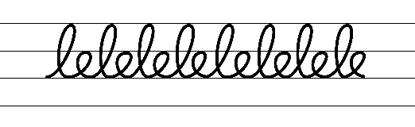  - Example cursive letter formations for diagonal joins to the letter e  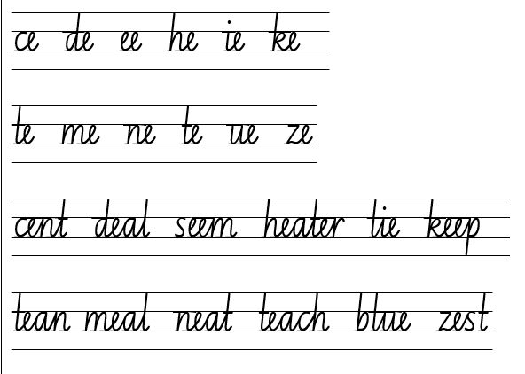  - Example cursive letter formations for diagonal joins to the letter s  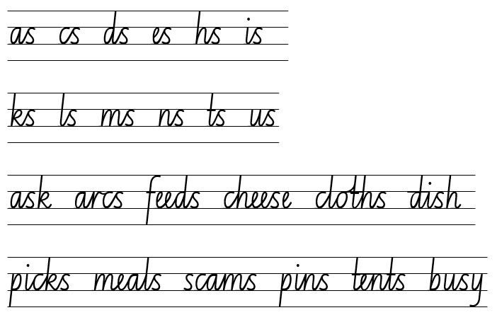  - Suggested practice text from the passage  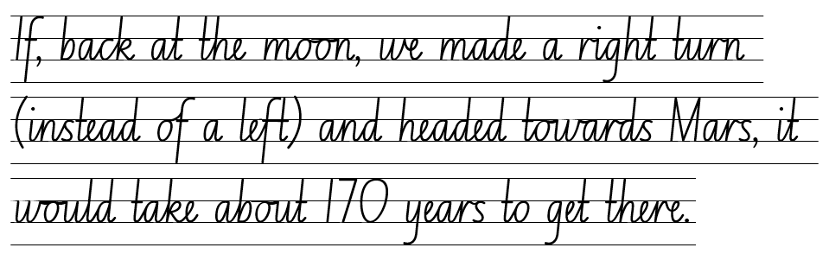
Software functionalities and typing  - Monitor goals that build on typing accuracy and rate  - Support students to value accuracy of typing over speed when setting goals.  - Use knowledge of the keyboard layout, for example, using the home, top and bottom row to build on typing accuracy and rate. Focus on letters. | Software functionalities and typing  - An example of a student goal  - Goal: Type with 98% accuracy or above.

Planning framework
To plan and document Component A teaching and learning, a planning scaffold is provided. To support you in your planning, a link to a detailed example of a one-week teaching and learning cycle is included in the scaffold. Additional resources to support teaching and learning in each focus area can be found at Lesson advice guides.

Component B teaching and learning
The following teaching and learning sequence has been designed to address Component B outcomes and content and develops conceptual understandings of English through the study of quality texts. Adapt the sequence as required to best meet the needs of your students.

Learning intentions and success criteria
Learning intentions and success criteria are best co-constructed with students.

Learning intention
Students are learning to identify perspective and context and discuss the language choices, purpose, audience, mode and medium of a text.

Success criteria
Students can:
- explain different perspectives and viewpoints
- explore different perspectives using a second person narrative voice
- describe how timelines as a text feature can help the reader to understand genre
- identify that language choices help represent the genre of a text.

Lesson 9: Exploring perspective
- Activity: Who Am I? Students retrieve planet facts from Week 2 and create a Who Am I? game. Students present facts to a partner, who must guess the planet based on the description given.
- Read text excerpts about ‘Women in Space’ on pages 11, 21, 29. Explore the following textual features and ask students to consider in what ways the subheading, images and photographs support readers:
- Venetia Burney – Subheading, image, caption (p 11)
- Alyssa Carson – Subheading, photograph (p 21)
- NASA Woman – Subheading, photograph (p 29)
- Consider the following questions with students:
- What is the purpose of the text excerpts?
- Who is the intended audience?
- In small groups, students use the Step Inside routine [PDF 194KB] to explore the author’s perspective about Women in Space. Students consider the following questions:
- What could a reader think about Women in Space?
- What might a reader know or believe about Women in Space?
- What might a reader care about, in relation to Women in Space?
- What language does the author use, for you to come to these conclusions?
- Discuss why the students think the author included sections of information about Women in Space. Explain that the author’s perspective is represented through the inclusion of these sections as he values the contribution women have made and will make to space projects.
- Revise note taking skills referring to the displayed class note taking poster and recall the note taking styles explored in previous lessons. For example, mind map, scaffolds, gist statements.
- Explain that students will take notes focusing on Women in Space using a note taking style of their choice. Provide time for students to setup their page for note taking.
- Re-read text excerpts about ‘Women in Space’ on pages 11, 21 and 29.
- As a class, guide students on how to use Resource 14: Planning template – Women in Space to plan a multimodal informative text.
- In small groups, students complete Resource 14: Planning template – Women in Space.
- Students use the planning template and recorded notes on Women in Space to create a multimodal informative text, including:
- Heading
- Subheadings
- Images
- Text
- A ‘Cool fact’ or ‘Did you know fact?’
Note: multimodal texts may be constructed digitally or as a poster.
Too easy? Students research an important woman in space to create a multimodal informative text.
- Students share their text with the class, discussing and identifying the predictable genre patterns in their multimodal informative text.
- Discuss the author’s purpose for why he included the Women in Space sections. Ask students to consider what audience this might appeal to and why is this important.

Assessment task 4 – Collecting work samples from this lesson allows students to demonstrate achievement towards the following syllabus outcome and content point:
EN2-OLC-01 – communicates with familiar audiences for social and leaning purposes, by interacting, understanding and presenting
- make notes when listening to spoken texts, asking questions to clarify or follow up on information and seeking assistance if required.

Lesson 10: Genre text comparison and second person narrative voice
- Introduce Meanwhile Back On Earth by investigating the front cover, blurb (inside front cover) and diagram on the inside front cover and back page. Ask what genre patterns students can identify in these parts of the text.
- Read Meanwhile Back on Earth. Draw attention to the author’s use of contractions. Make links to learning from Component A, and ask students to define contractions and explain the purpose of the apostrophe. Ask students to consider why the author chose to use contractions throughout the text. For example, the author uses informal language to show he is talking to the reader.
- Complete a class mind map, considering the following questions:
- What is the purpose of this text?
- What is the subject matter of the text?
- How is the text presented (form)?
- How is the text structured?
- What language and features have been used in the text?
- How is the text communicated (mode)?
- How is the text conveyed (medium)?
- Who is the intended audience of this text?
- Explain that Meanwhile Back On Earth brings is an imaginative text as can been seen through the illustrations, story structure, characters and humour, but readers can also see aspects of the informative genre through the factual information, diagrams, labels, mode and medium. This text can be referred to as a hybrid text as there is more than one genre.
- Explain that students will compare and contrast the types of genre in Meanwhile Back on Earth and Deadly Science using a Venn diagram. Display and model adding information to the Venn diagram, referring to both texts.
- Students use a Venn diagram to compare genre in Meanwhile Back On Earth and Deadly Science. Students should consider purpose, subject matter, form, structure, language choices and how these are shown across the 2 texts.
Too hard? Construct Venn diagrams in small groups.
- As a class, share responses from the Venn diagram and explore how texts can be characterised by more than a single genre.
- Read the sentence from Meanwhile Back on Earth ‘...Make sure you have the air conditioning going, and your sunglasses on...’ Ask how students know who the author is talking to (the use of ‘you’ and ‘your’).
- Explain that this technique called ‘second person’ narrative voice and can be used for various reasons including:
- to make a text more entertaining by allowing the reader to feel part of the text
- showing an uncommon point of view
- allowing the reader to reflect and make connections to the text based on how they would feel
- adding humour to the text.
- Explain that this technique is another example of how Meanwhile Back on Earth can be categorised by more than one genre.
- Discuss further examples of second person narrative voice in both Meanwhile Back on Earth and Deadly Science:
- ‘I hope you’re comfortable...’ Meanwhile Back on Earth
- ‘Do you want to keep going?’ Meanwhile Back on Earth ‘Alpha Centauri’ page
- ‘Do you want to go home?’ Meanwhile Back on Earth (final page)
- ‘You can see Saturn in the night sky...’ Deadly Science (p 16)
- ‘You’re able to spot Venus in the sky...’ Deadly Science (p 25)
- Model using second person narrative voice to write ‘it takes 27 days for the Moon to circle the Earth’ in a sentence. For example, ‘If you’re the moon, it would take you 27 days to circle the Earth!’
- Revise and highlight the use of a comma to separate a dependent clause before a main clause and the use of contractions as an informal language feature from Component A.
- In pairs, students experiment writing the following facts from Moon Gazing on pages 30 to 31 into sentences using second person narrative voice:
- ‘Warrumbungle National Park in NSW... it’s one of the best places in the world to see the Moon and stars’
- ‘The moon appears in different parts of the sky at different times, and it looks slightly different night after night’
- As a class, discuss how the choice of language (second person narrative) can help the reader to identify that a text can be characterised by more than a single genre.
Assessment task 5 – Observations from this lesson allow students to demonstrate achievement towards the following syllabus outcomes and content points:
EN2-RECOM-01 – reads and comprehends texts for wide purposes using knowledge of text structures and language, and by monitoring comprehension
- understand that word contractions are a feature of informal language and that apostrophes of contraction are used to signal missing letters.
EN2-CWT-01 – plans, creates and revises written texts for imaginative purposes, using text features, sentence-level grammar, punctuation and word-level language for a target audience
EN2-CWT-02 – plans, creates and revises written texts for informative purposes, using text features, sentence-level grammar, punctuation and word-level language for a target audience
EN2-CWT-03 – plans, creates and revises written texts for persuasive purposes, using text features, sentence-level grammar, punctuation and word-level language for a target audience
- use a comma to separate a dependent clause before a main clause.
EN2-UARL-01 – identifies and describes how ideas are represented in literature and strategically uses similar representations when creating texts
- identify different text genres when a text is characterised by more than a single genre
- identify and discuss the purpose of a text, and its intended audience, mode and medium.

Lesson 11: Exploring timelines as a text feature
- Begin by asking students if a text can be categorised by a single genre and how they know. Revise genre components that can be used to categorise texts based on their similarities (purpose, subject matter, form, structure and language choices). Reiterate that, even though texts may differ in mode or medium, they can see be categorised by the same genre; students can see this through Meanwhile Back on Earth and Deadly Science.
- View the timeline on the inside back cover of Meanwhile Back on Earth and explore the events that occur throughout the text (the timeline is a summary). Discuss how the timeline allows readers to understand the genre of the text. For example, through the purpose, subject matter, structure and language choices. Students identify that, even though readers can see the imaginative text, the subject matter also shows the informative text.
- View ‘The Big Bang scale of time’ diagram on page 5. Explain how the diagram is used to explore the history of time.
- View the graphic Earth timeline on page 23. Explore the diagram of how continents were formed.
- Discuss and compare the information represented in the 3 different timelines and explain how diagrams in informative texts provide a visual representation that enhances the text, making it accessible and easier to interpret. The timeline supports a reader to understand the genre. For example, purpose, subject matter and structure.
- Read the text excerpt ‘Pluto’s five moons’ (p 11) and draw attention to the diagram with matching numbers.
- Discuss the use of possessive apostrophes from Component A and locate them in ‘Pluto’s five moons’ (p 11). Revise the NASA acronym from Lesson 8.
- Using Resource 15: Pluto timeline model constructing a timeline.
- Explain that students will create their own timeline detailing NASA’s exploration of the planets.
- As a class, read the NASA Adventure labels on Resource 16: NASA mission timeline, discussing key dates NASA sent missions to explore the planets. Explain that these labels have been written as gist statements as they are the most important piece of information.
- Display the NASA Adventure timeline on Resource 16: NASA mission timeline and demonstrate how to read. For example, the timeline is in chronological order, it begins in 1962 and extends into the future to 2030.
- Model locating a label and writing it in the correct position on the timeline, emphasising the correct capitalisation of acronyms and use of apostrophes to indicate possession. For example, NASA’s Mariner 2 did a fly-by of Venus.
- Distribute individual enlarged copies of Resource 16: NASA mission timeline. In small groups, students locate and write the correct gist statement into the corresponding time on the timeline using the resource. Remind students to capitalise all letters in an acronym and to include apostrophes for possession.
Too easy? Students research important dates on the NASA website to complete the timeline.
- Students share their timelines with a partner, checking they have used the correct acronyms and apostrophes for possession.
- Reflect and discuss how including a timeline as a text feature can help a reader to identify the genre of a text and further their understanding.
Assessment task 6 – Observations and work samples from this lesson allow students to demonstrate achievement towards the following syllabus outcomes and content points:
EN2-CWT-01 – plans, creates and revises written texts for imaginative purposes, using text features, sentence-level grammar, punctuation and word-level language for a target audience
EN2-CWT-02 – plans, creates and revises written texts for informative purposes, using text features, sentence-level grammar, punctuation and word-level language for a target audience
EN2-CWT-03 – plans, creates and revises written texts for persuasive purposes, using text features, sentence-level grammar, punctuation and word-level language for a target audience
- use apostrophes for contractions, and to show singular and plural possession
- use capital letters to indicate the beginning of a sentence, proper nouns, headings and subheadings, to indicate the beginning of a poetry line, for emphasis, and when using acronym.
EN2-UARL-01 – Identifies and describes how ideas are represented in literature and strategically uses similar representations when creating texts
- understand that genre refers to texts that are grouped according to purpose, subject matter, form, structure and language choices, and that a type of text can differ in mode and medium
- identify and discuss the purpose of a text, and its intended audience, mode and medium.

Lesson 12: Language choices in specific genre
- Ask students to recall how different texts can be grouped. For example, purpose, subject matter, structure and language choices. Students elaborate on why understanding the way texts can be grouped is important for readers.
- Display an enlarged copy of the timeline on the inside back cover of Meanwhile Back on Earth. Look closely at some of the historical events. Students turn and talk to decide where they think Australia’s first astronomers would appear on the timeline.
- Refer to Deadly Science page 3 and re-read the Did you know? fact. Ask students to reflect on their answer from activity 2. Using a sticky note, select a student to draw an image to represent the first astronomers. Select students to use the sticky note to plot where they think 65 000 years ago would be represented near the timeline. Support students to clarify the position of the sticky note and label to represent the first astronomers.
- Revise how words can derive from other languages as discussed in Component A, such as the Aboriginal and Torres Strait Islander language. Read ‘First Astronomers’ (p 7) in Deadly Science. Discuss how the first astronomers used specific vocabulary to represent and understand the subject matter of space. For example, Bundjil is an ancestral wedged-tailed eagle and the creator spirit.
- Invite students to share background knowledge or language from Deadly Science that relate to the first astronomers. For example, The Dark Emu, Waluwarra.
- Explain that the names of planets derive from other languages. Revisit Deadly Science ‘What’s in a name’ excerpts throughout the text. Provide time for students to make careful observations and interpretations of the naming patterns. For example, Pluto (p 11), Neptune (p 12).
Note: all planets are named after Roman gods, except Earth.
- In small groups, students analyse Resource 17: What’s in a name? and consider:
- What language choices and structural features are used to support the text’s purpose?
- Does the text provide enough information to explain how and why the planets were named?
- What could be refined to support the text’s purpose?
- Students share their thinking to explain how the resource supports and enhances the reader’s understanding of a text. Prompt students to clarify their thinking using specific vocabulary.
- Explain that a paragraph will be written about how and why the planets were named. Refer to the paragraph outline from Lesson 8 to model writing a topic sentence. For example, ‘The naming of the planets in our Solar System was inspired by Greek Gods.’
- In pairs, students plan and write 2–3 sentences that supports the topic sentence, using Resource 17: What’s in a name?
Too hard? Students add a concluding statement to their paragraph.
- In small groups, students share their paragraph and consider what additional sentences could be added to further support the topic sentence.
Assessment task 7 – Observations from this lesson allow students to demonstrate achievement towards the following syllabus outcomes and content points:
EN2-VOCAB-01 – builds knowledge and use of Tier 1, Tier 2 and Tier 3 vocabulary through interacting, wide reading and writing, and by defining and analysing words
- understand that many words derive from other languages, including Aboriginal and Torres Strait Islander Languages, and that the pronunciation and spelling of words may reflect their etymology.
EN2-RECOM-01 – reads and comprehends texts for wide purposes using knowledge of text structures and language, and by monitoring comprehension
- identify and describe how text structure, features and language work together to achieve a text’s purpose.

Week 4

Component A teaching and learning
Component A focuses on the development of foundational skills and knowledge through regular, systematic and repeated practice. The mentor and supporting texts used in Component B of this unit can support the effective implementation of Component A teaching and learning.

Teaching guide
Guidance for explicit teaching, teaching notes, resources and examples for the related outcomes and content points have been provided in the table below.
Focus areas and teaching notes | Resources and examples
Reading fluency  Reading automaticity and rate  - Demonstrate use of navigation pathways to support fluency when engaging with print, visual and multimodal texts  - Navigation pathways refers to the path followed while moving through the content of a text. It involves navigating the text to support fluency in a way that doesn't disrupt the overall comprehension and allows the reader to engage with print, visual, and multimodal texts. | Reading fluency  Reading automaticity and rate  - Fluency and close reading passage– Jupiter (pp 18–19): introductory ‘Jupiter’ paragraph; ‘Fact’, ‘Cloud Belts’ paragraph; ‘Bright clouds’ paragraph and ‘Moons’ paragraph (176 words).  Note: the passage from the text will need to be a teacher-created resource.  - Examples following navigation pathways – ’Jupiter’ (pp 18–19)  - Navigation pathway created using headings, subheadings and the bolding of text. Different sized fonts are used for headings, subheadings, facts and informative text.  - The columns on page 19 provide a pathway for the reader to follow.  - Photographs with labels and captions, give meaning and to the text and provide additional information.
Monitoring reading fluency  - Recognise that there are different purposes and audiences for reading and adjust reading rate to suit a text’s purpose  - Reading rate for informative texts may depend on the vocabulary used. For example, Tier 3 technical and subject specific vocabulary may require the reader to slow down. | Monitoring reading fluency  - Tier 3 vocabulary from the passage where reading rate may be adjusted  - ‘Europa is thought to have abundant liquid water under its icy surface…’ (p 19)
Reading comprehension  Reading for interest and wide purposes  - Locate, select and retrieve relevant information from a print or digital text and consider accuracy of information presented  - The selection and retrieval of information requires readers to determine the relevance of the information to the topic and extract information by reading the material thoroughly, taking notes, and summarising the key points that pertain to the research question.  - Information can be located and selected by using headings and subheadings, scientific vocabulary and key words, captions and labels, and images. | Reading comprehension  Reading for interest and wide purposes  - Locate and select information from Jupiter (pp 18–19) using  - headings and subheadings – Jupiter, Fact, Cloud Belts  - scientific vocabulary and key words – orbit, southern hemisphere, Jupiter is made up of...’  - captions and labels – Juno, ‘The Southern Aurora of Jupiter...’  - use of images – photographs and drawings.  - Examples of information that could be located and selected from the fluency passage  - information about the name ‘Jupiter’  - definition of the ‘Great Red Spot’  - information about Jupiter’s moons.
Monitoring comprehension  - Reflect on own understanding of texts and monitor own goals for reading  - Readers need to actively think about how well they are understanding what they have read. Comprehension may fail if a reader lacks necessary content knowledge or vocabulary, if they have poor knowledge of cohesive ties or text structures, or if they lack reading stamina.  - If a reader loses understand, they might apply relevant strategies such as re-reading, looking up a word in the dictionary or generating an inference. | Monitoring comprehension  - Support students to work towards achievement of their personal goal for monitoring comprehension, generated in Week 1. For example:  - Draw on background knowledge to assist in understanding an informative text.  - Identify and determine meaning of unknown vocabulary to support understanding.  - Monitoring of goals will differ, based on the goal that is set. Strategies may include the use of self-assessment rubrics, documenting the actions taken to achieve a goal, or the use of work samples created in working towards the set goal.
Vocabulary  Learning and using words  - Build personal Tier 1, Tier 2 and Tier 3 vocabulary through social interactions, reading and writing  - Identify and discuss Tier 2 and Tier 3 words in the text to improve vocabulary knowledge and comprehension.  - Understand that many words derive from other languages, including Aboriginal and Torres Strait Islander Languages, and that the pronunciation and spelling of words may reflect their etymology  - The English language is made up of words derived from many other languages including Latin, French, Greek, German and Aboriginal and Torres Strait Islander Languages.  - The pronunciation and spelling of words can reflect the etymology. For example, the French spelling of the /sh/ phoneme is ‘ch’. This is seen in the words chef, parachute and chaperone. | Vocabulary  Learning and using words  - Suggested vocabulary from Deadly Science Solar System  - methane gas (p 14), Epsilon Ring (p 15), Ganymede (p 19), emissions (p 19), radiation (p 22), glaciers (p 22), geochemistry (p 26), terrain (p 26)  - Resource 18: Vocabulary scaffold – Week 4  - Words derived from other languages from the passage  - crystal – derives from the Ancient Greek word krustallos, meaning both ice and rock crystal.
Spelling  Phonological component  - Identify differences in vowel phonemes (short, long, diphthong and schwa vowels)  - Schwa /ə/  - Revise schwa. A schwa is a vowel sound in an unstressed or unaccented syllable, where a vowel does not make its long or short vowel sound. It usually sounds like the short /u/ sound but is shorter, softer and weaker.  - Recognise stressed and unstressed syllables in multisyllabic words and apply this knowledge when spelling  - Words with more than one syllable have both stressed (strong) and unstressed (weak) syllables. Stressed syllables are often louder and higher pitched. Unstressed syllables are usually said faster and at a lower volume.  - Understand that the schwa occurs in an unstressed syllable and apply this knowledge when spelling  - The vowel in the weak syllable is often schwa. For example, in the word ‘doctor’ the first syllable ‘doc’ is stressed and is clearly articulated. The second syllable ‘tor’ is unstressed and is pronounced as ‘tuh’, giving us ‘doctuh’. | Spelling  Phonological component  - Suggested words from Deadly Science Solar System  - bright-brighten (p 19), old-olden (p 27)  - Sample words for inquiry: wood-wooden, gold-golden, broke-broken, froze-frozen, wove-woven, ash-ashen, dark-darken, fast-fasten, wide-widen, loose-loosen, bright-brighten, soft-soften, sweet-sweeten, sharp-sharpen, fright-frighten.
Orthographic component  - Apply knowledge of taught vowel graphemes when spelling  - Identify the vowel graphemes that are pronounced as schwa, instead of their common pronunciation.  - The vowel grapheme [e] in the suffix -n is often pronounced as a schwa. | Orthographic component  - As above
Morphological component  - Identify inflected suffixes, explaining when and how to treat base words when they are affixed, and apply this knowledge when spelling  - Derivational suffix: -en  - Revise derivational suffixes.  - Introduce suffix  - ‘-en’ meaning ‘to become or cause to be’ or ‘made of’  - Explore adding ‘-en’ to nouns to form adjectives. For example, ash-ashen, wood-wooden.  - Explore adding ‘-en’ to adjectives to form verbs. For example, dark-darken, wide-widen. | Morphological component  - As above
Creating written texts  Sentence-level grammar  - Use adverbial phrases or clauses to add information to the verb or verb group of the main or other clauses, to provide reasons for or circumstance  - Revise adverbial phrases.  - Revise adverbial clauses.  - Adverbial phrases and clauses provide reasons for or circumstance. They provide information  - when (adverbial phrase/clause of circumstance- time)  - where (adverbial phrase/clause of circumstance- place)  - how (adverbial phrase/clause of circumstance- manner)  - why (adverbial phrase/clause of reason). | Creating written texts  Sentence-level grammar  - Examples of adverbial phrases or clauses from Deadly Science Solar System  - ‘Jupiter is 779 million kilometres from the sun…’ (where)  - ‘Europa is thought to have abundant liquid water under its icy surface...’ (where)  - ‘It spins extremely fast, turning once every 10 Earth hours.’ (how)  - ‘The Southern Aurora of Jupiter glows bright red because of hydrogen emissions.’ (why)
Punctuation  - Use a comma to separate a dependent clause before a main clause  - Complex sentences are formed by adding one or more dependent clauses to a main clause using subordinating conjunctions and/or relative pronouns (NESA Glossary).  - Review complex sentences where the dependent clause follows the main clause.  - Introduce complex sentences where the dependent clause precedes the main clause. Dependent clauses at the beginning of a sentence can be signalled by the subordinating conjunction.  - If the dependent clause precedes the independent clause, separate the clauses with a comma. For example, ‘Whenever it is a sunny day, I wear my hat.’ | Punctuation  - Innovated example of the use of a comma for a dependent clause from Deadly Science Solar System  - ‘Even though, humans have known about Jupiter for thousands of years, the rings were only discovered in 1979.’
Handwriting and digital transcription  Handwriting legibility and fluency  - Join letters when writing familiar words  - Horizontal joins are used to join after the letters o, r, v, w, x and f.  - Notice a slight dip in the horizontal join when joining to a short letter.  - When joining horizontally to the letter e, the dip needs to go lower to meet where the letter starts. | Handwriting and digital transcription  Handwriting legibility and fluency  - Suggested fluency pattern  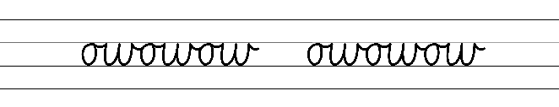  - Example cursive letter formations for horizontal joins from the letters o, r, v, w, x and f  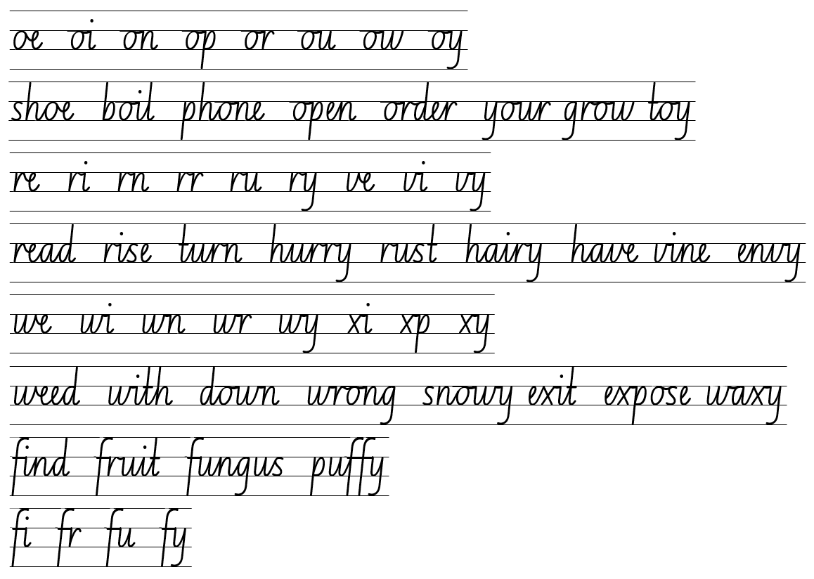  - Suggested practice text from the passage  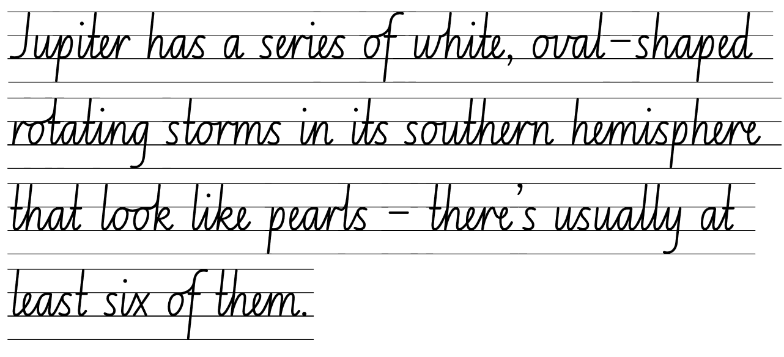
Software functionalities and typing  - Select and insert visual, print and audio elements into texts  - Revise visual and print elements that could be included when producing a multimodal text. | Software functionalities and typing  - Multimodal texts produced within Component B teaching and learning can feature visual, print and audio elements.

Planning framework
To plan and document Component A teaching and learning, a planning scaffold is provided. To support you in your planning, a link to a detailed example of a one-week teaching and learning cycle is included in the scaffold. Additional resources to support teaching and learning in each focus area can be found at Lesson advice guides.

Component B teaching and learning
The following teaching and learning sequence has been designed to address Component B outcomes and content and develops conceptual understandings of English through the study of quality texts. Adapt the sequence as required to best meet the needs of your students.

Learning intentions and success criteria
Learning intentions and success criteria are best co-constructed with students.

Learning intention
Students are learning to plan, create and revise texts for informative purposes.

Success criteria
Students can:
- summarise ideas when planning
- plan structures and language to suit the purpose of a text
- experiment with a range of text features to create a multimodal text
- edit, revise and publish constructed texts using self-reflection and peer feedback.

Lesson 13: Planning multimodal texts
- Display a double page from Deadly Science and from Meanwhile Back on Earth. Play a ‘genre expert’ game. Provide students with mini whiteboards and instruct students to create 2 columns, one for each text. Explain that students will have a set time limit to record the genre conventions they can identify on the displayed pages, under the correct columns. For example, structure – subheadings, images and illustrations; language – scientific; purpose – to inform, to entertain; narrative – second voice.
- Share and record student responses, referring to the genre jigsaw from Lesson 1 to cross reference. This will be referred to in future lessons.
- Explain that students will be constructing an informative multimodal text and a second person narrative to present to their peers. Students will need to demonstrate an understanding of the genre conventions. Lesson 13 to Lesson 16 will focus on the informative multimodal text and Lesson 17 to Lesson 19 will focus on the second person voice narrative.
Too easy? Students select a theme they notice across their research and note taking for their multimodal text. For example, ‘Who are the planets in our solar system named after?’
- Discuss and clarify the purpose and audience of the multimodal text.
- Review Resource 19: Writing cycle of planning, drafting, composing, editing, proofreading and publishing. Explain that students will revisit their notes from Lessons 4 to Lesson 8 and the corresponding pages of Deadly Science Solar System and select one planet to plan a text that explains and informs.
- Display Resource 20: Planning template. Use think-alouds to model selecting a planet and completing the resource. For example, My notes are about the appearance of Pluto. Therefore, I could use the heading ‘Appearance’.
- Students use Resource 20: Planning template to begin planning a multimodal text for their chosen planet.
- In pairs, students reflect on and share their plans. Display a list of guiding questions to support revising and editing. For example:
- How will the reader know the purpose of the text?
- How will the text engage the audience?
- Why did you select the vocabulary listed on the planning sheet?
- Provide time for students to revise and edit adding to the planning template.
Assessment task 8 – Observations from this lesson allow students to demonstrate achievement towards the following syllabus outcome and content points:
EN2-CWT-01 – plans, creates and revises written texts for imaginative purposes, using text features, sentence-level grammar, punctuation and word-level language for a target audience
EN2-CWT-02 – plans, creates and revises written texts for informative purposes, using text features, sentence-level grammar, punctuation and word-level language for a target audience
EN2-CWT-03 – plans, creates and revises written texts for persuasive purposes, using text features, sentence-level grammar, punctuation and word-level language for a target audience
- research, summarise and list topic-related ideas when planning
- plan structures and language to suit the purpose of a text.

Lesson 14: Creating a multimodal text
- Revise the planning templates from Lesson 13 and remind students that they are working towards constructing an informative multimodal text. Explain that a multimodal text is ‘a text that combines 2 or more expressive modes to communicate’ (NESA Glossary). Provide time for students to add to their plan if needed.
- Revisit Resource 19: Writing cycle and discuss how good writers move back and forth between the phases to produce quality writing. Explain that this lesson will focus on the drafting and composing phase. Students will consider what features will enhance the information presented. For example, layout, text, sentence structure.
- Co-construct a success criteria for writing (this will be referred to again in Lesson 14). For example:
- include headings and paragraphs beginning with topic sentences
- use temporal, conditional and causal conjunctions within sentences
- use capital letters to indicate the beginning of a sentence, proper nouns, headings, subheadings and acronyms
- use a comma to separate a dependent clause before a main clause
- use adverbial phrases or clauses to add information
- use scientific vocabulary
- use various multimodal features to present information.
- View The Sun page 28 to 29 in Deadly Science and discuss the layout of the text features. Draw students’ attention to the following:
- enlarged image of the sun
- showing size comparison with a caption
- ‘Heliophysics’ excerpt- in a white box on a black background (colours)
- images to compliment the information
- labelled diagrams ‘inside a sunspot’
- image with captions.
- Model drafting a multimodal text. Use think-alouds to complete the planning template from Lesson 13 and refer to the success criteria in activity 3. For example, ‘Pluto’s Appearance’ includes information about what the planet looks like, an image of Pluto may compliment this. A cool fact about Pluto may be that it has 5 moons.
- Students draft their multimodal text. Encourage students to review and edit their work throughout the drafting process. Remind students that visual representations, such as diagrams and images, enhance the text and provide the reader with additional information.

Lesson 15: Creating and editing a multimodal text
- Provide time for students to revise and finish drafting their multimodal text.
- Model asking questions to promote self-assessment as part of the revising phase of the writing cycle. For example:
- Is the purpose of my text clear?
- Is the layout easy to follow?
- Did I use enough scientific vocabulary?
- Revisit Resource 19: Writing cycle and reflect on how the students, as writers, have moved through the planning, drafting, composing and revising phase. Explain that the next step is editing.
- Explain that students will edit their multimodal text using the success criteria from Lesson 14 and agreed proofreading symbols.
- As a class, construct proofreading symbols used to edit. For example, [.]- insert full stop, ^ - insert comma. Display a copy of the proofreading symbols created, to refer to in the future.
Too hard? Select fewer symbols to focus on aligned to student or class goals.
- Model using the proofreading symbols to edit the first piece of information in the teacher modelled multimodal text from Lesson 14.
- In pairs, students work together to edit their text using proofreading symbols.

Lesson 16: Publishing a multimodal text
- Revisit Resource 19: Writing cycle and reflect on how the students, as writers, have moved through the planning, drafting, composing revising and editing phase. Explain that the next step is publishing. Students finish publishing their multimodal text from Lesson 15.
- Students publish their multimodal text by presenting it on an A3 piece paper or in a digital platform such as Google Docs.
- In pairs, students share their multimodal texts. Students refer to the success criteria and recorded genre conventions to provide feedback. Students consider the following questions when providing peer feedback:
- Is the purpose of the text clear for the intended audience?
- Is the layout easy to follow? Are headings and paragraphs with a topic sentence used?
- Was there enough use of scientific vocabulary?
- Can features, such as, conjunctions, capital letters and adverbial phrases and clauses be identified?

Week 5

Component A teaching and learning
Component A focuses on the development of foundational skills and knowledge through regular, systematic and repeated practice. The mentor and supporting texts used in Component B of this unit can support the effective implementation of Component A teaching and learning.

Teaching guide
Guidance for explicit teaching, teaching notes, resources and examples for the related outcomes and content points have been provided in the table below.
Focus areas and teaching notes | Resources and examples
Reading fluency  Monitoring reading fluency  - Recognise that there are different purposes and audiences for reading and adjust reading rate to suit a text’s purpose  - Reading rate for informative texts may depend on the vocabulary used. For example, Tier 3 technical and subject specific vocabulary may require the reader to slow down. | Reading fluency  Monitoring reading fluency  - Fluency and close reading passage – Meanwhile Back on Earth from ‘Meanwhile back on earth, two and a half millennia ago, some people were building the largest wall ever to be made...’ to ‘...Or, do you want to go home?’ (206 words)  Note: the passage from the text will need to be a teacher-created resource.  - Technical vocabulary from the passage where reading rate may be adjusted  - ‘Next stop: Alpha Centauri, just a seventy-seven-million-year drive away.’
Reading comprehension  Reading for interest and wide purposes  - Locate, select and retrieve relevant information from a print or digital text and consider accuracy of information presented  - The selection and retrieval of information requires readers to determine the relevance of the information to the topic and extract information by reading the material thoroughly, taking notes, and summarising the key points that pertain to the research question.  - Information can be located and selected by using headings and subheadings, scientific vocabulary and key words, captions and labels, and images. | Reading comprehension  Reading for interest and wide purposes  - Locate and select information from the passage using  - scientific vocabulary and key words: largest wall, animals and metal for fighting, Ice Age  - captions and labels: speech bubbles to add information about the characters thoughts  - use of images: to add meaning to the text: ‘largest wall ever made’, the image shows the Great Wall of China.
Monitoring comprehension  - Reflect on own understanding of texts and monitor own goals for reading  - Readers need to actively think about how well they are understanding what they have read. Comprehension may fail if a reader lacks necessary content knowledge or vocabulary, if they have poor knowledge of cohesive ties or text structures, or if they lack reading stamina.  - If a reader loses understand, they might apply relevant strategies such as re-reading, looking up a word in the dictionary or generating an inference. | Monitoring comprehension  - Support students to monitor their personal goal(s) as generated in Week 1.  - Monitoring of goals will differ, based on the goal that is set. Strategies may include the use of self-assessment rubrics, documenting the actions taken to achieve a goal, or the use of work samples created in working towards the set goal.  - Support students to determine whether their personal goal has been achieved and if a new goal needs to be set.
Vocabulary  Learning and using words  - Build personal Tier 1, Tier 2 and Tier 3 vocabulary through social and learning interactions, reading and writing  - Identify and discuss Tier 2 and Tier 3 words in the text to improve vocabulary knowledge and comprehension. | Vocabulary  Learning and using words  - Suggested vocabulary from Meanwhile Back on Earth  - millennia, Alpha Centauri.
Defining and analysing words  - Use word associations to build word knowledge  - Building an association between a known word and an introduced word further reinforces the meaning of the new word. Connecting words together through word association is a strategy for increasing word vocabulary.  - Word maps, word clines and explaining the relationship between words are activities that could be used for building word associations. | Defining and analysing words  - Examples from the passage  - Time: two and a half millennia, halfway, 5000 years  - Planets: Earth, Uranus, Neptune, Pluto.
Spelling  Phonological component  - Identify differences in vowel phonemes (short, long, diphthong and schwa vowels)  - Review identifying short vowel phoneme /i/ and schwa /ə/ within focus words.  - Recognise stressed and unstressed syllables in multisyllabic words and apply this knowledge when spelling  - Words with more than one syllable have both stressed (strong) and unstressed (weak) syllables. Stressed syllables are often louder and higher pitched. Unstressed syllables are usually said faster and at a lower volume.  - Understand that the schwa occurs in an unstressed syllable and apply this knowledge when spelling  - The vowel in the weak syllable is often schwa. For example, in the word ‘doctor’ the first syllable ‘doc’ is stressed and is clearly articulated. The second syllable ‘tor’ is unstressed and is pronounced as ‘tuh’, giving us ‘doctuh’. | Spelling  Phonological component  - Suggested words from the Meanwhile Back on Earth  - scientist, gravity, orbit, enormous (p 28), drive-driven (p 29).  - Sample words for inquiry: consolidate previous 4 weeks of learning.
Orthographic component  - Apply knowledge of taught vowel graphemes when spelling  - Identify the vowel graphemes that are pronounced as schwa, instead of their common pronunciation.  - The vowel grapheme [ou] in the suffix -ous is often pronounced as a schwa.  - The vowel grapheme [e] in the suffix -n is often pronounced as a schwa. | Orthographic component  - As above
Morphological component  - Identify inflected suffixes, explaining when and how to treat base words when they are affixed, and apply this knowledge when spelling  - inflected suffixes: tense (-s, -ing, -ed)  - derivational suffix: -ous and –en. | Morphological component  - As above
Creating written texts  Text features for multiple purposes  - Use temporal, conditional and causal conjunctions within sentences, and as connectives to link ideas across sentences for cohesion  - Review and use temporal, conditional and causal conjunctions within sentences  - Temporal conjunctions are words to indicate when something is happening  - temporal conjunctions include first, next, finally  - Conditional conjunctions are a cohesive device that describes the condition that needs to be met for something to happen. This may be in the form of a word (if) or phrase (in addition)  - conditional conjunctions include however, although, if, unless provided that, in case, even if, as long as  - Causal conjunctions are words or groups of words used as a cohesive device between sentences, when explaining how something works or why something happens  - causal conjunctions include as a result, because, due to, so, since, as, therefore | Creating written texts  Text features for multiple purposes  - Examples of conjunctions from the text  - ‘If we took a left turn at the moon (towards the sun), it would be a seventy-eight-year drive from Earth to Venus – our closest planet.’ (conditional)  - 'Meanwhile back on Earth, two and a half millennia ago, some people were building the largest wall ever to be made... so they could keep all the other people out.’ (temporal/causal)
Sentence-level grammar  - Use adverbial phrases or clauses to add information to the verb or verb group of the main or other clauses, to provide reasons for or circumstance  - Revise adverbial phrases.  - Revise adverbial clauses.  - Adverbial phrases and clauses provide reasons for or circumstance. They provide information:  - when (adverbial phrase/clause of circumstance- time)  - where (adverbial phrase/clause of circumstance- place)  - how (adverbial phrase/clause of circumstance- manner)  - why (adverbial phrase/clause of reason). | Sentence-level grammar  - Examples of adverbial phrases and clauses innovated from the passage  - Meanwhile back on Earth, some people were building the largest wall ever made. (phrase- where)  - Some humans, after sailing across the ocean, were fighting with the people who were already there. (clause- when)  - People are fighting each other with sticks and stones (phrase- how)
Punctuation  - Use a comma to separate a dependent clause before a main clause  - Complex sentences are formed by adding one or more dependent clauses to a main clause using subordinating conjunctions and/or relative pronouns (NESA Glossary).  - Review complex sentences where the dependent clause follows the main clause.  - Introduce complex sentences where the dependent clause precedes the main clause. Dependent clauses at the beginning of a sentence can be signalled by the subordinating conjunction.  - If the dependent clause precedes the independent clause, separate the clauses with a comma. For example, ‘Whenever it is a sunny day, I wear my hat.’ | Punctuation  - Example of the use of a comma for a dependent clause  - ‘If we kept heading towards the sun, it would be a 150-year drive to Mercury.’  - ‘But let’s keep going, as it’s only a short 2,400-year drive to Saturn.’
Handwriting and digital transcription  Software functionalities and typing  - Monitor goals that build on typing accuracy and rate  - Support students to value accuracy of typing over speed when setting goals.  - Use knowledge of the keyboard layout using the home, top and bottom row to build on typing accuracy and rate. Focus on letters and letter combinations.  - Select and insert visual, print and audio elements into texts  - Revise visual and print elements that could be included when producing a multimodal text. | Handwriting and digital transcription  Software functionalities and typing  - An example of a student goal  - Type with 98% accuracy or above  - Examples of multimodal features used in Meanwhile Back on Earth  - use of images to provide additional information or add meaning the text  - use of the timeline in the back of the book to provide additional information  - text is written in second person narrative.

Planning framework
To plan and document Component A teaching and learning, a planning scaffold is provided. To support you in your planning, a link to a detailed example of a one-week teaching and learning cycle is included in the scaffold. Additional resources to support teaching and learning in each focus area can be found at Lesson advice guides.

Component B teaching and learning
The following teaching and learning sequence has been designed to address Component B outcomes and content and develops conceptual understandings of English through the study of quality texts. Adapt the sequence as required to best meet the needs of your students.

Learning intentions and success criteria
Learning intentions and success criteria are best co-constructed with students.

Learning intention
Students are learning to plan a second person narrative and deliver multimodal presentations to an audience.

Success criteria
Students can:
- create a second person narrative to engage an audience
- plan, draft, write and edit a narrative
- self-reflect on presentations delivered to an audience
- discuss and reflect on their understanding of genre.

Lesson 17: Using second person narrative in writing
- Read the pages ‘Shall we take a detour...’ to ‘...it would be almost a year ago at home’ in Meanwhile Back On Earth.
- Revise second-person voice technique authors use in narratives. Ask students to explain why an author may choose to write in second voice and its impact. Refer to Lesson 10.
- Explain that students will use their informative multimodal text to write a second-person hybrid narrative text. Clarify that Meanwhile Back on Earth is a hybrid narrative; it is a narrative that provides the reader with information.
- Set the scene by telling the students they are the character on a journey in space. Allow thinking time for students to consider:
- Who? – Who is your audience? Who are you talking to? For example, in Meanwhile Back On Earth the father is talking to his children about the trip.
- What? – What are you doing? For example, in Meanwhile Back On Earth the family is taking a car trip.
- Where? – Where are you? For example, in Meanwhile Back On Earth the family are travelling through space and visiting different planets.
- How? – How will you use your informative multimodal text to write a hybrid narrative? How will you incorporate second person narrative voice?
- Display the headings: Who, What, Where and How. Co-construct a narrative plan under each heading, addressing the questions in the previous activity. Refer to the teacher-modelled multimodal text in Lesson 14, to ensure students include factual information.
- Students plan their second-person narrative using the headings Who, What, Where and How.
- Revisit the success criteria from Lesson 14 to clarify expectations and remind students to regularly refer to the criteria to self-reflect and monitor their work.
- Revise adverbial phrases or clauses to add information from Component A. For example, Huge bubbles of gas are occasionally ejected from the Sun and shoot across the solar system.
- Model how to write factual information using a second person narrative voice and adverbial phrases and clauses. For example, If you were on Pluto and looked up at the sky, you would see 5 moons in the distance.
- As a class, co-construct a short paragraph for the orientation, referring to the teacher-modelled plan and success criteria. Ensure the use of second-person narrative voice.
- Students begin writing a second person narrative referring to their plan, multimodal text and success criteria.
Too hard? Students write a narrative based on their multimodal text, without using second person voice.

Lesson 18: Writing and editing a second person narrative
- Revisit the second person narrative voice, teacher plan and co-constructed text from Lesson 17.
- Explain that students will share their plans and writing, ask questions to clarify student ideas and provide feedback as needed.
- In groups, students share their plans and take turns to provide feedback. Remind students to refer to the success criteria to support quality feedback.
- Students apply the feedback to reflect on and revise their writing and continue their second-person narrative.
- Explain that students will revise how to edit a paragraph, focusing on spelling and punctuation using proofreading symbols. Revise the writing and editing process from Lesson 15.
- In pairs, students take turns to edit their work using the agreed proofreading symbols.
- Students make changes to their draft then begin publishing their narrative. For example, using Google Docs or a lined piece of paper for display.

Lesson 19: Presenting a multimodal text
- Students finish publishing their second person narrative.
- Explain that students will complete a self-assessment of their multimodal text from Lesson 16 and their second person narrative. Model providing feedback on 2 aspects that met the criteria and 2 aspects that could be improved.
- Students self-assess their own multimodal text and second person narrative.
- Explain that students will present their informative multimodal text and second person narrative. Provide opportunity for students to practise their presentation before presenting.
- Discuss and construct a list of appropriate skills that students should demonstrate while presenting and listening to their peers’ presentations. For example, gestures, stance, eye contact, active listening.
- Students begin presenting their informative multimodal text and second person narrative.

Lesson 20: Presenting and reflecting on learning
- Revisit class constructed listening skills from Lesson 19.
- Students continue presenting their informative multimodal text and second person narrative.
- Recap students’ learning from this unit, discussing that genre is a term used to group different types of texts according to similarities in form and purpose.
- Students’ complete +1 Routine activity demonstrating what they have learnt about genre throughout the duration of the unit. This will provide opportunities for students to contribute to discussions with peers, stay on topic and express their own ideas.
Assessment task 9 – Observations and work samples from this lesson allow students to demonstrate achievement towards the following syllabus outcomes and content points:
EN2-OLC-01 – communicates with familiar audiences for social and learning purposes, by interacting, understanding and presenting
  - include multimodal features in planned and delivered presentations, to expand meaning and engage an audience
  - reflect on and monitor own presentations according to given criteria
  - contribute to discussions with peers and stay on topic, build on others’ ideas and express own ideas.
EN2-CWT-01 – plans, creates and revises written texts for imaginative purposes, using text features, sentence-level grammar, punctuation and word-level language for a target audience
EN2-CWT-02 – plans, creates and revises written texts for informative purposes, using text features, sentence-level grammar, punctuation and word-level language for a target audience EN2-CWT-03 – plans, creates and revises written texts for persuasive purposes, using text features, sentence-level grammar, punctuation and word-level language for a target audience
  - experiment using second person narrative voice for effect
  - create informative written texts that include headings, paragraphs beginning with topic sentences, and may conclude information in a final paragraph
- use adverbial phrases or clauses to add information to the verb or verb group of the main or other clauses, to provide reasons for or circumstance.
EN2-UARL-01 – identifies and describes how ideas are represented in literature and strategically uses similar representations when creating texts
  - understand that genre refers to texts that are grouped according to purpose, subject matter, form, structure and language choices, and that a type of text can differ in mode and medium.

Resource 1: Fluency and close reading passage analysis – Deadly Science Solar System
Focus | Notes
Passage | Deadly Science Solar System – (p 6) ‘Our Solar System’ and ‘Hello, neighbour’ sections (205 words)  Note: the passage from the text will need to be a teacher-created resource.
Synopsis | This passage is from a section from Deadly Science Solar System. This information provides a general introduction to the solar system. More detailed information is given to the zones within the Solar System.
Passage structure | The text is structured into:  Classification or Generalisation  What is the focus?  This passage provides a description of what makes up the solar system and how sparse it is.  Description  What are the important features to be elaborated?  Passage structure provide:  - information with headings that provide explicit and detailed information  - a meaning on the topic presented in the first paragraph  - information on what is in the solar system.
Language features | Language  - Technical language is used to create precise definitions and explanations of topic-specific information  - For example, terrestrial, orbit, asteroid  Non-specific time features  - Action verbs are in simple present tense  - For example, orbit, move  Temporal, conditional and causal conjunctions  - Teach temporal conjunctions (sequence - ‘when’): first, next, finally [after, before, when, while, since, until, as, meanwhile, during, whenever] Review and extend content on temporal conjunctions  - Teach conditional conjunctions (reason - ‘how’): however, although, if, unless [provided that, in case, even if, as long as]  - Teach causal conjunctions (cause/effect - ‘why’): as a result, because, due to, so [since, as, therefore]  - Examples from the passage  - ‘First, there is the Sun, around which the planets and other bodies orbit.'  - ‘Next there is the inner region, which is home to the terrestrial planets:’  - ‘As giants burn up their helium, they shrink again, becoming a planetary nebula.’ (causal)  - ‘When the supergiant burns the last of the helium, the core of the star explodes.’ (temporal)  - ‘If you get too close to a black hole, you will be spaghettified.’ (conditional)  Capital letters  - indicate the beginning of a sentence, proper nouns, headings and subheadings, to indicate the beginning of a poetry line, for emphasis, and when using acronyms  - proper nouns: Solar System, Sun, Earth  - headings: Our Solar System, Hello, neighbour!

Resource 2: Four corners teacher resource
Use the following questions to engage with space facts using four corners. Identify four spaces in your classroom and identify them as Corner 1, Corner 2, Corner 3, Corner 4. Students stand in the middle of the room, listen to the question and select a corner to move to that reflects their response. Tell students the correct answers (underlined) and then students return to the middle of the room and repeat.
- Who were the first astronomers? (Options: Indigenous Australians, Romans, Aztecs, Vikings)
- What is the creation of the universe and everything in it called by Indigenous Australians? (Options: Dreamtime, Space Stories, The Big Bang, Stone Age Stories)
- How many planets are there? (8, 6, 5, 12)
- What will happen if you get too close to a black hole? (you will be spaghettified- pulled and compressed at the same time, you will fly to the Milky Way and touch the stars, you will be transported to another galaxy, you will turn into an astronaut.
- How long is a day on Uranus? (approx. 17 hours, approx. 78 earth days, approx. 18 hours, approx. 2 weeks on earth)
- Which planet has series of white oval-shaped rotating storms that look like pearls? (Jupiter, Saturn, Mars, Venus)
- Which is the only planet known to support life? (Earth, Mars, Mercury, Saturn)
- Which is the biggest object in our solar system? (the Sun, the Moon, the Stars, Jupiter)

Resource 3: Genre jigsaw task
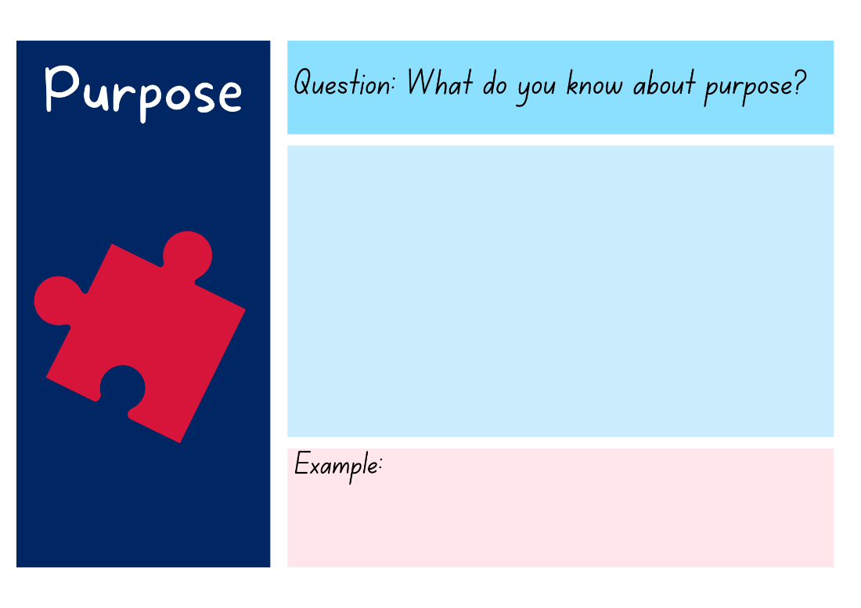
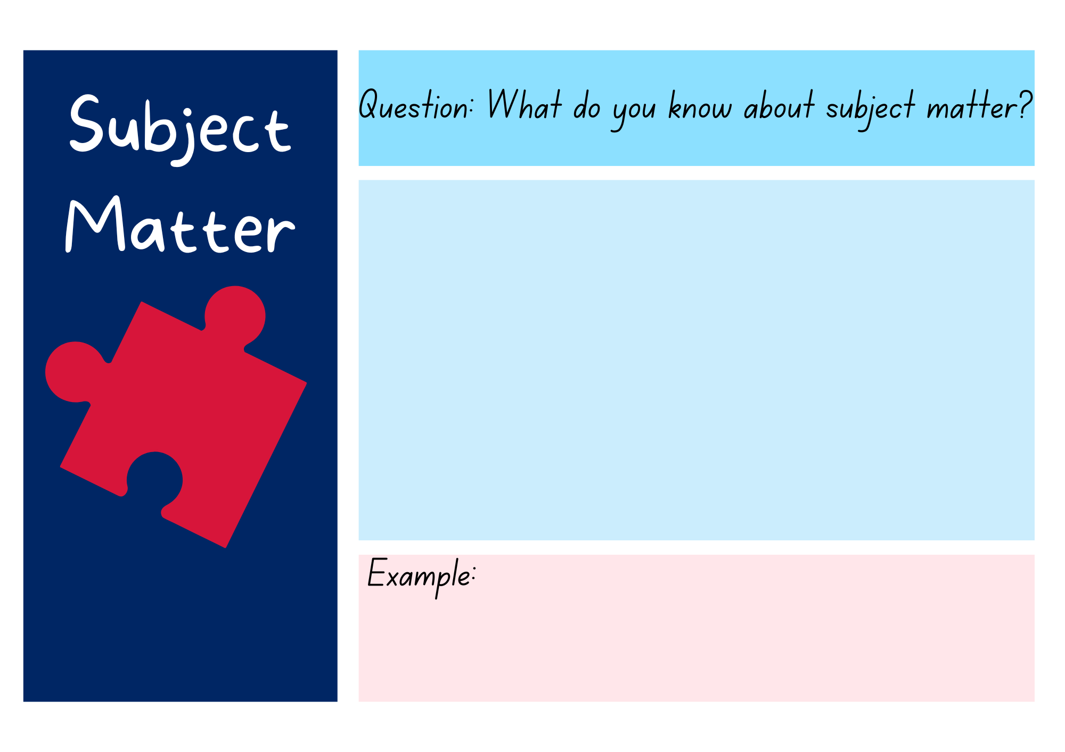
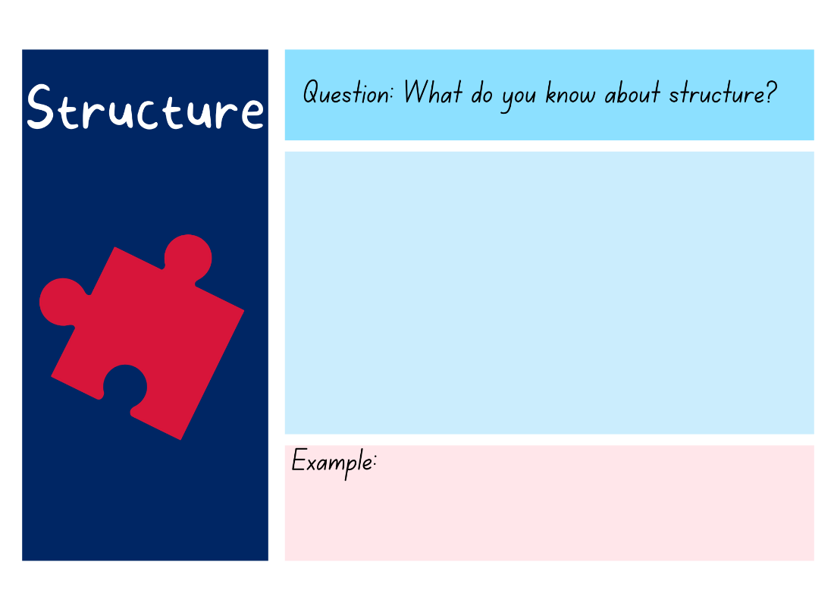
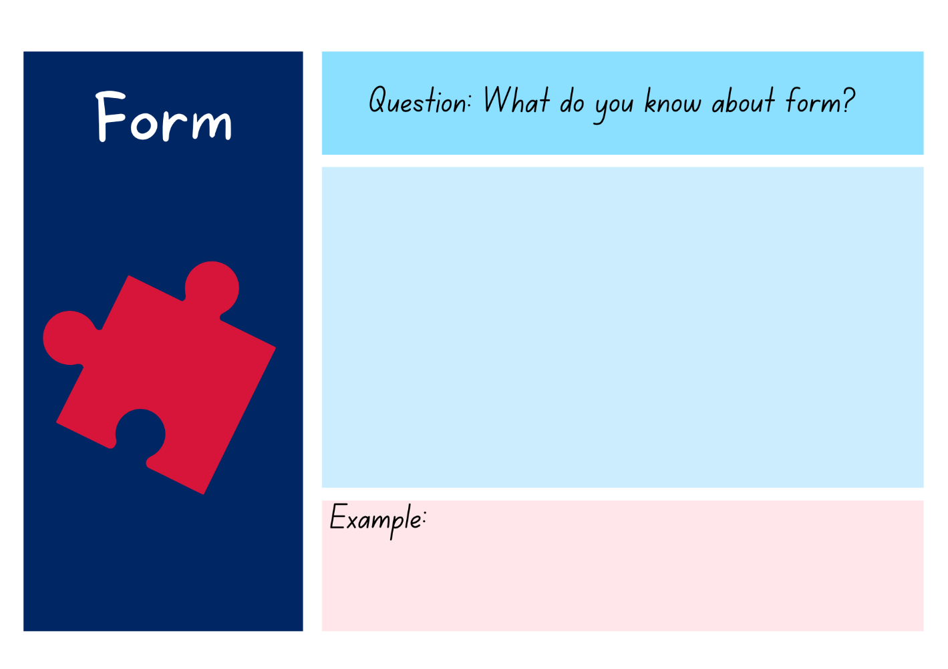
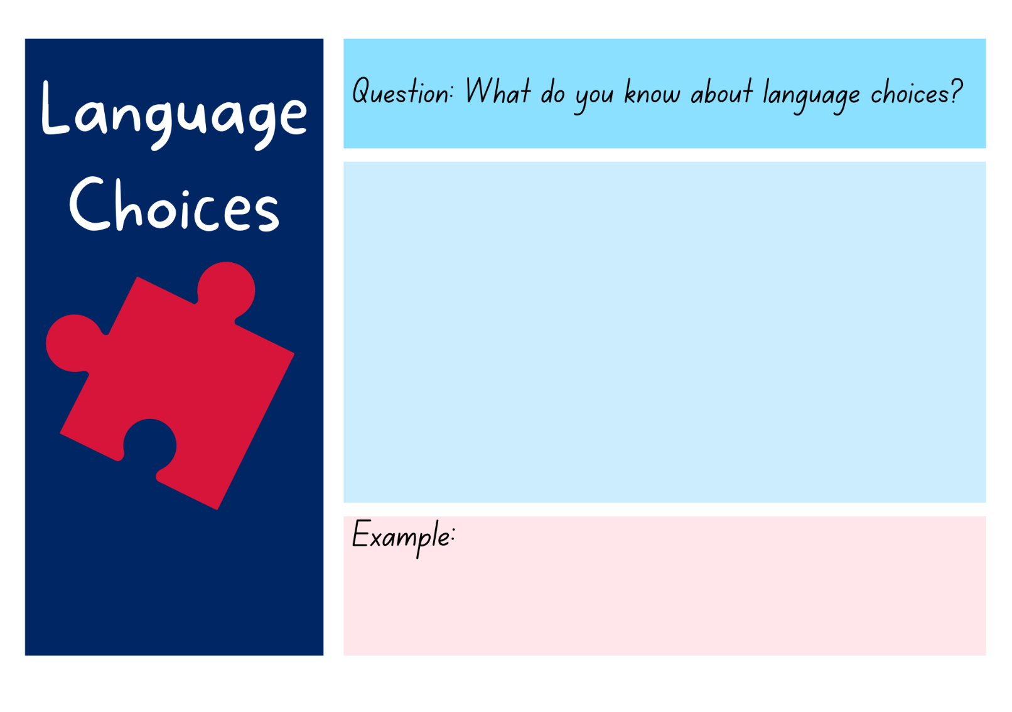

Resource 4: Genre detective
Heading
Sub-heading
Quick five fact box
Did you know fact
Cool fact
Fact
Labelled diagram
Caption
Arrows
Experiment
Photograph

Resource 5: Y-chart
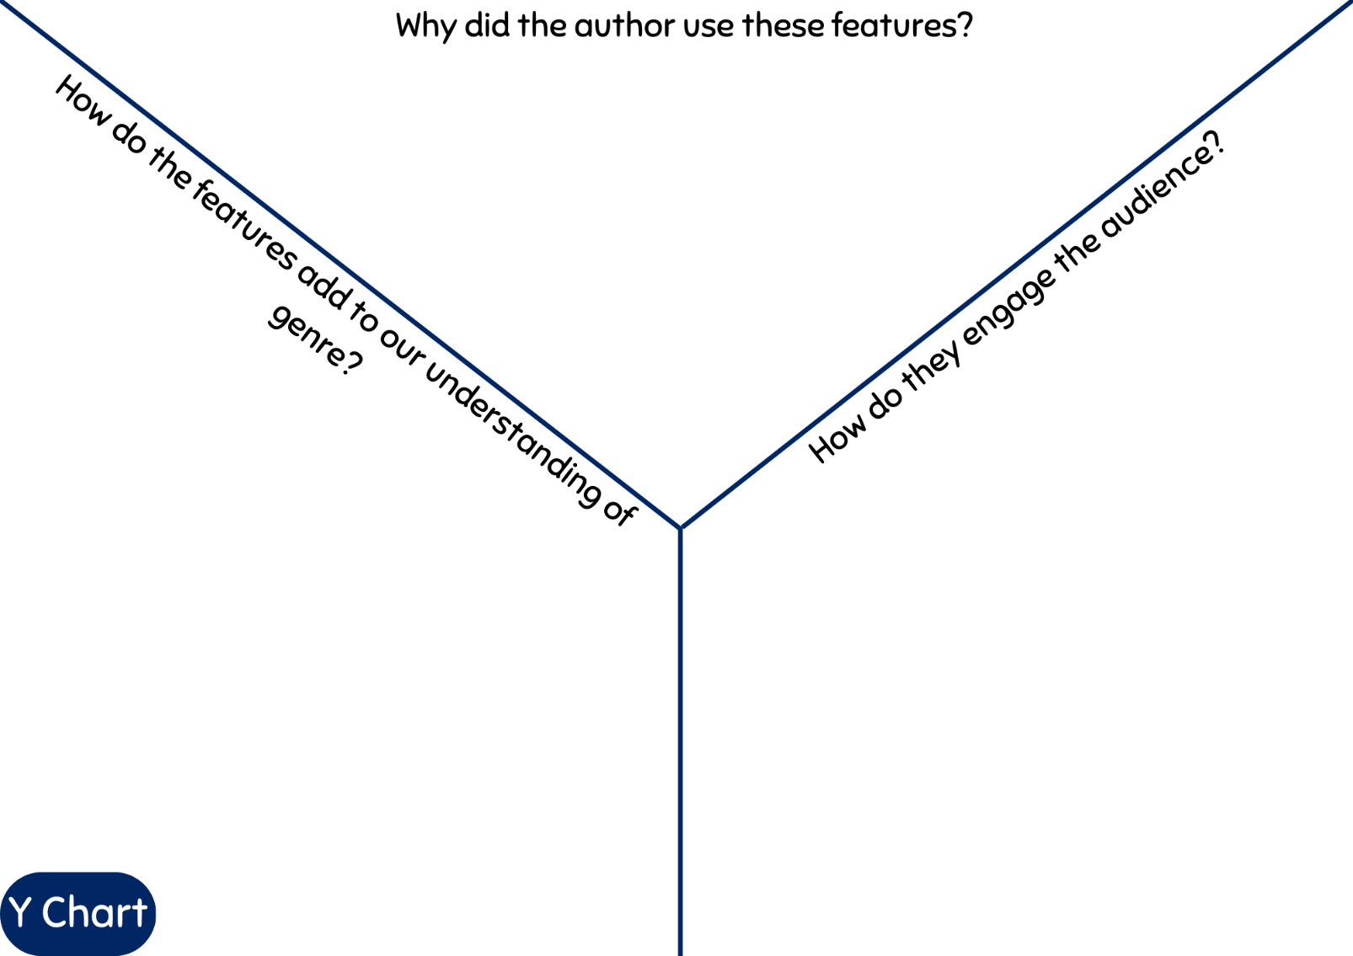

Resource 6: Vocabulary pyramid
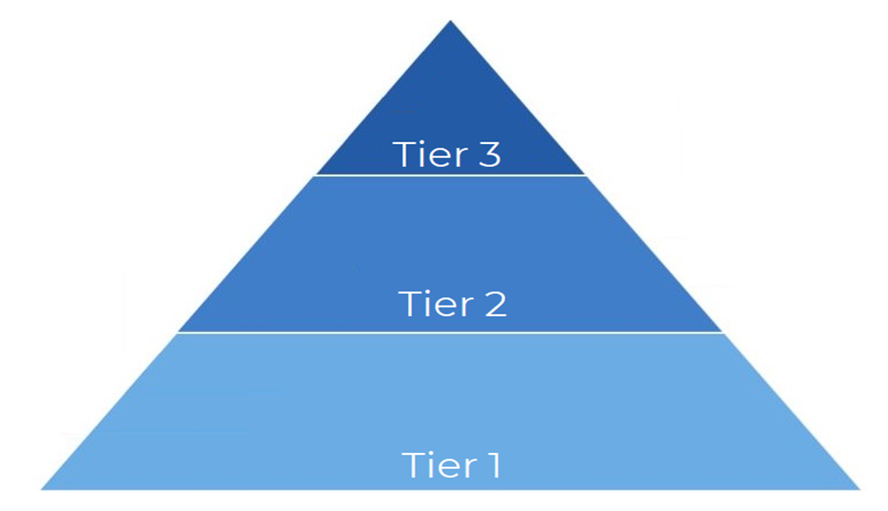

Resource 7: Word mat
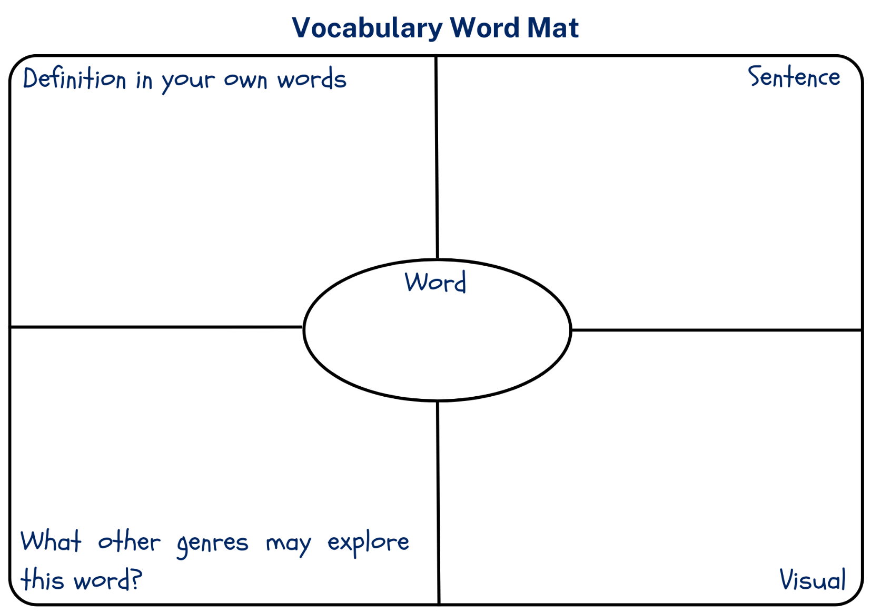

Resource 8: Stars flowchart
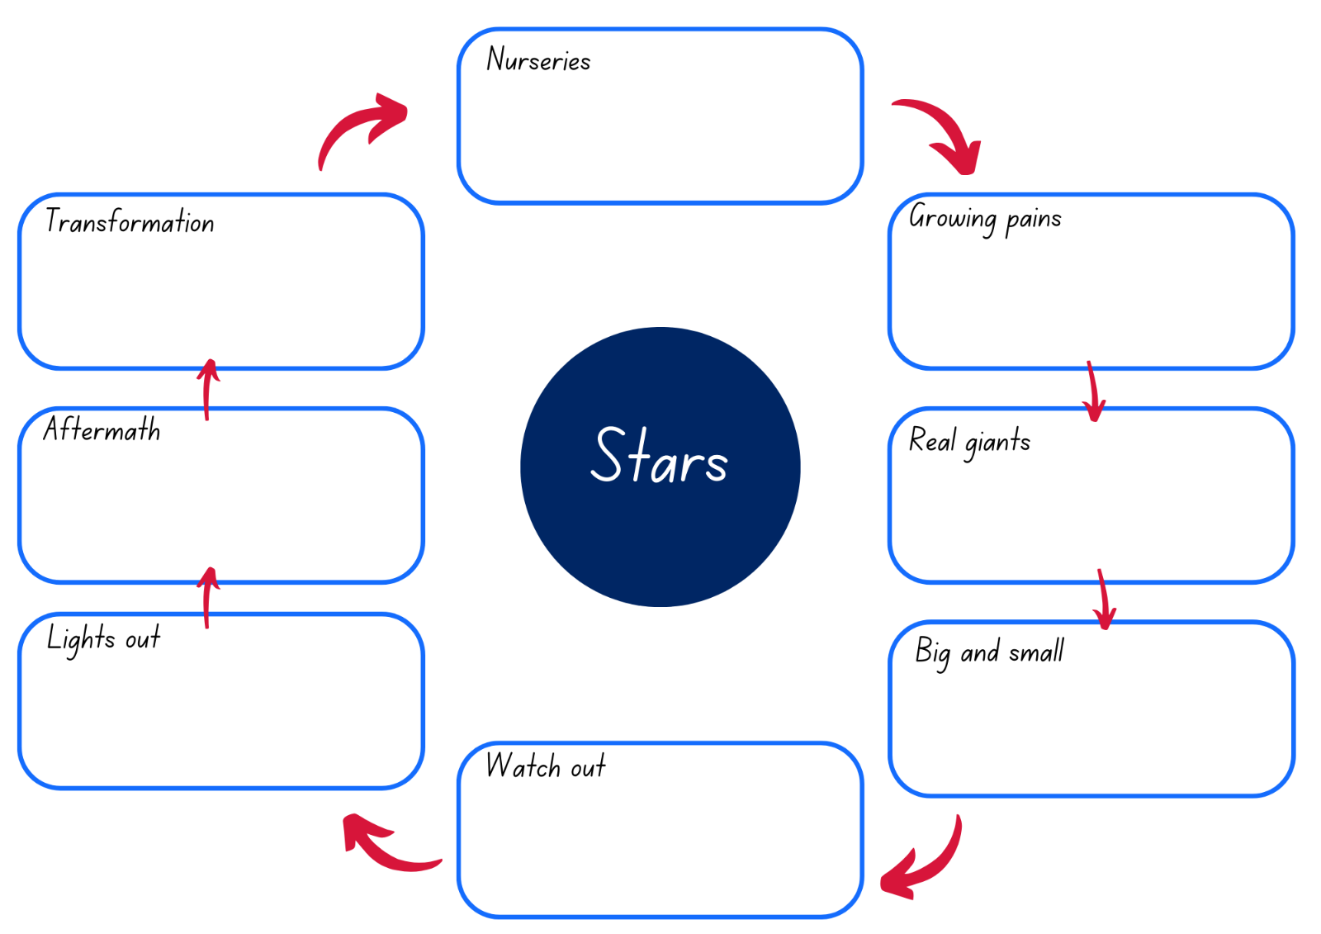

Resource 9: Gist statement scaffold
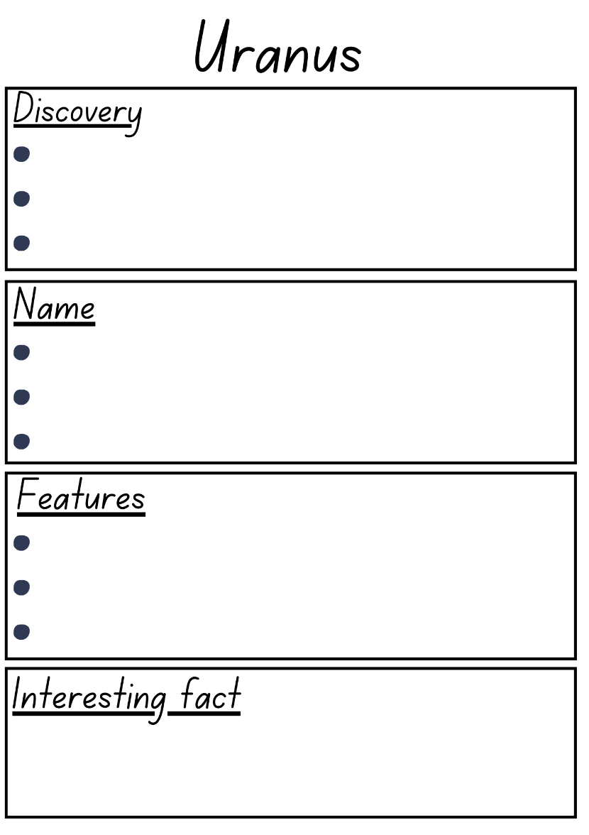

Resource 10: Writing scaffold
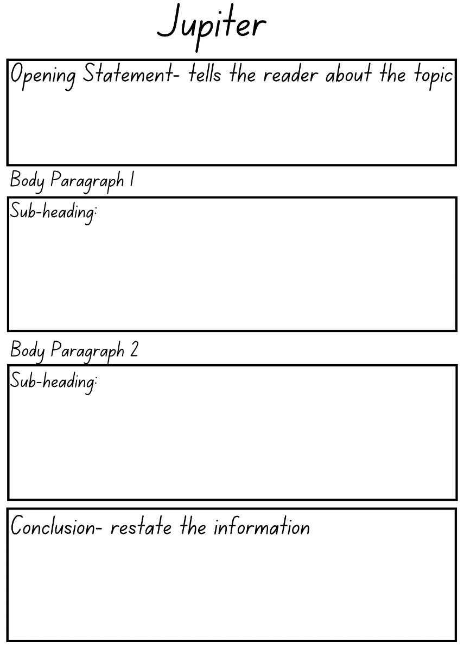

Resource 11: Headbands
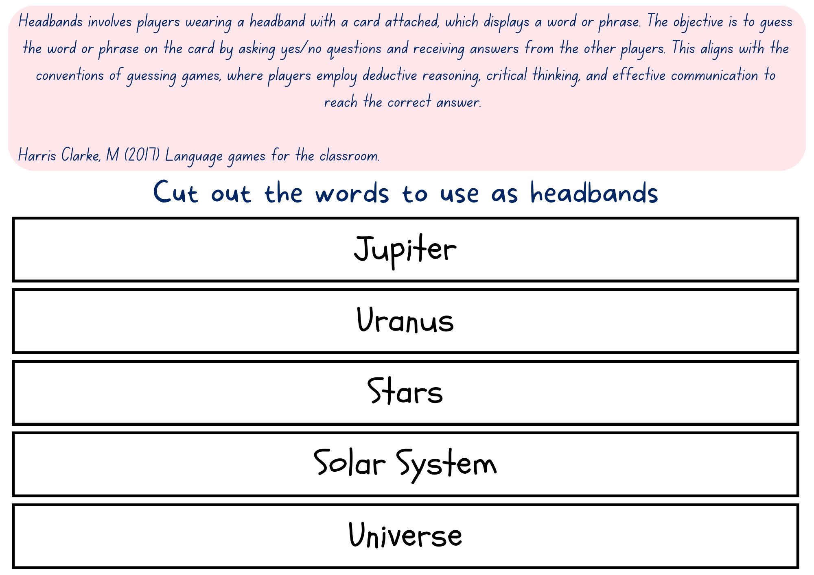

Resource 12: Gist statement graphic organiser
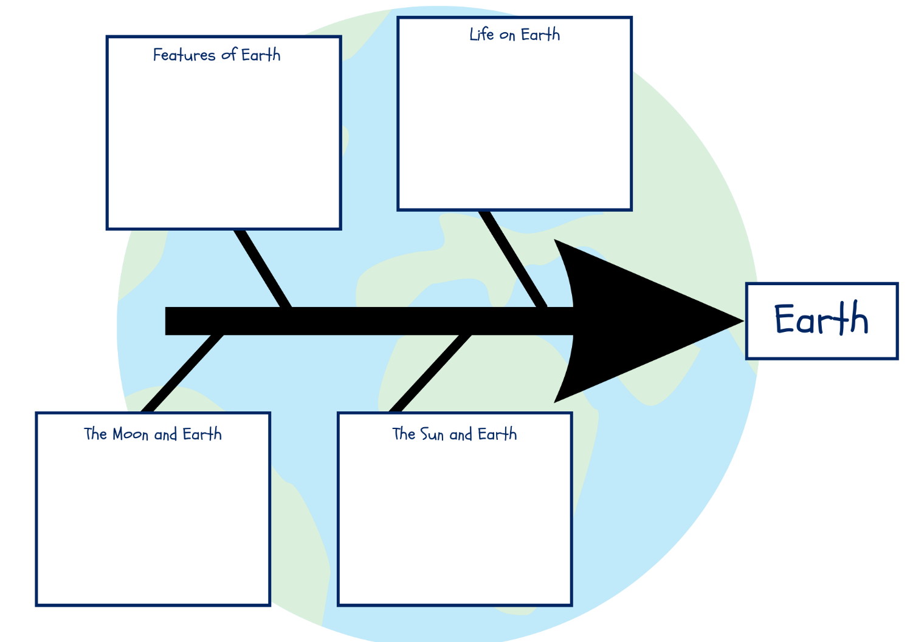

Resource 13: Fluency and close reading passage analysis – Southern Cross
Focus | Notes
Passage | This is a teacher-created passage about the Southern Cross.
Synopsis | This passage is a general statement written in second person about the size of space and the meaning of the Southern Cross in different Aboriginal and Torres Strait cultures.
Passage | Well, truth be told, Earth isn't all that massive. Not when you compare it to ... you know, space. How about we take a little detour and witness it firsthand? Then, let's slip on our space helmets ... transform this into a space car... and set off towards the moon. It's about a quarter of a million miles away, so we'll be looking at almost a year of driving to get there. During this journey, it's important to keep an eye out the windows and catch a glimpse of what's unfolding around us. Who can say what wonders we might encounter? Ah, behold the Southern Cross. Were you aware that Indigenous Australians take pride in being the world's earliest astronomers? The Aboriginal and Torres Strait Islander People have many distinct stories about the very same constellations. The one-of-a-kind Southern Cross constellation is widely regarded as a significant symbol among indigenous communities. For the Kulin Nation People of Victoria, around Melbourne, the Southern Cross represents Bundjil, an eagle-like sky god. In the eyes of Central Australia’s Arrernte people, the Southern Cross represents Waluwarra, the wedge-tailed eagle. Its talons are formed by the four radiant stars, while its nest is found within the dark Coalsack Nebula. On the other hand, the Ngarrindjeri people of Coastal South Australia see the Southern Cross as a stingray pursued by a pair of sharks—the two pointers edging the cross. The shark holds immense sacred value as a Ngarrindjeri totem. Let's get back on track with our original course. (225 words)
Passage structure | The text is structured into:  Classification or Generalisation  This a hybrid passage that is written as a narrative in second person voice but also provides factual information.  Description  - information is provided about the links between the Aboriginal and Torres Strait Islander people and the Southern Cross which provides opportunity to understand that many words derive from other languages  - is written in second person narrative voice  - includes apostrophes for contractions  - uses apostrophes to show possession
Language features | Language  - Technical language is used to create precise definitions and explanations of topic-specific information. For example: Southern Cross, constellation, astronomers  - Words derive from other languages. For example: Bundjil, Waluwarra  Temporal, conditional and causal conjunctions  - Teach temporal conjunctions (sequence - ‘when’): first, next, finally [after, before, when, while, since, until, as, meanwhile, during, whenever].  - Teach conditional conjunctions (reason - ‘how’): however, although, if, unless [provided that, in case, even if, as long as].  - Teach causal conjunctions (cause/effect - ‘why’): as a result, because, due to, so [since, as, therefore].  - Examples from the passage  - Temporal conjunctions: then, during  - Causal conjunctions: when, because  - Conditional conjunctions: how about, if, who can say  Apostrophes in contractions  - Examples: isn’t, let’s it’s, we’ll, what’s  Apostrophes to show possession  - Examples: world’s, Central Australian’s  Capital letters  - Indicate the beginning of a sentence and proper nouns

Resource 14: Planning template – Women in Space
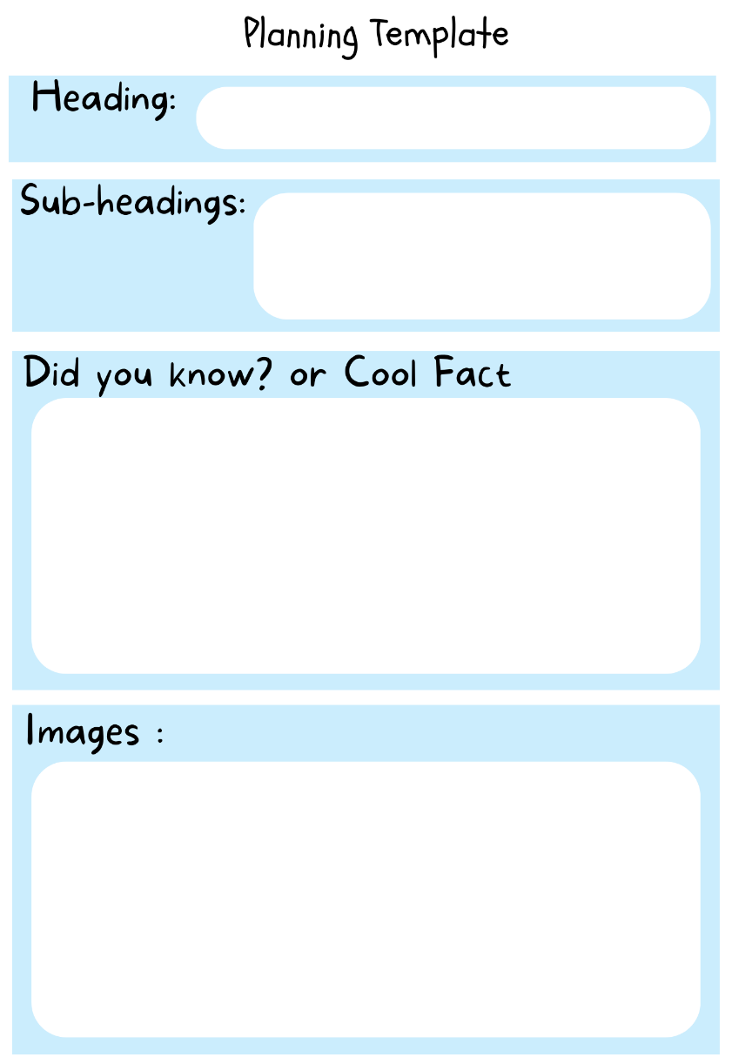

Resource 15: Pluto timeline
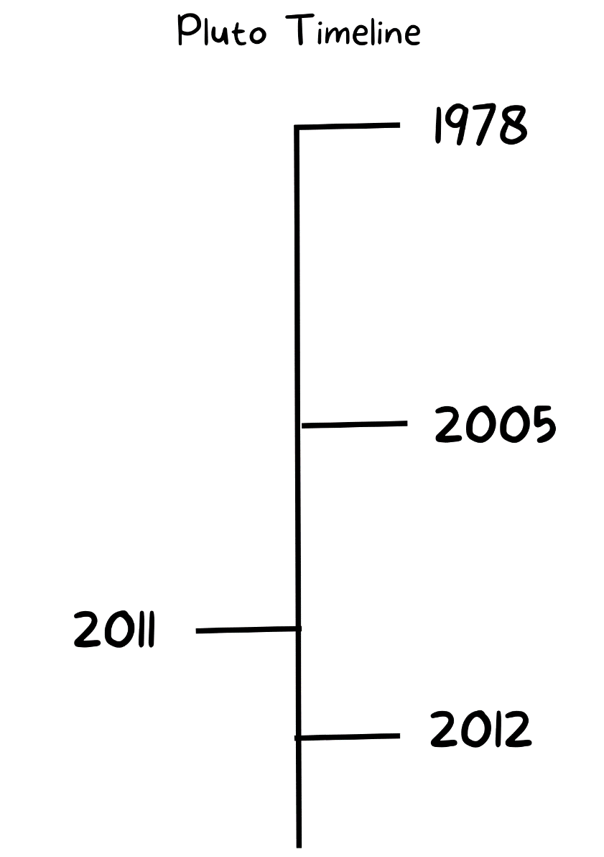

Resource 16: NASA mission timeline
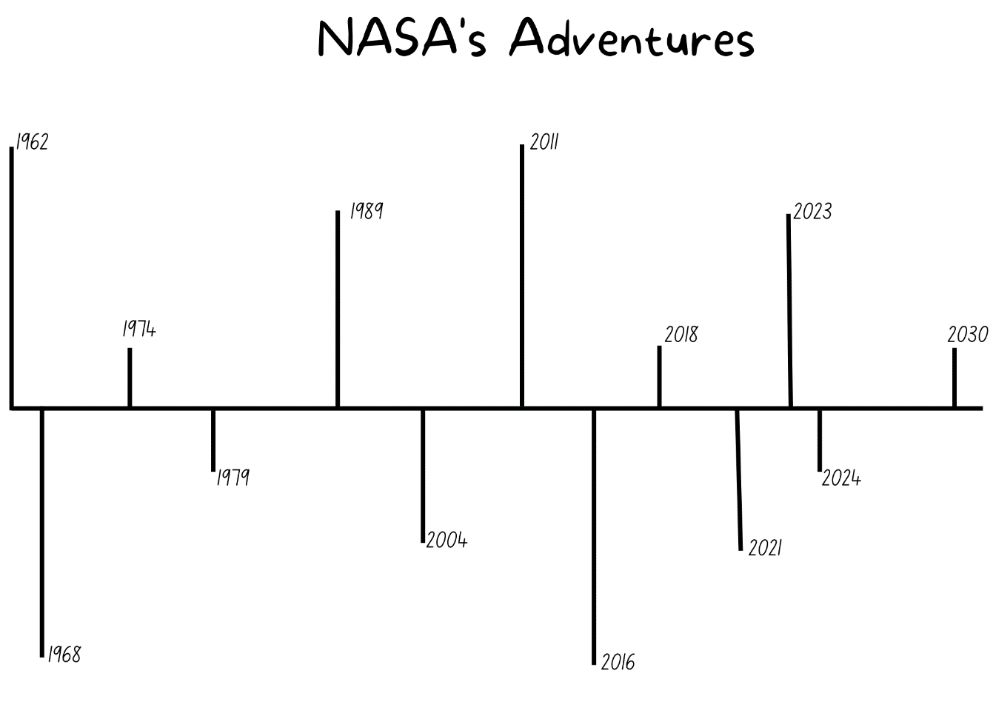
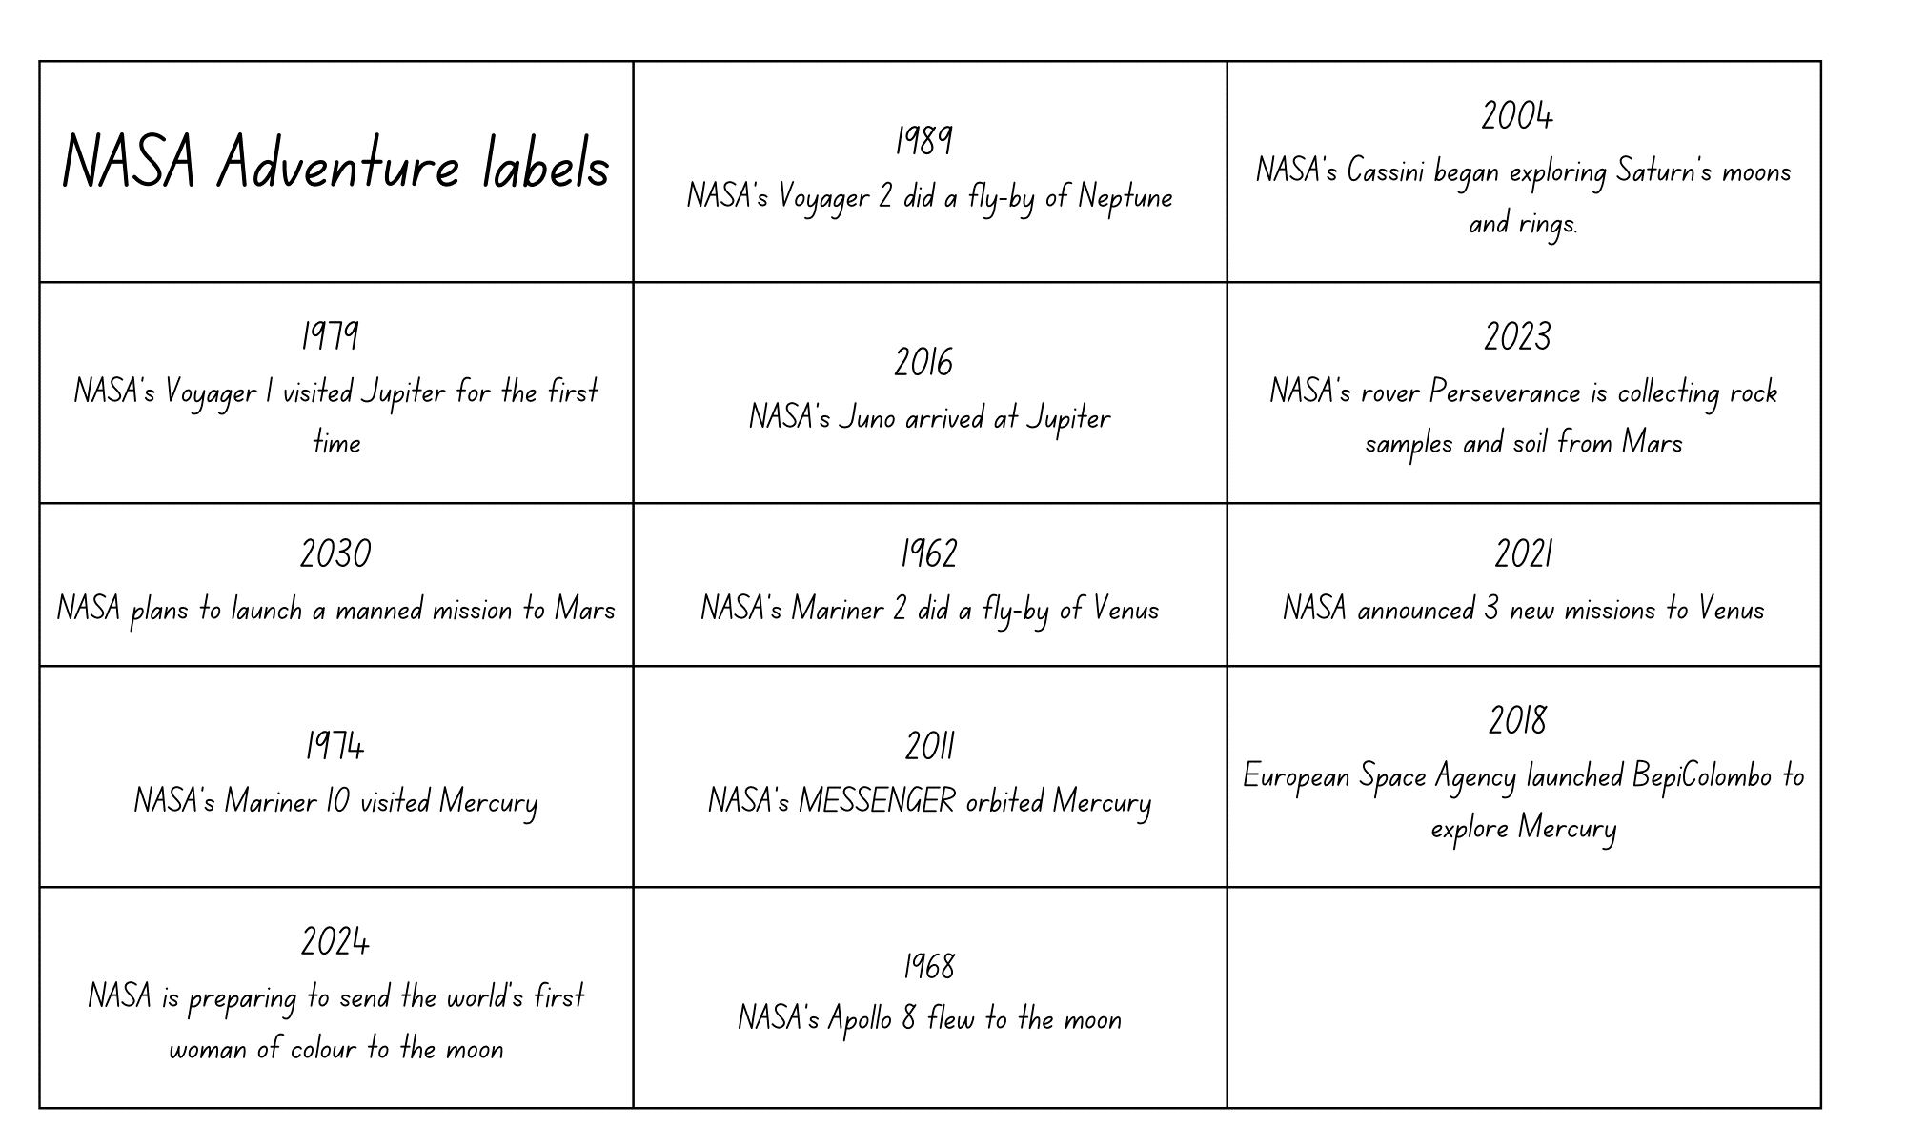

Resource 17: What’s in a name?
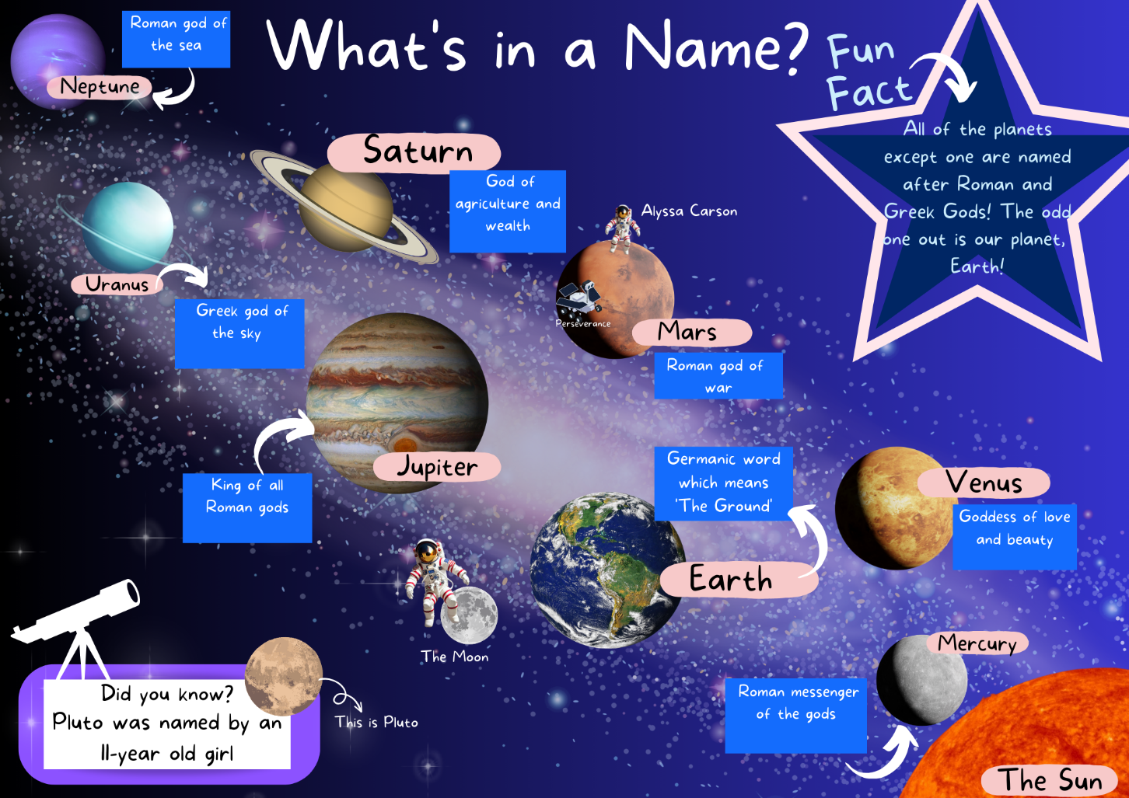

Resource 18: Vocabulary scaffold – Week 4
Sample word | Context | Student-friendly definition
methane gas | ‘Uranus is mostly made up of hydrogen and helium, but methane gas is also present.’ (p 14) | Colourless, odourless gas that occurs abundantly in nature and as a product of certain human activities.
Epsilon Ring | 'Some of Uranus’ smaller moons circle the planet just outside its bright Epsilon Ring.’ (p 15) | The brightest and densest part of the Uranian ring system.
Ganymede | 'Ganymede is even larger than Mercury.’ (p 19) | Jupiter's largest moon and is also the largest moon in the entire solar system.
emissions | 'The Southern Aurora of Jupiter glows bright red because of hydrogen emissions.’ (p 19) | Release of various substances, such as gases or particles, into the atmosphere.
radiation | '...if our Sun were much larger, the radiation from it would be too strong,…' (p 22) | The emission or transmission of energy in the form of electromagnetic waves or particles.
glaciers | 'Our melting glaciers are making Earth wider.’ (p 22) | Glaciers are large, thick masses of ice that form on land when fallen snow gets compressed into ice over many centuries.
geochemistry | 'MESSENGER (Mercury Surface, Space Environment, Geochemistry and Ranging) - …' (p 26) | The study of the chemical makeup of the earth and its rocks and minerals.
terrain | 'Special imaging techniques reveal Mercury’s different types of terrain.’ (p 26) | The lay of the land usually expressed in terms of the elevation, slope, and orientation of terrain features.

Resource 19: Writing cycle
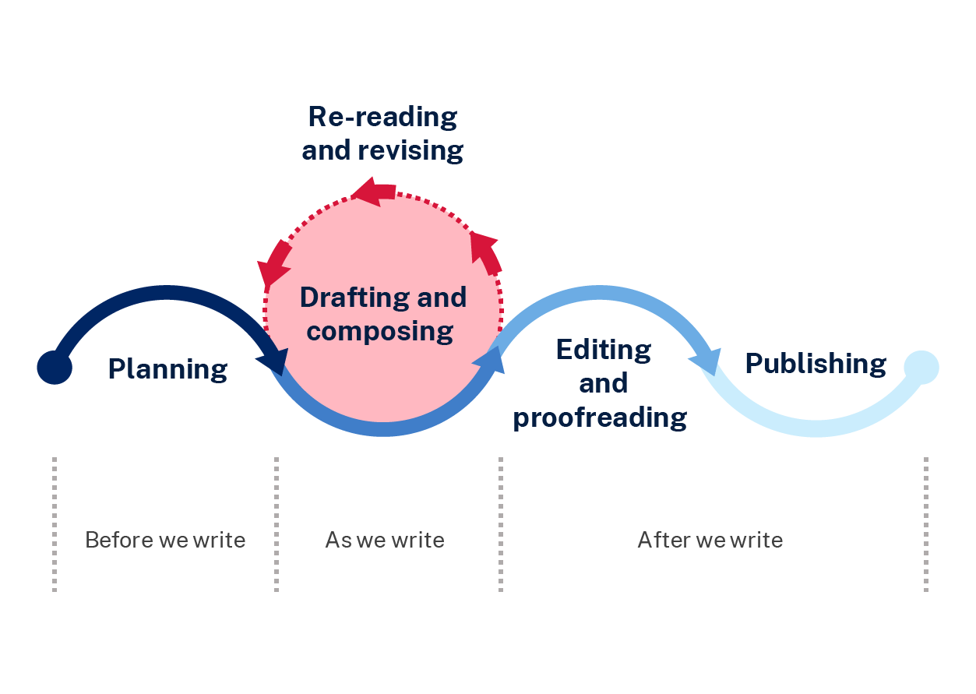

Resource 20: Planning template
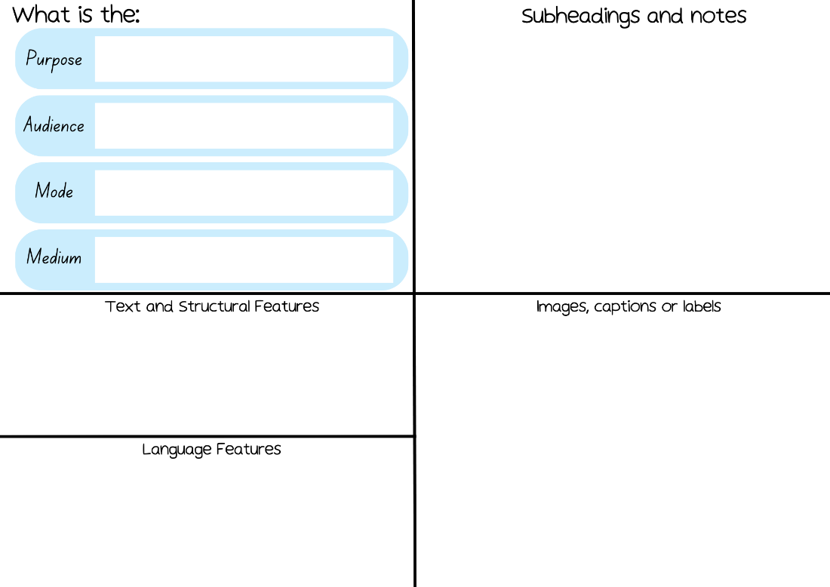

References
This resource contains NSW Curriculum and syllabus content. The NSW Curriculum is developed by the NSW Education Standards Authority. This content is prepared by NESA for and on behalf of the Crown in right of the State of New South Wales. The material is protected by Crown copyright.
Please refer to the NESA Copyright Disclaimer for more information. https://educationstandards.nsw.edu.au/wps/portal/nesa/mini-footer/copyright
NESA holds the only official and up-to-date versions of the NSW Curriculum and syllabus documents. Please visit the NSW Education Standards Authority (NESA) website https://educationstandards.nsw.edu.au/ and the NSW Curriculum website https://curriculum.nsw.edu.au/home.
English K–10 Syllabus © NSW Education Standards Authority (NESA) for and on behalf of the Crown in right of the State of New South Wales, 2022.
National Literacy Learning Progression © Australian Curriculum, Assessment and Reporting Authority (ACARA) 2010 to present, unless otherwise indicated. This material was downloaded from the Australian Curriculum website (National Literacy Learning Progression) (accessed 11 September 2023) and was not modified.
ABC (Australian Broadcasting Companies) (2022) Earth Rotation: Night and Day, ABC Education website, accessed 13 June 2023.
ABC (2023) 'Jupiter Profile' [video], Behind the News, ABC website, accessed 13 June 2023.
ABC (2022) 'Uranus Mission' [video], Behind the News, ABC website, accessed 13 June 2023.
Australian Geographic (2022) Deadly Science – The Solar System: Book 5 (Tutt C, eds.), Australian Geographic, Australia.
Hochman J and Wexler N (2017) The Writing Revolution: A Guide to Advancing Thinking Through Writing in All Subjects and Grades, John Wiley & Sons Inc, San Francisco.
Jeffers O (2022) Meanwhile Back on Earth, HarperCollins Publishers, GB.
NESA (NSW Education Standards Authority) (2023) ‘Glossary’, Resources, NESA website, accessed 12 September 2023.
President and Fellows of Harvard College (2022) Project Zero's Thinking Routine Toolbox, Project Zero website, accessed 1 June 2023.
Wet Tropics Management Authority (n.d.) Think Pair Share and 1-2-4 Strategies [PDF 53.1KB], Wet Tropics Management Authority, accessed 14 June 2023.

© State of New South Wales (Department of Education), 2023
The copyright material published in this resource is subject to the Copyright Act 1968 (Cth) and is owned by the NSW Department of Education or, where indicated, by a party other than the NSW Department of Education (third-party material).
Copyright material available in this resource and owned by the NSW Department of Education is licensed under a Creative Commons Attribution 4.0 International (CC BY 4.0) license.
This license allows you to share and adapt the material for any purpose, even commercially.
Attribution should be given to © State of New South Wales (Department of Education), 2023.
Material in this resource not available under a Creative Commons license:
- the NSW Department of Education logo, other logos and trademark-protected material
- material owned by a third party that has been reproduced with permission. You will need to obtain permission from the third party to reuse its material.
Links to third-party material and websites
Please note that the provided (reading/viewing material/list/links/texts) are a suggestion only and implies no endorsement, by the New South Wales Department of Education, of any author, publisher, or book title. School principals and teachers are best placed to assess the suitability of resources that would complement the curriculum and reflect the needs and interests of their students.
If you use the links provided in this document to access a third-party's website, you acknowledge that the terms of use, including licence terms set out on the third-party's website apply to the use which may be made of the materials on that third-party website or where permitted by the Copyright Act 1968 (Cth). The department accepts no responsibility for content on third-party websites.

