Meeting key learning area time allocation guidelines
This information provides advice on implementing key learning area time allocation guidelines when using a play-based learning approach.
The NSW Education Standards Authority (NESA) requires teachers to plan, program, teach and assess all syllabus outcomes (in the relevant stage), in all 6 key learning areas (KLAs). The department’s School day factsheet notes that the school day (excluding recess and lunch breaks) must be 4 hours and 45 minutes, equating to 23 hours and 45 minutes a week.
NESA provides the following diagram as a guide for K-6 time allocations for each KLA and additional activities. Note, 6–10% is approximately 1.5 to 2.5 hours in a typical teaching week.
Figure 1 – K-6 time allocations for each KLA
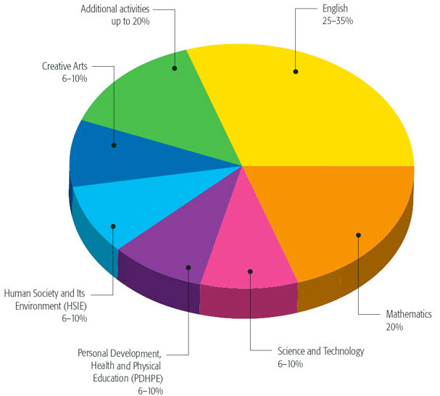
Image from NESA (2022).
The table below indicates the related approximate time allocations.
Table 1 – approximate time allocations for each KLA
KLA | Hours
English | 6–8
Mathematics | 4.75
Creative Arts | 1.5–2.5
Science and Technology | 1.5–2.5
HSIE | 1.5–2.5
PDHPE | 1.5–2.5
Additional activities | Up to 4.75

Weekly class timetable
The Curriculum requirements guide – Primary [PDF 232KB] state that the weekly class timetable must clearly indicate how much time will be spent on each KLA. Schools have the flexibility to develop timetables to address curriculum requirements in a way that best suits their context. When using a play-based approach, a class timetable will schedule time for each key learning area plus sessions of play-based learning. During the play-based sessions syllabus outcomes from a range of KLAs will be addressed.

Timetable examples
These examples show timetables that have been developed to implement NESA time allocation guidelines and include play-based lessons.

Example 1
Time | Monday | Tuesday | Wednesday | Thursday | Friday
9:00 | Play-based learning | Play-based learning | Play-based learning | Play-based learning | Roll  Assembly
9:50 | Roll | Roll | Roll | Roll | Scripture (from 9:45)
10:00 | Maths | Maths | Maths | Maths | Sport (from 10:15)
11:00 | Recess | Recess | Recess | Recess | Recess
11:20 | English | English | English | English | English
12:35 | Lunch | Lunch | Lunch | Lunch | Lunch
1:30 | Creative Arts | Library  Computers | Science and Technology | PDHPE | HSIE

Example 2
Time | Monday | Tuesday | Wednesday | Thursday | Friday
9:00 | Roll | Roll | Roll | Roll | Roll
9:10 | English | English | English | Scripture | English
10:00 | Maths | Maths | Maths | Maths (from 9:40) | Maths
11:00 | Lunch | Lunch | Lunch | Lunch | Lunch
11:45 | English | English | English | English | Library
12:15 | Play-based learning | Play-based learning | Sport | Play-based learning | Play-based learning
1:15 | Recess | Recess | Recess | Recess | Recess
1:45 | Science and Technology | HSIE | Creative Arts | Assembly | PDHPE

© State of New South Wales (Department of Education), 2023
The copyright material published in this resource is subject to the Copyright Act 1968 (Cth) and is owned by the NSW Department of Education or, where indicated, by a party other than the NSW Department of Education (third-party material).
Copyright material available in this resource and owned by the NSW Department of Education is licensed under a Creative Commons Attribution 4.0 International (CC BY 4.0) licence.

This licence allows you to share and adapt the material for any purpose, even commercially.
Attribution should be given to © State of New South Wales (Department of Education), 2023.
Material in this resource not available under a Creative Commons licence:
- the NSW Department of Education logo, other logos and trademark-protected material
- material owned by a third party that has been reproduced with permission. You will need to obtain permission from the third party to reuse its material.
Links to third-party material and websites
Please note that the provided (reading/viewing material/list/links/texts) are a suggestion only and implies no endorsement, by the New South Wales Department of Education, of any author, publisher, or book title. School principals and teachers are best placed to assess the suitability of resources that would complement the curriculum and reflect the needs and interests of their students.
If you use the links provided in this document to access a third-party's website, you acknowledge that the terms of use, including licence terms set out on the third-party's website apply to the use which may be made of the materials on that third-party website or where permitted by the Copyright Act 1968 (Cth). The department accepts no responsibility for content on third-party websites.

