Why are we using a play-based learning approach at our school?
Our teachers help children learn in a range of ways, including through play.

What does research tell us about play and learning?
Play-based learning suits children's brain development. Children learn when they:
- are active and doing things
- can touch and move things around
- work with others and talk about what they are doing and learning
- know how their learning relates to their home and community life
- build on and extend what they already know and can do
- are supported and challenged to learn more complex things
- are given opportunities to express their ideas, thinking and preferences
- make decisions about their learning.
When children engage in planned play-based learning experiences, they are doing all these things.

What is the teacher’s role in play?
Our teachers plan and provide play-based learning experiences that build on children’s interests. This motivates them to explore, investigate and try out new things. As the children play, teachers guide their learning. They do this by talking to the children about what they are doing, giving feedback and asking children questions to get them to think more deeply.

What does my child learn when they play?
As they play, children learn the academic skills that are required in the school curriculum as well as important skills and tools that will help them now and into the future, in all areas of their life, for example:
- communicating and getting along with others
- managing themselves and their emotions
- thinking skills such as how to work through and solve problems
- movement skills and coordination
- concentration, focus and persistence
- imagination and creativity.

Is my child learning all the English and mathematics they need to?
Yes. Our teachers carefully plan the experiences they provide for children to address all of the curriculum syllabus outcomes.

How does play help my child’s transition into school?
Children are already used to play-based learning when they start school. Continuing to learn through play at school helps them feel comfortable, confident and ready to learn new things.

How can I find out more?
We encourage you to read more about play-based learning. These are good places to start:
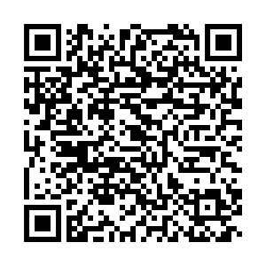 | How play helps child development (2:44)  Watch this short video to learn how play helps children develop.  raisingchildren.net.au/school-age/play-media-technology/play-school-age-development/play-helps-development
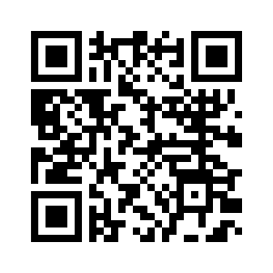 | Learning potential  Go to the ‘Primary School’ section of this webpage for ideas for helping your child learn at home.  learningpotential.gov.au/
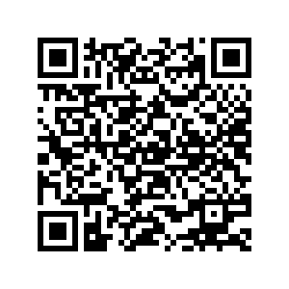 | School age: play & development  Read information about how school age children play and develop.  raisingchildren.net.au/school-age/play-media-technology/play-school-age-development
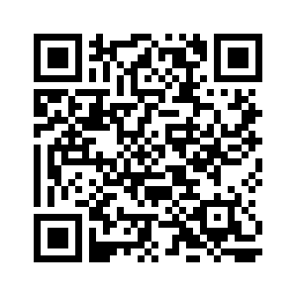 | Maths Trains Brains  Discover resources, tips and tricks to help you navigate your child's maths education journey.  education.nsw.gov.au/parents-and-carers/everyday-maths/primary

© State of New South Wales (Department of Education), 2023
The copyright material published in this resource is subject to the Copyright Act 1968 (Cth) and is owned by the NSW Department of Education or, where indicated, by a party other than the NSW Department of Education (third-party material).
Copyright material available in this resource and owned by the NSW Department of Education is licensed under a Creative Commons Attribution 4.0 International (CC BY 4.0) licence.
This licence allows you to share and adapt the material for any purpose, even commercially.
Attribution should be given to © State of New South Wales (Department of Education), 2023.
Material in this resource not available under a Creative Commons licence:
- the NSW Department of Education logo, other logos and trademark-protected material
- material owned by a third party that has been reproduced with permission. You will need to obtain permission from the third party to reuse its material.
Links to third-party material and websites
Please note that the provided (reading/viewing material/list/links/texts) are a suggestion only and implies no endorsement, by the New South Wales Department of Education, of any author, publisher, or book title. School principals and teachers are best placed to assess the suitability of resources that would complement the curriculum and reflect the needs and interests of their students.
If you use the links provided in this document to access a third-party's website, you acknowledge that the terms of use, including licence terms set out on the third-party's website apply to the use which may be made of the materials on that third-party website or where permitted by the Copyright Act 1968 (Cth). The department accepts no responsibility for content on third-party websites.

