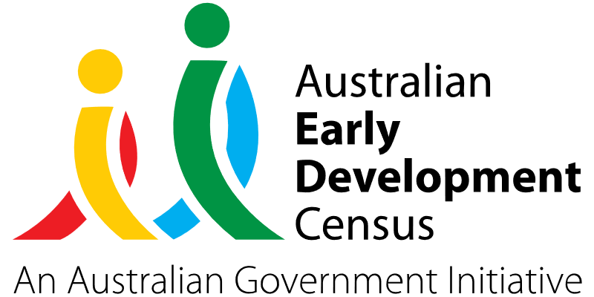

Supported playgroup initiative.

Toukley Public School

About the community
Toukley is a town in the Central Coast region of New South Wales, approximately 109 km north of Sydney and 54 km south of Newcastle.
Toukley Public School has an enrolment of 498 students from Preschool to Year 6, of which 161 (32%) are Aboriginal and/or Torres Strait Islander students that are supported through close connections with the Muru Bulbi Aboriginal Education Consultancy Group (AECG) and a designated Aboriginal Education Officer.
Toukley Public School receives significant equity loadings for socio-economic status, Aboriginal background and students with disabilities. Kooloora Preschool is the school’s designated Aboriginal preschool, with 40 places available for a part-time program to service Aboriginal families from all areas of the Central Coast.

What did the data show?
The Australian Early Development Census (AEDC) is a national measure of early childhood development that is collected at the time children commence their first year of full-time school. The AEDC collects data relating to 5 key areas of early childhood development, referred to as domains. The domains are: physical health and wellbeing; social competence; emotional maturity; language and cognitive skills (school-based); communication skills and general knowledge.
The 2021 AEDC data for Toukley Public School showed a significant increase in the proportion of children assessed as developmentally vulnerable in the social competence domain, from 2.6% in 2018 to 11.9% in 2021. Small increases in developmental vulnerabilities were also experienced across the emotional maturity, language and cognitive skills (school-based), and communication skills and general knowledge domains.
In addition, 18.6% of children at Toukley Public School were vulnerable on one or more domain(s) (from 14.1% in 2018) and 11.9% of children were vulnerable on 2 or more domains (from 3.8% in 2018).

Bringing about change
Toukley Public School educators identified that there was a gap in service provision of playgroups in the local area. The AEDC results were used by Toukley Public School to provide direction for services and programs to be delivered through the supported playgroup initiative, including child health, speech therapy and parenting sessions that support children’s development across all the AEDC domains but with a particular focus on the social competence domain.
The aim of the supported playgroup initiative was to work with families and other community organisations to provide a connected social environment for children and families. It addressed the following areas of need in the Toukley community:
- increased access to professional and/or specialist support for children prior to them starting school.
- increased proportion of children with healthy speech and language development
- increased parent awareness about the importance of social skills development prior to their child starting school.
- early identification of children with hearing loss.
The supported playgroup provided an early learning, and parent and child interaction platform based on the concept that it takes a community to raise a child. It promoted parents as their child’s first teacher and provided a safe and supportive environment where families could build connections with each other, the school and the local community. As an interface in the community where parenting practice and child engagement can be influenced, educators could provide a non-judgemental and connected environment for children to develop social connections, as well as encourage and support all parents to monitor their child’s behaviour.

Partnerships
The initiative was led by Toukley Public School’s Community Liaison Officer who provided the connections with families. The educators at Toukley Public School’s department preschool onsite supported the playgroup and ensured developmental outcomes were appropriately catered for. Support was also provided by the school’s Aboriginal Education Officer and local organisations, including the Toukley Neighbourhood Centre, Gudjagang Ngara li-dhi (GNL) Aboriginal Corporation and the Muru Bulbi AECG to ensure a culturally sensitive approach was maintained.

Achievements
The supported playgroup initiative effectively provided a soft entry point for families into the school environment. Providing families access to the school’s Community Liaison Officer, Aboriginal Education Officer and Deputy Principal allowed them to gain any extra supports they required and referrals to support agencies. Through the playgroup, educators were able to link vulnerable families to organisations that provide support in terms of food and housing that they might otherwise be unaware of.
The engagement of families at the playgroup has been reflected in boosted enrolments at both Kooloora Preschool and Toukley Public School. While the playgroup started small, it gradually expanded to have about 30 regular participants. Surveys of parents and carers of children participating in the supported playgroup reported observed growth in their child’s social skills, which was corroborated by the positive anecdotal verbal updates provided by educators running the playgroup.
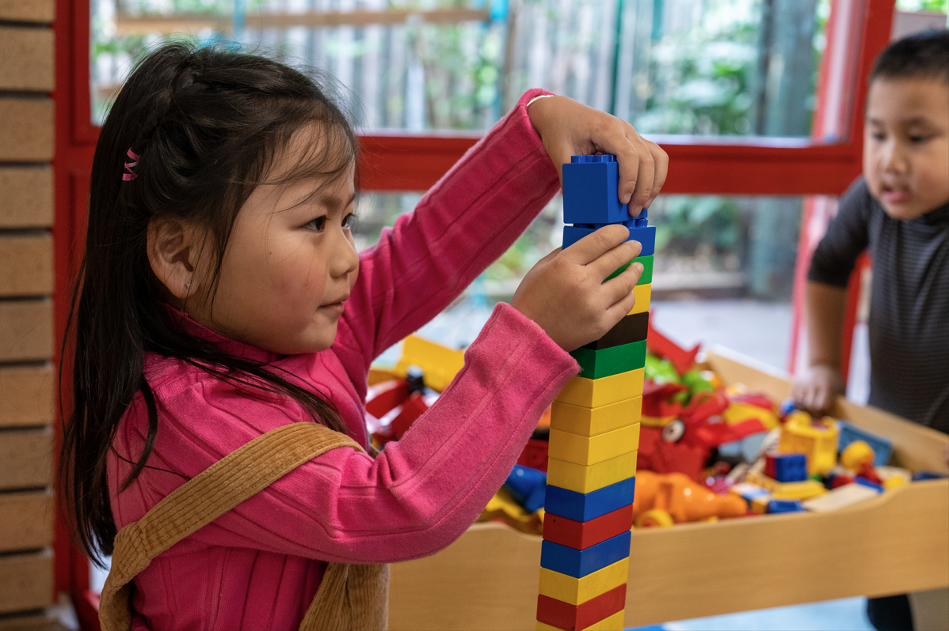

Looking ahead
As the supported playgroup continues in operation, Toukley Public School hopes to continue seeing an increase in social skills and competence of children attending the playgroup through exposure to other children in play-based experiences. Going forward, Toukley Public School would also like to work in conjunction with a speech pathologist to identify and support children with speech-related difficulties so they can meet developmental speech, language and communication milestones by the time they start school.
For more information, contact the AEDC NSW Project Team:
Phone: 1300 083 698
Email: aedc@det.nsw.edu.au

