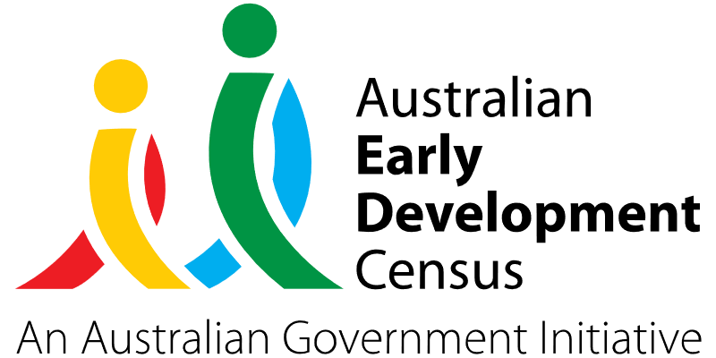

Partnerships for early detection, intervention and family supports

Fairfield City Council

About the community
Fairfield City is located in Western Sydney, approximately 32 km south-west of the Sydney Central Business District. It covers an area of 102 km², incorporating 27 suburbs, including Wetherill Park, Cabramatta, Fairfield, Canley Vale and Horsley Park.
Fairfield City is one of the most culturally diverse communities in Australia, with residents being born in more than 108 different countries and 69.7% of the population speaking a language other than English at home. Fairfield City Council – Best Start Education and Care operates 14 early childhood education and care services in the area, consisting of long day care, preschools and family day care schemes to meet the diverse needs of the local community.

What did the data show?
The Australian Early Development Census (AEDC) is a national measure of early childhood development that is collected at the time children commence their first year of full-time school. The AEDC collects data relating to 5 key areas of early childhood development, referred to as domains. The domains are: physical health and wellbeing; social competence; emotional maturity; language and cognitive skills (school-based); communication skills and general knowledge.
The 2021 AEDC data for the Fairfield City community showed higher levels of developmental vulnerabilities in comparison to NSW and Australian averages on the physical health, social competence, language and cognitive skills (school-based), and communication skills and general knowledge domains. The domain with the highest percentage of vulnerability for Fairfield City was the communication skills and general knowledge domain (16.4% compared to 8.4% in both NSW and Australia).
In the Fairfield City community, 28.6% of children were developmentally vulnerable on one or more AEDC domain(s) in 2021, and 15.4% were developmentally vulnerable on 2 or more AEDC domains.
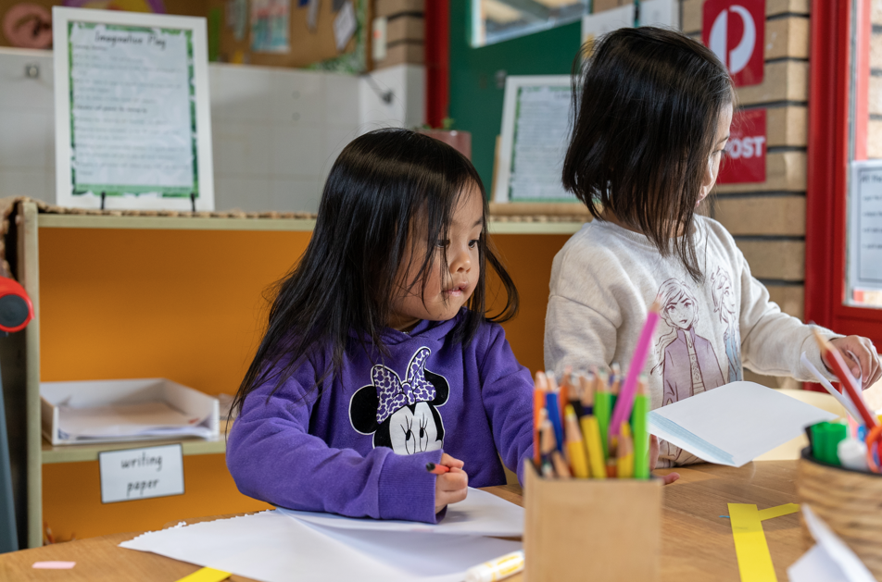

Bringing about change
The Fairfield City community has limited access to early intervention support services due to high demand. In addition to this, many services are being provided by private companies and are inaccessible for many families in the local area coming from a low socioeconomic background. This has resulted in additional needs of children going undetected for long periods of time and many attending school lacking developmentally appropriate communication and language skills.
This project initiated by Fairfield City Council directly addresses the communication and language development needs of young children in the community, which was highlighted in the Fairfield City AEDC data as a key area of concern. Early intervention for this group is essential to prevent ongoing disadvantage and difficulty in the early years of school impacting literacy learning, behaviour and participation in the classroom.
Working with highly respected sector professionals and stakeholders, including the University of Technology Sydney (UTS) and its Speech Pathology discipline, the project provides screening, assessment and management strategies for children at risk of speech, language and communication disorders across the 14 early childhood education and care services in the Fairfield City community. The project also serves to upskill families and extend the knowledge and practices of early years educators to better support young children’s speech and language development.

Partnerships
Fairfield City Council – Best Start Education and Care have a long history of partnership with UTS through the Speech Pathology discipline’s Reaching Out at UTS (SPROUTS) clinic. During the project, UTS provided allied health professionals, such as speech pathologists and speech pathology students, to work with children, educators and families.
Fairfield City Council early childhood education and care services also worked in conjunction with local schools (including teachers, translators and school counsellors) to support children's transition to school, by sharing assessments and discussing individual support plans and strategies. Following the in-field engagements at the early childhood and care services, Eastern Access Community Health (EACH) was also engaged to support families in sourcing support agencies and networks that will meet the needs of their children.
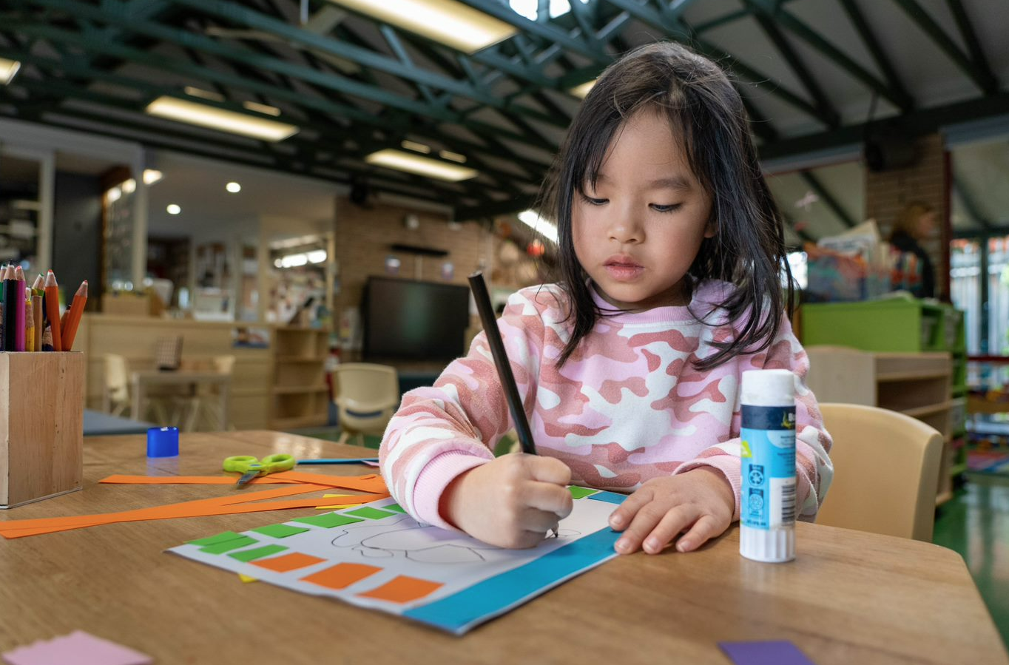
Achievements
As part of the project, a speech pathologist, together with 4 to 5 UTS speech pathology students, attended 5 of the 14 early childhood education and care services in the Fairfield City area to deliver assessments for children displaying language delays and to upskill educators. Over a period of 20 days, the Speech Pathology discipline from UTS implemented strategies to improve children’s communication, understanding, ability to express themselves and speech clarity. In addition, they upskilled educators on strategies to improve children’s communication and participation in the classroom.
In total, 86 children between the ages of 2 to 4 received assessment and support under the project to improve their language and communication skills outcomes. Families were offered feedback on their child’s developmental progress, and children who presented with needs or significant needs were offered a speech and language screener or full language assessment. This supported families to access additional services such as EACH, obtain referrals to local therapists and seek financial assistance.
The SPROUTS team offered professional development to educators by role modelling strategies and practices. The intervention support offered by SPROUTS therapists provided educators with a greater understanding of children’s needs and helped them to develop specific goals and strategies to improve the learning outcomes of children. Environmental changes and recommendations were provided to better support children’s engagement within educational programs and learning spaces.
Progress was also documented on children’s individual learning plans throughout the project. This ensured that any children attending school in January 2023 were able to successfully attend school with a personal action plan identifying their individual communication needs.

Looking ahead
Fairfield City Council would like to offer these speech and language assessments across all 14 early childhood education and care services in the Fairfield City community as an ongoing initiative. This would enable teachers and educators to consistently work collaboratively with allied health professionals to identify children’s developmental vulnerabilities in the early years and provide these children with early intervention to support a smoother transition to school.
For more information, contact the AEDC NSW Project Team:
Phone: 1300 083 698
Email: aedc@det.nsw.edu.au

