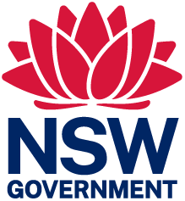 | 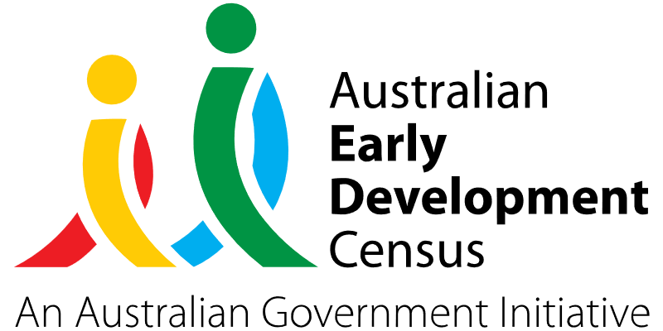

Outreach Kit for Local Playgroups

Big Sky Stories Ltd

About the community
Broken Hill is a frontier mining town in the far west of New South Wales, in the Australian outback.
In 2021, the estimated resident population of the City of Broken Hill was 17 661, with a population density of 103.6 persons per square km. It is a community with high vulnerabilities due to geographical isolation and socio-economic needs. The Socio-Economic Indexes for Areas (SEIFA) score in Broken Hill was 2 (out of 10) in 2021, reflecting considerable disadvantage compared to other New South Wales regions and surrounding areas.

What did the data show?
The Australian Early Development Census (AEDC) is a national measure of early childhood development that is collected at the time children commence their first year of full-time school. The AEDC collects data relating to 5 key areas of early childhood development referred to as domains. The domains are: physical health and wellbeing; social competence; emotional maturity; language and cognitive skills (school-based); communication skills and general knowledge.
The 2021 AEDC data for the community of far west NSW showed a 3.2% decrease in children developmentally vulnerable on 2 or more domains (from 13% in 2018 to 9.8% in 2021) but a 7.9% increase in children developmentally vulnerable on one or more domain(s) (from 23.0% in 2018 to 30.9% in 2021). 23.1% of children in the community identified as Aboriginal and Torres Strait Islander.
The most recent AEDC data also showed significant declines in the percentage of children on track on the physical domain (from 80.9% in 2018 to 73.4% in 2021) and the language and cognitive skills domain (from 77.8% in 2018 to 68.9% in 2021).
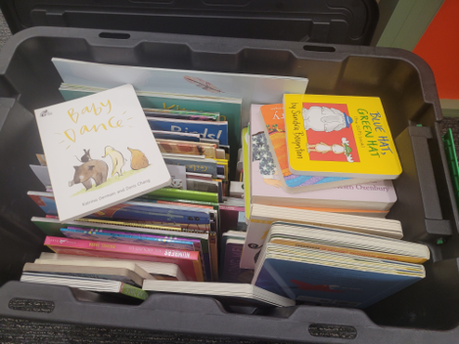

Bringing about change
The Big Sky Stories organisation was established to develop and foster lifelong language and literacy skills for families in the far west of New South Wales. This was in response to the identified need in the language and cognitive skills domain. Inspired by similar models in metropolitan areas, the goal of this project was to create a safe and inclusive space for the community to engage in workshops and creative opportunities to develop a greater understanding of the importance of early language and literacy learning opportunities.
An ‘outreach kit’ of resources was developed that could be transported to local playgroup sessions attended by children under 5 years of age. The kit included quality texts, reading mats, language resources such as puppets and accessible print materials to stimulate verbal communication and learning in the home environment.
Regular participation with existing playgroups enabled trained employees of Big Sky Stories to share expertise and use resources to model strategies, as well as encourage caregivers to engage in early language and literacy learning through intentional talk and reading together. By encouraging caregivers to participate in communication-based activities with their child at the playgroup sessions, this enabled them to develop skills and confidence in leading creative, artful language experiences and shared story opportunities.

Partnerships
Big Sky Stories was endorsed with a letter of support by Broken Hill City Council. Additional letters of support were obtained from several local primary schools, who believed the initiative would enhance early learning in the community.
Collaborative partnerships were established between Big Sky Stories and local playgroup service providers to build on their existing capacity to provide support for children under 5 years of age and their caregivers. The collaborative partners involved included:
- CatholicCare Broken Hill Playgroup
- Mission Australia Broken Hill Playgroup
- Broken Hill Public School Playgroup

Achievements
There were approximately 60 to 80 children and families who benefited from the Big Sky Stories playgroup sessions. The playgroups attended by Big Sky Stories employees generated considerable interest and saw an increased number of families attending on these days, with one of the playgroups growing from 25 to 40 children over the program.
The project enabled regular interactions between trained employees of Big Sky Stories, young children, and their caregivers. It led to service providers having an increased understanding of ways to encourage caregivers to intentionally speak, read and engage with their children during and outside of playgroup sessions. It also better equipped and encouraged caregivers as first teachers to continue modelled practices outside of the formal playgroup session, for greater language development and relationship building between caregiver and child.
Playgroup leaders reported seeing an increase in the number of playgroup children choosing to interact with picture books and finger puppets during playgroup, as well as an increase in the number of parents and caregivers sharing books with their children during playgroup sessions. All playgroup leaders and team members in each of the 3 playgroups attended by Big Sky Stories felt that these sessions provided valuable modelling, resources and strategies, and that a safe space was created for parents to learn about the importance of talking and reading with their children.
By directly supporting early literacy and language development, the project has strengthened children’s transition from early childhood education and care to formal school settings and supported their continuity of learning. 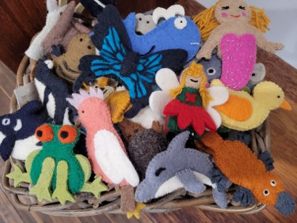

Looking ahead
Building on the success of the current program, Big Sky Stories would like to undertake the same program with other playgroups in Broken Hill. A regular story time at Big Sky Stories has been established for parents or caregivers and their babies, toddlers and pre-schoolers to continue improving children’s language and literacy development. Big Sky Stories also hope to create gift book packs for babies and toddlers, and ongoing support will be provided to parents and caregivers to continue sharing reading strategies and promoting story time with their children.
For more information, contact the AEDC NSW Project Team:
Phone: 1300 083 698
Email: aedc@det.nsw.edu.au

