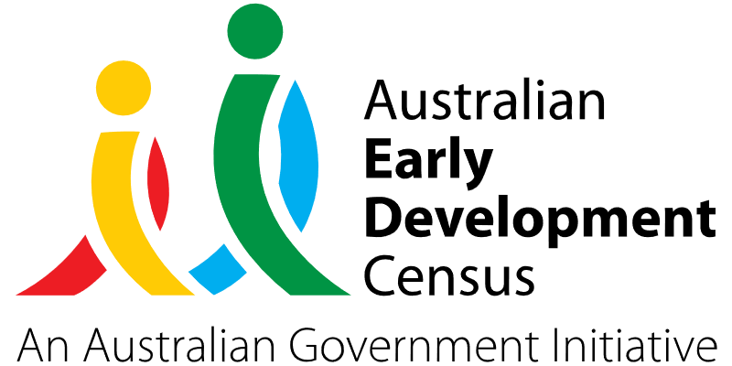

Prosocial Play Support Program

Ambrose Early Learning, Santa Sophia, Box Hill

About the community
Box Hill is located approximately 42 km north-west of the Sydney central business district, in the Hills Shire. It is a culturally diverse area as reflected in the Australian Bureau of Statistics 2021 census data, with 46.6% of the Box Hill population having a country of birth outside of Australia and 63.3% having both parents born overseas (in comparison to 39.4% in NSW and 36.7% in Australia).
Ambrose Early Learning, Santa Sophia, Box Hill provides early learning for children aged 3 to 5 years. There are 100 children enrolled in the early childhood education and care service, which includes children from 22 different cultural backgrounds. A large percentage of these children will attend the attached Catholic school, Santa Sophia Catholic College.

What did the data show?
The Australian Early Development Census (AEDC) is a national measure of early childhood development that is collected at the time children commence their first year of full-time school. The AEDC collects data relating to 5 key areas of early childhood development referred to as domains. The domains are physical health and wellbeing; social competence; emotional maturity; language and cognitive skills (school-based); communication skills and general knowledge.
The 2021 AEDC findings for the Hills community indicated increased vulnerabilities in the social competence, emotional maturity, language and cognitive skills (school-based), and communication skills and general knowledge domains. There was also a significant increase in the percentage of children vulnerable on one or more domain(s) (from 15.2% in 2018 to 17.1% in 2021) and children vulnerable on 2 or more domains (from 6.0% in 2018 to 8.1% in 2021).

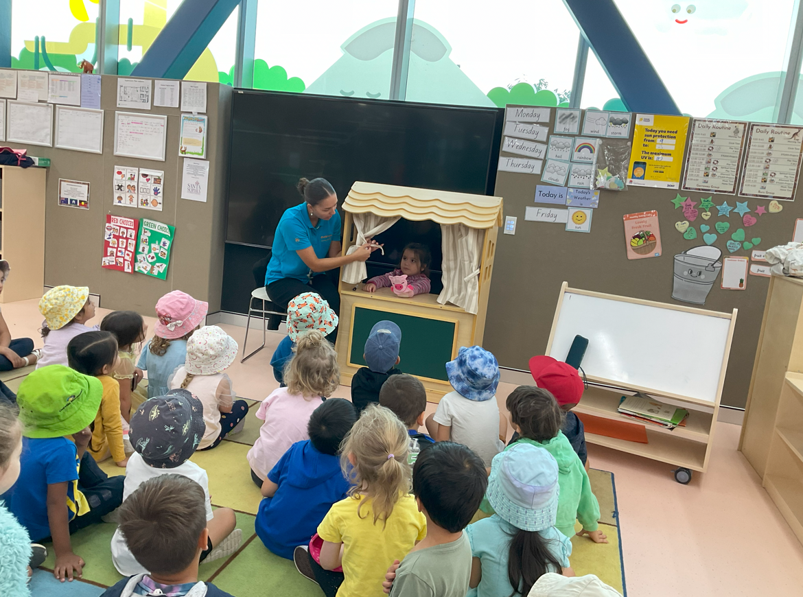

Bringing about change
The Prosocial Play Support Program was established to narrow the gap between vulnerable children and those on track in the social competence, emotional maturity, and communication skills domains. The program generated the following community initiatives:
- Occupational therapist visits to the service to provide professional learning opportunities for educators and engage with children to support social skill development.
- Clinical psychologist seminars held for families and educators to enhance their understanding of ways to support children in their social and emotional skill development.
- Purchase of resources to support children's language and communication development in a play-based social program. These resources included books to support literacy skills; puppets and games to support sharing, turn taking and other pro social skills; and feelings cards, sensory bottles and mindfulness stacking stones to support emotional regulation.

Partnerships
The program was delivered with support from the following key partners:
- Santa Sophia Catholic College
- NSW Health (occupational therapists)
- Be You Early Learning
- Catholic Care
- Child psychologists
- Statewide Eyesight Preschooler Screening (StEPS) program (a NSW Health initiative)
- Catholic Diocese of Parramatta Services Limited
- Munch & Move – Western Sydney Local Area Health District
- NSW / ACT Inclusion Agency (KU Children’s Services).

Achievements
The Prosocial Play Support Program improved children’s prosocial skills by allowing students opportunities to learn to share play spaces and materials with their peers, also leading to enhanced self-regulation. It supported the development of communication skills and social competence of children through active participation and engagement in language experiences alongside their peers with teacher support.
Families attending the Ambrose Early Learning service were asked to complete a survey about the changes they had observed in their child’s development of social skills and emotional regulation since the commencement of the program. Of the 25% of families who responded, 83% reported that they observed an increase in their child’s social skills over the course of the program and 71% reported that they observed an increase in their child’s emotional skills during the same period. This data matched the observations of educators who reported a positive change in these areas.
The program also boosted the confidence and awareness of families enrolled in the Ambrose Early Learning service, equipping them with knowledge of ways to support their children’s social and emotional development, as well as their communication skills. Families attending the clinical psychologist information sessions reported they had positively changed their practices at home to incorporate the strategies shared by the psychologist on building resilience and emotional regulation in children.
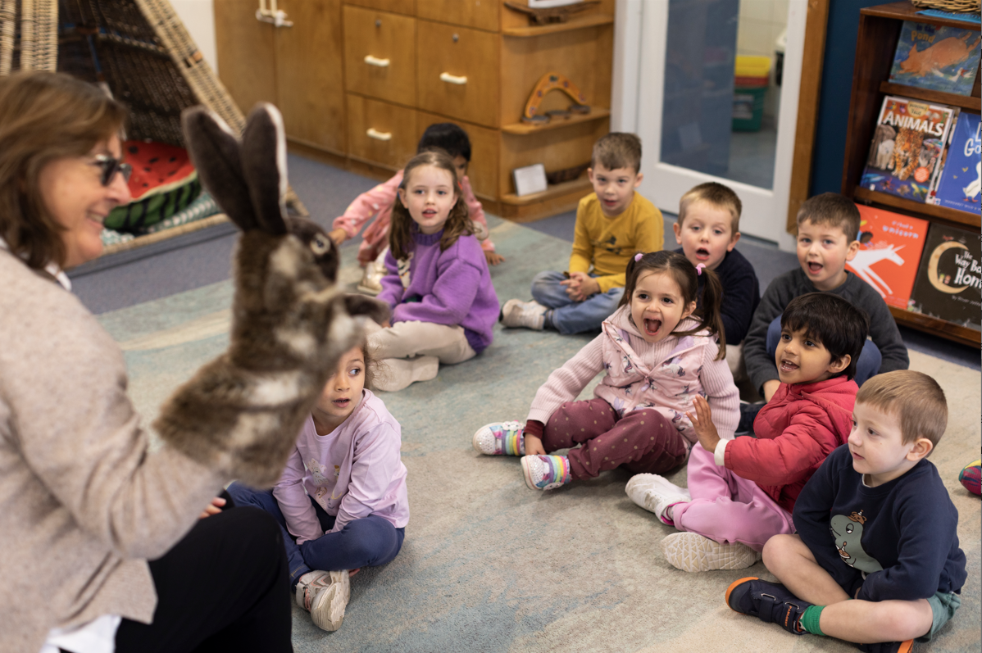

Looking ahead
While there have been observed improvements in children’s social skill development and emotional regulation stemming from the Prosocial Play Support program, it will take continued support to address and close the gaps in the social competence, communication skills and emotional maturity domains. Ongoing attention also needs to be given to helping children develop skills in communicating their feelings and needs during social conflict.
Ambrose Early Learning would like to continue offering families access to the support and expertise of the clinical psychologist and occupational therapist every year. They have also invested in resources to enable elements of the initiative to continue with current and future groups of children.
For more information, contact the AEDC NSW Project Team:
Phone: 1300 083 698
Email: aedc@det.nsw.edu.au

