My History, Your History, Our History competition – 175 years of public education in NSW

Historical research support guide

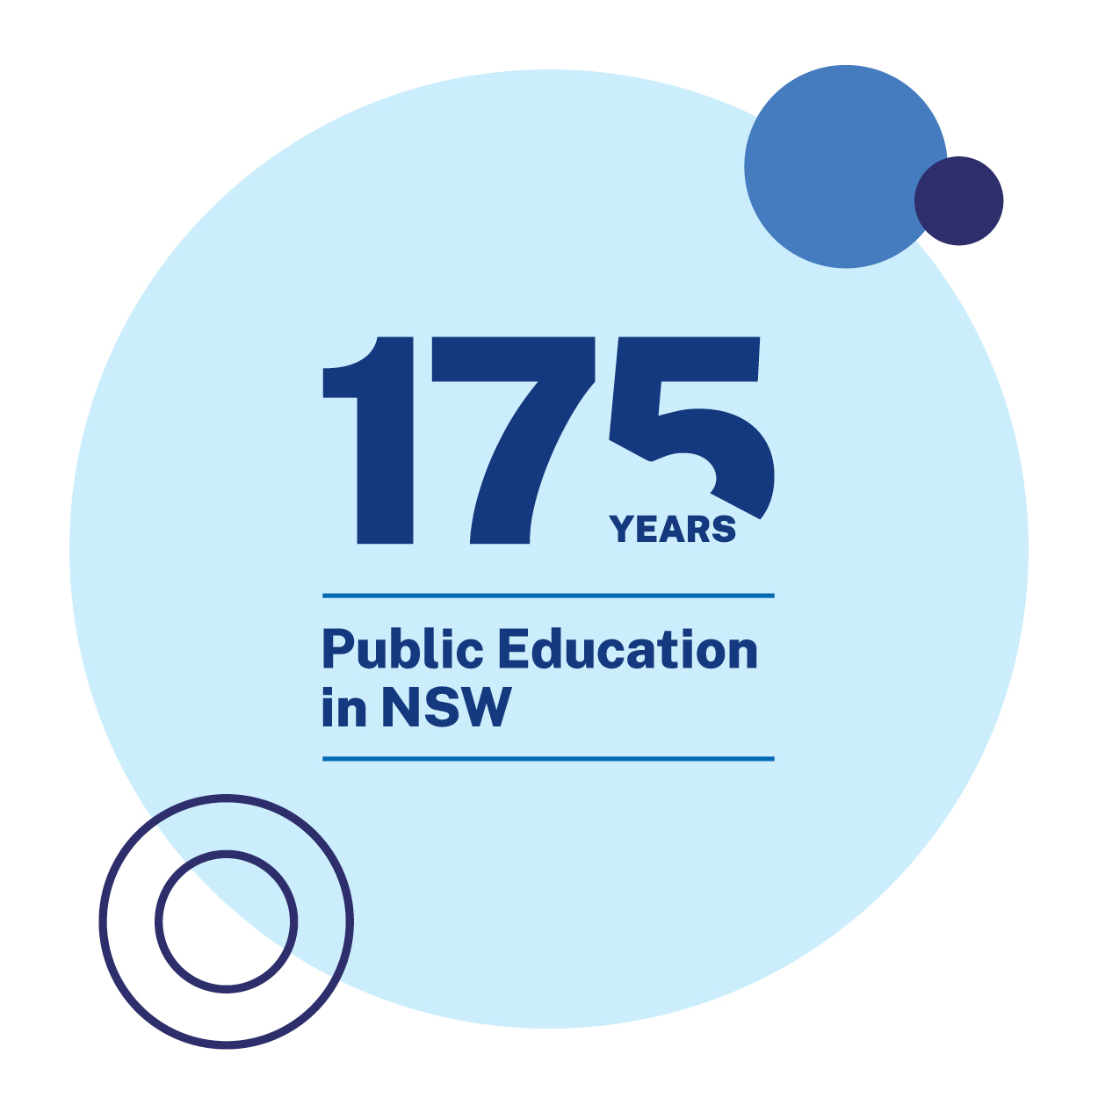

The 175 years of public education research competition
In 2023, the department is acknowledging 175 years of public education in NSW. The My History, Your History, Our History competition is one of the many ways in which school communities can learn from our past, celebrate our achievements and embrace the future.
My History, Your History, Our History targets the objectives of Stage 4 and Stage 5 history, as students develop skills to:
- undertake the process of historical inquiry
- communicate their understanding of history.
The competition will support students to develop their understanding of history concepts and refine their historical skills.

What is local history?
Local history focuses on specific suburbs, groups, and sites in the area. Local history supports students to reconstruct the history of a place with which they are personally connected, to understand how people lived, worked, and learned in their immediate community.
An investigation of local history could focus on:
- a student’s own school
- a local primary school
- a specific local site
- a local community group
- the wider local community.

Why undertake a local history investigation?
Local histories shape the character and identity of communities and groups.
An investigation of local history can:
- facilitate meaningful connections between the past and the present
- enhance collective understanding of continuity and change
- build foundational skills in historical inquiry
- promote and preserve the significance of community histories
- strengthen community links and partnerships.

Supporting students with local history research
The following material has been collated to support secondary students who are participating in the My History, Your History, Our History competition.
The resources are designed to support students to understand why and how to locate different sources for their local history investigation. The teaching strategies and resources are suggestions only and should be adapted to fit your specific school context and student needs. More information about the historical inquiry process in Stage 4 and Stage 5 history can be found on pp 39-46 of the History teaching S4 to S5 support document.

Artefacts
Students may be inspired by historic trophies, photographs, or plaques that commemorate significant people, places, or events from the past. Artefacts, such as school and community commemoration boards, can give details of institutional name changes, record the achievements of individuals, and demonstrate what types of achievements were valued in the past.
Useful artefacts from your school might include:
- yearbooks
- newsletters
- school plans or maps
- newspaper articles
- advertising materials
- photographs from excursions, theatre performances, and sporting events
- minutes from meetings of the P&C and SRC
- memorial plaques
- perpetual trophies
- leadership boards
- interview transcripts from former students and staff.
Engaging with artefacts can support students to develop their understanding of the historical concepts of continuity and change, empathetic understanding, and significance while they apply the historical skills of comprehension, analysis and use of sources, perspectives and interpretations, and research.
More information about working with artefacts is available on pp 16-20 of History teaching S4 to S5 support document.

Learning activities
With a partner, complete 5 Whys starting with the following question: why are artefacts useful in an historical inquiry?
Complete a class brainstorm about the following: how can we investigate the history of our school?
Explore your school site.
- Identify and record any memorial plaques or interesting signs you find.
- Use these observations and any other evidence available to you to create a chronology of interesting events in the history of your school.
Present your chronology in a timeline or visual storyboard.

Archives
Using archives can be an excellent way to add depth to historical research and discover new things about your topic. If students are using archives, they should carefully consider the key words to use to ensure the best chance of results that are relevant to the topic of choice, for example your school name and specific dates might be a useful starting point.
The NSW Department of Education website includes a section on the History of NSW government schools. The School history database search contains entries for more than 7,390 government schools in NSW since the first school (Kempsey National School) was opened in September 1848. The webpage Database facts will help students to use and understand the database, including how to track a school through changes of name and how to identify the differences between schools with the same name. It is suggested that students start their research with this database, as the information will help them to effectively navigate other archives.
Many local and national libraries have searchable digitised collections. Trove is a collaborative effort of many organisations, communities and individuals who work with the National Library to make Australian content easier to locate. There are more than 14 billion digitised records available via Trove. Help with understanding how to search the Trove database is available at Trove help searching.
The State Library of NSW and local libraries – including council, university, and community libraries – may also have accessible digitised catalogues. Connecting with librarians can support students to access material that might not be digitally available.
Heritage NSW maintains a digitised database – the Heritage online library – and the Museum of History NSW (MHNSW) also has a digital archive – see how to use the state archives collection.
When using a digitised archive, it is important that students keep a record of search terms. Using key words will help students to locate historical material relevant to their inquiry question. More information on keyword searches is available from the University of Newcastle Library Guides and Trove search.
Your school may have an archive collection that can be accessed – if your school has a teacher-librarian, ask them for assistance to guide student research.

Learning activities
Complete a Frayer diagram for the term ‘archive’.
Think about your selected topic and:
- identify archives that will be useful for your research
- brainstorm a list of key words that can be used as search terms to help you explore your topic in detail.
Use your key words to locate sources of information in relevant archives. Use a table like Table 1 to keep track of your sources.
Table 1 Research sources and notes
Source name and location | Notes
‘Beatle’ students defiant – The Canberra Times, Sat 10 July 1965 page 8 | Includes picture of Denis Ord (one of the boys with hair of an “(un)reasonable length”. Links to Source 3 and Source 4 The fact that this is a Canberra paper suggests that the decision by CHHS principal to ban the boys from classes was significant at the time.
Use an Affinity diagram to organise your archival sources and link them to your puzzle questions.

Interviews
Primary interviews can be a rich resource for students inquiring into their local community. Interviews are an effective research method for students to access the first-person accounts from relevant individuals. Interviews are an appropriate research tool to collect information about past:
- behaviour
- feelings
- attitudes
- opinions.
Interviews can be structured or unstructured, oral or written, in-person, virtual, or asynchronous. A group of students or a whole class may collaborate to design an interview for a single participant, who may be able to attend the school in. Alternatively, individual students, a group of students or a whole class may design an interview that can be conducted with multiple participants.
When creating interview questions, it is important that students understand the difference between open-ended questions, closed questions, and leading questions. Ethical considerations are a significant element of interviews – refer to that section of this document prior to engaging students in the interview process.
Conducting interviews will allow students to add a personal touch to their research projects and ensure that they have clear connections to specific details from the history of their school in their final product.
More information about interviews as oral histories is available on pp 36-38 of the resource History teaching S4 to S5 support document.

Learning activities
Complete a 5 Whys routine in response to the question ‘Why would an historian use interview as a research method?’
Your teacher will lead a class discussion about the advantages and disadvantages of:
- closed questions
- open-ended questions
- leading questions.
Based on this discussion, work in small groups to create a series of questions that would be useful to use in an interview with a past member of the school community for this project. Some examples to start you off include:
- Were you part of the school community?
- How would you describe your role in the school community?
- What were some of the most important rules when you were at the school?
- What was the most interesting or significant event you can recall happening at the school?
- Do you think the area and the school has changed since then?
- What do you most value about the time you spent as part of the school community?
- What do you most want students and staff at the school today to know about the school’s history?
Change the wording of any leading questions you have create to make them open-ended, non-leading questions.
Reflect on any closed questions and decide if they should be re-written as open questions.
Examine Source 4. Which response are you most interested in finding out more about? Create a probing question you could ask to elicit more information from the interviewee.
Engage with the article Choosing an interview type for qualitative research and apply your understanding to complete Table 2.
Table 2 Interview strengths and limitations
Type of interview | Strengths | Limitations
unstructured
semi structured
structured
If a primary source interview is relevant to your competition topic, it is likely that a semi structured interview will be the most appropriate structure. Engage with Guidelines for conducting oral history interviews and Semi-structured interviews guide (duration 4:06) and use the following prompts to help you to prepare for your interview (these prompts have been modified from Research methods guide: interview research.)
Design interview questions that:
- will gather information that you cannot get from other sources
- are relevant for your interviewee
- are clear and easy to understand
- are not leading questions.
Develop an interview guide to ensure that you:
- introduce yourself and explain the aim of the interview
- are clearly addressing your research aim
- sequence your questions by grouping them in themes
- can easily move between questions or themes.
Plan and manage logistical and ethical issues such as:
- Where will the interview take place?
- Who will be present during the interview?
- How you will address terms of informed consent and confidentiality?
- How the interview will be recorded?
- What technologies and tools you will need access to?
- How you will reduce and manage distractions?
- How much time each interview will take?
Additional information on interviewing for oral history can be found at Oral History NSW Resources, Smithsonian Institution Archives How to do oral history and the Oral History Association Best Practices.

Citation and referencing
Citing, or referencing, is a systematic way of acknowledging the sources that students have used in their research process. Good referencing allows students to demonstrate the historical skills of:
- comprehension, as they show evidence of reading and understanding historical texts
- analysis and use of sources, as they use information from a range of sources as evidence
- research, as they identify and locate a range of relevant sources
- explanation and communication, as they use evidence from a range of sources to create effective historical texts.
A consistent citation and referencing system will also support students to:
- respect intellectual property
- provide further resources for their audience
- practise academic integrity.
There are 3 main referencing or citation formats: APA, MLA, and Chicago. A brief discussion of these different formats is available at the Yale Poorvu Center of Teaching and Learning.
The way in which students cite their sources will depend on their final choice of communication form. Historical texts in video form may use on-screen captions to give some primary source information but leave the rest to a list of references (APA) or works cited (MLA). Historical texts in podcast form may have a reference list organised by time-stamped citations. Infographics and traditional essays may use Chicago style. Schools may have a preferred referencing system that students may already be familiar with. To be effective, a citation and referencing system should be consistent to allow students to effectively communicate how primary and secondary sources have contributed to their historical text.

Suggested learning activities
Engage with Why referencing is important (duration 1:29) and note down the 3 reasons why referencing is so important.
- Which of these 3 reasons for referencing is most important for historians? Why do you think this?
- Contribute to a Think, pair, share routine to share opinions with your class.

Ethical considerations
Teacher note – Students who are inquiring into the history of a local event, person or place will need to apply a specific skill set to achieve ethical, reliable, and effective research. The following material can be adapted to support the explicit teaching of these skills. Student and participant safety should be the primary concern when conducting local research.
Ethical research practices support effective research because:
- they promote trust that any source information collected will be used responsibly and treated with respect
- if participants feel comfortable with the ethical research process they are more likely to offer authentic experiences, increasing the research validity.
In practice, ethical research:
- ensures there are no negative effects on the research participants
- fully informs participants about the nature of the research and only proceeds with participant consent
- does not place participants in awkward situations or ask them to talk about sensitive topics that make them uncomfortable
- maintains participants right to confidentiality and privacy.

Suggested learning activities
Teacher note – A Gist statement is a comprehension strategy where students focus on the main idea of a text. Students are challenged to communicate their understanding precisely by using a limited number of words. This helps students to identify the difference between a main idea and a summary.
Engage with Informed consent and complete a Gist statement for this article.
Create a flowchart to plan your historical inquiry for the My History, Your History, Our History competition. Use Table 3 to identify any ethical concerns and devise actions to avoid or mitigate these concerns. Some common concerns are already entered into the table. Add others as relevant to your competition topic.
Table 3 Ethical concern and management actions
Possible ethical concerns | Notes and actions
Will there be participants who need to be fully informed about the scope and purpose of the research?
Will there be participants who need to give informed consent?
Identify any risks to research participants (social, emotional, and physical safety)
Identify any risks to the researcher (social, emotional, and physical safety)
How will you cite the intellectual property of others?
What bias do you bring to the project?
What bias is reflected in your sources?

Appendix – Chester Hill High School source study example
Teacher note – the following learning activities include artefacts from Chester Hill High School that can be used as examples that may be relevant when participating in My History, Your History, Our History competition. The cited artefacts are at the end of this section. These activities are intended as a model to spark thinking for students about what their own research might uncover. The Chester Hill High School artefact examples have been provided by Chester Hill High School. Photographs taken by History teacher Lucas Brown. Artefacts are housed in the Chester Hill School Museum, curated by former long-standing Head Teacher History, Graeme Brown. Thanks to Bob Daisley for Source 3 and his interview.
Contribute to a class See, think, wonder using Source 1, Source 2 and Source 3
Create a Venn diagram to represent the similarities and differences between these images from the past and your experiences of the present. Your Venn diagram could explore changes and continuities in:
- uniform
- hair styles
- nature of the student community.
Examine Source 4. What does the source suggest to you about the history of the school? Work in a small group to complete 4 Claim, evidence, reasoning statements to share your source interpretation. Below is a suggested statement:
Claim, evidence, reasoning sample statement
Chester Hill High School had strong traditional values regarding hairstyles in the 1960s. Source 4 shows students who did not meet hair style requirements faced punishment including being “banned from class” until they had their hair cut. This removal of students from class shows a strong stance by the school leadership against what were considered inappropriate hairstyles at the time.
Source 4 identifies Robert “Bob” Daisley as one of the young men suspended from class for his long hair. Explore his Wikipedia article to discover how his life progressed after that incident. Examine Source 5 and:
- Discuss Mr. Daisley’s memories and observations.
- What surprised you?
- What would you like to know more about?
- Why do you think things have changed since 1962?
Examine Source 6 and Source 7. Write a caption of 100 words for a display card to sit next to this artefact in a school museum display. Consider:
- the nature of the source
- what it shows us
- what visitors to the museum might find most interesting about the source.

Source 1
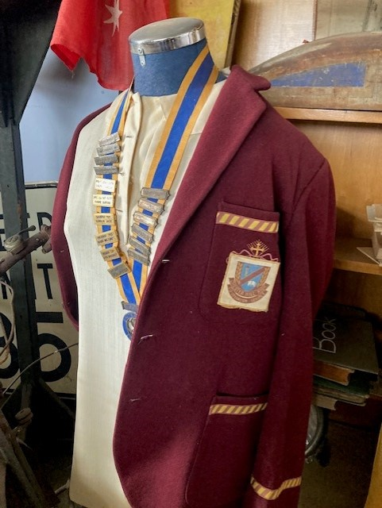
An SRC blazer, original girl’s blouse, and collection of annual SRC badges.

Source 2
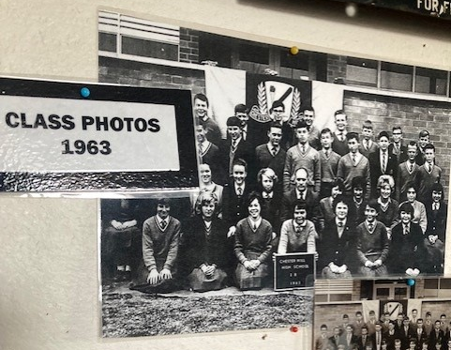
Extract from a display of class photographs from 1963.

Source 3
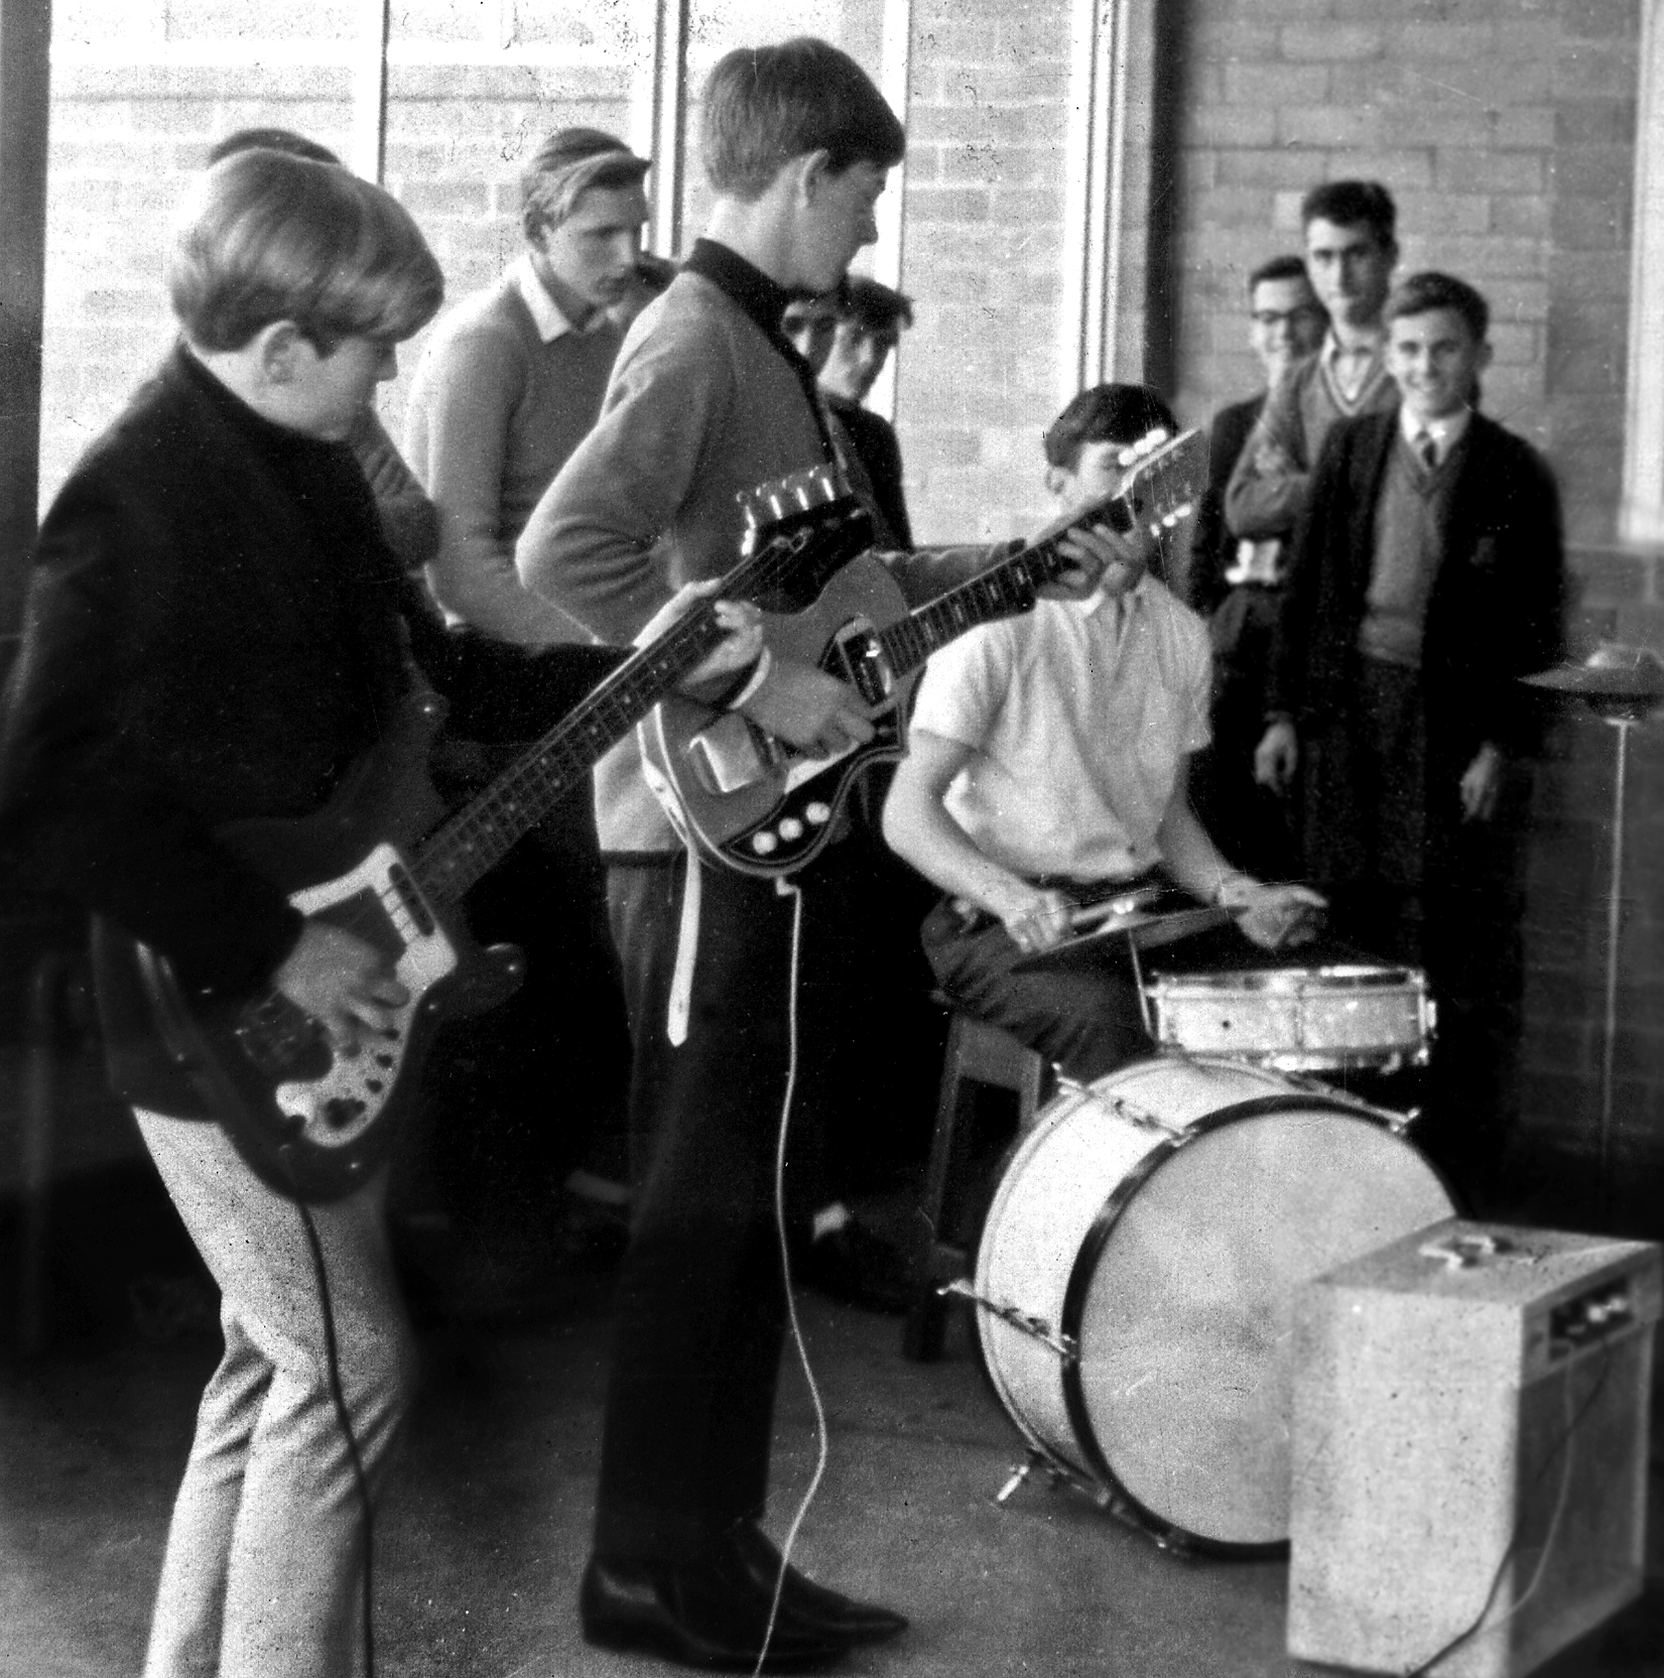
CHHS band paying a small concert at school in 1964, with Bob Daisley on bass.

Source 4
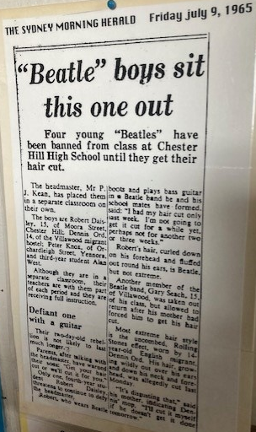
Photograph of a re-printed newspaper article on display in the school museum.
Transcript of source 4
“Beatle boys sit this one out”, The Sydney Morning Herald, Friday 9 July 1965.
Four young “Beatles” have been banned from class at Chester Hill High School until they get their hair cut.
The headmaster, Mr P.J. Kean, has placed them in a separate classroom on their own.
The boys are Robert Daisley, 15, of Moore Street, Chester Hill; Dennis Ord, 14, of the Villawood migrant hostel; Peter Knot, of Orchardleigh Street, Yennora, and third-year student Alan West.
Although they are in a separate classroom, their teachers are with them part of each period and they are receiving full instruction.
Defiant one with a guitar
Their two-day-old rebellion is not likely to last much longer.
Parents, after talking with the headmaster, have warned their sons: “Get your hair cut or we’ll cut it for you.”
Only one fourth-year student Robert Daisley threatens to continue to defy the headmaster.
Robert, who wears Beatle boots and plays bass guitar in a Beatle band he and his school mates have formed said: “I had my hair cut only last week. I’m not going to get it cut for a while yet, perhaps not another two or three weeks.”
Robert’s hair, curled down on his forehead and fluffed out round his ears, is Beatle, but not extreme.
Another member of the Beatle band, Gary Seach, 15, of Villawood, was taken out of his class, but allowed to return after his mother had forced him to get his hair cut.
Most extreme hair style is the uncombed, Rolling Stones effect, worn by 14-year-old English Migrant, Dennis Ord. His fair, growing wildly over his ears and down his neck and forehead, was allegedly cut last Monday.
“It’s disgusting that,” said his mother, indicating Dennis’s mop. “I’ll cut it myself if he doesn’t get it done tomorrow.”

Source 5
Interview with Bob Daisley, former student at Chester Hill High School, 25/04/2023.
1. Do we have your permission to record this interview and use it as research?
Yes.
2. How would you describe your role in the school community?
A pupil from 1962 to 1965, until I was more or less ‘expelled’. A rent-a-rebel. The year that I started at CHHS, 1962, was the first year of the school, it had just opened and we were the ‘Wyndham Report’ guinea pigs.
4. What were some of the most important rules when you were at the school?
School uniform was one, but I wore ‘my version’ of that which, to me, was ‘Rolling Stones’ attire.
6. What was the most interesting or significant event you can recall happening at the school?
Probably the Bee Gees and The Easybeats playing there in the mid-sixties, around ’64, ’65.
7. Do you think the area and the school has changed since then?
Very much so, I visited a few years back and noticed the change, but that seems to have happened with many schools, they look like prisons now.
8. What do you most value about the time you spent as part of the school community?
Making friends and launching my musical career. The first time that I ever played for a live audience was at CHHS. I have a book entitled ‘For Facts Sake’, which highlights my entire career and has my days at [the]… High School in detail.
9. What do you most want students and staff at the school today to know about the school’s history?
From my personal view, I’d have to say the bands, artists that played there. We had The Bee Gees play at a school fete there; The Easybeats played there one Saturday afternoon one year. Their guitarist, George Young (brother of Malcolm and Angus of AC/DC), attended CHHS for a while, and across the road from the school was the migrant hostel, where the Easybeats met each other and formed. Dick Diamond, the Easybeats’ bass player, lived in the next street to me (I was in Moora Street and he was in Virgil Avenue).

Source 6
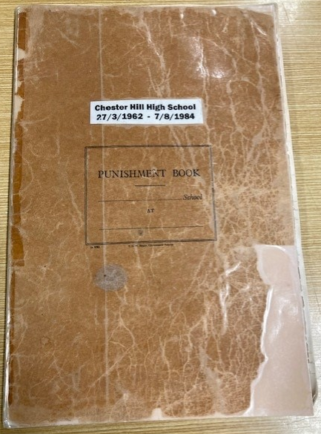
Front cover of a punishment record book, 1962-1984.

Source 7
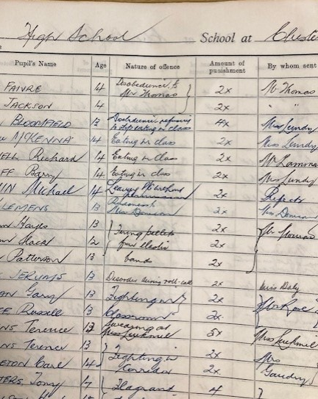
Extract from punishment book, 1962-1984. “Nature of offence” includes offences such as: eating in class, disobedient to teacher, disorder during roll call, fighting in corridor, and firing pellets from elastic bands.

References
American Psychology Association (APA)(n.d.) APA Style [website], APA, accessed 18 April 2023.
American Society for Quality (ASQ)(n.d.) Flowchart, ASQ – Learn about quality, accessed 18 April 2023.
Anderson L (17 May 2022) Using Claim, Evidence, and Reasoning (CER) with Primary Source Analysis, Library of Congress Blogs – Teaching with the library primary sources and ideas for educators, accessed 1 May 2023.
Canberra Times, The (Saturday 10 July 1965) ‘Beatle’ students defiant, The Canberra Times, page 8, accessed 18 April 2023.
Carrie (5 July 2020) How to teach claim, evidence, reasoning like a pro, Beakers and Ink, accessed 1 May 2023.
Complete Dissertation (n.d.) Choosing an interview type for qualitative research, Statistics Solutions, accessed 18 April 2023.
Dr Dee (16 February 2018) Semi-structured interviews guide [video], YouTube, accessed 18 April 2028.
Heritage NSW (n.d.) Heritage online library, Heritage NSW, accessed 18 April 2023.
Goalbook Toolkit (n.d.) Gist statements, Goalbook Toolkit – UDL Strategy Index, accessed 18 April 2023.
Learning Module (10 December 2018) Referencing – putting it all together [video], YouTube, accessed 18 April 2023.
Let’s talk science (n.d.) Crazy 8s, Let’s talk science – Learning strategies, accessed 18 April 2023.
Modern Language Association (MLA)(n.d.) MLA Style [webpage], MLA, accessed 18 April 2023.
Murdoch University Library (29 November 2018) Why referencing is important [video], YouTube, accessed 18 April 2023.
Museums of History NSW (MHNSW)(n.d.) How to use the state archives collection, MHNSW, accessed 18 April 2023.
National History Day (NHD)(n.d.) Guidelines for conducting oral history interviews, NHD – Resources, accessed 18 April 2023.
Oral History Association (OHA)(n.d.) Best practices, OHA, accessed 18 April 2023.
Oral History NSW (n.d.) Resources [webpage], Oral History NSW, accessed 18 April 2023.
Poorvu Center for Teaching and Learning (n.d.) Why are there different citation styles?, Yale, accessed 18 April 2023.
Project Zero (n.d.) See, think, wonder, Harvard Graduate School of Education, accessed 18 April 2023.
Project Zero (2015) Think, puzzle, explore, Harvard Graduate School of Education, accessed 18 April 2023.
Smithsonian Institution Archives (SIA)(n.d.) How to do oral history, SIA, accessed 18 April 2023.
State Library of New South Wales (SLNSW)(n.d.) Research and collections, SLNSW, accessed 18 April 2023.
Trove (n.d.) Trove [website], National Library of Australia, accessed 18 April 2023.
University Libraries (21 September 2018) Research methods guide: interview research, Virginia Polytechnic Institute and State University, accessed 18 April 2023.
University of Chicago (2017) The Chicago Manual of Style Online [website], The University of Chicago, accessed 18 April 2023.
University of Newcastle Library (13 April 2023) Library search help guides: search tips, University of Newcastle, accessed 18 April 2023.
University of Oxford (2 December 2021) Informed consent, University of Oxford – Research support, accessed 18 April 2023.

