Stage 6 Agriculture – Plant production

## Plant breeding resource 3 – Teacher resource

## Plant breeding resource 3

This unit is the last of a three-part series about plant breeding in agriculture. Resource 3 looks in depth at plant breeding trials and experimental design. Students will outline the basic components of experimental design and their role through analysis of real-world plant trials.

## Outcomes

* **H2.1** describes the inputs, processes and interactions of plant production systems.
* **H4.1** justifies and applies appropriate experimental techniques, technologies, research by methods and data presentation and analysis in relation to agricultural problems and situations.

[Agriculture](https://educationstandards.nsw.edu.au/wps/portal/nesa/11-12/stage-6-learning-areas/technologies/agriculture-syllabus) Stage 6 Syllabus © NSW Education Standards Authority (NESA) for and on behalf of the Crown in right of the State of New South Wales, 2013.

All images in the workbook, unless otherwise stated [© State of New South Wales (Department of Education), 2020](https://education.nsw.gov.au/about-us/copyright)

## Research methodology

The development of new varieties of crops is critical to the success and sustainability of farming systems. As the world’s population continues to grow, it will be necessary to produce more food from the world’s finite arable land. Hence new higher yielding plants, plants that produce higher quality products and survive in marginal areas are needed to maintain world food production.

An integral part of developing these new varieties is testing the breeding lines that researchers develop under a range of growing conditions to ascertain that they do possess the ability to produce higher yields or higher quality products. For this to happen, carefully controlled scientific field trials must be undertaken in various locations. Only then can we be sure that the new varieties are indeed superior to existing varieties.

Take some time to watch the following videos and explore the other resources in the links below.

* [Plant Breeding – wheat breeding for commercial production](https://education.nsw.gov.au/teaching-and-learning/curriculum/tas/tas-curriculum-resources-7-12/tas-11-12-curriculum-resources/plant-breeding-wheat#wheat-breeding-commercial) (duration 3:18).
* [Plant breeding – principles of agricultural research](https://education.nsw.gov.au/teaching-and-learning/curriculum/tas/tas-curriculum-resources-7-12/tas-11-12-curriculum-resources/plant-breeding-wheat#principles-agricultural-research) (duration 2:08).
* [Plant breeding – researching drought tolerance](https://education.nsw.gov.au/teaching-and-learning/curriculum/tas/tas-curriculum-resources-7-12/tas-11-12-curriculum-resources/plant-breeding-wheat#drought-tolerance) (duration 4:19).
* [MEF field map](https://cpb-ap-se2.wpmucdn.com/learning.schools.nsw.edu.au/dist/a/4/files/2015/02/MEF-field-map-images-for-DeptEd-doco-AP-edit-20lf02h.xlsx) – Excel spreadsheet showing layout, randomisation, replication and treatments across the MEF site.
* [MEF poster](https://cpb-ap-se2.wpmucdn.com/learning.schools.nsw.edu.au/dist/a/4/files/2015/02/MEF-field-operations-poster-updated-1l883e2.pdf) – PDF summary of field trial management for the MEF.

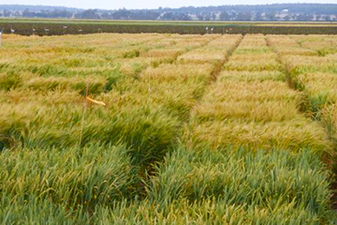

Each breeding line is planted twice within a treatment.

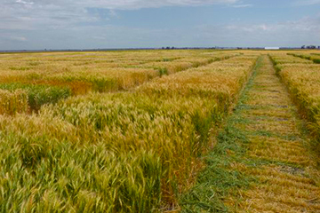

All treatments in the trial are subjected to the same conditions.

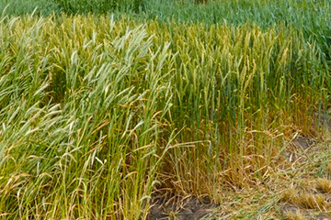

The phenotypes of the different breeding lines become quite apparent as the crop matures.

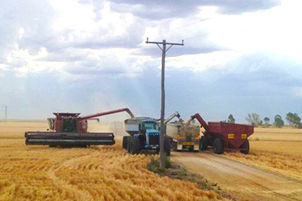

Headers empty their harvested grain into trucks for transport.

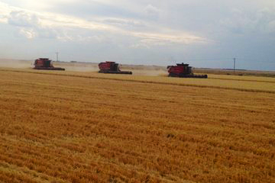

Headers working to harvest the wheat crop.

Outline why an agricultural experiment needs the following design features:

Standardisation

|  |
| --- |
| Standardisation ensures all treatments in the trial are subjected to the same conditions (other than the variable being investigated). It helps ensure that one part of a trial is not advantaged (or disadvantaged) by some factor. |

Replication

|  |
| --- |
| Repeating each treatment in a trial several times improves the accuracy of the trial. It reduces the influence of factors outside the control of the researcher on the result by allowing an average result to be calculated from the replicates. |

Randomisation

|  |
| --- |
| Randomly allocating experimental treatments throughout the growing area reduces the chance of environmental variations in the growing area affecting one treatment more than another. Another way of expressing this is that it reduces bias in the trial. |

A control

|  |
| --- |
| Provides a reference point with which to compare the results obtained in an experiment. |

After looking at the managed environment facility (MEF) trials being conducted at Narrabri, Yanco and Meredin in 2014, what do you think the **aim** of the experiment was?

|  |
| --- |
| The MEF trials aim to compare a large number (about 800) of experimental wheat genotypes (breeding lines) under dry (non-irrigated) and irrigated conditions to determine their ability to withstand drought conditions. |

After looking at the managed environment facility (MEF) trials at the University of Sydney’s Narrabri plant breeding centre in 2014, explain how the following design features were achieved in this specific trial.

**Explain:** provide why and/or how.

Standardisation

|  |
| --- |
| * each breeding line had the same planting density * each breeding line had the same planting depth * each breeding line was planted on the same day * all trial plots received the same soil preparation * the same weed control techniques were applied to all trial plots (sprayed with Glyphosate pre sowing) * all trial plots received the same chemical treatments for things such as rust diseases. |

Replication

|  |
| --- |
| Each breeding line (about 800 of them) was planted in at least two trial plots within each treatment. |

Randomisation

|  |
| --- |
| Each breeding line was randomly allocated to the trial plots in both the watered and non-watered parts of the trial area. |

A control

|  |
| --- |
| Two older varieties (Hartog and Janz) and a newer one (Suntop) were included in the trials. This allowed the researchers to compare the growth and yield of their experimental breeding lines with known standard varieties. |

Explain why a test of significance is needed before the results of agricultural experiments can be accepted. Use the following sentence starters to build your answer.

A test of significance is used to:

|  |
| --- |
| A test of significance is used to determine the likelihood that the results of a trial are due to some unforeseen chance factor rather than the variable being investigated in the trial. |

A test of significance is based on:

|  |
| --- |
| They are generally based on the amount of variation that there is between the replicates of each different treatment in the trial. |

Without a test of significance being conducted:

|  |
| --- |
| Without a test of significance being conducted false conclusions may be made from the trial data. |

Brainstorm a range of ways you think the managed environment facility trials will benefit Australian wheat farmers.

|  |
| --- |
| The MEF trials are comparing around 800 new breeding lines that have been developed by wheat breeders with currently available commercial wheat varieties. From all these breeding lines researchers will be able to choose the ones that perform best in either dry or normal soil moisture conditions and develop them to be released as new commercial varieties. The selection of these new varieties will be largely based on the yield of the breeding lines under dry soil conditions and/or the quality of the grain that they produce under these conditions.  Hence, from these trials’ farmers will gain access to new and improved varieties of wheat to grow in Australia. |

Outline two challenges that Australian wheat farmers are likely to face in the future years and explain how wheat breeding will help overcome them.

Breaking the question down:

* Highlight the HSC verbs and write a definition of what they mean.
* Underline the key ideas and focus points.
* Simplify the question down into basic steps of what is required.

|  |
| --- |
| HSC verbs: Outline and explain.  Key ideas and focus points:   * Two challenges * How breeding overcomes these.   Simplify the question: Outline two challenges and ways to overcome them through plant breeding. |

Complete your answer.

Challenge 1:

|  |
| --- |
| One of the biggest challenges facing wheat farmers is the development of new strains of diseases such as stem rust and stripe rust. If left unchecked, these diseases can severely limit wheat yields. Associated with this is the development of resistance to the chemicals that are currently available to help prevent these and other diseases. By developing new varieties of wheat that are resistant to these diseases’ wheat breeders can help improve crop yields and reduce the costs associated with chemical application. |

Challenge 2:

|  |
| --- |
| A second challenge facing farmers is that of climate change. Most climate scientists believe that large parts of Australia are becoming warmer and drier. This has serious ramifications for crop growth as the currently available varieties of crops will almost certainly not grow as well under these conditions. By breeding crop varieties that are more tolerant of higher temperatures and/or which make more efficient use of soil water plant breeders will help maintain crop yields in a changing climate. |

Answer the following question from the 2015 HSC agriculture exam.

Question 24, a.

Explain the importance of using standardised conditions and a control when conducting agricultural trials. (Four marks).

[Agriculture HSC exam paper 2015](https://educationstandards.nsw.edu.au/wps/portal/nesa/resource-finder/hsc-exam-papers/2015/agriculture-2015-hsc-exam-pack) © NSW Education Standards Authority (NESA) for and on behalf of the Crown in right of the State of New South Wales, 2015. Refer HPRM: MAIL20/149940.

**Explain:** relate cause and effect; make the relationships between things evident; provide why and/or how.

|  |
| --- |
| See 2015 HSC agriculture exam pack for sample answers and marking criteria. Use these to self-mark with students. |

## Breeding wheat

### Breeding new varieties of wheat

Wheat is Australia’s foremost crop. In 2012, approximately 13 million hectares of land was planted to wheat in Australia. This produced around 22.8 million tonnes of wheat with an average yield of 1.8 tonnes/hectare. These figures vary from season to season and are largely dependent on rainfall conditions in the winter cropping areas of southern Australia.

Australia is the fourth largest exporter of wheat in the world, exporting around 80% of its annual crop, despite being responsible for only around 3% of the world’s total wheat production each year. The major export markets are in the Asian and Middle East regions and include Indonesia, Japan, South Korea, Malaysia, Vietnam, Iraq, Iran and Sudan. The total value of these exports was $6.75 billion in the 2012-13 financial year, making wheat our most valuable agricultural export and the eighth most valuable overall.

A range of other winter growing crops are usually grown in rotation with wheat. These include barley, oats, triticale, lupins, chickpeas, field peas, faba beans, canola, lentils, safflower and linseed.

Take some time to watch the following videos.

* [Plant breeding – breeding disease resistance wheat](https://education.nsw.gov.au/teaching-and-learning/curriculum/tas/tas-curriculum-resources-7-12/tas-11-12-curriculum-resources/plant-breeding-wheat#breeding-disease-resistant-varieties) (duration 1:25).
* [Plant breeding – breeding for stem length in wheat](https://education.nsw.gov.au/teaching-and-learning/curriculum/tas/tas-curriculum-resources-7-12/tas-11-12-curriculum-resources/plant-breeding-wheat#stem-length) (duration 1:42).
* [Plant breeding – breeding drought and heat tolerant wheat](https://education.nsw.gov.au/teaching-and-learning/curriculum/tas/tas-curriculum-resources-7-12/tas-11-12-curriculum-resources/plant-breeding-wheat#drought-heat-tolerant-wheat) (duration 1:57).
* [Plant breeding – breeding for yield in wheat](https://education.nsw.gov.au/teaching-and-learning/curriculum/tas/tas-curriculum-resources-7-12/tas-11-12-curriculum-resources/plant-breeding-wheat#yield-in-wheat) (duration 1:44).

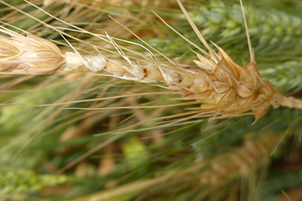

Poor grain development leads to low yield.

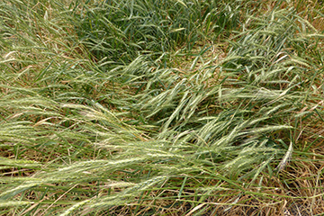

Wheat plants with long stems are more likely to lodge (fall over). This results in lowered yield and difficulties in harvesting.

Use the brainstorming method to list the major characteristics of the wheat plant that plant breeders concentrate on improving in the new varieties they develop.

For each of the characteristics added to the brainstorm above, extend each point and outline how it can improve wheat productivity.

|  |
| --- |
| **Stem length**: modern wheat varieties are bred to have a short, strong stem of around 60 cm in length. This allows them to carry the weight of a heavy head of grain without falling over (lodging). Lodging reduces grain yield by restricting water movement through the stem. Lodged wheat is also more difficult and slower to harvest.  **Disease resistance:** a range of diseases affect wheat plants including stripe rust, stem rust and Crown Rot. Each of these diseases has the capacity to reduce wheat yields in some way, such as by destroying leaf tissue and thus reducing the plant’s capacity to photosynthesize. Breeding plants that are resistant to these diseases improves crop yield.  **Drought tolerance:** plants that can grow and develop with less available water will give higher yields of grain in dry seasons.  **Heat tolerance:** plants that can develop to maturity and fill the heads with grain at higher temperatures have the capacity to yield more grain under the hot conditions experienced in most Australian wheat growing areas.  **Frost tolerance:** current wheat varieties are badly affected by frosts that occur at flowering time. Breeding varieties that are not sterilised by frosts have the capacity to increase wheat yields where frost is likely to occur while the plant is flowering.  **Salinity tolerance:** current wheat varieties are badly affected by saline soils which are an increasing problem in some of Australia’s wheat growing areas. The development of salt tolerant wheat varieties will allow farmers to increase wheat yields in these areas.  **Healthier wheat:** many nutritionists believe that wheat varieties with a higher fibre content, lower glycaemic index and higher levels of resistant starch will enable us to produce foods that are healthier for us. |

Explain why plant breeders need to continuously develop new varieties of wheat.

|  |
| --- |
| Diseases that affect wheat are continually developing and changing. This means that varieties that are disease resistant today may become susceptible in the future. Hence wheat breeders need to be breeding varieties that are resistant to these changed diseases in order to maintain and improve wheat yields.  The warming of the earth’s atmosphere and increased levels of carbon dioxide will also impact on the growth of wheat crops. Breeders will need to develop new varieties that will yield well under these warmer conditions. |

Answer the following question from the 2017 HSC agriculture exam.

Question 21, b.

Describe a trial that could be used to evaluate a new variety of a grain crop. In your answer, show how the trial demonstrates sound experimental design. (Four marks).

[Agriculture HSC exam paper 2017](https://educationstandards.nsw.edu.au/wps/portal/nesa/resource-finder/hsc-exam-papers/2017/agriculture-2017-hsc-exam-pack) © NSW Education Standards Authority (NESA) for and on behalf of the Crown in right of the State of New South Wales, 2017. Refer HPRM: MAIL20/149940.

**Describe:** provide characteristics and features of.

|  |
| --- |
| See 2017 HSC agriculture exam pack for sample answers and marking criteria. Use these to self-mark with students. |

Answer the following question from the 2018 HSC agriculture exam.

Question 22, b.

Explain one method that farmers can use to overcome the effects of extremes of temperature on plant production systems. (Four marks).

[Agriculture HSC exam paper 2018](https://educationstandards.nsw.edu.au/wps/portal/nesa/resource-finder/hsc-exam-papers/2018/agriculture-2018-hsc-exam-pack) © NSW Education Standards Authority (NESA) for and on behalf of the Crown in right of the State of New South Wales, 2018. Refer HPRM: MAIL20/149940.

**Explain:** relate cause and effect; make the relationships between things evident; provide why and/or how.

|  |
| --- |
| See 2018 HSC agriculture exam pack for sample answers and marking criteria. Use these to self-mark with students. |

### Controlling Crown rot in wheat using integrated pest management (IPM)

Crown Rot is one of the major diseases affecting wheat and other cereal crops in many of the wheat growing regions across Australia. In some seasons it causes significant losses in crop yields. A range of management strategies have been developed to combat the effects of this disease.

Take some time to watch the following video and explore the other resource in the links below.

* [Plant breeding – crown rot and integrated pest management](https://education.nsw.gov.au/teaching-and-learning/curriculum/tas/tas-curriculum-resources-7-12/tas-11-12-curriculum-resources/plant-breeding-wheat#crown-rot) (duration 2:13).
* [Root and crown disease of wheat and barley in Northern NSW](https://www.dpi.nsw.gov.au/agriculture/broadacre-crops/winter-crops/general-disorders-of-crops/root-crown-diseases) – website.

Create an information poster about Crown Rot. Include the following:

* Causal agent (pathogen)
* Host range
* Favourable environmental conditions for infection
* Disease symptoms
* Impact on crop yield
* Disease management strategies (for each one, explain how it helps manage crown rot).

|  |
| --- |
| **Causal agent (pathogen):** the fungus Fusarium pseudograminearum.  **Host range:** wheat and barley crops.  **Favourable environmental conditions for infection:**   * moisture stress in the crop * presence of cereal crop residues in the soil.   **Disease symptoms:**   * bases of the tillers turn brown * formation of white heads * cottony fungal growth may form inside tillers * pinkish fungal growth may form low on the tillers * pinched grain.   **Impact on crop yield:** heads of infected tillers fail to fill with grain or have pinched grain. This significantly lowers total grain yield.  **Disease management strategies:**   * Crop rotation using non-cereal such as faba beans, sorghum, sunflowers, canola, field peas, chickpeas. These crops act as a break crop allowing the fungal level in the soil to reduce over time. * Weed control in the crop, helps avoid moisture stress in the crop and prevents the fungus surviving on grass weeds. * Avoid high sowing densities, avoids moisture stress in the crop. * Match nitrogen input to soil moisture levels, avoids moisture stress in the crop. * Precision plant new crops between the rows of last season’s crop when using no till systems. This reduces the rate of infection by increasing the distance between the source of fungus and the new plants. * Ensure adequate crop nutrition, especially zinc, which improves crop vigour and helps plants resist infection. * Plant bread wheats which show a partial resistance to the disease, whereas durum wheats are highly susceptible. |

Explain the role that plant breeders can play in the management of crown rot in cereal crops.

**Explain:** make the relationship between things evident; provide why and/or how.

|  |
| --- |
| Plant breeders work on the development of wheat and barley varieties that are resistant to Crown Rot infection. These varieties would not be affected by Crown Rot enabling farmers to grow them more frequently without the risk of yield losses occurring. |

### Glasshouse trials

#### The importance of field and glasshouse trials in plant breeding.

Plant breeders generally utilize a combination of glasshouse and field trials when developing and evaluating new crop varieties. Sophisticated glasshouses and field equipment have been developed for this work.

Take some time to watch the following video.

[Plant breeding – breeding wheat for the future](https://education.nsw.gov.au/teaching-and-learning/curriculum/tas/tas-curriculum-resources-7-12/tas-11-12-curriculum-resources/plant-breeding-wheat#breeding-wheat-for-the-future) (duration 1:35)

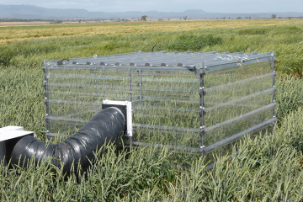

Controlled environment chambers in the field allow plant breeders to more closely mimic particular environmental conditions.

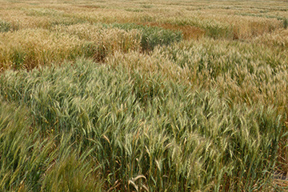

Field trials often involve large numbers of different varieties.

Discuss (provide points for and/or against) the use of both glasshouse and field trials in plant breeding work.

|  |
| --- |
| Environmental conditions such as temperature, carbon dioxide concentration, soil moisture levels and light levels are much more easily controlled in a glasshouse than in a field situation. Hence glasshouses are much more suited to conducting trials relating to the impacts of these environmental factors on the new varieties being developed by plant breeders. Given that most crops are going to be grown outdoors in a field environment it is vital that new varieties are tested in this manner. This allows researchers to evaluate the yield potential of new varieties under actual growing conditions. |

## Biometrical exercise

In this biometrical exercise you will examine the results of a field trial, measuring the effect of preplant urea on the yield and protein levels of wheat.

After you have read the aim, method and results of the trial, you should answer the questions which follow.

**Aim:**

To determine the effect of preplant urea on the yield and protein levels of wheat.

**Method:**

The trial was carried out on the same property. Each replication was carried out in paddocks with similar aspect and soil type.

All areas used in the trial had the following background:

* Prior to sowing wheat, canola had been grown.
* In February, the canola regrowth had been removed.
* In April, the areas had been sprayed with “Logran” to control ryegrass and canola regrowth.
* The wheat crop was sown in May to a depth of 20cm and at a row spacing of 17.5 centimetres.
* The seeding rate was 65 kilograms per hectare.
* 100 kilograms per hectare of DAP fertiliser was added with the seed.

There were three treatment groups:

* Treatment 1 received preplant urea at 60 kilograms per hectare.
* Treatment 2 received preplant urea at 120 kilograms per hectare.
* Treatment 3 received preplant urea at 180 kilograms per hectare.

The preplant urea treatments were applied to each plot one week prior to sowing. Each treatment is replicated three times within the trial.

Each plot was harvested individually with a specialised plot harvester.

The trial layout and yields obtained from each plot are shown below.

**Results:**

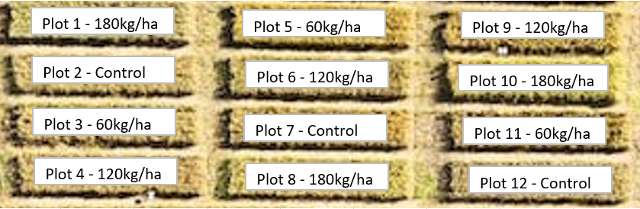

**Figure 1:** layout of treatment groups across preplant urea plant trials.

**Table 1:** Yield and protein results for preplant urea plant trials.

|  |  |  |  |  |
| --- | --- | --- | --- | --- |
| Plot number | Treatment number | Urea rate (kg/ha) | Yield (kg) | Protein (%) |
| 1 | 3 | 180 | 147.7 | 13.1 |
| 2 | Control | 0 | 107.5 | 10.4 |
| 3 | 1 | 60 | 110 | 10.9 |
| 4 | 2 | 120 | 109.3 | 12 |
| 5 | 1 | 60 | 110.5 | 11 |
| 6 | 2 | 120 | 147.5 | 12.2 |
| 7 | Control | 0 | 95 | 10.6 |
| 8 | 3 | 180 | 155 | 12.9 |
| 9 | 2 | 120 | 117.5 | 11.9 |
| 10 | 3 | 180 | 138.9 | 12.8 |
| 11 | 1 | 60 | 114.4 | 10.8 |
| 12 | Control | 0 | 109.5 | 10.5 |

**Questions:**

1. What plant nutrient(s) are supplied by urea?

|  |
| --- |
| The plant nutrient supplied by urea is nitrogen. |

1. Why were each of the treatments replicated three times?

|  |
| --- |
| The treatments were replicated three times for the following reasons:   * To reduce the standard deviation and hence improve the precision of the trial * To allow the results t to be accepted with more confidence * To provide an estimate of experimental error. |

1. Explain why all areas of land used for the trial received identical treatment except for the quantities of urea applied?

|  |
| --- |
| If all of the land used for the trial received identical treatment with the exception of the quantities of preplant urea applied, then any difference in the yield and protein percentages can be more easily accepted as being the result of the application of preplant urea. This is known as standardisation of conditions. |

1. Suggest some reasons for the use of the control?

|  |
| --- |
| The controls were used to obtain production figures for no preplant application of urea. This provides production figures for comparison. Also, the control in this trial is used to decrease the border effect. In the border areas of the treatment, the effect of the respective treatment may become hazy due to some overlap or interference of one treatment into another. In this trial the control reduces this effect and so makes the treatment yields more meaningful. |

1. Why do you think the treatments were allocated to the plots shown in figure1?

|  |
| --- |
| The treatments were most likely allocated to the plots through random allocation to reduce as much bias as possible. Randomisation is designed to control, reduce or eliminate if possible, bias. The fundamental goal of randomisation is to be certain that each treatment is equally likely to be assigned to and given experimental treatment. |

1. Calculate the mean (average) and sample standard deviation for each treatments yield and protein percentage. Use the table below to display this data.

|  |  |  |  |  |
| --- | --- | --- | --- | --- |
|  | Control | Treatment 1 | Treatment 2 | Treatment 3 |
| Mean yield (kg) | 104 | 111.6 | 124.8 | 147.2 |
| Standard deviation - yield | 7.86 | 2.41 | 20.11 | 8.06 |
| Mean protein (%) | 10.5 | 10.9 | 12.03 | 12.9 |
| Standard deviation - protein | 0.1 | 0.1 | 0.15 | 0.15 |

1. Explain why the standard deviation is a useful statistic. What does it tell you about the treatments/data in this trial?

|  |
| --- |
| The standard deviation is a useful statistic because it provides information about how the results varied or spread around the mean. In this trial, the results for Treatment 2 showed the greatest spread or variation around the mean for yield. This is in contrast with the results for Treatment 1 which showed the least spread or variation around the mean. |

1. Do you think that it would be a reasonable assumption to expect that increasing the quantity of urea would increase the protein percentage of the wheat? Explain your answer. Use data to support your answer.

|  |
| --- |
| Yes, it would be a reasonable assumption to expect that increasing the quantity of urea would increase the protein percentage of wheat, because nitrogen is an essential component of protein. If the quantity of urea supplied to the wheat plants was increased, then nitrogen supplied would be increased, hence protein percentage may be increased. The results from this trial showed that increasing the urea increased the protein percentage to 12.9, the control with no urea, only showed 10.5%. |

1. What evidence do you have that indicates that preplant application of urea affects the yields of wheat? Use data to support your answer.

|  |
| --- |
| The evidence that preplant application of urea affects the yields of wheat is that with increasing preplant applications of urea, the yield of wheat increases as shown by the means for the experimental trial. The control group with no urea applied showed and average yield of 104 kilograms per hectare yield while treatment three with 180 kilograms per hectare had an average of 147.2 kilograms per hectare yield. |

1. What other information may be useful to decide whether it is viable economically to apply greater quantities of urea as pre-plant fertiliser?

|  |
| --- |
| It would be necessary to know the cost of the extra urea required to produce the increased yield. This would need to be compared with the extra money received due to the increase in yield. In order to make the use of the pre-plant urea viable, the extra money received due to the increase in yield would need to exceed the cost incurred due to the pre-plant urea used. |

1. What recommendations would you make for further investigation into the effect of preplant application of urea on the yield and protein percentage of wheat?

|  |
| --- |
| Recommendations for further investigation into the effect of preplant application of urea would include:   * use in other locations and soil types * use with other varieties of wheat * use in conjunction with other fertilisers. |