Stage 6 Agriculture – Plant production

## Plant breeding resource 3 – Student workbook

Student name:

Class:

Teacher:

## Plant breeding resource 3

This unit is the last of a three-part series about plant breeding in agriculture. Resource 3 looks in depth at plant breeding trials and experimental design. Students will outline the basic components of experimental design and their role through analysis of real-world plant trials.

## Outcomes

* **H2.1** describes the inputs, processes and interactions of plant production systems.
* **H4.1** justifies and applies appropriate experimental techniques, technologies, research by methods and data presentation and analysis in relation to agricultural problems and situations.

[Agriculture](https://educationstandards.nsw.edu.au/wps/portal/nesa/11-12/stage-6-learning-areas/technologies/agriculture-syllabus) Stage 6 Syllabus © NSW Education Standards Authority (NESA) for and on behalf of the Crown in right of the State of New South Wales, 2013.

All images in the workbook, unless otherwise stated [© State of New South Wales (Department of Education), 2020](https://education.nsw.gov.au/about-us/copyright)

## Research methodology

The development of new varieties of crops is critical to the success and sustainability of farming systems. As the world’s population continues to grow, it will be necessary to produce more food from the world’s finite arable land. Hence new higher yielding plants, plants that produce higher quality products and survive in marginal areas are needed to maintain world food production.

An integral part of developing these new varieties is testing the breeding lines that researchers develop under a range of growing conditions to ascertain that they do possess the ability to produce higher yields or higher quality products. For this to happen, carefully controlled scientific field trials must be undertaken in various locations. Only then can we be sure that the new varieties are indeed superior to existing varieties.

Take some time to watch the following videos and explore the other resources in the links below.

* [Plant Breeding – wheat breeding for commercial production](https://education.nsw.gov.au/teaching-and-learning/curriculum/tas/tas-curriculum-resources-7-12/tas-11-12-curriculum-resources/plant-breeding-wheat#wheat-breeding-commercial) (duration 3:18).
* [Plant breeding – principles of agricultural research](https://education.nsw.gov.au/teaching-and-learning/curriculum/tas/tas-curriculum-resources-7-12/tas-11-12-curriculum-resources/plant-breeding-wheat#principles-agricultural-research) (duration 2:08).
* [Plant breeding – researching drought tolerance](https://education.nsw.gov.au/teaching-and-learning/curriculum/tas/tas-curriculum-resources-7-12/tas-11-12-curriculum-resources/plant-breeding-wheat#drought-tolerance) (duration 4:19).
* [MEF field map](https://cpb-ap-se2.wpmucdn.com/learning.schools.nsw.edu.au/dist/a/4/files/2015/02/MEF-field-map-images-for-DeptEd-doco-AP-edit-20lf02h.xlsx) – Excel spreadsheet showing layout, randomisation, replication and treatments across the MEF site.
* [MEF poster](https://cpb-ap-se2.wpmucdn.com/learning.schools.nsw.edu.au/dist/a/4/files/2015/02/MEF-field-operations-poster-updated-1l883e2.pdf) – PDF summary of field trial management for the MEF.

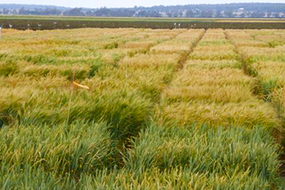

Each breeding line is planted twice within a treatment.

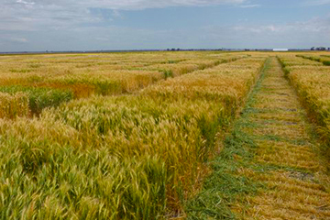

All treatments in the trial are subjected to the same conditions.

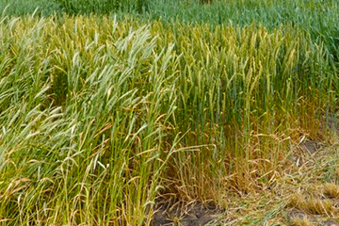

The phenotypes of the different breeding lines become quite apparent as the crop matures.

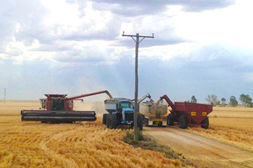

Headers empty their harvested grain into trucks for transport.

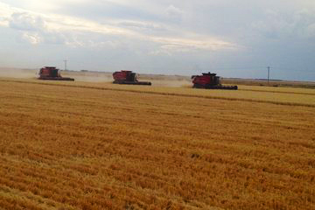

Headers working to harvest the wheat crop.

Outline why an agricultural experiment needs the following design features:

Standardisation

|  |
| --- |
|  |

Replication

|  |
| --- |
|  |

Randomisation

|  |
| --- |
|  |

A control

|  |
| --- |
|  |

After looking at the managed environment facility (MEF) trials being conducted at Narrabri, Yanco and Meredin in 2014, what do you think the **aim** of the experiment was?

|  |
| --- |
|  |

After looking at the managed environment facility (MEF) trials at the University of Sydney’s Narrabri plant breeding centre in 2014, explain how the following design features were achieved in this specific trial.

**Explain:** provide why and/or how.

Standardisation

|  |
| --- |
|  |

Replication

|  |
| --- |
|  |

Randomisation

|  |
| --- |
|  |

A control

|  |
| --- |
|  |

Explain why a test of significance is needed before the results of agricultural experiments can be accepted. Use the following sentence starters to build your answer.

A test of significance is used to:

|  |
| --- |
|  |

A test of significance is based on:

|  |
| --- |
|  |

Without a test of significance being conducted:

|  |
| --- |
|  |

Brainstorm a range of ways you think the managed environment facility trials will benefit Australian wheat farmers.

|  |
| --- |
|  |

Outline two challenges that Australian wheat farmers are likely to face in the future years and explain how wheat breeding will help overcome them.

Breaking the question down:

* Highlight the HSC verbs and write a definition of what they mean.
* Underline the key ideas and focus points.
* Simplify the question down into basic steps of what is required.

|  |
| --- |
|  |

Complete your answer.

Challenge 1:

|  |
| --- |
|  |

Challenge 2:

|  |
| --- |
|  |

Answer the following question from the 2015 HSC agriculture exam.

Question 24, a.

Explain the importance of using standardised conditions and a control when conducting agricultural trials. (Four marks).

[Agriculture HSC exam paper 2015](https://educationstandards.nsw.edu.au/wps/portal/nesa/resource-finder/hsc-exam-papers/2015/agriculture-2015-hsc-exam-pack) © NSW Education Standards Authority (NESA) for and on behalf of the Crown in right of the State of New South Wales, 2015. Refer HPRM: MAIL20/149940.

**Explain:** relate cause and effect; make the relationships between things evident; provide why and/or how.

|  |
| --- |
|  |

## Breeding wheat

### Breeding new varieties of wheat

Wheat is Australia’s foremost crop. In 2012, approximately 13 million hectares of land was planted to wheat in Australia. This produced around 22.8 million tonnes of wheat with an average yield of 1.8 tonnes/hectare. These figures vary from season to season and are largely dependent on rainfall conditions in the winter cropping areas of southern Australia.

Australia is the fourth largest exporter of wheat in the world, exporting around 80% of its annual crop, despite being responsible for only around 3% of the world’s total wheat production each year. The major export markets are in the Asian and Middle East regions and include Indonesia, Japan, South Korea, Malaysia, Vietnam, Iraq, Iran and Sudan. The total value of these exports was $6.75 billion dollars in the 2012-13 financial year, making wheat our most valuable agricultural export and the eighth most valuable overall.

A range of other winter growing crops are usually grown in rotation with wheat. These include barley, oats, triticale, lupins, chickpeas, field peas, faba beans, canola, lentils, safflower and linseed.

Take some time to watch the following videos.

* [Plant breeding – breeding disease resistance wheat](https://education.nsw.gov.au/teaching-and-learning/curriculum/tas/tas-curriculum-resources-7-12/tas-11-12-curriculum-resources/plant-breeding-wheat#breeding-disease-resistant-varieties) (duration 1:25).
* [Plant breeding – breeding for stem length in wheat](https://education.nsw.gov.au/teaching-and-learning/curriculum/tas/tas-curriculum-resources-7-12/tas-11-12-curriculum-resources/plant-breeding-wheat#stem-length) (duration 1:42).
* [Plant breeding – breeding drought and heat tolerant wheat](https://education.nsw.gov.au/teaching-and-learning/curriculum/tas/tas-curriculum-resources-7-12/tas-11-12-curriculum-resources/plant-breeding-wheat#drought-heat-tolerant-wheat) (duration 1:57).
* [Plant breeding – breeding for yield in wheat](https://education.nsw.gov.au/teaching-and-learning/curriculum/tas/tas-curriculum-resources-7-12/tas-11-12-curriculum-resources/plant-breeding-wheat#yield-in-wheat) (duration 1:44).

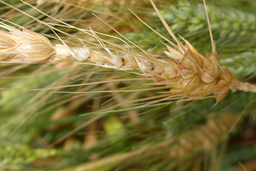

Poor grain development leads to low yield.

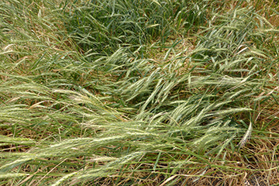

Wheat plants with long stems are more likely to lodge (fall over). This results in lowered yield and difficulties in harvesting.

Use the brainstorming method to list the major characteristics of the wheat plant that plant breeders concentrate on improving in the new varieties they develop.

For each of the characteristics added to the brainstorm above, extend each point and outline how it can improve wheat productivity.

Explain why plant breeders need to continuously develop new varieties of wheat.

|  |
| --- |
|  |

Answer the following question from the 2017 HSC agriculture exam.

Question 21, b.

Describe a trial that could be used to evaluate a new variety of a grain crop. In your answer, show how the trial demonstrates sound experimental design. (Four marks).

[Agriculture HSC exam paper 2017](https://educationstandards.nsw.edu.au/wps/portal/nesa/resource-finder/hsc-exam-papers/2017/agriculture-2017-hsc-exam-pack) © NSW Education Standards Authority (NESA) for and on behalf of the Crown in right of the State of New South Wales, 2017. Refer HPRM: MAIL20/149940.

**Describe:** provide characteristics and features of.

|  |
| --- |
|  |

Answer the following question from the 2018 HSC agriculture exam.

Question 22, b.

Explain one method that farmers can use to overcome the effects of extremes of temperature on plant production systems. (Four marks).

[Agriculture HSC exam paper 2018](https://educationstandards.nsw.edu.au/wps/portal/nesa/resource-finder/hsc-exam-papers/2018/agriculture-2018-hsc-exam-pack) © NSW Education Standards Authority (NESA) for and on behalf of the Crown in right of the State of New South Wales, 2018. Refer HPRM: MAIL20/149940.

**Explain:** relate cause and effect; make the relationships between things evident; provide why and/or how.

|  |
| --- |
|  |

### Controlling Crown rot in wheat using integrated pest management (IPM)

Crown Rot is one of the major diseases affecting wheat and other cereal crops in many of the wheat growing regions across Australia. In some seasons it causes significant losses in crop yields. A range of management strategies have been developed to combat the effects of this disease.

Take some time to watch the following video and explore the other resource in the links below.

* [Plant breeding – crown rot and Integrated pest management](https://education.nsw.gov.au/teaching-and-learning/curriculum/tas/tas-curriculum-resources-7-12/tas-11-12-curriculum-resources/plant-breeding-wheat#crown-rot) (duration 2:13).
* [Root and crown disease of wheat and barley in Northern NSW](https://www.dpi.nsw.gov.au/agriculture/broadacre-crops/winter-crops/general-disorders-of-crops/root-crown-diseases) – website.

Create an information poster about Crown Rot. Include the following:

* Causal agent (pathogen)
* Host range
* Favourable environmental conditions for infection
* Disease symptoms
* Impact on crop yield
* Disease management strategies (for each one, explain how it helps manage crown rot).

|  |
| --- |
|  |

Explain the role that plant breeders can play in the management of crown rot in cereal crops.

**Explain:** make the relationship between things evident; provide why and/or how.

|  |
| --- |
|  |

### Glasshouse trials

#### The importance of field and glasshouse trials in plant breeding.

Plant breeders generally utilize a combination of glasshouse and field trials when developing and evaluating new crop varieties. Sophisticated glasshouses and field equipment have been developed for this work.

Take some time to watch the following video.

* [Plant breeding – breeding wheat for the future](https://education.nsw.gov.au/teaching-and-learning/curriculum/tas/tas-curriculum-resources-7-12/tas-11-12-curriculum-resources/plant-breeding-wheat#breeding-wheat-for-the-future) (duration 1:35)

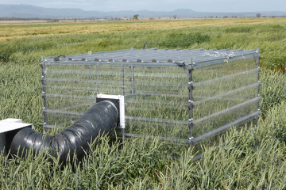

Controlled environment chambers in the field allow plant breeders to more closely mimic particular environmental conditions.

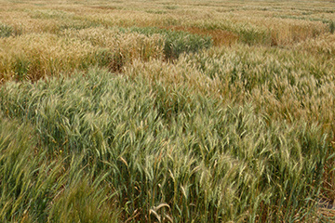

Field trials often involve large numbers of different varieties.

Discuss (provide points for and/or against) the use of both glasshouse and field trials in plant breeding work.

|  |
| --- |
|  |

## Biometrical exercise

In this biometrical exercise you will examine the results of a field trial, measuring the effect of preplant urea on the yield and protein levels of wheat.

After you have read the aim, method and results of the trial, you should answer the questions which follow.

**Aim:**

To determine the effect of preplant urea on the yield and protein levels of wheat.

**Method:**

The trial was carried out on the same property. Each replication was carried out in paddocks with similar aspect and soil type.

All areas used in the trial had the following background:

* Prior to sowing wheat, canola had been grown.
* In February, the canola regrowth had been removed.
* In April, the areas had been sprayed with “Logran” to control ryegrass and canola regrowth.
* The wheat crop was sown in May to a depth of 20cm and at a row spacing of 17.5 centimetres.
* The seeding rate was 65 kilograms per hectare.
* 100 kilograms per hectare of DAP fertiliser was added with the seed.

There were three treatment groups:

* Treatment 1 received preplant urea at 60 kilograms per hectare.
* Treatment 2 received preplant urea at 120 kilograms per hectare.
* Treatment 3 received preplant urea at 180 kilograms per hectare.

The preplant urea treatments were applied to each plot one week prior to sowing. Each treatment is replicated three times within the trial.

Each plot was harvested individually with a specialised plot harvester.

The trial layout and yields obtained from each plot are shown below.

**Results:**

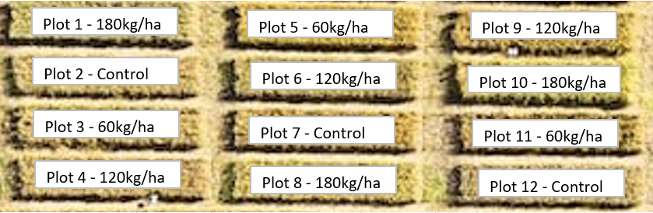

**Figure 1:** layout of treatment groups across preplant urea plant trials.

**Table 1:** Yield and protein results for preplant urea plant trials.

|  |  |  |  |  |
| --- | --- | --- | --- | --- |
| Plot number | Treatment number | Urea rate (kg/ha) | Yield (kg) | Protein (%) |
| 1 | 3 | 180 | 147.7 | 13.1 |
| 2 | Control | 0 | 107.5 | 10.4 |
| 3 | 1 | 60 | 110 | 10.9 |
| 4 | 2 | 120 | 109.3 | 12 |
| 5 | 1 | 60 | 110.5 | 11 |
| 6 | 2 | 120 | 147.5 | 12.2 |
| 7 | Control | 0 | 95 | 10.6 |
| 8 | 3 | 180 | 155 | 12.9 |
| 9 | 2 | 120 | 117.5 | 11.9 |
| 10 | 3 | 180 | 138.9 | 12.8 |
| 11 | 1 | 60 | 114.4 | 10.8 |
| 12 | Control | 0 | 109.5 | 10.5 |

**Questions:**

1. What plant nutrient(s) are supplied by urea?

|  |
| --- |
|  |

1. Why were each of the treatments replicated three times?

|  |
| --- |
|  |

1. Explain why all areas of land used for the trial received identical treatment except for the quantities of urea applied?

|  |
| --- |
|  |

1. Suggest some reasons for the use of the control?

|  |
| --- |
|  |

1. Why do you think the treatments were allocated to the plots shown in figure1?

|  |
| --- |
|  |

1. Calculate the mean (average) and sample standard deviation for each treatments yield and protein percentage. Use the table below to display this data.

|  |  |  |  |  |
| --- | --- | --- | --- | --- |
|  | Control | Treatment 1 | Treatment 2 | Treatment 3 |
| Mean yield (kg) |  |  |  |  |
| Standard deviation - yield |  |  |  |  |
| Mean protein (%) |  |  |  |  |
| Standard deviation - protein |  |  |  |  |

1. Explain why the standard deviation is a useful statistic. What does it tell you about the treatments/data in this trial?

|  |
| --- |
|  |

1. Do you think that it would be a reasonable assumption to expect that increasing the quantity of urea would increase the protein percentage of the wheat? Explain your answer. Use data to support your answer.

|  |
| --- |
|  |

1. What evidence do you have that indicates that pre-plant application of urea affects the yields of wheat? Use data to support your answer.

|  |
| --- |
|  |

1. What other information may be useful to decide whether it is viable economically to apply greater quantities of urea as pre-plant fertiliser?

|  |
| --- |
|  |

1. What recommendations would you make for further investigation into the effect of pre-plant application of urea on the yield and protein percentage of wheat?

|  |
| --- |
|  |